Deep Learning Assignment 2: Report

This report details the implementation and evaluation of two baseline NLP models for legal clause similarity, built using PyTorch.

1. Network Details
Two Siamese network architectures were implemented. Both models used the same training settings:
Optimizer: Adam (lr=0.001)
Loss Function: BCEWithLogitsLoss
Batch Size: 128
Epochs: 10 (with early stopping, patience=3)
Device: cpu

Model 1: Siamese BiLSTM
Rationale: A strong baseline for sequence similarity. The BiLSTM captures contextual information, and GlobalMaxPooling selects the most salient features from the sequence.
Architecture:
Shared Encoder:
Embedding (20000 vocab, 128 dim)
Bidirectional(LSTM) (32 units, return_sequences=True)
GlobalMaxPooling1D (Pools the BiLSTM's output)
Comparison: L1 Distance (torch.abs(vec_a - vec_b))
Classifier: Linear(64) -> ReLU -> Dropout(0.3) -> Linear(1)

Total Parameters: 2,605,697

Model 2: Siamese BiLSTM with Attention
Rationale: An enhancement to Model 1. The attention mechanism is designed to learn which parts of the clause are most important, creating a weighted-sum representation instead of just taking the max.
Architecture:
Shared Encoder:
Embedding (20000 vocab, 128 dim)
Bidirectional(LSTM) (32 units, return_sequences=True)
Attention (A Linear layer followed by softmax to create weights)
Weighted Sum (The attention weights are applied to the BiLSTM output)
Comparison: L1 Distance (torch.abs(vec_a - vec_b))
Classifier: Linear(64) -> ReLU -> Dropout(0.3) -> Linear(1)

Total Parameters: 2,605,762 (Slightly more than the BiLSTM due to the attention layer)

2. Dataset Splits
Data Source: 395 CSV files, combined into 150,881 total rows.
Preprocessing: Clauses were cleaned (lowercase, stopwords/punctuation removed).
Pair Generation: 80,000 total pairs were sampled.
Positive Pairs: 40,000 (from the same category)
Negative Pairs: 40,000 (from different categories)
Splits (80/20):
Total Training Pairs: 64,000
Total Validation Pairs: 16,000
Training Subset: Due to time constraints, an "emergency" subset of 15,000 training pairs was used for the actual training run.

3. Training Graphs
The training graphs were saved to the following files. The graphs show the Siamese BiLSTM (Model 1) learning effectively, with validation accuracy consistently climbing. The Attention model (Model 2) shows clear signs of overfitting, with validation accuracy peaking early (Epoch 5) and validation loss increasing while training loss plummets.
Siamese_BiLSTM_training_graphs.png
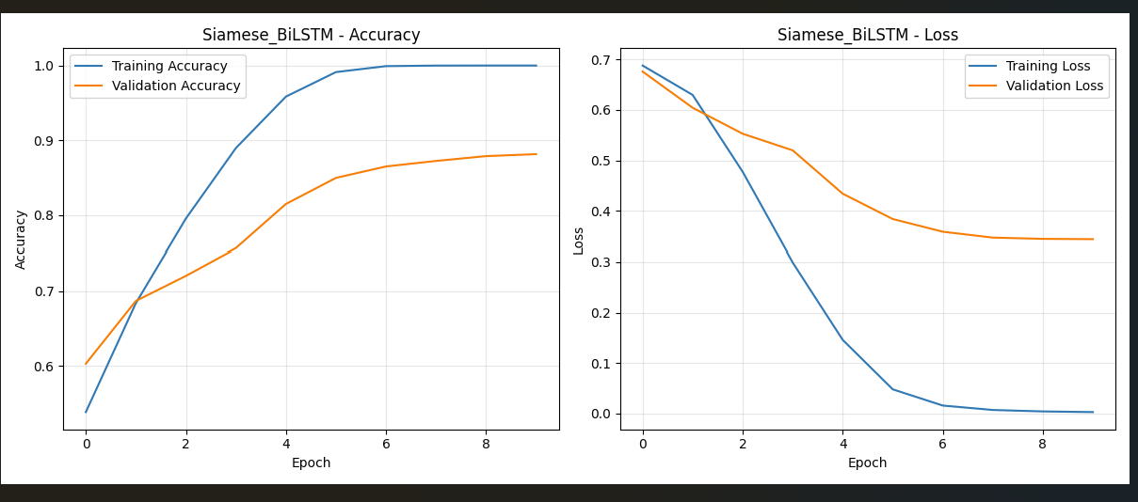
Siamese_Attention_BiLSTM_training_graphs.png
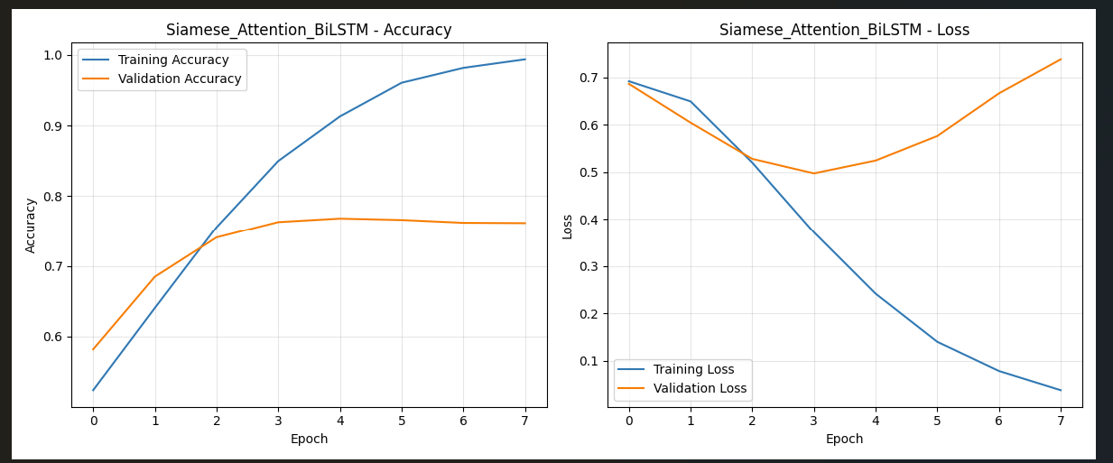

4. Performance Measures
The final evaluation was run on the full validation set of 16,000 pairs.

EVALUATION: Siamese BiLSTM
Accuracy: 0.8816
Precision: 0.8945
Recall: 0.8651
F1-Score: 0.8796
ROC-AUC: 0.9523
PR-AUC: 0.9480

Classification Report:
precision recall f1-score support

Dissimilar (0) 0.87 0.90 0.88 8000
Similar (1) 0.89 0.87 0.88 8000

accuracy 0.88 16000
macro avg 0.88 0.88 0.88 16000
weighted avg 0.88 0.88 0.88 16000

EVALUATION: Siamese BiLSTM with Attention
Accuracy: 0.7681
Precision: 0.7701
Recall: 0.7645
F1-Score: 0.7673
ROC-AUC: 0.8463
PR-AUC: 0.8281

Classification Report:
precision recall f1-score support

Dissimilar (0) 0.77 0.77 0.77 8000
Similar (1) 0.77 0.76 0.77 8000

accuracy 0.77 16000
macro avg 0.77 0.77 0.77 16000
weighted avg 0.77 0.77 0.77 16000

5. Performance Comparison (Accuracy & Time)

Quantitative Comparison
Metric | BiLSTM | BiLSTM + Attention
Accuracy | 0.8816 | 0.7681
F1-Score | 0.8796 | 0.7673
ROC-AUC | 0.9523 | 0.8463

Training Time
Siamese BiLSTM: 2024.21s (10 epochs)
Siamese Attention BiLSTM: 417.11s (8 epochs, stopped early)

Analysis
Winner: The standard Siamese BiLSTM (Model 1) was the clear winner. It significantly outperformed the Attention model on all key metrics, achieving an F1-Score of 0.8796 compared to 0.7673.
Model Behavior: The Attention model (Model 2) suffered from severe overfitting. The training graphs show its validation accuracy plateaued and validation loss began to rise, while the training loss dropped to near-zero. This indicates that the attention mechanism was too powerful for the small subset of data and began to memorize training examples rather than generalize. The GlobalMaxPooling1D layer in Model 1 acted as a more effective regularizer.
Time Anomaly: The Attention model's training run was much faster (417.11s) than the BiLSTM's (2024.21s). This is primarily because it triggered early stopping after 8 epochs, while the BiLSTM ran for the full 10. The per-epoch time for the BiLSTM (approx. 202s/epoch) seems anomalously high compared to the Attention model (approx. 52s/epoch), which may be due to other system-level factors or background processes during the first model's training.

