RDS
TASK 1: Create MariaDB DB on EC2
Task Title
Create MariaDB Database on an EC2 Instance
Objective
Deploy a MariaDB server on an EC2 instance for initial database creation and data storage.
Prerequisites
- VPC with public subnet
- EC2 instance
- Security Group allowing SSH (port 22)
- Key Pair
Step-by-Step Implementation
Step 1: Launch EC2 Instanc
- Instance Type: t2.micro
- Subnet: Public
- Security Group: SSH allowed
Evidence: EC2 running screenshot.

Step 2: Install MariaDB Server
sudo apt update -y
sudo apt install mariadb-server -y
sudo systemctl start mariadb
sudo systemctl enable mariadb
Evidence:
- systemctl status mariadb output

Validation
Validation 1: MariaDB is Running
sudo systemctl status mariadb
Validation 2: Login Check
sudo mysql -u root
Evidence: Successful login screenshot.

Issues Faced
None (or add if needed)

Conclusion
MariaDB successfully installed and running on EC2.
yum install apt
Yum install
dnf install mariadb105-server -y
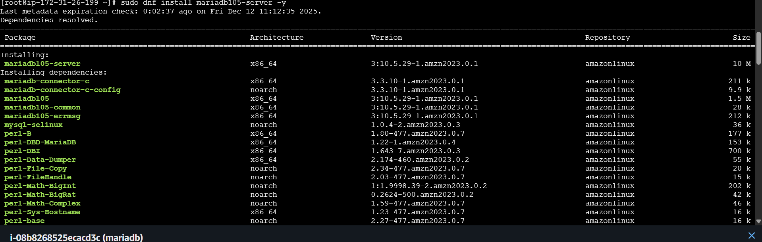
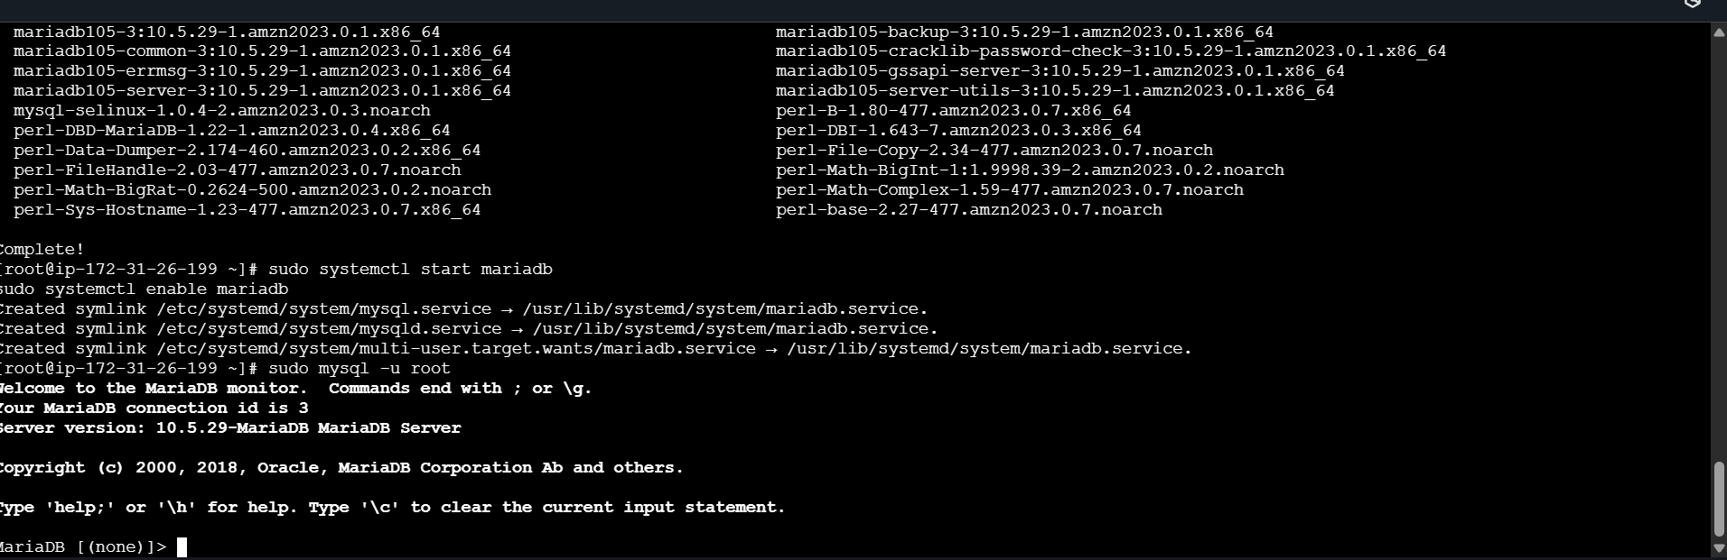

2.Insert some dummy data.

Steps:
Enter the database Command enter into the database which we have created: My sql -u root
Then I have entered in the folder called company using the command : Use company;
To view the table (Employees) I have enter the command : select * from employees;
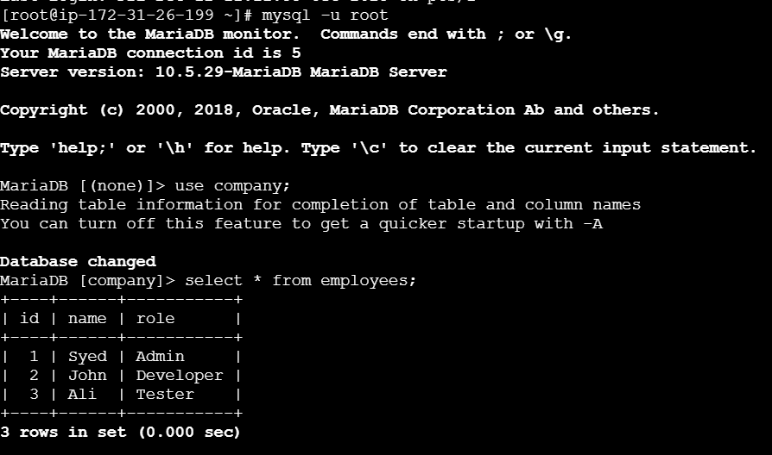

3.Take the backup of dummy data on EC2.To take the backup

we use the command: mysqldump -u root company > company_backup.sql

Ls -l to show the backup.sql file
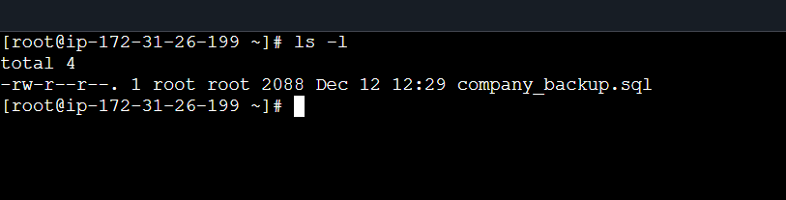

4.Launch MariaDB RDS instance.
✅ TASK 4: Launch MariaDB RDS Instance
Task Title
Deploy MariaDB on AWS RDS
Objective
Spin up an RDS MariaDB instance for managed database hosting.
Prerequisites
- RDS subnet group
- Security group allowing EC2 → RDS on port 3306

Step-by-Step Implementation
Step 1: Create RDS Instance
- Engine: MariaDB
- Instance type: db.t3.micro
- Storage: GP3
- Public Access: No
- Credentials: admin / password
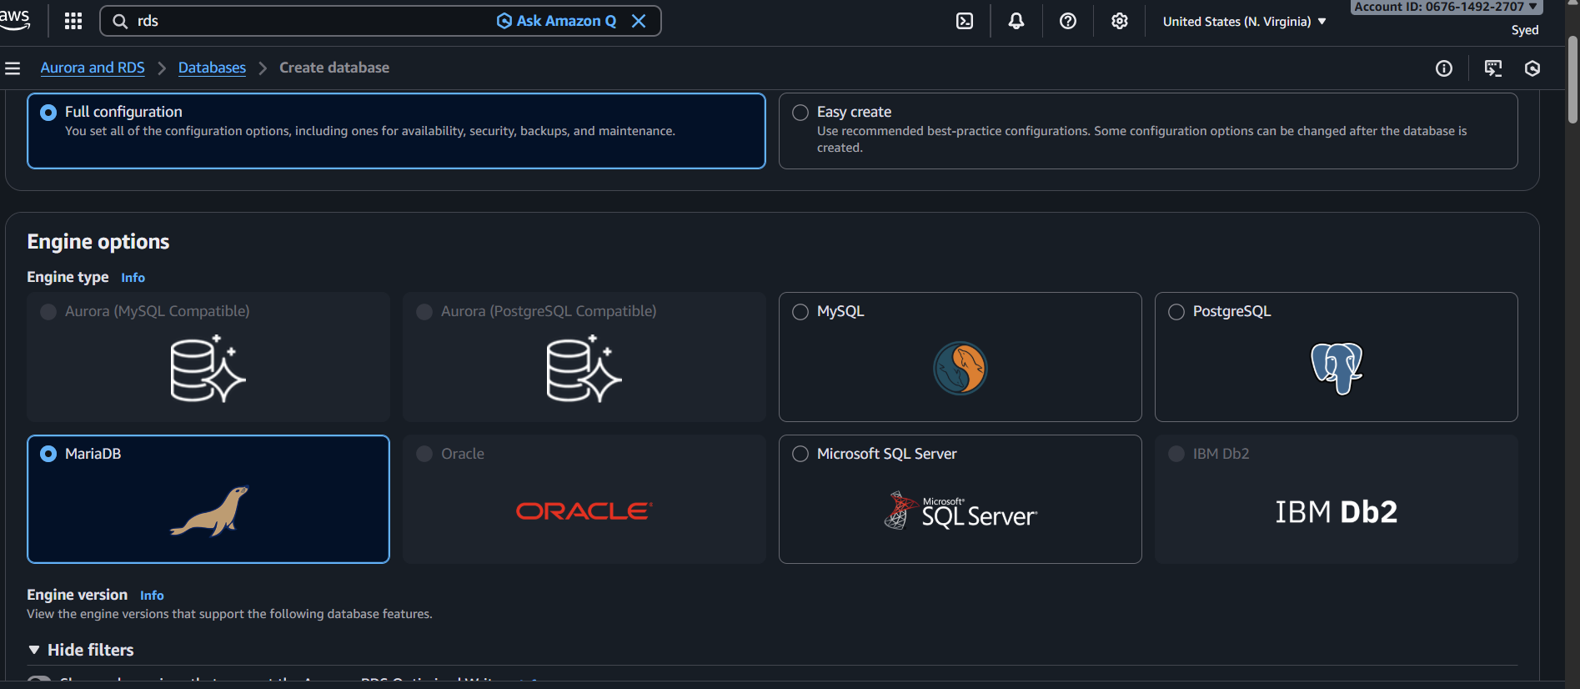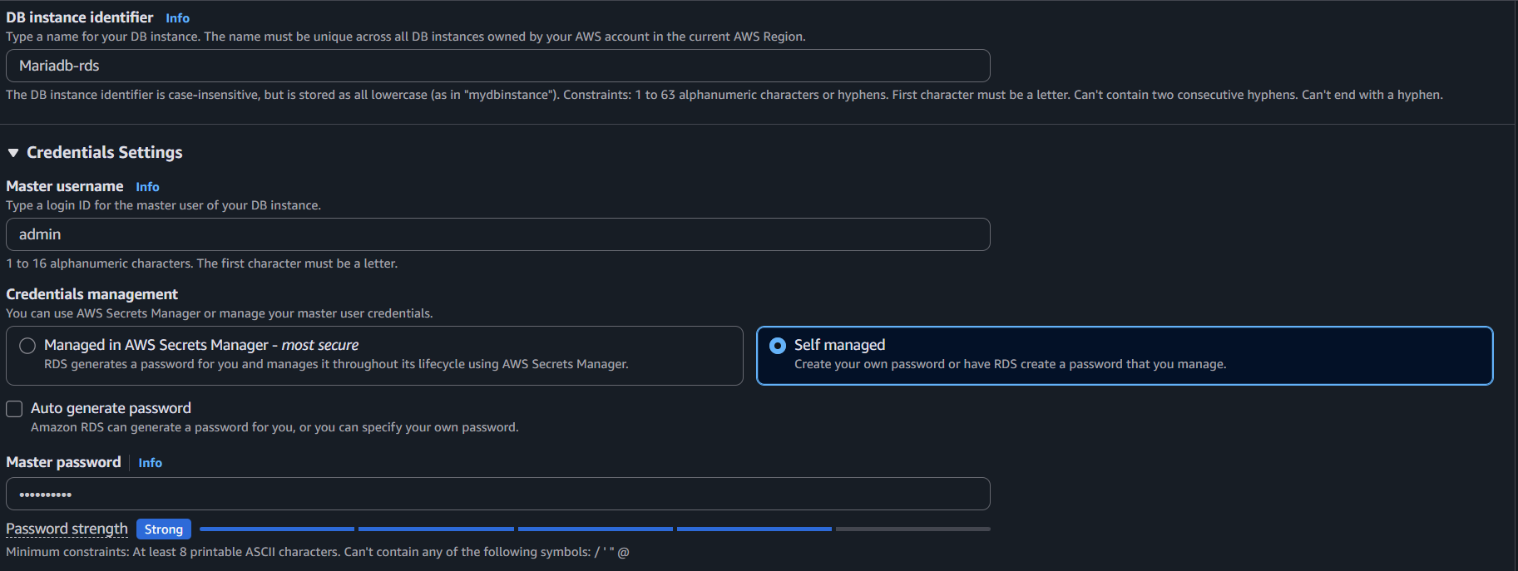
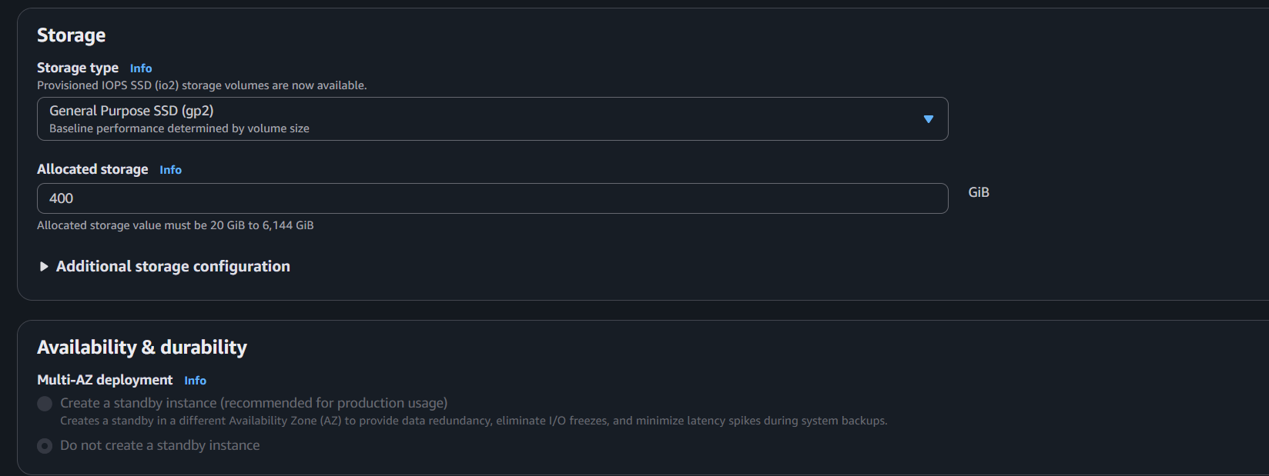
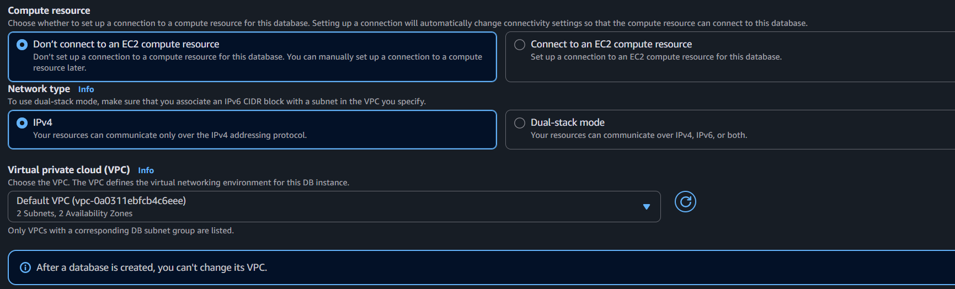
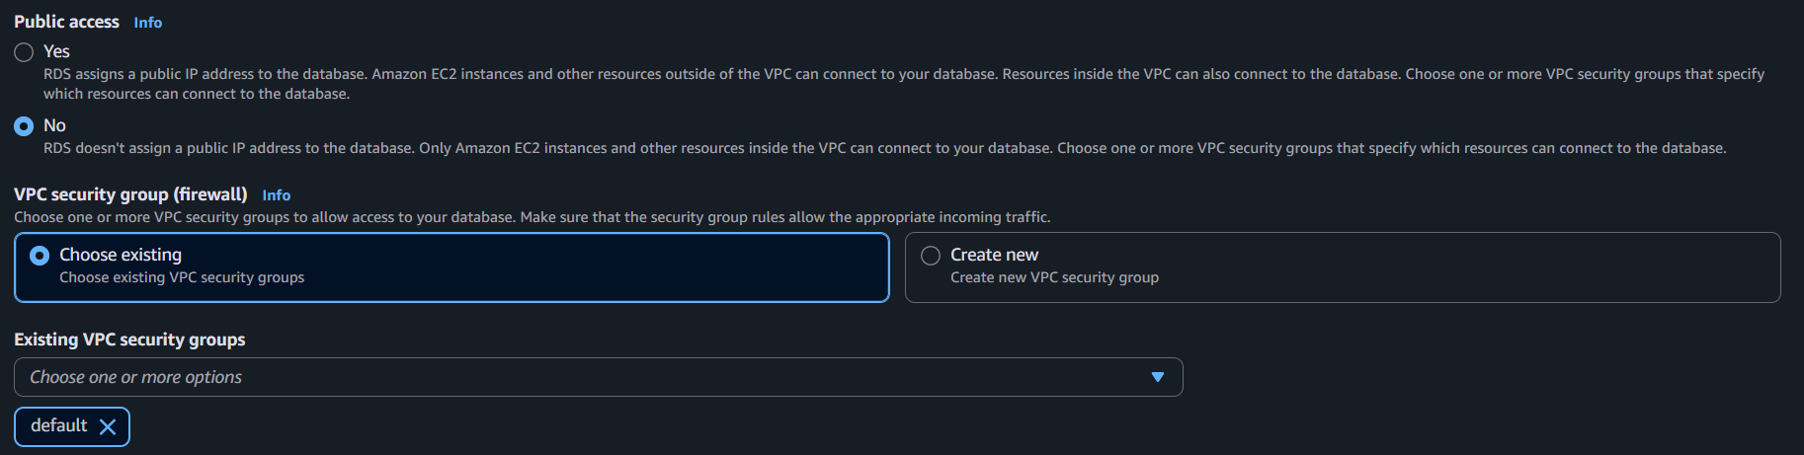

Evidence: RDS shows "Available" status.
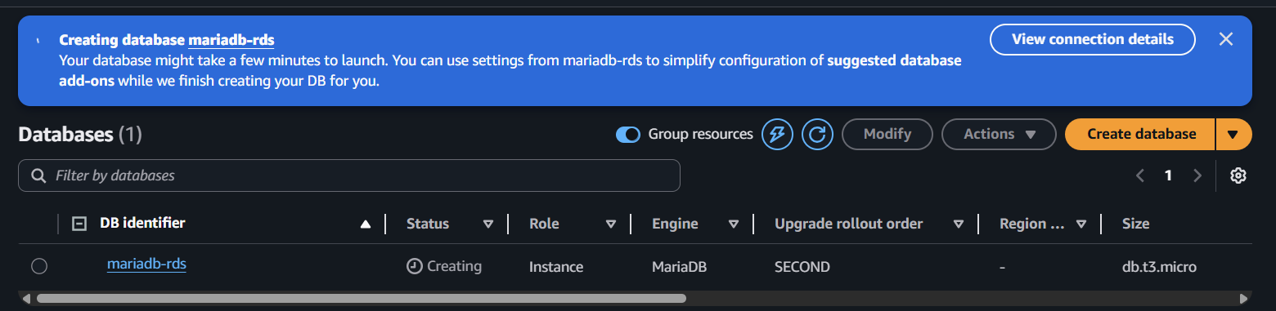
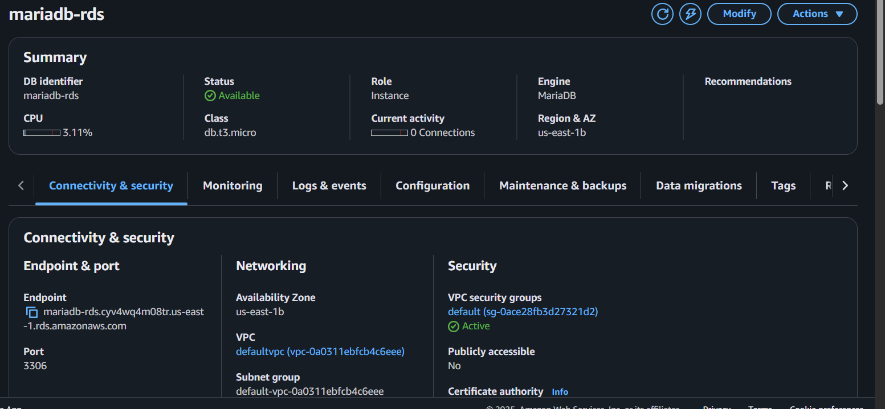
Conclusion
MariaDB RDS instance successfully deployed.

5.Migrate database from EC2 to RDS.

Task Title
Database Migration from EC2 MariaDB to RDS MariaDB
Objective
Import backup file from EC2 into RDS MariaDB instance.
Prerequisites
- Backup file ready
- EC2 security group allowed into RDS

Step-by-Step Implementation
Step 1: Import Backup
mysql -h <RDS-ENDPOINT> -u admin -p company < company_backup.sql

Step 2: Verify Data
mysql -h <RDS-ENDPOINT> -u admin -p -e "SELECT * FROM company.employees;"
Evidence: Shows inserted rows.
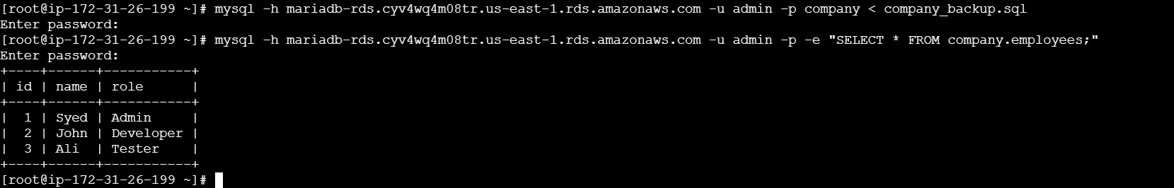

Conclusion
Database successfully migrated to RDS.

6.Install MySQL DB on EC2.
Task Title
Install MySQL Database on EC2 Instance
Objective
To install and configure MySQL database on an EC2 instance for database operations and migration testing.
Prerequisites
- VPC
- Public Subnet
- Internet Gateway
- Route Table attached
- EC2 Instance (Amazon Linux 2 / Ubuntu)
- Key Pair
- Security Group (Allow SSH 22, MySQL 3306 if required)
- IAM Role (Optional – SSM access)
Step-by-Step Implementation (With Evidence)
Step 1: Launch EC2 Instance
- Console Path: EC2 → Instances → Launch Instance
- Choose Amazon Linux 2 / Ubuntu
- Attach public subnet and security group
Evidence: EC2 instance running screenshot

Step 2: Connect to EC2
ssh -i key.pem ec2-user@<Public-IP>
Explanation: Connect securely to EC2.
Evidence: SSH terminal output

Step 3: Install MySQL
sudo yum update -y
sudo yum install mysql-server -y
Start MySQL:
sudo systemctl start mysqld
sudo systemctl enable mysqld
Evidence:
mysql --version
systemctl status mysqld

Step 4: Secure MySQL
sudo mysql_secure_installation
- Set root password
- Remove anonymous users
- Disable remote root login
Evidence: Terminal output

Step 5: Create Database & Table
CREATE DATABASE testdb;
USE testdb;
CREATE TABLE users (id INT PRIMARY KEY, name VARCHAR(50));
INSERT INTO users VALUES (1,'Syed');
Evidence: SQL output screenshot

Validation Steps (Mandatory)
Validation 1: Resource Health
- EC2 running & status checks passed
Evidence: EC2 status screenshot
Validation 2: Functional Check
mysql -u root -p
SHOW DATABASES;
Evidence: SQL output
Validation 3: Network Check
ping google.com
Evidence: Terminal output
Validation 4: Access Check
- SSH access successful
Evidence: SSH session screenshot

Conclusion
MySQL database successfully installed and configured on EC2.

7.Launch MySQL RDS image.

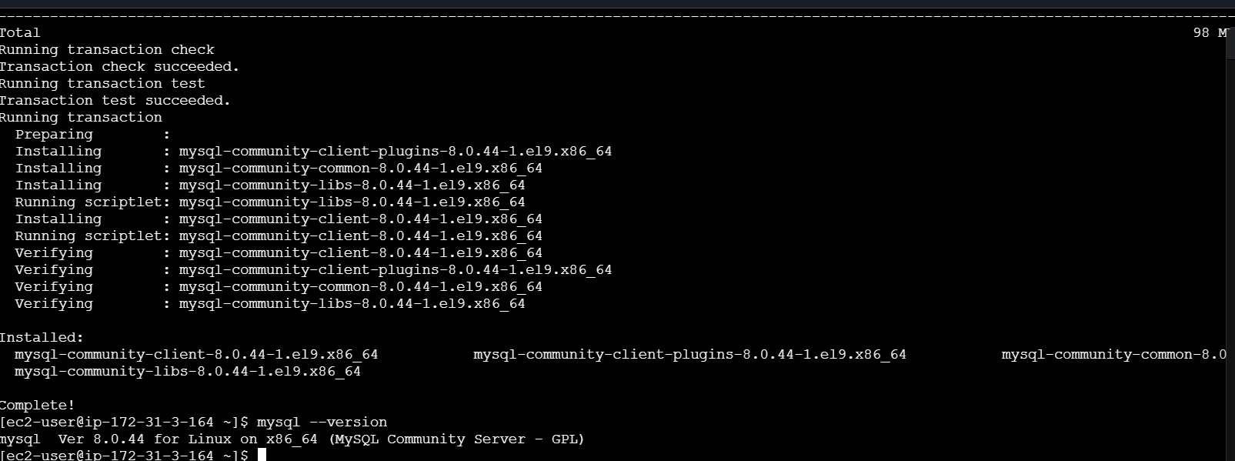

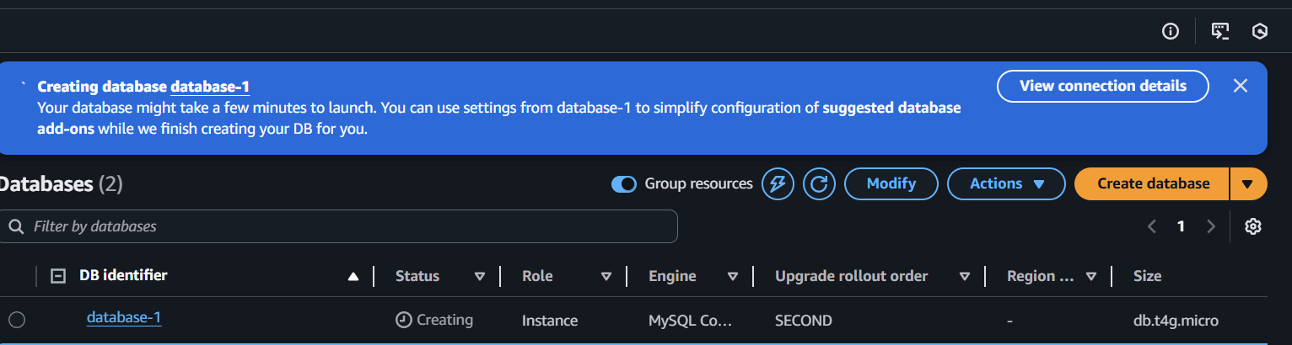
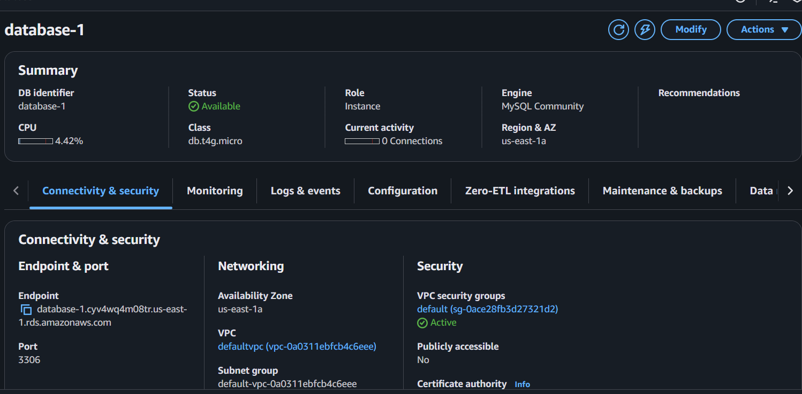
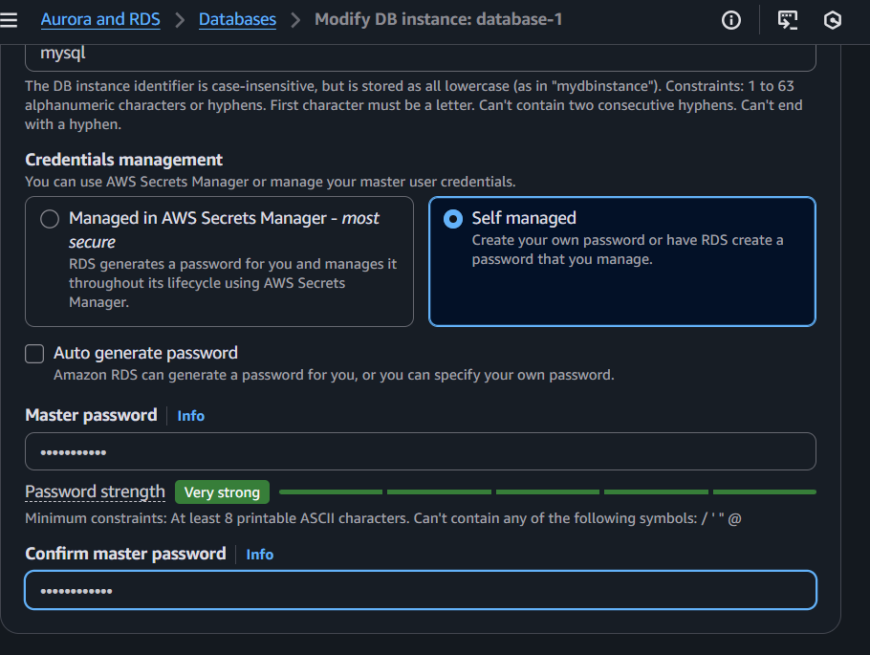

8.Configure Multi-AZ.
Task Title
Enable Multi-AZ for MySQL RDS Instance
Objective
Configure Multi-AZ deployment to provide high availability and automatic failover for the MySQL RDS instance.
Example: Convert a single-AZ RDS instance to Multi-AZ for improved durability.
Prerequisites
• VPC
• Private Subnets in at least two Availability Zones
• DB Subnet Group with subnets in AZ-A & AZ-B
• MySQL RDS instance (running)
• Security Groups
• Route Tables
• No pending maintenance on RDS

Step-by-Step Implementation (With Evidence)

Step 1: Open the RDS Console
Console Path:
AWS Console → RDS → Databases → Select your MySQL RDS instance
Explanation:
We start by accessing the DB settings to modify availability.
Evidence:
(Screenshot of selected MySQL RDS)
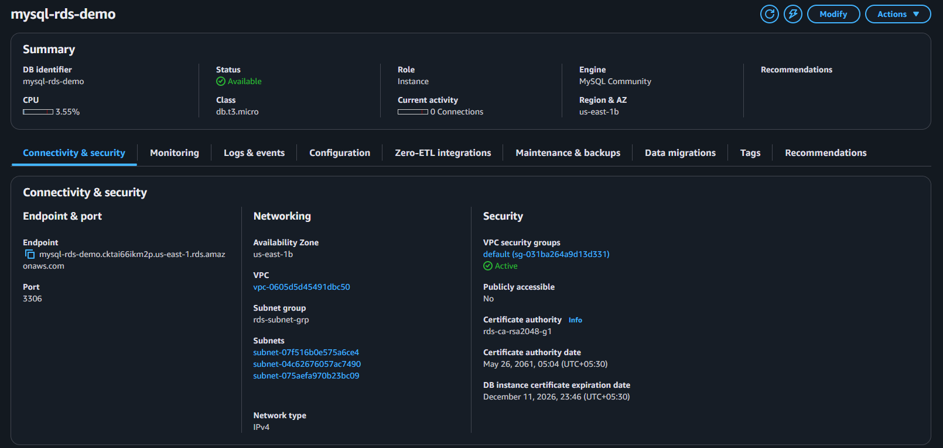
Step 2: Click “Modify”
Console Path:
Actions → Modify
Explanation:
Allows you to change configuration of an existing RDS instance.
Scroll to “Availability & Durability” Section
Select:
✔ Multi-AZ DB instance
(Do NOT select Multi-AZ cluster unless required)
Explanation:
Enables synchronous replication to a standby instance in another AZ.
Evidence:
(Screenshot of Multi-AZ option selected)
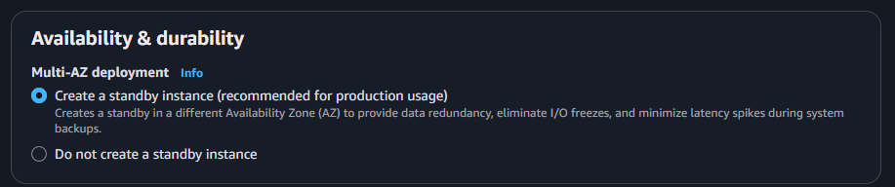
Step 4: Choose the Deployment Type
Choose:
✔ Multi-AZ DB Instance (One standby)
Explanation:
AWS will automatically deploy a second copy in another Availability Zone.
Evidence:
(Screenshot of AZ settings)
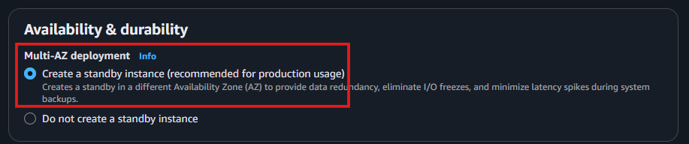
Step 5: Apply Changes
At the bottom choose:
✔ Apply Immediately (if allowed)
or
✔ Apply during next maintenance window (recommended for production)
Explanation:
Applies the Multi-AZ configuration.
Step 7: Wait for Status = “Available”
Check:
RDS → Databases → DB Status
Available
Multi-AZ: Yes
Explanation:
RDS now has 2 synchronous DB nodes across AZs.
Evidence:
(Screenshot showing “Multi-AZ: Yes”)
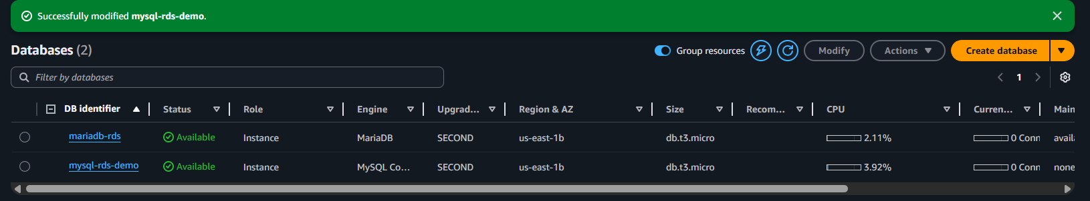
Validation Steps (Mandatory)

Validation 1: Resource Health
Check:
DB status = Available
Multi-AZ = Yes
Secondary AZ visible
Evidence:
RDS dashboard screenshot
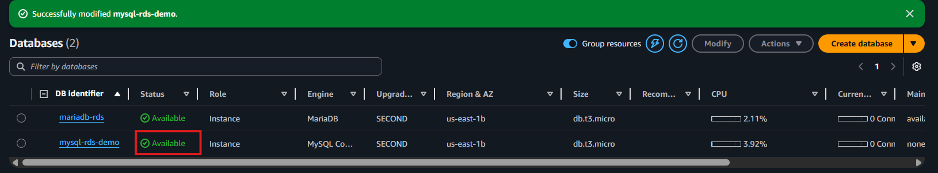
Validation 2:Reboot with Failover
Console Path:
RDS → Databases → Actions → multi-AZ-zones
What Happens:
Modifying to multi availability zones
Evidence:
Screenshot showing new AZ as primary
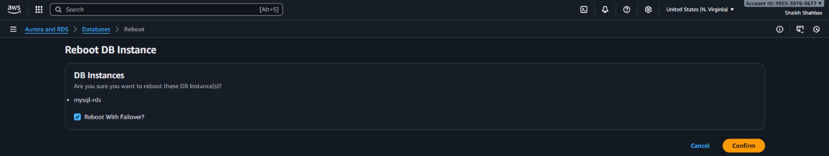
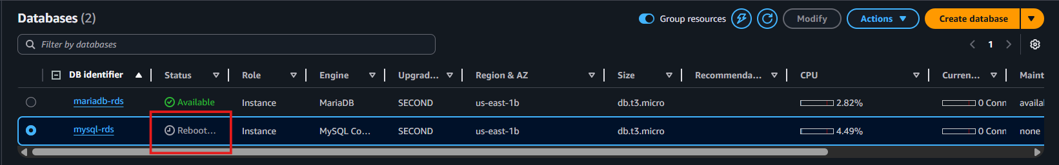
Validation 3: Application Connectivity
From EC2:
mysql -u admin -p -h <rds-endpoint>
Check:
Connection stays active before & after failover (few seconds downtime).
Evidence:
Terminal screenshot
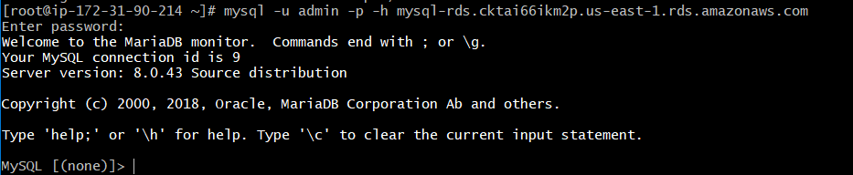
Validation 4: Network Check
From EC2:
telnet <rds-endpoint> 3306
Expected:
Connection successful
Evidence:
Screenshot showing TCP connection
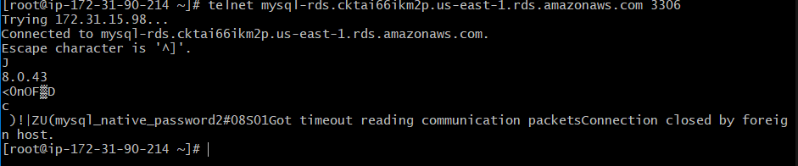
Issues Faced
Issue | Cause | Fix
“Cannot enable Multi-AZ” | Subnet group has only 1 AZ | Add subnet in second AZ
“Apply Immediately disabled” | Storage or class mismatch | Choose compatible instance class
Connection timeout | SG misconfigured | Allow EC2-SG → RDS-SG on port 3306

Conclusion
Multi-AZ is successfully enabled, ensuring high availability, synchronous replication, and automatic failover for the MySQL RDS instance.

9.Take backup of DB and restore the DB.
Task Title
Take Backup of MySQL RDS and Restore the Database

Objective
Create a manual snapshot of the MySQL RDS instance and restore it to a new RDS instance for validation and disaster recovery testing.

Prerequisites
• MySQL RDS instance running
• VPC
• Private Subnets
• RDS Subnet Group
• Security Groups
• IAM Role (optional)
• EC2 instance with MySQL client (for validation)
• Database name, credentials
• Permissions to perform RDS snapshot operations

Step-by-Step Implementation

Step 1: Open the RDS Console
Console Path:
AWS Console → RDS → Databases → Select your MySQL RDS instance
Explanation:
We start by selecting the DB to back up.
Evidence:
(Screenshot of selected RDS instance)
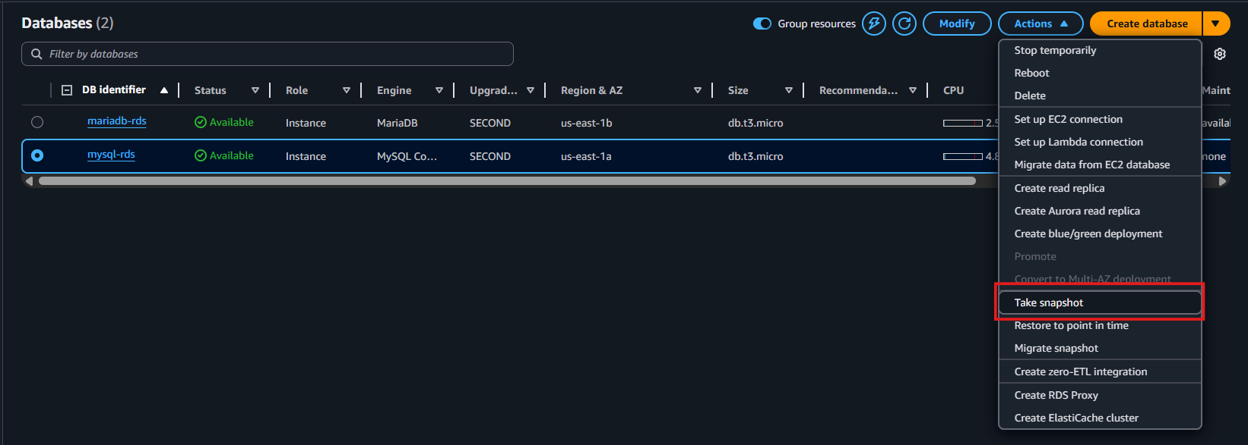
Step 2: Create a Manual Snapshot
Console Path:
Actions → Take snapshot
Enter Snapshot Name:
mysql-rds-backup-01
Explanation:
Creates a full backup of the DB stored in Amazon S3.
Evidence:
(Screenshot of snapshot creation popup)
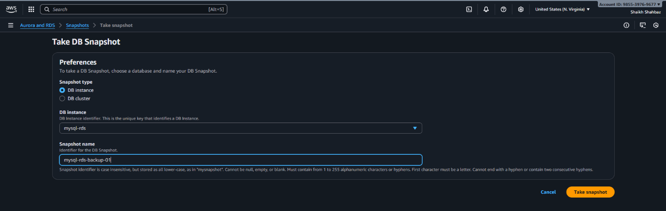
Step 3: Wait for Snapshot to Complete
Console Path:
RDS → Snapshots → Status: Creating → Available
Explanation:
Backup is ready once status becomes “Available”.
Evidence:
(Screenshot of snapshot “Available” status)
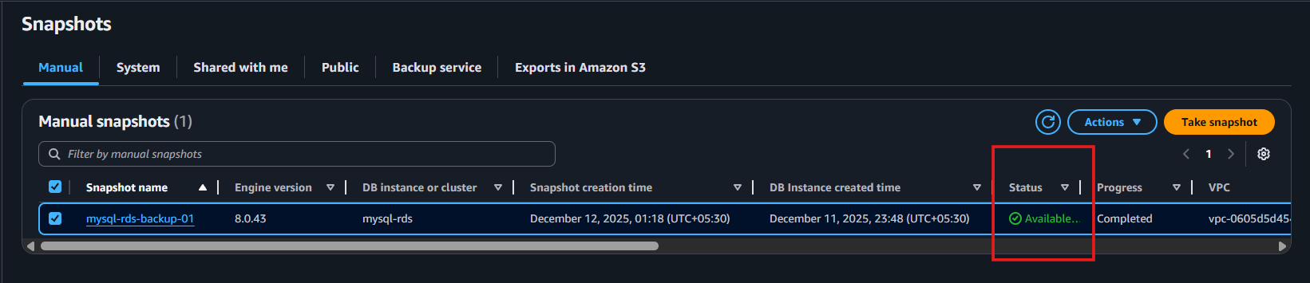
Step 4: Restore DB From Snapshot
Console Path:
RDS → Snapshots → Select your snapshot → Actions → Restore Snapshot
Enter New DB Identifier:
mysql-rds-restore-demo
Choose Settings:
• DB instance class → t3.micro
• Multi-AZ → Optional
• Storage → Same as original
• VPC → Same VPC
• Subnet Group → Private DB subnet
• Security Group → Same as original or new one
• Public Access → No
Explanation:
Restores DB to a brand-new RDS instance using snapshot data.
Evidence:
(Screenshot of “Restore snapshot” configuration)
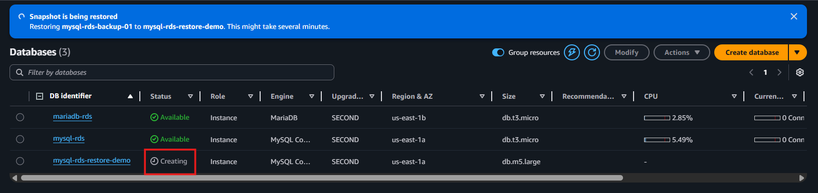
Step 5: Launch Restored Instance
Click:
✔ Restore DB Instance
Explanation:
AWS provisions a new RDS instance from the snapshot.
Evidence:
(Screenshot showing status “Creating”)
Step 6: Wait for Restored DB to Become Available
Console Path:
RDS → Databases → mysql-rds-restore-demo
Status should become:
Available
Explanation:
Restored DB is now ready to use.
Evidence:
(Screenshot showing “Available” status with endpoint)
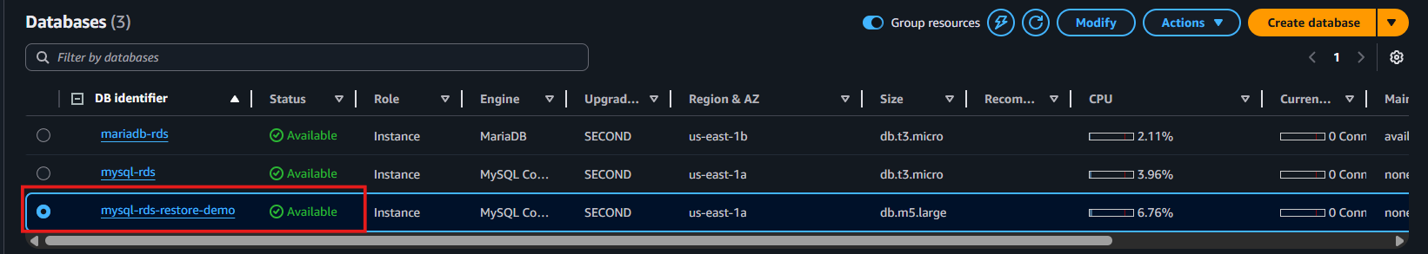
Step 7: Validate Restored DB from EC2
SSH into EC2 and run:
mysql -u admin -p -h <restored-rds-endpoint>
Then:
SHOW DATABASES;
Explanation:
Confirms that restored DB contains the same data as the original.
Evidence:
(Provide screenshot of query results)
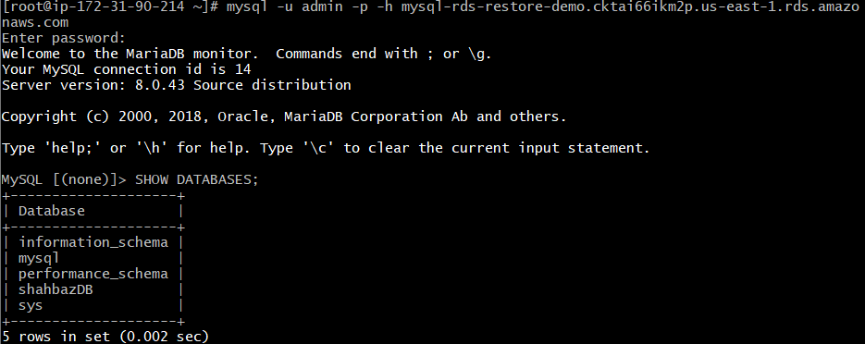
Validation Steps (Mandatory, With Evidence)

Validation 1: Snapshot Validation
Check:
Snapshot status = Available
Evidence:
(RDS snapshot screenshot)
Validation 2: Restore Validation
Check:
Restored RDS instance = Available
Evidence:
(Screenshot of restored DB)
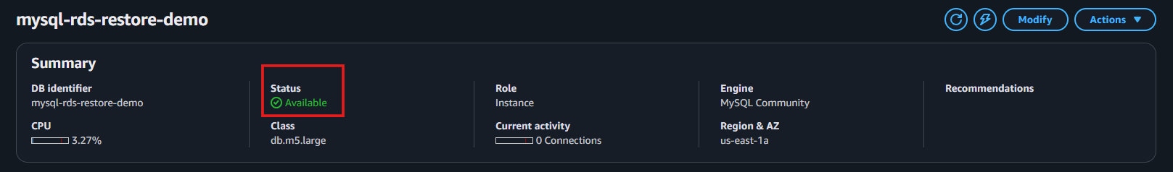
Validation 3: Functional Database Validation
Check:
Successfully connect and query restored DB.
Commands:
mysql -u admin -p -h <restored-rds-endpoint>
SHOW DATABASES;
Evidence:
Screenshot shows correct rows restored.
Validation 4: Network Connectivity
From EC2:
telnet <restored-rds-endpoint> 3306
Expected:
Connected successfully.
Evidence:
Terminal screenshot.
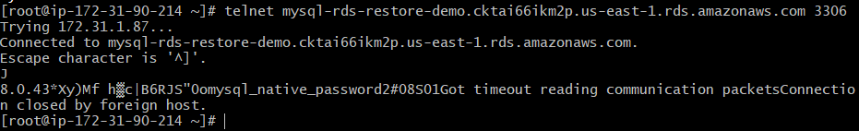
Issues Faced (Optional)
Issue | Cause | Fix
Snapshot stuck in “creating” | Heavy I/O on DB | Wait or reduce write load
Cannot restore snapshot | Wrong subnet group | Use DB subnet group with 2+ AZs
EC2 cannot connect | Wrong SG rules | Add inbound rule from EC2-SG → RDS-SG

Conclusion
Successfully created a manual backup of the MySQL RDS instance and restored the database to a new RDS instance. Data and schema are fully preserved and verified.

10.Create read replica.

Task Title
Create Read Replica for MySQL RDS
Objective
To create a highly available and scalable read replica of the primary MySQL RDS instance for improved performance and disaster recovery.
Prerequisites
• Existing MySQL RDS instance (Primary)
• RDS Subnet Group
• Security Group allowing traffic from application EC2
• Proper IAM permissions (RDSFullAccess recommended)
• VPC + Private Subnets for RDS

Step-by-Step Implementation

Step 1: Open RDS Dashboard
Console Path:
AWS Console → RDS → Databases
Action: Select your primary RDS instance.
Evidence:
(Use your screenshot similar to this)
[Primary RDS selected screenshot]
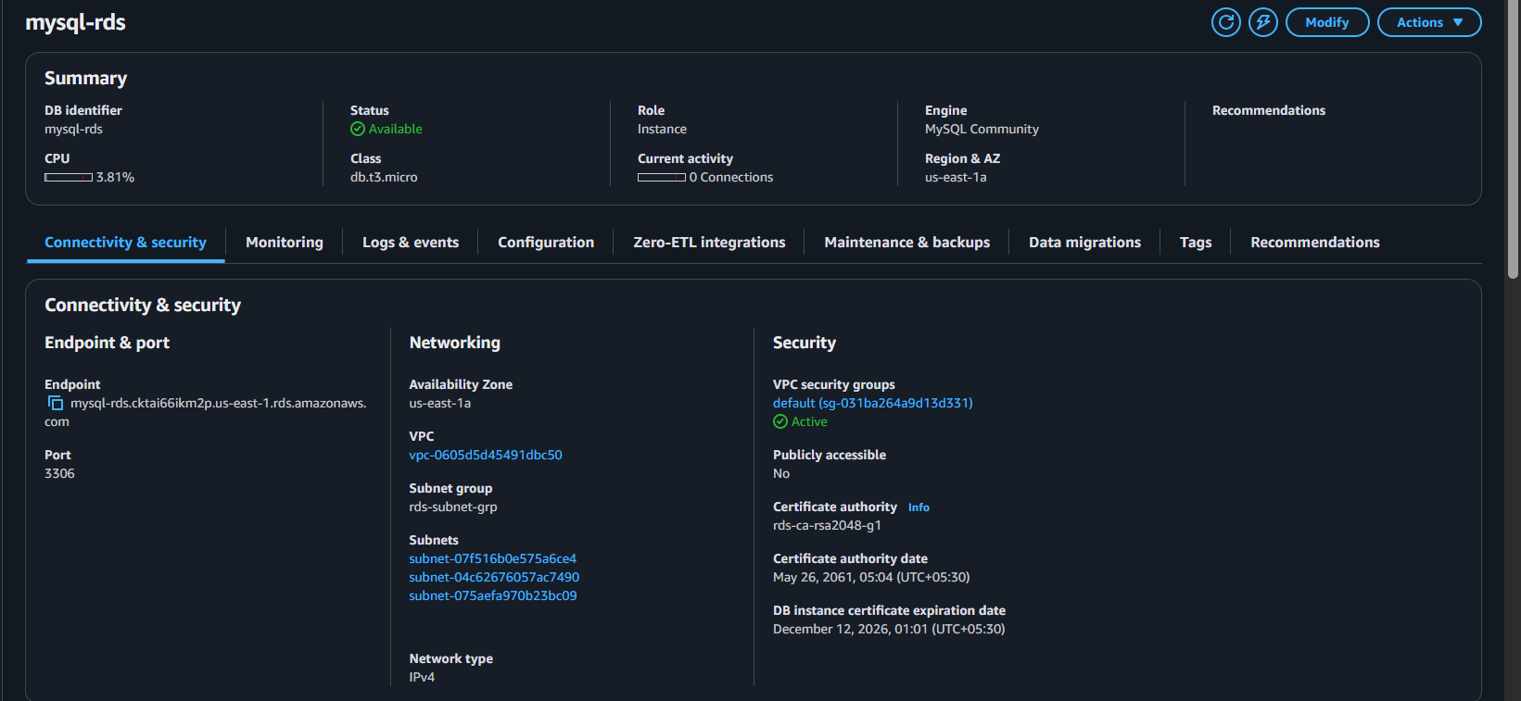
Step 2: Create Read Replica
Console Path:
RDS → Databases → Select primary RDS → Actions → Create read replica
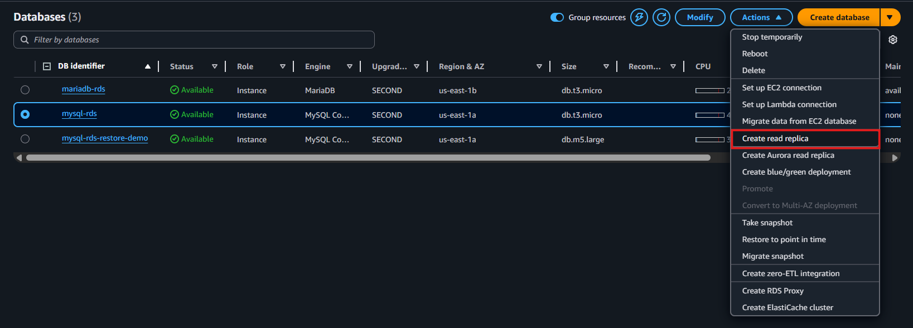
Configure:
• DB instance identifier: mysql-db-read-replica
• DB instance class: Same or smaller than primary
• Multi-AZ: Optional
• Storage: Same as primary
• VPC: Same VPC
• Subnet group: Select DB subnet group
• Security group: Allow app traffic
• Public access: NO (recommended)
• Backup: Optional
Evidence:
[Create read replica configuration screenshot]
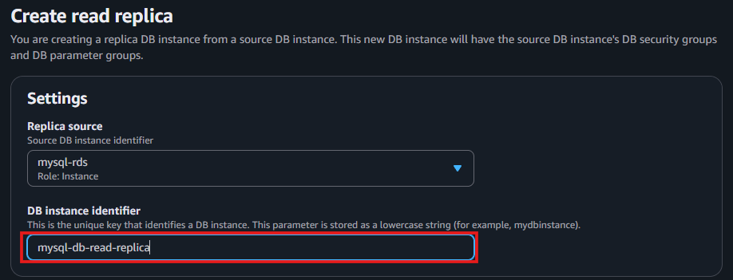
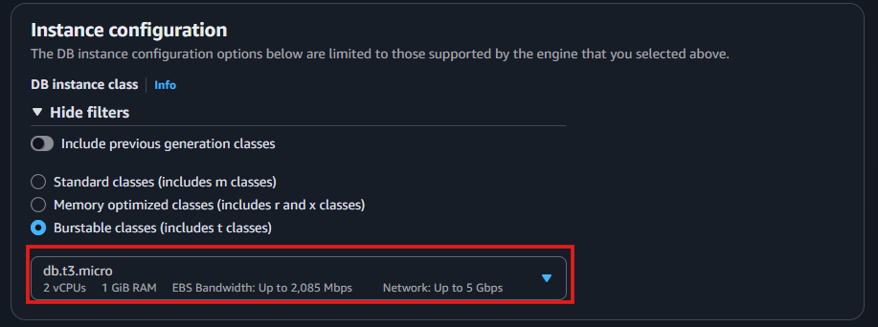
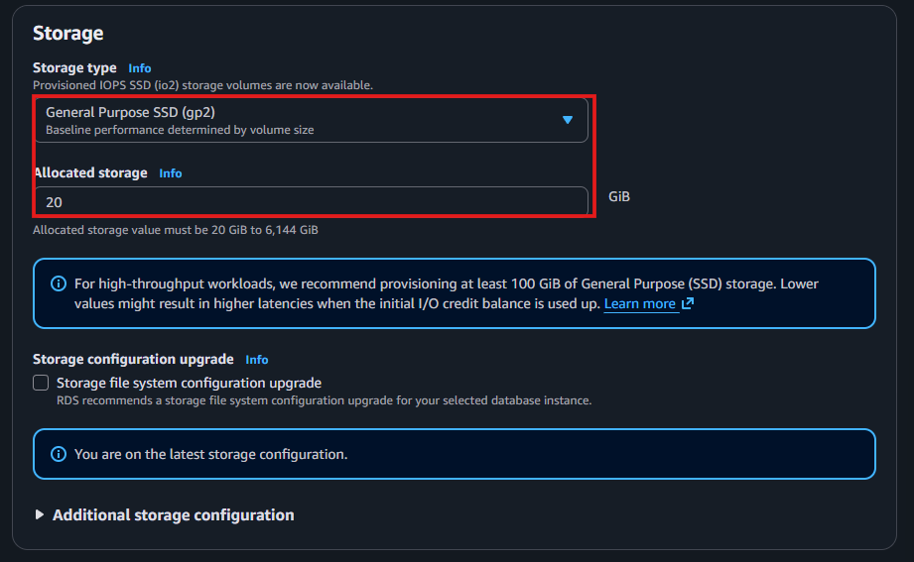
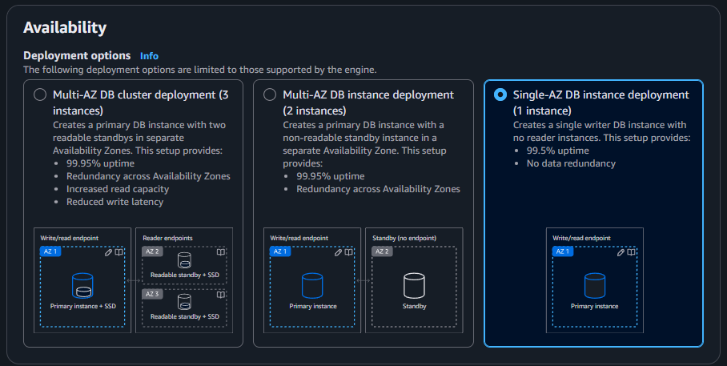
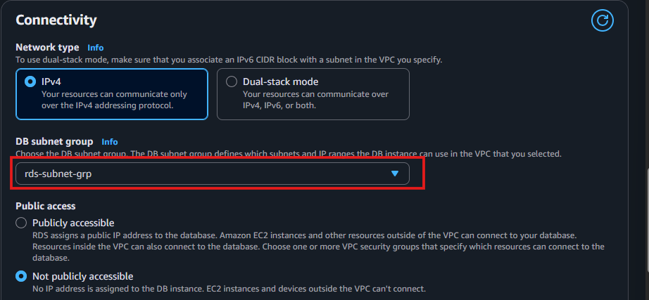
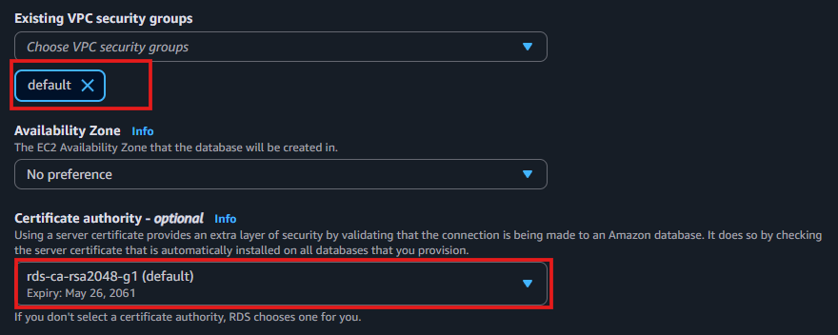
Step 3: Create the replica
Click Create read replica.
Expected Behavior:
Replica status will be creating → available.
Evidence:
RDS status: Creating
RDS status: Available
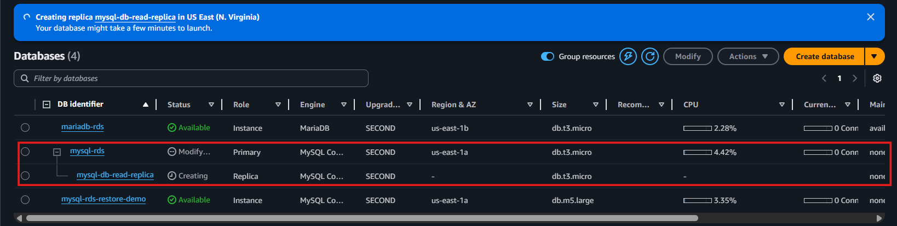
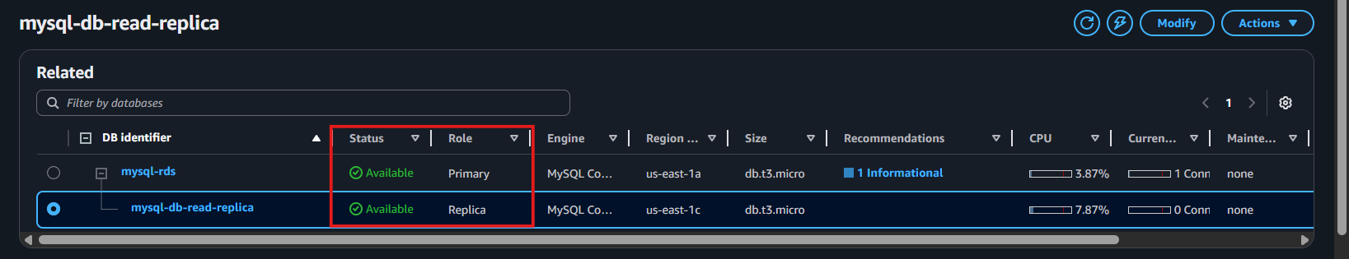
Step 4: Verify replication configuration
Open the replica → Configuration tab.
Check:
• Replication role: READ REPLICA
• Replication source: Primary instance name
• Replication status: Available
Evidence:
[Replication status screenshot]
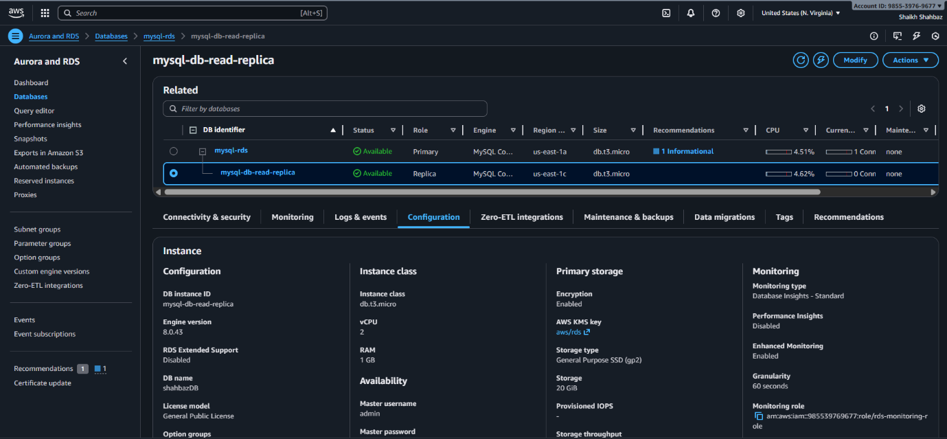
Step 5: Validate Read-Only Mode
Connect to the read replica:
mysql -h <replica-endpoint> -u admin -p
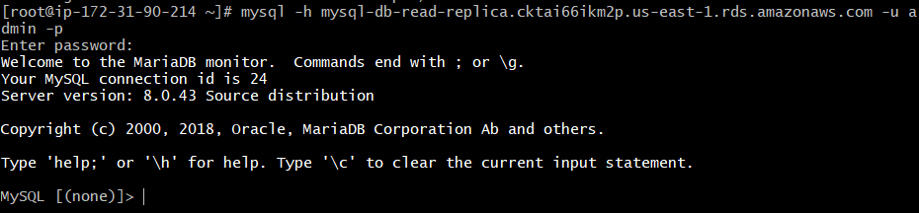
Run:
SHOW VARIABLES LIKE 'read_only';
Expected output:
Value: ON
Evidence:
read_only = ON
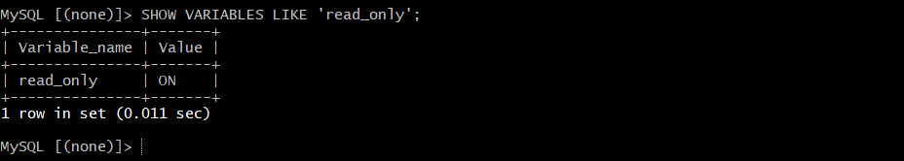
Validation Steps (Mandatory)

Validation 1: Resource Health
Replica status should be Available.
Evidence:
[Replica available screenshot]
Validation 2: Replication Health Check
Run:
SHOW SLAVE STATUS\G;
Check:
✔ Slave_IO_Running = Yes
✔ Slave_SQL_Running = Yes
✔ No replication errors
Evidence:
Slave_IO_Running: Yes
Slave_SQL_Running: Yes
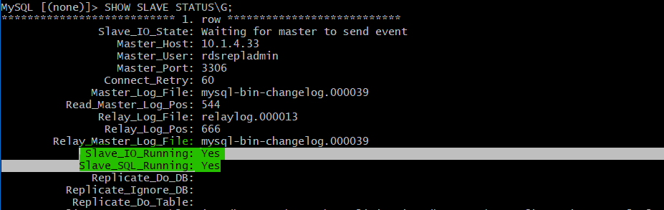

Issues Faced (Optional)
Issue | Fix
SG blocked replication port 3306 | Allowed inbound rule: Primary RDS → Replica
Replica stuck in creating | Rebooted primary + removed stale snapshots
KMS mismatch | Ensured same KMS key on both instances

Conclusion
A fully functional MySQL RDS Read Replica is created successfully.
Replication is healthy, read-only mode is enforced, and data sync is confirmed.

