Jenkins-01

Install Jenkins & Run on Port 8081

Steps:
Prerequisite to Install jenkins is java.Download jenkins Repo:

Install Java 17 version
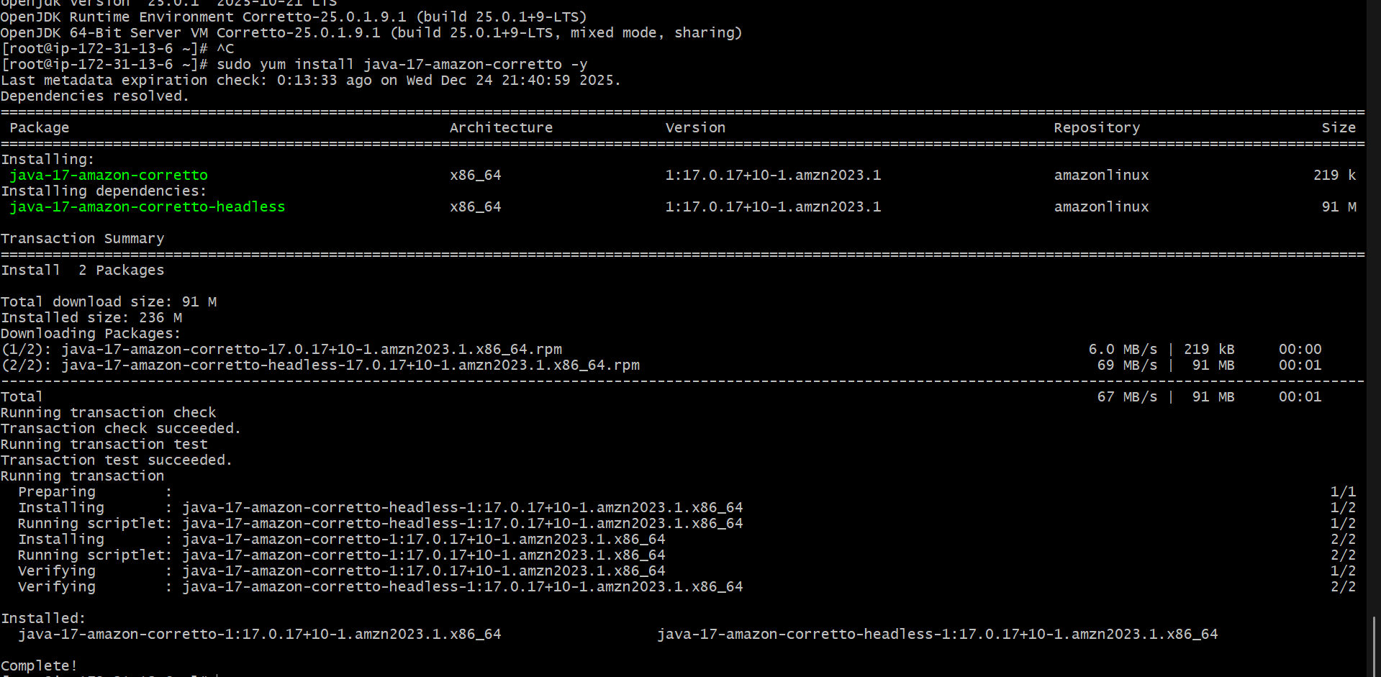
sudo wget -O /etc/yum.repos.d/jenkins.repo
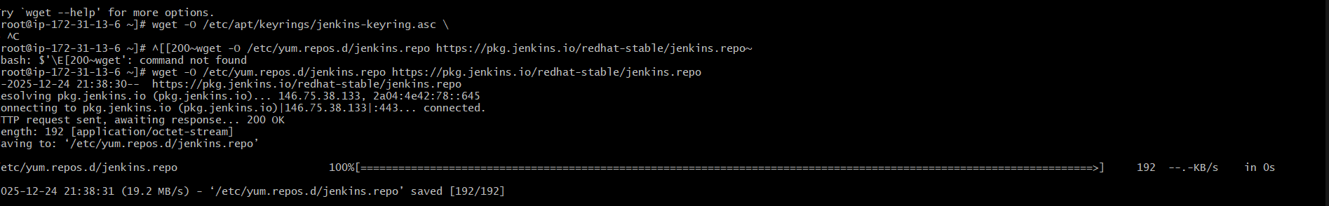

Yum upgrade
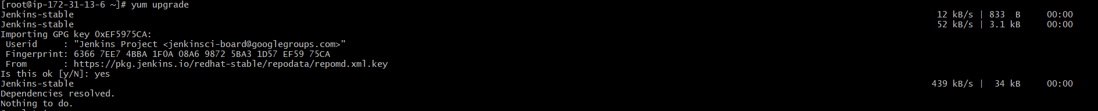

Yum install Jenkins

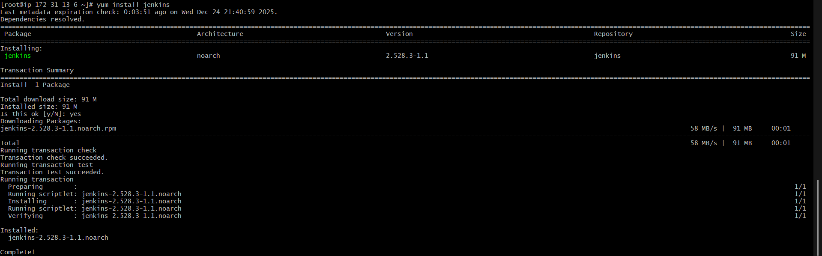
Systemctl start Jenkins
systemctl enable jenkins
Systemctl status Jenkins

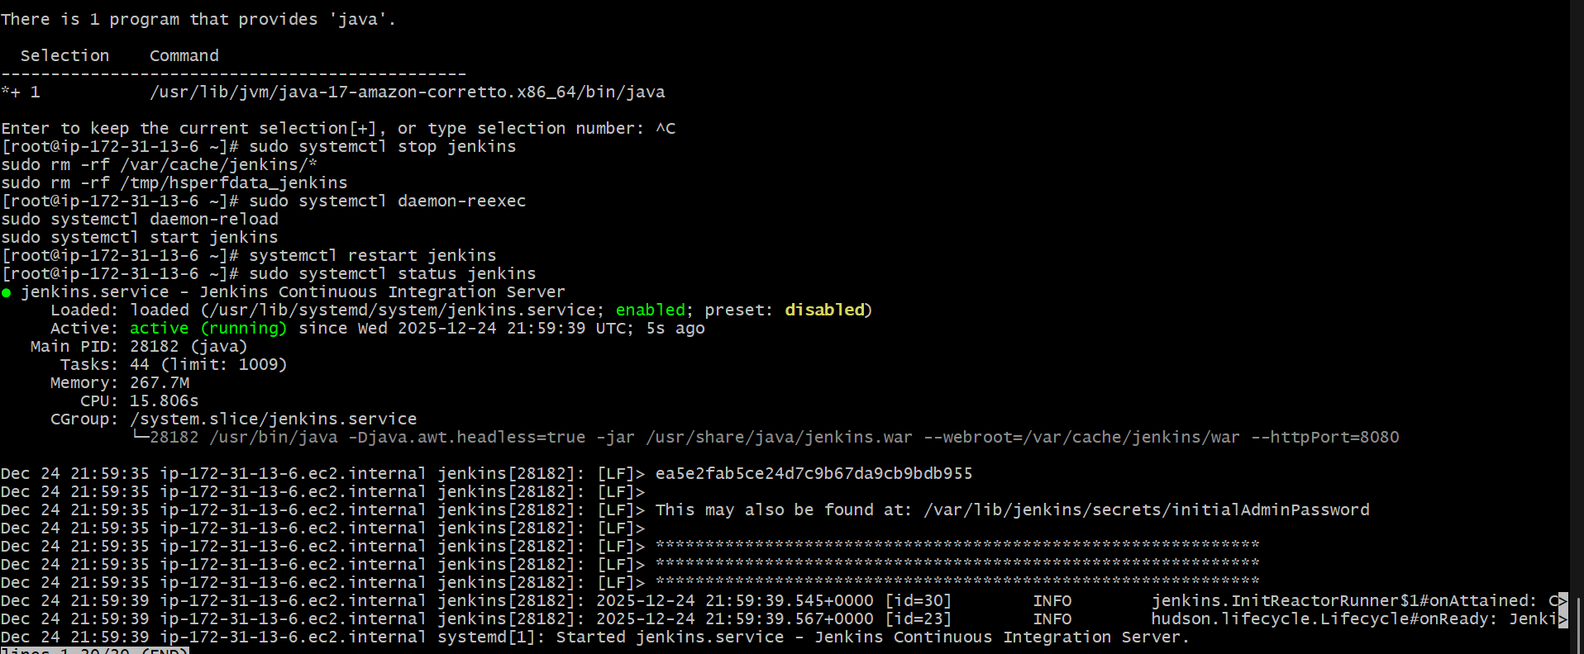

Publicip:8080

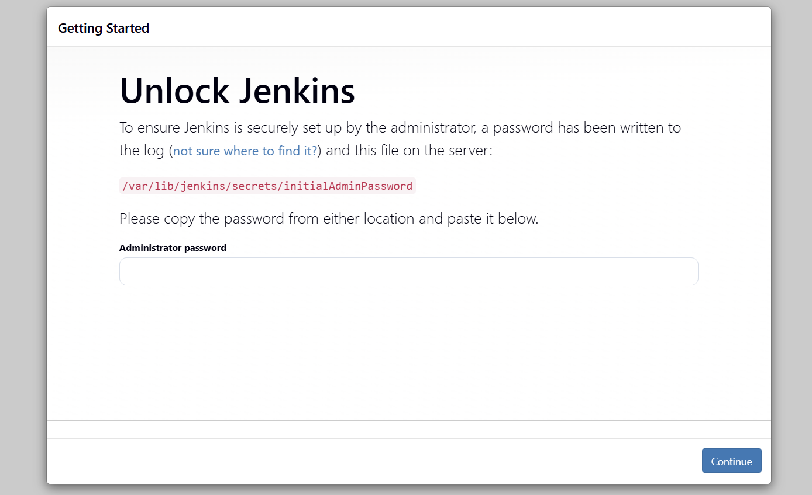

Public: 8081

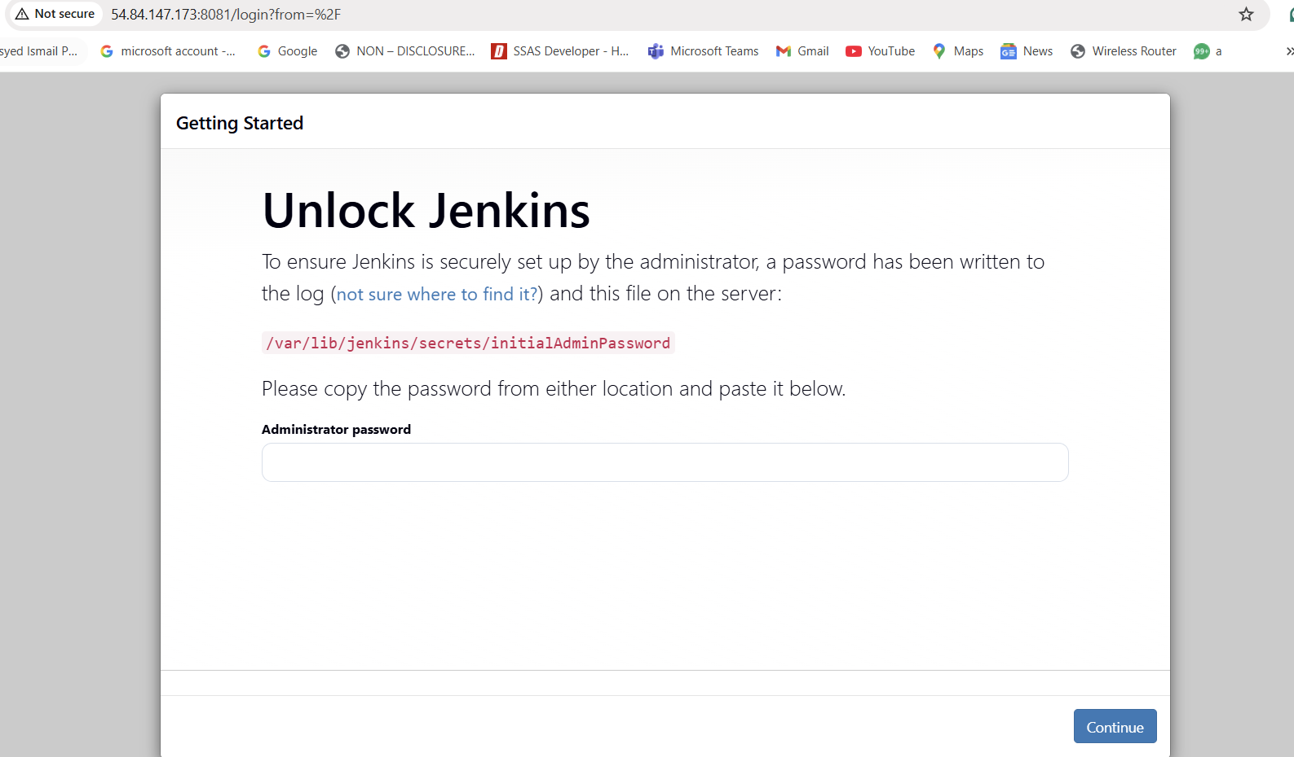

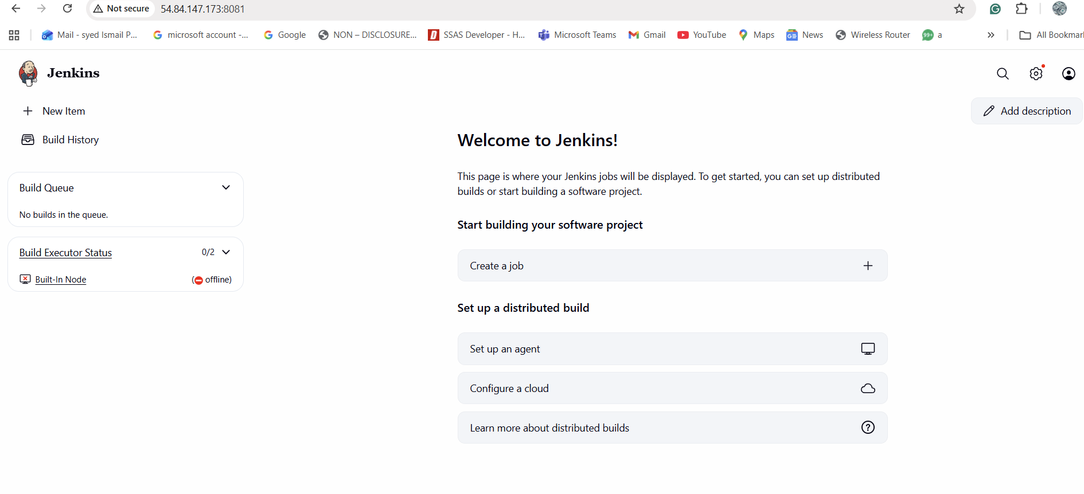

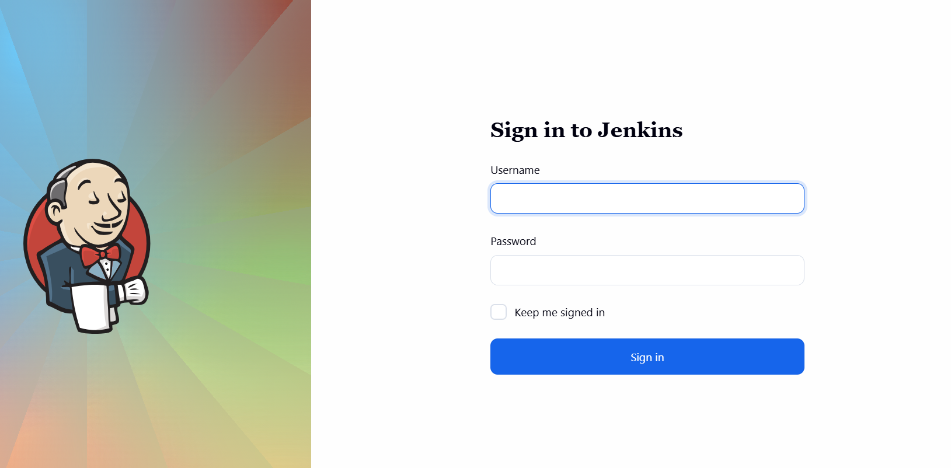

Rules based

Restart Jenkins

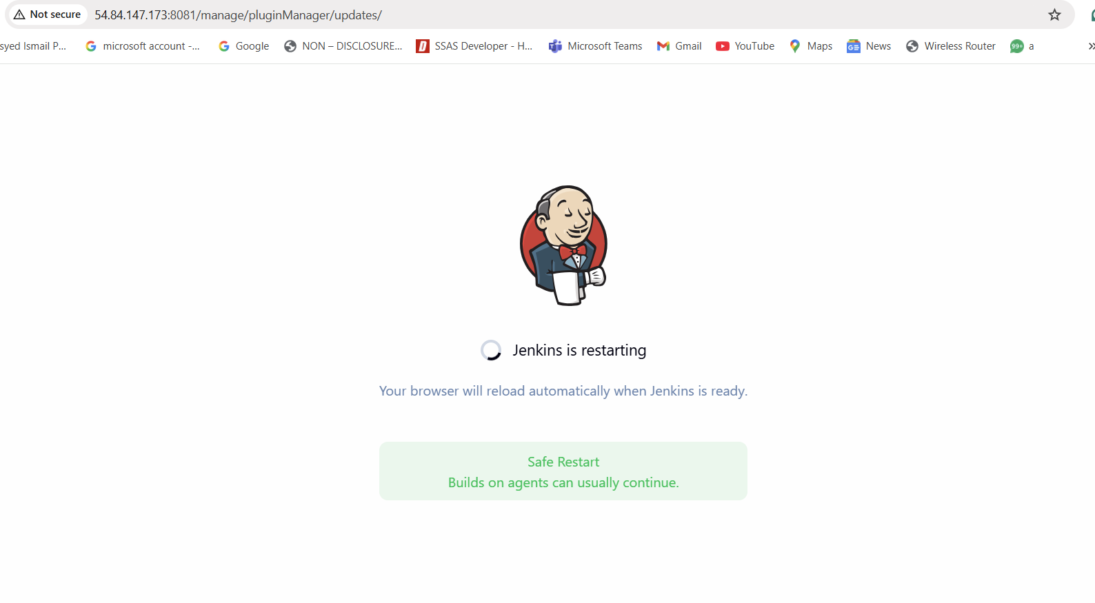
Configure Roles
Go to:
Manage Jenkins → Manage and Assign Roles → Manage Roles
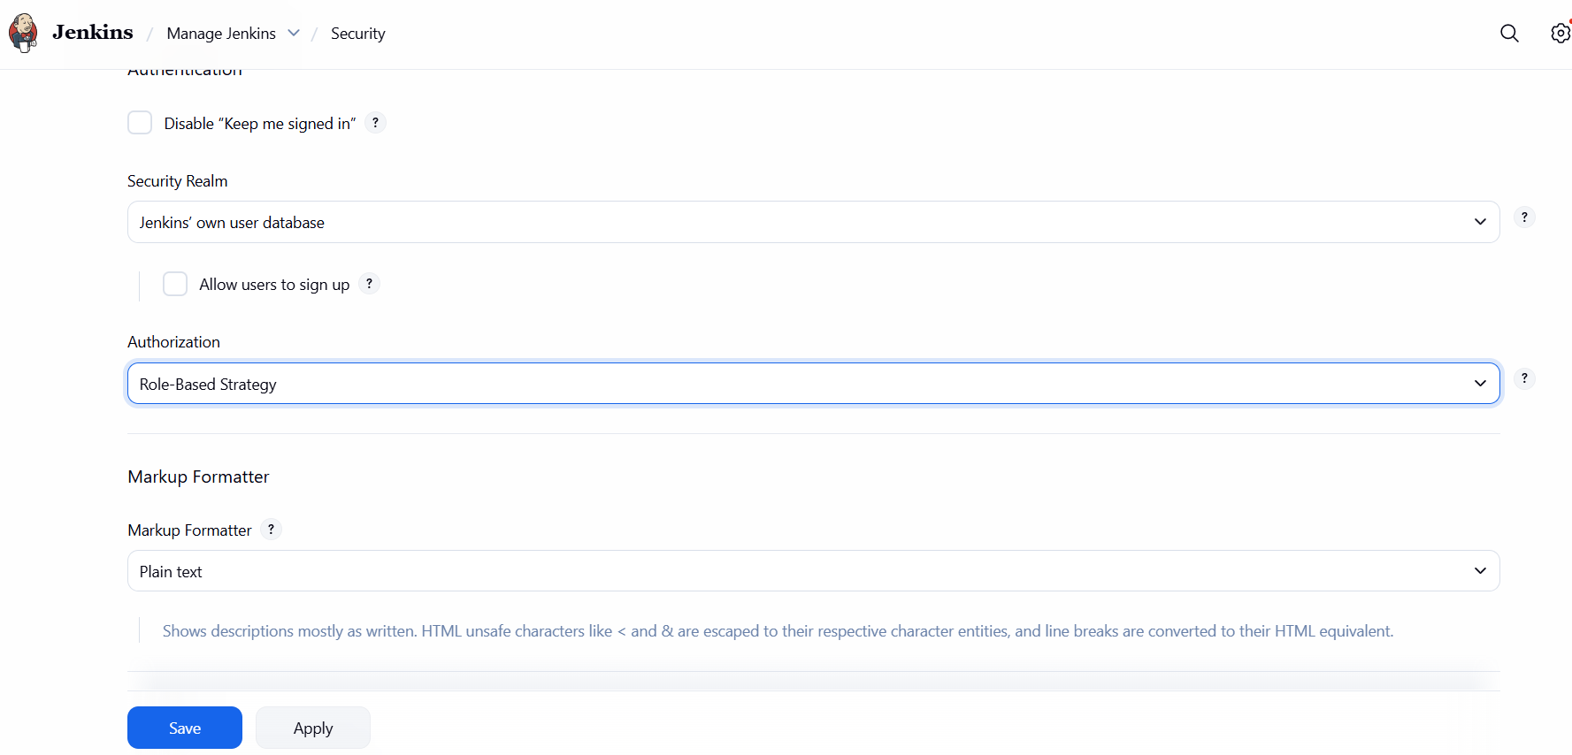

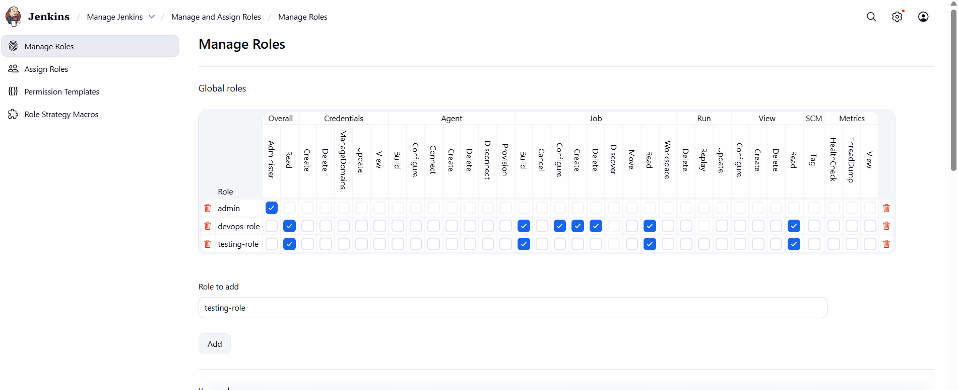
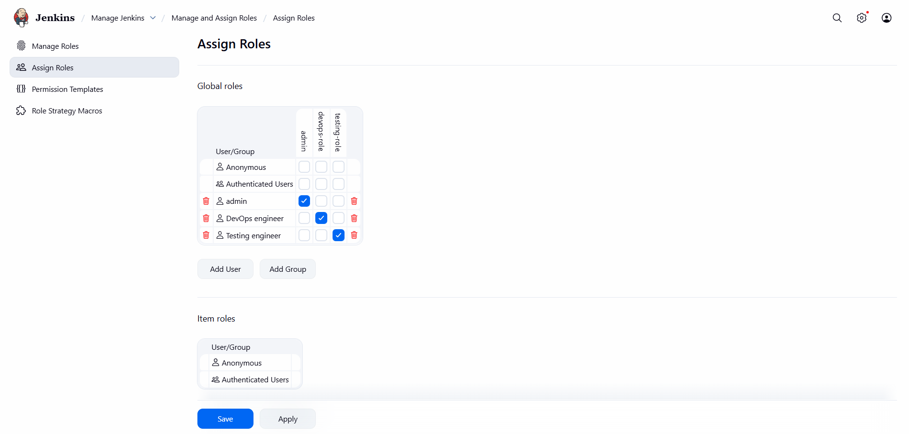

Create user Testing & DevOps
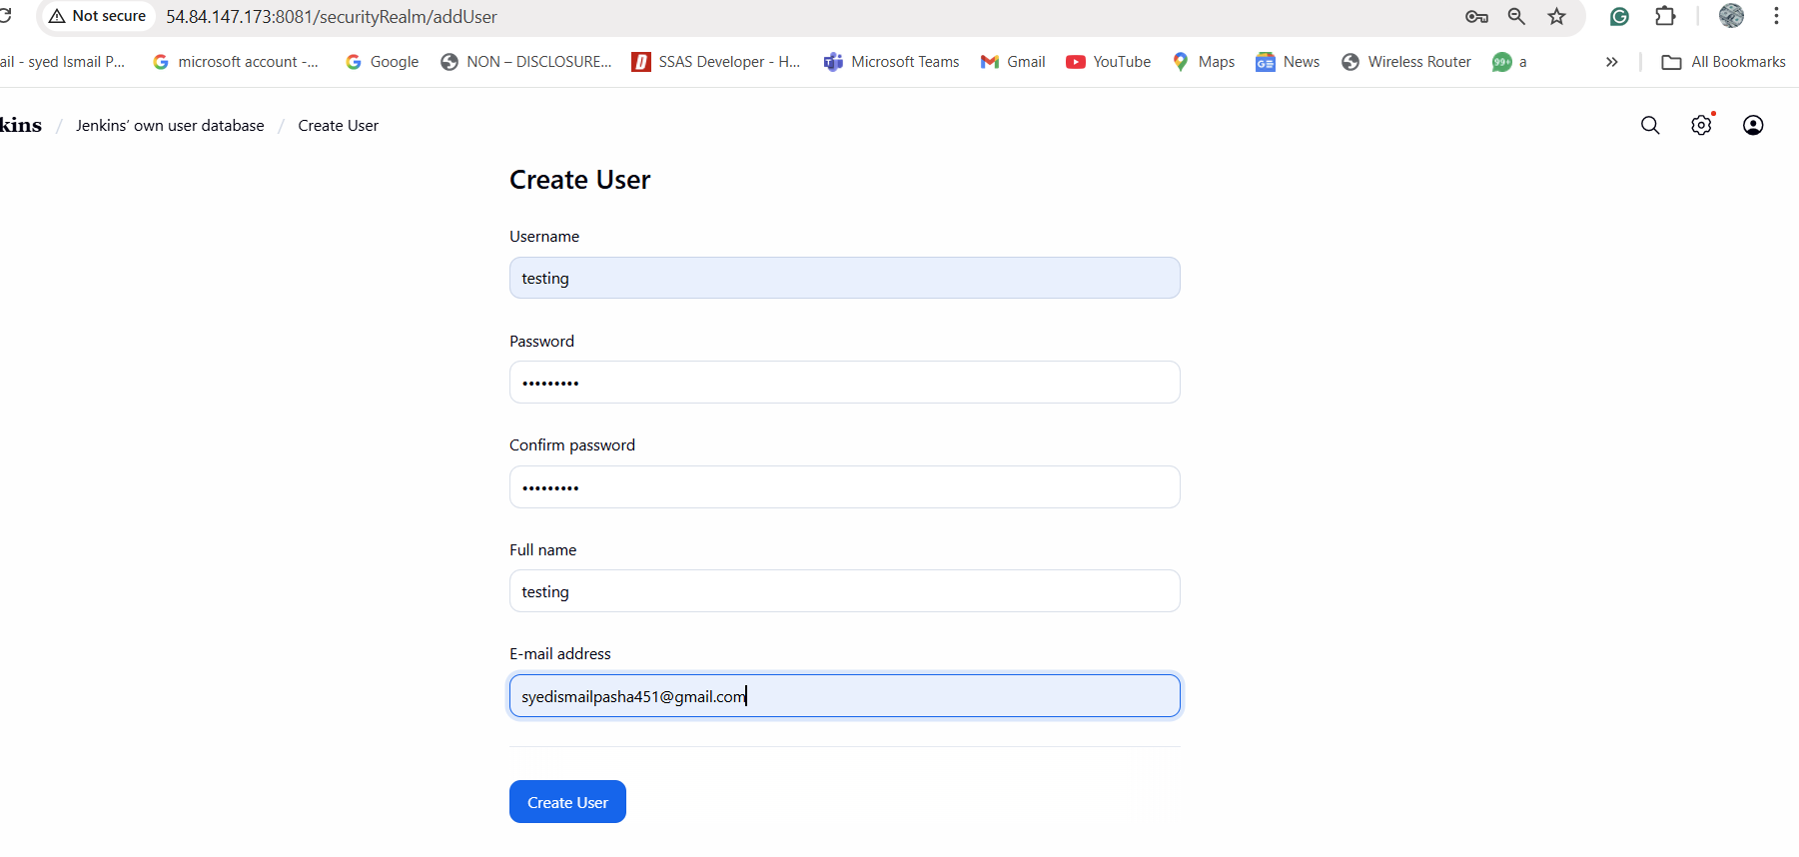

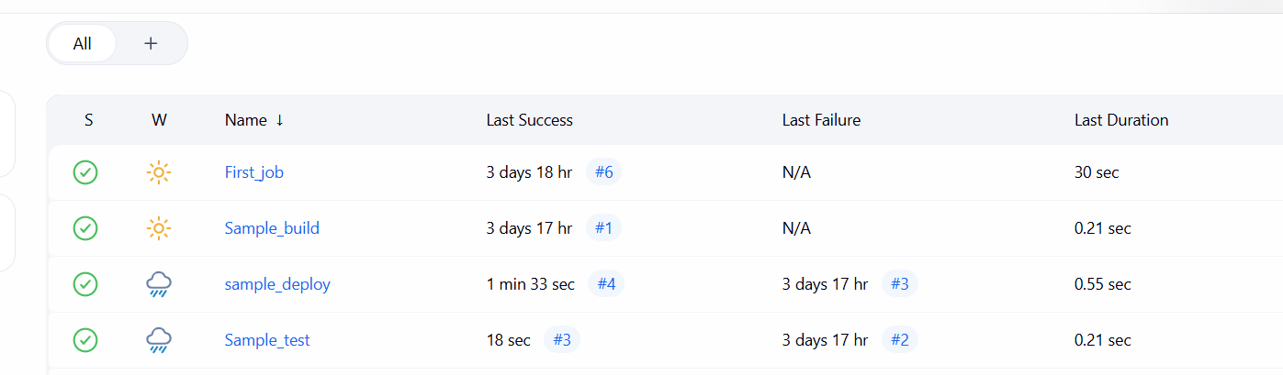

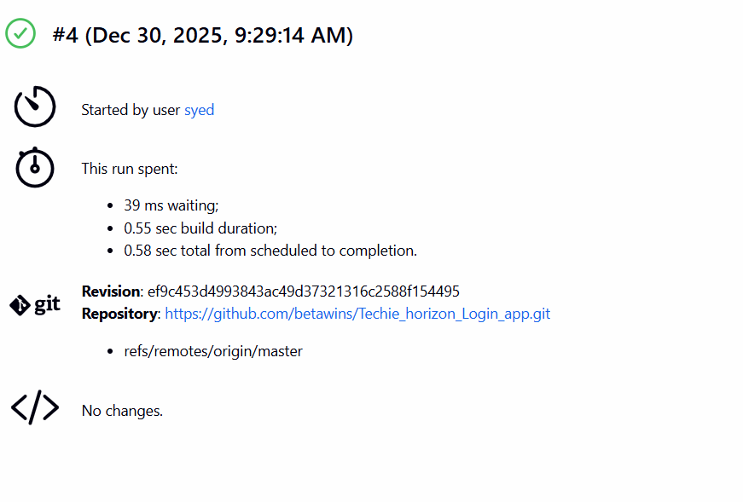

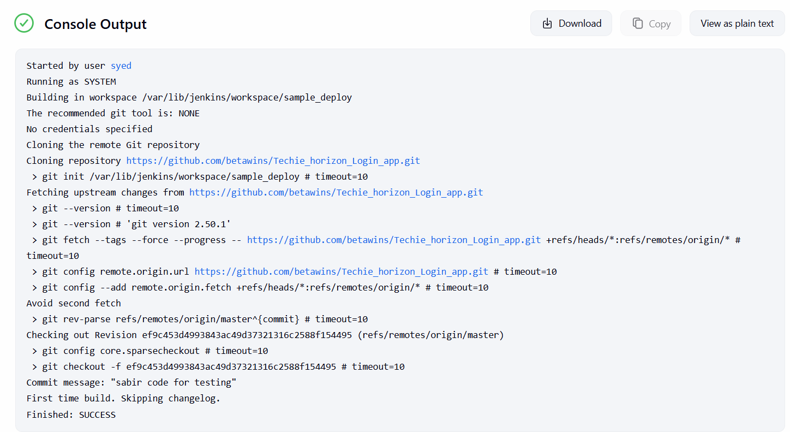

Jenkins Job with Private GitHub Repository
Step 1: Create GitHub Token
GitHub → Settings → Developer settings → Personal Access Token
Scopes:
- repo
Copy token.

Step 2: Add Credentials in Jenkins
Manage Jenkins → Credentials → Global → Add Credentials
- Kind: Username with password
- Username: GitHub username <Jenkins-private-repo>

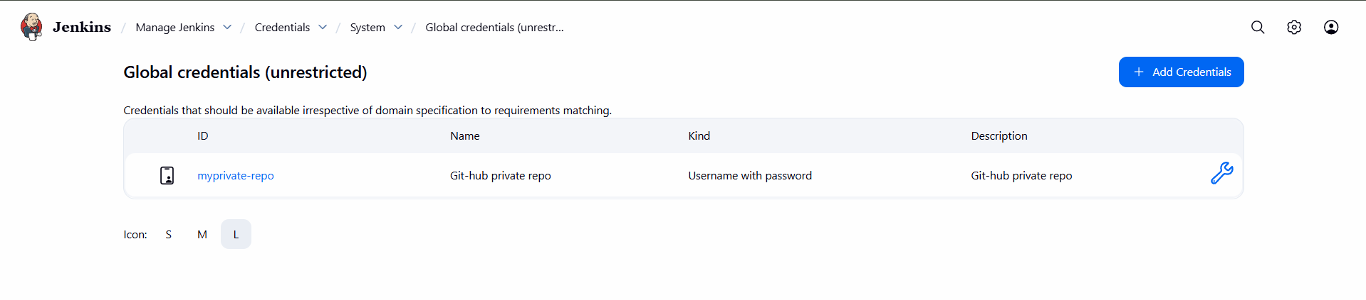
Step 3: Create Job
New Item → Freestyle → private-git-job
Source Code:
- Git
- Repo URL:
https://github.com/<username>/<private-repo>.git
- Credentials: select github-private-creds
Build Step:
echo "Cloned private repo successfully"
ls -l
Save → Build Now
If credentials are correct, repo will clone.

