REAL TIME IMPLEMENTATION OF TEXT RECOGNITION
AND TEXT TO SPEECH CONVERSION

Syed Jahangir Peeran
Student, Computer Science Department
IIIT, Sri City, Andhra Pradesh, India.
Email-ID: syedjahangir.p16@iiits.in

Abstract— This paper introduces an innovative, efficient and real time cost beneficial technique that enables user to hear the contents of documents/text images instead of reading through them. It combines the concept of Optical Character Recognition and Text to Speech Synthesizer (TTS) in MATLAB R2011b. This kind of system enables visually impaired people to interact with computers effectively through vocal interface. It also enables users to listen the audio created from the contents of web pages, e-books, documents and almost all electronically available data thereby enhancing the human-computer interactions. It is used to develop a system which extracts text data from images containing horizontally aligned text using our Character Recognition Algorithm and speaks out the extracted text data using Text to Speech synthesizer (TTS).
Keywords -Binarization, OCR, Pre-Processing, Templates, TTS.

Introduction
Machine replication of human functions, like reading, is an ancient dream. However, over the last five decades, machine reading has grown from a dream to reality. Speech is probably the most efficient medium for communication between humans. Text to speech technology is the process wherein the computer is made to speak. It uses the concepts of natural language processing. In Text reading applications, there are many different techniques available such as label reading, voice stick, brick pi reader and pen aiding. Speech synthesis is the artificial production of human speech [1]. A computer system used for this purpose is called a speech synthesizer, and can be implemented in software or hardware. Image acquisition, recognition and speech conversion using Character Recognition Algorithm and Text to Speech synthesizer (TTS) by MATLAB is an Image Processing Technology used to convert scanned images of machine printed or handwritten horizontal text (numerals, letters, and symbols), into a computer format text and the extracted text is converted into speech.

OCR can be used to extract the text under few constraints like considering only images with less number of objects in background. Here we deal with images which contains text as well as ones with objects in the background. The system takes an image as input, processes it and obtains required text from it. This text is later sent to spell check of Microsoft Word and then converted to speech.
The above method can be more accurate for images which contain only text, and can also give decent output for the images with objects in them.

Existing methodology
As for now, the old method to perform text to speech thconversion is followed. It requires a text document mandatory to convert it into speech. A person must type the text from the images of the books. Next, the converted text is sent to the Text to Speech synthesizer (TTS) for speech conversion. This is the only existing methodology in our country.

Basic working of the system
Our methodology involves two main modules. The first stage involves acquiring image from the camera and converting it into text document using Character Recognition Algorithm. The second stage involves natural language processing and digital signal processing for converting the text into speech using Text to Speech synthesizer (TTS).

Steps involved in our methodology
1. Image loading into MATLAB with GUI.
2. Pre-processing of the image (RGB to gray image, contrast adjustment, adaptive threshold).
3. Converting pre-processed image into text document using Character Recognition Algorithm.
4. Increasing the accuracy of the obtained text by using Microsoft Word Spell Checker API.
5. Converting text document into speech using TTS.

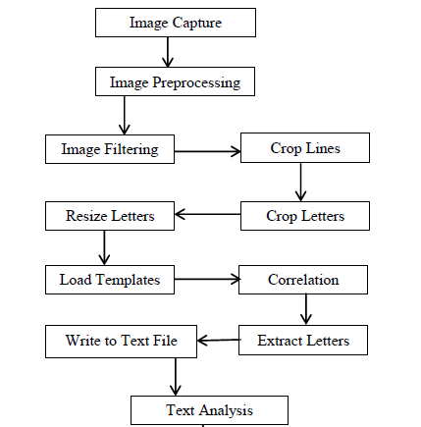

text synthesis
Recognition of scanned document images using Character Recognition Algorithm is now generally considered to be a solved problem for some scripts. Components of our algorithm consist of optical scanning, binarization, feature extraction and recognition.
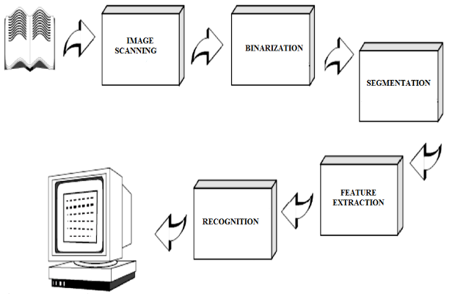
The extracted text will be pre-processed. Each symbol is extracted. The identity of each symbol comparing the extracted features with descriptions of the symbol classes obtained through a previous learning phase. Spelling Checker is used to reconstruct the words and numbers of the original text [2].

Speech synthesis
Speech is the vocalization form of human communication. Speech communication is more effective medium than text communication medium in many real-world applications.
Speech synthesis is the artificial production of human speech. A system used for this purpose is called a speech synthesizer, and can be implemented in software or hardware. Synthesized speech can be created by concatenating pieces of recorded speech that are stored in a database. The quality of a speech synthesizer is judged by its similarity to the human voice, and by its ability to be understood.

Text to speech synthesis
A Text-To-Speech (TTS) synthesizer is a computer-based system that should be able to read any text aloud. The block diagram given below explains the same [3].
A text-to-speech system (or "engine") is composed of two parts: a front-end and a back-end. The front-end has two major tasks. First, it converts raw text containing symbols like numbers and abbreviations into the equivalent of written-out words. This process is often called text normalization, pre-processing, or tokenization [4]. The front-end then assigns phonetic transcriptions to each word, and divides and marks the text into prosodic units, like phrases, clauses, and sentences. The process of assigning phonetic transcriptions to words is called text-to-phoneme conversion. The back-end often referred to as the synthesizer—then converts the symbolic linguistic representation into sound.
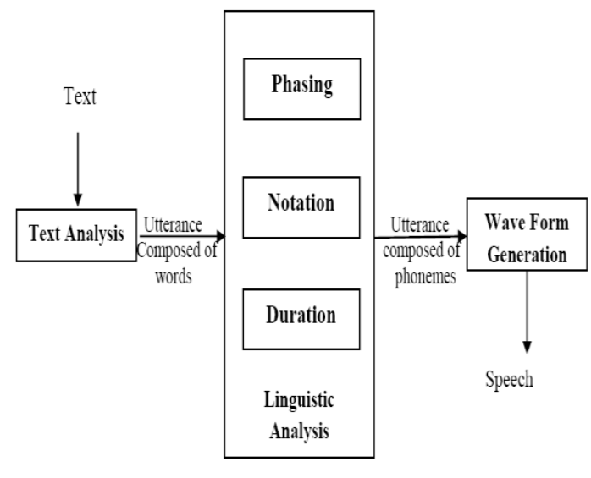

In certain systems, this part includes the computation of the target prosody (pitch contour, phoneme durations), which is then imposed on the output speech.

Procedure

Conversion of RGB image to gray scale image
RGB image is an image which is made up of three different colors namely red, green and blue respectively. Gray scale image is an image which is a combination of black and white colors respectively. rgb2gray is the command used in MATLAB to convert RGB images to grayscale by eliminating the hue and saturation information while retaining the luminance. I = rgb2gray (RGB) converts the true color image RGB to the grayscale intensity image I. rgb2gray converts RGB values to grayscale values by forming a weighted sum of the R, G, and B components: 0.2989 * R + 0.5870 * G + 0.1140 * B.


Adaptive Threshold
Adaptive threshold is the process of choosing the
threshold to minimize the intra class variance of the threshold black and white pixels. Gray thresh – Global image threshold using Otsu's method. LEVEL = graythresh(I) computes a global threshold (LEVEL) that can be used to convert an intensity image to a binary image with IM2BW.

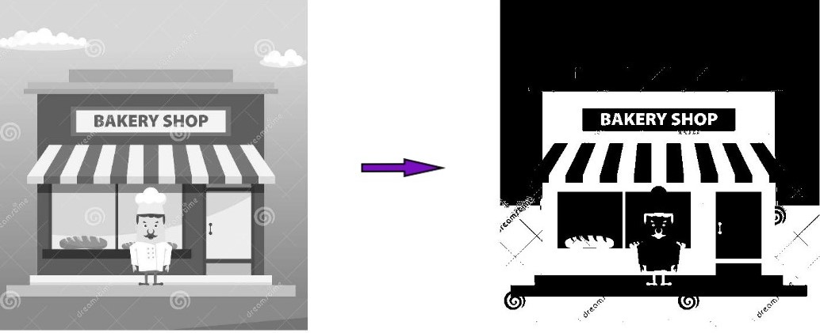 LEVEL is a normalized intensity value that lies in the range [0, 1]. im2bw – Convert image to binary image by thresholding. im2bw produces binary images from indexed, intensity, or RGB images. To do this, it converts the input image to grayscale format (if it is not already an intensity image), and then converts this grayscale image to binary by thresholding. The output binary image BW has values of 1 (white) for all pixels in the input image with luminance greater than LEVEL and 0 (black) for all other pixels.

Objects(Noise) Removal
Objects Removal is done by using bwareaopen () function. BW2 = bwareaopen(BW,P) removes all connected components (objects) that have fewer than P pixels from the binary image BW, producing another binary image, BW2. The default connectivity is 8 for two dimensions, 26 for three dimensions. This operation is known as an area opening [5].
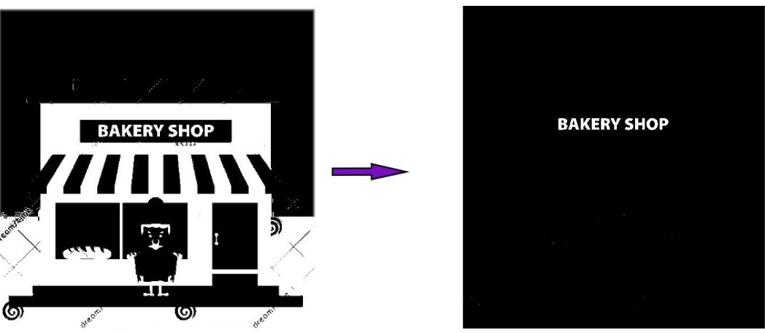

For removing large objects from the image, bwareaopen() function is applied on the image and later it is subtracted from the original image. By doing this, we obtain an image without any noises.

Line Extraction
Horizontal Splitting is applied to the pure black and white image which we got after the above two processes. We start off by splitting the above obtained image into horizontal segments. These segments are then divided into horizontal rows containing no trace of white (i.e., the row which is completely black). In this way all the lines are obtained.
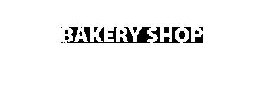

Character Extraction
Horizontal strips of useful text are obtained by applying the above method. Character Extraction is done by further splitting vertically to separate out characters by means of similar technique which was used in splitting horizontal lines. The characters are divided on basis of vertical rows having no trace of white. We also keep track of the average space between each character. It is used later to detect separation between two words.

Separating two closely spaced characters (Extra Case)
Cases can be found where it is difficult to extract characters from the given above approach. In such case, where there is no separable column or row, we use the concept of connected components. The set bits which belong to the first character are identified and will be used as source nodes for our algorithm. The indices of the set bits of the first character are added to a queue. Then the front-most set bit in the queue is taken and all neighbors to the set bit are added in the queue. The process is repeated till there are no unvisited set bits of the first character. The first character has been completely spanned by now and stored in a separate matrix. To obtain only the first character, we subtract the above obtained matrix from the original image.

Template Matching
Basically, over 69000+ images which contains both numerals and alphabets was collected from MNIST. It contains 1071 samples of 65 characters. This dataset is preprocessed and already saved in a template (.mat file form). This template is loaded while running the code. Now, each character obtained after during Character Extraction method undergoes comparison with our dataset using correlation function, r = corr2(A, B) returns the correlation coefficient between A and B, here A and B are matrices or vectors of the same size. r is a scalar double [7]. For further optimizations, if sure that the character we are looking for, is the most probably known (i.e., we found a matching of 95% common pixels), then we break then and there to avoid further unnecessary comparisons in our runtime. To space them properly we calculate the average space between words by finding the number of columns which are completely black and then compare it with our pre-defined value.

Spell Check
Finally, when character extraction is done, we obtain the sentences formed by the words, there may a chance where the words contain some other character because the accuracy we are got till now is only 95%. To increase the accuracy level each word is sent to the spell check function. The Spell Check function is not MATLAB inbuilt function. However, using ActiveX, the words are passed to the spell checker of Microsoft Word and the results are brought back to MATLAB.

8.Text to Speech Conversion
The text to speech conversion function synthesizes speech from the obtained string, and speaks it out. The audio output is mono, 16bits and 16k Hz by default [6].

Result
Text reading system has two main parts: image to text conversion and text to voice conversion. Image into text and then that text into speech is converted using MATLAB. For image to text conversion firstly image is converted into gray image then black and white image and then it is converted into text. Text to speech conversion is done by using TTS synthesizer.
Input Image:

Output:
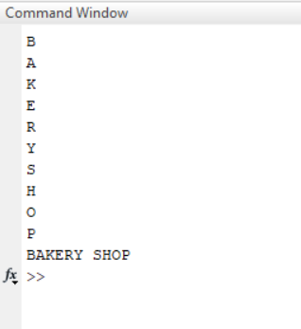

Conclusion
In our project by using Character Recognition Algorithm, ASCII formatted text file can be made from the raw images of books and the converted text can be made as speech through Text to Speech Synthesizer. By this approach we can read text from a document, Web page or e-Book and can generate synthesized speech through a computer's speakers or phone’s speaker. Through this method, we can make editing process of books or web pages easier. We can save the audio file for future use also.

This can save time by allowing the user to listen background materials while performing other tasks. System can also be used to make information browsing for people who do not have the ability to read or write. This approach can be used in part as well. If we want only to text conversion, then it is possible and if we want only text to speech conversion then it is also possible easily. People with poor vision or visual dyslexia or totally blindness can use this approach for reading the documents and books. People with speech loss or totally dumb person can utilize this approach to turn typed words into vocalization. Experiments have been performed to test the text reading system and good results have been achieved. Like any system in this world, this system also has few disadvantages. The MATLAB must be worked upon by trained people only.

References

- T. Dutoit, "High quality text-to-speech synthesis: a comparison of four candidate algorithms," Acoustics, Speech, and Signal Processing, 1994. ICASSP-94., 1994 IEEE International Conference on, vol.i, no., pp.I/565-I/568 vol.1, 19-22 Apr 1994.
- B.M. Sagar, Shobha G, R. P. Kumar, “OCR for printed Kannada text to machine editable format using database approach” WSEAS Transactions on Computers Volume 7, Pages 766-769, 6 June 2008
- http://www.voicerss.org/tts/
- http://www.comsys.net/technology/speechframe/text-to-speech-tts.html
- https://in.mathworks.com/help/images/ref/bwareaopen.html
- https://in.mathworks.com/matlabcentral/fileexchange/18091-text-to-speech?focused=5096318&tab=function
- https://in.mathworks.com/help/images/ref/corr2.html
- www.wikipedia.com

