**E-Project:** E-Books

**E-Books**

|  |  |  |
| --- | --- | --- |
| **Supervisor.** | Sir Jazib Habib | |
| **Batch.** | 2204B1 | |
| **Group.** | A | |
| **Serial No.** | **Enrollment Number** | **Student Name** |
| 1. | Student1369871 | Muneeb Sheikh |
| 2. | Student1370736 | Arman Ahmed |
| 3. | Student1370726 | Aliyan Ahmed |
| 4. | Student1373671 | Abdullah Bin Junaid |
| 5. | Student1373266 | Mudassir Yaqoob |

**EProject**: E-Books

# ACKNOWLEDGEMENT

The first, we would like to express my special thanks of gratitude to my teacher Sir Jazib Habib, who helped us a lot in finalizing this project within the limited time frame, valuable counselling and assistance for the accomplishment of this project.

Secondly we would also like to thank the E-Project team at Aptech Head Office, who gave us the golden opportunity to do this wonderful project about Care

Thirdly, we also thank the E-Project team, some of the benefits are as under:

* Re-enforcement of skills happens in the experiential learning process.
* A mentor, ensuring that we do not get drifted, constantly guides us.
* It gives us a lot of confidence to face an interview as we have worked on a project. We can explain virtually everything on the subject we have learnt.

**EProject**: E-Books

# SYNOPSIS

**The Objective of this program is to give a sample project to work on real life projects. These applications help you build a larger more robust application.**

**The objective is not to teach you concepts but to provide you with a real life scenario and help you create applications using the tools.**

**You can revise them before you start with the project.**

**It is very essential that a student has a clear understanding of the subject.**

**Kindly get back to eProjects Team in case of any doubts regarding the application or its objectives**

**E-Project**: E-Books

# PROBLEM DEFINITION

**We all need to visit doctors some time or the other. Sometimes it is an emergency situation, whereas most of the other time it is a planned checkup/visit. But in both the cases we have to visit the doctor to take an appointment or wait in long queues.**

**CARE Group is into medical services for long time and looking at the current medical scene have decided to come up with a WEBSITE, which will host the medical services available in different cities.**

**Individuals will be able to search for specialist doctors in their surroundings and even book online appointments.**

**Web site should also record the complete information regarding the Doctors and Patients.**

**Customer Specifications:**

**Website will host information about common Diseases, Preventions and Cures. It will also display the latest medical news and information on inventions in Medical Science.**

**The website will have three users/roles:**

1. **Administrator**
2. **Doctor**
3. **Patient**

**The Administrator should be able to do the following:**

1. **Add Cities to the master database.**
2. **Add Doctors to the Master database.**
3. **Modify Doctor Details.**
4. **Modify Patient Details.**
5. **Delete Cities**
6. **Delete Doctors**
7. **Delete Patients**
8. **Create/Manage Users/Logins**
9. **Manage information/details on the WEBSITE**

**The Doctor should be able to do the following:**

1. **Login into the system with his USER/PASSWORD**
2. **View his/her profile details**
3. **Add details to his/her profile**
4. **Modify his/her profile**
5. **View Appointments**
6. **Update his availability for DAY/WEEK/MONTH**

**The Patient should be able to do the following:**

1. **Register/Create Account [USERID should be unique].**
2. **Search Doctor based on location, Specialist**
3. **Book Appointment [Check Availability]**

**Note: Name, Address, Phone Numbers, Email-ids should be mandatory to be provided.**

**EProject**: E-Books

# CUSTOMER REQUIREMENT SPECIFICATION (CRS)

After discussion, we are supposed to create a website for them with the below mentioned requirement specifications:

The Home Page should have suitable logo, and decent color combination.

The site should display a menu which will contain the options as home,

about, Locator, contact, Support etc.

* Various pages having information about different types of doctors and

departments, Technology used in etc.

* The information should be categorized according to different doctors

 etc.

* When a user selects any dashborad line-up, will be displayed.
* Company should be displayed using (eg. GoogleMaps).

**EProject**: E-Books

# SCOPE OF THE WORK (IN BRIEF)

After all, the primary objective of a CARE website is **to provide as many avenues to prospective customers as possible to create an interest in them for the hospitals.**

6

**EProject**: E-Books

# WIREFRAMES

1. Admin Login Page

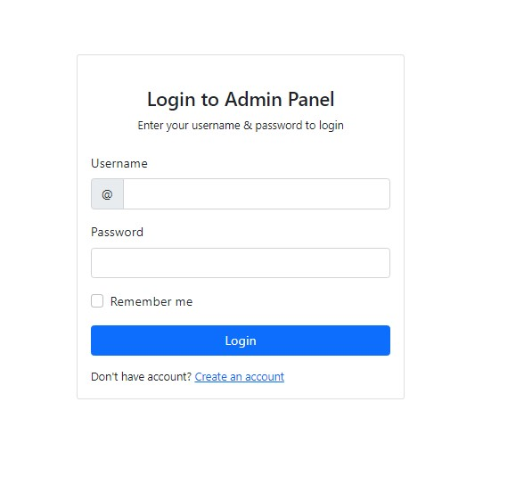

1. Dashboard

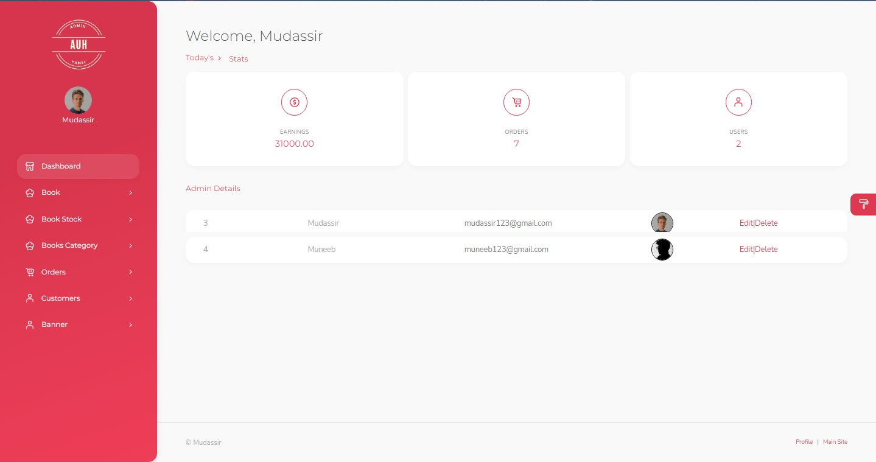

3. Books Details

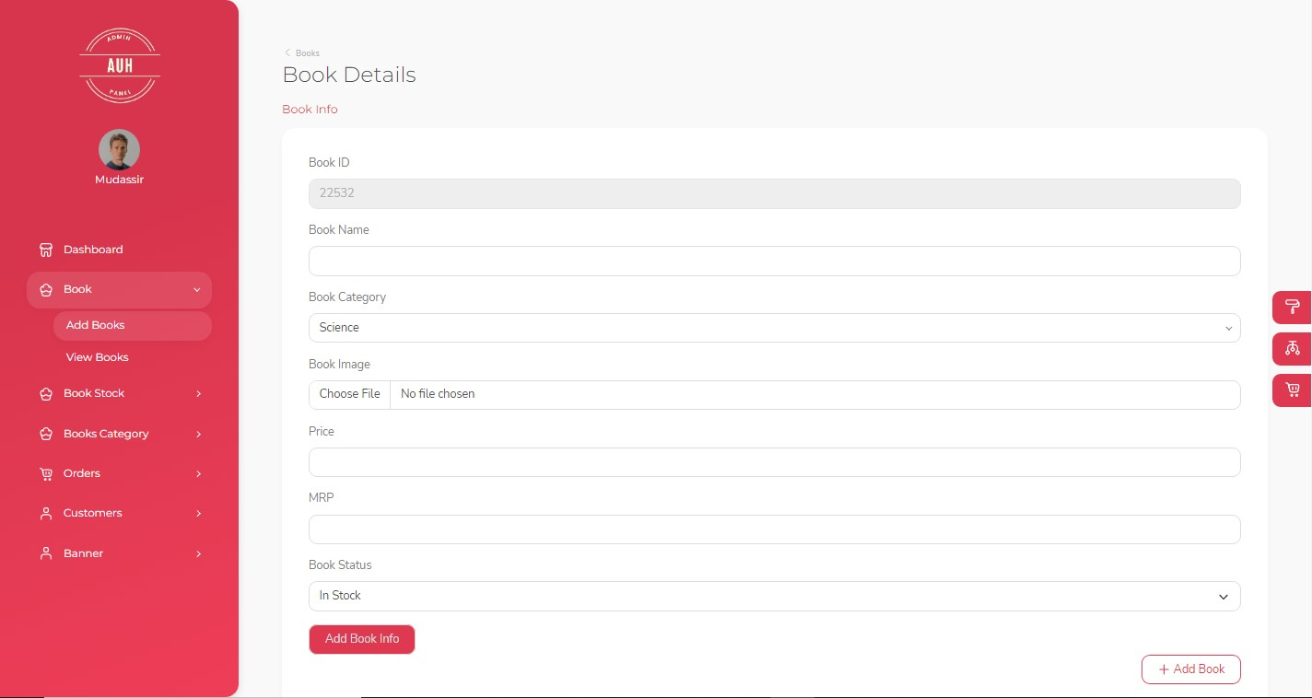

4. View Books

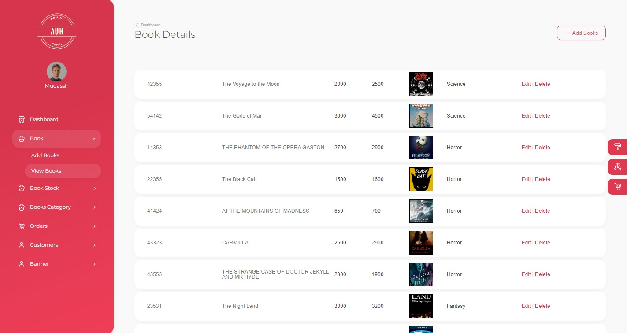

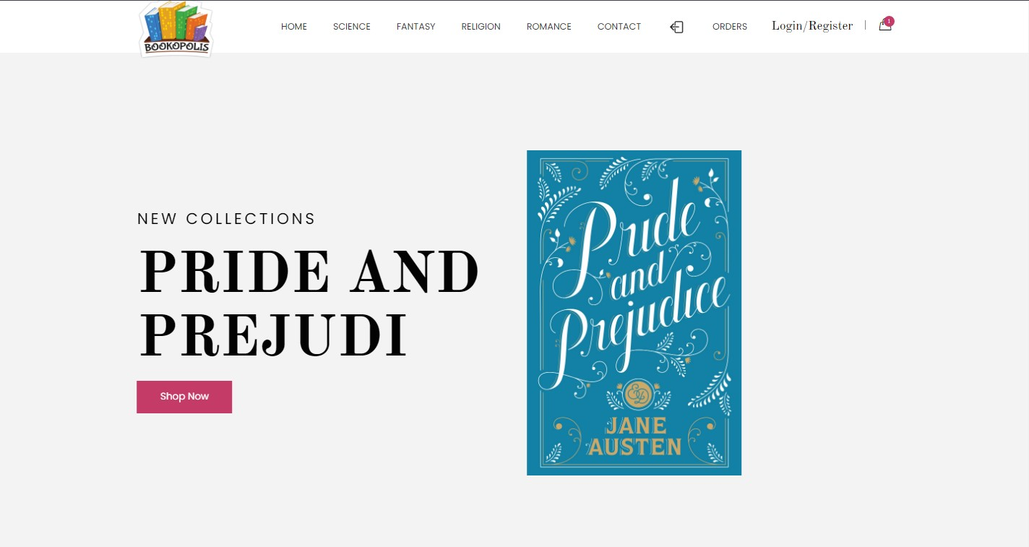

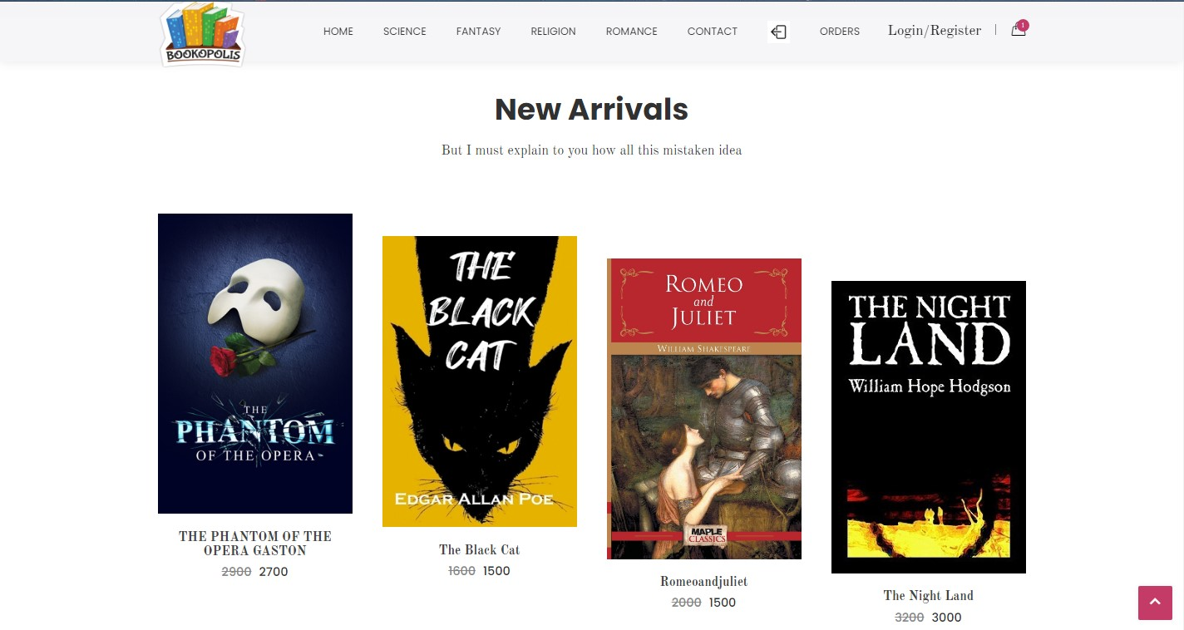

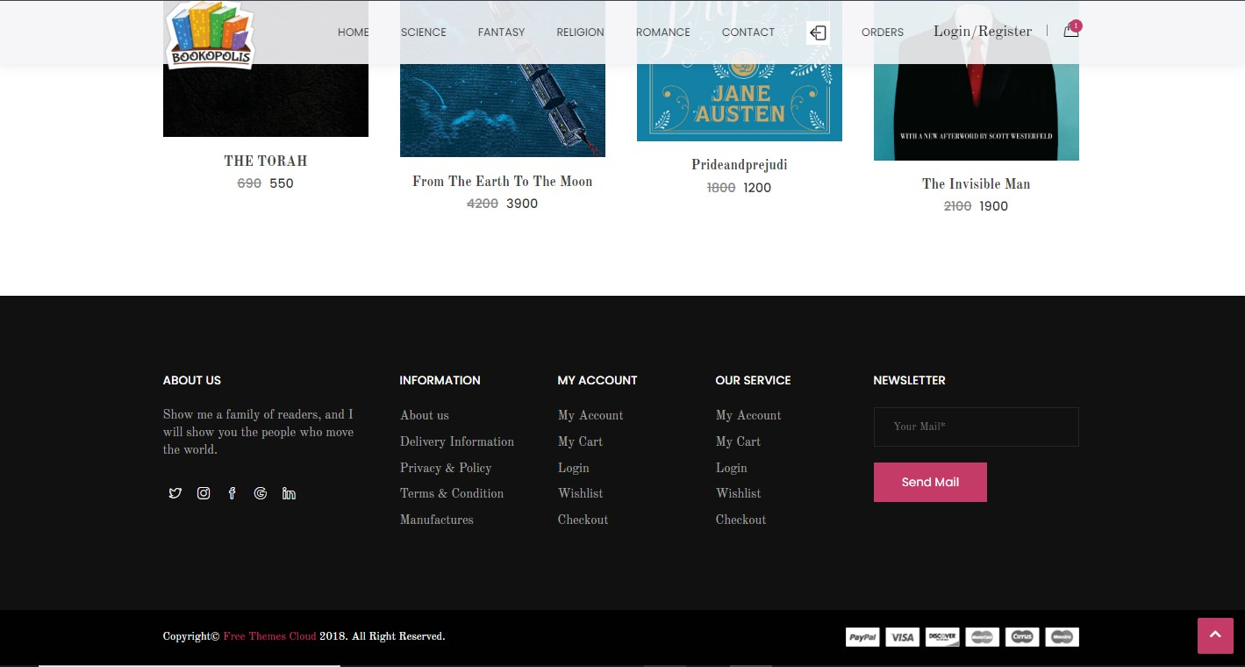

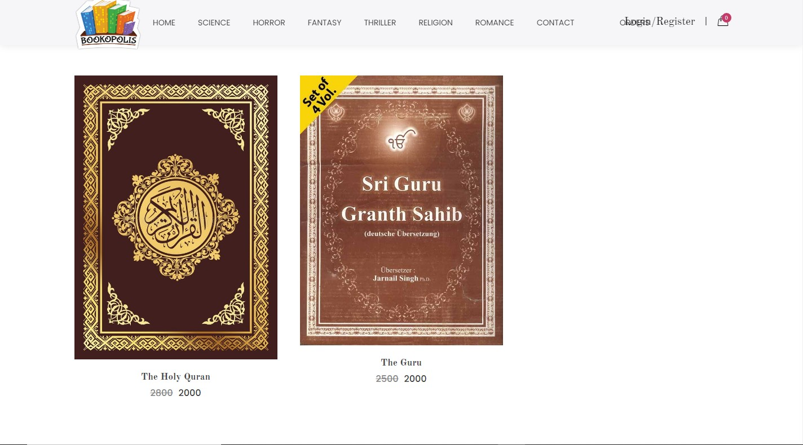

**EProject**: E-Books

1. About Page (2.About.cshtml)

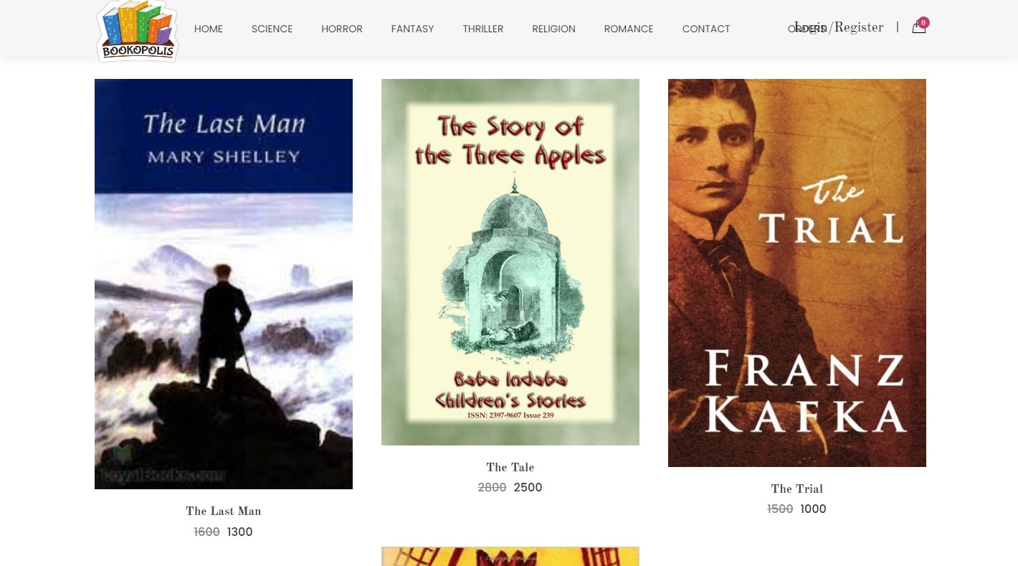

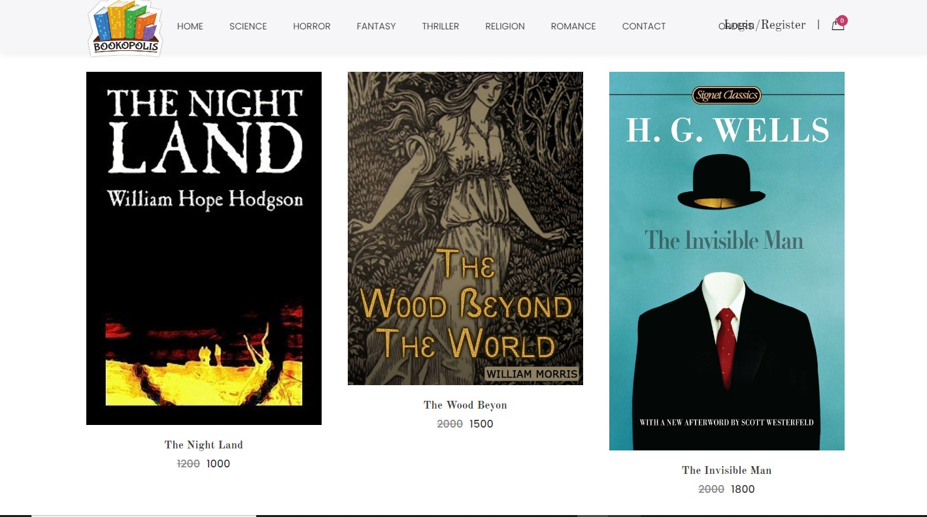

5

1. Add to Cart page

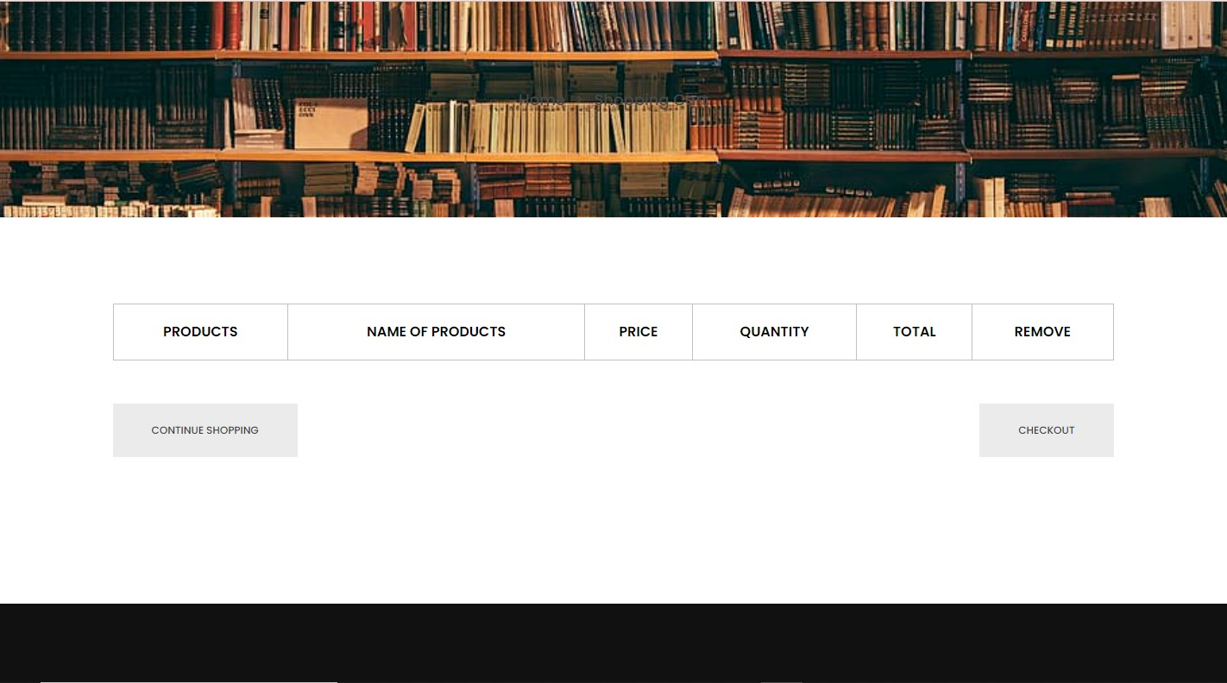

1. Contact Page (4.Contact.cshtml)

