Smart Career and Internship Management System:

SmartMatch aims to automate and personalize the career placement process through a data-driven and interactive approach. It functions as both a career management hub and a networking system, integrating three key dimensions:
- Smart Resume Database → A searchable database that stores and indexes all student resumes, extracts key skills and experience data, and enables recruiters to find suitable candidates efficiently.
- Skill-Based Job Matching → An intelligent matching engine compares student skills, CGPA, and academic details with job requirements, generating ranked “Top Matches” for each position.
- Interactive Networking Platform → A mutual interest system (inspired by Bumble) allows students and recruiters to connect through two-way interest acknowledgments. Once both express interest, the system creates a connection channel for real-time chat and collaboration.

Key Features

🔹 1. Smart User Profiles
*Students can create detailed career profiles with academic info, skills, projects, certifications, and uploaded resumes.
* Recruiters can build company profiles and define job or internship requirements.
* Dynamic dashboards display real-time profile completeness, pending applications, and new matches.

🔹 2. Resume Upload and Parsing

* Upload resumes in PDF or DOCX formats.
* The system parses the resume automatically to extract:
* Name, email, and contact details
* Education and GPA
* Technical and soft skills
* Experience, projects, and achievements
* Parsed data is stored in the database for faster search and matching.

🔹 3. Skill-Based Job Matching
* Uses a matching algorithm that compares student skills and qualifications with job requirements.
* Generates a match percentage or ranking score to help users identify best-fit opportunities.
* Recruiters can view top candidates instantly based on compatibility score.

🔹 4. Two-Way Interest Matching (Like Bumble)
* Both students and recruiters can express interest in each other’s profiles or postings.
* A connection is created only if both sides show mutual interest, ensuring quality and consent-based engagement.
* Once matched, chat and communication features are enabled automatically.

🔹 5. Internship & Job Management
* Recruiters can post, edit, and manage job listings with detailed criteria such as skills, CGPA, duration, and stipend.
* Students can apply, bookmark, and track their application status.
* Built-in filters allow users to search by category, company, duration, or location

🔹 6. Resume Rating and Feedback
🔹 7. Real-Time Messaging System

🔹 8. Application Tracking System
* Students can monitor their application progress: Applied → Under Review → Shortlisted → Rejected → Hired.
* Recruiters can manage applications from one dashboard and update statuses easily.

🔹 9. Analytics and Insights
🔹 10. Role-Based Access Control
🔹 11. Secure Authentication & Data Protection
🔹 12. Career Development Tools

🔹 13. Admin Control Panel
* Manage users, job postings, reports, and feedback.
* Approve or deactivate accounts and monitor system health.
* Export data and generate insights for institutional review.

🔹 14. Notification & Alerts System
🔹 15. Scalable and Modular Architecture

ENTITIES AND ATTRIBUTES

1. Student
Represents each registered student user on the platform.
Attributes:
- student_id (PK)
- name
- emai
- password_hash
- department
- cgpa
- graduation_year
- bio
- profile_photo
- resume_id (FK, optional)
- created_at
- updated_at

2. Resume
Stores resume details and upload paths for students.
Attributes:
- resume_id (PK)
student_id (FK)
- summary
- experience_years
- linkedin_link
- file_path
- uploaded_at

3. Skill
Contains a master list of all skills (technical and soft).
Attributes:
- skill_id (PK)
- skill_name

4. StudentSkill
Many-to-many relation between students and skills.
Attributes:
- student_id (FK)
- skill_id (FK)
- proficiency_level (optional: Beginner / Intermediate / Expert)

5. Project
Represents academic or personal projects added by students.
Attributes:
- project_id (PK)
- student_id (FK)\
- title
- tech_stack
- description
- project_link (optional)
6. Company
Stores organization or employer data.
Attributes:
- company_id (PK)
- name
- industry
- location
- description
- website
- contact_email
- created_at

7. Recruiter
Represents recruiters who post jobs/internships on behalf of companies.
Attributes:
- recruiter_id (PK)
- company_id (FK)
- name
- email
- password_hash
- designation
- profile_photo
- joined_at

8. JobPosition
Represents job/internship listings created by recruiters.
Attributes:
- job_id (PK)
- company_id (FK)
- recruiter_id (FK)
- title
- type (Internship / Part-time / Full-time)
- description
- required_cgpa
salary_range
- location
- posted_at
- status (Open / Closed)

9. JobSkill
Many-to-many link between JobPosition and Skill.
Attributes:
- job_id (FK)
- skill_id (FK)

10. Application
Tracks which student applied to which job, along with status.
Attributes:
- app_id (PK)
- student_id (FK)
- job_id (FK)
- status (Applied / Under Review / Shortlisted / Rejected / Hired)
- apply_date
- reviewed_date

11. Connection
Handles mutual interest (Bumble-style match) between students and recruiters.
Connection is “active” only if both sides show interest.
Attributes:
- connection_id (PK)
- student_id (FK)
- recruiter_id (FK)
- student_interest (boolean)
- recruiter_interest (boolean)
- connection_status (Pending / Matched / Rejected)
- created_at

💬 12. Message
Stores chat messages exchanged after a mutual connection.
Attributes:
- message_id (PK)
- connection_id (FK)
- sender_type (Student / Recruiter)
- sender_id (FK)
content
- sent_at
- read_status

13. RecruiterReview
Recruiter ratings and feedback for resumes or applications.
Attributes:
- review_id (PK)
- recruiter_id (FK)
- resume_id (FK)
- rating (1–5)
- feedback
- shortlisted (boolean)
- reviewed_at

14. Admin
System administrator for management and moderation.
Attributes:
- admin_id (PK)
- username
- password_hash
- email
- role (SuperAdmin / Moderator)
- created_at

15. Notification
Handles alerts for important events (match, new job, status updates).
Attributes:
- notification_id (PK)
- user_type (Student / Recruiter)
- user_id (FK)
- message
- link (optional: redirect path)
- is_read (boolean)
- Created_at
16. AnalyticsLog (optional but useful)
Stores system logs or metrics for dashboards.
Attributes:
- log_id (PK)
- user_id (FK)
- user_type
- action (e.g., Login, Applied, MessageSent, Rated)
- timestamp
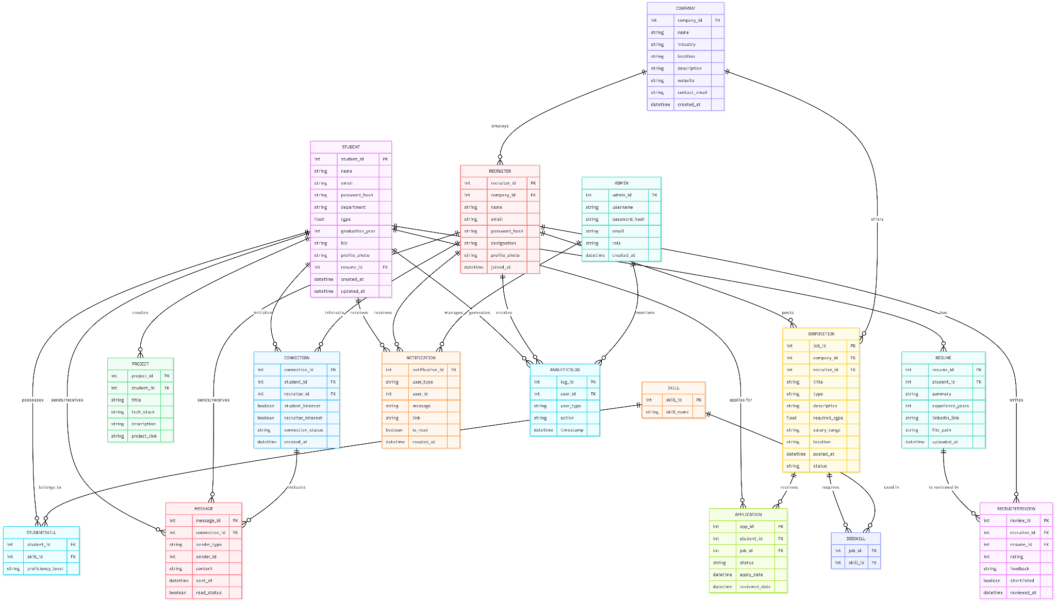
EER DIAGRAM :
SCHEMA :

[STUDENT] 1 ───< [RESUME]
[STUDENT] 1 ───< [PROJECT]
[STUDENT] 1 ───< [APPLICATION]
[STUDENT] M ───< [STUDENT_SKILL] >─── M [SKILL]

[RESUME] 1 ───< [RECRUITER_REVIEW]
[RECRUITER] 1 ───< [RECRUITER_REVIEW]
[COMPANY] 1 ───< [RECRUITER]

[COMPANY] 1 ───< [JOB_POSITION]
[JOB_POSITION] 1 ───< [APPLICATION]

[JOB_POSITION] M ───< [JOB_REQUIRED_SKILL] >─── M [SKILL]

Student ↔ Resume → One student can have multiple resumes.
Student ↔ Project → One student can create multiple projects.
Student ↔ Skill → Many-to-many via StudentSkill.
Student ↔ Application ↔ JobPosition → Students apply to jobs; one application links both.
Company ↔ JobPosition → A company can post many jobs.
Company ↔ Recruiter → Each company has one or more recruiters.
Recruiter ↔ Review ↔ Resume → Recruiters can review and rate resumes.
JobPosition ↔ Skill → Many-to-many via JobRequiredSkill.

