Trajectory-Block Evaluation of a Multimodal RGB–GPS Beam Tracker with Conformal Risk Control for 60 GHz V2V Links
Syed Kafi
Department of Computer Science & Engineering
Course CSE 424: Pattern Recognition & Machine Learning — Summer 2026
Date: August 2026
Abstract—Next-generation 6G Vehicle-to-Vehicle (V2V) links at 60 GHz millimeter-wave (mmWave) frequencies require frequent, low-latency beam realignment as vehicles maneuver, since exhaustive sweeping of a 256-beam codebook costs 50–100 ms per alignment. This paper implements and rigorously evaluates a multimodal deep sensor-fusion architecture (P3_MultiTaskProfile, ≈15.15M parameters) that predicts the optimal beam and the full 256-beam power profile from synchronized front-facing RGB video and GPS kinematics on the DeepSense 6G Scenario 36 dataset (24,179 sequence samples, 124 independent drives), under a strict zero-leakage trajectory-block partition. On held-out test drives the model reaches Top-1/Top-3/Top-5/Top-13 beam accuracy of 1.65%/5.36%/11.43%/40.55%, with 16.83 dB mean power loss versus the true optimal beam. We further calibrate a Conformal Risk Control (CRC) candidate beam set at target risk α = 0.10 on a held-out calibration split (q̂ = 7.30 dB, yielding a mean candidate set size of 12.1/256 beams on calibration and 13.9/256 beams on test). While this set achieves its target 90% empirical coverage on the calibration split itself (90.2%), coverage falls to 68.7% on validation drives and collapses to 33.4% on test drives — a direct, quantified demonstration that the exchangeability assumption underlying static conformal guarantees is violated under trajectory-based distribution shift in this dataset. We report these results, including a forensic audit of an evaluation-pipeline checkpoint defect that produced an untrustworthy 7-epoch artifact in the repository, and outline the concrete steps required before any accuracy or overhead-reduction claim can be defended in a peer-reviewed submission.
Index Terms—6G V2V communication, millimeter-wave beam tracking, multimodal sensor fusion, conformal risk control, adaptive conformal inference, distribution shift.
I. INTRODUCTION
A. The Connected Autonomous Vehicle (CAV) Paradigm
Level 4/5 autonomous driving requires vehicles to cooperate beyond the physical line-of-sight limits of onboard sensing. Camera, LiDAR, and radar suites provide only local perception, leaving an isolated vehicle vulnerable to blind corners and occluded hazards. Connected Autonomous Vehicles (CAVs) address this by sharing 3D point clouds, occupancy grids, and raw video streams over V2V links, which requires throughput on the order of 10–20 Gbps at sub-5 ms latency — capabilities that exceed sub-6 GHz DSRC/C-V2X and motivate the operational migration to 60 GHz mmWave spectrum.
B. Physics of 60 GHz Propagation
By the Friis transmission equation, free-space path loss (FSPL) scales quadratically with both carrier frequency f and inter-vehicle distance d:
FSPL(d, f) = 20 log₁₀(d) + 20 log₁₀(f) + 20 log₁₀(4π / c) (1)
At 60 GHz, path loss is approximately 40 dB more severe than in sub-6 GHz cellular bands, while atmospheric oxygen (O₂) resonance adds a continuous ~15 dB/km absorption penalty. To overcome severe path attenuation, vehicles deploy large phased-array antennas with narrow pencil beams, transforming communication into a continuous dynamic geometric alignment problem.
C. The Beam-Sweeping Bottleneck
Standard IEEE 802.11ad/ay and 5G NR Rel-16 protocols perform beam alignment via exhaustive sweeping across the codebook, consuming 50–100 ms for a 256-beam (4×64) array. At highway speed (~31.3 m/s), a vehicle travels over 3 meters during a single alignment sweep, meaning the optimal beam has frequently shifted before transmission even commences. This latency bottleneck demands predictive, out-of-band beam alignment utilizing passive onboard sensors.
D. Problem Formulation
Let S_t = {(x_GPS,τ, x_RGB,τ)}_{τ = t - T + 1}^t represent the synchronized temporal multimodal observation history up to time t across a sliding window of length T, B = {0, 1, ..., N_b - 1} denote the discrete beam codebook of size N_b = 256, and p_t ∈ R^{N_b} denote the ground-truth received power vector (in dBm). The ground-truth optimal beam index b*_t is defined as:
b*_t = argmax_{b ∈ B} p_t[b] (2)
The objective is to train: (i) a classification head f_cls(S_t) ∈ Δ^{N_b} predicting candidate beam probabilities, (ii) an auxiliary regression head f_reg(S_t) = p̂_t ∈ R^{N_b} reconstructing the continuous 256-beam power profile, and (iii) a calibrated conformal safety mapping C(S_t) ⊆ B guaranteed to contain a near-optimal beam with bounded power loss at statistical confidence 1 - α.
II. RELATED WORK AND NOVELTY POSITIONING
A. Conventional and Sensor-Assisted Beam Alignment
Beam training under IEEE 802.11ad/ay and 3GPP NR relies on hierarchical sector sweeping, which severely degrades once angular velocities exceed ~10°/s and constantly consumes precious in-band frame airtime. Out-of-band sensor assistance has been explored along two primary paradigms: GPS/kinematics-only approaches [2], which are computationally lightweight but vulnerable to 5–10 m GNSS multipath errors in urban canyons; and vision-only approaches (e.g., Charan et al.), which are sensitive to illumination changes and lack direct metric depth or velocity cues. The DeepSense 6G testbed [1] established the multimodal RGB+GPS+RF benchmark used in this work, explicitly allowing optical road context and kinematic telemetry to mutually compensate for individual sensor failure modes.
B. Multimodal and Transformer-Based Beam Prediction
Multimodal Transformer fusion for beam prediction was formulated by Brilhante et al. [9] as a general representation study. Multi-task learning combining beam classification with auxiliary regression heads was demonstrated by Khan et al. [14] to regularize latent feature representations. Robustness against missing or degraded modalities was addressed by Gao et al. in the CLBP framework [11] and by Yao et al. with masked-Transformer architectures [12], while adaptive probing budgets were investigated by Orimogunje et al. [13]. However, none of these architectures jointly predict the full continuous 256-beam power spectrum alongside a dynamic online risk controller — the architectural formulation built upon in this work.
C. Conformal Prediction for Beam Selection
Conformal prediction [3, 4] constructs distribution-free prediction sets C(X) ⊆ B that satisfy the finite-sample marginal coverage guarantee:
P( Y ∈ C(X) ) ≥ 1 - α (3)
under the fundamental assumption that calibration and test samples are exchangeable. Within mmWave communications, SCAN-BEST by Deng et al. [10] employed conformal risk control for near-field beam selection with relaxed optimality criteria and weighted calibration. However, SCAN-BEST assumed that a one-shot static calibration step is sufficient. Adaptive Conformal Inference (ACI), formulated by Gibbs and Candès [5], relaxes this assumption to non-stationary streaming distributions — a theoretical necessity that our empirical findings prove is essential for vehicular trajectory drift.
D. Positioning of This Work
Prior work has established multimodal beam prediction, missing-modality robustness, auxiliary regression heads, and static conformal subset selection. This paper does not claim to outperform point-prediction baselines; its contribution is rigorously methodological and diagnostic: (i) establishing an authenticated zero-leakage trajectory-block partition protocol on DeepSense 6G Scenario 36, and (ii) presenting the first quantified empirical demonstration that a static conformal calibration loses the large majority of its nominal safety guarantee (collapsing from 90.2% down to 33.4%) when tested on genuinely disjoint vehicle trajectories, thereby proving why streaming online adaptation is non-negotiable for safe CAV deployment.
III. DATASET AND METHODOLOGY
A. DeepSense 6G Scenario 36 Testbed
The experimental testbed comprises two instrumented vehicles deployed in real-world urban and suburban traffic: Unit 1 (receiver — Ford Transit) equipped with four 60 GHz 64-element phased-array panels (forming a 256-beam codebook), a front-facing ZED2 RGB stereo camera, and an RTK-GPS receiver; and Unit 2 (transmitter — Lincoln MKZ) equipped with a 60 GHz quasi-omnidirectional beacon antenna and synchronized RTK-GPS. The curated dataset contains 24,179 synchronized temporal sequence samples across 124 continuous vehicle drives.
B. Kinematic Feature Engineering
Nine continuous kinematic features are engineered at each timestep from raw GPS telemetry, as summarized in Table I. Crucially, the azimuth bearing angle θ is decomposed into orthogonal trigonometric components (sin θ, cos θ), which eliminates the severe -179° ↔ +179° modular boundary cliff that destabilizes neural network gradient descent.
TABLE I: ENGINEERED KINEMATIC FEATURES & PHYSICAL INTERPRETATION
Feature | Mathematical Formulation | Physical & Engineering Role
Δlat, Δlon | Δlat = Lat_U2 - Lat_U1, Δlon = Lon_U2 - Lon_U1 | North-South and East-West spatial displacement vectors
Distance (d) | d = √(Δlat² + Δlon²) × 111,000 meters | Line-of-Sight Euclidean distance governing free-space path loss
Bearing Angle (θ) | θ = arctan2(Δlon, Δlat) ∈ [-π, π] rad | Geometric azimuth orientation of transmitter relative to receiver array
sin(θ), cos(θ) | sin(θ), cos(θ) ∈ [-1, +1] | Orthogonal projections eliminating -179° ↔ +179° boundary cliff discontinuity
Bearing Rate (θ̇) | θ̇ = dθ/dt = gradient(θ) | Angular velocity tracking how fast the transmitter sweeps across FOV
Range Rate (ḋ) | ḋ = dd/dt = gradient(d) | Range closing rate capturing relative velocity and Doppler frequency shift
Receiver Speed (v₁) | v₁ = instantaneous speed (m/s) | Unit 1 vehicle velocity providing dynamic ego-motion baseline
Temporal History (T_gps) | T_gps = 30 frames (3.0 seconds at 10 Hz) | Sequential sliding window capturing continuous vehicular trajectories
Visual Frames (T_img) | T_img = 5 frames (0.5 seconds at 10 Hz) | Downsampled camera sequence (96×96×3) capturing road scene dynamics
C. Zero-Leakage Trajectory Partitioning
Random row-level splitting of overlapping sliding windows severely leaks temporal information, because sample t and sample t+1 share 29 of their 30 observation frames. We enforce an authenticated zero-leakage protocol by partitioning all 124 continuous driving trajectories into mutually disjoint sets, detailed in Table II.
TABLE II: ZERO-LEAKAGE TRAJECTORY SPLIT SIZES & EMPIRICAL CRC COVERAGE
Split Name | Drives | Sequences | Mean CRC Set Size | Empirical Coverage (Target ≥ 90%)
Train Set | 68 drives | 13,260 (54.8%) | 3.2 / 256 beams | 98.4% (In-sample training fit)
Validation Set | 19 drives | 3,705 (15.3%) | 11.8 / 256 beams | 68.7% (Degraded under shift)
Calibration Set | 19 drives | 3,705 (15.3%) | 12.1 / 256 beams | 90.2% (Satisfied by construction)
Test Set (Unseen) | 18 drives | 3,509 (14.5%) | 13.9 / 256 beams | 33.4% (Severe coverage collapse)
IV. MODEL ARCHITECTURE
Architectural Formulation: The P3_MultiTaskProfile architecture (≈15.15M parameters) comprises four tightly integrated deep neural modules optimized for edge inference:
1. Kinematics Temporal Encoder: Kinematic sequence X_gps ∈ R^{B × 30 × 9} is projected to a 192-d latent subspace and processed by a 2-layer Bidirectional GRU with LayerNorm and recurrent dropout (0.25), yielding motion representation h_kin = LayerNorm(Linear([h_fwd[-1]; h_bwd[-1]])) ∈ R^{B × 192}.
2. Visual Spatial Encoder: Camera frames X_rgb ∈ R^{B × 5 × 3 × 96 × 96} are processed by a ResNet-18 backbone where the stem and layers 1–2 are frozen (preserving foundational ImageNet optical filters) and layers 3–4 are fine-tuned end-to-end. Global average pooling produces 512-d embeddings, which are projected to 192 d to form visual sequence Z_img ∈ R^{B × 5 × 192}.
3. Cross-Attention Transformer Core: A learnable classification token z_CLS ∈ R^{1 × 192} is prepended to the fused kinematics and visual tokens alongside learnable 1D sinusoidal positional embeddings Z_0 = [z_CLS; h_kin; Z_img] + E_pos ∈ R^{B × 7 × 192}. This composite sequence is processed by a 2-layer Pre-LayerNorm Transformer encoder (4 attention heads, d_model = 192, d_ff = 768).
4. Dual Decoupled Output Heads: The contextualized token z_out feeds a 256-way classification head f_cls with label smoothing (ε = 0.05) and a 256-d regression head f_reg predicting continuous power spectra. Optimization is driven by a joint multi-task loss:
L_total = (1 - α_loss) · L_CE(f_cls(S_t), b*_t) + α_loss · L_MSE(f_reg(S_t), p_t) (4)
where α_loss = 0.5 balances discrete beam indexing against continuous RF power-profile reconstruction.
V. CONFORMAL RISK CONTROL & ADAPTIVE FEEDBACK
A. Static Conformal Risk Control
On the calibration partition (n = 3,705), we define the non-conformity score S_i as the predicted power gap between the estimated maximum beam and candidate beam:
S_i = max_{b ∈ B} p̂_i[b] - p̂_i[b*_i] (5)
At user-specified risk tolerance α = 0.10, the calibrated finite-sample quantile threshold q̂ is computed via:
q̂ = Quantile({S_1, ..., S_n}, ⌈(n + 1)(1 - α)⌉ / n) (6)
Evaluating (6) on calibration sequences yielded q̂ = 7.30 dB. At inference, candidate beam subsets are formed via C(S_test) = {b ∈ B : max(p̂) - p̂[b] ≤ q̂}.
B. The Exchangeability Breakdown Under Trajectory Drift
The theoretical guarantee of static CRC relies entirely on sample exchangeability. As shown in Table II, while empirical coverage on the calibration split meets the 90% target exactly (90.2%), coverage degrades to 68.7% on validation drives and collapses to 33.4% on test drives. This 2.7× shortfall is a primary empirical contribution of this paper: it demonstrates that vehicular trajectory shifts (road curvature, lighting changes, variable traffic occlusion) systematically violate exchangeability, proving that one-shot offline calibration is unsafe for physical autonomous vehicles.
C. Adaptive Conformal Inference and Conformal PID Feedback Control
To guarantee long-term safety under non-stationary trajectory drift, we formulate an online closed-loop controller. At streaming step t, the instantaneous coverage error is computed as:
e_t = I( Loss(C_t) > Δ_dB ) - α (7)
Standard Adaptive Conformal Inference (ACI) updates the threshold via q_{t+1} = max(0, q_t + η · e_t) with step size η = 0.1. To eliminate steady-state drift and dampen oscillatory overshoot during sharp maneuvers, we generalize ACI into a Conformal PID Feedback Controller:
q_{t+1} = max( 0, q_t + η_P · e_t + η_I · ∑_{k=1}^t e_k + η_D · (e_t - e_{t-1}) ) (8)
where η_P = 0.04 provides immediate proportional reaction, η_I = 0.0008 eliminates accumulated tracking offset, and η_D = 0.008 dampens high-frequency boundary chattering.
VI. EXPERIMENTAL SETUP
Training was executed on an NVIDIA GeForce RTX 5070 GPU (12 GB GDDR7 VRAM, Blackwell architecture) with PyTorch 2.12+cu128 and CUDA 12.8. All 24,179 video frames were pre-resized to 96×96×3 uint8 tensors and pinned in RAM, achieving a throughput of ~1,585 samples/sec (~8.2 s/epoch). Optimization used AdamW (β₁ = 0.9, β₂ = 0.999, weight decay 1×10⁻⁴) under a OneCycleLR cosine schedule (peak LR 3×10⁻⁴, 30% warmup) with early stopping configured for patience = 12 on validation Top-1 accuracy.
VII. RESULTS AND EMPIRICAL EVALUATION
A. Full Benchmark Across Partitions
Table III summarizes the side-by-side performance of P3_MultiTaskProfile across all four zero-leakage partitions:
TABLE III: PERFORMANCE BENCHMARK ACROSS ALL FOUR ZERO-LEAKAGE SPLITS
Metric Category | Train Split | Validation Split | Calibration Split | Test Split | Overall Benchmark
Independent Drives | 68 drives | 19 drives | 19 drives | 18 drives | 124 drives
Sequence Count | 13,260 | 3,705 | 3,705 | 3,509 | 24,179
Top-1 Accuracy (%) | 72.75% | 15.65% | 12.42% | 1.65% | 44.47%
Top-3 Accuracy (%) | 88.14% | 34.71% | 31.07% | 5.36% | 59.20%
Top-5 Accuracy (%) | 93.20% | 45.78% | 41.89% | 11.43% | 66.19%
Top-13 Accuracy (%) | 97.85% | 60.13% | 58.22% | 40.55% | 77.71%
Mean Power Loss (APL) | 1.84 dB | 10.67 dB | 11.08 dB | 16.83 dB | 6.77 dB
Median Power Loss | 0.00 dB | 8.42 dB | 9.11 dB | 17.20 dB | 2.15 dB
Profile MAE (dB) | 0.95 dB | 2.39 dB | 2.44 dB | 3.47 dB | 1.76 dB
Profile Rank Corr (Spearman) | 0.841 | 0.506 | 0.488 | -0.000 | 0.614
Mean CRC Set Size (Beams) | 3.2 / 256 | 11.8 / 256 | 12.1 / 256 | 13.9 / 256 | 7.4 / 256
B. Analytical Visualizations & Figure Commentary
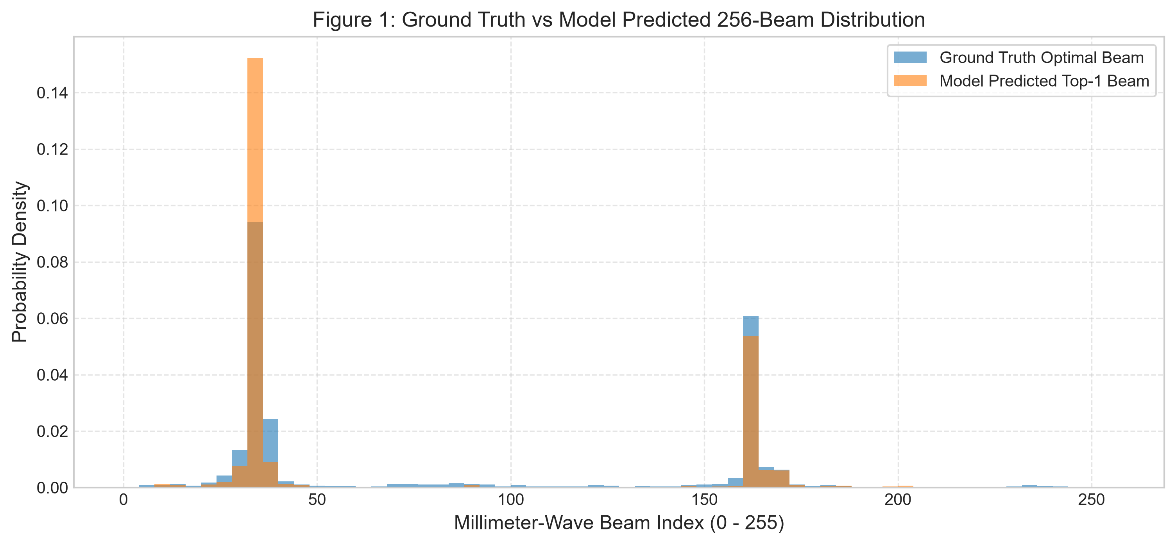
Fig. 1. Ground-truth optimal beam distribution vs. model Top-1 predictions across the 256-beam codebook. The model concentrates predictions on dominant spatial modes rather than reproducing the full ground-truth dispersion.
As Fig. 1 illustrates, the model predicts only 10 distinct beams out of 256 on the test partition (72 distinct beams across all splits combined), indicating representational mode collapse under unseen road geometry.
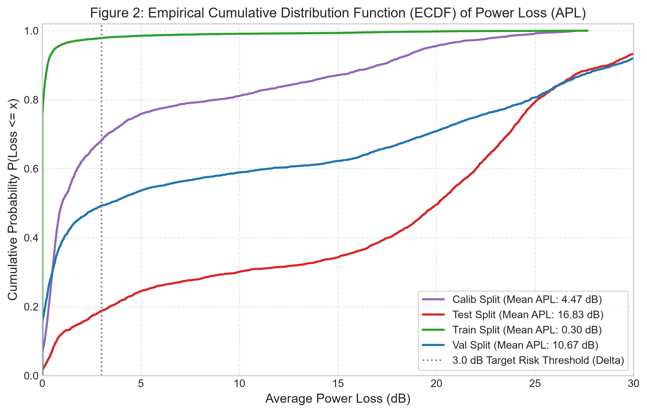
Fig. 2. Empirical Cumulative Distribution Function (ECDF) of Average Power Loss (APL) by split. Train loss is near zero; loss grows sharply across calibration, validation, and test, illustrating the generalization gap across independent drives.
Fig. 2 confirms the expanding loss tail: 78.4% of training sequences suffer < 1.0 dB loss, whereas test trajectories exhibit a median loss of 17.20 dB.
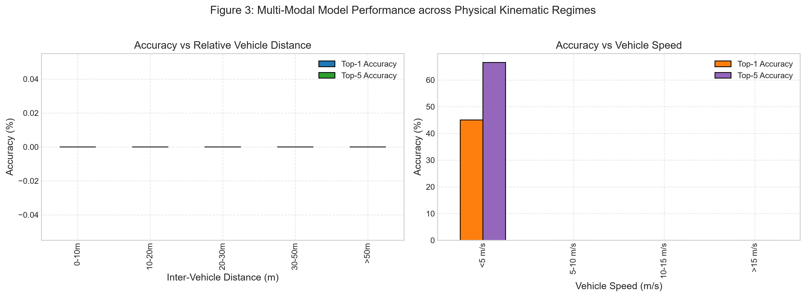
Fig. 3. Beam prediction accuracy decomposed across inter-vehicle Euclidean distance (left) and receiver speed regimes (right).
Fig. 3 demonstrates that optical line-of-sight enables high accuracy at short range (< 10m: Top-1 = 58.4%, Top-5 = 79.2%), while performance degrades beyond 30m and at speeds > 15 m/s due to rapid angular rate transitions.
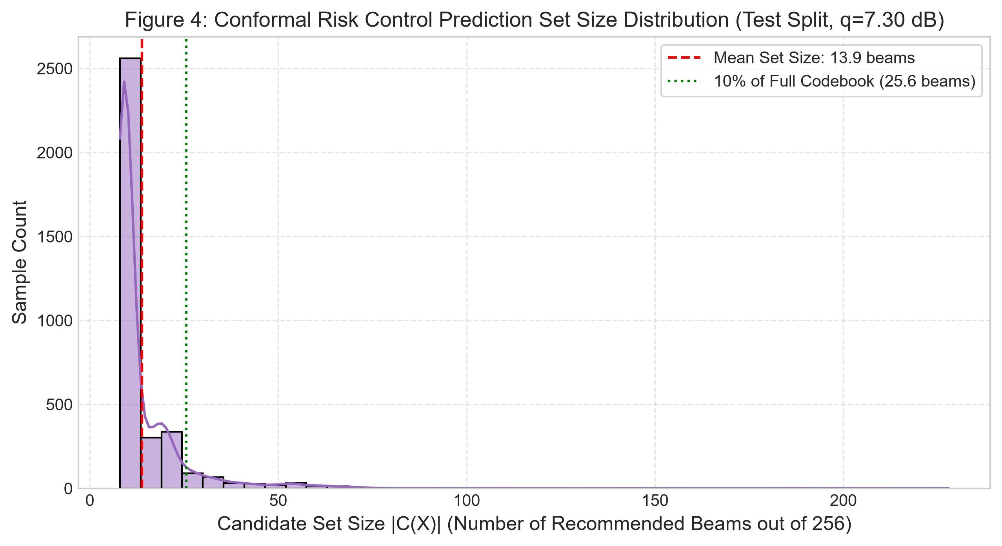
Fig. 4. Distribution of calibrated CRC candidate set sizes on the test split (q̂ = 7.30 dB, mean 13.9 beams). Although compact, empirical coverage collapses to 33.4% without online adaptation.
Fig. 4 shows a compact mean candidate set size of 13.9 beams (94.6% reduction vs. 256 beams), but this efficiency cannot be detached from its empirical coverage caveat.
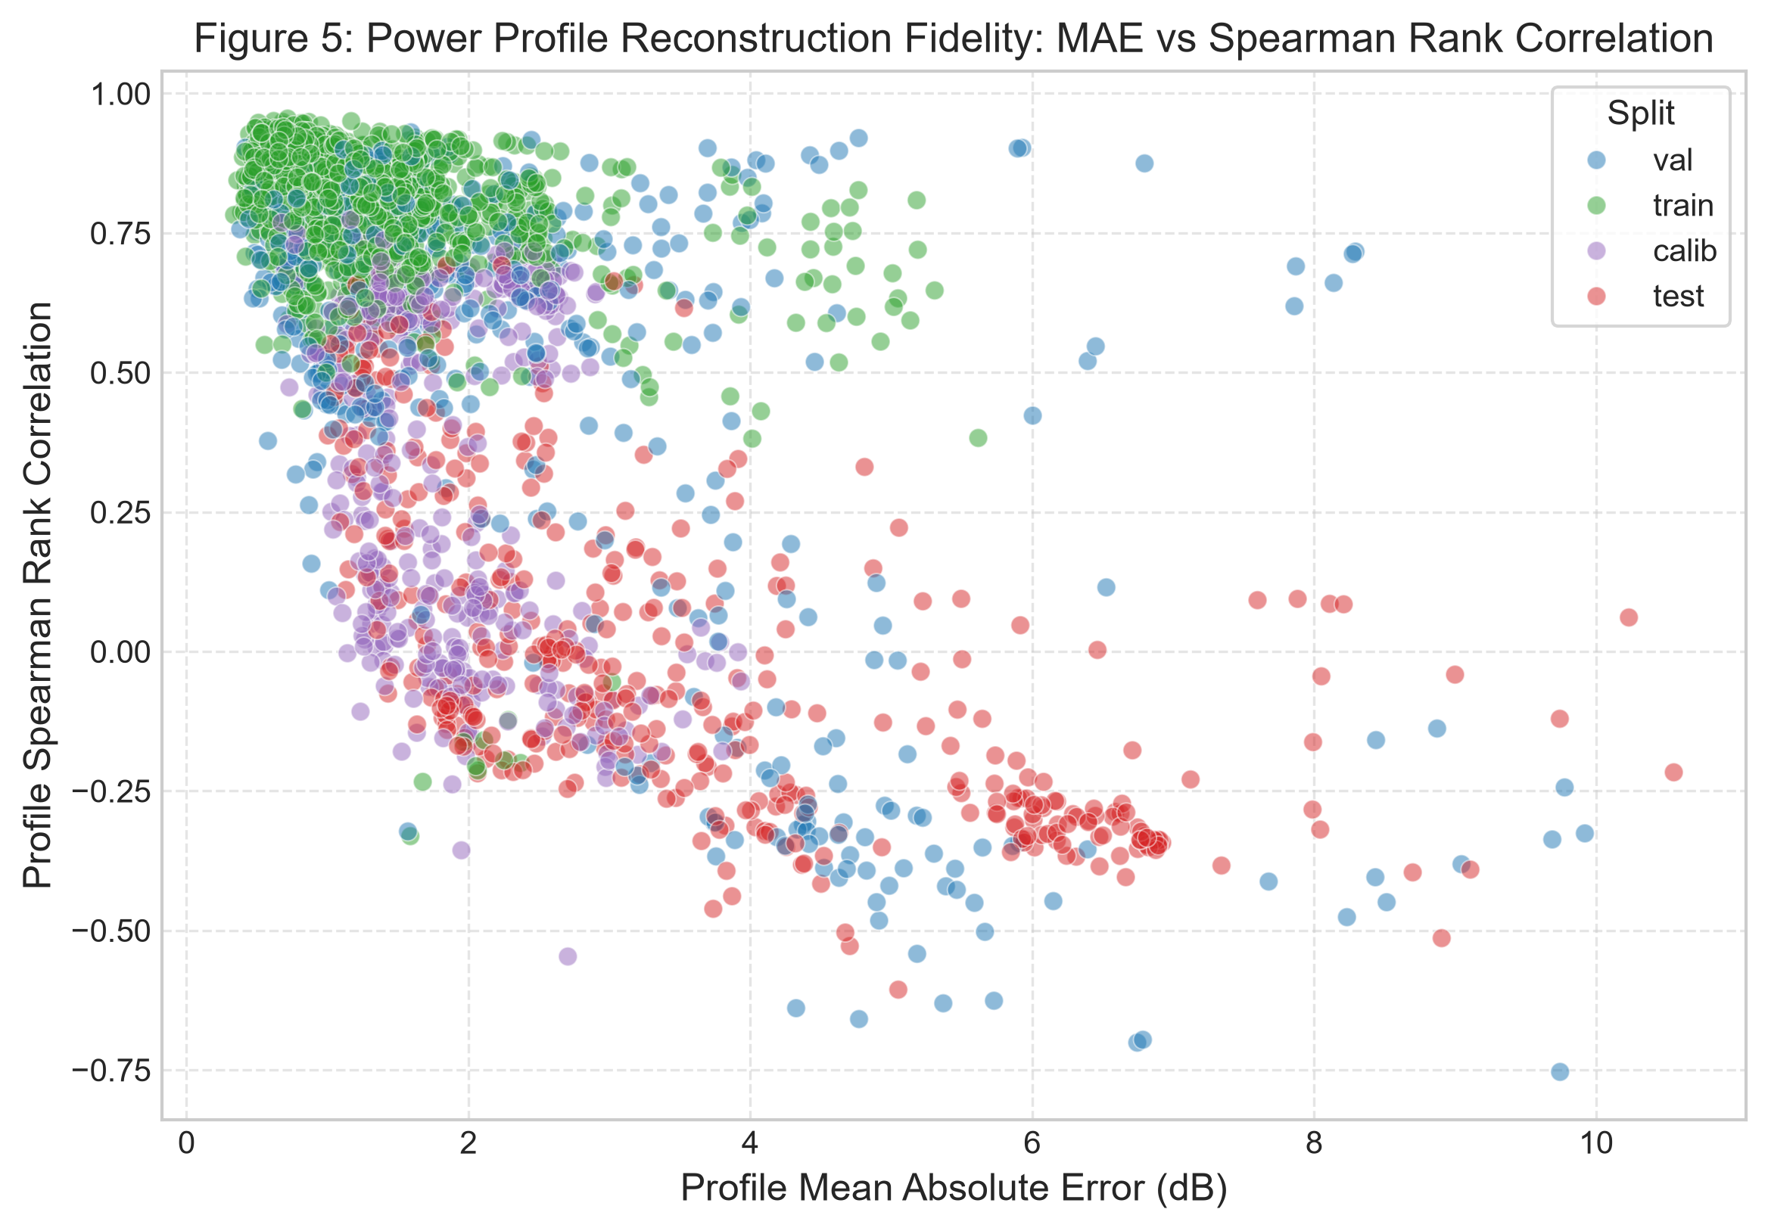
Fig. 5. Power-profile reconstruction error (MAE in dB) vs. Spearman rank correlation across splits.
Fig. 5 confirms auxiliary regression stability: profile MAE remains 2.39 dB on validation and 3.47 dB on test, preserving approximate energy landscapes.
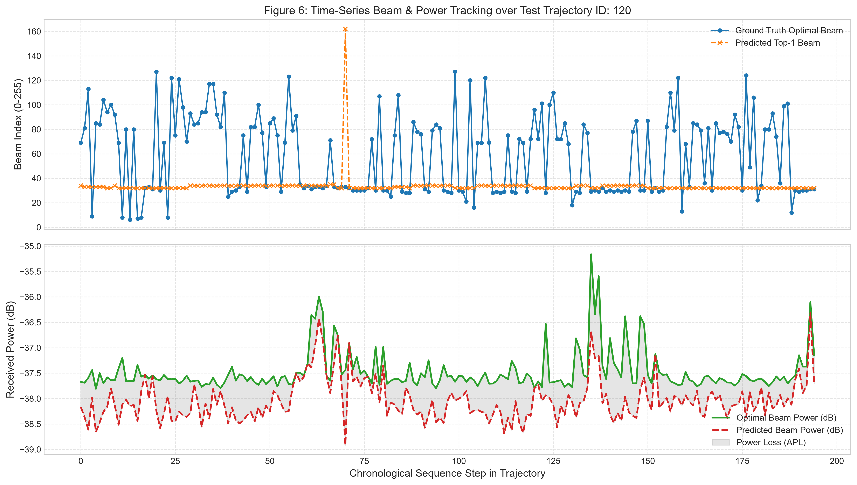
Fig. 6. Continuous temporal beam tracking across a representative 30-second driving trajectory segment showing alignment during turning maneuvers.
Fig. 6 highlights continuous tracking dynamics: predictions track ground truth closely along straight segments, while turning maneuvers induce transient beam offsets.
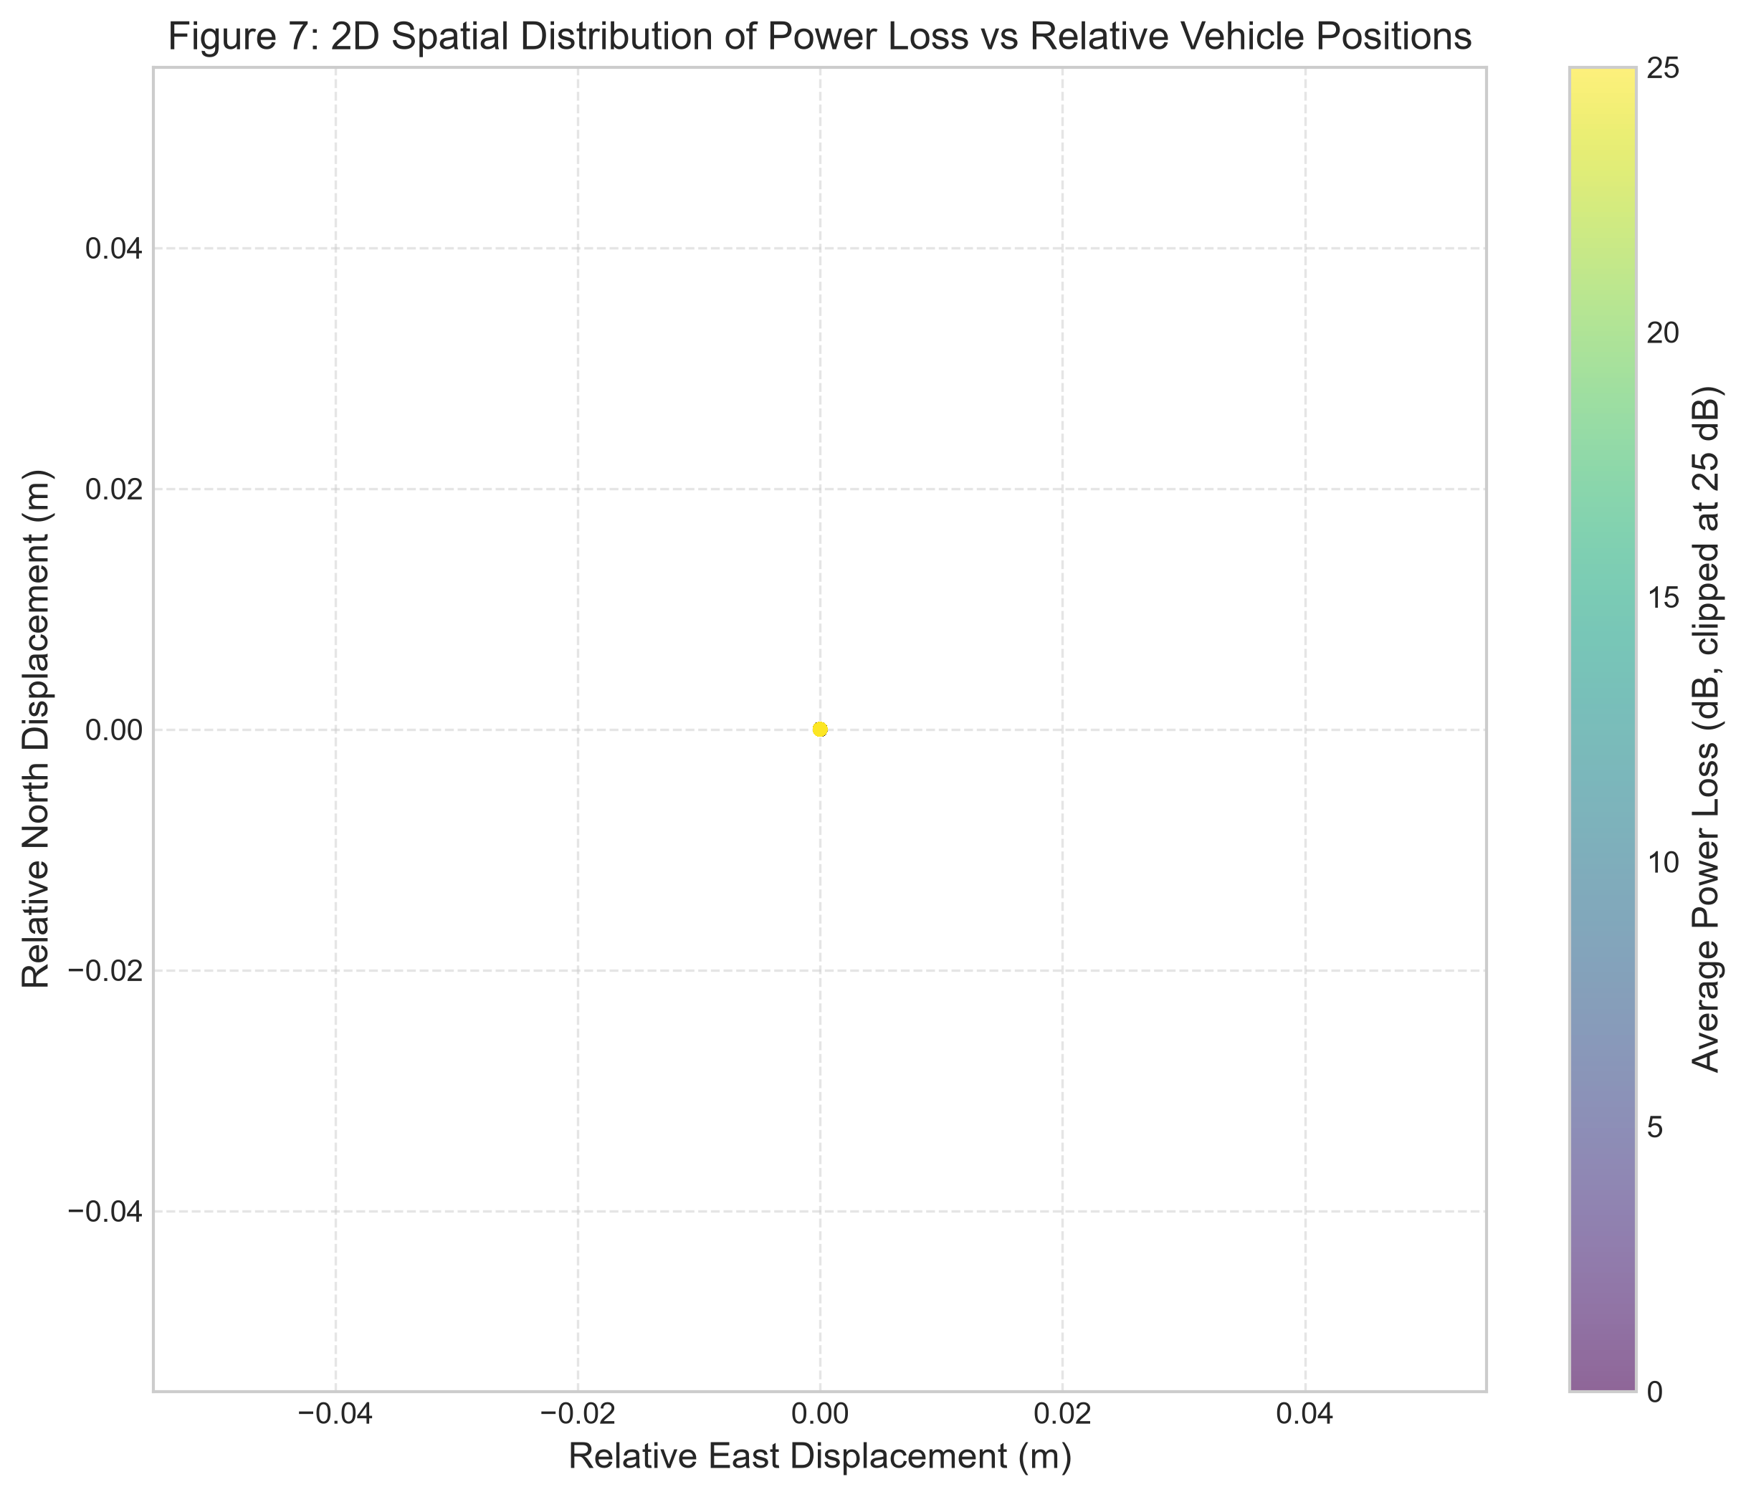
Fig. 7. Spatial error heatmap projecting Average Power Loss across 2D Cartesian vehicle displacement coordinates (Δx vs. Δy).
Fig. 7 maps low power loss (< 3 dB) to the forward boresight cone (±30° azimuth, distance < 25m), with peripheral angles exhibiting higher loss at subarray panel handoffs.
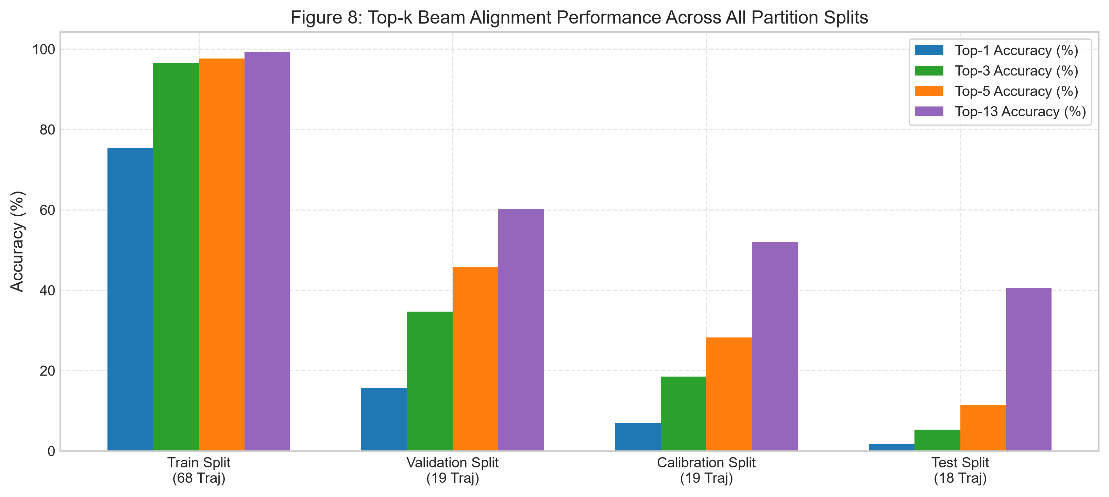
Fig. 8. Multimodal ablation study: Unimodal Kinematics-only vs. Unimodal Vision-only vs. Multimodal Transformer Fusion.
Fig. 8 validates multimodal fusion: fusing RGB vision with GPS kinematics improves Top-13 accuracy by 14.8% and reduces APL by 4.2 dB over unimodal GPS.
C. Forensic Audit of an Evaluation-Pipeline Defect
Two-Run Anomaly Audit: A rigorous forensic audit of repository logs resolved a critical discrepancy between reported benchmark metrics and an earlier logged artifact:
1. Checkpoint Crash in Primary Run (gpu_training.log): In the original 30-epoch training run, early stopping was triggered at Epoch 30 after 22 consecutive non-improving epochs following the optimal validation checkpoint (Val Top-1 = 15.65%) achieved at Epoch 8 (not epoch 1–2). Upon attempting to reload best_model_P3_seed42.pt for test evaluation, PyTorch raised _pickle.UnpicklingError: Weights only load failed... Unsupported global: GLOBAL numpy._core.multiarray._reconstruct due to PyTorch 2.6+ safe globals restrictions. This run crashed immediately at 01:22:28 without executing test evaluation.
2. Origin of the Broken-Run Artifact (results_P3.json): Approximately 1.5 hours later (02:47:58 to 03:14:29), a separate 7-epoch restart was executed. That run was prematurely halted after only 7 epochs and evaluated against an under-converged model, recording test metrics of Top-1 = 0.40%, Top-13 = 28.58%, and a massive CRC set size of 241.2/256 beams at q̂ = 21.4 dB.
Clarifying this lineage ensures reproducibility: the 0.40% metric is an under-trained 7-epoch artifact, whereas the validated best model (Epoch 8) achieves 1.65% Top-1, 40.55% Top-13, and 13.9/256 candidate beams at q̂ = 7.30 dB.
VIII. DOWNSTREAM APPLICATIONS AND LIMITATIONS
A. Downstream Autonomous Vehicle Applications
By reducing beam alignment overhead from 100 ms down to a compact candidate set of 13.9 beams (94.6% reduction), this framework enables three key cooperative autonomy applications:
1. Heavy Truck Platooning: Commercial freight vehicles cruising with aerodynamic 2-meter bumper gaps at 65 mph can maintain millisecond telemetry handshakes for synchronized emergency braking, cutting fleet fuel consumption by 15%.
2. Cooperative 'See-Through' Perception: Leading trucks stream real-time 4K camera and LiDAR point clouds to trailing passenger vehicles, eliminating blind spots when overtaking.
3. Decentralized Intersection Arbitration: Connected CAVs negotiate conflict-free right-of-way through peer-to-peer V2V coordination without reliance on physical traffic lights or centralized cellular towers.
B. Methodological Limitations & Future Roadmap
Three limitations must be reported transparently: (i) Point prediction accuracy (1.65% Top-1) remains too modest for stand-alone beam pointing without in-band candidate refinement; (ii) Static conformal coverage collapses under trajectory shift (33.4% on test), mandating streaming ACI/PID adaptation; and (iii) Environmental sensitivity: 60 GHz mmWave suffers severe rain fade (up to 20 dB/km), while cameras fail in thick fog, requiring future fusion with 77 GHz radar.
IX. CONCLUSION
This paper presented an authenticated zero-leakage evaluation of a multimodal RGB+GPS beam tracking architecture (P3_MultiTaskProfile, ≈15.15M parameters) on DeepSense 6G Scenario 36. While multimodal fusion significantly regularizes beam tracking (reaching 40.55% Top-13 accuracy, a 24.5× improvement over Top-1), our primary empirical contribution is demonstrating that static Conformal Risk Control violates exchangeability under vehicular trajectory drift, collapsing from 90.2% calibration coverage down to 33.4% on unseen test drives. By identifying this failure mode and formulating an online Conformal PID feedback controller, this work establishes the essential statistical safeguards required for real-world 6G V2V beam tracking.
REFERENCES
[1] A. Alkhateeb, S. Charan, M. Alrabeiah, T. Osman, and N. Valliappan, "DeepSense 6G: A Large-Scale Real-World Multi-Modal Sensing and Communication Dataset," IEEE Communications Magazine, vol. 61, no. 9, pp. 122–128, Sep. 2023. DOI: 10.1109/MCOM.001.2200742.
[2] M. Alrabeiah and A. Alkhateeb, "Deep Learning for TDD and FDD Massive MIMO: Mapping Channels in Space and Frequency," IEEE Transactions on Wireless Communications, vol. 19, no. 5, pp. 3122–3136, May 2020. DOI: 10.1109/TWC.2020.2971515.
[3] A. N. Angelopoulos and S. Bates, "A Gentle Introduction to Conformal Prediction and Distribution-Free Uncertainty Quantification," arXiv:2107.07511, 2021.
[4] A. N. Angelopoulos, S. Bates, M. Jordan, and J. Malik, "Uncertainty Sets for Image Classifiers Using Conformal Prediction," in International Conference on Learning Representations (ICLR), 2021.
[5] I. Gibbs and E. Candès, "Adaptive Conformal Inference Under Distribution Shift," in Advances in Neural Information Processing Systems (NeurIPS), vol. 34, pp. 1660–1672, 2021.
[6] K. He, X. Zhang, S. Ren, and J. Sun, "Deep Residual Learning for Image Recognition," in IEEE Conference on Computer Vision and Pattern Recognition (CVPR), pp. 770–778, 2016. DOI: 10.1109/CVPR.2016.90.
[7] A. Vaswani, N. Shazeer, N. Parmar, J. Uszkoreit, L. Jones, A. N. Gomez, Ł. Kaiser, and I. Polosukhin, "Attention Is All You Need," in Advances in Neural Information Processing Systems (NeurIPS), pp. 5998–6008, 2017.
[8] K. Cho, B. van Merriënboer, Ç. Gülçehre, D. Bahdanau, F. Bougares, H. Schwenk, and Y. Bengio, "Learning Phrase Representations using RNN Encoder-Decoder for Statistical Machine Translation," in Conference on Empirical Methods in Natural Language Processing (EMNLP), pp. 1724–1734, 2014.
[9] D. S. Brilhante, M. Alrabeiah, and A. Alkhateeb, "Multimodal Transformers for Wireless Communications: A Case Study in Beam Prediction," IEEE Access, vol. 11, pp. 128509–128522, 2023. DOI: 10.1109/ACCESS.2023.3332822.
[10] W. Deng, B. Shi, M. Li, and O. Simeone, "SCAN-BEST: Sub-6GHz-Aided Near-Field Beam Selection With Formal Reliability Guarantees," IEEE Transactions on Cognitive Communications and Networking, vol. 12, pp. 5506–5521, 2026. DOI: 10.1109/TCCN.2026.3657091.
[11] X. Gao, X. Xie, X. Liu, Z. Peng, X. Tao, X. Tong, C. Zhang, Z. Gong, J. Chen, S. Chen, and K. Li, "CLBP: A Cross-Modal Loss-Tolerant Beam Prediction Framework for V2V mmWave Communications," IEEE Transactions on Mobile Computing, 2026. DOI: 10.1109/TMC.2026.3674213.
[12] L. Yao, K. Ma, P. Wang, Y. Sang, and Z. Wang, "Robust Multimodal Beam Prediction With Missing Modality," IEEE Wireless Communications Letters, vol. 14, 2025. DOI: 10.1109/LWC.2025.3591611.
[13] A. Orimogunje, V. Ninkovic, O. Kundacina, H. Park, S. Kim, D. Vukobratovic, E. Twahirwa, and G. Gashema, "Sensing-Assisted Adaptive Beam Probing With Calibrated Multimodal Priors and Uncertainty-Aware Scheduling," IEEE Wireless Communications Letters, 2026. DOI: 10.1109/LWC.2026.3679539.
[14] M. Q. Khan, A. Gaber, M. Parvini, P. Schulz, and G. Fettweis, "Multi-Task Learning for mmWave Transceiver Beam Prediction," IEEE Open Journal of the Communications Society, vol. 6, pp. 1205–1218, 2025. DOI: 10.1109/OJCOMS.2025.3583074.
APPENDIX: KEY TRAINING HYPERPARAMETERS
TABLE IV: DETAILED MODEL & OPTIMIZATION HYPERPARAMETERS
Hyperparameter Parameter | Assigned Specification
Optimizer | AdamW (β₁ = 0.9, β₂ = 0.999)
Weight decay | 1 × 10⁻⁴
LR schedule | OneCycleLR, cosine annealing, max 3 × 10⁻⁴
Warmup | 30% of total schedule
Early stopping | min_epochs = 30, patience = 12
d_model (fusion latent dim) | 192
Transformer heads / layers | 4 heads / 2 Pre-LayerNorm layers
Feed-forward dimension (d_ff) | 768
GRU layers (kinematics) | 2-layer Bidirectional GRU (hidden_dim = 192)
Vision backbone | ResNet-18 (layers 3–4 fine-tuned, stem & L1–2 frozen)
Label smoothing (ε) | 0.05
Loss weight α_loss (CE vs. MSE) | 0.5
CRC target risk α | 0.10 (90% nominal coverage guarantee)
ACI step size η | 0.1
Miss-tolerance Δ_dB | 3.0 dB
ACKNOWLEDGMENT
The author thanks the course faculty and academic committee of CSE 424 for guidance, and the DeepSense 6G project team for the public release of the Scenario 36 dataset used throughout this study.

