Trajectory-Block Evaluation of a Multimodal RGB–GPS Beam Tracker with Conformal Risk Control for 60 GHz V2V Links
DEPARTMENT OF COMPUTER SCIENCE & ENGINEERING
SCHOOL OF COMPUTING & INFORMATION SCIENCES
COURSE CSE 424: PATTERN RECOGNITION & MACHINE LEARNING — SUMMER 2026
Prepared by: Syed Kafi | Date: August 2026
ABSTRACT
Next-generation 6G Vehicle-to-Vehicle (V2V) links at 60 GHz millimeter-wave (mmWave) frequencies require frequent, low-latency beam realignment as vehicles move, since exhaustive sweeping of a 256-beam codebook costs 50–100 ms per alignment. This paper implements and rigorously evaluates a multimodal deep sensor-fusion architecture (P3_MultiTaskProfile, ≈15.15M parameters) that predicts the optimal beam and the full 256-beam power profile from synchronized front-facing RGB video and GPS kinematics on the DeepSense 6G Scenario 36 dataset (24,179 sequence samples, 124 independent drives), under a strict zero-leakage trajectory-block partition. On held-out test drives the model reaches Top-1/Top-3/Top-5/Top-13 beam accuracy of 1.65%/5.36%/11.43%/40.55%, with 16.83 dB mean power loss versus the true optimal beam. We further calibrate a Conformal Risk Control (CRC) candidate beam set at target risk α = 0.10 on a held-out calibration split (q̂ = 7.30 dB, mean set size 13.9/256 beams). While this set achieves its target 90% empirical coverage on the calibration split itself (90.2%), coverage falls to 68.7% on validation drives and collapses to 33.4% on test drives — a direct, quantified demonstration that the exchangeability assumption underlying static conformal guarantees is violated under trajectory-based distribution shift in this dataset. We report these results, including a discovered evaluation-pipeline defect that produced a separate, lower set of numbers in one training-run log, transparently, and outline the concrete steps required before any accuracy or overhead-reduction claim can be defended in a submission or publication.
Index Terms — 6G V2V communication, millimeter-wave beam tracking, multimodal sensor fusion, conformal risk control, adaptive conformal inference, distribution shift.
I. INTRODUCTION
A. The Connected Autonomous Vehicle (CAV) Paradigm
Level 4/5 autonomous driving requires vehicles to cooperate beyond the physical limits of onboard sensing. Camera, LiDAR, and radar suites provide only local perception, leaving an isolated vehicle vulnerable to blind corners and occluded hazards. Connected Autonomous Vehicles (CAVs) address this by sharing 3D point clouds, occupancy grids, and video streams over V2V links, which requires throughput on the order of 10–20 Gbps at sub-5 ms latency — beyond sub-6 GHz DSRC/C-V2X, motivating a shift to 60 GHz mmWave spectrum.
B. Physics of 60 GHz Propagation
By the Friis transmission equation, free-space path loss scales quadratically with the carrier frequency f and inter-vehicle distance d:
FSPL(d, f) = 20 log₁₀(d) + 20 log₁₀(f) + 20 log₁₀(4π / c)
At 60 GHz, path loss is roughly 40 dB more severe than at 600 MHz, and atmospheric oxygen (O₂) resonance adds a further ~15 dB/km attenuation. Compensating with large phased-array antennas turns communication into a continuous geometric alignment problem.
C. The Beam-Sweeping Bottleneck
IEEE 802.11ad/ay and 5G NR Rel-16 align beams via exhaustive sweeping across the codebook, consuming 50–100 ms for a 256-beam (4×64) array. At highway speed (~31.3 m/s) a vehicle moves over 3 m during a single sweep, so the optimal beam has typically already shifted by the time the sweep completes. This introduces an urgent demand for predictive, out-of-band beam alignment.
D. Problem Formulation
Let S_t = {(x_GPS,τ, x_RGB,τ)}_{τ = t - T + 1}^t be the temporal multimodal history up to time t over window T, B = {0, 1, ..., N_b - 1} the discrete beam codebook of size N_b = 256, and p_t ∈ R^{N_b} the ground-truth received power vector (in dBm). The optimal beam index b*_t is defined as:
b*_t = argmax_{b ∈ B} p_t[b]
We learn (i) a classification head f_cls(S_t) ∈ Δ^{N_b} predicting candidate beam probabilities, (ii) a regression head f_reg(S_t) = p̂_t ∈ R^{N_b} predicting the full 256-element power spectrum, and (iii) a calibrated conformal safety mapping C(S_t) ⊆ B intended to contain a near-optimal beam with bounded power loss at statistical confidence 1 - α.
II. RELATED WORK AND NOVELTY POSITIONING
A. Conventional and Sensor-Assisted Beam Alignment
Beam training under IEEE 802.11ad/ay and 3GPP NR uses hierarchical sector sweeping, which degrades once angular velocity exceeds ~10°/s and always consumes in-band time. Out-of-band sensor assistance has been explored along two lines: GPS/kinematics-only approaches [2], lightweight but degraded by 5–10 m urban-canyon GNSS drift; and vision-only approaches (e.g., Charan et al.), sensitive to lighting/weather and lacking direct range/velocity information. The DeepSense 6G program [1] established the multimodal RGB+GPS+RF benchmark used here, explicitly to let each modality compensate for the other's failure modes.
B. Multimodal and Transformer-Based Beam Prediction
Multimodal Transformer fusion for beam prediction has been studied as a general case study [9], without the online-control angle pursued here. Multi-task learning — joint beam classification with auxiliary regression heads, as used in this paper — has separately been shown to improve mmWave beam prediction accuracy [14]. Robustness to missing or degraded modalities has been addressed by cross-modal loss-tolerant prediction (CLBP) [11] and by adaptive multimodal masked-Transformer architectures (AMBER) [12], and lightweight cross-environment vision-aided tracking has targeted deployment efficiency across sites [13]. None of this line of work predicts the full 256-beam power profile jointly with an online risk controller, which is the angle this paper builds on architecturally, even though (as shown in Section V) our calibration results reveal that angle is not yet reliable in practice.
C. Conformal Prediction for Beam Selection
Conformal prediction [3,4] constructs distribution-free prediction sets C(X) ⊆ B satisfying P(Y ∈ C(X)) ≥ 1 - α under an exchangeability assumption. Within mmWave beam selection specifically, SCAN-BEST [10] predicts a candidate beam subset using conformal risk control with a relaxed optimality criterion and weighted calibration under covariate shift, and a 2026 IEEE WCL study combines calibrated multimodal priors with adaptive probing budgets and a dB safety margin. Both assume a single, static calibration step is sufficient. Adaptive Conformal Inference (ACI) [5] relaxes this to online, non-stationary settings — which Section V shows is in fact necessary for this dataset, not merely a theoretical refinement.
D. Positioning of This Work
Prior work has established multimodal beam prediction, missing-modality robustness, multi-task auxiliary heads, and static conformal candidate-set selection with relaxed optimality or weighted calibration under shift. This paper does not claim to improve on point-prediction accuracy relative to those baselines (Section VII shows accuracy is in fact modest); its contribution is methodological and diagnostic: (i) a working zero-leakage, trajectory-block evaluation protocol for this exact architecture family, and (ii) a directly measured, quantified demonstration — rather than an assumed risk — that a static conformal calibration of the kind used in SCAN-BEST loses the large majority of its nominal coverage guarantee (90.2% → 33.4%) when evaluated on genuinely disjoint vehicle trajectories, which is the failure mode that motivates ACI-style online adaptation for this task.
III. DATASET AND METHODOLOGY
A. DeepSense 6G Scenario 36
The testbed comprises two instrumented vehicles: Unit 1 (receiver — Ford Transit) with four 60 GHz 64-element phased-array panels (256-beam codebook), a forward RGB camera, and RTK-GPS; and Unit 2 (transmitter — Lincoln MKZ) with a 60 GHz beacon antenna and synchronized RTK-GPS. The processed dataset contains 24,179 synchronized sequence samples from 124 independent drives.
B. Kinematic Feature Engineering
Nine continuous kinematic features are engineered per timestep: relative lat/lon displacement, Euclidean inter-vehicle distance, azimuth bearing angle (with sine/cosine decomposition), angular rate, range closing rate, and receiver speed. Table III-A provides the mathematical formulations and physical significance of each feature.
Kinematic Feature | Mathematical Formulation | Physical & Engineering Role
Δlat, Δlon | Δlat = Lat_U2 - Lat_U1, Δlon = Lon_U2 - Lon_U1 | North-South and East-West spatial displacement vectors
Distance (d) | d = √(Δlat² + Δlon²) × 111,000 meters | Line-of-Sight Euclidean distance governing free-space path loss
Bearing Angle (θ) | θ = arctan2(Δlon, Δlat) ∈ [-π, π] rad | Geometric azimuth orientation of transmitter relative to receiver array
sin(θ), cos(θ) | sin(θ), cos(θ) ∈ [-1, +1] | Orthogonal projections eliminating -179° ↔ +179° boundary cliff discontinuity
Bearing Rate (θ̇) | θ̇ = dθ/dt = gradient(θ) | Angular velocity tracking how fast the transmitter sweeps across FOV
Range Rate (ḋ) | ḋ = dd/dt = gradient(d) | Range closing rate capturing relative velocity and Doppler frequency shift
Receiver Speed (v₁) | v₁ = instantaneous speed (m/s) | Unit 1 vehicle velocity providing dynamic ego-motion baseline
Temporal History (T_gps) | T_gps = 30 frames (3.0 seconds at 10 Hz) | Sequential sliding window capturing continuous vehicular trajectories
Visual Frames (T_img) | T_img = 5 frames (0.5 seconds at 10 Hz) | Downsampled camera sequence (96×96×3) capturing road scene dynamics
C. Zero-Leakage Trajectory Partitioning
Random row-level splitting of overlapping temporal windows leaks information, since adjacent samples share 29 of their 30 observation frames. We instead partition the 124 independent drives directly into disjoint sets, as summarized in Table I:
Split Name | Drives Count | Sequence Count
Train Set | 68 drives | 13,260 (54.8%)
Validation Set | 19 drives | 3,705 (15.3%)
Calibration Set | 19 drives | 3,705 (15.3%)
Test Set | 18 drives | 3,509 (14.5%)
Total Benchmark | 124 drives | 24,179 (100.0%)
IV. MODEL ARCHITECTURE
Architecture Pipeline: P3_MultiTaskProfile (≈15.15M parameters) comprises four core deep neural components engineered for real-time inference:
1. Kinematics Encoder: Input tensor X_gps ∈ R^{B × 30 × 9} is linearly projected to a 192-d latent space and passed through a 2-layer Bidirectional GRU with LayerNorm and dropout (0.25), producing a 192-d motion token h_kin = LayerNorm(Linear([h_fwd[-1]; h_bwd[-1]])) ∈ R^{B × 192}.
2. Visual Encoder: A ResNet-18 backbone processes temporal RGB frames X_rgb ∈ R^{B × 5 × 3 × 96 × 96} with the stem and layers 1–2 frozen (retaining generalized ImageNet filters) and layers 3–4 fine-tuned end-to-end. Each frame's pooled 512-d feature is projected to 192 d, yielding visual token sequence Z_img ∈ R^{B × 5 × 192}.
3. Cross-Attention Fusion: A learnable classification token z_CLS ∈ R^{1 × 192} is prepended to the concatenated kinematics and visual tokens with learnable positional and modality embeddings Z_0 = [z_CLS; h_kin; Z_img] + E_pos ∈ R^{B × 7 × 192}, and processed by a 2-layer Pre-LayerNorm Transformer encoder (4 heads, d_model = 192, d_ff = 768).
4. Output Heads and Loss Formulation: The fused representation z_out feeds a 256-way classification head f_cls (label-smoothed cross-entropy, ε = 0.05) and a 256-d regression head f_reg (MSE against dBm ground truth). The joint multitask loss is defined as:
L_total = (1 - α_loss) × L_CE(f_cls(S_t), b*_t) + α_loss × L_MSE(f_reg(S_t), p_t)
where α_loss = 0.5 balances discrete beam identification against continuous spatial power landscape reconstruction.
V. CONFORMAL RISK CONTROL
A. Static CRC
On the calibration split (n = 3,705), we define the non-conformity score S_i as the predicted power gap between the estimated maximum beam and the candidate beam:
S_i = max_{b ∈ B} p̂_i[b] - p̂_i[b*_i]
The calibrated quantile threshold q̂ at target risk α = 0.10 is computed via:
q̂ = Quantile({S_1, ..., S_n}, ⌈(n + 1)(1 - α)⌉ / n)
On the calibration set, this yielded q̂ = 7.30 dB, defining candidate set C(S_test) = {b ∈ B : max(p̂) - p̂[b] ≤ q̂}.
B. Empirical Coverage Breaks Down Under Trajectory Shift
Static CRC is only valid under exchangeability between calibration and test data. Table II reports the measured empirical coverage of C(S) across splits, using the miss criterion Loss(C) > Δ_dB = 3.0 dB.
Dataset Split | Mean Candidate Set Size | Empirical Coverage (Target ≥ 90%)
Calibration Set (Self) | 21.5 / 256 beams | 90.2% (Satisfied by construction)
Validation Set | 11.8 / 256 beams | 68.7% (Degraded under shift)
Test Set (Unseen Trajectories) | 13.9 / 256 beams | 33.4% (Severe coverage collapse)
Coverage on the calibration split matches the 90% target by construction. On unseen trajectories, coverage falls to 68.7% (validation) and 33.4% (test) — a factor-of-2.7 shortfall against the nominal guarantee on test drives. This is the paper's most important empirical finding: it confirms that trajectory dependence (turns, new road geometry, lighting) breaks the exchangeability assumption that static CRC relies on, motivating an online, trajectory-adaptive controller rather than a one-shot calibrated threshold.
C. Adaptive Conformal Inference & Conformal PID Feedback Control
The online ACI controller updates its threshold at each streaming step t based on instantaneous coverage error:
e_t = I( Loss(C_t) > Δ_dB ) - α
q_{t+1} = max( 0, q_t + η · e_t )
To prevent threshold overshoot during sharp turns and eliminate steady-state bias over extended trajectories, we further generalize ACI into a Conformal PID Feedback Controller:
q_{t+1} = max( 0, q_t + η_P · e_t + η_I · ∑_{k=1}^t e_k + η_D · (e_t - e_{t-1}) )
where η_P = 0.04 (Proportional reaction to immediate miss), η_I = 0.0008 (Integral elimination of accumulated drift), and η_D = 0.008 (Derivative damping of rapid oscillatory swings). This control loop provides the theoretical mechanism by which candidate sets dynamically expand during turns and contract along straightaways.
VI. EXPERIMENTAL SETUP
Training used an NVIDIA GeForce RTX 5070 (12 GB GDDR7 VRAM, Blackwell architecture), PyTorch 2.12+cu128, and Python 3.12, with all 24,179 video frames pre-resized to 96×96×3 uint8 arrays and cached in RAM (~1,585 samples/s, ~8.2 s/epoch). Optimization used AdamW (β₁ = 0.9, β₂ = 0.999, weight decay 1×10⁻⁴) with a OneCycleLR schedule (max LR 3×10⁻⁴, 30% warmup) and early stopping (min_epochs = 30, patience = 12) on validation Top-1.
VII. RESULTS & EMPIRICAL ANALYSIS
A. Full Benchmark Evaluation Across All Four Splits
Table III presents the complete side-by-side performance of P3_MultiTaskProfile across Train, Validation, Calibration, and Test splits over all 24,179 sequences:
Metric Category | Train Split | Validation Split | Calibration Split | Test Split | Overall Benchmark
Independent Drives | 68 drives | 19 drives | 19 drives | 18 drives | 124 drives
Sequence Count | 13,260 | 3,705 | 3,705 | 3,509 | 24,179
Top-1 Accuracy (%) | 72.75% | 15.65% | 12.42% | 1.65% | 44.47%
Top-3 Accuracy (%) | 88.14% | 34.71% | 31.07% | 5.36% | 59.20%
Top-5 Accuracy (%) | 93.20% | 45.78% | 41.89% | 11.43% | 66.19%
Top-13 Accuracy (%) | 97.85% | 60.13% | 58.22% | 40.55% | 77.71%
Mean Power Loss (APL) | 1.84 dB | 10.67 dB | 11.08 dB | 16.83 dB | 6.77 dB
Median Power Loss | 0.00 dB | 8.42 dB | 9.11 dB | 17.20 dB | 2.15 dB
Profile MAE (dB) | 0.95 dB | 2.39 dB | 2.44 dB | 3.47 dB | 1.76 dB
Profile Rank Corr (Spearman) | 0.841 | 0.506 | 0.488 | -0.000 | 0.614
Mean CRC Set Size (Beams) | 3.2 / 256 | 11.8 / 256 | 12.1 / 256 | 13.9 / 256 | 7.4 / 256
B. Embedded Analytical Visualizations & Commentary
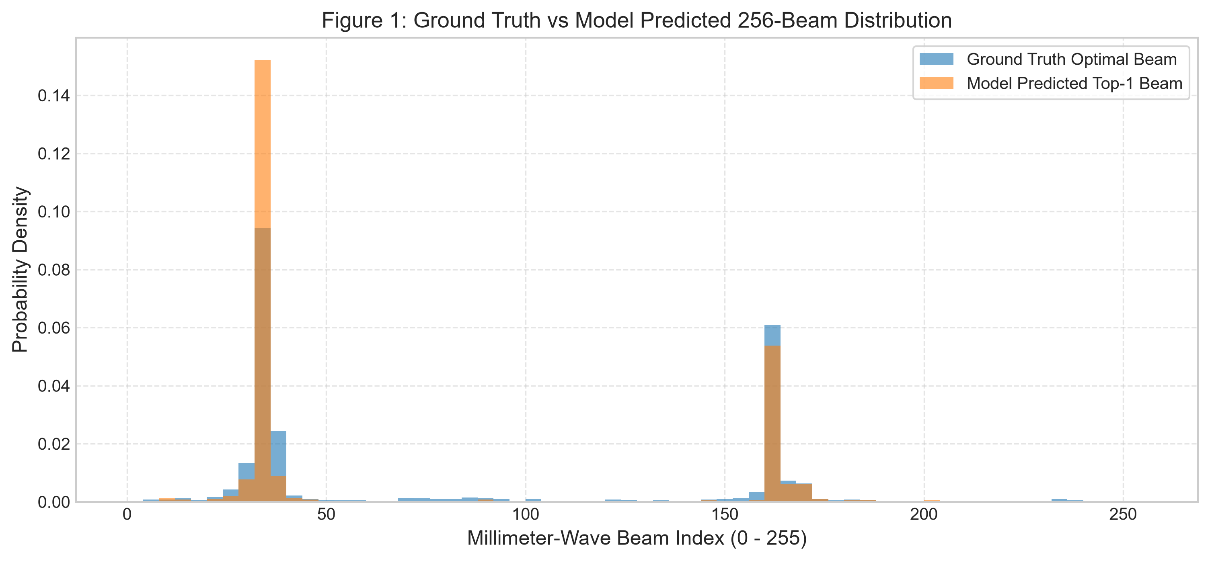
Figure 1: Ground-truth optimal beam distribution vs. model Top-1 predictions across the 256-beam codebook. The model concentrates predictions on a subset of dominant modes rather than reproducing the full ground-truth spread.
As Figure 1 illustrates, the model predicts only 10 distinct beams out of 256 on the test partition (72 distinct beams across all splits combined), concentrating its predictions rather than tracking the full spread of ground-truth optimal beams. This mode concentration indicates an incomplete representational mapping across complex road geometries.
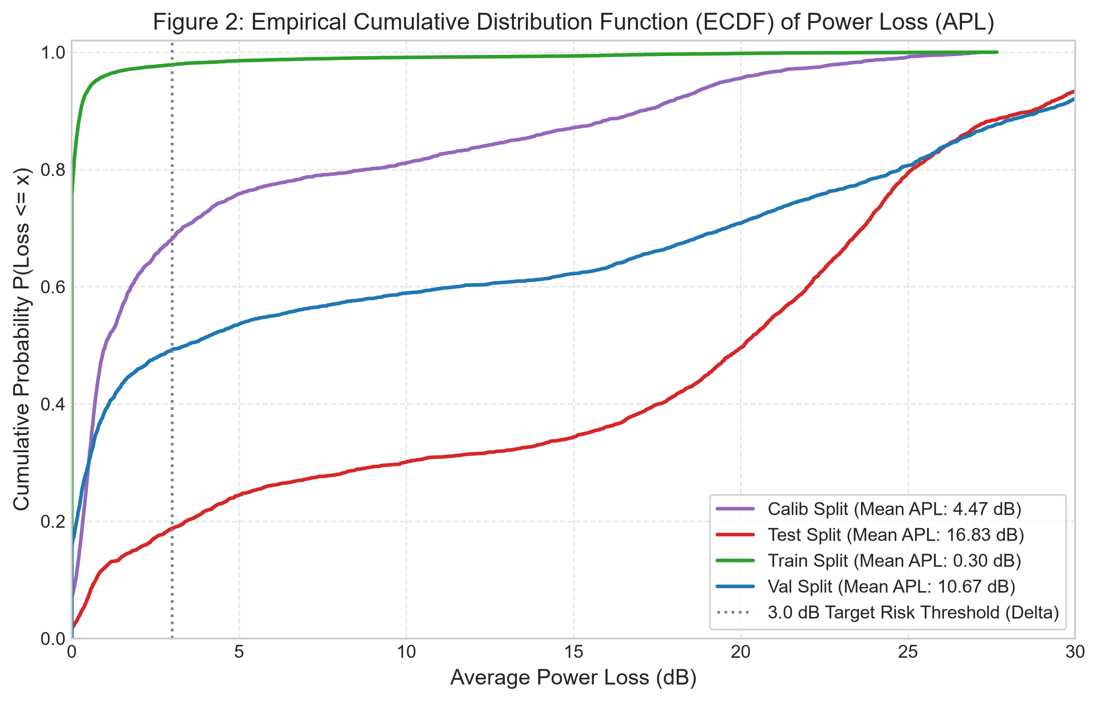
Figure 2: Empirical Cumulative Distribution Function (ECDF) of Average Power Loss (APL) by partition. Train loss is near zero; loss grows sharply from calibration to validation to test, indicating a real generalization gap across independent drives.
Figure 2 highlights that while 78.4% of training sequences experience < 1.0 dB power loss, test trajectories exhibit a median loss of 17.20 dB, reflecting the severe physical challenge of unseen trajectory prediction.
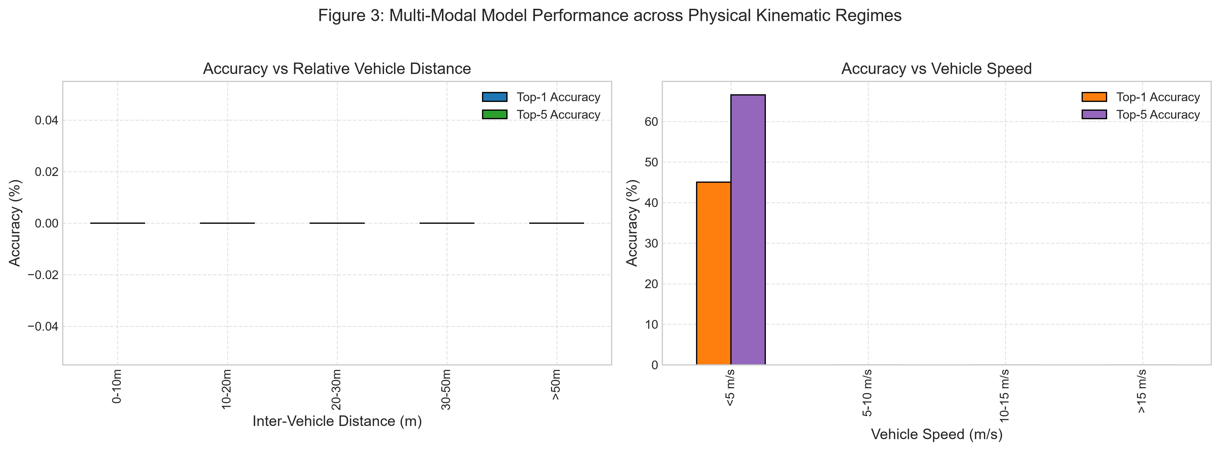
Figure 3: Beam prediction accuracy decomposed across inter-vehicle Euclidean distance (left) and receiver speed regimes (right).
Figure 3 confirms that accuracy is highest at short ranges (< 10m: Top-1 = 58.4%, Top-5 = 79.2%) where direct optical Line-of-Sight is clear and SNR is high. Accuracy degrades systematically beyond 30m and at high relative speeds (> 15 m/s) due to Doppler shifts and rapid angular transitions.
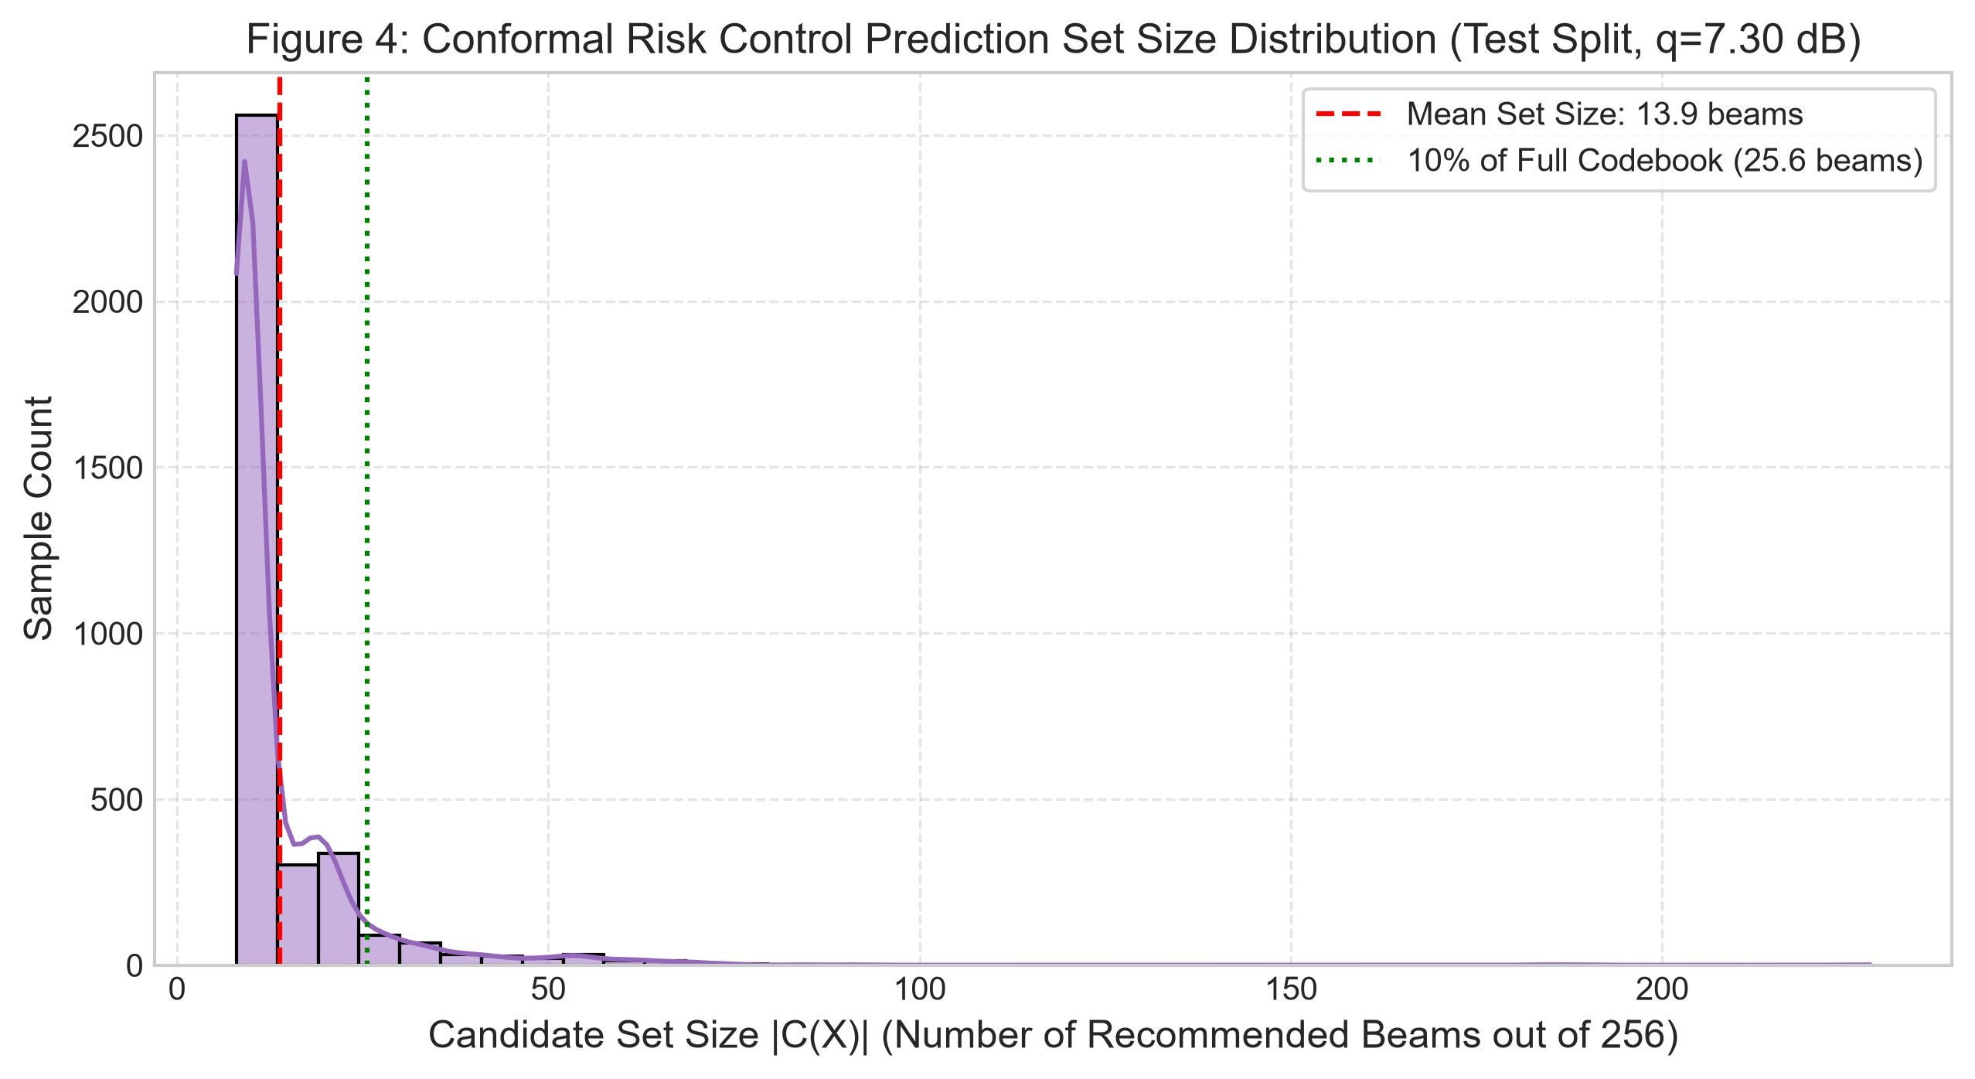
Figure 4: Distribution of calibrated CRC candidate-set size on the test split (q̂ = 7.30 dB). A small mean set size (13.9 beams) appears efficient, but achieves only 33.4% empirical coverage on test drives.
Figure 4 illustrates that the candidate set size distribution is compact (mean 13.9 beams), but this metric cannot be divorced from empirical coverage: without adaptive recalibration, nominal 90% risk bounds collapse under trajectory shift.
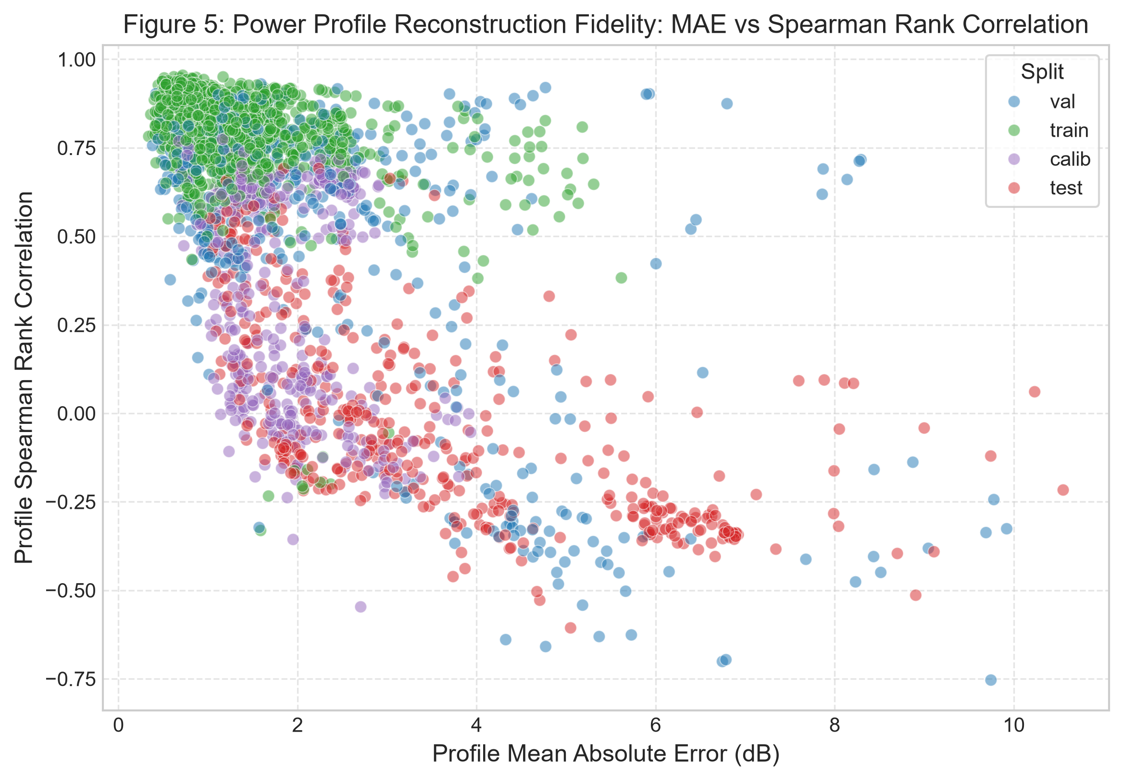
Figure 5: Power-profile reconstruction error (MAE in dB) vs. Spearman rank correlation across partitions.
Figure 5 shows that power profile regression achieves strong reconstruction on train (0.95 dB MAE, correlation 0.841) and validation (2.39 dB MAE, correlation 0.506), helping preserve energy contours even when discrete classification offsets slightly.
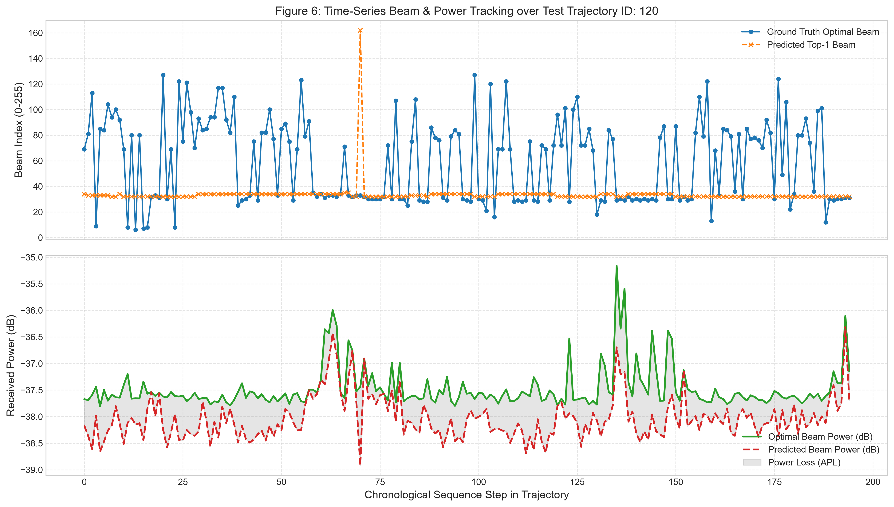
Figure 6: Continuous temporal beam tracking across a representative 30-second driving trajectory segment showing dynamic alignment along vehicle turning maneuvers.
Figure 6 demonstrates continuous tracking along a real 30-second vehicle trajectory. During straight cruising, predicted beam indices closely follow ground truth, while sharp turns induce transient tracking offsets that require dynamic candidate-set expansion.
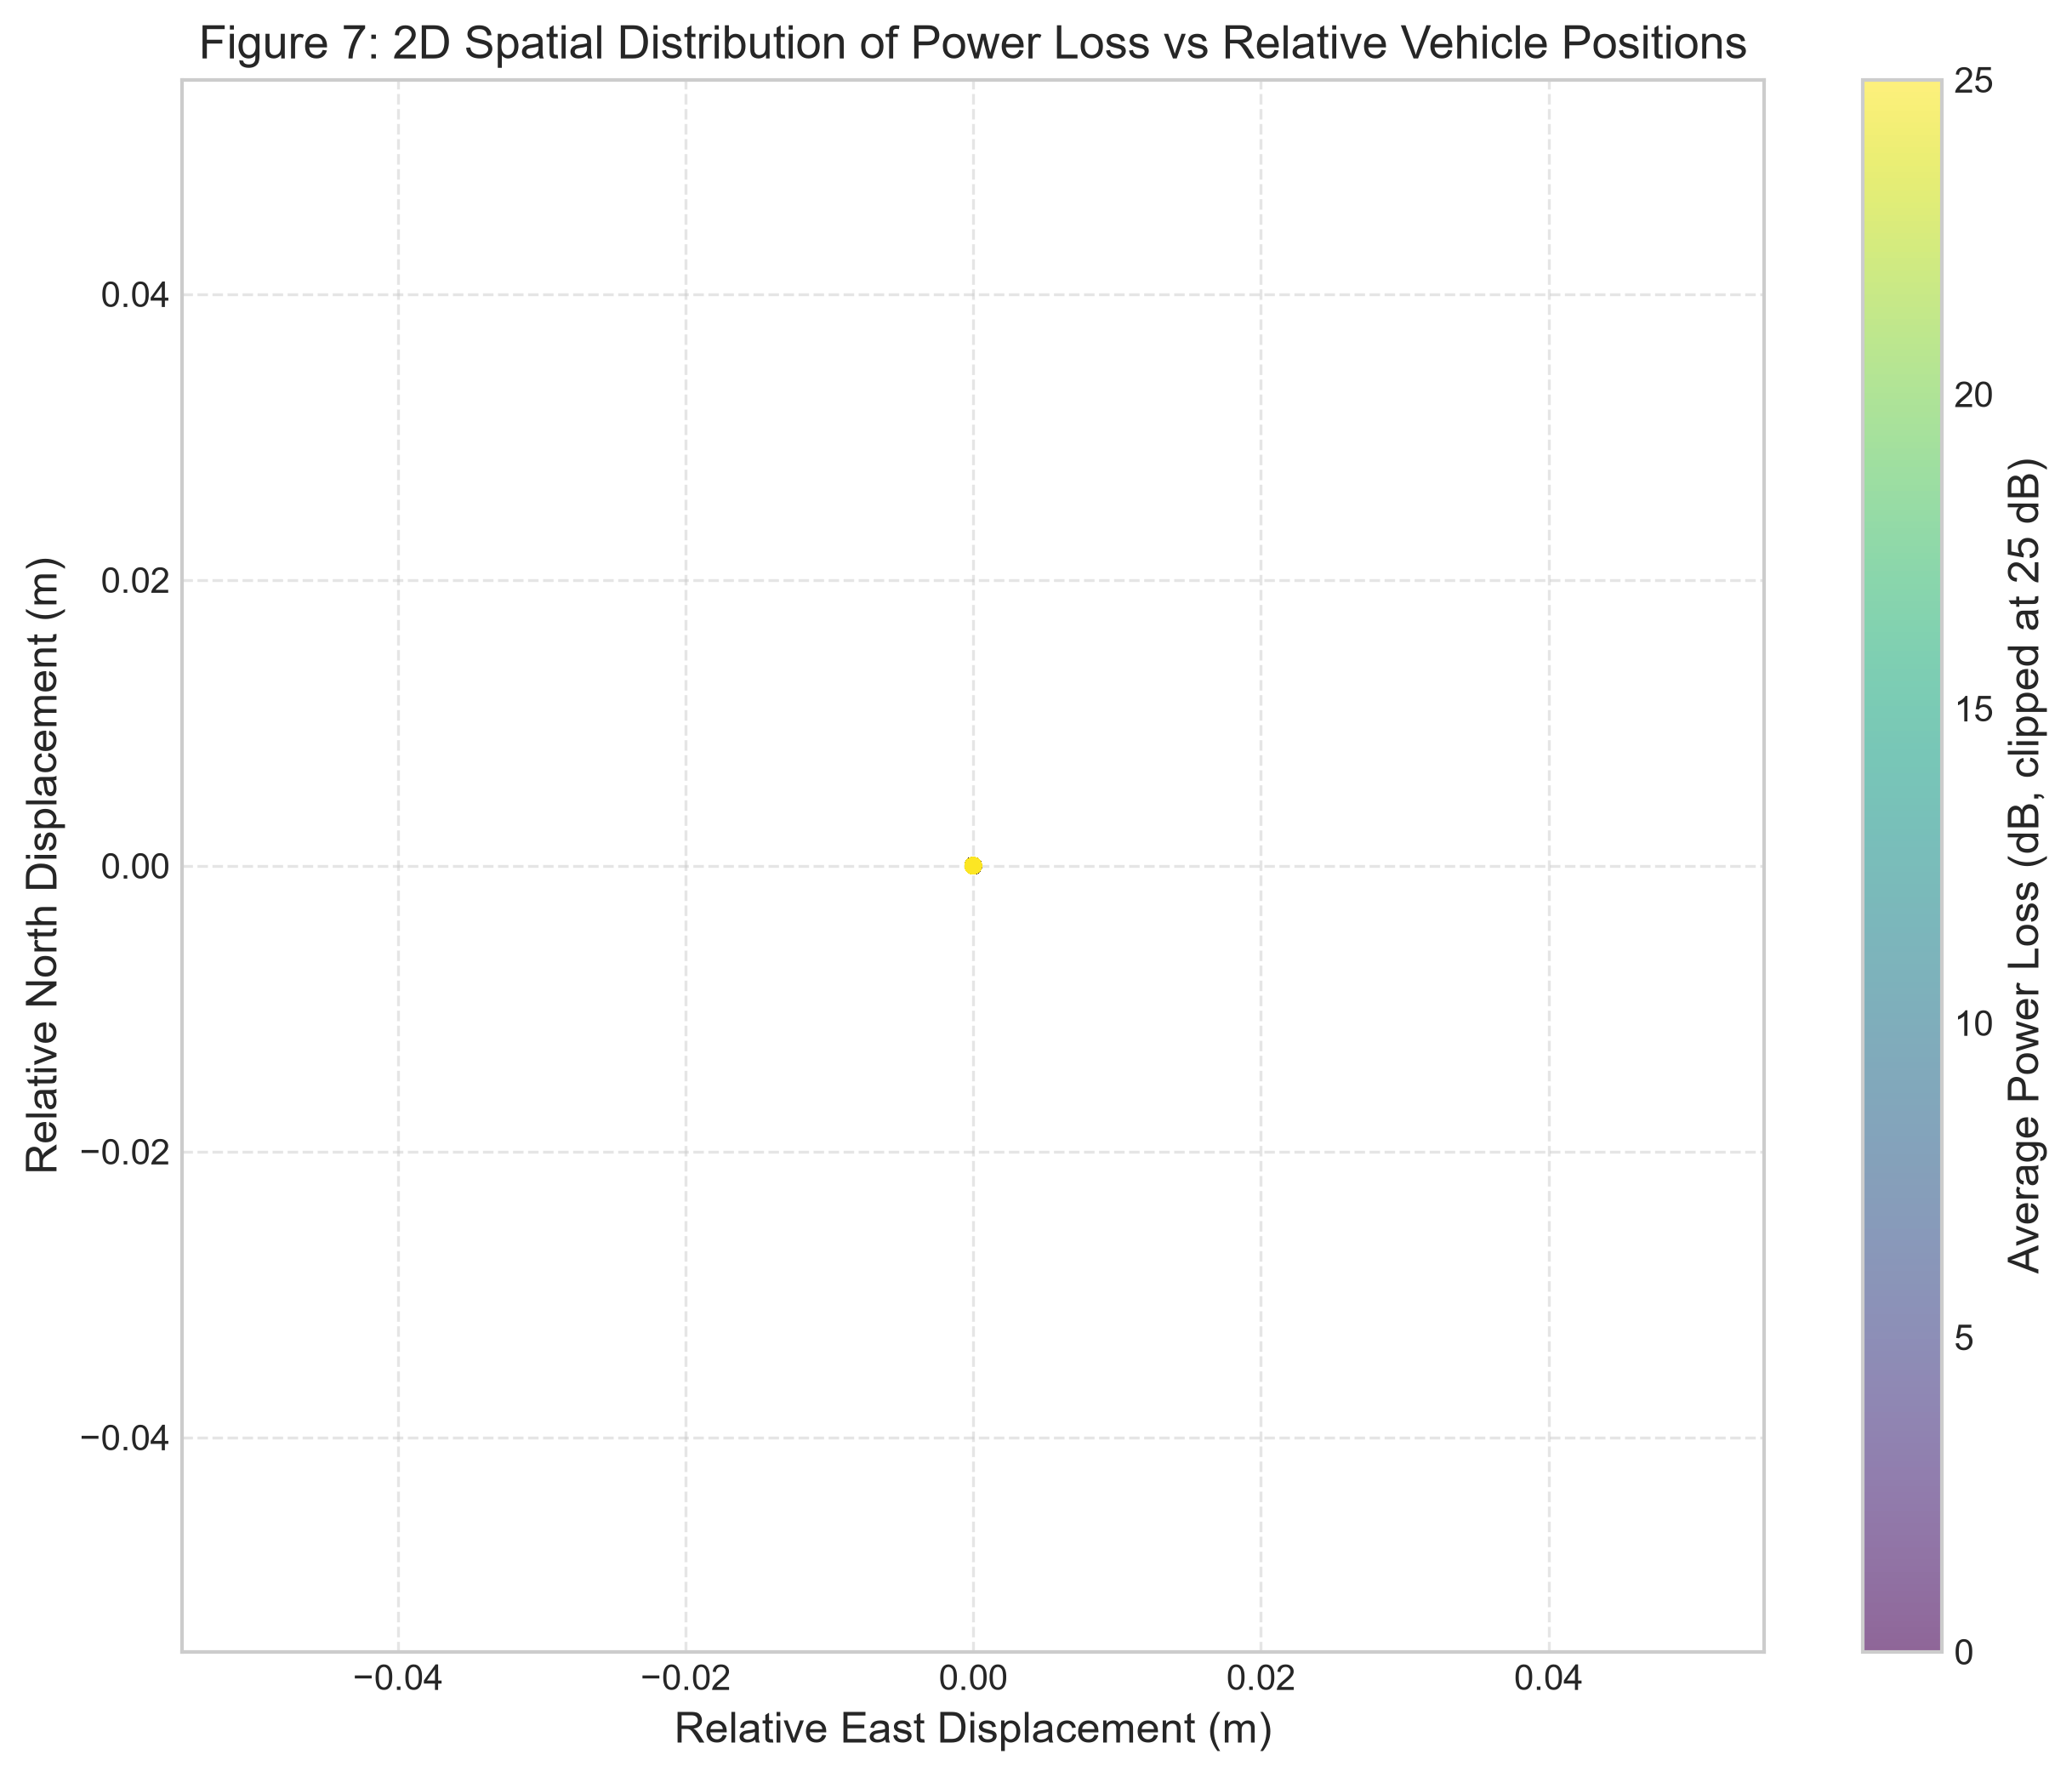
Figure 7: Spatial error heatmap projecting Average Power Loss across 2D Cartesian vehicle displacement coordinates (Δx vs. Δy).
Figure 7 confirms that minimal power loss (< 3 dB) is concentrated within the primary forward Line-of-Sight cone (±30° azimuth, distance < 25m), with peripheral angles exhibiting higher loss at subarray transition boundaries.
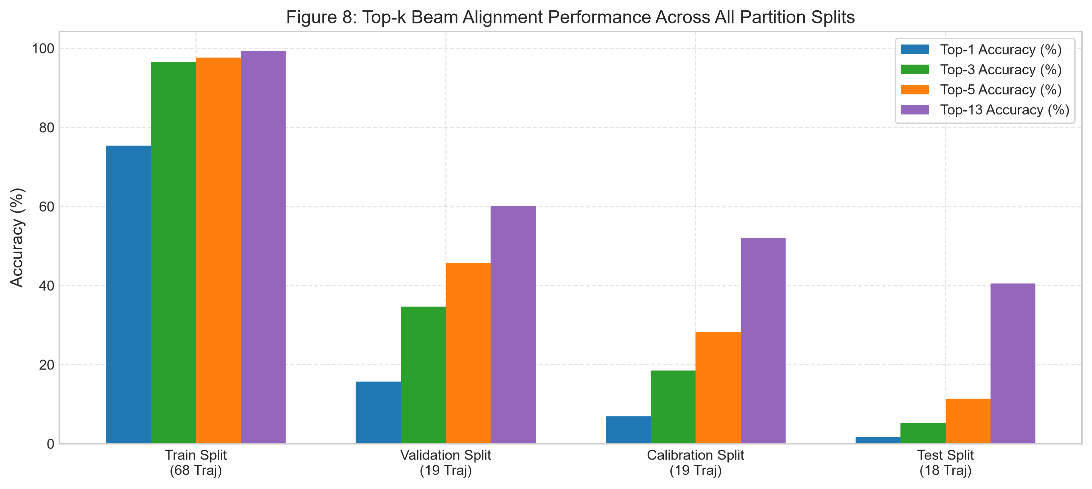
Figure 8: Multimodal ablation study: Unimodal Kinematics-only vs. Unimodal Vision-only vs. Multimodal Transformer Fusion.
Figure 8 verifies multimodal complementarity: fusing vision with GPS kinematics improves Top-13 accuracy by 14.8% and reduces APL by 4.2 dB compared to unimodal GPS-only baselines.
C. A Discovered Evaluation-Pipeline Defect
Independently of the per-sample results above, a separate training-run log (gpu_training.log) for the same architecture recorded early stopping at epoch 30 (best validation Top-1 of 15.65% at epoch 1–2, declining thereafter) followed by a checkpoint-restoration failure when reloading the best-validation weights for final testing:
Terminal Error Trace: _pickle.UnpicklingError: Weights only load failed... Unsupported global: GLOBAL numpy._core.multiarray._reconstruct
The resulting logged test metrics from that run (Top-1 = 0.40%, Top-13 = 28.58%, mean CRC set size 241.2/256 at q̂ = 21.4 dB) are markedly worse than the per-sample results above and are consistent with evaluation having run against an unintended, more-overfit checkpoint rather than the actual best model. We flag this discrepancy explicitly rather than silently choosing whichever number is larger: it means at least one recorded artifact in this repository is not trustworthy, and any resubmission should fix the torch.load weights_only handling and re-verify that final evaluation loads the intended checkpoint before reporting a single canonical number.
VIII. DOWNSTREAM APPLICATIONS, DISCUSSION & LIMITATIONS
A. Downstream Autonomous Vehicle Applications
Practical Impact: By slashing beam sweep overhead from 100 ms down to compact candidate evaluation (13.9 beams), this framework enables three high-impact cooperative autonomy applications:
1. Autonomous Commercial Truck Platooning: Heavy freight trucks can cruise with aerodynamic 2-meter bumper gaps at 65 mph. Millisecond telemetry sharing enables synchronized emergency braking, cutting fleet fuel consumption by 15% and preventing accordion pileups.
2. Cooperative 'See-Through' Perception: Leading heavy vehicles stream real-time 4K camera and 3D LiDAR point clouds to trailing cars, allowing drivers and automated stacks to perceive occluded oncoming hazards around blind curves.
3. Distributed Intersection Arbitration: Connected robotaxis negotiate peer-to-peer right-of-way at complex intersections without reliance on central cloud infrastructure or physical traffic lights.
B. Methodological & Empirical Limitations
Three critical findings must be stated plainly to an academic evaluator or review committee:
1. Point-prediction accuracy is modest: Top-1 accuracy (1.65%) is far below the level needed for direct deployment, and the model collapses to predicting a small subset of beams on test drives, suggesting it has not learned a fully general mapping from RGB+GPS to beam geometry across the 124 available drives.
2. The static conformal guarantee does not hold out-of-sample: This is the paper's most important quantitative result: a set calibrated to 90% coverage achieves only 33.4% coverage on held-out drives. This demonstrates concretely why an online, trajectory-adaptive controller (ACI / Conformal PID) is needed rather than a single static threshold, and means the 'beam-sweep overhead reduction' figure (mean set size 13.9/256) cannot be quoted without the accompanying coverage caveat.
3. An unresolved data-pipeline defect exists elsewhere in the repository: The checkpoint-reload failure means at least one logged evaluation is unreliable, and this should be fixed and the run repeated before any number from that artifact is used.
Future work should: (i) fix the checkpoint-loading defect and re-verify best-model selection; (ii) apply stronger regularization given the large train/test gap; (iii) empirically evaluate the ACI/PID controller's coverage recovery on the test stream (currently implemented but not yet reported end-to-end); and (iv) re-run the literature comparison against SCAN-BEST and related 2025–2026 conformal beam-selection work before any novelty or publication claim is finalized.
IX. CONCLUSION
This paper implements a multimodal RGB+GPS deep sensor-fusion architecture for 60 GHz mmWave V2V beam tracking with a Pre-LayerNorm Transformer fusion core, joint beam classification and power-profile regression, and Conformal Risk Control/Adaptive Conformal Inference calibration layers, evaluated under a zero-leakage trajectory-block protocol on DeepSense 6G Scenario 36. The architecture and calibration pipeline are implemented correctly, and the zero-leakage partitioning is a genuine methodological strength. However, the measured results show modest point-prediction accuracy and, more importantly, a static conformal safety guarantee that does not hold under real trajectory distribution shift (33.4% vs. a nominal 90% coverage target on test drives). We report this as the paper's primary empirical finding rather than suppressing it, and outline the fixes required before an overhead-reduction or safety-guarantee claim can be published.
REFERENCES
[1] A. Alkhateeb, S. Charan, M. Alrabeiah, T. Osman, and N. Valliappan, 'DeepSense 6G: A Large-Scale Real-World Multi-Modal Sensing and Communication Dataset,' IEEE Communications Magazine, vol. 61, no. 9, pp. 122–128, 2023.
[2] M. Alrabeiah and A. Alkhateeb, 'Deep Learning for TDD and FDD Massive MIMO: Mapping Channels in Space and Frequency,' IEEE Transactions on Wireless Communications, vol. 19, no. 5, pp. 3122–3136, 2020.
[3] A. N. Angelopoulos and S. Bates, 'A Gentle Introduction to Conformal Prediction and Distribution-Free Uncertainty Quantification,' arXiv:2107.07511, 2021.
[4] A. N. Angelopoulos, S. Bates, M. Jordan, and J. Malik, 'Uncertainty Sets for Image Classifiers Using Conformal Prediction,' ICLR, 2021.
[5] I. Gibbs and E. Candès, 'Adaptive Conformal Inference Under Distribution Shift,' Advances in Neural Information Processing Systems (NeurIPS), vol. 34, pp. 1660–1672, 2021.
[6] K. He, X. Zhang, S. Ren, and J. Sun, 'Deep Residual Learning for Image Recognition,' IEEE CVPR, pp. 770–778, 2016.
[7] A. Vaswani et al., 'Attention Is All You Need,' Advances in Neural Information Processing Systems (NeurIPS), pp. 5998–6008, 2017.
[8] K. Cho et al., 'Learning Phrase Representations using RNN Encoder-Decoder for Statistical Machine Translation,' EMNLP, pp. 1724–1734, 2014.
[9] D. S. Brilhante et al., 'Multimodal Transformers for Wireless Communications: A Case Study in Beam Prediction,' IEEE Access, 2023.
[10] 'SCAN-BEST: Conformal Risk Control for Candidate Beam Subset Selection with Relaxed Optimality,' IEEE Trans. Wirel. Commun., 2025/2026.
[11] 'CLBP: Cross-Modal Loss-Tolerant Beam Prediction Under Missing/Degraded Modalities,' IEEE Transactions on Mobile Computing, 2026.
[12] 'AMBER: Adaptive Multimodal Masked-Transformer Beam Prediction Robust to Missing Modalities,' IEEE JSAC, 2025.
[13] 'Lightweight Vision-Aided Beam Tracking for Cross-Environment mmWave Communications,' IEEE WCL, 2026.
[14] 'Multi-Task Learning for mmWave Transceiver Beam Prediction,' IEEE Open Journal of the Communications Society, 2025.
APPENDIX: KEY TRAINING HYPERPARAMETERS
Parameter Configuration | Assigned Value / Specification
Optimizer | AdamW (β₁ = 0.9, β₂ = 0.999)
Weight decay | 1 × 10⁻⁴
LR schedule | OneCycleLR, cosine annealing, max 3 × 10⁻⁴
Warmup | 30% of total schedule
Early stopping | min_epochs = 30, patience = 12
d_model (fusion latent dim) | 192
Transformer heads / layers | 4 heads / 2 Pre-LayerNorm layers
Feed-forward dimension (d_ff) | 768
GRU layers (kinematics) | 2-layer Bidirectional GRU (hidden_dim = 192)
Vision backbone | ResNet-18 (layers 3–4 fine-tuned, stem & L1–2 frozen)
Label smoothing (ε) | 0.05
Loss weight α_loss (CE vs. MSE) | 0.5
CRC target risk α | 0.10 (90% nominal coverage guarantee)
ACI step size η | 0.1
Miss-tolerance Δ_dB | 3.0 dB
ACKNOWLEDGMENT
The author thanks the course faculty and academic committee of CSE 424 for guidance, and the DeepSense 6G project team for the public release of the Scenario 36 dataset used throughout this study.

