Fraud Detection and Risk Analysis in Financial Transactions

Prepared by
Syed Karimoon
Tools: Excel, MySQL, Power BI
Portfolio: https://github.com/syedkarimoon

1. Introduction
This project focuses on detecting fraudulent transactions using SQL and Power BI. A dataset of 50,000 transactions was used, with 10,000 rows utilized for SQL validation.

2. Problem Statement
Financial fraud is increasing rapidly. Identifying suspicious transactions manually is difficult. This project aims to detect fraud patterns and high-risk transactions.

3. Tools Used
• Excel: Initial data cleaning
• Power BI : Dashboard and visualization
• MySQL : Query based analysis

4. Dataset Description
Total Records: 50,000
Validation Dataset: 10,000 rows (used in MySQL)
Columns: Transaction_ID, Customer, Transaction Amount, Transaction Time, Location, Payment Method, Is Fraud
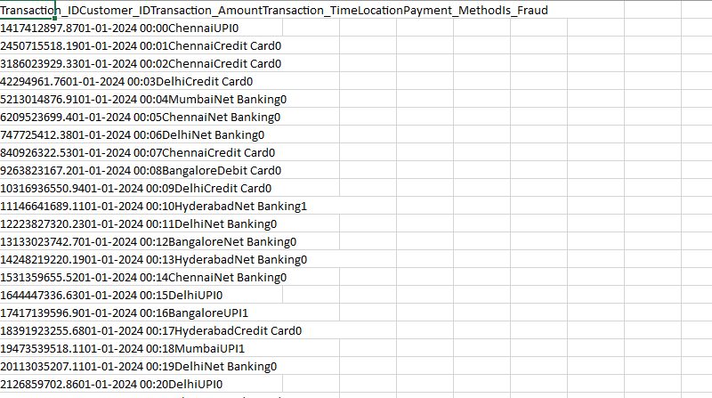
RAW DATA SET

5. Data Cleaning
• Removed null values
• Checked duplicates
• Validated data types
• Converted datetime format

DATA BEFORE CLEANING
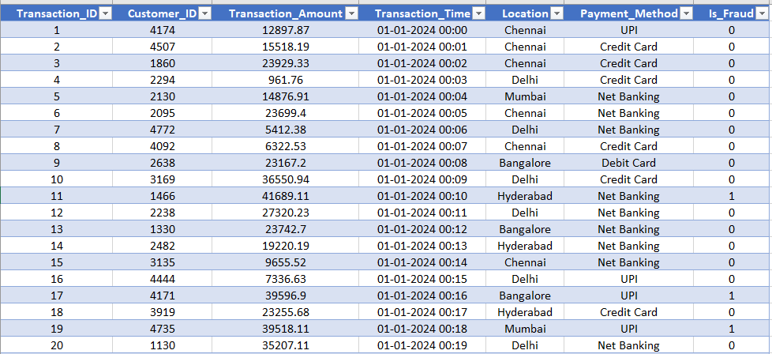
DATA AFTER CLEANING

6. SQL Analysis (10K Rows)

MySQL Implementation and Analysis
Steps:
- Convert Excel to CSV
- Import into MySQL
- Create database and table
METHOD USED: Excel → CSV → MySQL

STEP 1: Open MySQL Workbench
- Open MySQL Workbench
- Click on your connection (example: Local instance MySQL)
- Enter root password
- You will see the SQL Editor screen

STEP 2: Create a Database

STEP 3: Create Table

STEP 4:
Performed fraud detection queries such as:

• High-value transactions
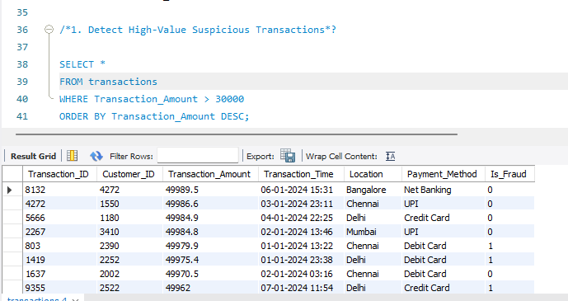
• Fraud by location
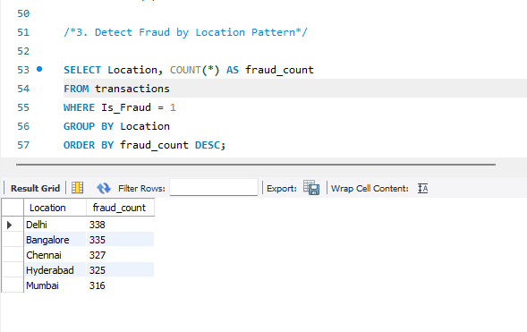

• Fraud by payment method
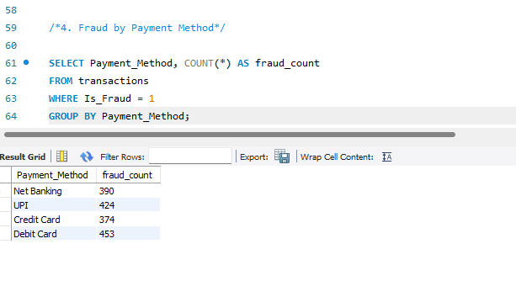
• Risk classification using CASE

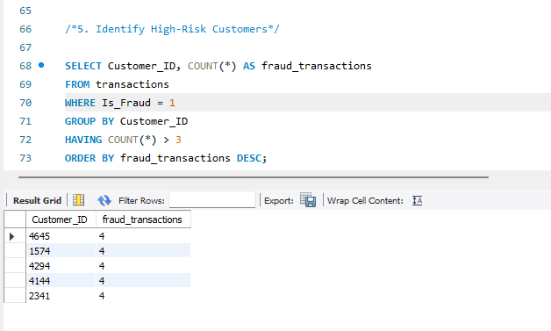

7. Power BI Dashboard (50K Rows)
Created interactive dashboard with:
• KPIs: Total Transactions, Fraud Count, Fraud %, Total Amount
• Charts: Fraud by Location, Payment Method, Risk Distribution
• Line Chart: Fraud Trend
• Table: High-risk customers
• Slicers: Location, Risk Level, Date, Payment Method
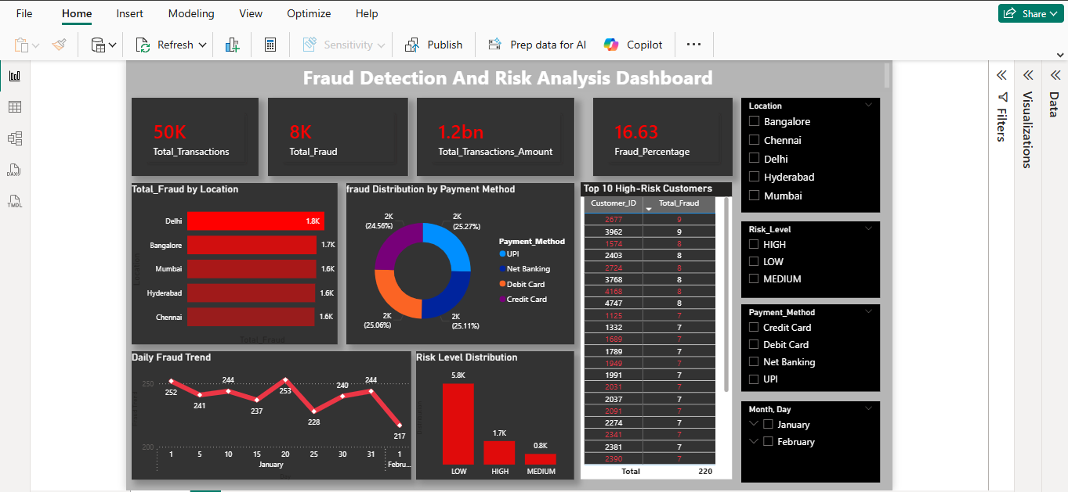
Power Bi Dashboard

8. Risk Level Logic
High Risk: Amount > 30000 and Night transactions
Medium Risk: Amount between 15000–30000
Low Risk: Remaining transactions

9. Key Insights
• Fraud mostly occurs in high-value transactions
• Night transactions show higher risk
• Certain locations have higher fraud rates
• Repeat customers involved in fraud identified

10. Conclusion
The project successfully identifies fraud patterns and provides insights to reduce financial risks. The dashboard enables decision-making and monitoring.

