SocioImpact: Socioeconomic Impact Dashboard
Full-Stack Portfolio Project Documentation / README
Project Type | Full-stack web application
Tech Stack | React, Material UI, Node.js, Express.js, Microsoft SQL Server, Axios, Recharts, CSV Import/Export
Purpose | Track community projects, funding, jobs created, people supported, training hours, and socioeconomic impact metrics.
Status | Working local prototype with live SQL Server data and CSV import/export

1. Project Overview
SocioImpact is a full-stack socioeconomic impact tracking dashboard built to demonstrate practical product development, database integration, data import/export workflows, and user-focused reporting. The application allows organizations to manage community initiatives and track measurable outcomes such as funding, jobs created, people supported, training hours, regional reach, and project status.
This project was designed as a portfolio application for software/product companies that build data-driven tools for measuring organizational and community impact. It demonstrates React frontend development, Node.js/Express API development, SQL Server database integration, CRUD operations, dashboard analytics, and CSV processing.

2. Key Features
- Dashboard analytics: Displays live project totals, funding tracked, jobs created, people supported, training hours, and monthly impact charts.
- Project management: Users can view, add, edit, and delete socioeconomic impact projects.
- SQL Server integration: Project data is stored and retrieved from a Microsoft SQL Server database.
- CSV import: Users can upload CSV files containing project data and import multiple records into SQL Server.
- CSV export: Users can export all project records from SQL Server into a downloadable CSV file.
- Impact reporting pages: Includes pages for impact metrics, reports, support tickets, and CSV workflows.
- Responsive UI: Built with Material UI components for a clean, professional dashboard interface.

3. Tech Stack
Layer | Tools / Technologies
Frontend | React, JavaScript, Material UI, Recharts, Axios
Backend | Node.js, Express.js, CORS, dotenv
Database | Microsoft SQL Server 2022 Developer Edition, SSMS
CSV Processing | multer, csv-parser, json2csv
Development Tools | VS Code, Git, GitHub Desktop, npm

4. Application Architecture
The application follows a simple three-layer architecture:
React Frontend (localhost:5173)
|
| Axios HTTP Requests
v
Node.js / Express API (localhost:5000)
|
| mssql package
v
Microsoft SQL Server Database
Database: socioeconomic_impact_db
Table: Projects

5. Database Design
Main database used in this project:
Database: socioeconomic_impact_db
Main Table: Projects
Projects table fields:
Field | Purpose | Example
id | Unique project ID | 1
project_code | Readable project code | P-001
project_name | Project title | Rural Solar Access Program
community | Community or region | St. John's
status | Project status | Active
funding_amount | Funding tracked | 420000
jobs_created | Jobs created through the project | 42
people_supported | People impacted or supported | 1200
training_hours | Training hours delivered | 850
start_date | Project start date | 2026-01-15
end_date | Project end date | 2026-12-31
description | Project summary | Tracks community energy impact.
created_at | Record creation timestamp | Auto-generated

6. API Endpoints
Method | Endpoint | Purpose | Status
GET | /api/health | Check backend server health | Working
GET | /api/projects | Fetch all projects from SQL Server | Working
POST | /api/projects | Add a new project | Working
PUT | /api/projects/:id | Update an existing project | Working
DELETE | /api/projects/:id | Delete a project | Working
POST | /api/projects/import-csv | Import projects from CSV file | Working
GET | /api/projects/export-csv | Export projects as CSV file | Working

7. Local Setup Instructions
Prerequisites:
- Node.js and npm
- Git
- Microsoft SQL Server Developer or Express
- SQL Server Management Studio (SSMS)
- VS Code
Clone the repository:
git clone https://github.com/syedmaazanwer/socioeconomic-impact-dashboard.git
cd socioeconomic-impact-dashboard
Install and run backend:
cd backend
npm install
npm run dev
Backend runs on:
http://localhost:5000
Install and run frontend:
cd frontend
npm install
npm run dev
Frontend runs on:
http://localhost:5173

8. Environment Variables
Create a .env file inside the backend folder. Example for local development:
PORT=5000
DB_SERVER=localhost
DB_NAME=socioeconomic_impact_db
DB_USER=impact_app
DB_PASSWORD=your_local_password
DB_PORT=1433

9. CSV Import Format
CSV files should follow this header structure:
project_code,project_name,community,status,funding_amount,jobs_created,people_supported,training_hours,start_date,end_date,description
P-005,Youth Coding Bootcamp,St. John's,Active,80000,10,220,500,2026-04-01,2026-09-30,Digital skills training for youth and newcomers

10. Screenshots
Add screenshots below before submitting or sharing the project portfolio document.

10.1 Dashboard Page
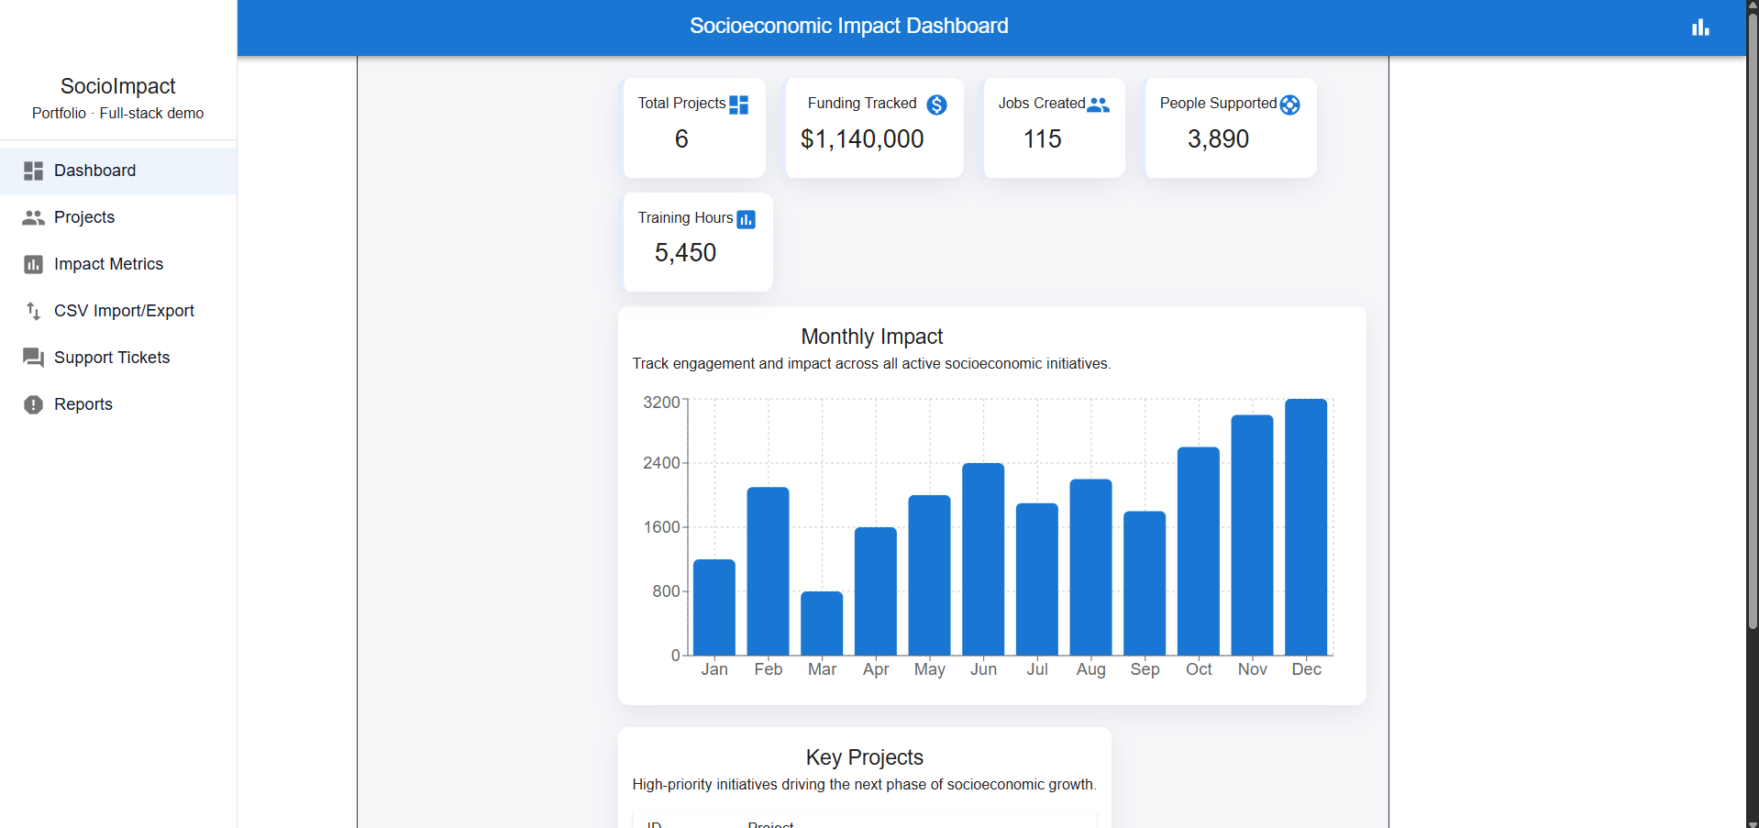
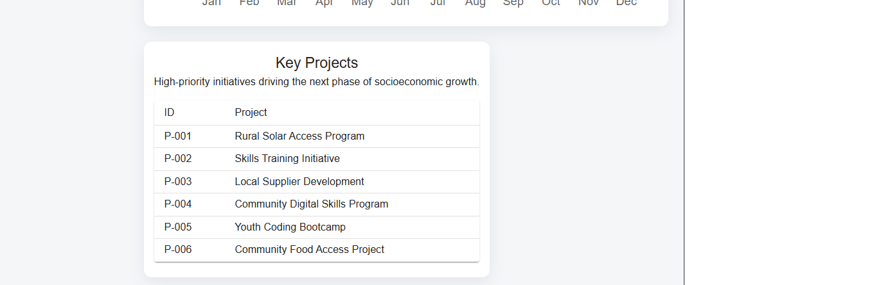
Figure 1. Dashboard showing live totals, key projects, and monthly impact chart.

10.2 Projects Page
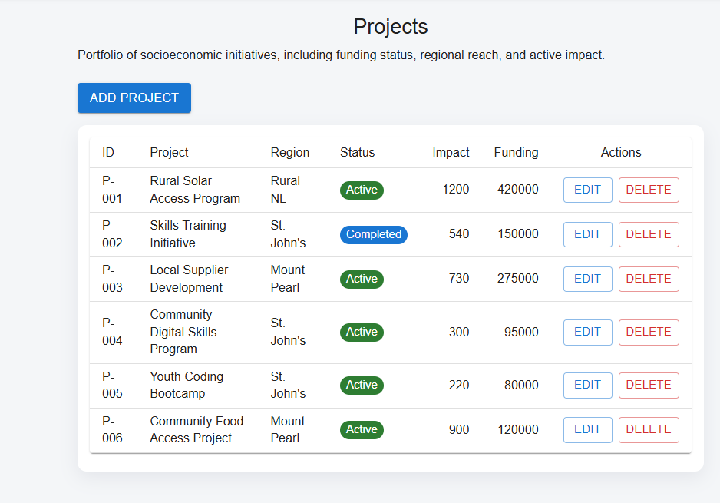
Figure 2. Projects table showing records from SQL Server with add/edit/delete functionality.

10.3 Add Project Dialog
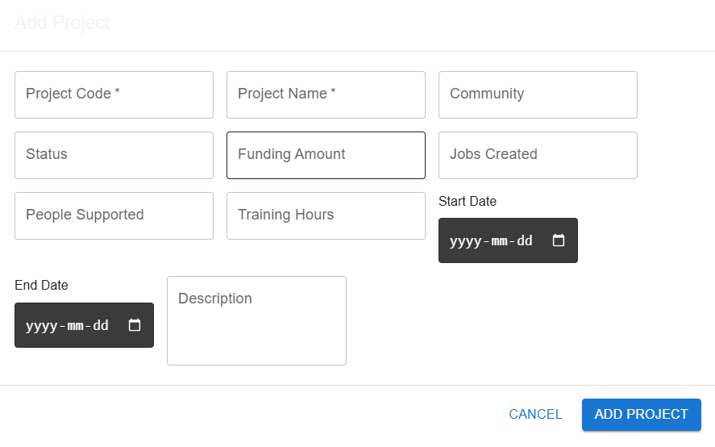
Figure 3. Material UI form used to add new project records.

10.4 CSV Import/Export Page
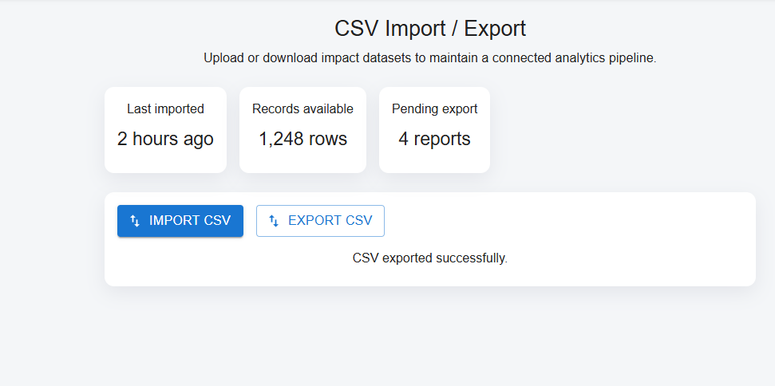
Figure 4. CSV workflow page for importing and exporting project datasets.

10.5 Exported CSV File
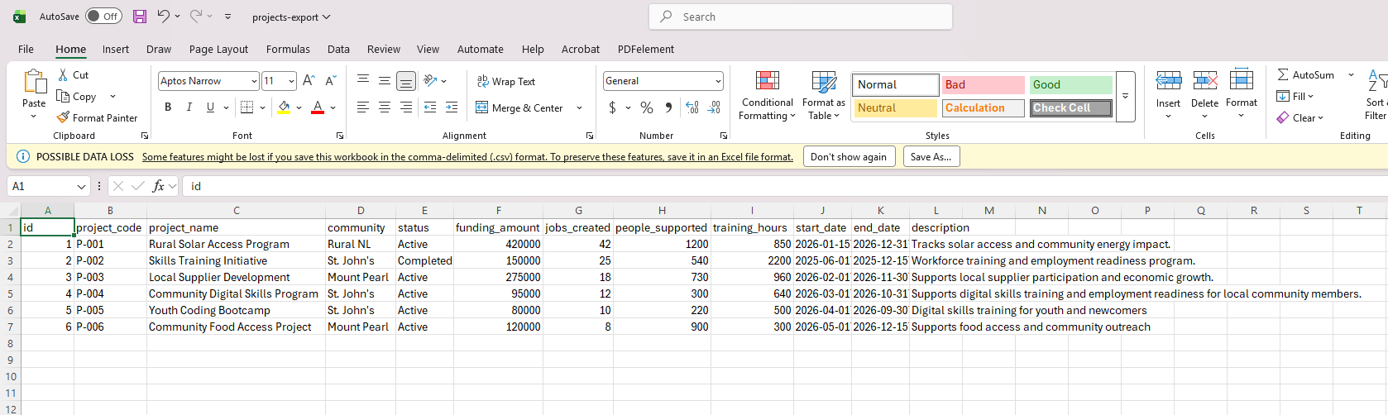
Figure 5. Exported CSV opened in Microsoft Excel showing project records from SQL Server.

11. Why This Project Is Relevant
This project is relevant for full-stack developer and product software roles because it demonstrates the ability to build a database-driven application with real product features. It directly covers full-stack development, React UI design, Node.js API development, SQL Server integration, data import/export workflows, user support concepts, reporting, documentation, and agile-style feature building.

12. Future Improvements
- Add user authentication and role-based access control.
- Add advanced filtering and search for project records.
- Add Power BI dashboard integration or downloadable PDF reports.
- Add unit tests and API tests.
- Deploy frontend and backend to cloud hosting.
- Add audit logs for project changes and CSV imports.

