RANK: AI-assisted End-to-End Architecture for Detecting Persistent Attacks in Enterprise Networks
Modern government and enterprise networks often suffer with sophisticated persistent attacks which will be designed and managed by experienced attackers which are difficult to detect. To combat against such attack propose paper introducing Novel Rank based AI assisted algorithm which consists of multiple modules and technologies.
Propose algorithms utilizing RANK, AI algorithms along with MITRE framework where AI algorithms will help in identifying attack type and MITRE framework will assigned score to each trained and test data based on the attack it’s closely correlating.
RANK, the first end-to-end architecture for detecting persistent attacks through incorporating numerous alerts in a meaningful and automated approach. Ranking approach consists of 3 different sub-modules describing below.
- Alert templating and merging: In this step, the aim is to reduce the number of generated alerts by merging together the ones pertaining to the same step of the attack. These merged alerts are referred to as generalized alerts.
- Alert graph construction: Once the number of alerts is reduced, we establish relationships between generalized alerts by calculating correlation between all dataset attributes, and form an alert graph representing those relationships.
- Alert graph partitioning: The partitioning part focuses on finding the smallest sub-graphs within the alert graph that correspond to concise incidents and known as incident graphs. This sub-graph can be formed by dividing distinct incident into different groups
- Incident scoring: Scores are assigned to each incident graph found in previous step, utilizing factor graphs (FG) and alert scores. For each incident graph, we can compute the likelihood of presence for all MITRE tactics, a useful and important summary. A final single score is predicted for the graph indicating maliciousness and whether the graph should be reviewed by an analyst. For graphs with high scores, the incident graph along with score and summary are delivered to the security analyst for final review
- AI Algorithms: all ranked features will be trained with multiple AI algorithms such as Random Forest, KNN, Naïve Bayes and many more. Each algorithm performance is evaluated using accuracy, true and false positive score.
To train and test propose algorithm performance author has Darpa2000 dataset along with MITRE enterprise attack dataset.
SCREEN SHOTS
We have coded this project using JUPYTER notebook and below are the code and output screens with blue colour comments
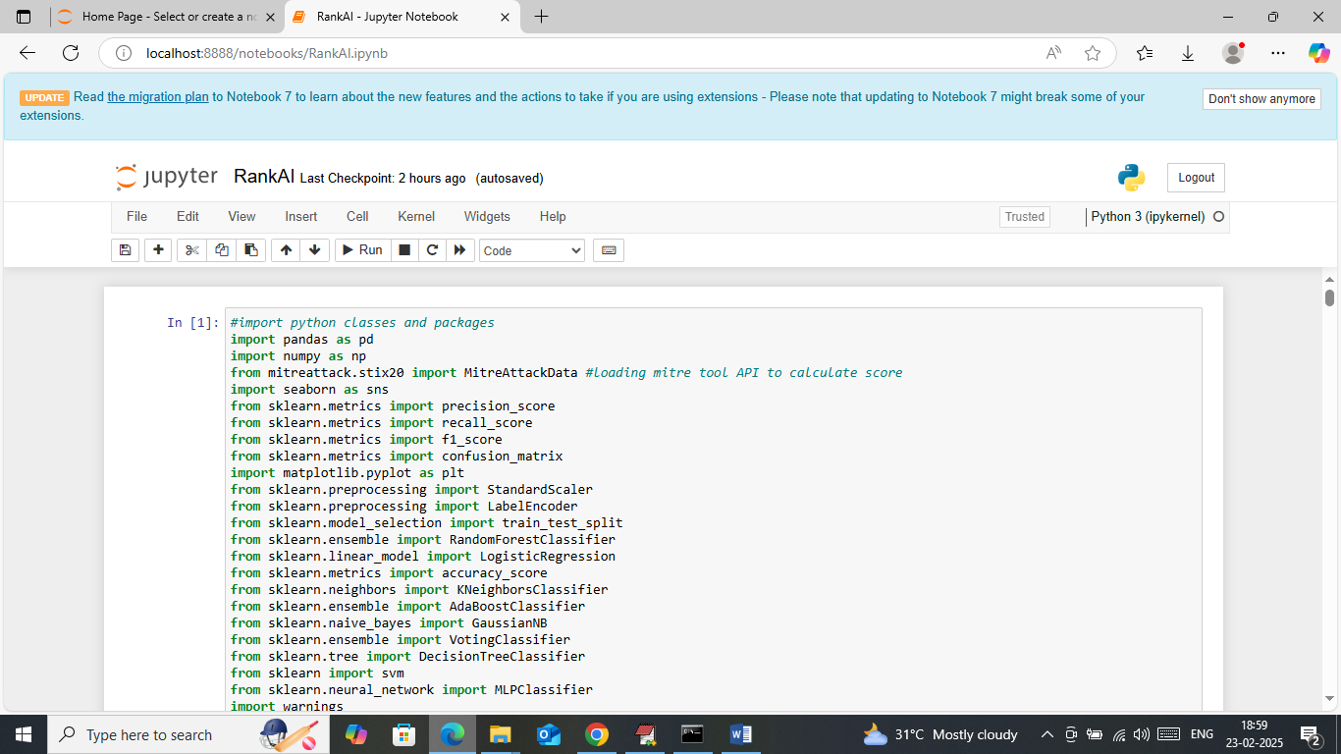
In above screen loading and displaying required python classes and packages
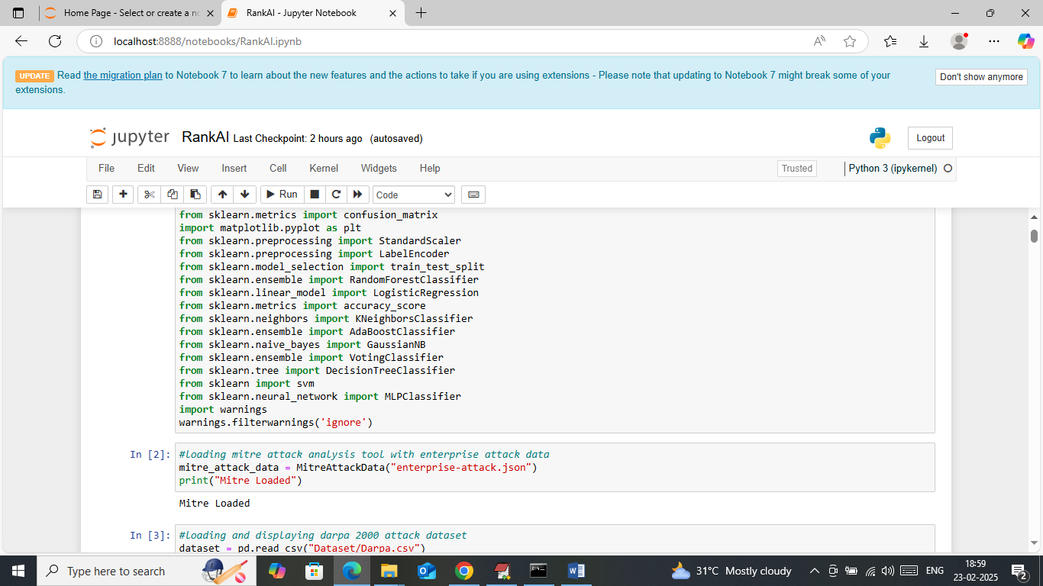
In above screen loading MITRE framework with enterprise dataset
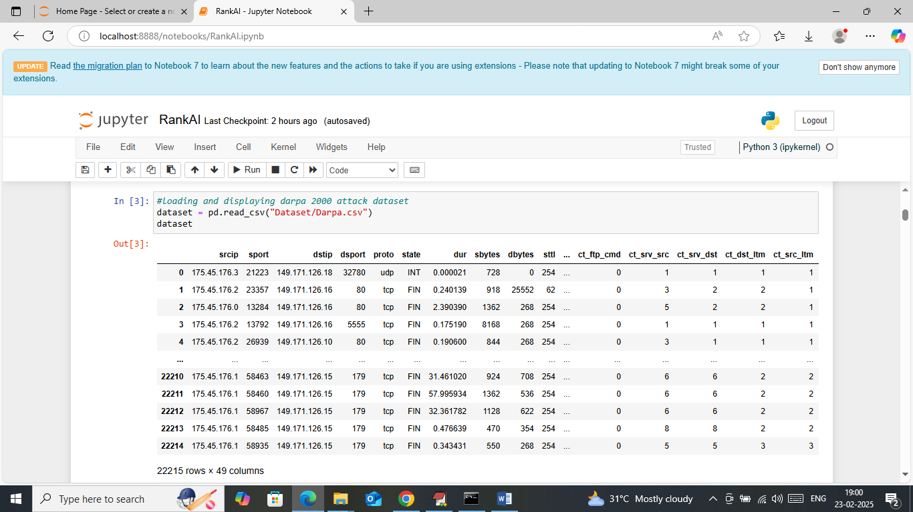
In above screen loading and displaying Darpa2000 dataset
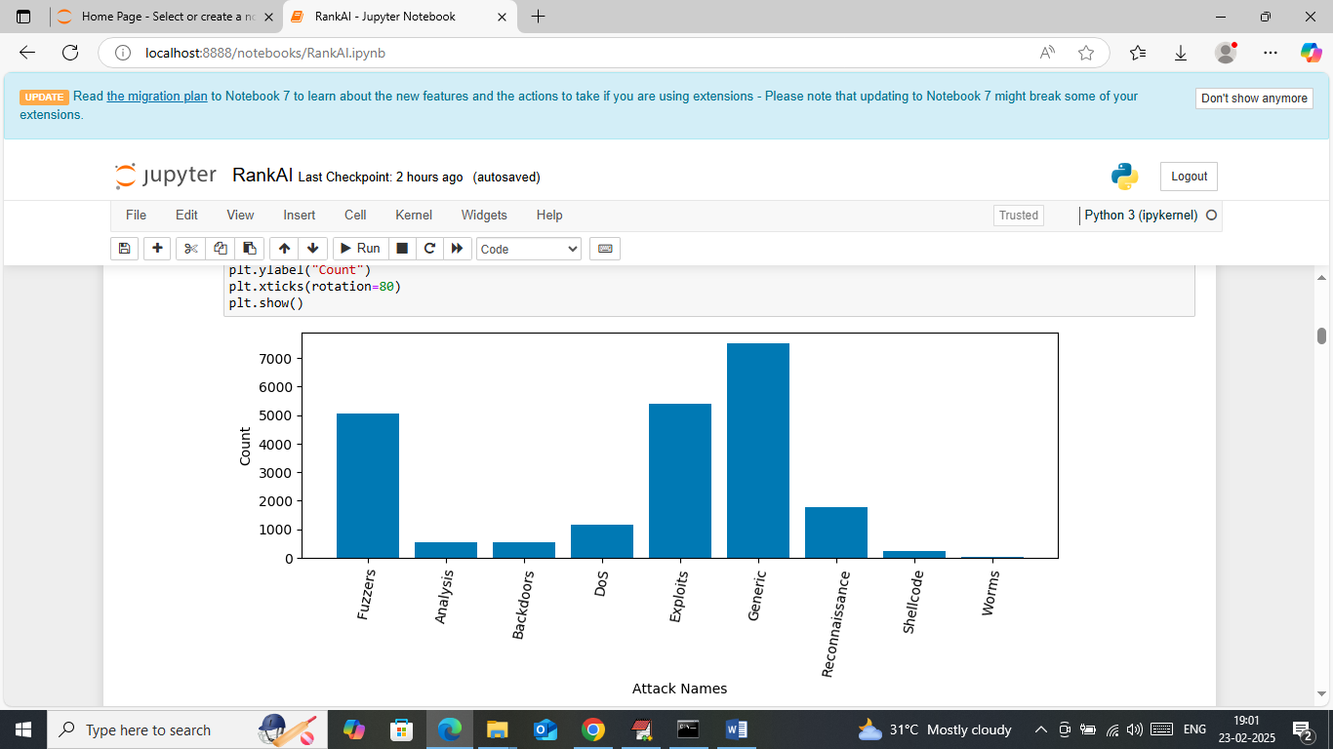
In above screen visualizing different attacks found in dataset where x-axis represents attacks names and y-axis represents count
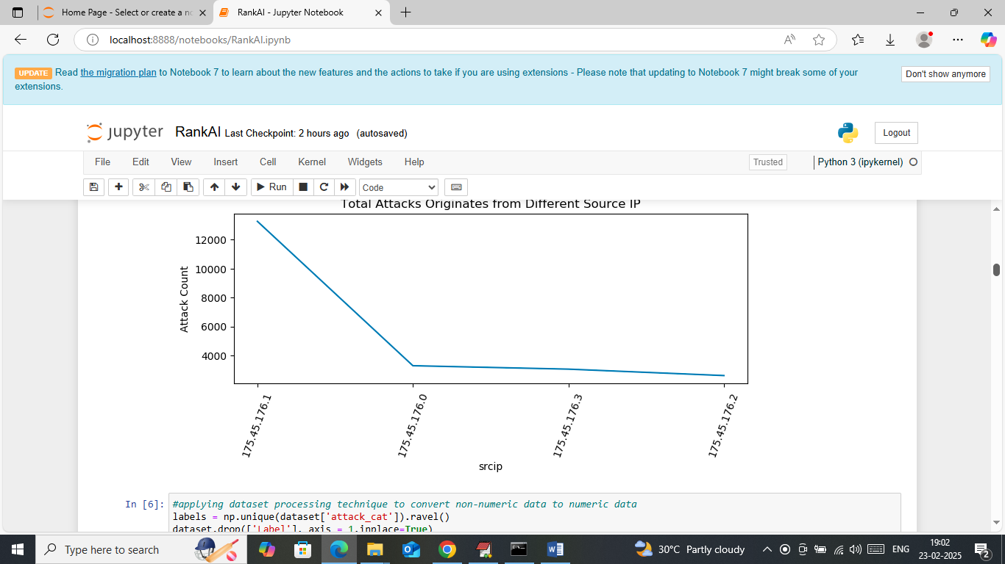
In above screen visualizing graph of different IP which originates more number of attacks where x-axis represents IP and y-axis represents number of attacks from that IP
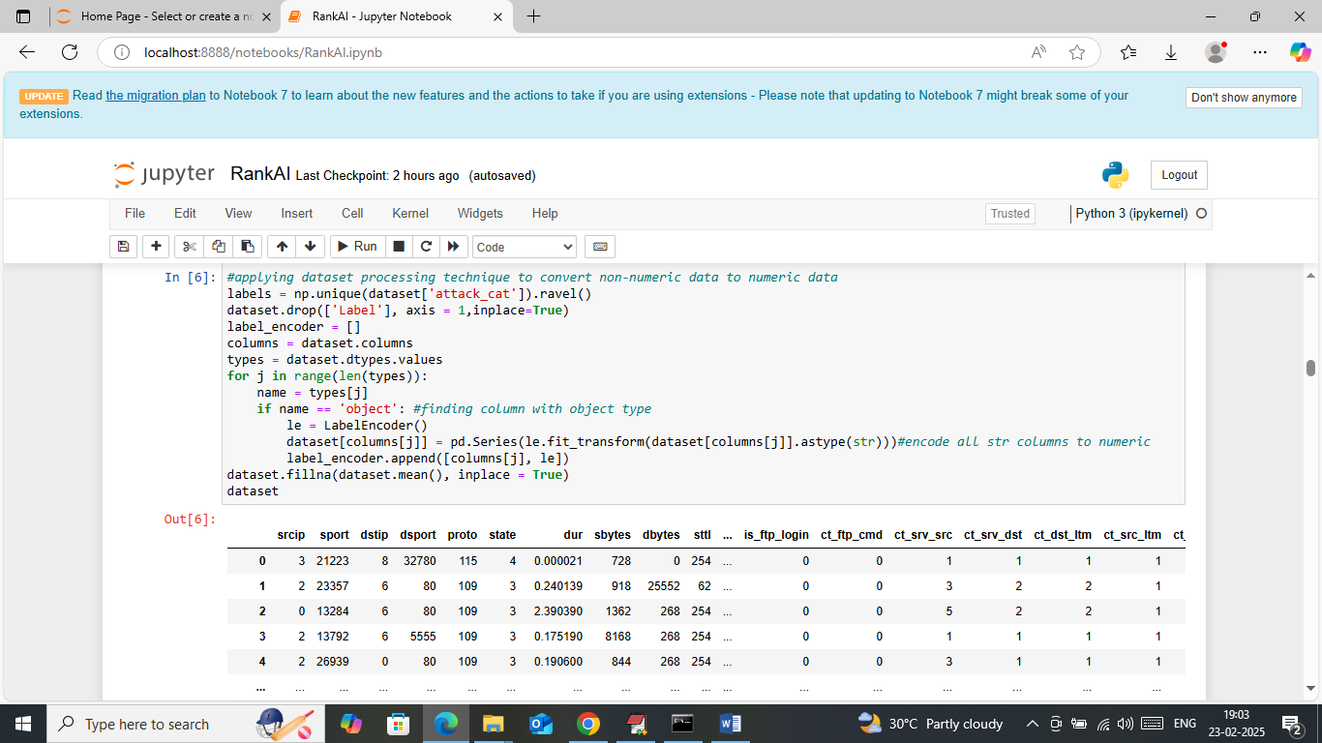
In above screen applying dataset processing technique to convert non-numeric data to numeric data and then handling missing values with mean and then displaying processed data values
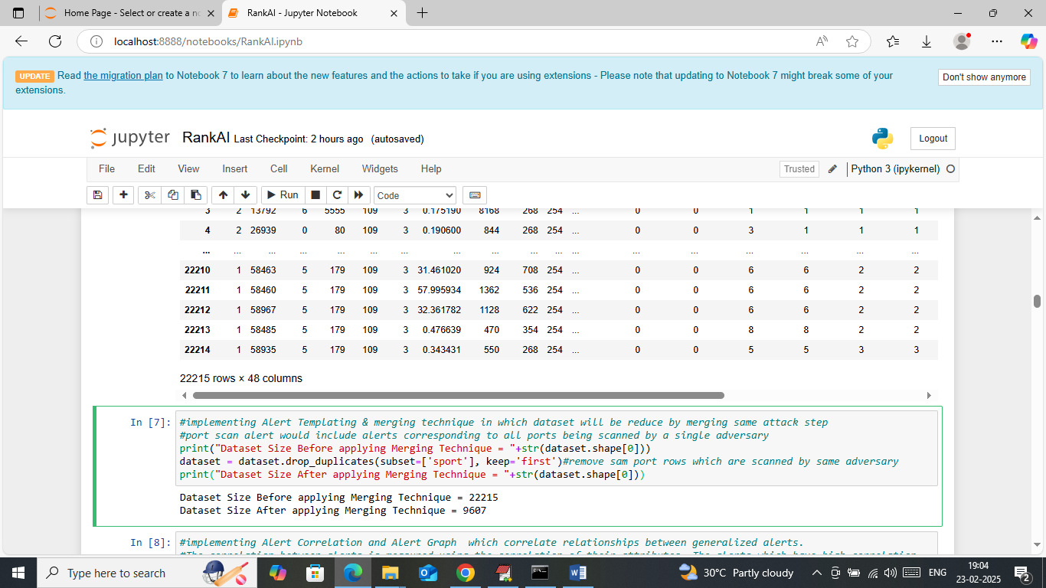
In above screen implementing Merging and templating technique by filtering out same attack step happening from same IP and port and then displaying initial dataset size and then displaying reduce dataset size
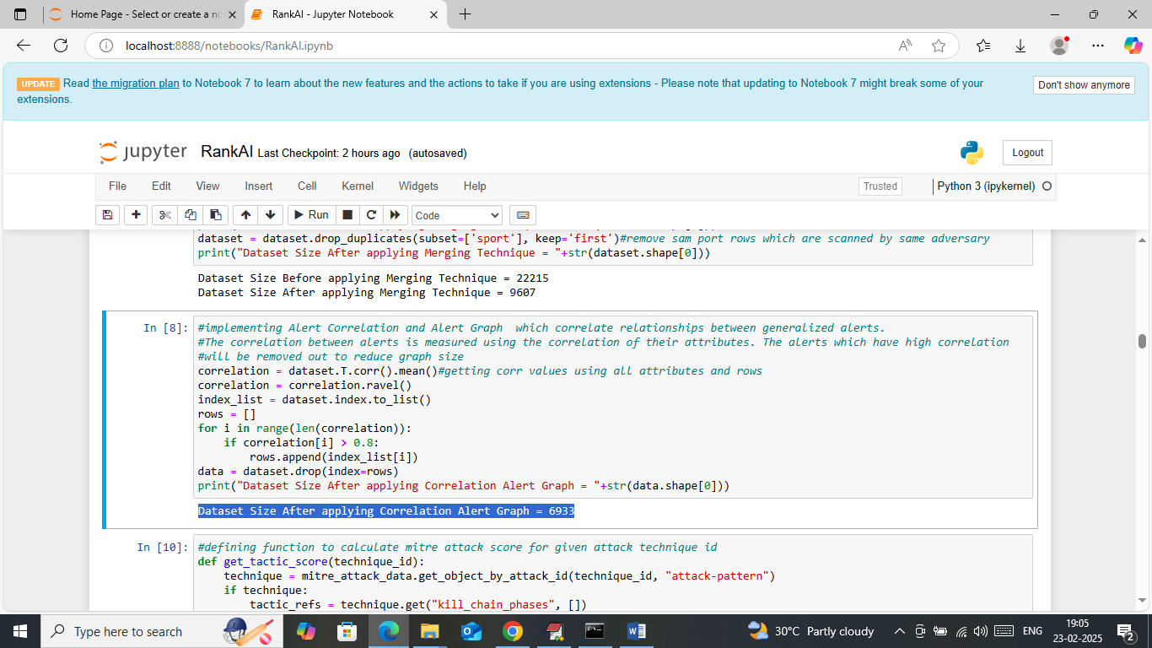
In above screen implementing Alert graph construction by calculating correlation values between all attributes and then generating alert graph by removing all those rows which are highly correlating.
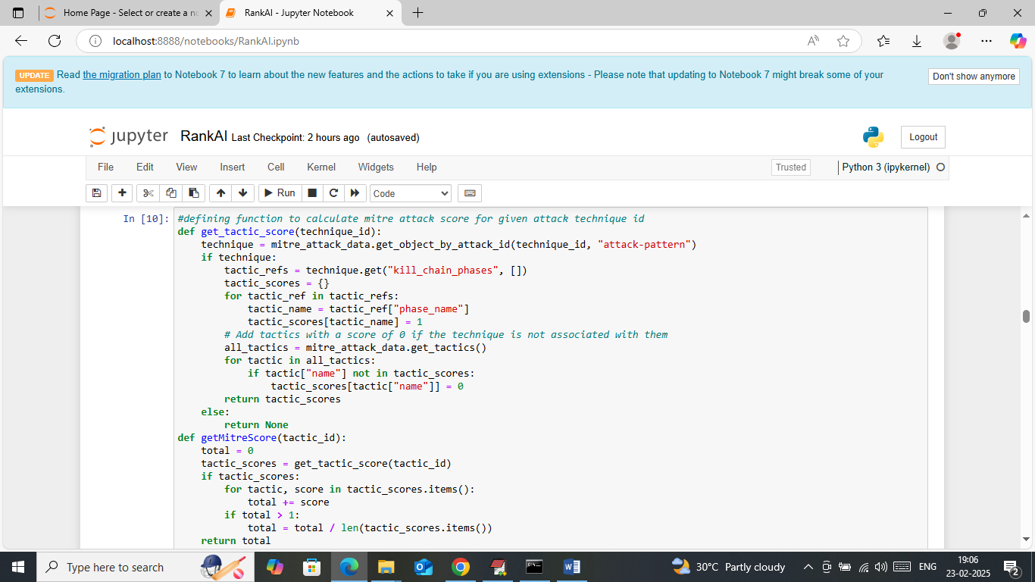
In above screen defining function to calculate MITRE score for given incident type
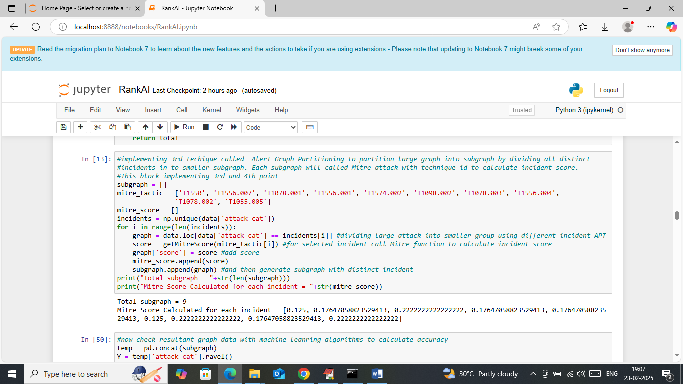
In above screen implementing 3rd technique to generate sub-graphs by adding same or concise incidents to same graph and then calculate MITRE factor score by using incident type and then displaying number of generated sub-graphs along with MITRE score calculate for each incident
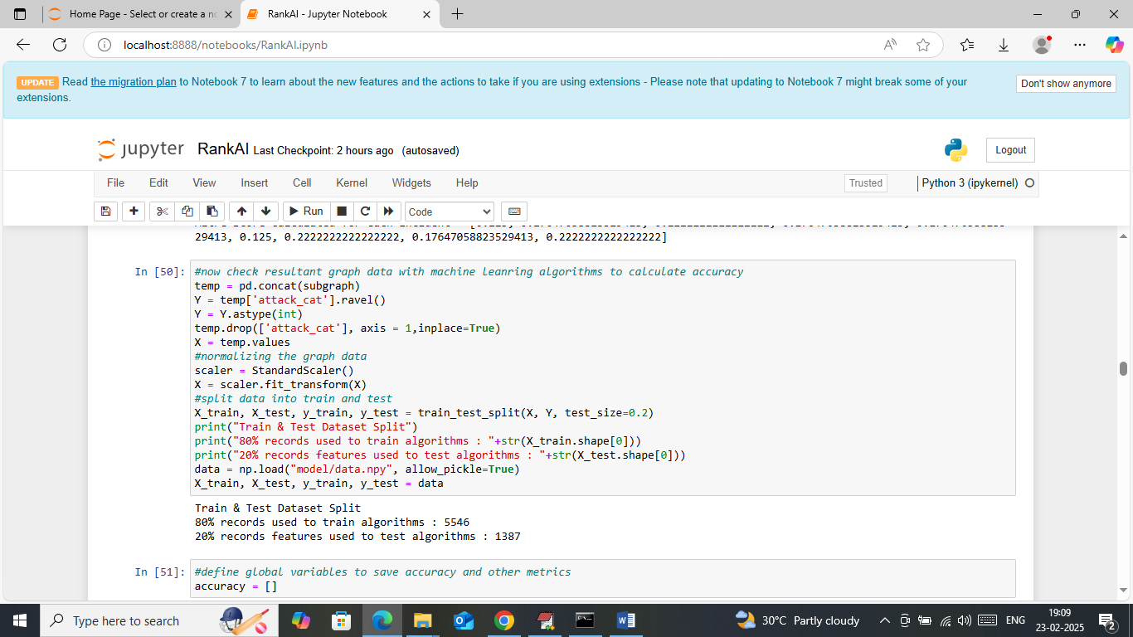
In above screen all sub-graphs data will is processing to train with AI algorithms where all processed sub-graph data is split into train and test where application using 80% graph data for training and 20% for test data
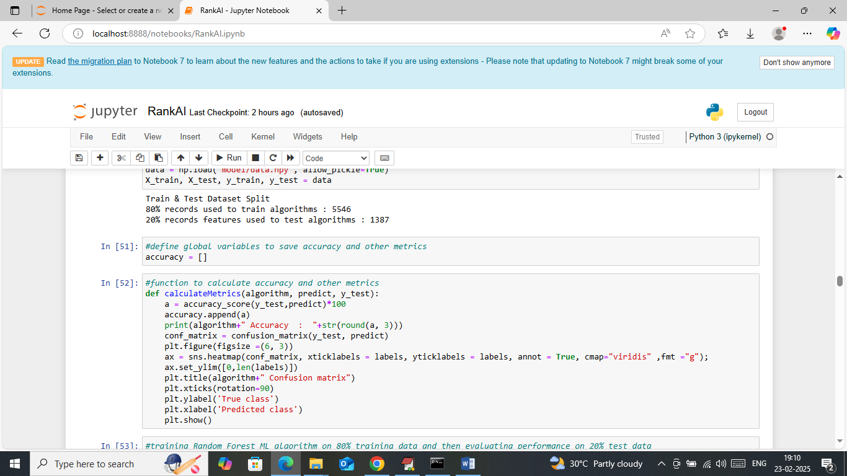
In above screen defining function to calculate accuracy and other metrics
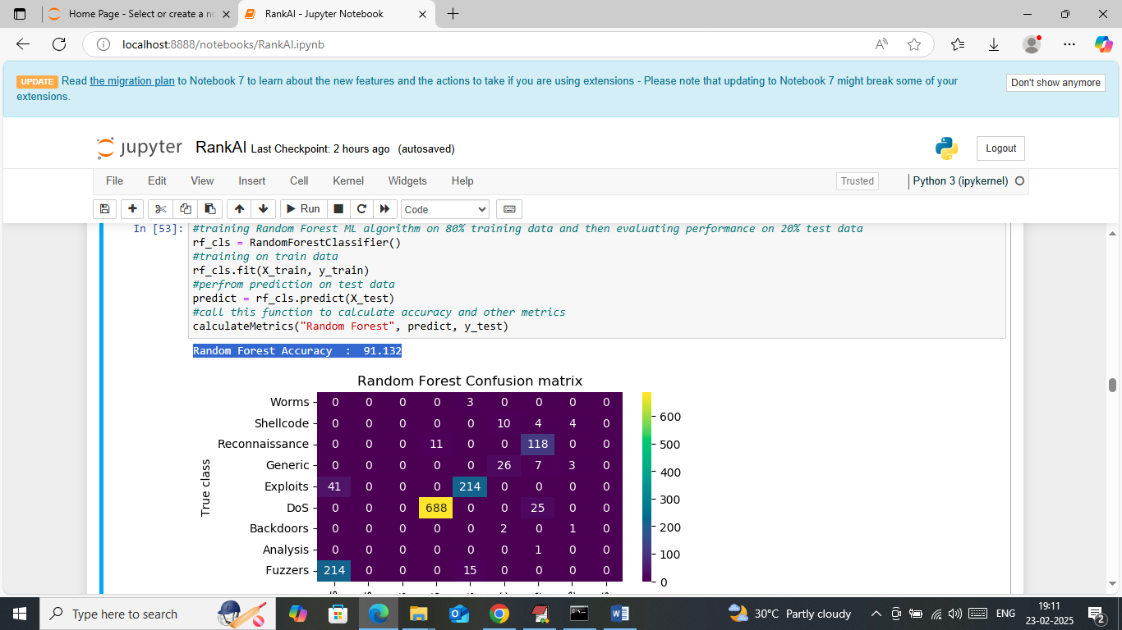
In above screen training Random Forest algorithm on graph training data and then performing prediction on test data and then Random Forest got 91% balances accuracy and in confusion matrix graph x-axis represents ‘Predicted attacks’ and y-axis represents true attacks and then all different colour boxes in diagonal represents correct prediction count (true positives) and remaining all blue boxes represents incorrect prediction (false positives) count which are very few
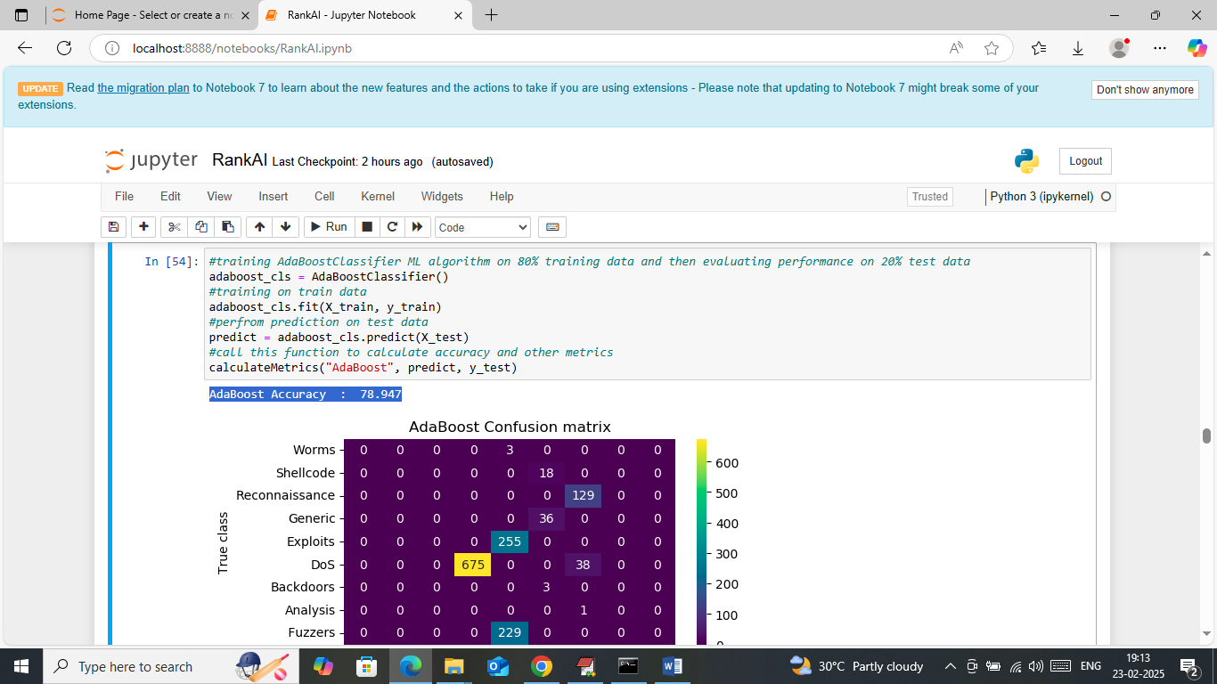
In above screen ADABOOST got 79% accuracy
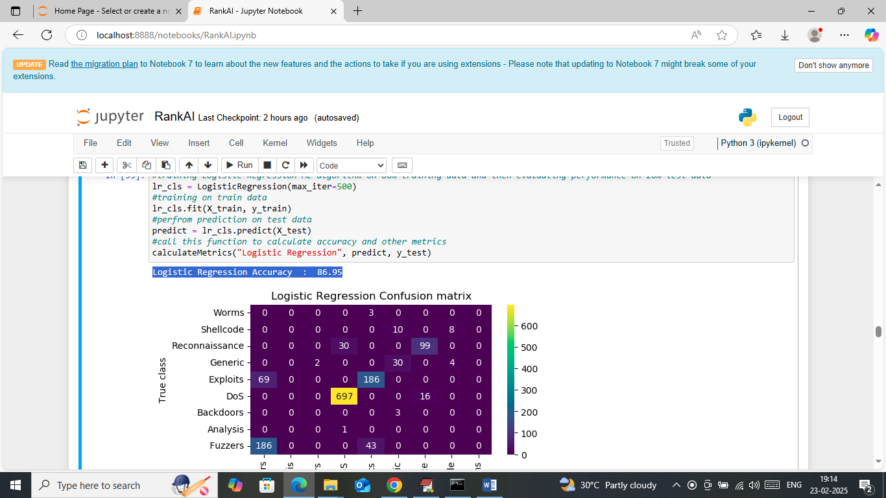
In above screen Logistic Regression got 87% accuracy
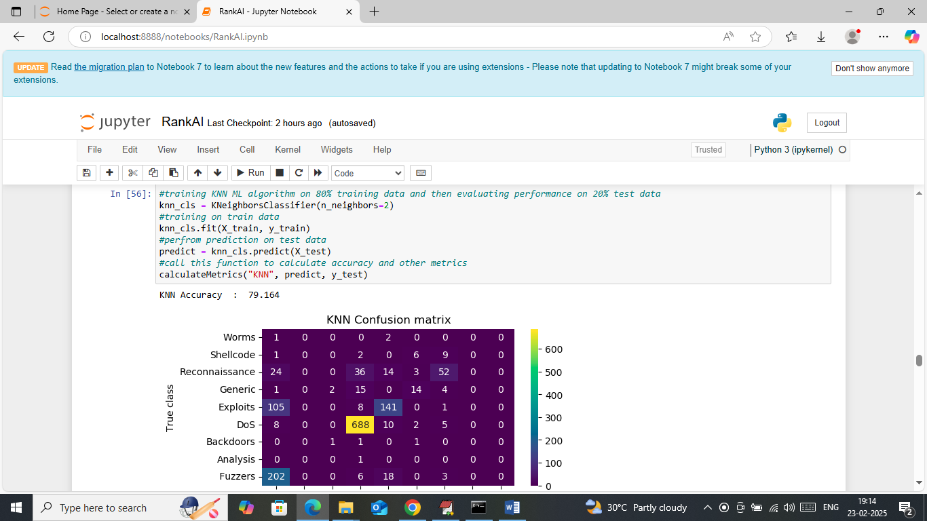
In above screen KNN got 79% accuracy
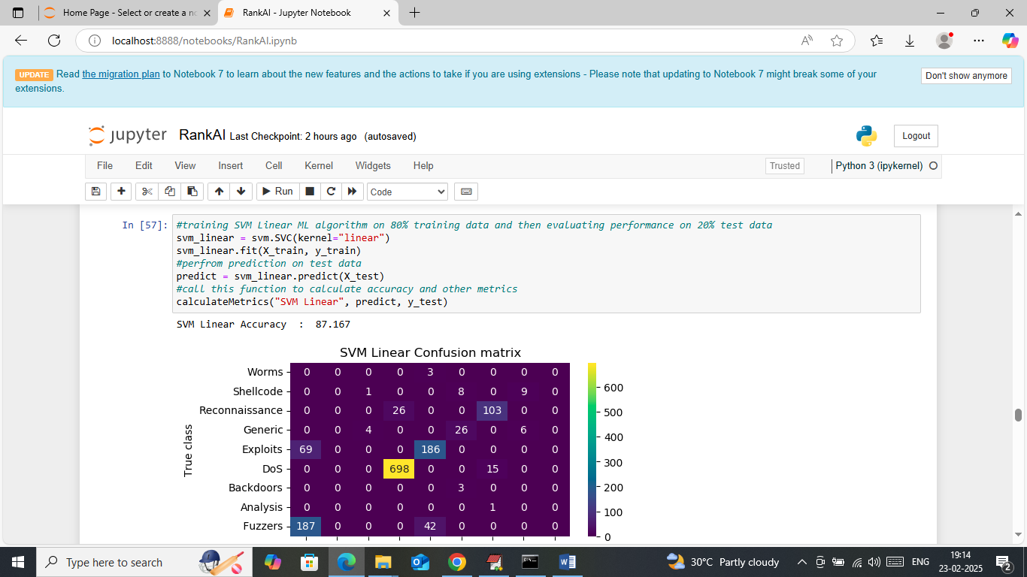
In above screen SVM linear got 87% accuracy
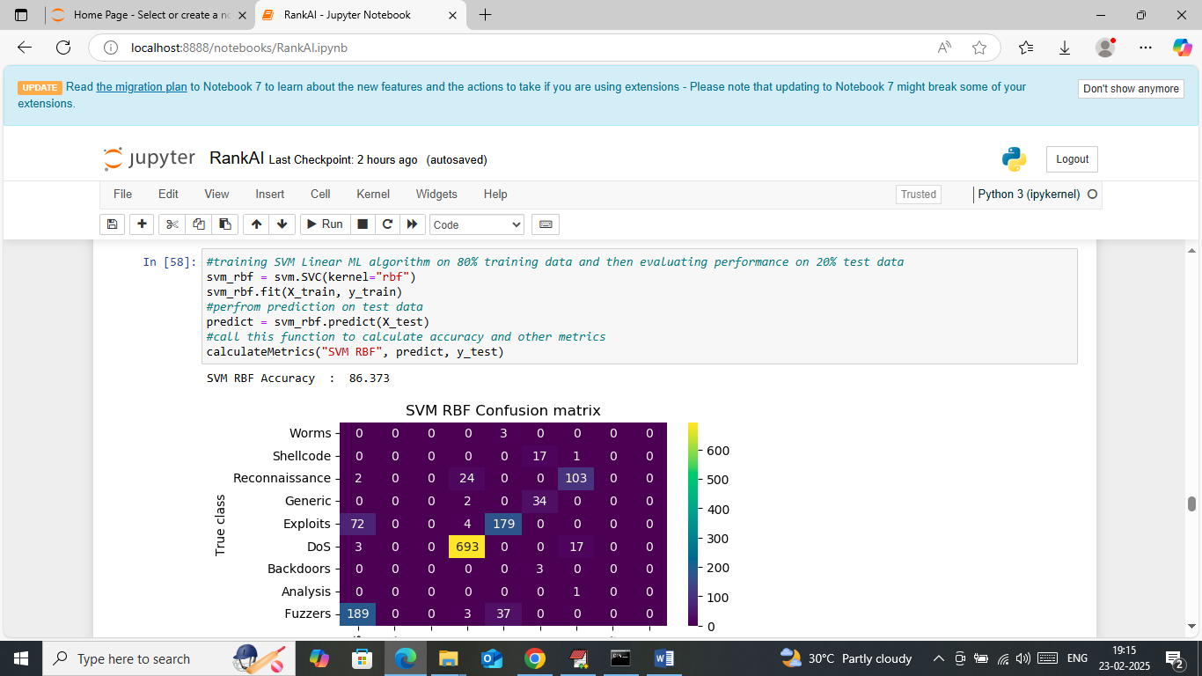
In above screen SVM RBF got 86% accuracy
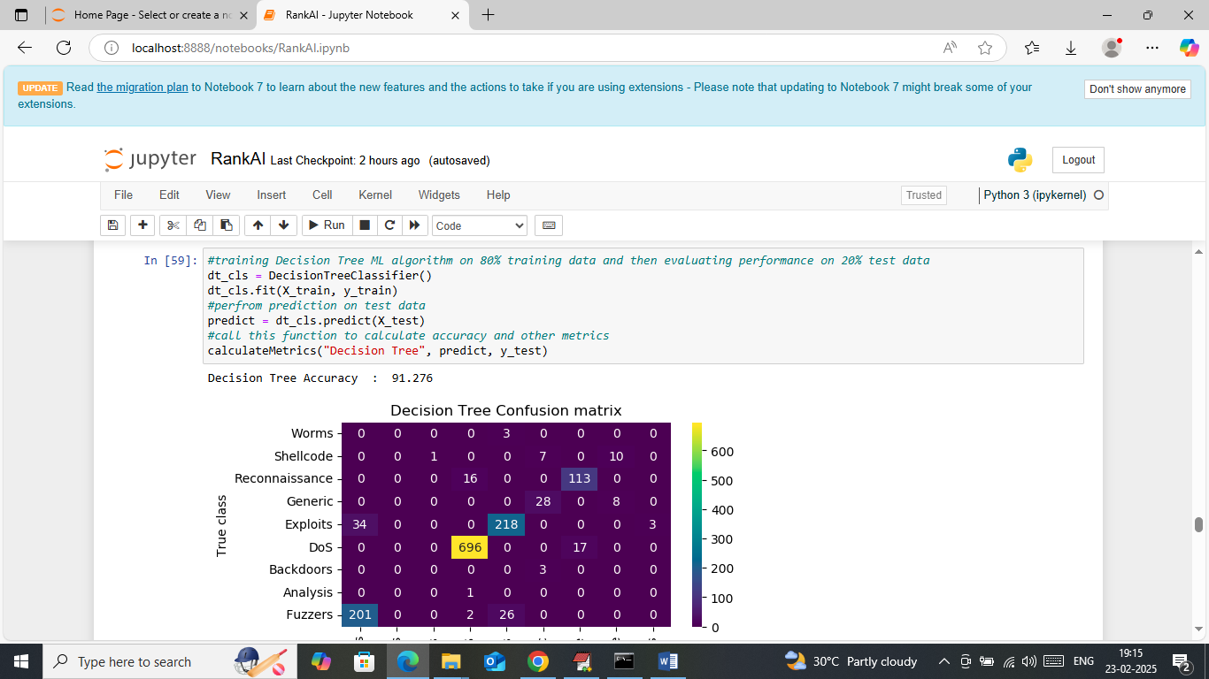
In above screen Decision Tree got 91% accuracy
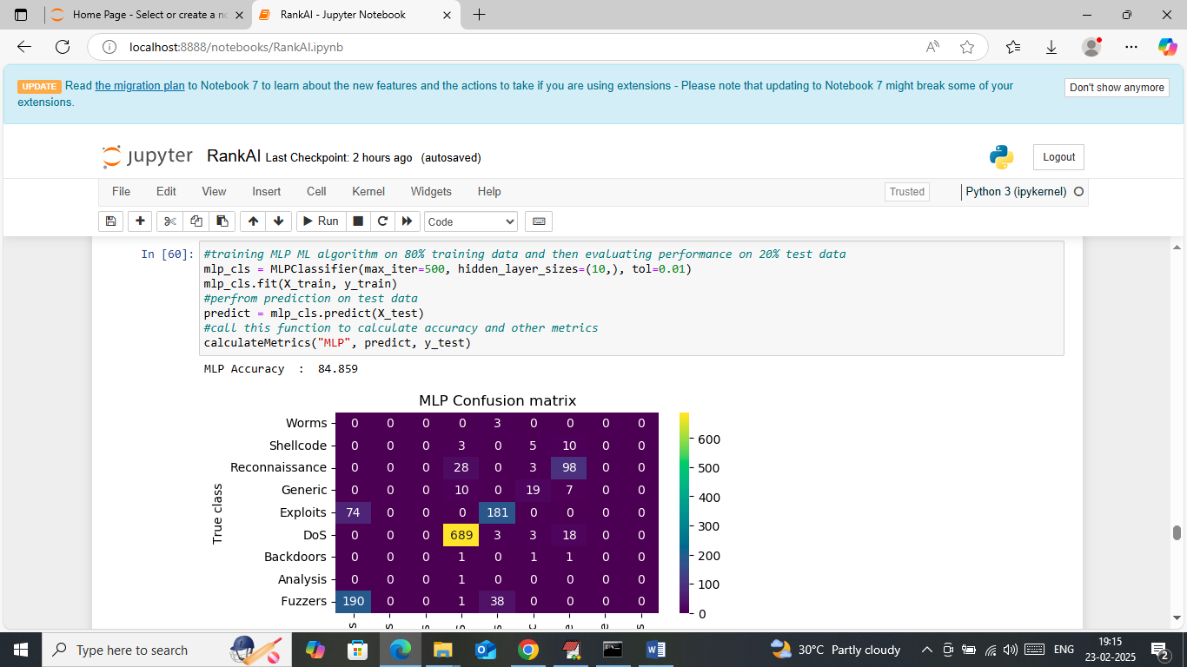
In above screen MLP got 84% accuracy
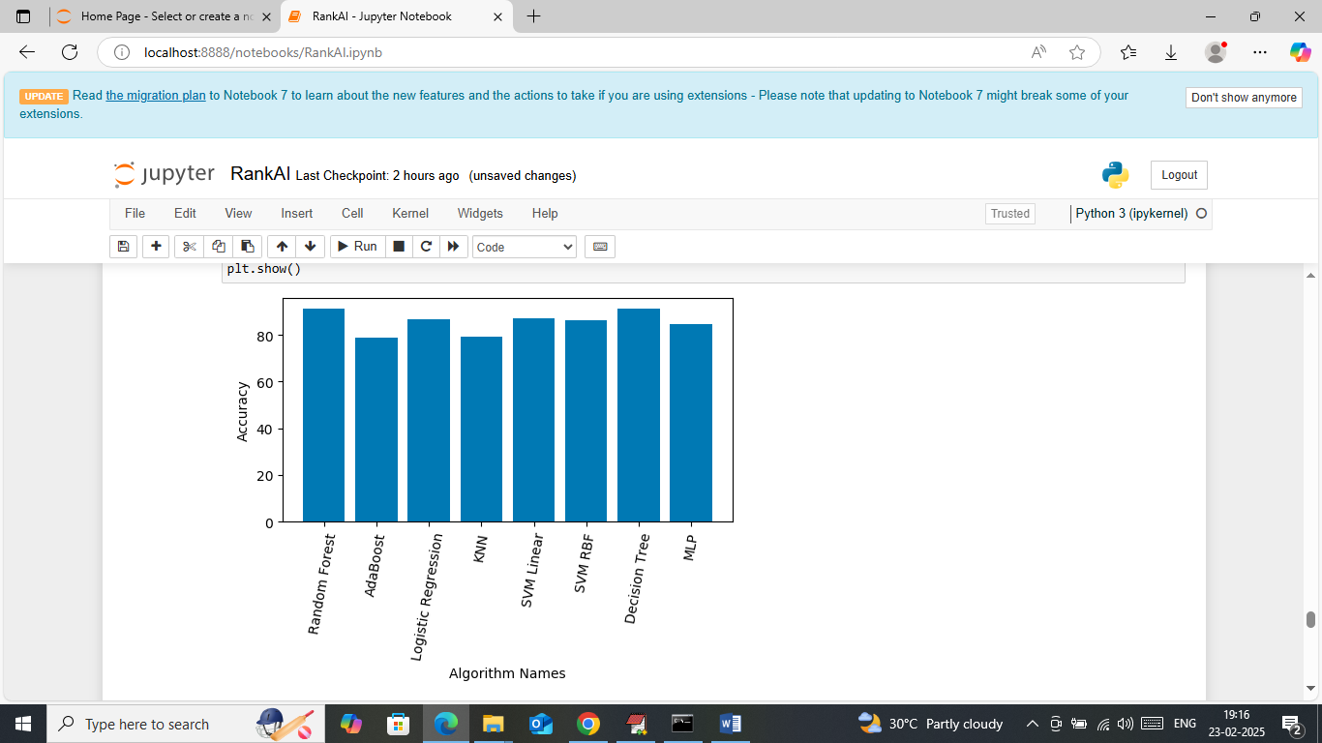
In above screen visualizing comparison graph between all algorithms where x-axis represents algorithm names and y-axis represents accuracy. In above graph can see all algorithms got closed accuracy with based paper with minor difference
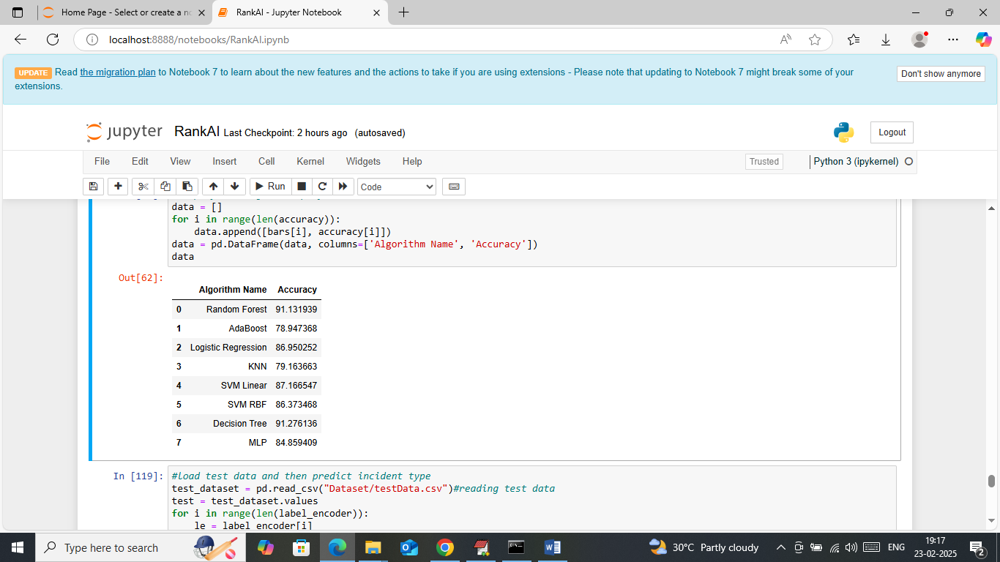
In above screen displaying all algorithms accuracy in tabular format
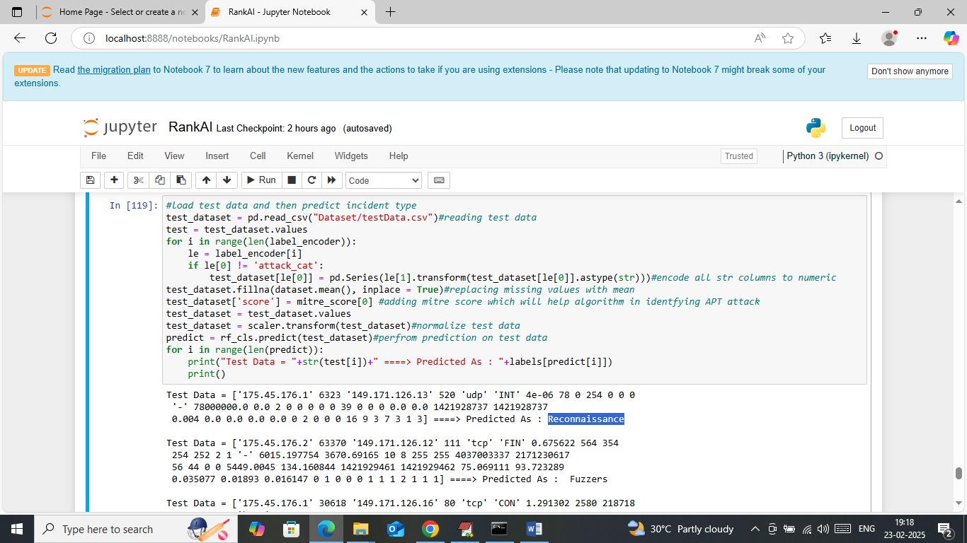
In above screen loading test data values and then processing all test data along with MITRE score and then applying Random Forest algorithm to predict attack type. In above output area in square bracket can see TEST data values and after = arrow symbol can see attack predicted type.
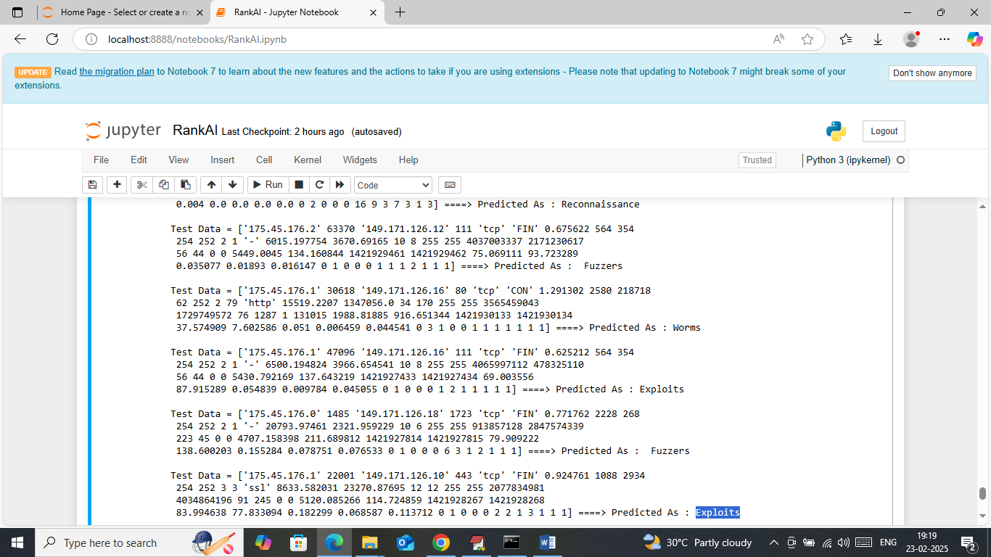
In above screen displaying all different predicted attacks types.

