Rank AI Extension Concept
In this paper author has proposing extension concept to establish relationship between attacks using graph. Future work for this system can focus on modeling causal relationships between the telemetry events and integrating them into the graph construction logic.
To implement above extension we have used Graph-CNN algorithm which will establish relationship between training features and class labels using graph structures such as Nodes and edges. Each training features will be consider as node and all close features which has some similarity will be connected to same class label using edges. Graph-CNN algorithm will generate graph using training features and labels and then trained a model and this model can be applied on test data to calculate prediction accuracy
In below screen showing extension code and output
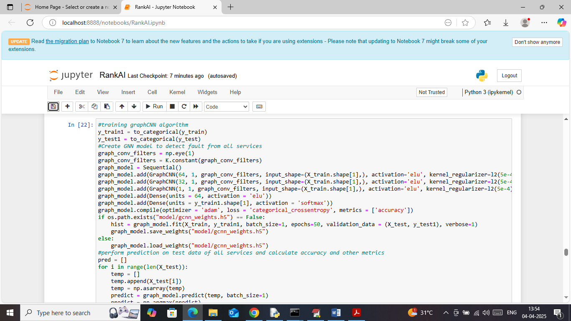
In above screen creating Graph-CNN model using different number of layers and each layer having different number of neurons to filter and optimize graph training features. In above graph model we have used 3 layers with 64, 32 and 64 number of neurons. This trained model can be applied on test data to get below output
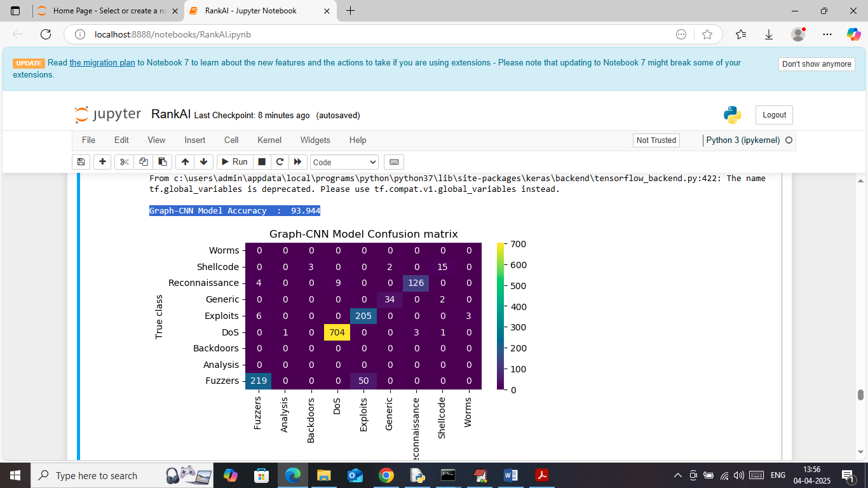
In above screen Graph-CNN extension model got 93.94% accuracy and can see confusion matrix classification graph
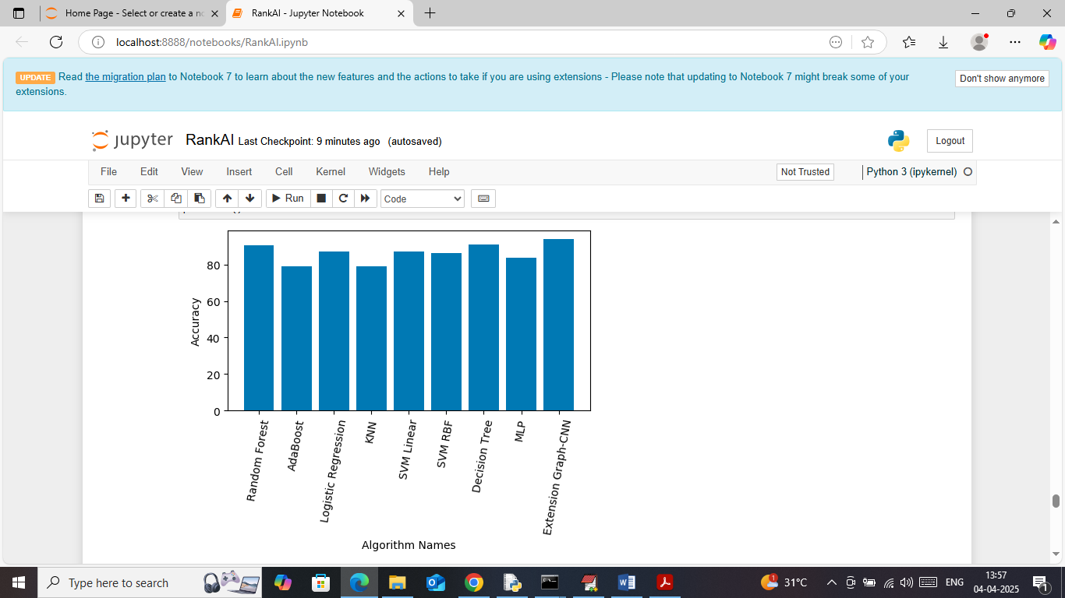
In above screen showing comparison graph between all algorithms
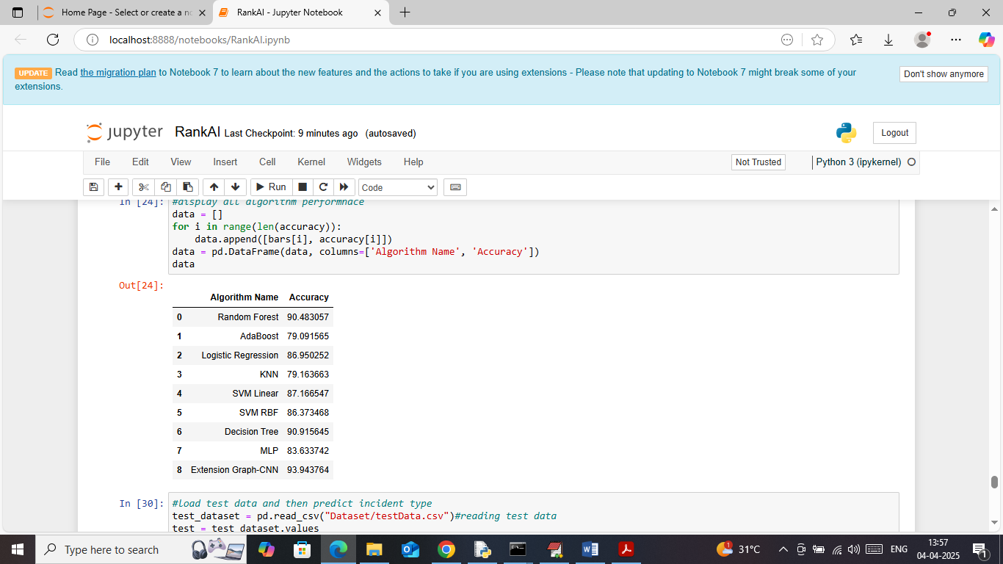
In above screen showing accuracy comparison table between all algorithms
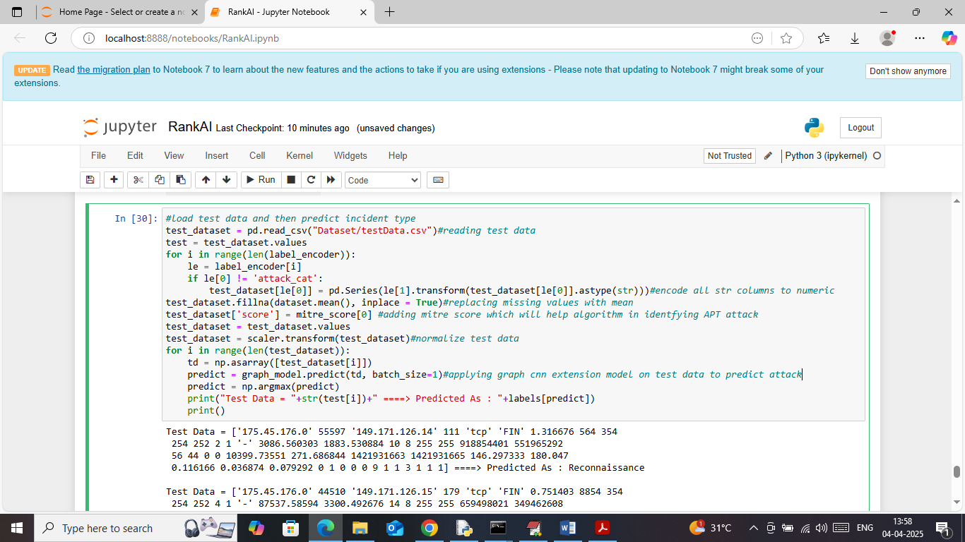
In above screen while predicting test data we have used extension algorithms only.

