[**http://demo.guru99.com/test/drag_drop.html**](http://demo.guru99.com/test/drag_drop.html)

**Before Drag and Drop**

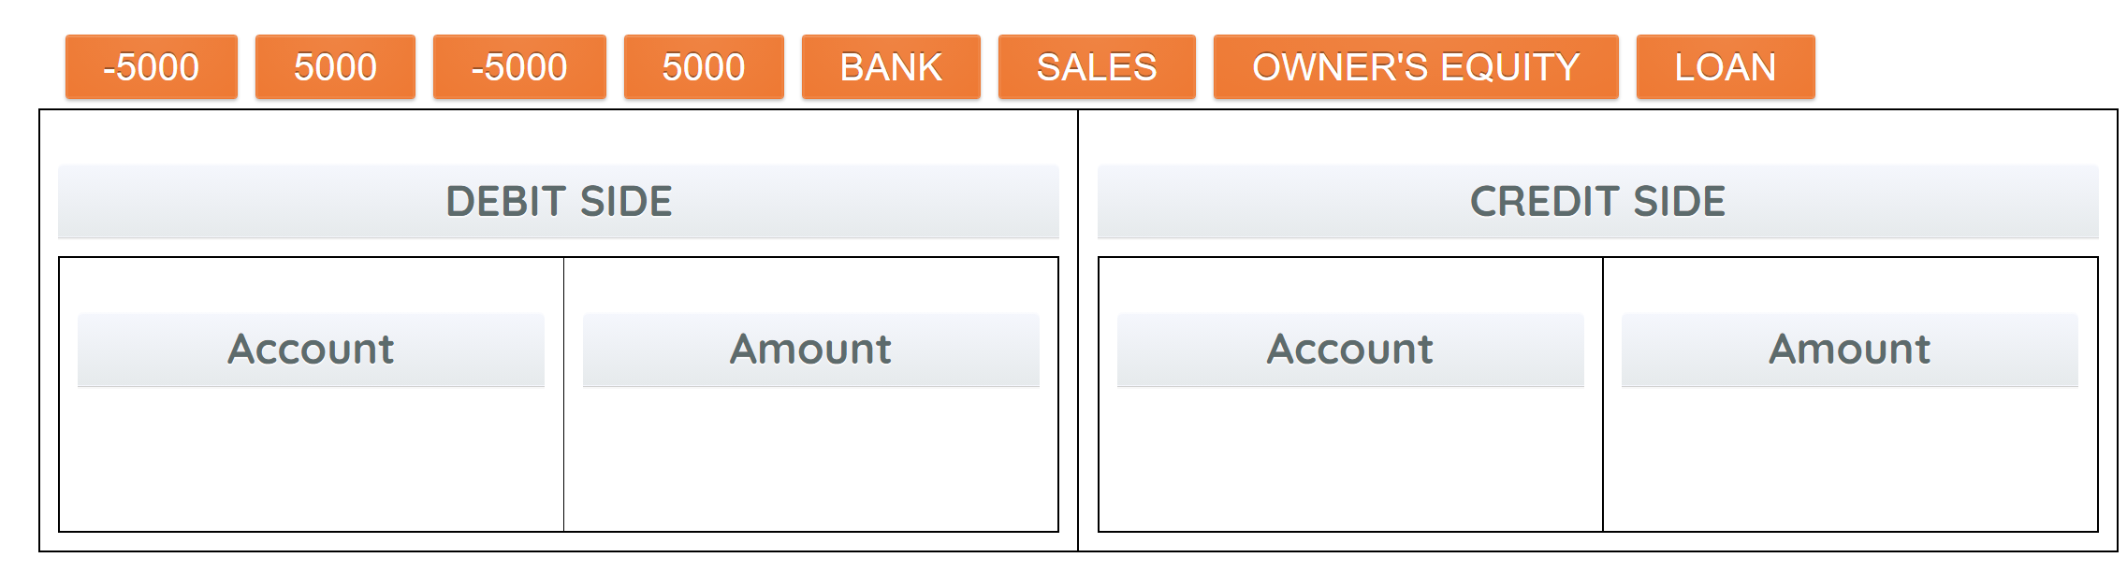

**After Drag and Drop**

