**Program Run Screenshots**

1. **Run the program**

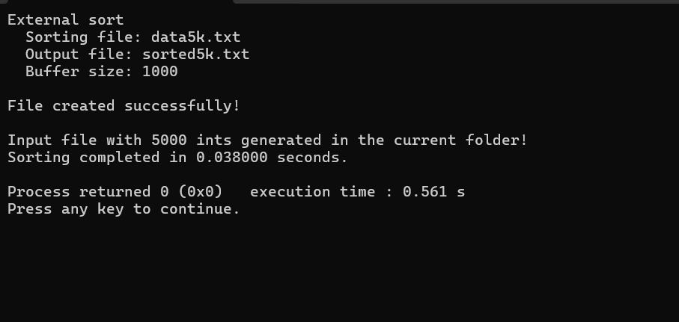**Below screenshot shows the console run window.**

**Below screenshots show portion of the INPUT FILE with random ints.**

**Below screenshots show portion of the OUTPUT file with SORTED ints.**

