**Program Run Screenshots**

1. **First run with only ONE input file**

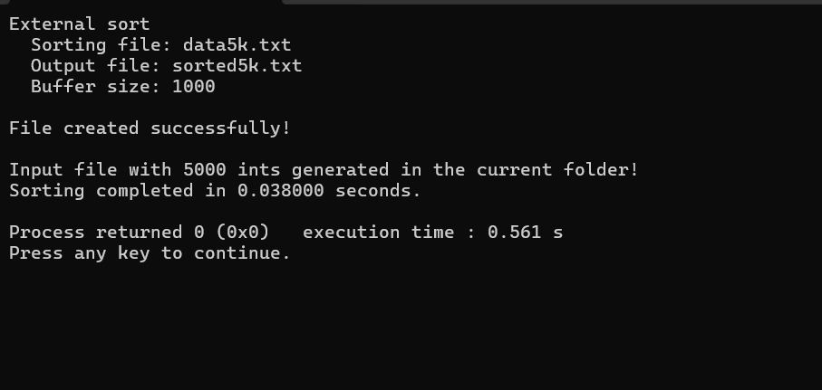**Below screenshot shows the console run window.**

**Below screenshots show portion of the INPUT FILE with random ints.**

**Below screenshots show portion of the OUTPUT file with SORTED ints.**

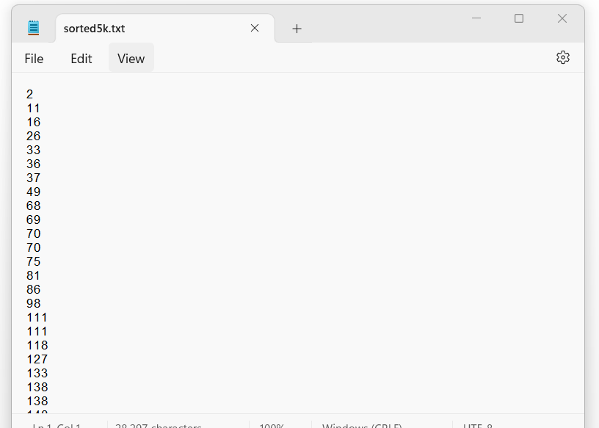

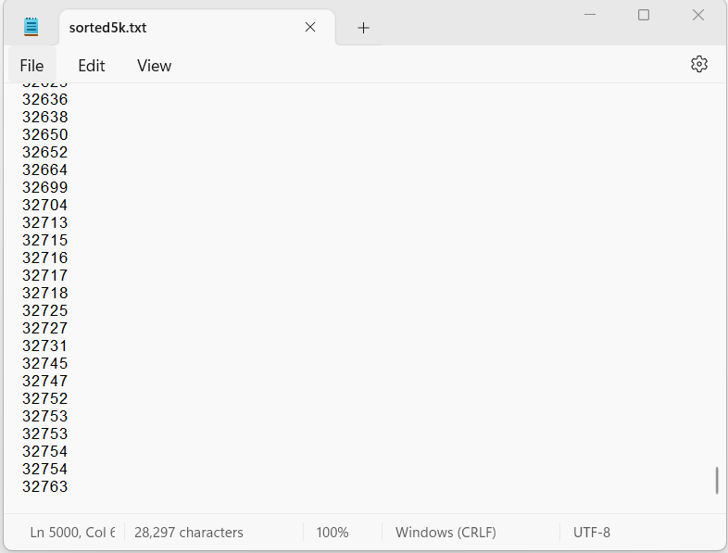

1. **Second run with 5 input and 5 output files**

