**AI Photo Booth**

Core Ideas:

Generative Adversarial Networks (GANs) can be used to create realistic and high-quality images that can be used in marketing to enhance the appeal of a product. Here are some ways in which GAN generated images (examples generated by use of “Stable-Diffusion” (an open source GAN generation package) can be used to improve the marketing of a product:

1. **Showcase the product in different environments:** GANs can be used to generate images of the product in different environments, such as on a beach or in a cityscape. These images can be used to show how the product fits into different lifestyles and environments, making it more appealing to potential customers e.g., the below image was generated by author showing a “Ketchup bottle next to some tomatoes”. It can be further customized using techniques of ***“Prompt Engineering”***.

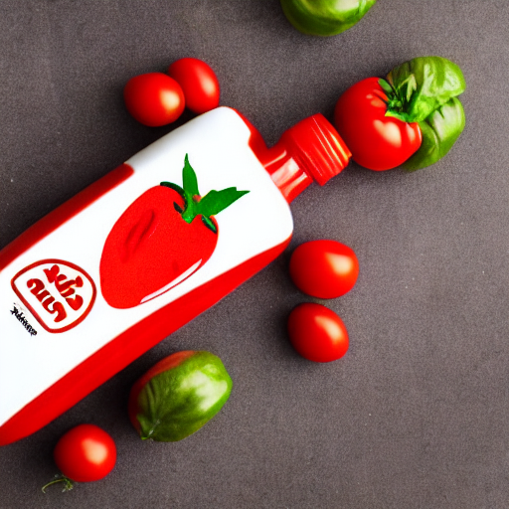

1. **Create customized images:** GANs can be trained to generate images based on specific customer preferences. For example, if a customer is looking for a particular color or design, GANs can generate images that match those preferences. This can help to personalize the marketing message and make it more relevant to the individual customer.
2. **Show the product in action:** GANs can generate images that show the product in action, such as a person using the product or the product in use in a particular setting. This can help customers visualize how the product works and how it can benefit them in their daily lives.
3. **Create eye-catching visual content:** GANs can be used to generate visually stunning images that catch the eye and make the product stand out. This can help to increase brand awareness and generate interest in the product.
4. **Create social media content:** GANs can generate images that are ideal for use on social media platforms, such as Instagram and Facebook. These images can be used to promote the product and engage with potential customers.

Overall, GAN generated images can be a powerful tool for enhancing the marketing of a product, as they can create realistic and visually stunning images that help to engage with customers and promote the product's benefits.