**ReactJS**

React is a library for building composable user interfaces. It encourages the creation of reusable UI components, which present data that changes over time. Lots of people use React as the V in MVC. React abstracts away the DOM from you, offering a simpler programming model and better performance. React can also render on the server using Node, and it can power native apps using React Native. React implements one-way reactive data flow, which reduces the boilerplate and is easier to reason about than traditional data binding.

Reactjs can be easily labeled as a bestseller. Launched back in 2013, this JavaScript library has quickly won popular affections. Today it is maintained by Facebook, together with the developer community. It is used by the leading companies, like Apple, PayPal, Netflix, while over 32 thousand of websites are built using React JS framework.

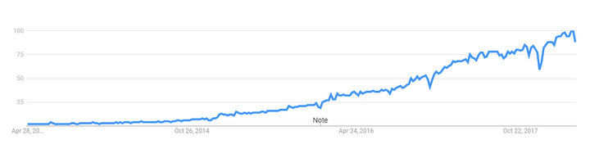

**Popularity of React over the last five years worldwide**

# React Features

* **JSX**

JSX is JavaScript syntax extension. It isn't necessary to use JSX in React development, but it is recommended.

* **Components**

React is all about components. You need to think of everything as a component. This will help you maintain the code when working on larger scale projects

* **Unidirectional data flow and Flux**

React implements one-way data flow which makes it easy to reason about your app. Flux is a pattern that helps keeping your data unidirectional

# Advantages

* React.js is extremely efficient
* Makes writing Javascript easier
* Gives you out-of-the-box developer tools
* Awesome for SEO
* Uses virtual DOM , it will increase the performance

# Limitations

* React.js is only a view layer.
* Integrating React.js into a traditional MVC framework such as rails would require some configuration (i.e., substituting erb with React.js)
* There is a learning curve for beginners who are new to web development.

# Why you should use

* React.js works great for teams, strongly enforcing UI and workflow patterns
* The user interface code is readable and maintainable
* Lot of demand for developers with ReactJS experience