CS451

Cloud Computing

FALL 2023

Assignment

TASK

**1 – Create a bare metal virtual machine environment.**

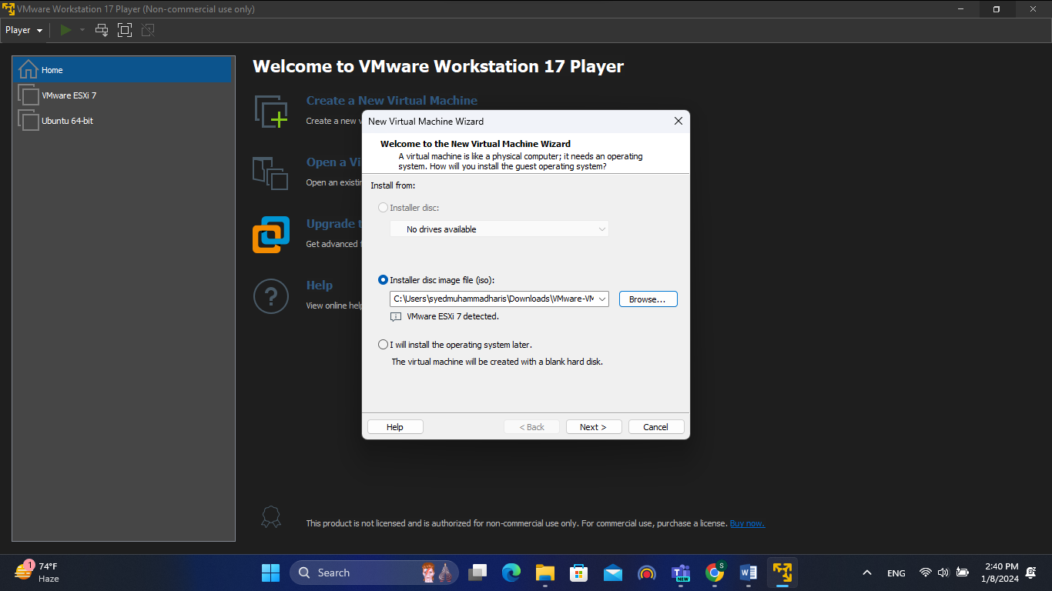

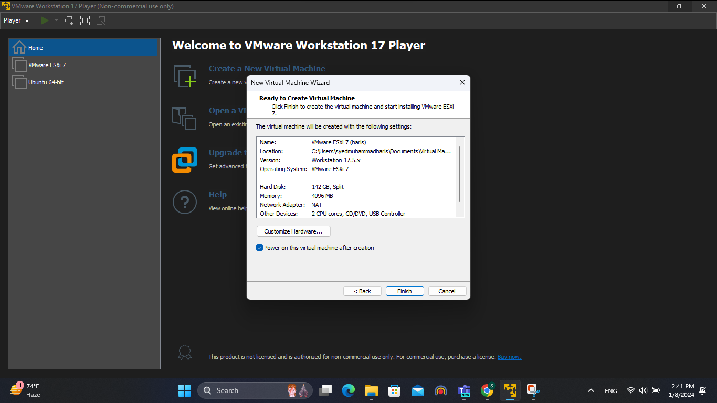

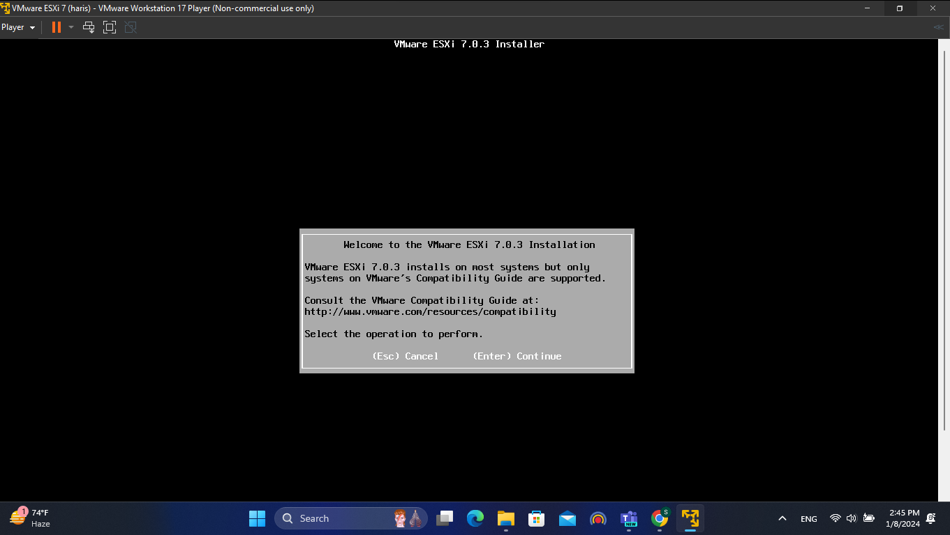

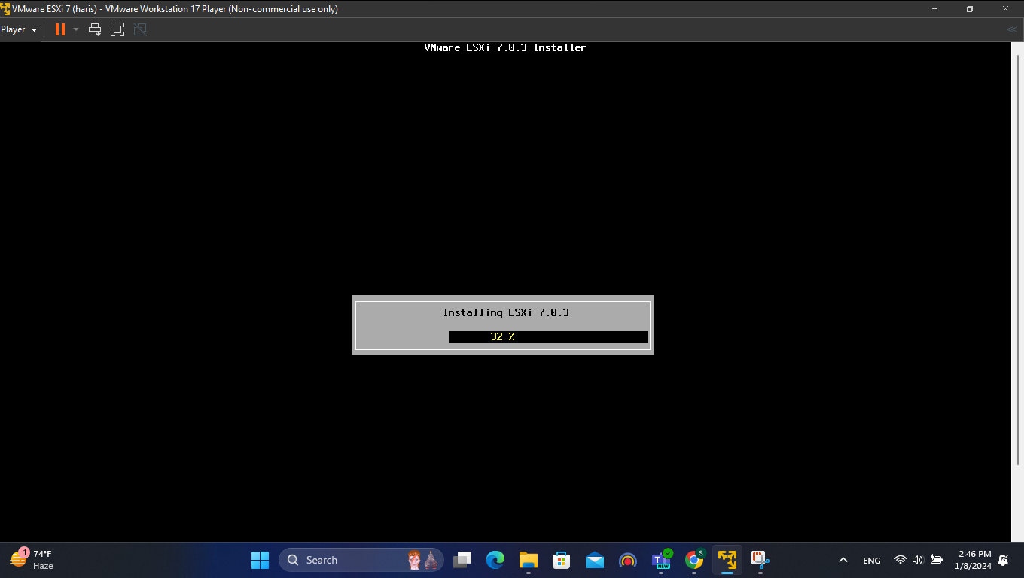

**2 – Deploy the ESXI vsphere.**

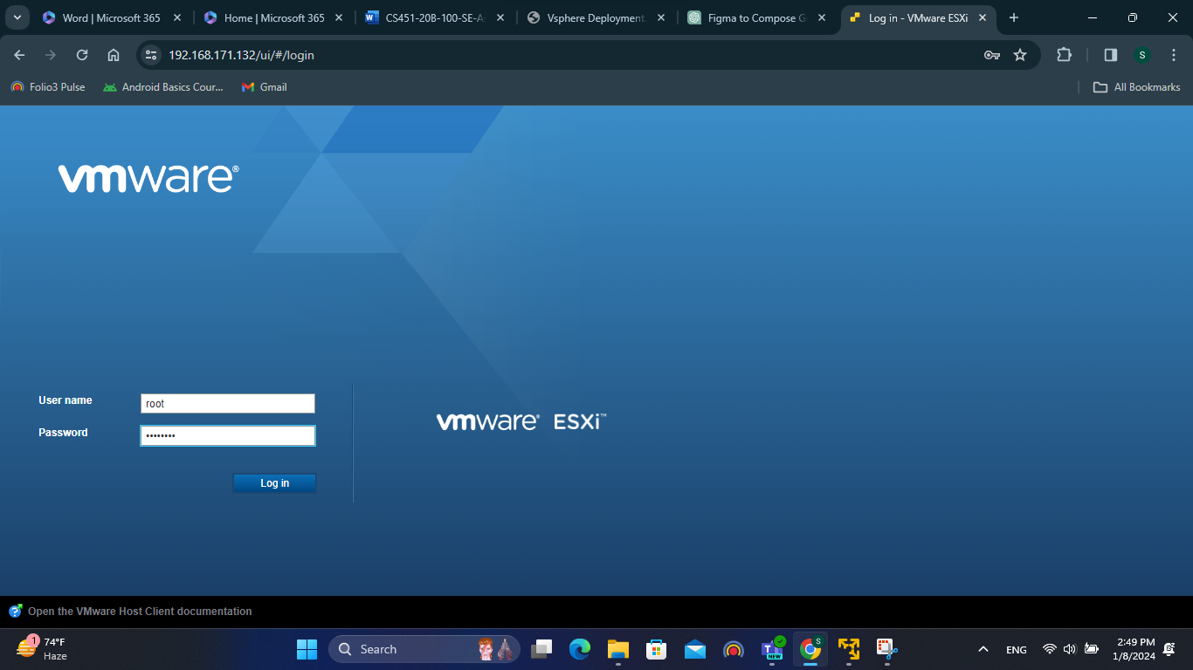

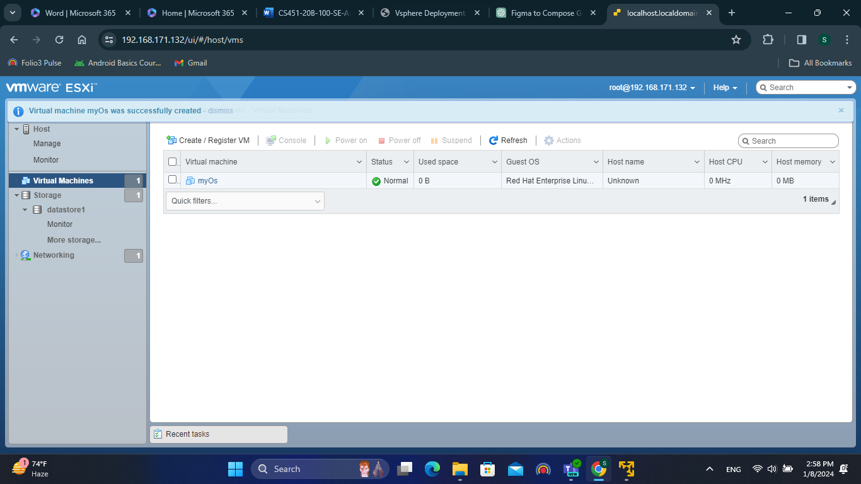

**3 – Deploy the webserver in ESXI virtual machine. Access the web services from the host.**

**4 – Create docker environment.**

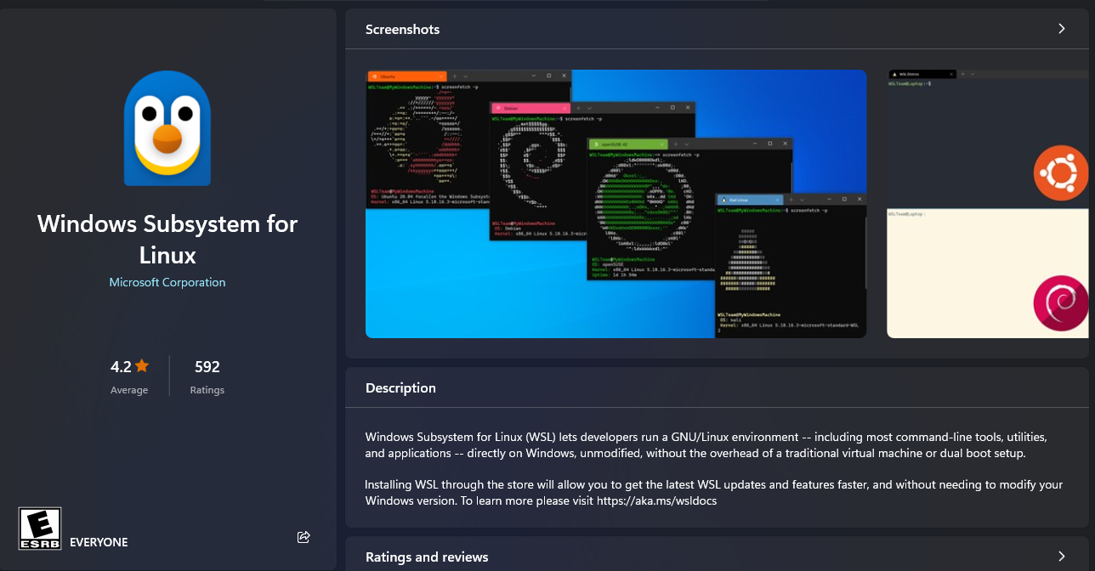

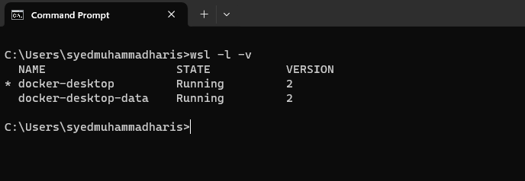

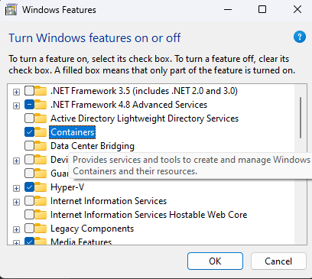

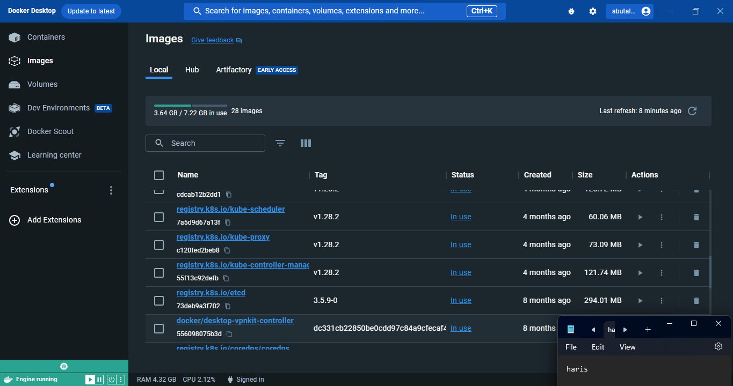

**5 – Deploy torrent in containerize environment.**

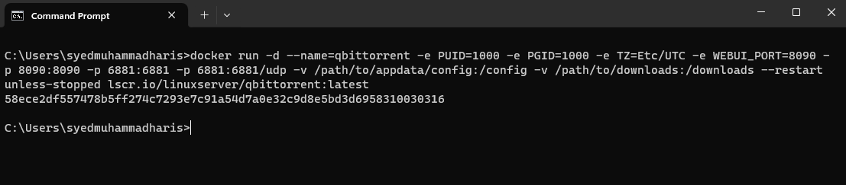

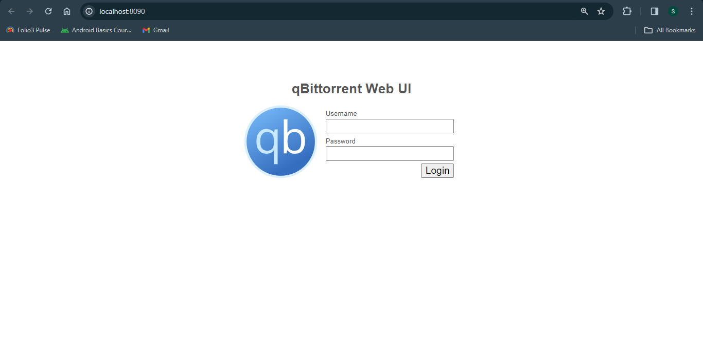

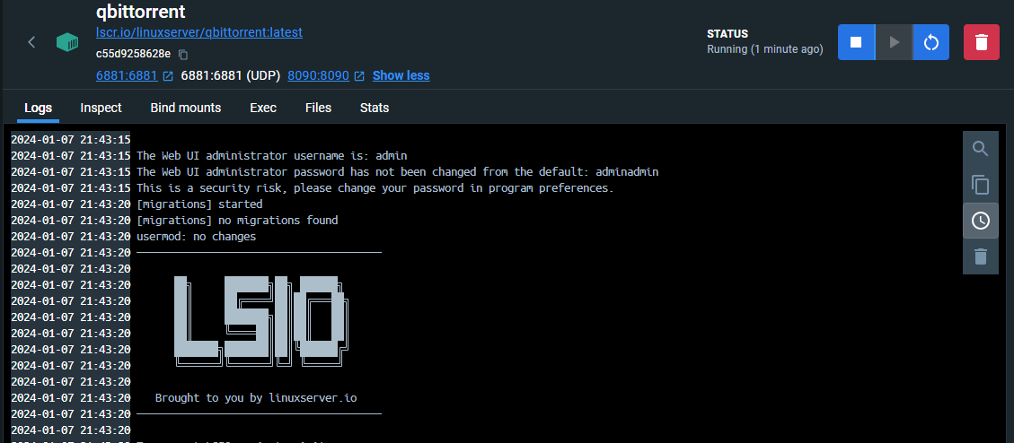

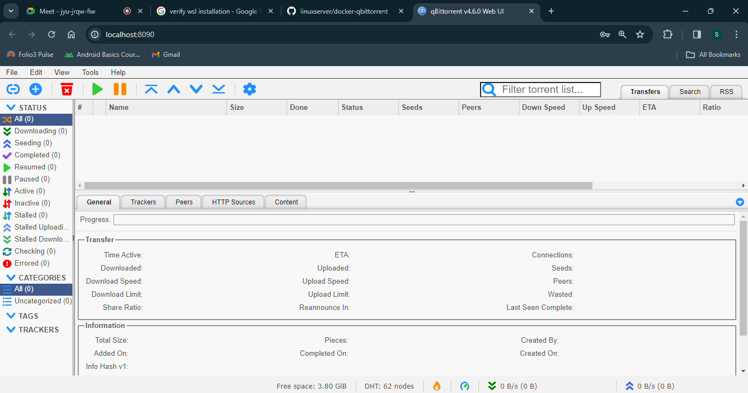

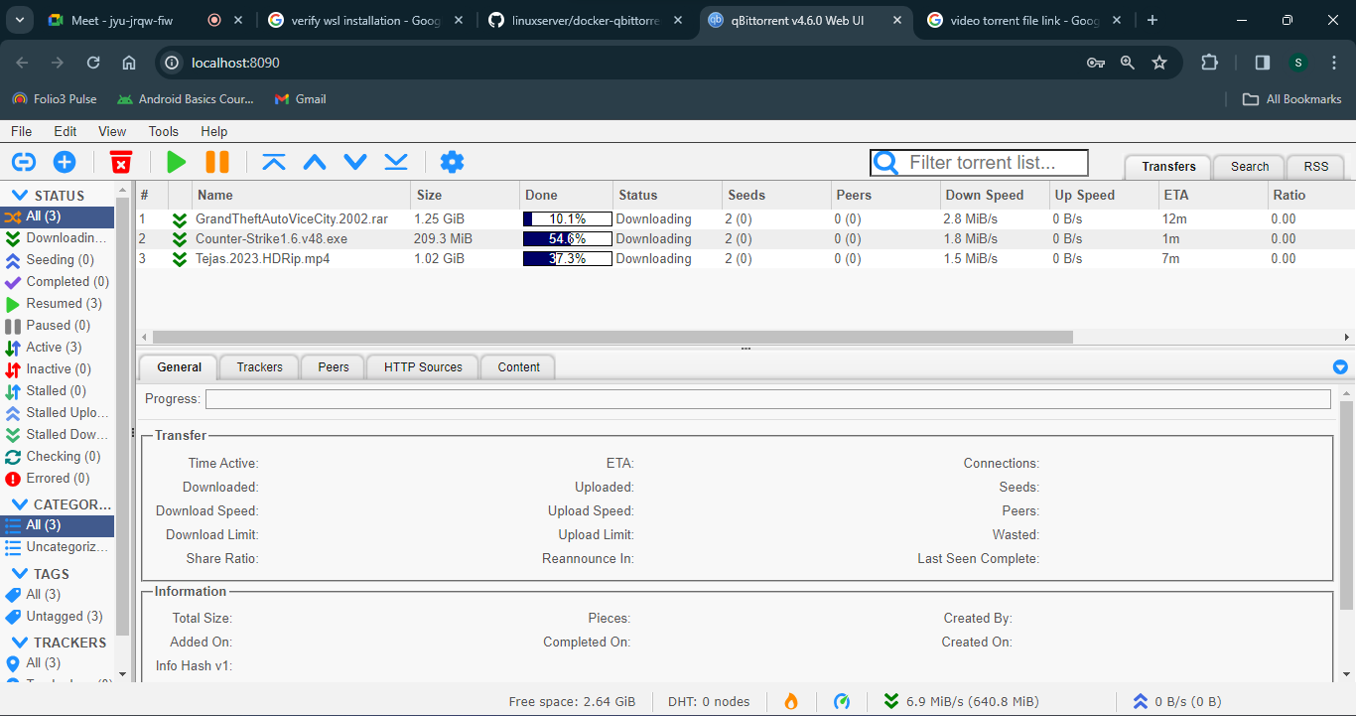

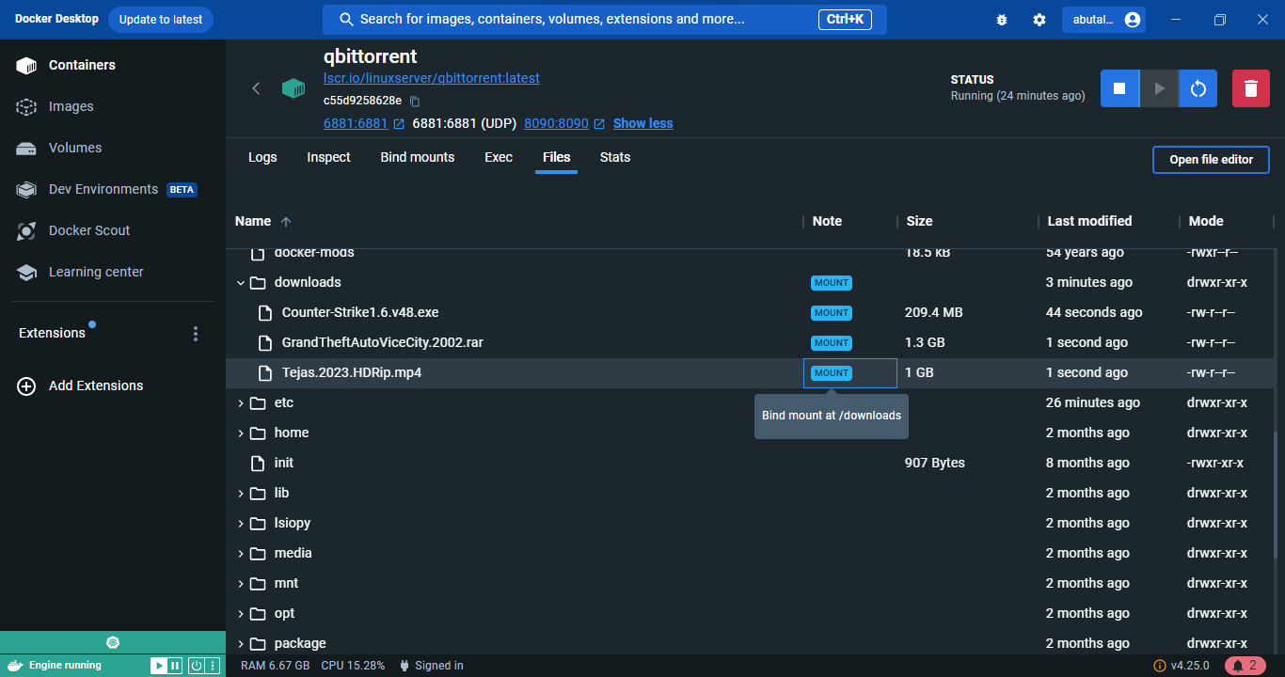

**6 – Deploy 3 webservers which executed in parallel. Access the web service from host through different ports.**

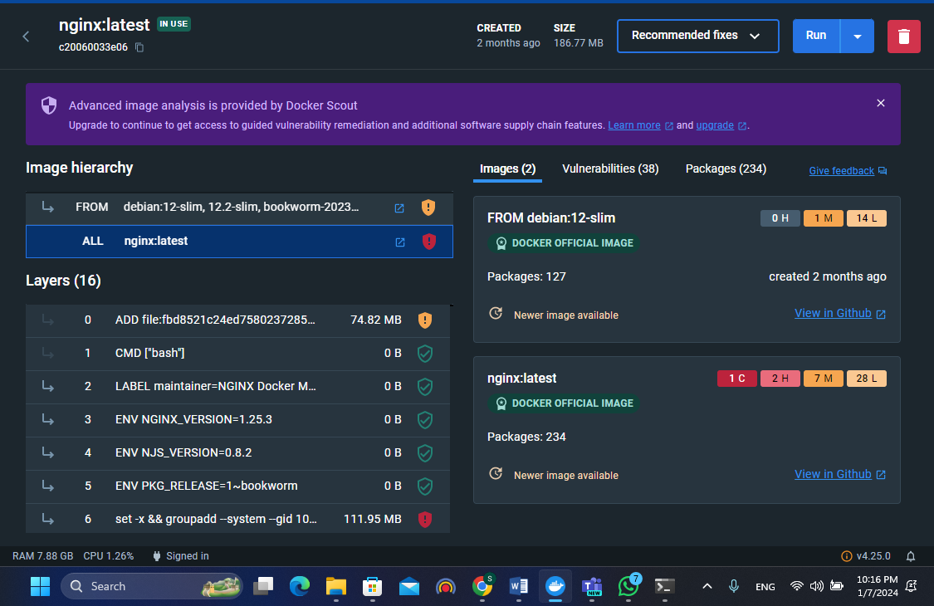

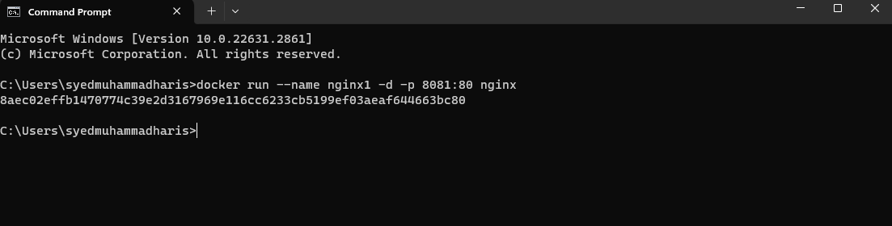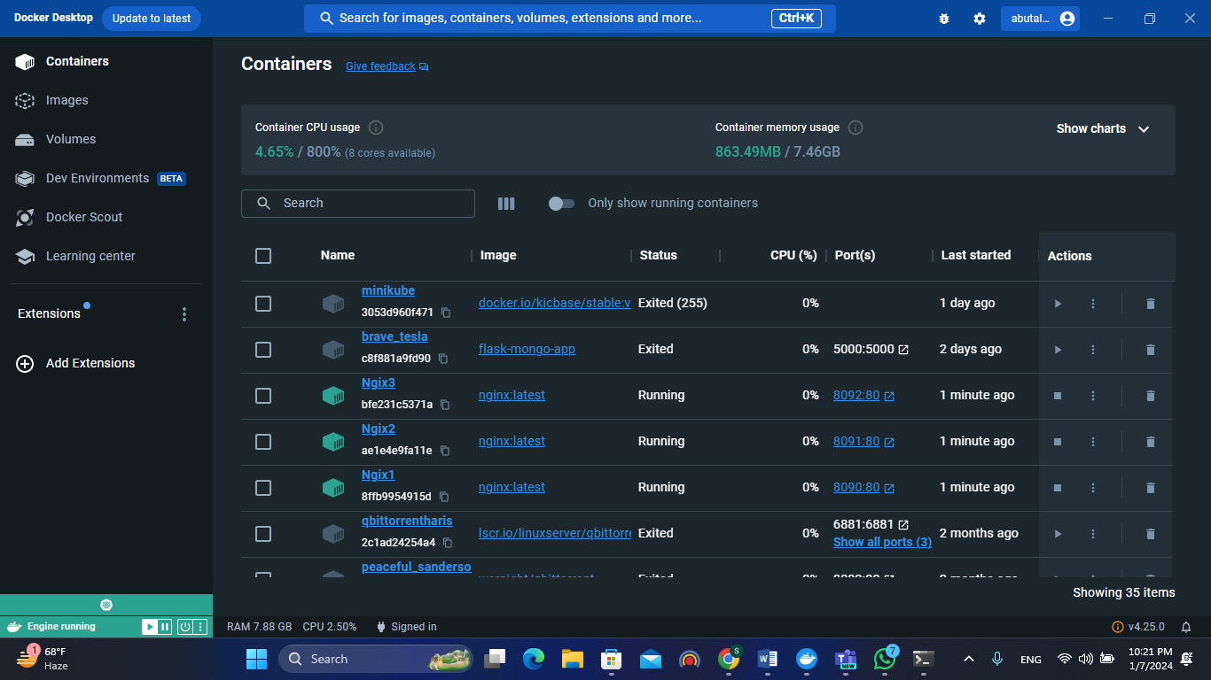

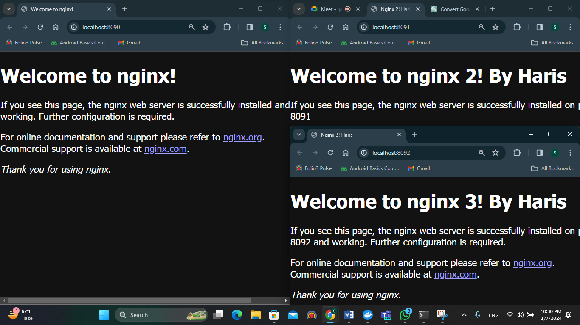

**7 – Create kubernetes environment.**

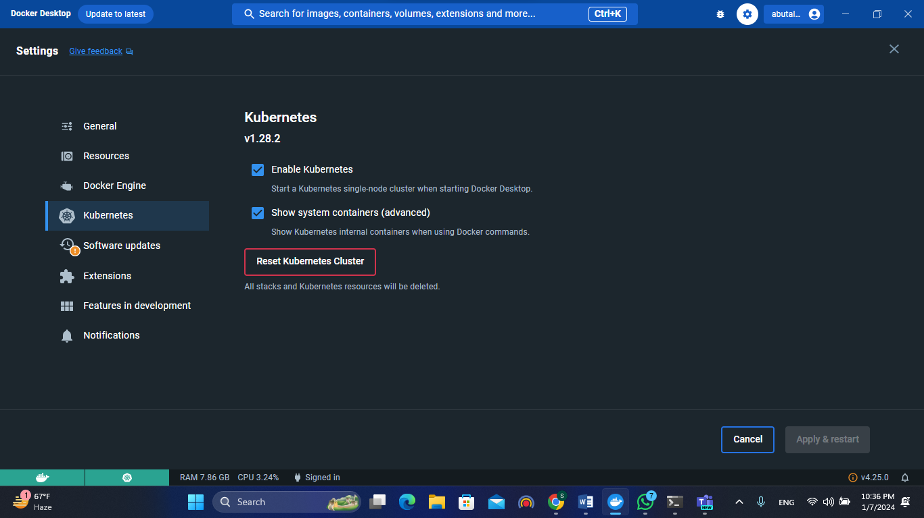

**8 – Deploy nginx PODs**

**9 - Deploy the nginx containers connecting with persistent storage.**

**10 – Need to create a single feature application having front end and backend. Backend code connects the data base, the database is running over the container or host machine.   
Deploy the application over the kubernetes PODs.**

