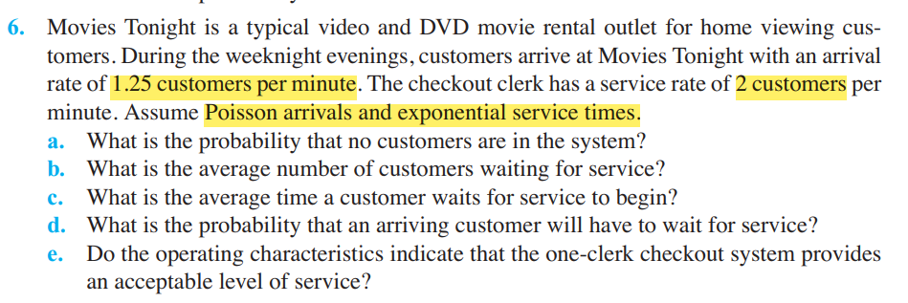

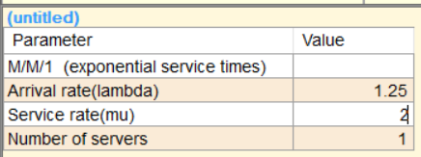

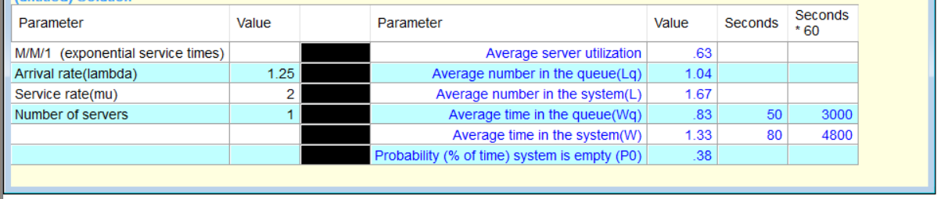

1. 0.38 / 38%
2. 1.04
3. 0.83 / 83%
4. 0.62/62%
5. As the average time in the queue is not much so this system is good for use.

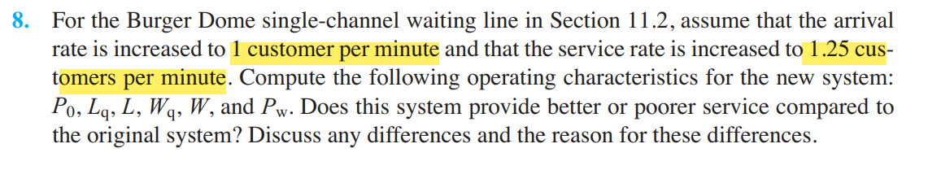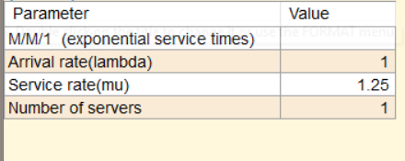

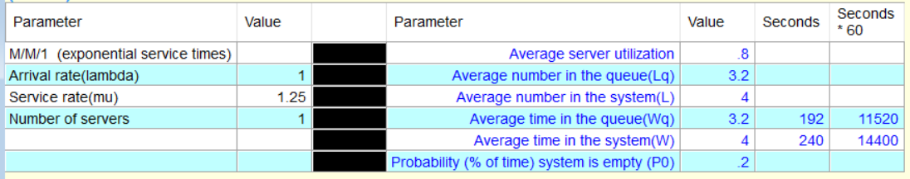

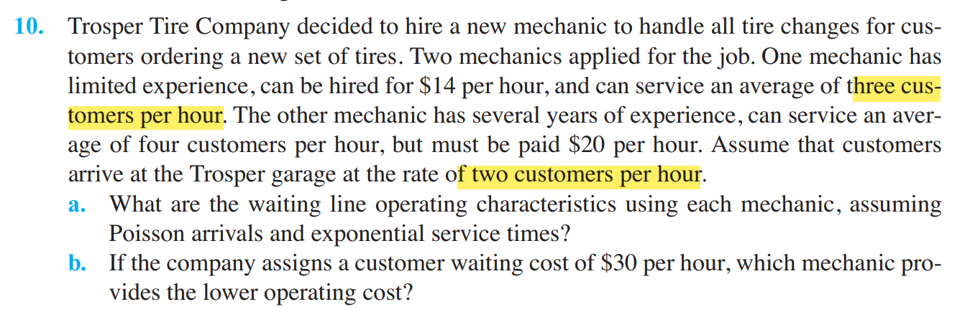

1. 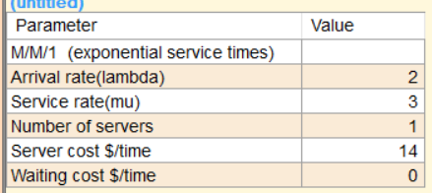

Mechanic 1

|  |  |  |
| --- | --- | --- |
| Parameters | Values | minutes |
| Average server utilization | .67 |  |
| Average number in the queue(Lq) | 1.33 |  |
| Average number in the system(L) | 2 |  |
| Average time in the queue(Wq) | .67 | 40 |
| Average time in the system(W) | 1 | 60 |
| Probability (% of time) system is empty (P0) | .33 |  |
| Cost (Labor + # IN SYSTEM*wait cost) | 14 |  |
| Cost (Labor + # WAITING * wait cost) | 14 |  |

Mechanic 2:

|  |  |  |
| --- | --- | --- |
| **Parameters** | **Values** | **minutes** |
| Average server utilization | .5 |  |
| Average number in the queue(Lq) | .5 |  |
| Average number in the system(L) | 1 |  |
| Average time in the queue(Wq) | .25 | 15 |
| Average time in the system(W) | .5 | 30 |
| Probability (% of time) system is empty (P0) | .5 |  |
| Cost (Labor + # IN SYSTEM*wait cost) | 20 |  |
| Cost (Labor + # WAITING * wait cost) | 20 |  |

1. Waiting Cost 30$

Mechanic 1:

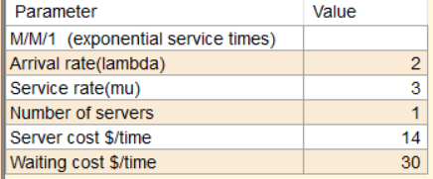

|  |  |  |
| --- | --- | --- |
| **Parameters** | **Values** | **minutes** |
| Average server utilization | .67 |  |
| Average number in the queue(Lq) | 1.33 |  |
| Average number in the system(L) | 2 |  |
| Average time in the queue(Wq) | .67 | 40 |
| Average time in the system(W) | 1 | 60 |
| Probability (% of time) system is empty (P0) | .33 |  |
| Cost (Labor + # IN SYSTEM*wait cost) | 74 |  |
| Cost (Labor + # WAITING * wait cost) | 54 |  |

Mechanic 2:

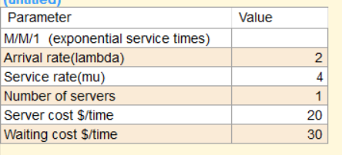

|  |  |  |
| --- | --- | --- |
| **Parameters** | **Values** | **minutes** |
| Average server utilization | .5 |  |
| Average number in the queue(Lq) | .5 |  |
| Average number in the system(L) | 1 |  |
| Average time in the queue(Wq) | .25 | 15 |
| Average time in the system(W) | .5 | 30 |
| Probability (% of time) system is empty (P0) | .5 |  |
| Cost (Labor + # IN SYSTEM*wait cost) | 50 |  |
| Cost (Labor + # WAITING * wait cost) | 35 |  |

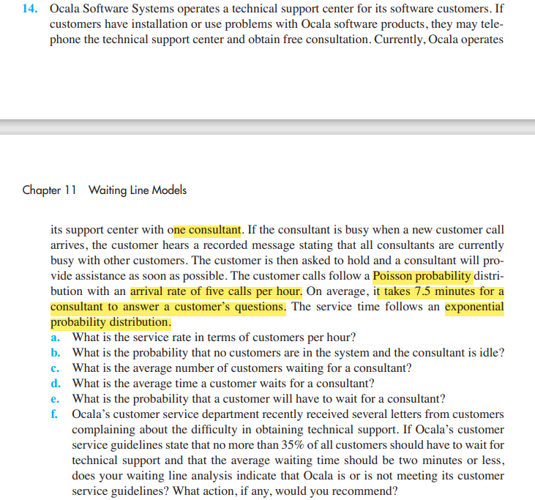

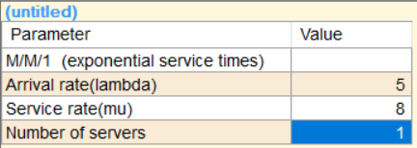

|  |  |  |
| --- | --- | --- |
| **Parameters** | **Values** | **minutes** |
| Average server utilization | .63 |  |
| Average number in the queue(Lq) | 1.04 |  |
| Average number in the system(L) | 1.67 |  |
| Average time in the queue(Wq) | .21 | 12.5 |
| Average time in the system(W) | .33 | 20 |
| Probability (% of time) system is empty (P0) | .38 |  |

1. 8
2. 0.38 / 38%
3. 1.04
4. 12.5 minutes
5. 1-0.38 = 0.62
6. If we increase are service rate to 15 or more than that then we can achieve desired waiting time in the queue.

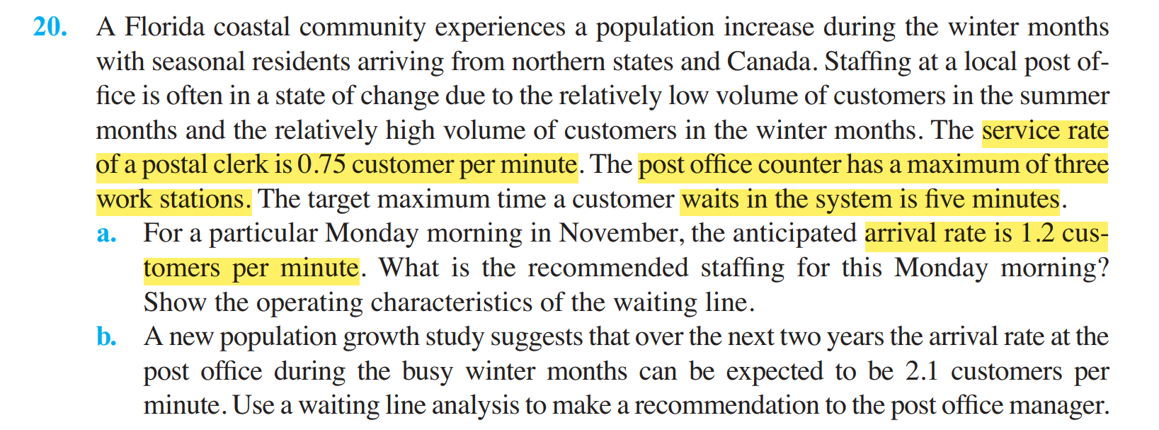

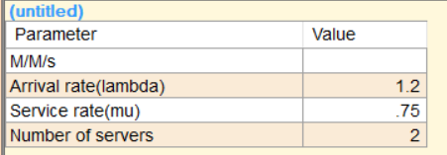

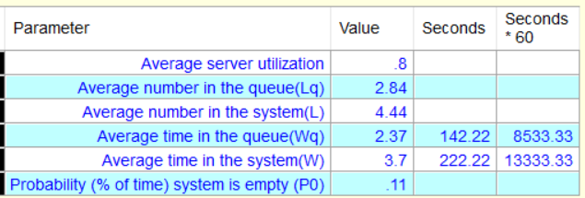

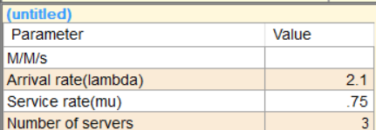

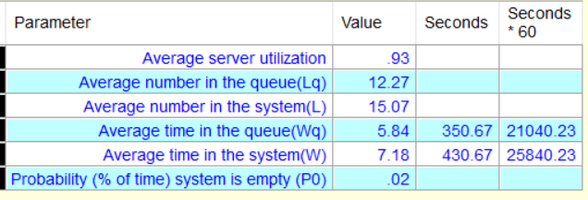

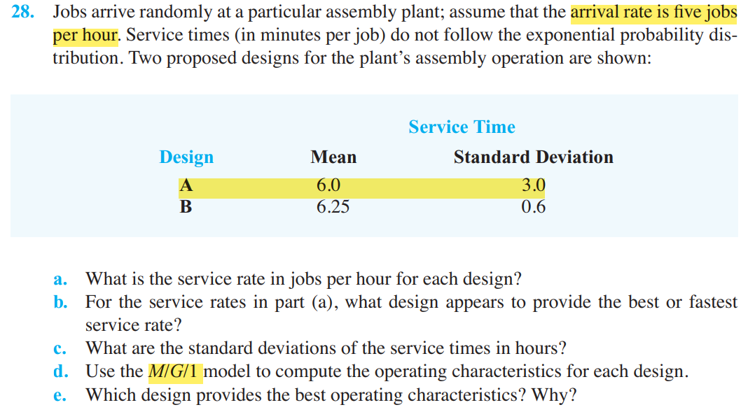

1. 60/6 = 10 for A , 60/6.25 = 9.6 for B
2. A is more fastest
3. 3 min /60 🡪 0.05 0.6 min /60🡪 0.01
4. 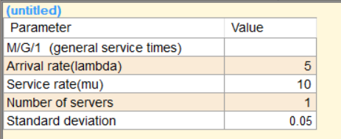

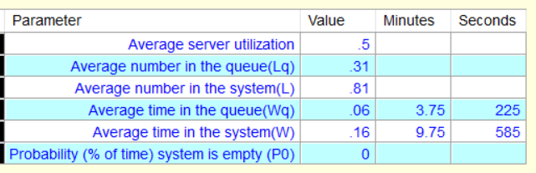

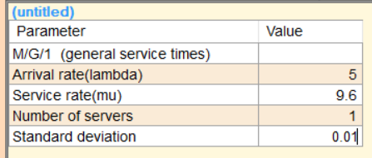

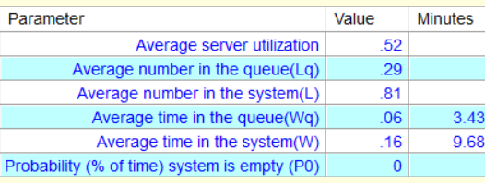

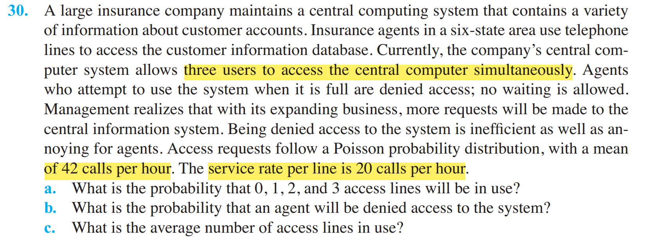

1. 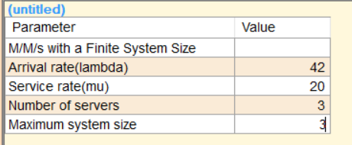

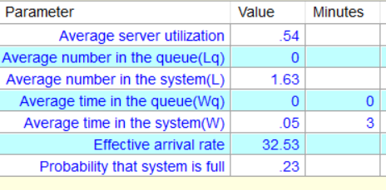 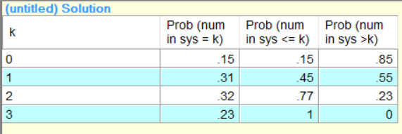

1. 0.23 / 23 % of the time system is full
2. Average number in the system 1.63

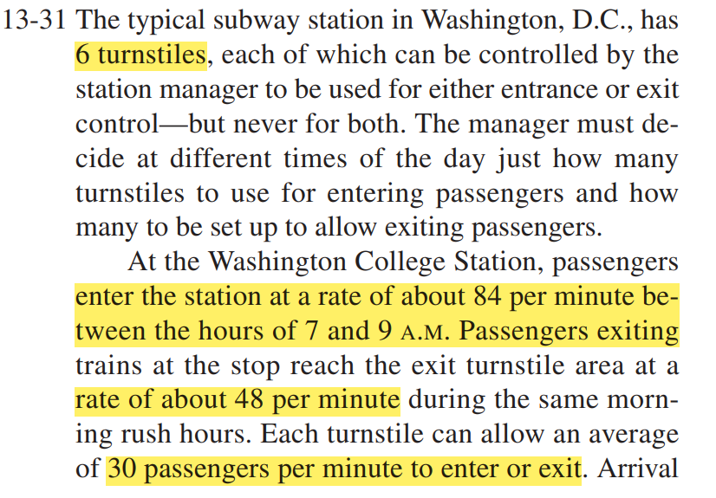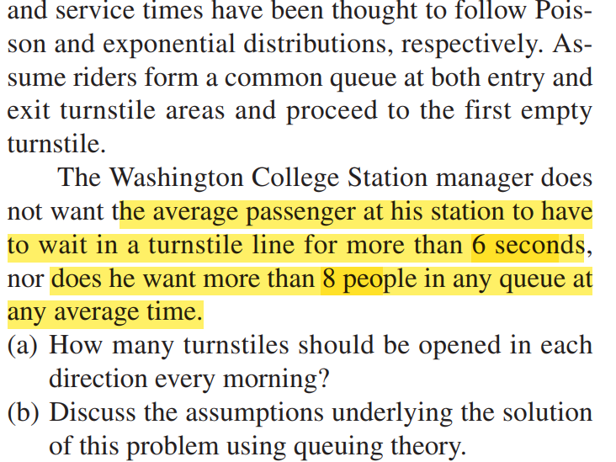

Enter and Exit combination

Enter = 5 Exit=1

Enter= 4 Exit=2

Enter=3 Exit =3

**First Combination**

Enter = 5

Entrance: M/M/s

Arrival = 84 per min, Service Time = 30 per min

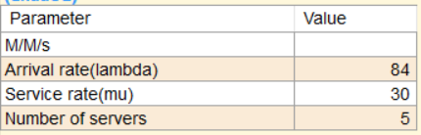 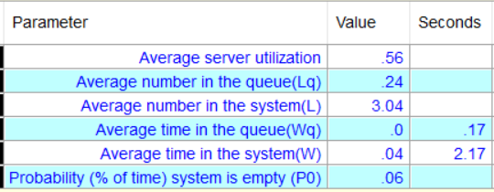

Enter=4

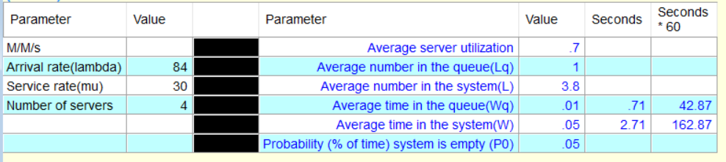

Enter = 3

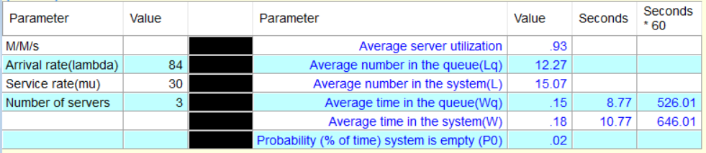

Now for Exit

Arrival = 48 per min, Service Time = 30 per min

Exit=1

Not possible

Exit=2

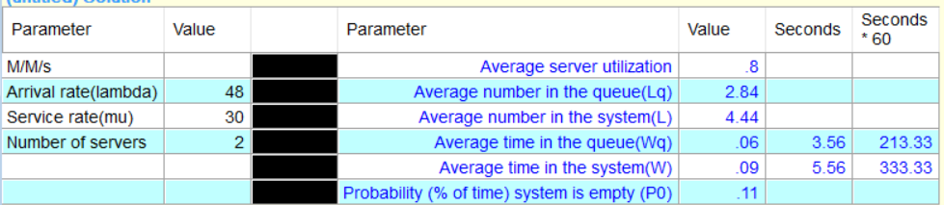

Exit=3

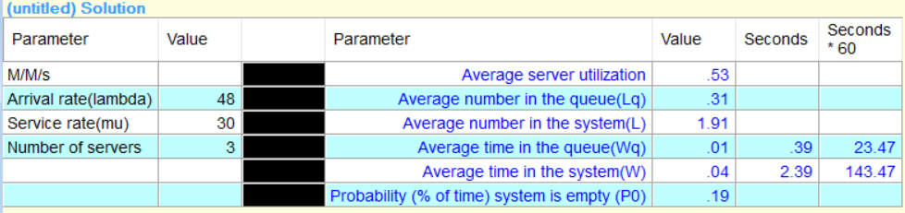

Enter= 4 Exit=2  
is suitable as it meets the criteria