The Track Racing

Handbook



Syed Misbah

[syedmisbah.github.io](http://www.syedmisbah.github.io/) | +91 9066665419

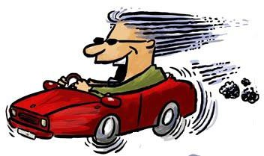

**The Handbook of Track Driving**

Nowadays everyone wants to be a speed racer. Whether is comes out of being a true car lover, or just for the sake of testing your limits to attain that adrenaline rush, street racing, drag racing and performance rallying are something most people having a car aspire or are inspired to do. But one cannot simply drive like Sebastien Loeb or Peter Solberg without having at least a basic technical knowledge of how it all works. And this is what this article, which I have compiled after a great deal of research and personal experience, educates you on…from the techniques behind all those drags and drifts to the underlying principle of how spark plugs and the infamous NOS kits work!

**Warning**: I am 24 right now, and I have had my fair share of high-speed experiences as well as a couple of near misses. Let me tell you this: It is not a good thing at all to drive at insanely high speeds (above 130 kph) in India in any car, be it a Lamborghini or a Skoda. All of your mind is focused on the next few kms of visible blacktop and their flanks, and even if you know there is absolutely nothing around as far as you can see, you have to keep telling yourself that's not enough. After having reached those speeds you realize that it was a bad idea, and that curve in the distance has come in a matter of seconds. You then hysterically reach for the brakes trying to slow down for the corner and just when you feel like you have it under control and are taking the corner slowly, you look at the speedo; the car is still doing 140. At those speeds you lose your sense of perspective. This effect is called velocitization. If 200 seems fast to you, braking down to 100 will seem like you are almost about to stop. Doing such speeds, on any road-especially Indian roads is suicidal. This holds for any car, anywhere.

## DO NOT RACE on public roads, ever. If you’ve to race, go to your local racing track and book a day. Racing IS DANGEROUS and can cost you your life & possibly that of others.

Contents

**Warning**. 2

Oversteering: 7

In road cars 7

In race cars 8

Understeering: 8

Physics 8

Design 9

Basics 10

How it’s done abroad! 10

Drag Racing Techniques 13

For Manual Transmissions 14

For Automatic Transmissions 15

Drifting 17

What is drifting? 17

History 18

Today 18

Cars 19

How Is Drifting Done? 20

Drifting Techniques 21

Heel-Toe-Shifting: 21

Instructions: 21

Power-Over Drift: 21

Handbrake/Handbrake Drift/Parking Turn: 22

Instructions: 22

Left-Foot Braking: 22

Instructions: 23

Pendulum: 23

Instructions: 23

Scandinavian Flick: 24

Instructions: 24

Careful Clutch-Stab: 24

Quick Clutch-Stab 24

Power Slides: 25

Instructions: 25

AWD Power Slide 25

Instructions: 25

Clutch-Kick Drift: 26

Shift-Lock Drift: 26

Dirt Drop Drift: 27

Feint/Inertia Drift: 27

Changing Side Swing: 28

Manji Drift: 28

Jump Drift: 28

Kansei Drift: 29

Long Slide Drift: 29

Swaying Drift (Choku-Dori): 30

Donuts/ Doughnuts: 30

Drift Angles: 33

Front-wheel-drive drift: 33

Late Apex and 90-Degree Corner Drifts: 35

Medium Speed and S-Corner Drifts: 36

THINGS YOU SHOULD KNOW 37

Torque: 37

Work: 37

Power: 37

Horsepower: 37

Torque Vs. Power: 38

Steering 39

Steering Wheel Grip 39

Steering Wheel Control 40

A Visual Aid for Steering Right! 41

Shifting 43

A Visual Aid for Shifting Right! 44

Short-Shifting 45

Braking and Accelerating 46

Braking 46

Accelerating 47

Smooth Acceleration: 48

Braking Distance: 49

Cadence Braking: 49

Braking Around a Corner: 50

Winter Driving 50

Cornering 50

A Visual Aid for Cornering Right! 53

Complex Corner Sets: 56

Corning Examples 56

Visual Field 59

Reference Points 61

Passing 63

Automobile Configuration 64

Camber Angle 66

Improving Air Induction 67

Increasing the Exhaust Rate 69

Maximizing Combustion 69

Spark Plugs 70

SPARK PLUG BASICS: 71

Heat rating and heat flow path of spark plugs 72

Tip Temperature and Firing End Appearance 73

Advancing Ignition Timing 74

Engine Speed and Load 74

Ambient Air Temperature 74

Humidity 74

Barometric Pressure/Altitude 75

Pre-ignition 75

Detonation 75

Misfires 76

Fouling 76

FAQ’S 77

Q: How do I choose the right spark plug? 77

Q: How do I "read" a spark plug? 78

Normal Condition 78

Dry and Wet Fouling 79

Overheating 79

Deposits 79

Lead Fouling 80

Breakage 80

Normal Life 81

Abnormal Erosion 81

Melting 81

Erosion, Corrosion and Oxidation 81

Lead Erosion 82

Q: What is a "fouled" spark plug? 82

Q: Do I need to set the "gap" when installing a new set of plugs? 83

Q: Are special plugs always necessary on a modified engine? 83

Q: How do I install spark plugs correctly? 84

Q: When should I use a resistor spark plug? 84

Q: Why are there different heat ranges? 84

Q: What do the numbers and letters in a part number represent? 85

Q: Does humidity affect spark plug temperature? 85

Q: Does ignition timing affect a spark plug's temperature? 85

Q: Does compression ratio affect firing end temperature? 85

Q: Can old spark plugs be cleaned? 85

Q: What is the maximum I can open or close the gap? 85

Q: What is pre-ignition? 86

Q: What is detonation? 86

Nitrous Oxide Systems – The Need for *Speed!!!* (A special thanks to Gordon for this!) 87

How to Make Horsepower 87

What Nitrous Oxide Is and What Nitrous Oxide Isn’t? 88

Spark Plugs and Nitrous Oxide: What Works, What Doesn't, and Why 89

Types of Nitrous Oxide Systems an Overview of Wet, Dry and Direct Port Systems 90

**Oversteer and understeer**

Before learning about drag racing, drifting, etc., we first need to know about the basics underlying them.

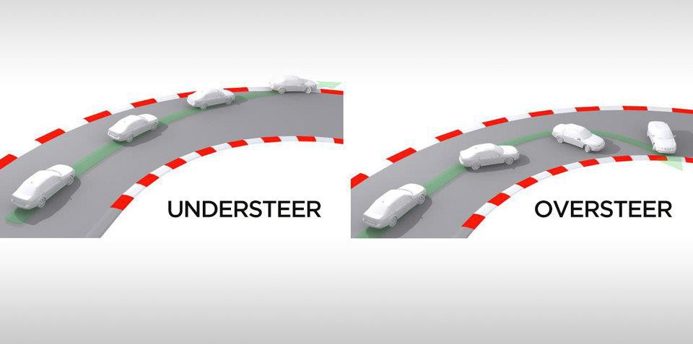

# Oversteering:

Oversteer occurs when the rear tires have a loss of traction during a cornering situation, thus causing the rear of the car to head towards the outside of the corner. The act of deliberately sending a car sideways through a series of corners is actually a popular form of motorsport that originated in Japan known as drifting. A more technically correct definition is that oversteer is the condition when the slip angle (I have given the meaning of *slip angle* in the “**understeering**” section.) of the rear tires exceeds that of the front tires. Rear-wheel drive cars are generally more prone to oversteer, in particular when applying power in a tight corner.

## In road cars

Contrary to popular opinion, modern rear-wheel-drive cars are much more user-friendly in this regard, as they are set up to understeer, and the more powerful ones even have onboard computer systems which can automatically brake the car or override the driver's throttle inputs. This is because understeer is generally much safer for novice drivers, whereas oversteer is much more difficult to correct when one's not prepared for it. The natural reaction of most drivers in case of loss of control is to try to slow down either by lifting their foot off the gas pedal or even by braking. Both of these will help bring an understeering vehicle under control but can have disastrous effects in the case of oversteer. This is because braking causes weight transfer towards the front of the car, thus reducing rear

traction even further. The right oversteer correction is to gently steer into the slide, then take the power away as needed. Indeed, cutting the power mid-corner can induce oversteer even in a front wheel drive vehicle. This is known as ‘lift-off oversteer’. "Trail braking," or continuing to apply brake pressure after turning into a curve, can induce oversteer by transferring weight off of the rear tires, regardless of whether the car is front, rear or all-wheel drive. Note that in a front-wheel-drive vehicle, it is often better to simply accelerate hard to correct a slide.

## In race cars

A car that tends neither to oversteer nor understeer when pushed to the limit is said to have neutral handling. It seems intuitive that racing drivers would prefer a slight oversteer condition to rotate the car around a corner, but this is wrong for two reasons. The most important reason is that the most important thing in racing is accelerating early as you pass the apex. The driver who accelerates sooner and/or harder has a large advantage. The rear tires need some excess traction to accelerate the car in this critical phase of the corner, while the front tires can devote all their traction to turning. So, the car must be set up with a slight understeer. Also, an oversteering car would be virtually impossible to trail brake, as the additional oversteer caused by trail braking would spin the car. Trail braking is a way to go faster in many, although not all, corners. If possible, watch a race carefully. If a racecar shows any noticeable oversteer exiting a corner, the car behind will accelerate better off the corner and make ground or pass. Note that this applies only to pavement racing. Dirt racing is a different matter.

# Understeering:

Understeer is a term for a car handling condition during cornering in which the circular path of the vehicle's motion is of a greater diameter than the circle indicated by the direction its wheels are pointed. In other words, it means that understeering happens when the front of the car does not have as much grip as the driver wants, and the car has a tendency to plough straight on at a corner.

## Physics

Under all high speed (greater than approximately 10mph (16 km/h) for a typical automobile) cornering conditions a wheeled vehicle with pneumatic tires develops a greater lateral (i.e., sideslip) velocity than is indicated by the direction in which the wheels are pointed. The difference between the circle the wheels are currently tracing and the direction in which they are pointed is the slip angle. Or simply saying, *slip angle* is the angle between the tires actual path and its natural path. If the slip angle of the front and rear wheels is equal, the car is in a neutral steering state. If the slip angle of the front wheels exceeds that of the rear, the vehicle is said to be understeering. If the slip angle of the rear wheels exceeds that of the front, the vehicle is said to be oversteering.

## Design

Any vehicle may understeer or oversteer at different times based on road conditions, speed, and available traction. The design of a vehicle, however, will tend to produce a particular "terminal" condition when the vehicle is pushed to and past its limits of adhesion. "Terminal understeer" refers to a vehicle which, as a function of its design, tends to understeer when cornering loads exceed tire traction.

Terminal handling conditions are a function of vehicle length and front/rear weight distribution (and thus the vehicle's polar moment of inertia) and front/rear tire traction (further modified by the relative roll stiffness of the front and rear, which affects the outward weight transfer during cornering). A front-heavy vehicle with low rear roll stiffness (from soft springing and/or undersized or nonexistent rear anti-roll bars) will have a tendency to terminal understeer: its front tires, being more heavily loaded even in the static condition, will reach the limits of their adhesion before the rear tires, and thus will develop larger slip angles. Front-wheel-drive cars are also prone to understeer because not only are they usually front-heavy, transmitting power through the front wheels also reduces their ultimate grip.

Although understeer and oversteer can each cause a loss of control, as explained earlier, many automakers design their vehicles for terminal understeer in the belief that it is easier for the average driver to control than terminal oversteer. Unlike terminal oversteer, which often requires several steering corrections, understeer can often be reduced simply by reducing speed.

**Drag Racing**

## Basics

Drag racing is all about wringing the maximum acceleration out of the car. Basically, a proper drag race tournament consists of a series of two-car eliminations in an all-out acceleration contest from a standing start between two vehicles over an exact distance at a special drag racing track. In India it is usually done on any empty straight road.

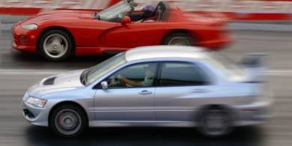

## How it’s done abroad!

Abroad, drag racing facilities are outfitted with "Christmas Tree" lights, and the standard distance is usually either a quarter-mile (1,320 feet) or an eighth-mile (666 feet).

Competing vehicles are divided into a variety of classes, with specific rules that determine eligibility based on type of car and modifications allowed. In addition to the regular "heads-up" races where both cars start off together, there are also handicapped races, known as "E.T. Bracket Racing," where two vehicles of varying performance can race on a potentially even basis. The anticipated elapsed times for each vehicle are compared, with the slower car receiving a head start equal to the difference of the two. With this system, any two vehicles can be paired in a competitive race.

In a professional category racing, the "Christmas Tree" lights control the most important aspect of the race-the launch. The first row of yellow lights warns drivers as they *slowly* approach the starting line. The second row confirms the "staged" position, which is when the front wheels of the car should be stopped on the starting line as it crosses the staged sensor beam. Then come the "three-amber starting system" lights. In a "pro start," all three amber floodlights in a driver's lane flash almost simultaneously before the green light comes on. In a regular handicap race, drivers get a countdown of one amber light at a time until the green light comes on. The pro start system runs with a 0.4-second difference between amber and green lights, while the handicap system runs with a 0.5second difference between each of the bulbs. As the green light turns on, the race begins and the timer is started. The timer stops only when the car crosses the finish line at the other end of the track, with time and trap speed recorded. If the last red light turns on, the driver is disqualified. This is caused by a car leaving the starting line before the green light comes on, or staging too deep past the starting line.

There are techniques to gain an advantage even before the light goes green. People remove all excess weight and loose items, including spare tire, jack, hubcaps, CDs, beer cases and even excess petrol in the fuel tank. Now comes dealing with the tires.

Firstly, any negative camber (information about camber is given later on in the article) is dialed out in the suspension setup, which can be done at any alignment shop. This gives optimum grip for the tires. Secondly, all those 18-inch rims with those stiff low-profile tires are ditched, for the old stock 15-inch wheels with high-profile tires. These absorb the initial jolt when launched, and reduce tire spin and wheel hop. People who are really serious and have the money, replace their tires with drag racing slicks at the strip.

Once waved into the staging area, the cars proceed slowly. If the cars have street tires, then there is no need to go through a water box— they simply drive around it. If the cars are running slicks, then they idle through the water to get the slicks wet. After wetting the tires, the cars pull forward a few feet and do a burnout to warm up the tires.

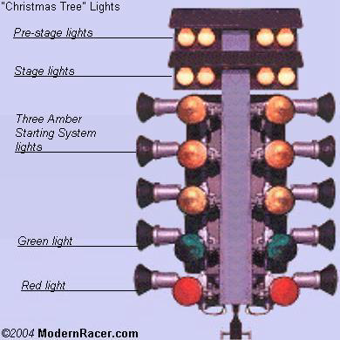

When you pull up at the line for staging, you can try your luck, or your skill, to stage as far into the staged beam as you can. How you stage has a large effect on things like your reaction time and final time.

Staging "shallow" means that your car takes more time to pass through the staged light and increases your reaction time, assuming all other variables are constant. However, it lowers your final elapsed time, and increases your trap speed. This is because the timer doesn't start the timing until the tire comes out of the starting line beam. By then, your car is already moving, so you get a slight running start. This only gives you an advantage over your opponent if you are a bit quicker in your reaction time to make up the difference. The thing is, the race is won based on who crosses the finish line first, not your elapsed time. It's possible to have a quicker time and still lose because you were late off the line. Shallow staging also allows for a driver who leaves early or creeps forward a bit before the green light.

"Deep" staging puts you at the edge of disqualification, but also a little closer to the finish line, which is always an advantage. If you find that you can't get your reaction time down enough, either because your car is a little jumpy off the line or you are having trouble leaving on that last yellow, deep staging can help. If the driver has large-diameter front tires, he probably would want to deep stage to decrease the rollout. But many drivers should also be aware that if the car has very little ground clearance, pieces of the front bodywork or suspension can also trigger the lights. The driver also has to be sure that it is really his tire in the staged beam, and not his front chin spoiler.

So, in short, shallow staging increases your reaction time, reduces your elapsed time and increases trap speed, while being the safe choice for beginners. Deep staging decreases your reaction time, increases elapsed time and reduces the final trap speed, putting you at the edge of disqualification, so it should be reserved for experienced racers.

That, I hope, should cover the basics of getting ready for your drag run without heavy modifications to your car. There are more things that people do, like put ices on the air intake and such, but those are touchy subjects. And launching the car is another subject by itself.

For now, it is just about having fun.

## Drag Racing Techniques

Drag racing, as explained earlier, is best described as a tournament consisting of a two-car straight-line race. It is an all-out acceleration contest from a standing start between two vehicles over an exact distance. Professional drag strips are available for public use all over the world, but the illegal street racing culture has popularized drag racing nowadays in such a way that most common folks think of drag racing as a bunch of sticker-clad street cars

causing mayhem at night. Movies like 2 fast 2 furious didn’t help much either!

Well, whatever gets you going; it is a fact that the launch becomes the deciding factor in any drag race where the machinery is equal.

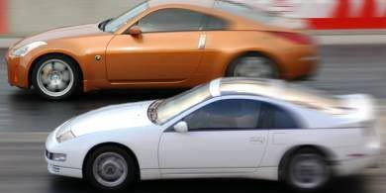

The race not only depends on the launch, but also on how much you know about your car. Every car has its own launching method, and the techniques detailed here will help you determine what is best for your car. All you need to do is experiment with your car, and be aware of any changes to your setup, tarmac quality or weather conditions that could change what you thought was the best method. Pretty much the only hard and fast rule is to practice in various conditions. Drag racing is definitely hard on your car, but to become consistent in your driving, you will have to sacrifice some hard-earned cash for tires, repairs and modifications.

The way you launch your car is based mainly on two variables the type of transmission in your car (manual or automatic), and the drive wheels (front-wheel-drive, rear-wheel drive or all-wheel-drive).

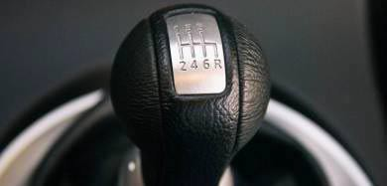

## For Manual Transmissions

We will take a look at managing a manual transmission first. With a stick shift, the main aim is not only to avoid excessive wheel spin by pressing the throttle too much, but also to avoid bogging down the motor by pressing the throttle too little. The driver has to get the throttle input just right. Each car engine has a different rpm range in which it will produce the most power. The trick is to keep the engine in this *sweet spot* from the moment you cross the starting line all the way to the finish line, without any of this peak power being wasted.

Launching a car hard from a dead stop is accomplished by slipping the clutch and spinning the tires, both within reason. Power is lost here, but most engines have narrow power and torque bands, so the fastest launch will include wheel spin and slipping the clutch. The only way to find out how much slipping would be *just right* is to experiment at the track, holding the throttle at various rpm levels at launch to see how much juice is needed for the quickest start.

While playing with the clutch and throttle, use the parking brake to keep your car from rolling. This is the only way to keep your car stationary while you work the clutch with the left foot and the throttle with the right. You then release the parking brake as you launch.

Some people may say a manual benefit from power-shifting during a race, which is to keep the throttle floored between shifts. It is not a good idea for a beginner, since an ill-timed shift can cause your engine to over-rev and inflict permanent damage.

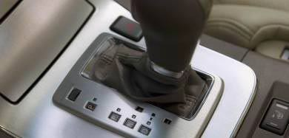

## For Automatic Transmissions

In general, automatic transmissions are known as being more useful for lazy drivers than for hardcore racers. But it may be surprising for some to know that many pro drag-racing cars have heavy-duty auto gearboxes. That's because the brake-torque launch is an automatic specialty. This launch involves keeping the car stationary by flooring the brakes with the left foot, while using the right foot to rev up the engine against the torque converter. In technical terms, this *preloads* the entire drivetrain with the stress of a launch, allowing the engine to rev closer to its power and torque peaks at the starting line. Brake-torqueing is also beneficial for turbocharged engines as it allows boost to build up before the launch, reducing turbo lag. The only problem is that there is a lot of stress on the transmission, and the consequent heat build-up can destroy your automatic gearbox.

Unless your car has too much power for the tires to handle, a brake-torque launch usually will not spin the wheels. This is because the automatic transmission absorbs the shock by design, and brake-torqueing actually reduces stress on the rest of the drivetrain. Instead of a sudden massive load, the drivetrain has the torque applied slower instead of one huge jolt.

If your car has power brakes, you could apply the brake-torqueing technique even better. At the starting line, shift your auto gearbox into neutral and floor the brake pedal with your left foot. Rev the engine once and quickly get off the throttle. You will feel the brake pedal sink further to the floor. This greatly increases the braking force. Now shift back into gear. You will now be able to rev up the engine even higher against the torque converter.

The downfall of standard automatics is their easy-going nature while shifting, so you lose power during the actual race, where a manual would have allowed for more aggressive upshifts. However, the shift points of an automatic can be professionally modified for drag racing, and some new automatics even allow for manual shifting or have a sport setting for quicker gear changes. In fact, you could shift up through the gears even on most conventional automatics for a little more *oomph*.

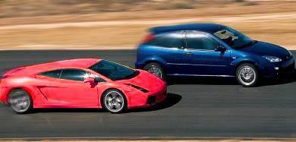

The drive wheels make a big difference in the way your car launches. Most front-wheel drive cars lose traction and spin the front wheels more easily because the sudden acceleration transfers weight off of the front wheels toward the rear. This is the reason why front wheel-drive pro drag-racing cars have wheelie bars installed at the back, to keep the front end pressed to the ground. You have to launch using less throttle than you would with a rear-wheel-drive, to avoid excessive wheelspin, and then you gradually apply more throttle as you gain traction.

Rear-wheel-drive cars have more traction off the line, as the weight transfers toward the rear during acceleration. You need to slip the clutch more to keep the engine from bogging down because spinning the tires isn’t that easy, especially if you are low on power but have wide rear tires. Also watch out for wheel hops.

Recently, all-wheel-drive cars have made inroads in the sport compact market with the likes of the Mitsubishi Lancer Evo and the Subaru WRX. These high-tech four-wheel driven machines often have more traction than they can use, so a nearly full-throttle launch is possible without a hint of wheelspin. Generous throttle application is needed since bogging down the motor is even easier in these cars. But these perfect-looking launches are very hard on the clutch and drivetrain. These cars actually last longer for drag-race duty when equipped with an automatic, and the easiest of all to launch, but the most hardcore of these rally-bred cars only come with a manual in keeping with their corner-carving tradition.

Anyway, after figuring out the best way to launch your type of car, you then fine-tune your technique to factor in environmental conditions like the track surface, the weather and ambient temperature. Learn the handling quirks of your own car, and practice in various conditions. Vary only one parameter at any given time amount of launch revs, sweet spot of the clutch, etc.

After your now-perfect launch, just keep the steering wheel straight, shift just before the tach hits redline, and floor it after every shift. With an automatic, shifting it manually can fractionally improve your time, but just leaving it in *Drive* probably will be better for beginners. After crossing the finish line, just slowly and gradually apply the brakes and take in the rush that you just experienced.

# Drifting

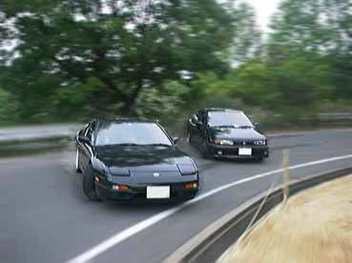

## What is drifting?

Basically, drifting is getting your car sideways down a road. It doesn't sound very hard does it? Sounds a lot like power sliding (for all those who aren’t familiar with this term I have given information about it later on in this article) huh? Well it isn't. It's much more complex. Instead of a drifter causing a drift and then countering to straighten out, he will instead over-counter so his car goes into another drift. That is the reason many drifters do it in the mountains, because there are many sharp turns strung together. So, in essence, a good drifter has the ability to take five or six opposing turns without having traction at any point in time.

In technical terms, drifting refers to the difference in slip angle between the front and rear tires of a car. When the rear wheels are slipping at a greater angle than the front wheels, the car is drifting, or oversteering. The rear end of the car appears to chase the front end around a turn, the driver utilizes both front tires and the rear tires to control the actual direction of the car. More throttle induces more rear wheel slip angle and the rear of the car wants to overtake the front. The goal is for the driver to achieve steering lock and use the throttle to fine tune the car's angle and direction.

Drifting is a driving style distinguished by oversteering into and completely through the corners. This is usually done with FR (front-wheel-drive) layout vehicles, as the power and weight distribution characteristics on these cars are ideal for the maneuver. Drifting may be done informally for fun, in a formal setting where the goal is a mix of fun and building skills for improved car control, or in competitive motorsports. Competitive drifting is a motorsport rated on style, rather than speed around a track or position in a group of cars. Overall performance is judged on four factors: cornering angle, line, speed and excitement/style.

Drifting is not the fastest way around a racetrack. Drifting is useful in rallying, but in circuit racing is slower than conventional techniques.

## History

Many attribute the return of drifting as a competitive sport to mountain-road racers of rural Japan. Informal challenges on back mountain roads (called Touge pronounced "Toh-gey") eventually evolved into a heavily funded and advertised competitive events, sanctioned by organizations and held on private tracks. Drifting began in the United States in 1996 with an event at Willow Springs racetrack in California hosted by the magazine Option, but it did not become popular until around 2002, and has since exploded into a massively popular form of motorsport. Japanese drifters are still considered to be at the cutting edge of technique and car development, but their American counterparts are quickly catching up.

Rumor has it that Drift King Keiichi Tsuchiya was in a car race, and was dead last. He decided to swing the car around the corners, shocking and amazing the crowd. When accessed later for comment, Tsuchiya called it "drifting." While this is not the origin, it is probably where it obtained its name and introduction. In 1977, Keiichi began his racing career driving many different cars in amateur racing series events. Racing these underpowered cars was difficult but again a great learning experience. Later, Keiichi was picked up to drive the ADVAN sponsored Toyota AE86/Sprinter Trueno (JDM Corolla GT-S). During many races on a downhill corner he would drift the car and carry a better corner speed than his competitors. This technique is what made him the Drift King, not, as most believe, that he was first in the drift scene.

Many of the techniques used today in drifting were developed by rally drivers competing on dirt, gravel and snow. On such surfaces, the fastest way to take a corner is generally by sliding.

## Today

Nowadays, drifting has evolved into a competitive sport where drivers compete in rear wheel-drive cars to keep their cars sideways as long as possible. At the top levels of competition, especially the D1 Grand Prix in Japan, the United Kingdom and the United States, drivers are able to keep their cars sliding for extended periods of time, often through several turns. Drifting competitions are judged based not on the time it takes to complete a course, but on line, angle, speed, and show factor. Line involves taking the correct line, which is usually announced by judges. Angle is the angle of a car in a drift, the more the better. Speed is the speed entering a turn, the speed through a turn, and the speed exiting the turn; faster is better. The show factor is based on multiple things, such as the amount of smoke, how close the car is from the wall, and falling aero. It's based on how "cool" everything looks. Final rounds of competition often include tandem drift runs nicknamed "tsuiso" (chase-run) in Japanese, where one car follows another through the course, attempting to keep up with or even pass the car in front. In the tsuiso rounds, it doesn't matter if the racing line is wrong; it matters who has the most exciting drift.

Normally, the leading car usually produces a max-angle, but still close off the inside a little to prevent passing. The chasing car usually drifts with less angle, but very close to

the lead car. But a car does not even have to keep up, and in fact in some cases a car that was left behind on the straight produces a beautiful drift, winning him that round. A spin, understeer, or collision results in a disqualification of the offending party.

## Cars

Any Rear-Wheel-Drive (RWD) car can be drifted (with those having a limited-slip differential preferred), and some All-Wheel-Drive (AWD) cars can also drift, often with less angle, but higher speed. There is some debate over whether or not Front-Wheel Drive (FWD) vehicles can drift. By the technical definition (rear wheels slipping at a greater angle than front wheels), they are indeed able to drift. However, many consider FWD vehicles a poor choice for drifting, as the frequent use of the emergency brake (necessary to drift FWD cars) slows them down and makes them harder to control. Also, since they use their front tires for both steering and power, the car loses control after a single slide, while RWD cars can drift through consecutive corners. In this way, the definition of drifting is frequently challenged to say that FWD cars cannot drift, only power slide. However, some drifters such as Kyle Arai or Keisuke Haketeyama use EF Civics to drift, and succeed in doing so, sometimes besting out their RWD opponents.

AWD vehicles, such as the Subaru Impreza WRX STi, and Mitsubishi Lancer Evolution drift at a much different angle and are usually induced by power-over. As the front wheels are also driven on an AWD vehicle there is a noticeable lack of counter steer. D1 and other professional competitions do not allow AWD vehicles. However, vehicles like the Impreza and the Lancer are being converted to only use the rear wheels so as to become an RWD car that can compete in drift competitions that prohibit AWD cars.

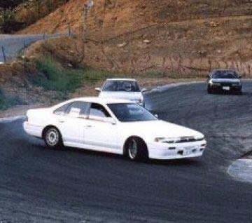

## How Is Drifting Done?

Drifting can be initiated in two ways depending on whether you have a front or rear wheel drive car. The first method is to depress the clutch and gear down into second gear when approaching a corner or bend in the road, and rev your engine to about 4000-5000 RPM. As you are coming up, slightly turn your steering wheel so the car is going away from the corner and then cut back towards it while at the same time releasing the clutch causing the rear wheels to spin. Basically, you are doing a burnout. At this point you should feel a loss of traction in your tires giving your car a hydroplane effect as you begin sliding around the curve. Don't let the drift go because this will give you momentum to take on the next corner. Keep your foot on the accelerator as you control your car keeping it from spinning out as you approach the next turn. Now cut your steering wheel in the direction of the turn and your car will power slide right through it. If you came out of your first drift too slow and you start to regain traction, just pop the clutch again to get your wheel's spinning.

The second technique is used by a few drifters in rear-wheel-drives, but is the only way you can really drift a front-wheel-drive. You have to use the side/hand brake. A front wheel drive cannot whip its tail out because the tires are being driven in the front as opposed to the rear. So, when approaching a turn/bend you pull the side brake until you feel your car lose tire traction. And the rest is pretty much the same except that it's much harder to take more than one turn with a front wheel driver. This is because using the hand brake will cause you to slow down.

# Drifting Techniques

## Heel-Toe-Shifting:

Heel-toe-shifting is a race shifting technique that allows drivers to downshift quickly while applying the brakes. Proper heal toe shifting keeps the engine, transmission, and wheel speed matched up so there is no jolt through the driveline while downshifting. When drifting, heel toe downshifting allows drivers to downshift in order to increase engine rpm, while braking to transfer weight forward and off the rear wheels.

## Instructions:

1. Before entering a turn, do your initial braking to transfer your vehicle’s weight forward. Double clutch / heel-toe downshift (see next step). Turn your wheels into the corner. Carry enough momentum into the corner to induce oversteer.
2. Clutch in, bring your vehicle into neutral, and release clutch. While on the brakes, slide your right heel over to the gas pedal and rev up (blip) the engine to match transmission and engine speed. Without matching revs on downshift, the engine speed will cause a jolt through the driveline, upsetting rear traction uncontrollably.
3. After matching revs, clutch in, and downshift your vehicle. Double clutching is optional, but reduces wear on your transmission. Use the handbrake/side brake/handbrake if momentum and downshift do not create enough oversteer.
4. Release the clutch, get off the brakes, and press the accelerator. Accelerate enough to keep tires spinning to continue oversteer. Add steering input (counter steering) to keep your vehicle from pivoting or spinning out.

## Power-Over Drift:

**Instructions:**

1. Enter a turn at any speed. The power-over drift is based on horsepower so it does not necessarily need much speed or rotational force to perform.
2. Turn your wheels sharply into the turn, and get on the throttle enough to cause your wheels to lose traction. The cornering force of the vehicle combined with the excessive throttle will cause your vehicle to oversteer.
3. When you feel the vehicle’s rear end kicking out, immediately counter steer the wheels to face straight with the road. Your vehicle will pull in the direction of the front wheels, as long as the wheels are still moving. Keep on the throttle. If you press the brakes or let off the throttle because your vehicle is in an extremely oversteered condition, you will spin out

or leave the road.

1. When you wish to straighten out your car, after completing the drift, let off the throttle smoothly and straighten out the wheels as your vehicle kicks in line behind the front tires.

## Handbrake/Handbrake Drift/Parking Turn:

This technique is pretty straightforward; pull the handbrake to induce rear traction loss and balance drift through steering and throttle play. Some people debate the fact that if using the handbrake creates an actual drift, or just a power slide, but ultimately, using the ebrake is no different than any other technique for starting drifts. This is generally the main technique to perform a controlled drift in an FWD vehicle. This is one the first techniques beginners will use as their cars are not powerful enough to lose traction using other techniques. Also, this technique is used heavily in drift competitions to drift big corners.

The **handbrake turn/parking turn**, is a driving technique used to deliberately slide a car sideways, either for the purpose of negotiating a very tight bend quickly, or for turning around well within the vehicle's own turning circle.

## Instructions:

1. Enter a turn at a speed too high for the vehicle to handle (if you do not drift, your vehicle should experience understeer at this speed).
2. Heel-toe Downshift to get your vehicle into a gear low enough to pull you through a drift (2nd gear).
3. Turn your wheels sharply into the turn. By the time you finish downshifting and turning your wheels, you should be at the apex of the turn.
4. Hold in the release button on your handbrake and pull up your brake sharply, then quickly release (handbrake is held up for only about 1 second). If using a RWD car, clutch in while pulling your handbrake. If using a FWD car, keep on the throttle while pulling your handbrake.
5. When you feel the vehicle’s rear end kicking out, immediately counter steer the wheels to face straight with the road. Your vehicle will pull in the direction of the front wheels, as long as the wheels are still moving. Keep on the throttle. If you press the brakes or let off the throttle because your vehicle is in an extremely oversteered condition, you will spin out or leave the road.
6. When you wish to straighten out your car, after completing the drift, let off the throttle smoothly and straighten out the wheels as your vehicle kicks in line behind the front tires.

## Left-Foot Braking:

It is the technique of using the left foot (as opposed to the more usual right foot) to break a modern car.

At its most basic purpose, left-foot braking can be used to decrease the time spent between the right foot moving between the brake and throttle pedals. It can also be used to control

the load transfers.

One common race situation that requires left-foot braking is when a racer is cornering under power. If the driver doesn't want to lift off the throttle, and potentially cause a trailing throttle oversteer situation, left-foot braking can induce a mild oversteer situation, and help the car "tuck," or turn-in better. Mild left-foot braking can also help cure an understeer situation.

In rallying it applies primarily to front wheel drive vehicles. It is closely related to the handbrake turn, but involves locking the rear wheels using the foot brake, which is set up to apply a significant pressure bias to the rear brakes. The vehicle is balanced using engine power by use of the accelerator pedal, operated by the right foot. The left foot is thus brought into play to operate the brake. Rear wheel drive rally vehicles do not use this technique because they can be much more easily turned rapidly by using excess power to the wheels and the use of opposite lock steering.

## Instructions:

1.Upon entering a turn, turn in as usual using the steering wheel. 2.Use your left foot to apply the brakes progressively.

3.Depending on engine power, you will probably need to apply more throttle to maintain speed. The higher the braking applied the larger the effect.

**Note:** The more slippery the surface and higher the speed, the more the effect. Highly dependent on engine power and tuning.

Most cars are tuned for front brake bias for understeer (which is considered safest for passenger cars) makes it harder to use. It wears the brakes faster than normal, the front pair in particular.

## Pendulum:

This technique applies to all RWD and AWD cars. It is used as a destabilizer, for initiating small and large power slides. Also helps car turn around unusually sharp short corners where no power slide is needed.

Its basic theory of operation is that body roll and weight transfer from the two wheels on one side to the other is much stronger, therefore lessening/breaking rear wheel traction.

## Instructions:

Brake earlier than normal before the turn, if speed is too high. If you do not brake earlier and braking is needed, there will be no maneuvering room for the pendulum. Keeping your speed neutral, while still on the straight before the turn:

1. Quickly start to turn away from the turn.
2. Immediately steer back into the actual turn.
3. If power slide is intended, apply sufficient throttle for wheelspin.

**Note:** The more slippery the surface and higher the speed, the more the effect. It is hard to perform at lower speeds without a tighter steering rack.

## Scandinavian Flick:

The Scandinavian flick applies to all cars that are not equipped with automatic transmissions or ABS brakes. It is similar to pendulum, but only serves as destabilizer. It is also safer and more appropriate to use at extremely slippery conditions.

The theory of operation behind it is that the rear wheels are not given a chance to regain traction after being locked up from the quick sudden rotation of the car.

## Instructions:

Instead of braking normally in a straight line:

1. Flick the car slightly away from the turn.
2. Immediately release throttle and Apply full braking (wheels must lock) and clutch (or else the engine will stall). The car will now head down the road in a sideways skid pointing away from the turn, decelerating.
3. Put shifter into appropriate gear and turn the steering wheel all the way in the direction of the upcoming turn.
4. As the turn arrives, let go of brakes. The car will slingshot into the turn in the same way as if a pendulum was used. Let go of clutch and get back on the throttle.

**Notes:** If you hesitate when first applying the brakes, you may go off the road or the front wheels may lock before the rear, making the car aim itself back in the direction of travel.

## Careful Clutch-Stab:

**Applies to:** RWD and AWD with manual transmission.

**Usage:** Low speed destabilizer.

**Theory of Operation:** Sudden overpowering of wheels causes wheel spin.

**Instructions:** Press clutch pedal, come off throttle and start turning. Match revs to speed, then let go of clutch quickly while applying (depending on engine power output) a lot of throttle.

**Notes:** Useful when having braked too late for a Scandinavian flick or pendulum, especially on AWD drive trains.

## Quick Clutch-Stab

**Applies to:** RWD and AWD with manual transmission.

**Usage:** Low speed destabilizer.

**Theory of Operation:** Revs of engine will quickly rise when clutch is disengaged, and will suddenly overpower the wheels when re-engaged causing wheel spin.

**Instructions:** While turning, apply throttle and stomp the clutch pedal once quickly. **Notes:** Useful when having braked too late for a Scandinavian flick or pendulum, especially on AWD drive trains.

## Power Slides:

**RWD Power Slide**

This applies to all RWD cars and is used to eliminate risk of fatal under steer on less than ideal roads, resulting in higher cornering speeds. Its basic theory of operation is that spinning rear tires have decreased lateral grip.

## Instructions:

1.If the engine power is sufficient to break traction simply flick the car into the turn. 2.Immediately apply enough throttle to break traction while at the same time counter steering the car (newbies will notice that if you do not do this at the same time as you apply the throttle you will end up spinning out).

1. More throttle = More lateral tail slide, less forward propulsion. Less throttle = Less lateral tail slide, more forward propulsion.
2. Find the proper balance. The ideal is as little tail slide as possible, just enough to stop it from regaining grip and understeering.
3. To stop sliding, back off throttle gently and apply opposite lock (relative to the turn).

**Note:** Stronger engines are easier to work with. Limited-slip or locked differential is nearly a must-have for proper operation. It is possible to use the end of a power slide to pendulum into another, in the opposite direction. Useful when going from one turn that leads directly into the other. Theory of operation is the same as the final moments of the Scandinavian flick.

## AWD Power Slide

This technique applies to all AWD cars. It is used to eliminate risk of fatal under steer on less than ideal roads, resulting in higher cornering speeds.

Its basic theory of operation is that spinning tires have decreased lateral grip.

## Instructions:

1.Destabilize the car. After having done so, stay on the throttle. 2.More throttle = More sideways motion, less forward propulsion.

Less throttle = Less sideways motion, more forward propulsion. 3.Ideally the rotation of the car is perfect so it needs no adjustments from the steering wheel then it is merely kept straight.

1. If adjustments are needed, simply turn the steering wheel and use the throttle to adjust cornering line.
2. Find the proper balance. The ideal is sliding at an as angle possible without regaining traction and under steering.
3. To stop sliding, counter-steer (relative to the turn). If needed, further throttle.

**Note:** Stronger engines are easier to work with. Limited-slip or locked center and rear differential is nearly a must-have for proper operation. It is

possible to use the end of a power slide to pendulum into another, in the opposite direction. Useful when going from one turn that leads directly into the other. Theory of operation is the same as the final moments of the Scandinavian flick.

## Clutch-Kick Drift:

**Instructions:**

1. Enter a turn at a speed too high for the vehicle to handle (if you do not drift, your vehicle should experience understeer at this speed).
2. Turn your wheels into the turn and stay on the throttle.
3. At this speed, your vehicle should start to experience understeer. When this happens or right before this happens, clutch in, but stay on the throttle.
4. By clutching in and staying on the throttle, your engine will now rev up to high rpms. As soon as this happens, dump the clutch, causing your rear wheels to break traction.
5. When you feel the vehicle’s rear end kicking out, immediately counter steer the wheels to face straight with the road. Your vehicle will pull in the direction of the front wheels, as long as the wheels are still moving. Keep on the throttle. If you press the brakes or let off the throttle because your vehicle is in an extremely oversteered condition, you will spin out or leave the road.
6. When you wish to straighten out your car, after completing the drift, let off the throttle smoothly and straighten out the wheels as your vehicle kicks in line behind the front tires.

## Shift-Lock Drift:

**Instructions:**

1. Enter a turn at a speed too high for the vehicle to handle (if you do not drift, your vehicle should experience understeer at this speed).
2. Turn your wheels into the turn and quickly downshift into a lower gear (2nd gear).
3. By quickly downshifting (but not Heel-Toe Downshifting) you will put stress on the driveline, causing the vehicle to slow down and your engine rpms to increase.
4. After downshifting, quickly get on the throttle causing your wheels to break traction, sending your vehicle into a drift.
5. When you feel the vehicle’s rear end kicking out, immediately counter steer the wheels to face straight with the road. Your vehicle will pull in the direction of the front wheels, as long as the wheels are still moving. Keep on the throttle. If you press the brakes or let off the throttle because your vehicle is in an extremely oversteered condition, you will spin out or leave the road.
6. When you wish to straighten out your car, after completing the drift, let off the throttle smoothly and straighten out the wheels as your vehicle kicks in line behind the front tires.

## Dirt Drop Drift:

**Instructions:**

1. Enter a turn at a low to medium speed.
2. Turn your wheels into the turn and stay on the throttle, but drive slightly off the roadway with the side of your vehicle opposite of the turn you wish to make. (Ex. if you are turning left, let your right-side wheels drop into the dirt)
3. When your rear wheel goes off the road, the low traction surface should cause your wheels to break traction. Stay on the throttle as your vehicle returns to the roadway to continue the drift.
4. When you feel the vehicle’s rear end kicking out, immediately counter steer the wheels to face straight with the road. Your vehicle will pull in the direction of the front wheels, as long as the wheels are still moving. Keep on the throttle. If you press the brakes or let off the throttle because your vehicle is in an extremely oversteered condition, you will spin out or leave the road.
5. When you wish to straighten out your car, after completing the drift, let off the throttle smoothly and straighten out the wheels as your vehicle kicks in line behind the front tires.

## Feint/Inertia Drift:

**Instructions:**

1. On approach to a turn, steer your vehicle away from the direction of the turn you wish to be made. The distance you begin to turn your vehicle away from the turn depends on how fast you are traveling. When you turn your vehicle away from the direction of the turn you want to make, you are loading up your suspension on one side of your vehicle, compressing the springs so that when you turn in the opposite direction, your vehicle will "bounce" back to its desired direction.
2. Once your suspension is compressed on the side of your vehicle opposite of the turn you wish to make, quickly turn back in the opposite direction. This feint motion should be done smoothly, but not necessarily quickly. Turning your wheels too quickly in opposite directions will cause your vehicle to understeer.
3. After rebounding your vehicle back into its desired direction, get on the throttle. When combined with the rotational force of the rebound, the excessive throttle will send your vehicle into a drift. FWD vehicles can use the handbrake instead of the throttle to induce oversteer.
4. When you feel the vehicle’s rear end kicking out, immediately counter steer the wheels to face straight with the road. Your vehicle will pull in the direction of the front wheels, as long as the wheels are still moving. Keep on the throttle. If you press the brakes or let off the throttle because your vehicle is in an extremely oversteered condition, you will spin out or leave the road.
5. When you wish to straighten out your car, after completing the drift, let off the throttle smoothly and straighten out the wheels as your vehicle kicks in line behind the front tires.

## Changing Side Swing:

This technique is used extensively in the Japanese D1 competition and is very similar to Inertia/Feint drift. It is often done on the first entry drift corner, which is often a long double apex turn just before a very fast straight-way. If the straight-way before that double apex is of a downhill orientation, the driver keeps driving on side of the track that is close test to the corner. Then with correct timing in mind, the driver abruptly changes the car onto the other side. This movement has the car momentum to be altered causing the rear wheels to lose traction. The car is in a drift motion right now. Then the drift is carried over into the corner and through it.

## Manji Drift:

This is used while drifting on straightaways. The driver of the car sways the car from side to side while the car is in a drift, which looks impressive. It can be initiated through all the above techniques.

## Jump Drift:

**Instructions:**

1. Enter a turn at medium speed.
2. Turn your wheels into the turn and stay on the throttle, but drive the inside wheels of your vehicle over a low curb.
3. When your rear wheel bounces over the curb, stay on the throttle. When your wheels return to the road, they should be spinning faster than what available traction can handle, causing your wheels to break traction. Stay on the throttle as your vehicle begins to drift.
4. When you feel the vehicle’s rear end kicking out, immediately counter steer the wheels to face straight with the road. Your vehicle will pull in the direction of the front wheels, as long as the wheels are still moving. Keep on the throttle. If you press the brakes or let off the throttle because your vehicle is in an extremely oversteered condition, you will spin out or leave the road.
5. When you wish to straighten out your car, after completing the drift, let off the throttle smoothly and straighten out the wheels as your vehicle kicks in line behind the front tires.

## Kansei Drift:

**Instructions:**

1. Enter a turn at high speed. The Kansei Drift should be performed at race speeds. If you do not drift, your vehicle should experience severe understeer at this speed.
2. Turn your wheels sharply into the turn, and let off the throttle quickly. The cornering force of the vehicle combined with the loss of throttle will cause your vehicle to oversteer.
3. When your vehicle begins to lose traction, get on the throttle again quickly. This will overpower the wheels for the traction that is available, sending your vehicle into a drift.
4. When you feel the vehicle’s rear end kicking out, immediately counter steer the wheels to face straight with the road. Your vehicle will pull in the direction of the front wheels, as long as the wheels are still moving. Keep on the throttle. If you press the brakes or let off the throttle because your vehicle is in an extremely oversteered condition, you will spin out or leave the road.
5. When you wish to straighten out your car, after completing the drift, let off the throttle smoothly and straighten out the wheels as your vehicle kicks in line behind the front tires.

## Long Slide Drift:

**Instructions:**

1. Enter a turn at high speed to perform this drift.
2. Turn your wheels into from the turn.
3. Hold in the release button on your handbrake and pull up your brake sharply, then quickly release (handbrake is held up for only about 1 second). If using a RWD car, clutch in while pulling your handbrake.
4. When you feel the vehicle’s rear end kicking out, immediately counter steer the wheels to face straight with the road. Your vehicle will pull in the direction of the front wheels, as long as the wheels are still moving. Keep on the throttle.
5. If your vehicle begins to lose speed while sliding sideways, heel-toe downshift into a gear low enough to pull your vehicle through the drift.
6. When you wish to straighten out your car, after completing the drift, let off the throttle smoothly and straighten out the wheels as your vehicle kicks in line behind the front tires.

## Swaying Drift (Choku-Dori):

**Instructions:**

1. Enter a turn at medium to high speed to perform this drift.
2. Turn your wheels away from the turn.
3. Hold in the release button on your handbrake and pull up your brake sharply, then quickly release (handbrake is held up for only about 1 second). If using a RWD car, clutch in while pulling your handbrake.
4. When you feel the vehicle’s rear end kicking out, immediately counter steer the wheels to face straight with the road. Your vehicle will pull in the direction of the front wheels, as long as the wheels are still moving. Keep on the throttle.
5. Your vehicle will now be sliding sideways in an angle away from the turn you wish to make.
6. When you want to turn your vehicle back into the direction of the turn you wish to make, let off the throttle quickly and completely. By letting off the throttle quickly, your vehicle will snap back in the opposite direction. Once your vehicle is at its desired angle, get on the throttle again to maintain the drift.
7. Let go of the steering wheel so that your vehicle's wheels line up with the road again. Counter steer if necessary.
8. If your vehicle begins to lose speed while sliding sideways, heel-toe downshift into a gear low enough to pull your vehicle through the drift.
9. When you wish to straighten out your car, after completing the drift, let off the throttle smoothly and straighten out the wheels as your vehicle kicks in line behind the front tires.

## Donuts/ Doughnuts:

A "doughnut" or “donut” is the act of rotating the rear of the car around the front wheels continuously, thereby creating circular skid marks if done right, and causing lots of tire smoke. All in all, it is a pretty pointless technique, with no real use except to show off. Fair enough.

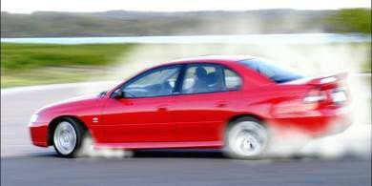

The doughnut is performed differently in FWD and RWD cars. Truth be told, the only *real* doughnuts are performed with a high-powered rear-wheel-drive car. The best doughnuts you'll ever see are performed by V8 Mustangs, Z28 Camaros and Trans Ams, along with rally-bred all-wheel-drive monsters like the Lancer Evo and WRX STi, which send more power to the rear wheels than the front ones. Rear-drivers equipped with a limited-slip differential also have an advantage, as both driving wheels’ spin at the same rate. However, doughnuts are possible with a wide range of cars, but it is a very tricky technique and requires lots of practice. You are sure destroy a lot of tires in the process; so make sure that the local used tire dealer is your best friend!

First, we'll look at rear-wheel-drive doughnuts. The trick to making a doughnut happen is to quickly start oversteering but not so much that you just do a sudden 180-degree spin and stop. The most common method using a manual transmission is to select 1st gear, slowly start driving around in a large circle, then turn the steering wheel to do a tighter circle while at the same time pressing the clutch and pulling the handbrake. When the r e a r wheels lock up and the car starts to skid, floor the accelerator, release the handbrake and let the clutch out. You will now start spinning if your car has enough power. It takes practice trying to balance the throttle to produce a round enough doughnut with the rear wheels while keeping the inside front wheel at roughly the same place. With an automatic, you should first shift into 2 (or L or whatever it's called in your car the idea is to choose the gear used to climb hills, so you get the most torque). You then apply moderate pressure on the brake pedal with your left foot, and then floor the throttle completely with your right foot. The rear wheels should now start spinning while the locked front wheels hold the car in one place. If the wheels don't start spinning, back off the brake pedal a little bit. As your rear wheels start spinning, slowly get off the brake pedal until the car starts moving. Start to turn the wheel and release the brake pedal more, and as you speed up, turn the wheel more sharply and take most of the pressure off the brake pedal. The car will jump forward and turn sharply, and the rear will be moving sideways. If you start to slow down, apply the brakes lightly, and back off the brakes as you start to spin faster. Once you are spinning real fast, you can even flick the wheel the other way to start spinning in the opposite direction. If you cannot start a spin at all, then your car is too weak for this sort of thing. A last-ditch attempt may be to clamp your car's brake lines that lead to the rear wheels, thereby somewhat disabling your rear brakes, and there are also devices called line locks which do this, but if you have no idea about car mechanicals, just give up and buy a new car.

Now for front-wheel-drive doughnuts. These reverse doughnuts look even crazier than rear-wheel-drive doughnuts. They are more easily performed with long-wheelbase cars like Maximas, Bonnevilles or Accords. To start the doughnut, turn the steering wheel completely in one direction and shift into reverse. Then, if you are using a manual, press the

clutch, floor the accelerator and drop the clutch. The car will lurch backwards and turn for a while before the front wheels lose grip and start to slide. The front will now rotate tightly around the back wheels. Back off the throttle a bit so that you don't hit the redline. The car will slow down when you back off, so then you will have to hold the throttle at a constant position. You can even turn the wheel quickly all the way in the other direction, to make the

car slide around the other way. Please be aware that these reverse doughnuts generate huge lateral G's, so if you have a weak stomach, carry a barf bag in the car. Now, to attempt straightforward RWD-style doughnuts with your frontdriver, you can use the handbrake. It is very hard to break rear-wheel traction on a dry surface, so a slippery surface is recommended. To do this, turn the steering wheel completely in one direction and shift into first gear in manual or the hill-climbing gear in automatic. Floor the throttle, and the car will start turning sharply. As the car body rolls to one side, yank the handbrake to get the rear wheel slide started. Now you will have to keep one hand on the handbrake and keep pulling and releasing it at the right moments to keep the rear end sliding. The power should be kept up but you should be careful not to over-rev your engine in first gear. As stated before, you need to do this on a slippery surface, like a wet parking lot or gravel. On grass or dirt, you can even leave the handbrake up and keep spinning. A popular trick to do doughnuts on tarmac is to put plastic trays or wooden planks under the rear tires and keep the handbrake up.

If you have an AWD, you can pretty much forget about doing doughnuts. Most upscale AWD cars either don't have the power or are set up all wrong. If you have a rear-biased AWD car, the technique is basically the same as that for RWD cars, except that you have to play with much higher rpms to break all four wheels loose.

For best results, turn off the a/c and turn off traction control or any other electronic gimmicks if you can, as traction control kills wheel spin. Do not expect to do doughnuts if you cannot turn off that fancy ESP system of yours. Doughnuts look great and are an excellent way to impress lesser mortals, but it is costly on tires, and is stressful on differentials and engines. Reverse doughnuts are even worse, especially on universal joints. And doughnuts can also mess up your wheel alignment. Moderation is the key to a long life for your car, your wallet and your driving license.

## Drift Angles:

Drift angles change based on which wheels are pushing or pulling the car.

## Front-wheel-drive drift:

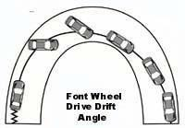

**Rear-wheel-drive drift:**

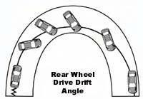

**All-wheel-drive drift:**

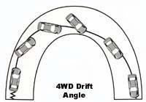

**Uphill and Downhill Drifts:**

Drift angles change based on the slope of the road.

**Downhill Drift** Brake into the turn and steer into the corner until slight oversteer is felt, then throttle out:

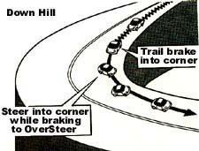

**Uphill Drift** Begin with heel-and-toe for an even blend of RPM on the downshift, then turn in and apply throttle:

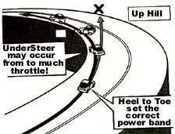

## Late Apex and 90-Degree Corner Drifts:

There are two different ways of approaching a corner.

**Drift Angle for Late Apex** Stay outside of the turn late, then begin turn into the apex point:

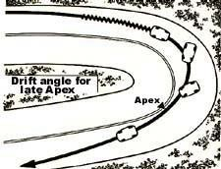

**90-Degree Corner** Drift through the turn at a medium drift angle for correct apex exit:

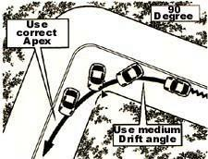

## Medium Speed and S-Corner Drifts:

Drift angles change based on the nature of the corners.

**Medium Speed Drift Angle** Keep a good speed when entering a medium type corner. Don't enter too fast or you will lose the Ageing point:

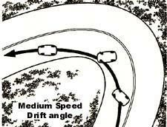

**S-Corner Drift Angle** Set up is key for this style of turn. Begin the drift but always remember the exit of the second part of the corner is most critical and also to set up for the correct Apex:

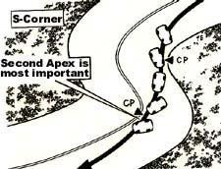

# THINGS YOU SHOULD KNOW

## Torque:

Torque is a twisting force about an axis of rotation. It is measured in units of force times distance from the axis. When you tighten a bolt, you exert a torque on it. If the spanner is 1foot-long and you exert a force of 10 pounds on the end of it then you apply a torque of 10-foot pounds. If the spanner is 2 feet long, then the same force would apply a torque of 20-foot pounds. Whether the torque applied creates movement or not is a separate issue. If the bolt has already been tightened to a torque of 50-foot pounds and you apply a spanner to it using a torque of 20-foot pounds, then it won't move any further.

## Work:

Work is also measured in units of force times distance but there is a subtle distinction between Torque and Work. For work to take place there must be movement involved. Work can be defined as the product of force times distance moved. Let’s imagine we have a sack of grain on the floor weighing 100 pounds and we want to lift it onto a table 3 feet high we would need to do 300-foot pounds of work against gravity to achieve this.

## Power:

Power is the rate at which work is done. The more power a thing generates; the more work it can do in a given space of time. Let’s imagine we ask a small child and an adult to both lift the sack of grain above onto the table. The adult might be able to lift the whole sack in one go but the child would probably not. However, the child could take a pan and lift the grain one panful at a time until the whole 100 pounds was on the table. It would take longer but the end result would be the same. Both the child and the adult would have done 300-foot pounds of work but at different rates we can therefore say that the adult was more "powerful" than the child.

If the adult lifted the whole bag in one go in 5 seconds, then he would have done work at the rate of 300-foot pounds in 5 seconds i.e. 300 x 60/5 = 3,600-foot pounds per minute. If the child took 1 minute with the pan, then his rate of doing work would be 300-foot pounds per minute only 1 twelfth the rate of the adult. In other words, the adult generated 12 times as much power as the child.

The more power a car engine generates; the more work it can do in a given period of time. This work might be driving the car at high speed against air resistance, moving the car up a steep hill or just accelerating the car rapidly from rest.

## Horsepower:

It was James Watt who refined Newcomen's steam engine design and turned it into a machine capable of doing work at a reasonably efficient rate. The most common applications of steam power in the early days were pumping water or lifting coal from mines. As far as coal is concerned it was horses that did most of this work before the coming of steam power.

Watt needed to be able to rate the power output of his steam engines in order to advertise them. He decided that the most sensible unit of power to compare them to was the rate at which a horse could do work. He tested the ability of a variety of horses to lift coal using a rope and pulley and eventually settled on the definition of a "Horsepower" as 33,000-foot pounds per minute or 550-foot pounds per second. In fact, the horses he tested could not keep up a steady work rate as high as this (he actually averaged them at 22,000-foot pounds per minute) but being a conservative man, he added 50% to the rate he measured in case other people had more powerful horses than he had tested. Maybe modern engine builders might take note of the good sense of James Watt and not be quite so optimistic in the power claims for their own engines!!

So, a horse walking at a comfortable speed of 5 feet per second would need to raise a weight of 110 pounds to do work at the rate of 1 Horsepower. Not so hard you might think in fact a strong man can do that amount of work but only in short bursts. A horse can easily do work at a faster rate than this but again not without rest. A steam engine, provided you keep it fueled can run continuously. Watt's measurement was designed to take account of the fact that machines can run forever but animals or men need to stop and rest from time to time.

All the B means is "brake". The old word for a dyno because the engine torque was measured by applying a brake to the flywheel rather than a torque converter or electrical motor, which is how it's done nowadays. There's no other difference between the two and they both just mean horsepower.

## Torque Vs. Power:

In the simplest terms, torque is the twisting force the engine applies to the crankshaft and then on to the transmission.

Power, by contrast, is measured as the torque times the rotational speed. In imperial measures, one horsepower is equal to 550 foot-pounds (of torque) per second. Two engines can produce the same power but have very different torque ratings for the following simple reason:

One horsepower can be produced by moving one pound 550 feet OR by moving 550 pounds one foot, provided that either function is achieved in one second.

The difference comes in the fact that the high-torque engine will be rotating slower than the low-torque engine at the same power output but it will be twisting the crankshaft a lot more vigorously.

In theory, different gear ratios most commonly four or five in cars' gearboxes should mask different torque characteristics by altering engine speed to suit, but the reality is that engines which produce high torque figures at low revolutions respond much more readily in give and take driving.

The practical advantages come in the form of reduced gear changing, lower engine revs and wear and, invariably, lower fuel consumption in all conditions other than constant speed driving.

For Mr. Average, torque is therefore more important than horsepower, unless you spend your life racing around at high revs.

# Steering

The steering wheel is where you will get most of your feedback of the track surface from the front tires, suspension, and brakes. As simple as steering may seem to be, for maximum control and smoothness, there are definitely some techniques you should be aware of.

Your hands will spend a great deal of time on the steering wheel, so for both sensory input and comfort, how the steering wheel feels in your hand is important. Depending on the size of your hand, you may want a wheel that is thicker or thinner. The exact style, size, and construction are up to you. If you're thinking of changing from the stock steering wheel, choose one that is comfortable gripping the wheel with your driving gloves on.

## Steering Wheel Grip

The proper grip of the steering wheel starts with the hands at the 9:00 and 3:00 positions. Contrary to the 10 and 2 o'clock positions you probably learned, you have greater range of motion and control with your hands in the 9 and 3 o'clock positions. The palms should be cupping the outer diameter of the wheel, with the thumbs wrapped around the ring and resting on top of the cross brace. The heel of the palm should be positioned to apply a slight pressure on the front of the wheel for stabilizing your arm movements don't make your thumbs do all the stabilizing. Most stock steering wheels in sports cars, and even sedans, today are properly designed for the 9 and 3 positions with padded thumb detents.

The grip itself should be relaxed just tight enough to maintain control and good contact for sensory input. A tight grip on the wheel will tire your hands and arms quickly, and more importantly will significantly reduce the sensitivity to the vibrations needed to sense the control limits of the vehicle.

While it is a natural tendency to grip the wheel tightly while corning, no amount of squeezing on that wheel will increase the traction of your tires! However, the more relaxed the grip (without losing contact with the wheel), the more of that traction you will be aware of. It is a learned response to relax your hands (in fact, your entire body) during high g-force cornering, but it is something that you must force yourself to learn as quickly as possible. It will increase your sensitivity to the car's traction limits, and improve your awareness of the car's handling.

Something to practice to ensure your hands, arms and shoulders are relaxed before entering a corner, is to take a deep breath during the straight beforehand. Breath deep, relax your muscles, and exhale. Another thing to do when you're in a long enough straight and clear of other cars, is to relax one hand at a time and wiggle the fingers (leaving the palm

and thumb on the wheel). Doing this often will keep the muscles in the hand, wrist, and forearm from cramping.

## Steering Wheel Control

When turning a corner, lead into the turn by "pushing" the wheel with the hand opposite the turn (left hand for a right turn), and stabilizing the wheel with the other hand. Push the steering wheel through the 12:00 position rather than pulling it towards the 6:00 position when turning. For large steering inputs like a turn, the pushing arm has more control because the wrist stays in a firm position. The opposite wrist becomes quite bent and will not provide smooth control. "Pulling" the wheel is effective for small steering inputs such as moving across the track width where the action is really limited to a movement of the wrist, and not the whole arm. If you're a puller right now, it will take a little re-training to make this comfortable, but in the long run it will make you a smoother driver.

One of the critical keys to maximizing speed through corners is smooth car control, which comes from smooth steering. If the car is to travel on a smooth consistent arc, then the steering input must also be a smooth consistent turn. The purpose of this smoothness is to maximize the traction of the tires. To understand this, take a sheet of paper, place it on a table, and place a book on the paper. Pull the paper slowly across the table gradually increasing the speed. The book stays on the paper. Now, start to drag the paper again, but at some point, suddenly jerk the paper. The book loses traction and slides across the paper.

We'll talk more about the tire’s perspective of this later, but for now the motion of dragging the paper is like your steering input. The traction of the tire is significantly influenced by your ability to provide smooth turning. Sudden jerks in the wheel will be like sudden jerks on the paper, and the tire will slide. The smoother driver will have more traction, and will have higher corner speeds.

It is common to think you *are* turning smoothly, when in fact you are turning on a smaller, tighter, and jerkier radius than you need to. A typical tip off to a driver that needs to be smoother is when a car tends to understeer during the first half of a turn. More often than not this is caused by the driver's lack of steering smoothness than by car setup problems.

## A Visual Aid for Steering Right!

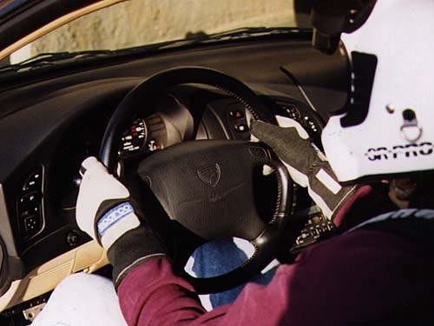

**The proper hand positions are 3:00 and 9:00 with the thumbs wrapped around the ring resting on the cross brace, the palms cupping the outer diameter of the ring, and the heels of the palm applying a light pressure to the front of the wheel. The grip should be relaxed--just tight enough for control and good sensory input.**

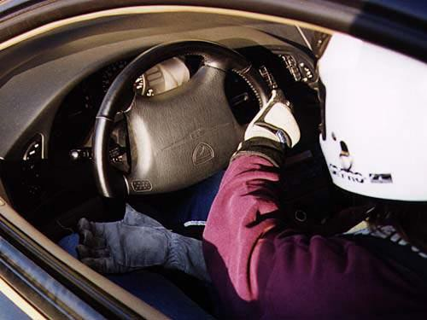

**Most corners can be driven through without moving the hands from the 3 and 9 positions in a sports car. This allows your arms a little more than 180 degrees of wheel turn. Note in this photo that the thumb of the right hand is kept under the cross brace of the wheel. This provides extra stability.**

**If a corner requires a little more steering input than 180 degrees, the following technique provides the most control. This should get the car through even slow, tight, 90-degree turns. Let's look at a right turn for the example.**

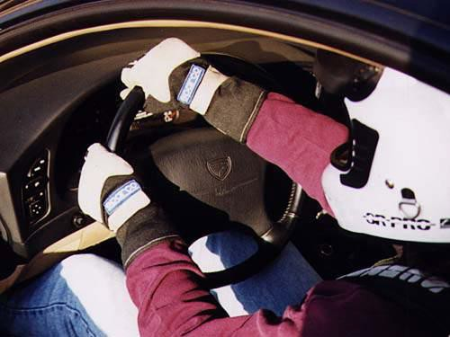

**Just before the turn-in point, relax the grip on the right hand and slide it along the wheel to the 11:00 position (don't take your hand off the wheel). This places both hands close together at the start of the turn.**

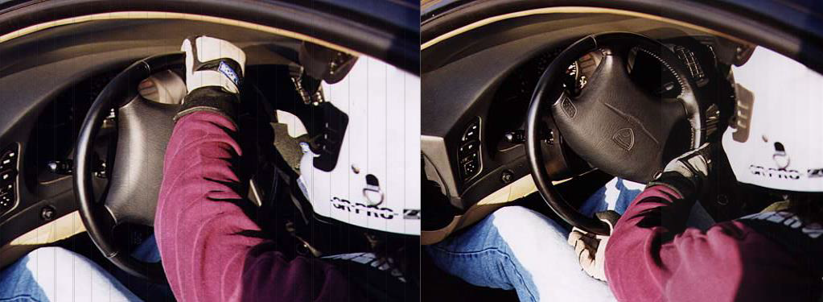

**Keep both hands close together, and progress through the turn. This hand position allows about 260 degrees of steering wheel movement placing the right hand about 6:00.**

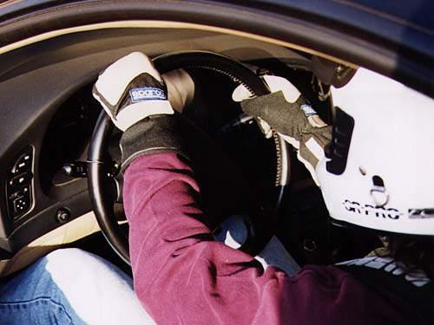

**When unwinding from this position, leave both hands tight on the wheel until the right hand reaches 9:00. Relax**

**the right-hand grip slightly, finish leading the unwind with the left hand, and allow the wheel to slide through the right hand.**



**For hairpins, or switch-back corners, you will likely need to use a hand over hand action. Some drivers like to start a large steering input like this by placing the leading hand at the 6:00 position, and turning a full 360 degrees before involving the other hand. This seems to simply the action, but it has the drawback of having only one hand on the wheel for quite a while. The control is not likely to be as smooth, the sensory input is halved, and in a racing situation in traffic, the ability to maintain control if bumped is reduced. Smaller, repetitive hand moves in a hand over hand situation is better.**

# Shifting

You may think shifting is a no-brainer function, but in a sport where the difference of winning may be 1/100th of a second, every detail counts. This discussion is to point out how to use the shifter, and we're assuming the use of a typical H-box shifter in a streetcar for this.

Many people fall into two bad habits on the street when shifting. First, "Hollywood" has taught everyone that it looks cool to always leave your right hand on the shift knob.

Wrong! You may as well tie your hand behind your back as leave it on the shift knob. Your hand belongs on the steering wheel always. When you need to shift shift, and get your hand back on the wheel. Don't even rest it on the shifter for a few seconds ahead of time to "get ready." Every time your hand leaves the steering wheel you've given up 50% of the tactile feedback you have from your hands, and 50% of your capability to control the car. If you're racing with other cars around you, you never know when you may get tapped. Even when racing alone, mechanical failure may cause handling trouble. You'll want both hands on the wheel when that happens.

The second bad habit some people have is shifting with excessive force. Too tight a grip, and slamming from one gear to another will actually slow your shifting down, and cause excessive mechanical wear. Proper shifting uses an open palm grip on the top of the shift knob, and a gentle but fast guide from one gear to another. Repeating again all shifting is properly done with the hand open and cupped over the top of the knob, not wrapped around it like a fighter plane control stick.

To shift from the top of the H to the bottom, start by forming a cup with your palm and fingers. Place the palm of the hand over the top of the shift knob. Using the underside of your fingers and your palm against the knob, use a smooth straight-line motion to guide the lever to the next gear. Assuming the shift lever has a fairly short travel, the action involves

your wrist for the majority of the movement. Do not attempt to slam it or force it faster than it wants to go. If you are locking your wrist and moving your whole arm at the shoulder, you are using too much force.

To shift from the bottom of the H to the top, again start by forming a cup with your palm and fingers. This time when you place the hand over the shift knob, the emphasis of contact is on the heel of the palm. Start with the wrist slightly bent up. Push the lever using the palm heel in a straight line using your wrist to extend the position of the palm heel while following through with a gentle push of the arm. This shift is more arm motion than wrist.

When shifting across the H such as between 2nd and 3rd gears, do not try to make a conscious jog in your hand movements. The linkage needs very little input to make the diagonal path across neutral. Your shift should almost look like a straight diagonal line. Making a distinctive zigzag through neutral is strong-arming the shifter and will slow the shift down.

Using smooth, soft control of the lever does not imply doing it slowly. A gentle force of the lever will allow the shift linkage to move freely through its natural motions. If you strongarm the motion you will end up forcing the linkage through lines that have more resistance. This will slow the shifting down. Use as much wrist movement as possible in place of moving the whole arm.

Some of you may be tempted to learn the techniques of "speed shifting" shifting without using the clutch in the interest of saving time. Many schools and professional racers have shown over and over that there is no speed or lap time advantage to this, and it carries a much higher risk of gearbox damage.

## A Visual Aid for Shifting Right!

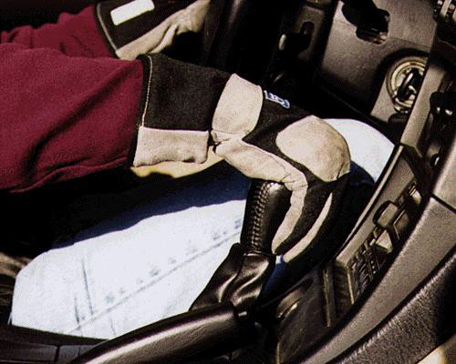

**Shifting from the top of the box to the bottom, form an open cup with your hand, and place over the shift knob with the inside of your fingers and the palm of your hand making contact. Guide the lever quickly, but without strong-arming it. Push it, but don't slam it. The movement is primarily from the wrist. If you're locking your wrist around the shifter like a fighter-plane control stick, you will actually be slowing your shift down.**

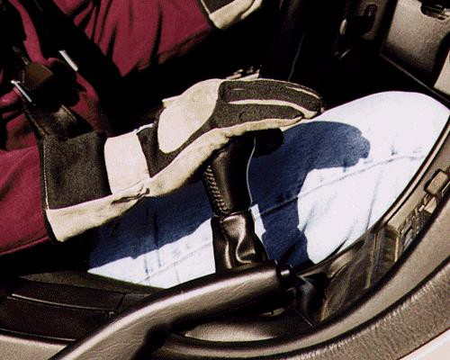

**Shifting from the bottom of the box to the top, cup your hand over the shift knob, and using the heel of the palm, push the lever into the next position. This shift involves more arm motion than does a top to bottom shift, but again no choke holds or body slams the shifter is a precision machine, not a wrestling opponent.**

# Short-Shifting

Short-shifting is where you change up a gear before it is needed; In other words, you change up a gear before you have used up the previous gear.

Why would you want to do this? Well this is a valid question because short-shifting almost always means you will be instantly losing some power and torque due to being in a higher gear than is necessary.

Well there are two main reasons:

One reason is to purposefully take away torque from the wheels. Maybe it is a bump/slippery curve and you will be unable to use the full torque of the gear you would normally be in, so it might be a safer bet to be in a higher gear to reduce the likelihood of sudden wheelspin, etc.

The other (and more common reason) is to save the time taken to change gear. Let’s say you have a tight 2nd gear left-hand bend, followed by a long straight. You are at about 2/3 revs as you approach the apex.

You can both stay in second gear and use the extra torque to accelerate as quickly as possible.

Or you can change up to 3rd before you need to start accelerating and sacrifice the extra acceleration for the time saving in not having to change gear.

A judgment has to be made as to which would be quicker. In race driving this is normally already tried and tested for your formula on the track you are racing on so it is often predecided. In rallying it is less clear, and probably slightly less important.

The main reasons you would use short-shifting in rallying would be for balance rather than outright time and speed. If there was a twisty section ahead for the next 50 yards and you will need 1 up change in the middle of it, you may decide to get the change done before the complex to avoid upsetting the car mid-way through it.

# Braking and Accelerating

One of the keys to good race driving is smoothness, and this most certainly applies to the use of the brake and accelerator pedals.

## Braking

On the street, braking and accelerating are done at relatively low levels compared to the vehicle's capability. The tire’s traction limits are rarely maxed out. Sure, you can romp on the gas and spin the tires at a light, or slam on the brakes and slide the car a little, but it’s very easy to bring the car back under control.

In the rain, or especially the snow, you know you have to be much gentler and smoother with the brakes and with the accelerator. If you lose control on a wet or snowy surface, it can be much harder to regain control. There is much less traction to work with.

Braking and accelerating when racing on a road racecourse, even when dry, is treated something like driving on a wet surface gently and smoothly. Braking and accelerating are used in conjunction with the corners you brake going into them and accelerate coming out of them. Because the objective is to have the car moving as fast as possible through the corner, the tires will be utilizing most of the available traction (done right they should be using 100% of the available traction). The driver must be very smooth with the use of the brakes going into the corner and the accelerator coming out of the corner. A sharp change in braking or power at these points will upset the car's traction balance just as quickly as if you were driving on ice. Working within the last 1% of traction means there is no reserve to call upon to gain back control of the car. Even the pros very rarely recover a car that has lost control. It's not because they don't know how, it's because there's no traction left to work with. It is imperative to learn how to be consistently smooth in braking and accelerating on a road course.

There are three phases in braking. First, braking begins with a rapid, but not instant, application of as much braking force as possible. How rapid the brakes can be applied will depend on the suspension in the car. The stiffer the springs and shocks, the more rapidly maximum braking can be applied. Soft springs will have significant forward roll, which will require a little longer and smoother ramp-up of braking to keep the car stable. Second, once the car settles onto the front tires, you'll be trying to minimize the length of the braking zone, so it will require taking the tires to the edge of locking up. You'll need to be very aware of the vibrations in your foot from the pedal and in your hands from the steering wheel to feel that small difference (therefore racing shoes are highly recommended). The car will travel some distance using a fairly constant brake pedal pressure.

The third phase is towards the end of the braking zone when the vehicle has been slowed to near its final speed. Gradually release pressure off the pedal making the transition from full to zero braking force as smooth as possible. During braking, the front tires are under heavy load, which increases the available traction. A sudden release of the brakes will abruptly reduce the load and reduce the traction potential of the front tires, which at this point is needed for turning into the corner.

The turn-in is one of the points where the car will be the most sensitive to sudden weight transfer transitions as though it were being driven on ice. Indecisive braking resulting in a last second extra tap, or a sudden release of the brake pedal will unsettle the car's handling and force the driver to slow down to gain control and hopefully avoid a spin.

As the braking zone completes, and you ease off the brake pedal, you will have to apply some throttle to reach a steady state of neither acceleration nor deceleration. Depending on the shape of the turn, the steady throttle zone will vary, but with a typical late-apex corner, it will be from the turn-in to just before the apex.

## Accelerating

From this point to the turn's exit point, the use of the accelerator must be equally smooth for the same reasons they were for braking. Through the turn, the car will have settled with a certain loading of each tire. A sudden change in that with the accelerator can also upset the available traction on one or more tires and cause a loss of control. Controlled use of the accelerator is a matter of depressing and releasing it in smooth motions. Don't make sudden jerks in pedal position.

In a typical streetcar, applying the accelerator smoothly isn't as difficult to master as smooth braking. Once a car is moving fairly fast, most streetcars just don't have enough horsepower to really cause trouble under most acceleration circumstances. Even the factory exotics and highly modified streetcars rarely have more than 400 horsepower, and in a car weighing 2500 to 3200 pounds, that just isn't an overabundance of power to learn to control. The typical professional open wheel car weighs 1500-1800 lbs., and has 700900 horsepower. That's about 5x the power to weight ratio of your typical street sports car.

Nevertheless, whether it’s relatively easy to control or not, the introduction of 5 h.p too

much at the right point, and you may as well have an extra 900. Coming out of a turn, as soon as the car begins to straighten out, gradually apply more power the straighter the car gets. Use smooth consistent pedal pressure indecisive on and off stabs will end up being slower than a smooth increase.

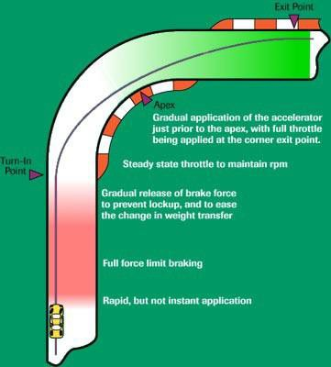Because most streetcars aren't overly sensitive to rough throttle control (although there are definitely some exceptions), it's easy to develop bad habits with the accelerator. Even though you may not have to be ultra-smooth to maintain control, having the discipline to develop smooth control will still improve lap times, and should you have the opportunity to drive a higher horsepower car, you'll have the skills to keep the car pointed in the right direction.

**Braking and acceleration into and out of a typical corner. Notice how the pedal pressure varies during the course of cornering.**

## Smooth Acceleration:

Accelerating from a standing start is a balancing act of wheel spin and engine revs.

If the revs are too low, the engine will bog down and you will not be providing the tires with anywhere near the maximum torque they can deliver to the road. If the revs are too high, you will exceed this max and spin the wheels.

If you can accurately balance Traction vs. Torque you will get the maximum possible acceleration. In the real world however, this is not possible every time.

Due to the fact that you are in first gear, and therefore putting the maximum torque to the wheels, and the fact that the road surface and in particular, the changes in road surface have a greater effect at slow speeds, you would have to be a complete god to instantly and

accurately adjust the throttle and clutch to account for it and keep the Traction vs. Torque at max. The only way this is really possible is to have really high revs and balance using the clutch. The only problem here is that your clutch will last about ten minutes is you keep that up!

For this reason, the best method is to use controlled wheel spin. Build the revs up to just into the power band. Smoothly let out the clutch so that the wheels gradually start to spin and balance the spin to be just before they are starting to bite again. Keep this up until you are at a high enough speed that the wheels could grip and you would still be in the power band.

## Braking Distance:

Reaction times for a racing driver will be around 0.25 sec but perhaps over one second for an older person whose mind and legs are not as agile.

The best braking deceleration is generally taken as 1g the retardation due to gravity if you throw a stone into the air. Some cars can brake more fiercely than this (1.0-1.2g) as tires key into the road surface rather than rub across it.

The recommended stopping distance is thinking (reaction) distance plus braking distance. The Highway Code assumes that the average driver has a reaction time of 0.7 seconds to think and then operate the brake pedal. At 30 mph, this is 30 feet, 40 mph is 40 feet etc. Braking at 1g from 30 mph stops the car in 30 feet. In practice, Highway Code distances are calculated at 0.7g (43 feet from 30 mph) to allow for a gradual build-up to maximum braking. A racing driver with a 0.25 second reaction time and good road car brakes might stop from 30 mph in 11 + 25 = 37 feet. An older person with a one-second reaction time and a normal car would need 44 + 43 = 87 feet.

Braking distances increase as speed x speed so 43 feet from 30 mph means 172 feet from 60 mph. So, keep your distance from the car in front. On fast roads you should leave at least two seconds between the car in front and your car passing the same spot more if it is slippery.

## Cadence Braking:

If you lock the front wheels under heavy braking, you can no longer steer. ABS (anti-lock braking) automatically keeps the tires on the point of locking so that you can continue to steer as well as slow down.

If you don't have ABS you can use cadence braking whereby you lock the wheels, then release the brakes so that you can steer, brake again, release and steer again in sequence until you have avoided the hazard. This is particularly useful on slippery roads, but it takes practice and quick thinking to be able to release the brakes when you are sliding towards the hazard.

## Braking Around a Corner:

When you brake, weight is transferred forwards from the back wheels to the front. In a corner, weight is transferred from the inside wheels to the outside, and designers adjust the front and rear spring stiffness to give the handling balance they want.

Try braking hard and cornering at the same time and it will be very easy to lock the inside rear wheel and start a spin. Even suddenly removing power from a front-wheel-drive car in mid-corner can be enough to start a spin.

It is possible to brake gently in a corner and not lose control, but if you meet an emergency in mid-corner and brake hard, loss of control is much more likely than if you were braking in a straight line. It is safer to brake before the corner than halfway round it.

# Winter Driving

Front wheel drive, rear wheel drive and all-wheel-drive cars behave differently. Be certain that you know how your particular type of car will react to driving situations and to your inputs.

In icy conditions, do one thing at a time. Brake in a straight line. "Coast" through corners on a steady throttle and accelerate when you are through the corner.

Centrifugal force is your enemy, especially under slippery conditions. It increases with speed and/or reduced radius in a corner.

Beware of wide tires. They will hydroplane sooner than narrow tires due to the wider contact patch.

If you should lose control remember the correct skid control techniques for your type of car. Look where you want to go, steer where you want to go and release the gas pedal gently to allow the contact patches to regain traction. DON'T BRAKE!

# Cornering

In the end, road racing comes down to cornering. Assuming equal cars, the driver able to sustain the highest speeds through the turns will have the lowest lap times.

To get terminology cleared up first, every corner is made of three parts. We'll call them the entry, the apex, and the exit. The entry is where turning begins. The apex is the point where the car reaches the furthest point on the inside of the turn. The exit is where the car is driving straight again.

The objective in driving through a corner, or a series of corners, is to have the fastest possible speed at the exit of corner, or the last corner of a series. It is not necessarily to have the fastest speed going into the corner, nor even the fastest speed in the middle of the corner. The last corner exit before a straight is the most important segment. The speed of the exit determines the speed during and at the end of the straight. If you can increase the average speed of an entire straight, that will have greater impact that a faster average over the shorter distance of the entry to the turn, or through the turn itself. The path, or "line" you drive through a corner will determine the exit speed. In general, the fastest line through a corner is the one that allows the greatest radius, or straightest path. As a car can go faster around a large corner than it can around a tight corner, the shortest path around a corner is rarely the fastest.

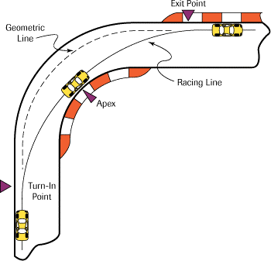To illustrate these concepts so far, the classic teaching aid is to look at a 90-degree bend. In the illustration below, the dotted line follows the path of the road. The solid line indicates a path that maximizes the radius of the turn, or attempts to make the turn as straight as possible. As you can see there is significant difference in the tightness of the turn that follows even the outside of the road compared to the one that utilizes the whole width of the road surface.

As mentioned, the objective in any corner is to have the highest exit speed. In addition to increasing the corner radius, this also involves taking a line that allows the earliest possible point of getting back into the throttle. To do this, the car must be straightening back out on the corner exit path as early as possible. We can modify the above corner line further to allow this.

The illustration below now shows the previously noted large radius path in the dotted line. The solid colored line shows a path known as the "late apex." This path moves forward the point at which the car reaches the corner apex. The late apex straightens out the exit path of the car, and therefore allows the driver to apply the accelerator earlier. This increases

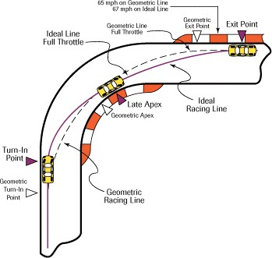the exit speed, and in effect lengthens the straight that allows for higher speed at the end of the straight.

While the geometric racing line is faster than the natural line of the road, there is still a faster technique for most corners. The technique is called using a late apex. Delaying the turn-in point, and beginning the turn with a slightly sharper bend can aim the car to apex later than the geometric apex point. This straightens out the second part of the turn, allowing the driver to apply the accelerator earlier. The car will have to slow down a little more at the turn in phase, but exit speed will be higher. That exit speed gives the driver that much more speed on the straight, which will result in lower lap times overall.

This approach works for corners that require hard accelerating cornering out of them, which will be most of them. However, there are many types of corners, and combinations of corners that require some analysis to understand the best approach. Along the right are small figures of corner examples.

## A Visual Aid for Cornering Right!

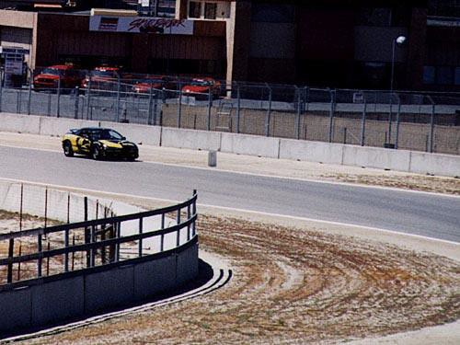

**Approach the corner on the edge of the track to maximize the potential radius. The turn in point for this corner is about one full car length past the brake marker you see in front of the car. By this point, braking should be almost complete and the driver will be easing smoothly off the brakes.**

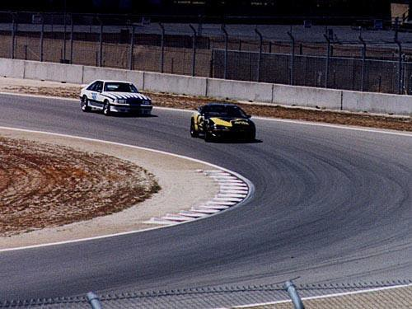

**Midway between the turn-in and the apex. Here the driver maintains a constant speed. Using a late apex line, about another two car lengths into the turn from this photo, the driver will begin to accelerate.**

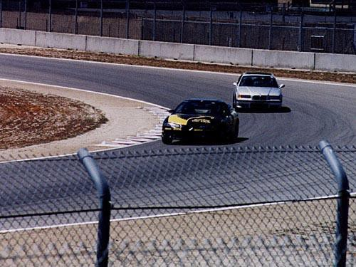

**The apex of this corner is slightly late as is the case with simplest corners on the track. The apex is marked by the point the car reaches in inside most position on the track. At this point the driver is almost full on the gas. (Note the second car is very wide, and is not likely to touch the curb marker without slowing down significantly).**

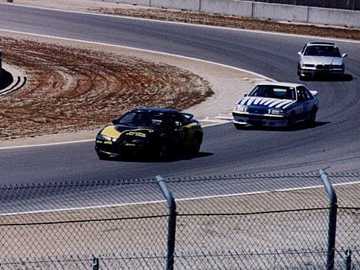

**Coming off the apex, the car is now headed for the opposite side of the track. By this point the driver should be at full throttle.**

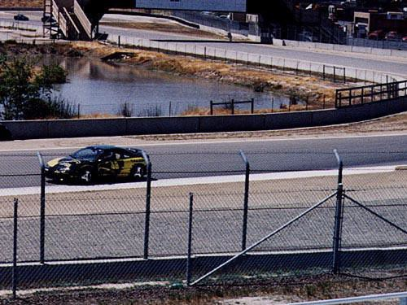

**The corner exit should be taken as wide as possible. If the corner markers are flat enough, and not excessively slippery, use them as part of the track. However, be careful with tall curbs, they can suck the car up and over them very quickly.**

## Complex Corner Sets:

Not all corners can be taken on the classical racing line. Sets of corners sometimes require a different approach to maximize the exit speed of the last corner. For each illustration below, a track segment will be shown, the fastest line indicated, and some possible lines you might be tempted to believe are better.

## Corning Examples

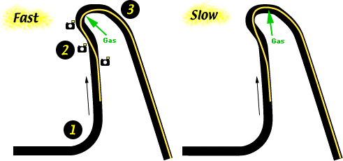

**Fast Line** the objective in this turn set is to maximize the exit speed coming out of the hairpin. The straight after the hairpin is longer than the one leading into it after turn 1, therefore maximizing speed coming out of turn 3 is more important than maximizing speed heading into turn 2.

To do this, the driver must drive a line that allows the earliest acceleration point. Planning the line by working the corners in reverse (because the highest priority one is the last one), the driver would want to late apex the entry to the hairpin to allow early acceleration out of it (show by the green arrow). To carry the highest speed possible into that late apex, the line to the apex must have as large a radius as possible (the radius prior to the green arrow). To accomplish a large radius entry into the hairpin, the left-hand bend of turn 2 must be entered with a very late apex, allowing the car to travel the far-left side of the track through turn 2, then into a wide radius late apex for the hairpin.

This line creates a very short straight through turn 2 into turn 3. Depending on the speed of the car coming out of turn 1, the braking line through turn 2 is likely to be too short. Additionally, because of the sharpness of the hairpin, it will be easy to create understeer entering the turn from either too sharp a turn-in or not easing off the brakes smooth enough.

This is a very tight corner set and a common mistake will be to brake very hard through the short straight in turn 2, jump off the brakes quickly for the turn-in to the hairpin, and sharply turn the wheel. This will create a lot of understeer, and slow the car significantly.

To maximize the speed through the hairpin, it will be important to come off the brakes smoothly, and have a smooth turn in. To set up for this, most braking may have to be done before the turn-in to turn 2, the trail braking through the turn-in, and easing up through the apex of turn 2. Entering the short little straight of turn 2 a little too slow is not going to cost as much time as entering it too fast, understeering and going wide through the hairpin, and delaying the point of getting back onto the gas. Such a mistake will cost several MPH of top speed down the following straight.

**Slow Line** this line might be your first instinct. It carries higher speed into the corner set by taking a straight path between the two bends of turns 2 and 3. This reduces the initial turn in, and delays the braking point. It will feel much faster heading into the turns, and that segment will indeed be faster than the fast line alternative shown.

However, that fast entry line causes an early apex on the right-hand bend heading into the hairpin. An early apex pushes the car to the outside of the track early to carry speed through the initial part of the corner. After that, a very tight turn after apexing is required to stay on the track. Compared to a late apex for the second bend, this requires a slower speed through the hairpin, and delays the point where you can get back on the gas. This line is faster for a short distance through turn 2, but is much slower along the entire straight after turn 3.

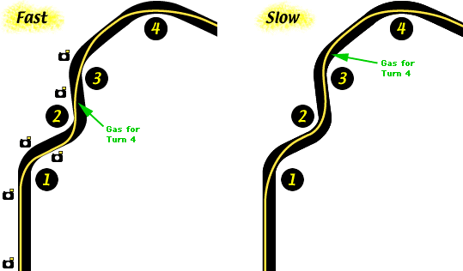

**Fast Line** the objective in this turn set is to maximize the exit speed coming out of turn

3. Turn 4 can be taken flat out, so the exit speed coming out of 3 sets the speed through turn 4 and the following lengthy straight. Setting up this series of corners begins with the turn-in to turn 1. Unlike the "normal" racing line, turn 1 is taken with a very late apex to allow the car to stay on the far-right side of the track after the turn. This positions the car to take turn 2 in a similar manner with a very late apex keeping the car on the far-left side of

the track. This finally places the car in the correct position to take turn 3 with a typical racing line. Not only can turn 3 be taken with a typical line, but using this line allows acceleration towards turn 4 to start before turn 3.

This is a classic example of the need to "sacrifice" the highest possible speed in turns 1 and 2 in order to maximize the speed of turn 3, which is more important. Some people do not agree with the term "sacrifice," and would rather call this corner prioritization, or proper "setting up" of turn 3. No matter what you call it, you must analyze corner sets like this to recognize that the fast line is the correct way, and that you must temper your instinct to blast through 1 and 2 as in the "slow" line diagram which puts the car in the completely wrong position for turn 3, and delays the point at which the driver is accelerating for turn 4.

**Slow Line** this line might be your first instinct. It carries higher speed into the corner set by taking a normal racing line through turn 1, but immediately forces a scramble through turns 2 and 3 which severely slows the car's speed through turn 4.

# Visual Field

One of the first things you were probably taught when learning to drive was the simple principle of "look where you want to go." You were told, "don't look at oncoming traffic, and look at the cars in your lane in front of you." "Don't stare at the dividing lines, look at the road between them." "Don't look at the wall beside you, look at the lane in front of you." All sound, practical advice, and the same goes for racing.

If you've played, or even watched, just about any sport, you'll notice that the player is constantly looking forward, and not at what he's doing. In basketball, football, or hockey a player does not watch himself handle the ball. Rather, he looks down the playing field at where he wants to go or pass. The player’s field of vision is not the few feet in front of him, but the whole field before him and beside him. The more of the field area the player can see and keep track of, the greater are his abilities to avoid opponents, plan a path through the field, and anticipate the movements of others.

The distance and amount of territory the player can keep track of is called his visual field. This requires the combination of two distinct skills. First, the player must look farther ahead than his immediate surroundings. He has to look where he wants to be, not where he is.

Second, even though the human eye has a narrow field of focus (only a small portion of what the eye sees is in focus), the player must be able to distinguish activities in those areas that are not currently in focus.

These skills are critical to race driving as well. It should be apparent how they would apply to road full of cars driving for position, but they are equally important for a single car to navigate an empty track at maximum possible speed.

There is a tendency by inexperienced drivers to focus with a tunnel vision right in front of the car. It's a natural reaction. The amount of information the driver is thinking about can be overwhelming, and it is easy to become visually fixated on what is happening right in front of the car. Looking farther ahead requires taking in even more input. At first, it can be very difficult, but as the driver develops shifting, braking, and traction sampling skills into “second nature” habits, he can spend more conscious time expanding his visual field. An everyday example of these skills at work can be drawn from the scenario of trying to walk faster than everyone else through a crowded sidewalk. Think of how you do this.

Whether you're conscious of it or not, your brain tries to anticipate the movements of those in front of you. By gauging the rhythm and timing of your speed along with the speed and position of others on the sidewalk, your brain calculates when and where "openings" should appear that you could walk through. In order to make these calculations in time to be useful, you must look a certain distance ahead of where you are. The faster you want to go, the farther ahead you need to look. If you were to look at the ground, or only a couple feet in front of you, you would frequently bump into people.

You achieve a certain level of fluid movement through the crowd by looking ahead and anticipating your environment’s changing conditions, while keeping tabs on your

immediate surroundings through peripheral vision. Your body responds automatically by adjusting speed, and your side-to-side position as you “dodge” the people around you.

This same technique applies to driving on the track. A driver cannot be focused on where he is on the track. He has to be focused on where he wants to be next on the track. To drive the smoothest and fastest line through a corner, or a series of corners, your brain must get input from far enough down the track to calculate the smoothest lines, and anticipate the amount of steering and pedal input to use.

Driving through a corner consists of four phases, and requires that the driver be looking ahead at least one, if not two, phases at a time. The first phase is the braking zone before the turn. The second is the turn-in, the third is the apex, and the fourth is the exit. If the driver is focused only on the current phase where the car is, he will not be driving smoothly or as fast as is possible through the corner. Each phase will seem like a surprise and will be driven as a jerky sequence of four lines rather than as one fluid path.

To describe the use of an expanded visual field through the corner sequence, I’ll describe a typical turn after a long straight. As you approach a corner, your focal point will be the braking reference point. A few car lengths before you reach the braking point, your eyes must focus on the turn-in point. From your peripheral vision, you will notice the braking reference point and apply the brakes. Your eyes are still focused on the turn-in point, and as you approach and get within a few car lengths, your eyes must now look to the corner apex. Keeping the eyes focused on the apex reference point, use your peripheral vision to notice the turn-in reference point and begin the turn-in. Now, as you are approaching the apex, stay focused on the reference point until a few car lengths away, where you will once again shift focus to the next point, which is the exit reference point. You will drive through the apex looking at the exit point, not the apex marker. As you approach the exit point, your focus should now shift to looking down the straight, and you will use your peripheral vision again to drive out to the actual exit point as you reach it.

In some situations, such as tight chicanes or esses, you may need to be looking through several corner reference points, and driving through them almost entirely with your peripheral vision.

Using your peripheral vision while also focusing in the center of your vision takes some practice especially at the speeds involved of race driving. If you have already been track driving for a while, at first, this technique may slow you down due to the uncertainty of using your peripheral vision. However, once you get used to it, you will notice that you'll hit your reference points more consistently, and you'll carry a couple more miles per hour through turns you thought you were already maxing out. Developing these skills can take a few weekends on the track. However, stick to it. Develop the skill first, and then bring up your speed. In the end you'll go much faster.

To practice looking ahead, make sure that you are looking through the center of the height

of the front windshield. Several instructors even suggest that you put a thin tapeline on the windshield as a reminder to be looking above it farther down the track until you fully develop this as a habit. These skills can also be practiced during street driving. Around street corners or on windy roads, practice keeping your focal point well ahead of where you are driving, and "seeing" with your peripheral vision.

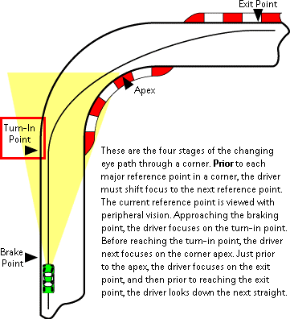

# Reference Points

In the cornering article, we discussed the three phases of the turn. We also discussed that there is an optimum line through every corner. For consistency, the driver will need a set of fixed reference points to mark the phases of the corner, so the line can be driven identically every lap.

Upon approaching a corner, the driver needs a fixed point to use as a reference for starting the turn-in. Guessing each time or "going by the feel" will guarantee that the driver will turn in too soon sometimes, and too late other times. Inconsistent and slower than perfect lap times will result, and give a more consistent competitor an advantage. To prevent this, in the practice sessions the driver must quickly determine the correct starting point for the turn-in and find a permanent visual landmark to use for reference.

Next, is the apex point. This is the target point that the inside tire of the car should touch as it reaches the maximum inside point of the driving line. Again, without a fixed point to target, inconsistency and slower times will result.

Last, is the exit point. This is the target point after the apex that the car tracks out to on the opposite side of the track and is completely pointed straight again, or is otherwise pointed

properly for the next corner.

In each case, the reference point should be a permanent landmark. A tire skid on the track is no good. Other skids later on could obscure the original one. Likewise, a particular rock, weed, or grass tuft on the side may be questionable if they are in danger of being driven over if a car goes off course. You should look for unique features in the road itself if possible.

Some tracks have permanent signs in the braking zones, or have bump markers such as those that separate lanes on the highway. You might start braking exactly at one of the markers, or a car length before or after.

At the corner apex, most permanent road course tracks will have the white or red & white cement corner markers. When you find the right apex point, note whether it is half way, three-quarters, or wherever, and aim for that spot each time.

The corner exit reference point can be the toughest to find. Many tracks have exit markers just like the apex that can be used, but not all. You may have to search for other fixed landmarks off the track that the car exit path lines up with such as telephone poles, trees, or signs.

What about a reference point for the start of braking? There is some debate about this. Some people suggest that there should not be a reference point for the start of braking. The argument is that the turn-in point is the focus, and the driver must learn to sense when to start the braking to achieve the proper speed at the turn-in point. It is assumed that some laps will be faster than others because traffic is involved, and with all these variables, the focus must be placed on the turn-in point, not in looking for the braking point that may be too soon for slower speeds. This is a valid theory.

Nevertheless, one of the key attributes of skilled driving is consistency, and one of the keys to consistency is reference points. In practice, qualifying, or time trialing, a braking reference point is just as effective for marking the capabilities of the car's performance (for braking) as is the turn-in point (for corner entry grip), and acceleration point (for corner exit grip).

An example of where a braking reference point is a must is a blind corner. A corner at the top of, or just below, the crest of a hill will not be visible to the driver during braking.

The debate of whether there is or should be a reference point for braking is largely semantics. Physiologically, your mind and body needs some reference to know when to start braking, and how to make that action consistent. For braking, the term "reference point" itself describes the purpose. It is a point of reference, and will not be so much a "target" as it is for the turn-in, apex, and exit points. If the driver is at maximum speed before the turn, he's going to need to know when to start braking. If another lap is slower, he'll know he can start braking a little later. Regardless of how it is used and whether you call it a "reference point" or not, having a point or reference for the maximum braking performance of the car

for each turn avoids guessing.

# Passing

Most club racing of the hot lapping or time trialing variety will not allow passing in corners. Autocrossing doesn't involve passing at all. However, should you venture into racing that involves passing, or you get in a situation where passing in a corner is inevitable, here's some things to know.

Passing is typically achieved under three circumstances: you utilize your car's greater horsepower or momentum exiting a corner to pass on a straight, you pass under braking by controlling the preferred driving line entering a corner, or you take advantage of your opponent's mistakes.

First rule it is the responsibility of the driver initiating the pass to ensure that it is done safely. Where you pass, and how you pass must be done in a manner that your "opponent" is aware of.

Second rule blocking is illegal. Swerving, whether it's six inches or six feet, to keep another car from getting beside you is blocking. Most organizations will allow you one move to protect your position. A repeated left-right move is blocking.

Third rule if another driver has legitimately placed his car beside yours; leave room for the other car to carry a line through the corner. You don't necessarily have to give him the optimum line, but cutting a car off that results in forcing it off course is poor racing, and if the officials see it as deliberate, you're subject to penalty. Racing is not a roller derby. Eliminating your competition is not one of the objectives.

Passing under braking or on a straight close to a corner requires a little more planning than a simple pass on in the middle of a long straight. The object of passing in the braking zone is to control the inside line to the upcoming corner. By placing your car between the other car and the corner apex, the other car must yield to give you room to continue your driving line through the corner. In this manner you have essentially "controlled" the preferred line into the corner.

The potential downside to making this move is that your car will not be taking the turn on the optimum line. You may control the corner entry, but if you have to slow down too much, or make too early an apex, the car you've just passed may carry more speed or a better exit line, and pass you right back coming out of the corner.

During practice sessions, you will need to not only practice the optimum racing line for fast laps when you're clear of traffic, but you will want to practice some passing lines. Move in from the edge of the track where you'd normally drive, brake a little farther and turn in a little later. Practice taking a line that puts your car in the middle of track coming out of the corner, or at least far enough over from the edge so as not to leave enough room to be

passed on the exit. (Hogging the road so there's not enough room to pass, but still avoiding the swerving, is not blocking). By practicing these passing driving lines, you'll

be ready to use them, and there's less chance that you'll cause an accident when attempting a pass.

# Automobile Configuration

The suspension in a drift car is very tight and unforgiving even the chassis is tightened with roll cages and strut braces. Die-hard drifting enthusiasts also alter the suspension geometry to enable the car to slide better. As with everything, modification of the body and suspension components is a trade-off. Hard suspension in the front and a soft suspension in the back is easiest for first timers, but a handicap at higher levels. Most cars use an integrated coilover/shock (MacPherson strut) combination called shakocho. This allows for the height of the car to be adjusted. Better shakocho will be what the Japanese call "full-tap". This means the bottom of the strut is also a coil over, so you can change the height of the car from the bottom, and the height of the spring with the top. Usually a driver wants to have full stroke on his shocks, so he will raise the spring to its highest point. There is no perfect height setting or spring/shock combo for any car, but there are perfect setups for particular drivers. Many suspension manufacturers, such as Kei Office, APEX'i, Tein, JIC Magic, and HKS, offer suspension tuned specifically for drifting, allowing many people to enter the sport competitively.

One common trend that used to be popular in Japan was "Oni-can." In English, it means Demon Camber. It involves setting the suspension with obscene amounts of negative camber (more about this is given at the end of this article). The car will be very easy to slide and lose grip, but stability, grip, and overall ability to control the car will be compromised. As such, this setting is very dangerous, and is not recommended.

The differentials are limited-slip differentials (LSD), which are divided into clutch-type differentials and viscous Limited-Slip Differentials (VLSD), not the standard open differential. On an open differential, the automatic transfer of power to the spinning wheel causes the car to the inside wheel spinning out of control, and the other spinning at the actual speed of the car. A LSD allows the two wheels connected to the LSD to spin in a certain speed range, to give power to both wheels through a turn, allowing a car in a drift to use both wheels for power in a drift. LSD's are separated in three categories, 1 Way, 1.5 Way, and 2 way. A 1way LSD means it only locks the differential under acceleration, while a 2-way LSD locks them under acceleration and deceleration. A 1.5-way LSD allows locking under both acceleration and deceleration, but it is weaker than a 2-way under deceleration. It is common to use a 2-way LSD for drift cars however 1-way and 1.5-way LSD can be used.

The cars quite often have different tires on the front and back, and the owner may have quite a few sets. This is because a single afternoon of drifting can destroy a new set of tires. As a rule, good tires go on the front for good steering. On the back, hard-compound tires are used quite often second-hand ones as they tend to end up in a cloud of smoke. As a

driver gets better, she will most likely want to upgrade the tires used in the rear for a higher grip compound. Although cheap/hard tires are fun purely for their slipperiness and ease of drifting, they quickly become a hindrance for high-speed drifts.

In addition, for the typical "drift car look," the tires are stretched over a wide rim. This is known as a "hipari" tire. For example, 205 50/16 tires may be fitted to an 8" rim, or 215 45/17 to a 9" rim; this allows for a bigger, wider, "cooler looking" wheel to be used. The driver is essentially still racing on a tire meant for a 7.5" or 8" wheel, but has the "cool wide look." The only real performance benefit of stretching tires on the wheel, is that it lowers the overall height of the sidewall and can add a feeling of firmness to turning and decrease body roll associated to a weak sidewall.

The clutches on these cars tend to be very tough ceramic brass button or multiple-plate varieties. This is because a lot of drifters use the clutch to commence the wheel spins (and hence the drift) by popping the clutch at high engine RPMs. At the D1 level, most of the drifters who do not drive lightweight Hachi Rokus do not use "Clutch Kick" to initiate a drift. Most of the higher powered/better sponsored cars use the Handbrake to initiate the drift.

Some cars, like the HKS S15, only need to utilize their suspension geometry to start a drift.

Engine power does not need to be high, and in fact if you have too much power e.g. more than 500 h.p (400 kW), the car can be very hard to handle/drift. Some drivers have 600 h.p (450 kW) cars, and essentially perform long burnouts. Don't be fooled, drifting still retains the elements of speed and angle. Intercooler efficiency is reduced because of the angle of the car which reduces the air that passes through them. Rear spoilers usually only serve cosmetic purpose, since drifting cars won't need the downforce with the speed they use.

# Camber Angle

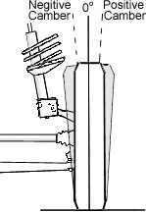

**Camber angle** is the angle made by the wheel of an automobile; specifically, it is the angle between the vertical axis of the wheel and the vertical axis of the vehicle when viewed from the front or rear. It is used in the design of steering and suspension. If the top of the wheel is further out than the bottom (that is, away from the axle), it is called **positive camber**, if the bottom of the wheel is further out than the top, it is called **negative camber**.

Camber angle alters the handling qualities of a particular suspension design in particular, negative camber improves grip when cornering. This is because it presents the tire, which is taking the greatest proportion of the cornering forces, at a more optimal angle to the road, increasing its contact area and transmitting the forces through the vertical plane of the tire, rather than through a shear force across it. On the other hand, for maximum straight-line acceleration, obviously the greatest traction will be attained when the camber angle is zero and the tread is flat on the road. Proper management of camber angle is a major factor in suspension design, and must incorporate not only idealized geometric models, but also

real-life behavior of the components; flex, distortion, elasticity, etc. What was once an art has now become much more scientific with the use of computers, which can juggle all the variables mathematically instead of relying on the designer's intuitive feel and experience, and as a result the handling of even low-priced automobiles has improved dramatically in recent years.

In older cars with double wishbone suspensions, camber angle was usually adjustable, but in newer models with McPherson strut suspensions it is normally fixed. While this may reduce maintenance requirements, if the car is lowered by use of shortened springs, this changes the caster angle and can lead to increased tire wear and even impaired handling. For this reason, individuals who are serious about modifying their car for better handling will not only lower the body, but also modify the mounting point of the top of the struts to the body to allow some lateral movement for caster adjustment. Aftermarket plates with slots for strut mounts instead of holes are available for most of the commonly modified models of cars.

# Improving Air Induction

Improving the Suck – if you put a piece of cloth over your mouth and suck in air you will not have too much of a problem but if the cloth were wet or a double thickness thing start to get harder. The air filter is a very necessary part of the engine unless you are operating in a laboratory so the aim is to get an efficient air filter that is not too thick and is not oily greasy or dirty.

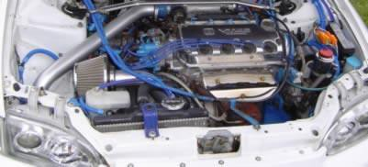

The best filters for flow rates are usually constructed of a sponge impregnated with a dirt retentive spray to aid filtration or comprise a fine grade metallic mesh. The bigger the surface area of the filter the better the airflow will be. Mainstream cars today can be fitted with an air induction kit that completely replaces the air intake box.

The plus is much better air flow, particularly at higher revs, and the induction roar as air is sucked into the engine the downside is also the roar some people dislike the extra noise these kits create. Smaller engined cars can actually lose power when an air filter is fitted. It can be challenging to deliver COLD air (which carries more oxygen) to the engine as the temperature under the bonnet can get quite high and a 20 degrees rise in temperature can rob you of up to 3% of your power! An intercooler can be added which is sprayed with Co2 and reduces the temperature of the air intake. It should be noted that in some small engine non-turbo applications the car will feel less powerful with an induction kit in these instances the best option is a direct replacement panel air filter that goes in the standard air box.

So, the best kits come with a cold air feed pipe and are fitted in an air box which shields the intake air from the high under bonnet temperatures – the best compromise between the standard air intake box and the induction kit. Some kits have a long pipe that the filter sits at the end nearest the bonnet which really does help cut down the noise and improves the intake temperature. Kits that protrude under the front bumper which claim to get more air forced in through the pressure built up on the front of the car as it cuts through air do not have significant power gains, other than the benefit of the cold air from outside the engine bay, the RAM effect takes speeds up over 100 mph before a benefit is realized they are however a great way to collect many botanical specimens of fly's, moths and bugs in the air filter!

**Note:** Be careful where you site the cold air feed the last thing you want is to be sucking water into the engine every time you splash through a puddle. If the air filter is enclosed in a box with a cold air feed, then more power can be obtained avoiding the hot under bonnet air (Carbon fiber boxes are very good for their heat shielding and durability). It also good to wrap the exhaust manifold with a heat resistant material to keep the under-bonnet temperatures down and tasteful vents can be added to the bonnet to take away the heat.

# Increasing the Exhaust Rate

Getting rid of the exhaust fumes is important, as the lesser the pressure there is in the exhaust system, the higher is the BHP. Polishing the inside of the exhaust will aid in the fast exit of gases.

Having a larger diameter exhaust is preferable, as the pressure needed to expel the air is lower, and hence the whole process will be quicker, with the advantage that a lower push is needed. Cats suck power by slowing up the airflow but are sadly a requirement on today's cars – typical reduction of 4 bhp overall. So, if you find a high flow sports cat or use an off road only de cat pipe, you will notice an improvement.

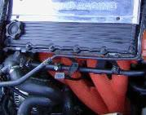

The shape of the exhaust manifold (painted red in picture) is just as critical as the primary and secondary length, and this is something best left to the experts to calculate. To improve a standard exhaust, smooth out its inside with a grinding wheel on a drill or buy a purpose-built stainless-steel unit for your car. Most sports silencers add a deep roar to the exhaust, but this does little to the overall experience. One of the best exhausts are the standard ones with their rear silencers removed. The center expansion section becomes larger to help muffle the sound and really improves things a lot.

# Maximizing Combustion

A turbo or supercharger forces air into the engine at a greater pressure and more air and more fuel = bigger bang = more power. Turbo chargers use the force of the expelled exhaust to drive a turbine and ram fresh air into the engine. Superchargers however are driven by the engine’s drivetrain. Superchargers give an increase at all revs the higher the revs the more induction charge there is and turbochargers have the same effect although lower down there is what is known as turbo lag – where the effect of the turbo cuts in at a higher rev range. Turbo chargers produce more power than supercharges but most modern engine would need an engine management computer upgrade to be able to handle the altered air flow – the fuel injectors would need to run at a higher pressure to get the fuel into the now pressurized combustion chamber.

The suck has a big effect on the bang or combustion part of the process. Primarily you need a strong spark so make sure you have a good set of spark plugs.

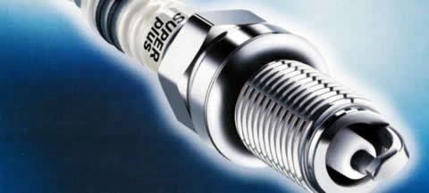

Faulty high-tension leads – HT leads will not cause a weaker spark they will just prevent the spark from happening so if you are having a misfire or uneven idle make sure the HT leads are in good order – flexing and bending them is often enough to damage then so make sure that they are handled carefully. Timing the spark is critical too early and the engine could be damaged and too late and the compression will be lower potentially causing damage to the cat & exhaust if the exhaust ports are open before the explosion fully happens.

# Spark Plugs

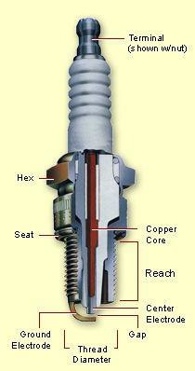

Spark plugs are one of the most misunderstood components of an engine. Numerous questions have surfaced over the years, leaving many people confused.

This guide was designed to assist the technician, hobbyist, or race mechanic in understanding, using, and troubleshooting spark plugs. The information contained in this guide applies to all types of internal combustion engines: two stroke engines, rotary engines, high performance/racing engines and street vehicles.

Spark plugs are the "window" into your engine (your only eyewitness to the combustion chamber), and can be used as a valuable diagnostic tool. Like a patient's thermometer, the spark plug displays symptoms and conditions of the engine's performance. The experienced tuner can analyze these symptoms to track down the root cause of many problems, or to determine air/fuel ratios.

## SPARK PLUG BASICS:

The spark plug has two primary functions:

* To ignite the air/fuel mixture
* To remove heat from the combustion chamber

Spark plugs transmit electrical energy that turns fuel into working energy. A sufficient amount of voltage must be supplied by the ignition system to cause it to spark across the spark plug's gap. This is called "Electrical Performance."

The temperature of the spark plug's firing end must be kept low enough to prevent preignition, but high enough to prevent fouling. This is called "Thermal Performance", and is determined by the heat range selected.

It is important to remember that spark plugs **do not create heat**, they can only **remove** heat. The spark plug works as a **heat exchanger** by pulling unwanted thermal energy away from the combustion chamber, and transferring the heat to the engine's cooling system.

The heat range is defined as a plug's ability to dissipate heat. The rate of heat transfer is determined by:

* The insulator nose length
* Gas volume around the insulator nose
* The materials/construction of the center electrode and porcelain insulator

A spark plug's heat range has no relationship to the actual voltage transferred though the spark plug. Rather, the heat range is a measure of the spark plug's ability to remove heat from the combustion chamber. The heat range measurement is determined by several factors; the length of the ceramic center insulator nose and its' ability to absorb and transfer combustion heat, the material composition of the insulator and center electrode material.

## Heat rating and heat flow path of spark plugs

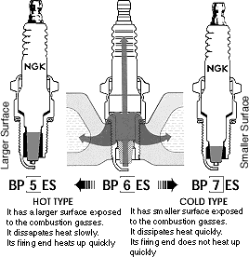

The insulator nose length is the distance from the firing tip of the insulator to the point where insulator meets the metal shell. Since the insulator tip is the hottest part of the

s p a r k plug, the tip temperature is a primary factor in pre-ignition and fouling. Whether the spark plugs are fitted in a lawnmower, boat, or a racecar, the spark plug tip temperature must remain between 500C-850°C. If the tip temperature is lower than 500°C, the insulator area surrounding the center electrode will not be hot enough to burn off carbon and combustion chamber deposits. These accumulated deposits can result in spark plug fouling leading to misfire. If the tip temperature is higher than 850°C the spark plug will overheat which may cause the ceramic around the center electrode to blister and the electrodes to melt.

This may lead to pre-ignition/detonation and expensive engine damage. In identical spark plug types, the difference from one heat range to the next is the ability to remove approximately 70°C to 100°C from the combustion chamber. A projected style spark plug firing tip temperature is increased by 10°C to 20°C.

## Tip Temperature and Firing End Appearance

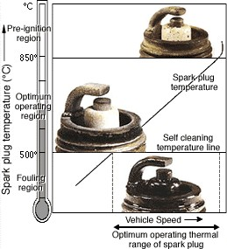

The firing end appearance also depends on the spark plug tip temperature. There are three basic diagnostic criteria for spark plugs: good, fouled and overheated. The borderline between the fouling and optimum operating regions (500 °C) is called the spark plug self-cleaning temperature. The temperature at this point is where the accumulated carbon and combustion deposits are burned off.

Bearing in mind that the insulator nose length is a determining factor in the heat range of a spark plug, the longer the insulator nose, the less heat is absorbed, and the further the heat must travel into the cylinder head water journals. This means the plug has a higher internal temperature, and is said to be a hot plug. A hot spark plug maintains a higher internal operating temperature to burn off oil and carbon deposits, and has no relationship to spark quality or intensity.

Conversely, a cold spark plug has a shorter insulator nose and absorbs more combustion chamber heat. This heat travels a shorter distance, and allows the plug to operate at a lower internal temperature. A colder heat range is necessary when the engine is modified for performance, subjected to heavy loads, or is run at high rpms for a significant period of time.

The colder type removes heat more quickly, and will reduce the chance of preignition/detonation and melting or damage to the firing end. (Engine temperature can affect the spark plug's operating temperature, but not the spark plugs heat range).

Below is a list of some of the possible external influences on a spark plug's operating temperatures. The following symptoms or conditions may have an effect on the actual temperature of the spark plug. The spark plug cannot create these conditions, but it must be able to cope with the levels of heat...if not, the performance will suffer and engine damage can occur.

**Air/Fuel Mixtures** seriously affect engine performance and spark plug operating temperatures.

* + Rich air/fuel mixtures cause tip temperature to drop, causing fouling and poor drivability
  + Lean air/fuel mixtures cause plug tip and cylinder temperature to increase, resulting in pre-ignition, detonation, and possibly serious spark plug and engine damage
  + It is important to read spark plugs many times during the tuning process to achieve the optimum air/ fuel mixture

**Higher Compression Ratios/Forced Induction** will elevate spark plug tip and in cylinder temperatures

## Advancing Ignition Timing

* Advancing ignition timing by 10° causes tip temperature to increase by approx. 70°-100° C

## Engine Speed and Load

* Increases in firing-end temperature are proportional to engine speed and load. When traveling at a consistent high rate of speed, or carrying/pushing very heavy loads, a colder heat range spark plug should be installed

## Ambient Air Temperature

* As air temperature falls, air density/air volume becomes greater, resulting in leaner air/fuel mixtures.
* This creates higher cylinder pressures/temperatures and causes an increase in the spark plug's tip temperature. So, fuel delivery should be increased.
* As temperature increases, air density decreases, as does intake volume, and fuel delivery should be decreased

## Humidity

* As humidity increases, air intake volume decreases
* Result is lower combustion pressures and temperatures, causing a decrease in the spark plug's temperature and a reduction in available power.
* Air/fuel mixture should be leaner, depending upon ambient temperature.

## Barometric Pressure/Altitude

* + Also affects the spark plug's tip temperature
  + The higher the altitude, the lower cylinder pressure becomes. As the cylinder temperature de-creases, so does the plug tip temperature
  + Many mechanics attempt to "chase" tuning by changing spark plug heat ranges
  + The real answer is to adjust jetting or air/fuel mixtures in an effort to put more air back into the engine.

***Types of Abnormal Combustion***

## Pre-ignition

* + Defined as: ignition of the air/fuel mixture before the pre-set ignition timing mark
  + Caused by hot spots in the combustion chamber...can be caused (or amplified) by over advanced timing, too hot a spark plug, low octane fuel, lean air/fuel mixture, too high compression, or insufficient engine cooling
  + A change to a higher-octane fuel, a colder plug, richer fuel mixture, or lower compression may be in order
  + You may also need to retard ignition timing, and check vehicle's cooling system
  + Pre-ignition usually leads to detonation; pre-ignition and detonation are two separate events

## Detonation

* + The spark plug's worst enemy! (Besides fouling)
  + Can break insulators or break off ground electrodes
  + Pre-ignition most often leads to detonation
  + Plug tip temperatures can spike to over 3000°F during the combustion process (in a racing engine)
  + Most frequently caused by hot spots in the combustion chamber. Hot spots will allow the air/fuel mixture to pre-ignite. As the piston is being

forced upward by mechanical action of the connecting rod, the pre-ignited explosion will try to force the piston downward. If the piston can't go up

(because of the force of the premature explosion) and it can't go down (because of the upward motion of the connecting rod), the piston will rattle from side to side. The resulting shock wave causes an audible pinging sound. This is detonation.

* + - Most of the damage than an engine sustains when "detonating" is from excessive heat
    - The spark plug is damaged by both the elevated temperatures and the accompanying shock wave, or concussion

## Misfires

* + - A spark plug is said to have misfired when enough voltage has not been delivered to light off all fuel present in the combustion chamber at the proper moment of the power stroke (a few degrees before top dead center)
    - A spark plug can deliver a weak spark (or no spark at all) for a variety of reasons...defective coil, too much compression with incorrect

plug gap, dry fouled or wet fouled spark plugs, insufficient ignition timing, etc.

* + - Slight misfires can cause a loss of performance for obvious reasons (if fuel is not lit, no energy is being created)
    - Severe misfires will cause poor fuel economy, poor driveability, and can lead to engine damage

## Fouling

* + - Will occur when spark plug tip temperature is insufficient to burn off carbon, fuel, oil or other deposits
    - Will cause spark to leach to metal shell...no spark across plug gap will cause a misfire
    - Wet-fouled spark plugs must be changed...spark plugs will not fire
    - Dry-fouled spark plugs can sometimes be cleaned by bringing engine up to operating temperature
    - Before changing fouled spark plugs, be sure to eliminate root cause of fouling

## FAQ’S

**Q: How often should I replace my spark plugs?**

**A:** Unfortunately, there is no single answer to this question. As spark plugs grow older, they lose their sharp edges as material from the center and ground electrodes is slowly eroded away. As the gap between these two points grows, the voltage required to bridge the gap increases proportionately. Even the best ignition systems will be strained to supply enough voltage to completely burn the fuel. It is at this point, when fuel is being left unburned, that the time has come to change spark plugs.

Replacing worn out spark plugs with new ones (with sharp new edges) effectively restores the ignition system's efficiency. Misfires are reduced, power is restored, economy of operation is enhanced and emissions are reduced.

The best guide is the manufacturer's recommendation for your vehicle, as this particular service varies from brand to brand and model to model. In the absence of this information or in conjunction with it, you can rely on the advice of a mechanic who is familiar with your type of vehicle. In the best of all worlds, this would be a mechanic who is also familiar with the vehicle you own. If you find a good mechanic, whether dealer or independent, stick with him. The better he knows your personal vehicle, the better he will be able to diagnose and service it. The end result is very much like a doctor-patient relationship and, in the long run, you will have a healthier vehicle.

## Q: How do I choose the right spark plug?

**A:** There are several factors such as thread reach, thread diameter, the insulator nose projection and whether the spark plug incorporates a gasket or is of the conical type to consider when choosing the correct spark plug for your needs.

In most cases, it is not until the engine is modified, or the compression is raised significantly, that stock ignition systems and spark plugs begin to show signs of being inadequate. At this point, a variety of factors determine which spark plug will be best suited for a particular configuration. In these modified engines, specific electrode/tip combinations, electrode materials and colder heat ranges can provide measurable gains in power. If your vehicle has had extensive modifications, it would be best to seek the advice of the manufacturer of your vehicle, the aftermarket supplier who manufactured your modifications, or your mechanic.

## Q: How do I "read" a spark plug?

**A:** Being able to "read" a spark plug can be a valuable tuning aid. By examining the insulator firing nose color, an experienced engine tuner can determine a great deal about the engine's overall operating condition.

In general, a light tan/gray color tells you that the spark plug is operating at optimum temperature and that the engine is in good condition. Dark coloring, such as heavy black wet or dry deposits can indicate an overly rich condition, too cold a heat range spark plug, a possible vacuum leak, low compression, overly retarded timing or too large a plug gap.

If the deposits are wet, it can be an indication of a breached head gasket, poor oil control from ring or valve train problems or an extremely rich condition depending on the nature of the liquid present at the firing tip.

Signs of fouling or excessive heat must be traced quickly to prevent further deterioration of performance and possible engine damage.

Examples of common problems that affect the firing nose of the plug:

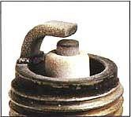

# Normal Condition

An engine's condition can be judged by the appearance of the spark plug's firing end. If the firing end of a spark plug is brown or light gray, the condition can be judged to be good and the spark plug is functioning optimally.

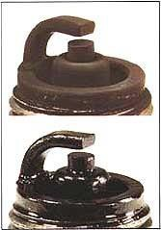

# Dry and Wet Fouling

Although there are many different cases, if the insulation resistance between the center electrode and the shell is over 10 ohms, the engine can be started normally. If the insulation resistance drops to 0 ohms, the firing end is fouled by either wet or dry carbon.

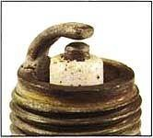

# Overheating

When a spark plug overheats, deposits that have accumulated on the insulator tip melt and give the insulator tip a glazed or glossy appearance.

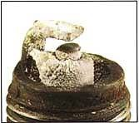

# Deposits

The accumulation of deposits on the firing end is influenced by oil leakage, fuel quality and the engine's operating duration.

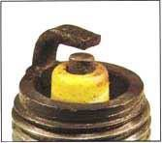

# Lead Fouling

Lead fouling usually appears as yellowish-brown deposits on the insulator nose. This cannot be detected by a resistance tester at room temperature. Lead compounds combine at different temperatures. Those formed at 370-470°C (700790°F) having the greatest influence on lead resistance.

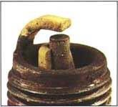

# Breakage

Breakage is usually caused by thermal expansion and thermal shock due to sudden heating or cooling.

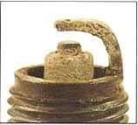

# Normal Life

A worn spark plug not only wastes fuel but also strains the whole ignition system because the expanded gap (due to erosion) requires higher voltages. Normal rates of gap growth are as follows:

*Four Stroke Engines:* 0.01~0.02 mm/1,000 km (0.00063~0.000126 inches/1,000 miles)

*Two Stroke Engines:* 0.02~0.04 mm/1,000 km (0.000126~0.00252 inches/1,000 miles)

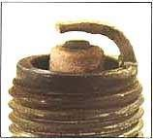

# Abnormal Erosion

Abnormal electrode erosion is caused by the effects of corrosion, oxidation and reaction with lead all resulting in abnormal gap growth.

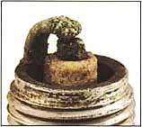

# Melting

Melting is caused by overheating. Mostly, the electrode surface is rather lustrous and uneven. The melting point of nickel alloy is 1,200~1,300°C (2,200~2,400°F).

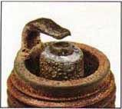

# Erosion, Corrosion and Oxidation

The material of the electrodes has oxidized, and when the oxidation is heavy it will be green on the surface. The surface of the electrodes is also fretted and rough.

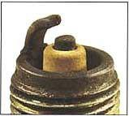

# Lead Erosion

Lead erosion is caused by lead compounds in the petrol which react chemically with the material of the electrodes (nickel alloy) as high temperatures; crystal of nickel alloy falls off because of the lead compounds permeating and separating the grain boundary of the nickel alloy. Typical lead erosion causes the surface of the ground electrode to become thinner, and the tip of the electrode looks as if it has been chipped.

**Q: How much of a performance improvement can I expect from changing plugs? A:** A common misconception is that changing spark plugs will result in a large power increase. In most cases, removing even seriously worn out spark plugs will only result in

very modest power gains, typically about 1-2% of total engine output. This could be even less for computer-controlled vehicles, primarily because most newer vehicles have more powerful ignition systems and the vehicle's computer can make adjustments so that vehicle operation seems smoother and more seamless.

Many people think that simply supplying more spark to the firing tip can and will combust more fuel. What they don't understand is that most new car engines are so efficient that they are already burning all of the available fuel. Simply adding more spark voltage can't burn more fuel because there is no more fuel to burn.

When a stock or near-stock engine is given a fresh set of spark plugs, peak efficiency is restored. The power gains that come from this restored state of tune are usually minimal. Any company that tells you that their spark plug will provide significant gains in power in a stock or near-stock engine is making blanket statements that may not be supportable.

## Q: What is a "fouled" spark plug?

**A:** A spark plug is considered fouled when the insulator nose at the firing tip becomes coated with a foreign substance such as fuel, oil or carbon. This coating makes it easier for the voltage to follow along the insulator nose, leach back down into the metal shell and ground out rather than bridging the gap and firing normally.

Many factors can contribute to spark plug fouling. The air/fuel ratio may be too rich as a result of incorrect carburetor adjustment or a poorly performing fuel injection system. Worn piston rings or valve seals may allow too much oil to leak into the combustion chamber, leading to oil fouling. The ignition system may not be performing properly. Prolonged idling or continuous low-speed driving may keep the spark plug from reaching its optimum operating temperature. Using too cold a spark plug can lead to the same

problem. Finally, a dirty air cleaner can create a too-rich condition that can lead to fouling. Fuel, oil and carbon fouling can all be the result of different causes but, once a spark plug is fouled, it will not provide adequate voltage to the firing tip and that cylinder will not fire properly. In many cases, the spark plug cannot be cleaned sufficiently to restore normal operation. Therefore, it is recommended that a plug be replaced once it is fouled.

## Q: Do I need to set the "gap" when installing a new set of plugs?

**A:** Maybe. A spark plug part number might fit hundreds of engines and, although the factory will typically set the gap to a pre-selected setting, this may not be the right gap for your particular engine. Insufficient spark plug gap can cause pre-ignition, detonation and even engine damage. Too much gap can result in a higher rate of misfires, loss of power, plug fouling and poor fuel economy. It is always best to check the gap against the manufacturer's specifications.

Another consideration that should be taken into account is the extent of any modifications that you may have made to the engine. As an example, when you raise compression or add forced induction (a turbo system, nitrous or supercharger kit) you must reduce the gap (about .004" for every 50 hp you add). However, when you add a high-power ignition system (such as those offered by MSD, Crane, Nology) you can open the gap from .002-

.005".

The manufacturer of your vehicle, the company that produced the aftermarket products you've used and/or your mechanic are all additional sources of gapping information if you've modified your vehicle.

## Q: Are special plugs always necessary on a modified engine?

**A:** It depends on the modifications. The term "modified" refers to those engines that have received bolt-on improvements that may or may not raise the engine's total compression ratio. These can include turbocharging, supercharging, nitrous oxide injection, the use of smaller-chambered cylinder heads, modified piston configurations, free-flowing cylinder heads, change of induction components and/or the use of different fuel types and octane. These kinds of modifications generally require a change from stock spark plugs.

Modifications that will typically not require specialized plugs (in most cases the factory installed plug will be more than adequate) include adding a free-flowing air filter, headers, mufflers and rear-end gears. Basically, any modification that does not alter the overall compression ratio will not usually necessitate changing plug types or heat ranges. Such minor modifications will not significantly increase the amount of heat in the combustion chamber; hence, a plug change is probably not warranted.

However, when compression is raised, along with the added power comes added heat. Since spark plugs must remove heat and a modified engine makes more heat, the spark plug must remove more heat. A colder heat range spark plug must be selected and plug gaps should be adjusted smaller to ensure proper ignitability in this denser air/fuel mixture.

Typically, for every 75-100 hp you add, you should go one step colder on the spark plug's heat range. A hotter heat range is not usually recommended except when severe oil or fuel fouling is occurring.

## Q: How do I install spark plugs correctly?

**A:** It is essential to tighten a spark plug to the specified turning angle or torque setting. First, screw in the plug finger tight until the gasket meets the cylinder head. Then seat the plug/gasket with a torque or turning angle wrench as specified in the chart below.

|  |  |  |  |
| --- | --- | --- | --- |
| Spark plug type | Thread Diameter | Cast Iron Cylinder | Aluminum Cylinder |
| Flat seat type (with gasket) | 18 ø mm | 25.3~32.5 | 25.3~32.5 |
|  | 14 ø mm | 18.0~25.3 | 18.0~21.6 |
|  | 12 ø mm | 10.8~18.0 | 10.8~14.5 |
|  | 10 ø mm | 7.2~10.8 | 7.2~8.7 |
|  | 8 ø mm | -- | 5.8~7.2 |
| Conical seat type (without gasket) | 18 ø mm | 14.5~21.6 | 14.5~21.6 |
| Conical seat type (without gasket) | 14 ø mm | 10.8~18.0 | 7.2~14.5 |

This is very important, as excessive tightening of a spark plug can cause breakage of the metal shell and damage to the interior seals. At the same time, insufficient tightening can lead to overheating of the spark plug and potential detonation.

## Q: When should I use a resistor spark plug?

**A:** Companies like NGK have NGK "R" or resistor spark plugs that use a 5k-ohm ceramic resistor in the spark plug to suppress ignition noise generated during sparking. It is strongly recommended to use resistor spark plugs in any vehicle that uses on-board computer systems to monitor or control engine performance. This is because resistor spark plugs reduce electromagnetic interference with on-board electronics.

It is also recommended on any vehicle that has other on-board electronic systems such as engine-management computers, two-way radios, GPS systems, depth finders or whenever recommended by the manufacturer.

In fact, using a non-resistor plug in certain applications can actually cause the engine to suffer undesirable side effects such as an erratic idle, high-rpm misfire, engine run-on, power drop off at certain rpm levels and abnormal combustion.

## Q: Why are there different heat ranges?

**A:** It is a common misconception that spark plugs create heat. They don't. A heat range refers to how much heat a spark plug is capable of removing from the combustion chamber. Selecting a spark plug with the proper heat range will ensure that the tip will maintain a temperature high enough to prevent fouling yet be cool enough to prevent pre-ignition.

While there are many things that can cause pre-ignition, selecting a spark plug in the proper heat range will ensure that the spark plug itself is not a hot spot source.

## Q: What do the numbers and letters in a part number represent?

**A:** The various numbers and letters in a spark plug code or identification number basically identify the features and functions of a particular plug. Included would be information such as plug type, heat rating, construction, thread diameter, thread reach and firing end construction.

## Q: Does humidity affect spark plug temperature?

**A:** Yes, humidity does affect spark plug temperature. As the humidity increases, the intake air mass decreases. This results in lower combustion pressures and temperatures, causing a decrease in the spark plug's temperature.

## Q: Does ignition timing affect a spark plug's temperature?

**A:** Yes, ignition timing directly affects the firing end temperature of the spark plug. Advancing the ignition timing prolongs the time to compress the burning gases. The preignition temperature also elevates gradually, since the pressure and temperature of the combustible mixture is low before ignition. Advancing your timing elevates firing end temperatures.

## Q: Does compression ratio affect firing end temperature?

**A:** Yes, the by-product of increased compression is the elevation in cylinder temperatures. This is why it is recommended to choose a spark plug suitable for your application. All major spark companies recommend dropping heat ranges and altering Air/Fuel mixtures and timing as needed. It is very important to dissipate the excess heat from the combustion chamber in order to prevent pre-ignition.

## Q: Can old spark plugs be cleaned?

**A:** Yes, you can clean spark plugs. However, it is good to remember that spark plugs are a wearable item, so it's important to make sure you check to see if it's worth cleaning before you go through the following steps.

* If the firing end is wet, make sure you clean the spark plug with a quick drying cleaner. (Examples: contact cleaner or brake cleaner).
* Sand blast the spark plug using low air pressure and use a dry compound.
* Completely blow all the sand from the spark plug.
* Using a wire brush clean the threads and re-gap.

**NOTE:** Insufficient cleaning of the spark plug may lead to spark plug failure in a very short period of time. Clean the spark plug thoroughly to avoid problems later. Remember, if a spark plug is fouling it's usually a result of engine side factors or incorrect heat range selection.

## Q: What is the maximum I can open or close the gap?

**A:** It is not recommended to adjust the spark plug gap < or > .008". The reason for this is the ground electrode and center electrode won't line up properly, hindering spark plug performance.

## Q: What is pre-ignition?

**A:** Pre-ignition is defined as the ignition of the air/fuel mixture before desired ignition timing.

## Q: What is detonation?

**A:** Detonation is a spark plugs worst enemy. It can break insulators and ground electrodes. Spark plug temperatures can reach in excess of 3000 °F.

Detonation, in simple terms, is a violent uncontrolled burn of the air/fuel mixture, which occurs when excessive heat and cylinder pressure causes the air/fuel mixture to spontaneously ignite.

*Reference:* [*www.ngksparkplugs.com*](http://www.ngksparkplugs.com/)

# Nitrous Oxide Systems – The Need for *Speed!!!* (A special thanks to Gordon for this!)

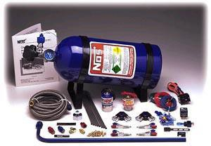

Nitrous Oxide is becoming popular by the day and is the answer to everyone's need POWER, SPEED, and ACCELERATION! The world-famous brand that gave this magical thing so much hype is "NOS Nitrous Oxide System"! They provided one of the safest, easy-to-use and best systems. Let’s see the system that has changed Indian cars in the last three years.

Speed Run 2003 held in Mumbai had a handful of cars (mostly Indian) using NOS. In two years, the number of cars using NOS has almost tripled, and was also being used in the Foreign class.

The NOS system can enable you to get almost 20-200 bhp gains. You can improve on your timings by 3-4 seconds. I've found some information on nitrous oxide from the NOS site itself.

## How to Make Horsepower

An engine operates by burning fuel, which then expands and pushes the pistons down. Want to make more horsepower? Burn more fuel so it will push the pistons down with more force. Sounds pretty simple. But, it's not quite so easy. While there are any number of factors that make increasing power a complex engineering problem, we will deal with three of the most basic ones here.

First, all fuels require oxygen in order to burn. If you want to burn more fuel, you need to also put in more oxygen. Virtually all engine performance products increase power by increasing the flow of fuel and oxygen. Camshafts, larger carburetors or valves, porting, intake manifolds, exhaust headers, superchargers, turbochargers, and nitrous oxide are clear examples of how improved engine breathing (putting in more oxygen in order to burn more fuel) will give you an increase in horsepower. Nitrous oxide injection systems are probably the most efficient way to increase the flow of oxygen and fuel. That's the basic reason why nitrous systems produce such large horsepower increases.

Another basic power factor is vaporization of the fuel. Petrol, as with other racing fuels, will not burn in a liquid state. The petrol must be turned into vapor for it to burn. This process of turning petrol into vapor is simple evaporation. It is basically no different from setting a glass of water outside and waiting for it to dry up. In the engine, of course, evaporation happens very quickly. Engine heat and fuel atomization are the keys to accelerating the evaporation process enough to turn raw petrol into a vapor at 8000 RPM. The process of atomization turns raw fuel flow into tiny droplets which then evaporate faster due to the larger amount of surface area presented for evaporation. The size of the fuel droplets is very important. Take a large droplet of petrol, break it up into 10 smaller droplets, and you've increased the surface area for more efficient evaporation. The result is more fuel available to be burned and do work during combustion. A well-designed nitrous system will produce very small droplet sizes in the supplemental fuel that flows into the engine with nitrous. This is one of the reasons why NOS nitrous systems can make more horsepower than some other systems.

The third basic power factor we will look at is air/fuel mixture density. Ever try to jog on top of a 10,000-foot pass in the Rockies? Leaves you gasping for breath, doesn't it? That's because the air is thinner, less dense, higher up in the atmosphere than it is at sea level. It is also why you would run slower on a track in Denver than you would near sea level in New Jersey. Density is affected by atmospheric pressure (the weight of the atmosphere above you), heat, and humidity. We can't change the pressure of the atmosphere; but we can regulate the heat of our intake charge to some extent. Cool cans and intercoolers make extra power by cooling the fuel and air/fuel mixture to make it denser. And, the denser the mixture is, the more the cylinder is packed with fuel and air to burn and make power. When nitrous oxide is injected, it turns from a liquid to a gas instantly and becomes very cold. This cold nitrous vapor drops the temperature of the whole intake charge in the manifold by as much as 65 degrees F. The denser mixture that results helps an engine produce even more extra horsepower with a nitrous system.

## What Nitrous Oxide Is and What Nitrous Oxide Isn’t?

To your engine, nitrous oxide is a more convenient form of normal air. Since we are only interested in the oxygen the air contains, nitrous oxide provides a simple tool for manipulating how much oxygen will be present when you add additional fuel in an attempt to release more power. The power always comes from the fuel source. Nitrous oxide is not a fuel. Nitrous oxide is a convenient way to add the additional oxygen required to burn more fuel. If you add only nitrous oxide and do not add additional fuel, you would just speed up the rate at which your engine is burning the fuel that it normally uses.

This, more often than not, leads to destructive detonation. The energy comes from the fuel, not the nitrous. Nitrous oxide simply allows you to burn a greater quantity of fuel in the same time period; thus, the overall effect is a tremendous increase in the total amount of energy, or power, released from the fuel and available for accelerating your vehicle.

There is no voodoo involved in nitrous oxide. In effect, using nitrous is no different from using a bigger carburetor, a better manifold, a supercharger, or a turbocharger.

Understand that the air you and your engine breathe is made up, at sea level, of 78% nitrogen, 21% oxygen, and just 1% other gases. Nitrous oxide (N2O) is made by simply taking the 2 major components of earth's atmosphere (in this case 2 molecules of nitrogen and 1 molecule of oxygen) and attaching them together with a chemical bond. When the nitrous oxide goes into your engine the heat of combustion breaks the chemical bond to provide your engine more oxygen with which to burn fuel. As you've read, all race engines operate under the same principles: more air (better breathing, supercharging, turbocharging, or nitrous) plus more fuel in a denser vapor equals more power.

## Spark Plugs and Nitrous Oxide: What Works, What Doesn't, and Why

Over the years there seems to have been a great amount of technical material written about the simple operation of a spark plug and what they can do in relation to the way an engine runs. There are a few basic characteristics about spark plugs that you need to know to make an intelligent choice about the correct spark plug for your application.

First, and most important; a spark plug must be of the correct design to operate within the environment of your engine, not the other way around. This means that the spark plug has virtually no influence on how the engine burns fuel or runs in general. The correct spark plug will simply survive the conditions present in your engine. A spark plug must maintain a certain temperature to keep itself clean. The wrong heat range can cause an overheated plug or a fouled plug. The heat range refers to the temperature of the ceramic material surrounding the center electrode.

Lean air/fuel ratios are more difficult to light because there are less fuel molecules in the area of the plug gap when the plug is scheduled to fire; thus, projected nose plugs were designed for late-model lean-burn engines. Modern high-energy ignition* also allowed larger plug gaps. All the while this was happening, something else happened. Something that no one seems to have really noticed as the real culprit when the issue of factory type plugs being used with nitrous comes up. We'd like to clue you in.

Quite often, a factory type, wide-gap projected plug will produce a misfire condition after only a few seconds of nitrous use. The misfire is not due to the heat range. The misfire occurs because the ground strap of the spark plug becomes a glowing ember because it is too long to dissipate the extra heat produced by a nitrous-accelerated burn condition. The correct fix for this phenomenon is to replace the plugs with one that has a shorter ground strap. By doing this, you will shorten the path for the heat being absorbed by the ground strap. You can use the same heat range; you just have to find a non-projected nose plus with a shorter and preferably thicker ground strap.

If you only change the heat range of the spark plug to a colder heat range, you may very

well still have the misfire problem. Since the length of the ground strap is the cause of the misfire, a colder spark plug may have the same length of ground strap as the hotter plug you replaced it with.

* Modern high-energy ignition: High energy coils being used on cars for a higher voltage and a shorter pulse, this allows for a larger gap between the points to aid ignition.

It is often practiced that 2 separate sets of plugs are used, one when using nitrous and one when not using nitrous, i.e., daily use.

Note: The fuel is atomized at the carb or the injectors before it enters the cylinder. A larger spark would mean a faster ignition of the fuel as more of the air fuel mixture is in contact with the spark.

Spark plug gaps should generally be .030" to .035". Never try to gap a plug designed for an

.060" gap down to .035". Find the correct non-projected nose plug designed for an

.035" gap.

Nitrous Oxide systems are safe, but you need to select the right system for your engine. If you have a perfect match, you'll have perfect and superb results. Depending on the match, you can get anything between 40-60 bhp minimum. Let’s now see the different types of Nitrous Oxide Installations/Systems.

## Types of Nitrous Oxide Systems an Overview of Wet, Dry and Direct Port Systems

These are three basic types of nitrous systems: dry manifold, wet manifold and direct port.

Dry manifold systems are becoming more popular as the bulk of today's cars employ electronic fuel injection. In a dry manifold system, the nitrous oxide can be injected anywhere between the intake ports and upstream of the throttle butterfly. The most misunderstood is the "dry" type of system. A "dry" nitrous system simply means that the fuel required to make additional power with nitrous will be introduced through the fuel injectors (remember, fuel makes power, nitrous simply lets you burn more of it). This keeps the upper intake dry of fuel. We accomplish this by two methods. First, is to increase the pressure to the injectors by applying nitrous pressure from the solenoid assembly when the system is activated. This causes an increase in fuel flow just like turning up the pressure on your garden hose from 1/2 to full. The second way we can add the required fuel is to increase the time the fuel injector stays on. This is accomplished by changing what the computer sees, basically tricking the computer into adding the required fuel. In either case, once the fuel has been added, the nitrous can be introduced to burn the supplemental fuel and generate additional power.

We can see this in a different light. The enrichment fuel is delivered through the existing

fuel injectors or dedicated fuel nozzles near the mouth of the intake ports. As you've probably guessed, the dry manifold name is derived from the lack of fuel in the intake manifold.

In some EFI nitrous set-ups the existing injectors can be used to inject the normal fuel quantity in addition to the enrichment required for nitrous operation. If the OE injectors are being used you will probably need increased fuel pressure to provide the necessary extra fuel flow. A high-flow fuel pump may also be required.

Alternatively – if the existing injectors are large enough – you can take the option of increasing injector duty-cycle when the nitrous system is activated. A programmable management system with switchable maps is ideal for this purpose.

Note that mounting the nitrous nozzles closer to the intake ports gives a noticeable nitrous 'hit' but provides less intake air cooling and mixing.

The second type of nitrous kit is the "wet" style of kit. These kits include carburetor plate systems and add nitrous and fuel at the same time and place (normally 3-4" ahead of the throttle body for fuel injected applications or just under the carb as with plate systems).

This type of system will make the upper intake wet with fuel. These systems are best used with intakes designed for wet flow and turbo/supercharged applications.

In some applications, however, the nitrous and enrichment fuel can be injected about 10 – 30cm upstream of the throttle to give slightly better mixing and a greater cooling effect. As the name implies, a wet manifold system uses an intake manifold that's wet with fuel.

The last type of system is the direct port system. Just as its name implies, it introduces the nitrous and fuel directly into each intake port on an engine. These systems will normally add the nitrous and fuel together through a fogger nozzle or a NOSzleTM. The fogger nozzle mixes and meters the nitrous and fuel delivered to each cylinder. This is the most powerful and one of the most accurate types of systems. This is due to the placement of the nozzle in each runner, as well as the ability to use more and higher capacity solenoid valves. A direct port system will have a distribution block and solenoid assembly that delivers the nitrous and fuel to the nozzles by way of connecting tubes.

Because each cylinder has a specific nozzle and jetting (both nitrous and fuel), it is possible to control the nitrous/fuel ratio for one cylinder without changing that of the other cylinders. These systems are also one of the more complicated systems when installation is considered, as the intake must be drilled, tapped, and the "plumbing" made to clear any existing obstructions. Because of this and the high output of these systems, they are most often used on racing vehicles built for the strain of such high horsepower levels.

***References (hopefully I haven’t left out any!):***

[*http://www.driftsession.com/technique.htm*](http://www.driftsession.com/technique.htm)

[*http://streetracing.tiora.net/ja-*](http://streetracing.tiora.net/ja-)[*pan/drift/drift1.htm*](http://streetracing.tiora.net/japan/drift/drift1.htm)

[*http://www.dur.ac.uk/r.g.bower/PoM/pom/node31.html*](http://www.dur.ac.uk/r.g.bower/PoM/pom/node31.html)

[*http://news.bbc.co.uk/sport1/hi/motorsport/formula_one/car_behaviour/de-*](http://news.bbc.co.uk/sport1/hi/motorsport/formula_one/car_behaviour/de-)[*fault.stm*](http://news.bbc.co.uk/sport1/hi/motorsport/formula_one/car_behaviour/default.stm)

[*http://rogerkrausracing.com/overundr.html*](http://rogerkrausracing.com/overundr.html)

[*http://www.holley.com*](http://www.holley.com)