A MINOR PROJECT REPORT
ON

FACIAL EXPRESSION RECOGNITION USING CONVOLUTIONAL NEURAL NETWORKS ALGORITHM AND DEEP LEARNING

Submitted to
Lords Institute of Engineering and Technology, Autonomous, Hyderabad
In partial fulfillment of the academic requirements (5th Semester) for the award of the degree of

BACHELOR OF ENGINEERING
In

COMPUTER SCIENCE AND ENGINEERING – AI&ML
Submitted by
SYED MOAZAM (160923748131)

Under The Guidance Of
Ms ZEBA RUQSHANH
Assistant Professor

DEPARTMENT OF COMPUTER SCIENCE AND ENGINEERING - AI&ML
LORDS INSTITUTE OF ENGINEERING AND TECHNOLOGY
(UGC Autonomous)
(Approved by AICTE |Accredited by NBA| Accredited by NAAC ‘A’ grade | Affiliated to OU-HYD)
2025-2026

DEPARTMENT OF COMPUTER SCIENCE AND ENGINEERING - AI&ML
LORDS INSTITUTE OF ENGINEERING AND TECHNOLOGY
(UGC Autonomous)
(Approved by AICTE |Accredited by NBA| Accredited by NAAC ‘A’ grade | Affiliated to OU-HYD)

CERTIFICATE

This is to certify that the minor project work entitled "FACIAL EXPRESSION RECOGNITION USING CONVOLUTIONAL NEURAL NETWORKS ALGORITHM AND DEEP LEARNING" is submitted by Syed Moazam (160923748131) in partial fulfillment for the award of degree of Bachelor of Engineering (5th Semester) in "Computer Science and Engineering – AI&ML" of Lords Institute of Engineering and Technology, Hyderabad during the academic year 2025-2026. The project report has been approved as it satisfies the academic requirements in report of minor project work prescribed for the Bachelor of Engineering. The result embodied in this project report has not been submitted either in partial or in full, for the award of any other degree in this institute or any institute or university.

Ms Zeba Ruqshanh
Dr. Abdul Rasool MD
ASSISTANT PROFESSOR HEAD OF THE DEPARTMENT

DECLARATION

I hereby declare that the Minor Project report entitled "FACIAL EXPRESSION RECOGNITION USING CONVOLUTIONAL NEURAL NETWORKS ALGORITHM AND DEEP LEARNING" is submitted by Syed Moazam (160923748131) in partial fulfillment of the academic requirements for the 5th Semester of the degree of Bachelor of Engineering in "Computer Science and Engineering - AI&ML" in the Lords Institute of Engineering and Technology, Hyderabad, is a record of bona fide minor project work carried out by me under the guidance of Ms Zeba Ruqshanh.
I further declare that the work reported in this Minor Project and the result embodied in this project report has not been submitted either in partial or in full, for the award of any other degree in this institute or any institute or university.

SYED MOAZAM
(160923748131)

DATE:
PLACE: HYDERABAD

ACKNOWLEDGEMENT

I avail this opportunity to express my profound sense of gratitude to all who rendered their valuable help and time in the completion of the Minor Project on time with quality.
I would like to express my immense gratitude and sincere thanks to Management of Lords Institute of Engineering and Technology for providing infrastructure necessary equipment, support and excellent academic environment which was required during research and development of the Minor Project.
I am thankful to DR. RAVI KISHORE SINGH, the Principal of Lords Institute of Engineering and Technology for providing the necessary guidance to pursue and successfully complete the Minor Project on time with quality.
I am mostly obliged and grateful to DR. ABDUL RASOOL MD, Head of the Department, Computer Science and Engineering - AI&ML, Lords Institute of Engineering and Technology, Hyderabad for his valuable guidance, keen and sustained interest and encouragement throughout the implementation of this Minor Project.
I wish my deepest sense of gratitude to internal guide Ms ZEBA RUQSHANH, Assistant Professor, Lords Institute of Engineering and Technology for her valuable advice and guidance in the critical review and Minor Project implementation.
I express my gratitude to all the other faculty members of CSE-AI&ML Department who helped me in learning, implementing and Minor Project execution.
Finally, I acknowledge with gratitude the unflagging support and patience of my parents for the guidance and encouragement during this Minor Project work.

SYED MOAZAM
(160923748131)

ABSTRACT

Facial Expression Recognition (FER) has emerged as a significant research area in human–computer interaction, psychological analysis, and intelligent systems. With the rapid advancements in Artificial Intelligence, Deep Learning (DL) techniques—especially Convolutional Neural Networks (CNNs)—have demonstrated superior accuracy in automatically learning and classifying facial expressions from images. This project focuses on developing an efficient FER system using a CNN-based architecture that extracts spatial features directly from facial images without manual feature engineering. The system is trained on a labeled dataset containing multiple emotion categories such as happy, sad, angry, fear, surprise, disgust, and neutral.
The proposed CNN model performs a sequence of operations including image preprocessing, convolution, activation, pooling, and fully connected layers to accurately identify subtle variations in facial muscles. Deep Learning enables hierarchical feature learning, enhancing model robustness against variations in lighting, background, occlusion, orientation, and facial diversity. Experimental results show that CNN-based FER achieves improved recognition performance compared to traditional machine learning approaches. The model can be integrated into applications such as healthcare monitoring, real-time surveillance, emotion-aware assistants, smart classrooms, and interactive entertainment systems. Overall, this work highlights the effectiveness of CNN and deep learning-based methods in building an intelligent and reliable facial expression recognition system.

EXPECTED:
PO: PO1, PO2, PO3, PO4, PO5, PO6, PO8, PO9, PO10, PO11, PO12
PSO: PSO1, PSO2, PSO3
SDG 16 : Peace, Justice and Strong Institutions

 | INDEX
Contents Acknowledgement Abstract  List of Tables  List of Figures |  | Page No.  i ii iii v
CHAPTER-1: INTRODUCTION |  | 1
1.1 Introduction |  | 1
CHAPTER-2: LITERATURE SURVEY |  | 4
2.1 Literature Review |  | 4
CHAPTER-3: FEASIBILITY STUDY |  | 12
3.1 Economic Feasibility |  | 12
3.2 Technical Feasibility |  | 14
3.3 Social Feasibility |  | 15
CHAPTER-4: SYSTEM ANALYSIS |  | 18

4.1 Existing System 18
4.2 Disadvantages Of Existing System 19
4.3 Proposed System 21
4.4 Advantages Of Proposed System 22
CHAPTER-5: PROJECT METHODOLOGY 25
5.1 Software Development Life Cycle 25
5.2 Adopted Methodology 27
5.3 Waterfall Model 27
CHAPTER-6: REQUIREMENT SPECIFICATION 30
6.1 Hardware Specifications 30
6.2 Software Specifications 33
CHAPTER-7: SYSTEM DESIGN 36
7.1 System Architecture 36
7.2 Dataflow Diagram 39
CHAPTER-8: IMPLEMENTATION AND CODE 40
8.1 Sample Code 40
CHAPTER-9: OUTPUT 51
9.1 User View 51
9.2 Prediction 52
9.3 Image Processing 53
9.4 Prdicted Expression Output 54
CHAPTER-10: CONCLUSION AND FUTURE SCOPE 55
10.1 Conclusion 55
10.2 Future Scope 57
CHAPTER-13: BIBLIOGRAPHY 59

LIST OF FIGURES

S.no | Figure No. | Name of the Figure | Page No.
1. | 7.1 | System Architecture | 38
2. | 7.2 | Data Flow Diagram | 39
3. | 9.1 | User View of Facial Expression Recognition | 51
4. | 9.2 | Choosing an image from files for Facial Expression Recognition | 52
5. | 9.3 | Prediction in process for Facial Expression Recognition | 53
6. | 9.4 | Result being displayed of Facial Expression | 54

CHAPTER-1
INTRODUCTION

1.1 INTRODUCTION TO FACIAL EXPRESSION RECOGNITION
Facial Expression Recognition (FER) is an essential subfield of computer vision and artificial intelligence that focuses on automatically identifying human emotions from facial features. Human faces are rich sources of non-verbal communication, conveying emotional states such as
happiness, sadness, anger, fear, surprise, and disgust.
These emotions form a universal language that transcends linguistic and cultural boundaries, making FER an increasingly significant area of research. With the rapid growth of machine learning and deep learning techniques, FER systems have advanced remarkably, achieving better accuracy, robustness, and real-world applicability.
FER primarily aims to bridge the gap between human communication and machine understanding. As digital systems become more integrated into our everyday lives—through smartphones, social platforms, surveillance systems, healthcare devices, and human–computer interaction—machines must be able to interpret human emotions in order to respond appropriately. This has led to a surge in interest towards developing computational models capable of analyzing facial expressions in images, videos, or real-time streams.
The process of recognizing facial expressions involves multiple steps, beginning with image acquisition, preprocessing, feature extraction, and finally, classification of the emotion.
Traditional FER techniques relied heavily on handcrafted features like Local Binary Patterns (LBP), Histogram of Oriented Gradients (HOG), Gabor filters, and geometric models of facial landmarks. While these approaches were effective to some extent, they were limited in capturing subtle variations in expressions, illumination changes, head poses, and occlusions.
With advancements in deep learning, Convolutional Neural Networks (CNNs) have become the backbone of modern FER systems. CNNs automatically learn complex and hierarchical representations of facial features directly from raw image data. This eliminates the need for manual feature extraction and significantly improves accuracy.
Models trained on large FER datasets—such as FER2013, CK+, or JAFFE—can identify patterns that are not easily detectable using traditional methods. CNN-based models also generalize better across different facial structures, demographic variations, and real-world noise.
In typical FER systems, preprocessing plays a vital role in enhancing image quality and preparing data for accurate prediction. Preprocessing steps include face detection, image resizing, normalization, and sometimes conversion to grayscale to reduce computational complexity.
After preprocessing, the CNN model extracts spatial features related to eyebrows, eyes, mouth, and other key regions responsible for emotional expressions. These learned representations are then passed to a classifier—often a softmax layer—that categorizes the emotion into discrete classes.
The applications of Facial Expression Recognition are vast and diverse. In healthcare, FER is used for diagnosing psychological conditions, monitoring patient mood, and assisting in autism therapy by improving social interaction. In security and surveillance, FER aids in detecting suspicious behavior or stress indicators.
In marketing, companies analyze customer reactions to products or advertisements using FER-driven sentiment analysis. Additionally, FER enhances user experience in gaming, smart homes, and human–robot interaction by enabling devices to respond adaptively to user emotions.
Despite significant progress, FER still faces several challenges. Variations in lighting, background noise, occlusions (like glasses or masks), facial hair, different angles, and cultural differences in expressing emotions can affect model performance. For instance, real-time FER systems must operate efficiently under dynamic and unpredictable environments.
Similarly, subtle emotions such as contempt, confusion, or boredom are difficult to classify accurately due to overlapping facial cues. Deep learning models require large amounts of labeled data to handle such diversity, and collecting emotion-annotated datasets remains a time-consuming task.
Another complexity arises from the fact that human emotions are inherently subjective. People express emotions differently based on personality, age, culture, and context. A smile may signify happiness in one context but could reflect embarrassment or politeness in another. FER systems have to be trained carefully to handle such ambiguities.
Advanced architectures such as CNN–LSTM hybrids, attention mechanisms, and transformer-based models are being explored to improve contextual understanding and temporal emotion recognition from video sequences.
Ethical considerations are also an important aspect of FER research. Since facial data is personally identifiable and sensitive, ensuring privacy, data security, and responsible usage is crucial. FER should not be used for intrusive surveillance or without user consent. Researchers and developers must comply with ethical guidelines and ensure transparency in how facial data is collected, processed, and stored.
Modern FER systems increasingly utilize explainable AI techniques to interpret how models reach certain predictions. Explain ability helps in building trust among users, especially in applications related to healthcare and security. It also enables developers to debug models, detect biases, and ensure fairness across demographic groups.
In recent years, FER technology has been integrated with cloud-based platforms and mobile applications, making it more accessible. With lightweight deep learning models and hardware accelerators, real-time emotion detection has become feasible even on smartphones and embedded devices. Combined with edge computing, FER can operate locally without transmitting data to external servers, thus providing enhanced privacy and reduced latency.
Overall, Facial Expression Recognition has evolved into a powerful tool that enhances the interaction between humans and intelligent systems. Its ability to decode emotional states plays a significant role in improving communication, safety, healthcare, entertainment, and automation.
As research continues to advance—driven by innovations in deep learning, large-scale datasets, and computational power—FER systems will become increasingly accurate, reliable, and capable of understanding complex multi-modal human emotions.
The ultimate goal is to enable machines that can perceive, interpret, and respond to human emotions naturally and empathetically, paving the way for truly intelligent and compassionate technologies.

CHAPTER-2
LITERATURE SURVEY

2.1 LITERATURE REVIEW

Title : “Deep Facial Expression Recognition: A Survey”
Author: Shan Li & Weihong Deng (2018)
Abstract: Li and Deng’s 2018 survey is one of the most influential works in the facial expression recognition (FER) domain, offering an extensive historical and technical overview of the field as it transitioned from handcrafted-feature approaches to deep learning–based pipelines. The authors begin by establishing the foundations of FER—its pipeline involving face detection, alignment, feature extraction, and classification—and then describe how traditional methods such as Local Binary Patterns (LBP), Gabor features, SIFT, and LDA/SVM classifiers dominated early research. They note that although these methods achieved decent accuracy in controlled environments, they struggled significantly in real-world conditions due to variation in pose, illumination, occlusion, and subject identity.
The core of the survey focuses on convolutional neural networks (CNNs) and the emergence of deep-learning architectures. The authors categorize CNN-based FER approaches into three dominant styles: end-to-end CNN classification, hybrid deep learning models (CNN + RNN, CNN + SVM), and generative approaches (GANs). Detailed comparisons of commonly used datasets—including CK+, JAFFE, FER2013, AffectNet, and SFEW—highlight the challenges researchers face, such as class imbalance, expression intensity variability, and annotation inconsistency.
Li and Deng further provide an in-depth analysis of issues like overfitting due to limited training data, the necessity of transfer learning, and the importance of data augmentation for improving generalization. They also discuss expression-unrelated variations such as identity bias and propose domain adaptation and disentangled representation learning as promising solutions. Their concluding remarks outline open challenges such as building culturally unbiased FER systems, handling spontaneous expressions, and improving robustness in unconstrained environments. Overall, the survey provides a systematic understanding of FER’s evolution and serves as an essential reference for CNN- and deep-learning-based FER research.

Title : “Facial Expression Recognition: A Review”
Author: Y. Huang (2019)
Abstract: Huang’s 2019 survey presents a structured categorization of methods in facial expression recognition while placing strong emphasis on the transition from conventional computer vision techniques to modern deep-learning approaches. The survey begins by defining facial expressions as crucial channels of non-verbal communication and highlighting their importance across diverse fields, including medical diagnosis, human–computer interaction, behavioral analysis, and surveillance.
Huang first divides FER techniques into two major categories: conventional methods and deep-learning-based methods. Conventional approaches typically depend on handcrafted features—such as Eigenfaces, LBP, Gabor wavelets, optical flow, and geometric landmarks—which are fed into classifiers like SVM, KNN, and Random Forests. While efficient, these approaches often fall short in real-world applications due to sensitivity to noise, lighting changes, and pose variations.
Transitioning to deep learning, Huang describes how CNNs revolutionized feature extraction by automatically learning hierarchical feature representations directly from raw pixel inputs. The survey explains several CNN variants used in FER, including shallow CNNs, VGG-style deep networks, residual networks, and hybrid models combining CNNs with LSTMs for temporal FER. The author also explores transfer learning, where pre-trained models such as VGG16, ResNet, and InceptionNet are fine-tuned on FER datasets, significantly boosting accuracy.
The survey also compares popular datasets—including CK+, MMI, JAFFE, FER2013, and SFEW—highlighting their advantages and limitations. Evaluation metrics such as accuracy, F1 score, and confusion matrices are summarized. Huang concludes by identifying open challenges in FER, such as occlusions, low-resolution images, cultural influences on expressions, and the need for larger annotated datasets. This survey is widely valued for its clear taxonomy and balanced comparison between classical and deep-learning methods.

Title : “Deep Facial Expression Recognition: A Comprehensive Survey”

Author: M. Sajjad et al. (2023)
Abstract: Sajjad and colleagues’ 2023 survey presents an updated and in-depth review of deep-learning-based FER research, capturing the latest architectural trends, datasets, and deployment challenges. The survey begins by outlining the FER pipeline and emphasizing its relevance in affective computing, smart environments, driver monitoring, medical diagnostics, and human–robot interaction.
A major portion of the survey is dedicated to CNNs. It explains how CNNs extract spatial features of expressions, while 3D CNNs and hybrid CNN-LSTM architectures capture both spatial and temporal dynamics. The survey evaluates state-of-the-art models such as ResNet, DenseNet, MobileNet, EfficientNet, and Vision Transformers (ViTs), discussing their effectiveness in addressing FER challenges like pose variation, illumination differences, occlusion, and subtle expression intensity changes.
Sajjad et al. also highlight the emergence of Generative Adversarial Networks (GANs) for synthetic data generation, domain adaptation, and identity disentanglement—important for reducing dataset bias. The survey presents a detailed comparison of modern FER datasets, including AffectNet, RAF-DB, SFEW 2.0, AFEW, and ExpW, noting the gap between controlled and in-the-wild FER performance.
Practical aspects, such as deployment in real-time systems and edge devices, receive special attention. Lightweight models and pruning/quantization techniques are discussed as key solutions for resource-constrained environments. Ethical concerns—bias, privacy, and fairness—are also covered as emerging topics in FER research.
The survey concludes with future directions: creating culturally diverse datasets, improving FER robustness in real-world scenarios, incorporating multimodal inputs (audio, body language), and using self-supervised learning. It is an excellent reference for the state of FER research as of 2023.

Title: “Survey on Visual-Cue-Based Facial Expression Recognition”

Author : R. R. Adyapady (2023)
Abstract: Adyapady’s 2023 review focuses on visual-cue-based FER techniques with a strong emphasis on deep learning and CNN-driven solutions. The survey begins by outlining the biological and psychological importance of facial expressions and then describes the evolution from geometric features to appearance-based descriptors and finally to deep-learning models.
The survey provides an in-depth comparison of traditional methods such as HOG, LBP, Active Shape Models, and optical flow but ultimately concludes that handcrafted features are not sufficiently robust for naturalistic conditions. Deep learning, especially CNNs, is presented as the dominant solution due to its ability to automatically learn discriminative features.
Adyapady categorizes CNN-based FER systems into static image FER and dynamic video FER. The former relies solely on spatial features extracted by CNN layers, while the latter incorporates temporal information using models like LSTMs, GRUs, 3D CNNs, and attention mechanisms. The survey also highlights the value of transfer learning, where models pretrained on large datasets (like ImageNet) are fine-tuned for FER tasks, achieving high accuracy even with limited FER-specific data.
The study provides a detailed comparison of datasets such as CK+, Oulu-CASIA, FER2013, RAF-DB, and AffectNet. It emphasizes the challenges of real-world FER—including occlusion, varying head poses, inconsistent lighting, and limited training samples—while recommending augmentation strategies and GAN-generated synthetic data as solutions.
Adyapady also discusses deployment challenges such as latency, computational constraints, and privacy concerns in real-time applications like surveillance and emotion-driven user interfaces. The survey concludes by summarizing future trends, including lightweight CNN architectures, multimodal fusion, and improved annotation techniques.

Title: “Recent Advances in Deep Facial Expression Recognition”
Author: T. Kopalidis (2024)
Abstract: Kopalidis’ 2024 survey provides a contemporary overview of the latest advancements in deep-learning-based FER, making it highly relevant for researchers working with CNNs, attention models, and dataset challenges. The survey starts with a detailed timeline that shows the transition from shallow CNNs to modern architectures such as ResNet, EfficientNet, Vision Transformers, and hybrid CNN-transformer systems.
A central theme of the survey is the problem of overfitting in FER due to limited annotated datasets. Kopalidis explains that FER datasets are significantly smaller than those used in general computer vision tasks, making it difficult to train large models without overfitting. Techniques such as aggressive augmentation, transfer learning, synthetic data generation using GANs, and self-supervised learning are discussed as key solutions.
The survey provides deep technical evaluations of various CNN models, comparing their accuracy, parameter counts, computational complexity, and strengths in expression intensity recognition. A special emphasis is placed on expression-unrelated variations, such as identity, head pose, aging, and illumination—all of which impact FER performance. Models that attempt to disentangle identity from expression are highlighted as promising research directions.
Datasets such as AffectNet, RAF-DB, FERPlus, and ExpW are discussed with respect to difficulty levels and real-world applicability. The survey critiques the inconsistency of labels across datasets and the challenge of cross-database generalization, noting that models trained on one dataset often perform poorly on others.
Finally, Kopalidis outlines future trends including transformer-based FER models, multimodal emotion recognition, domain generalization research, and ethical considerations such as bias and fairness. This survey is valuable for understanding cutting-edge FER problems and solutions.

Title: “A Survey on Facial Expression Recognition of Static and Dynamic Methods”

Author: (2024, arXiv)
Abstract: This 2024 arXiv survey distinguishes itself by providing a dual-framework perspective: static-image FER and dynamic FER, making it especially valuable for researchers working with video-based expression recognition. The paper begins by stating the importance of recognizing temporal cues such as micro-expressions, subtle transitions, and motion-based emotional signals that static images often fail to capture.
For static FER, the survey covers CNN-based architectures including VGG, ResNet, MobileNet, and EfficientNet. It explains the typical pipeline—face detection, alignment, normalization, CNN feature extraction, and classification. Challenges such as occlusion, illumination, expression intensity, and cross-subject variation are thoroughly discussed.
For dynamic FER, the survey evaluates temporal modeling strategies such as LSTM networks, GRUs, 3D CNNs, C3D models, Temporal Convolutional Networks (TCNs), and attention-based video models. The role of recurrent networks in capturing sequential emotional changes is explored, along with an analysis of datasets like MMI, AFEW, Oulu-CASIA, SMIC, and CASME II.
The survey also presents a “model-oriented” and “challenge-oriented” taxonomy, categorizing FER research either by architecture style (CNN, RNN, GAN, transformer models) or by problem type (identity bias, low-resolution images, dataset imbalance, spontaneous expressions).
Finally, cross-database evaluation methods, domain adaptation, multimodal fusion (audio + face), and evaluation metrics are discussed. The paper concludes by recommending future research areas such as real-time FER, lightweight architectures, self-supervised learning, and cultural diversity in emotion labeling.

Title: “Facial Expression Recognition Under Occlusion: A Survey”

Author: Ligang Zhang, Brijesh Verma, Dian Tjondronegoro & Vinod Chandran (2018)
Abstract: This 2018 survey focuses on an often overlooked challenge: occlusion in FER. Occlusion can occur due to objects (scarves, masks, glasses), hands, hair, environmental factors, or self-occlusions caused by head pose. The survey explains that CNN-based FER systems are highly sensitive to missing facial information, making occlusion handling a crucial research direction.
Zhang and colleagues categorize occlusion-robust FER techniques into three main classes:
- Feature reconstruction methods – Predicting missing facial regions using dictionary learning, autoencoders, or GANs.
- Occlusion-aware feature extraction – Using robust descriptors (Gabor filters, LBP variants, deep embeddings) that selectively focus on visible regions.
- Deep-learning solutions – CNNs trained with occluded data, attention mechanisms that reweight visible regions, and part-based networks that analyze independent facial zones (eyes, mouth, nose).
The survey provides a detailed analysis of datasets containing occlusions or manually created occlusion subsets. The authors also discuss the limitations of existing models, including their tendency to overfit to non-occluded faces and the lack of large occlusion-specific datasets.
The paper emphasizes that deep-learning-based solutions—especially GANs for occlusion removal and attention-based CNNs—show the most promise. It concludes by recommending future directions such as occlusion-specific data augmentation, multimodal cues (audio, physiological signals), and 3D modeling to reconstruct occluded regions.

Title: “Facial Expression Recognition: A Comprehensive Review”

Author: S. Rajan, P. Chenniappan, S. Devaraj & N. Madian (2019)
Abstract: Published in IET Image Processing, this 2019 survey offers a broad review of FER methodologies ranging from classical machine learning approaches to modern deep-learning systems. The survey begins with an explanation of the psychological basis of expressions and Ekman’s six universal emotions, followed by an overview of the traditional FER pipeline.
Rajan et al. examine conventional methods, describing geometric landmark features (distances, angles), appearance features (LBP, HOG, Gabor), and motion-based features (optical flow). The limitations of these methods—such as susceptibility to lighting changes and difficulty capturing subtle emotions—are highlighted.
The survey transitions into deep-learning-based FER and provides detailed comparisons of CNN architectures, hybrid CNN-LSTM models for video FER, and multimodal fusion techniques that combine facial expressions with speech or physiological signals. It also analyzes the performance of deep models across datasets like CK+, JAFFE, FER2013, MMI, and SFEW.
The paper offers a strong discussion on preprocessing steps such as face alignment, histogram equalization, cropping, and augmentation. It also reviews evaluation metrics including accuracy, F1-score, precision–recall, ROC curves, and confusion matrices.
Rajan et al. conclude by emphasizing research gaps such as recognition of compound emotions, cross-cultural differences, and real-time FER performance. Their survey is particularly useful for understanding the role of CNNs in modern FER pipelines.

Title: “Survey on Deep Learning-Based Facial Expression Recognition”

Author: Chengxu Liang & Jianshe Dong (2023)
Abstract: Liang and Dong’s 2023 survey provides a concise but thorough overview of deep-learning techniques in FER, making it a valuable recent resource for understanding current trends. The survey begins by analyzing FER challenges—ambiguity, subtle expressions, spontaneous behavior, low-quality images—and explains how CNNs have become the dominant method for FER due to their hierarchical feature-learning capability.
The survey reviews popular deep architectures such as VGGNet, ResNet, InceptionNet, XceptionNet, and DenseNet. It also discusses temporal models including LSTMs and 3D CNNs, which are more effective for video-based FER. Lightweight models (MobileNet, ShuffleNet) and transformer-based FER models are also covered.
Transfer learning and fine-tuning strategies are highlighted as essential solutions to the shortage of FER-specific training data. Liang and Dong also review several loss functions tailored to FER, including center loss, angular softmax, and contrastive loss, which help improve discriminative power.
The authors present a survey of FER datasets, categorizing them into constrained (CK+, JAFFE) and in-the-wild (RAF-DB, AffectNet, SFEW). Evaluation protocols such as subject-independent testing, k-fold cross-validation, and cross-dataset testing are discussed.
The paper concludes by identifying future directions in deep FER research: multi-task learning, occlusion-robust networks, domain generalization, self-supervised learning, and cultural diversity considerations.

Title: “Deep Learning-Based Facial Expression Recognition: A Short Review”

Author: X. Qi (2024)
Abstract: Qi’s 2024 review provides a clear and modern overview of deep-learning approaches in FER with a focus on CNN-based architectures and practical considerations for implementation. The survey explains standard FER preprocessing techniques such as face detection, grayscale conversion, normalization, data augmentation, and alignment—highlighting their importance in reducing noise and improving CNN performance.
Qi compares several CNN architectures, including classical deep networks (VGG, ResNet), lightweight models (MobileNet, SqueezeNet), and hybrid networks that combine CNNs with RNNs or attention modules. The review emphasizes the need for efficient architectures that can perform well on edge devices, such as mobile phones and IoT systems.
The paper highlights the significance of transfer learning, especially when working with limited datasets such as FER2013 or JAFFE. Qi describes how pretrained models from ImageNet or face-recognition tasks can be fine-tuned to significantly improve accuracy.
The review discusses common datasets used in FER research, emphasizing the differences between controlled datasets and large in-the-wild collections like AffectNet and ExpW. The survey also evaluates the difficulty of recognizing subtle, compound, or occluded expressions.
Qi concludes by suggesting future improvements such as transformer-based FER models, multi-modal emotion recognition systems, GAN-augmented dataset expansion, cross-dataset generalization research, and fairness-aware FER systems. This review is particularly useful for researchers looking to build CNN-based FER models with practical performance and deployment considerations.

CHAPTER-3
FEASIBILITY STUDY
A feasibility study evaluates whether a proposed project is realistic, achievable, cost-effective, technically sound, and socially acceptable. For Facial Expression Recognition (FER) using Convolutional Neural Networks (CNN) and Deep Learning (DL), feasibility assessment plays a crucial role in determining the practicality of implementing such a system in real-world scenarios.
This chapter explores Economic Feasibility, Technical Feasibility, and Social Feasibility, providing an in-depth analysis of each factor to ensure the project can be executed successfully.
3.1 ECONOMIC FEASIBILITY
Economic feasibility, also known as cost–benefit analysis, evaluates whether the financial benefits of the FER system outweigh the costs required for development, deployment, and maintenance.
Developing a CNN-based FER project involves several financial considerations, which typically include hardware costs, software requirements, labor expenses, dataset acquisition, and long-term operational overhead.

3.1.1 Cost of Hardware and Infrastructure
A Facial Expression Recognition system requires hardware capable of running deep learning models efficiently. For project-level or academic implementation, hardware demands are modest—typically a machine with 8–16 GB RAM, a modern CPU, and optionally a GPU (such as NVIDIA GTX/RTX series) for faster training. Such hardware is increasingly affordable, and many open-source environments like Google Colab offer free GPU access, significantly reducing infrastructure expenditure.
For deployment, FER modules can run on low-cost embedded systems like Raspberry Pi 4, NVIDIA Jetson Nano, or Edge TPU, depending on application scope. These devices are cost-effective and suitable for small-scale real-time recognition.

3.1.2 Software and Licensing Costs

The use of open-source libraries such as TensorFlow, Keras, OpenCV, NumPy, and Python eliminates the need for expensive software licenses. Most state-of-the-art deep learning frameworks are freely available, which substantially reduces overall project cost.
Additionally, datasets like FER-2013, CK+, JAFFE, and RAF-DB are free or low-cost, making them ideal for research-based projects.

3.1.3 Development and Operational Costs

The major cost drivers include:
- Model training time (GPU rental, cloud computing if required)
- Human resources (developers, data engineers, testers)
- System maintenance and updates
- Data preprocessing and annotation labor (if custom datasets are used)
In most academic or prototype implementations, these costs are minimal because students or research personnel perform development activities internally.

3.1.4 Cost–Benefit Analysis

The benefits of FER systems include:
- Automation of emotion recognition
- Enhanced human–computer interaction
- Use in security, healthcare, education, and entertainment
- Scope for commercialization and scalability
Considering the low operational cost, reliance on open-source tools, and growing demand across industries, facial expression recognition offers high value and low development cost, making it economically feasible.

Conclusion:
The project is economically viable because it requires minimal financial investment while offering significant functional and commercial benefits.
3.2 TECHNICAL FEASIBILITY
Technical feasibility evaluates whether the required technology, methods, tools, and expertise are available for successful implementation. Facial Expression Recognition using CNN and Deep Learning is technically feasible due to advancements in machine learning frameworks, computational hardware, and accessible datasets.

3.2.1 Availability of Technical Resources

Modern deep learning frameworks like TensorFlow, Keras, PyTorch, and OpenCV simplify the development of FER models. CNN architectures such as VGGNet, ResNet, MobileNet, and Custom CNNs make it possible to learn complex facial features automatically. These tools are mature, well-documented, and widely used in industry and academia.
The availability of pretrained models further reduces the training complexity, enabling developers to achieve high accuracy even with limited data.

3.2.2 Dataset Availability
FER research requires high-quality facial expression datasets. Publicly available datasets such as:
- FER-2013
- CK+ (Cohn-Kanade)
- JAFFE
- AffectNet
provide diverse examples of various emotions. These datasets include labeled images for emotions such as happiness, sadness, anger, disgust, surprise, fear, and neutral expressions—critical for training CNN models.

3.2.3 System Design and Model Implementation
The proposed system uses a pipeline consisting of:
- Image acquisition (upload or camera capture)
- Preprocessing (grayscale conversion, resizing, normalization)
- Feature extraction using CNN layers
- Classification using softmax
- Prediction and output display
Such a design requires no specialized hardware beyond standard systems used for deep learning. This ensures smooth integration and execution.

3.2.4 Scalability and Integration
The FER system is technically scalable. Once trained:
- The model can be deployed in real-time applications
- APIs can integrate FER into websites, mobile apps, or desktop software
- Models can run on cloud servers or edge devices
Additionally, the model can be expanded to detect additional emotions or combined with speech recognition, biometric systems, or behavior analytics.

3.2.5 Technical Challenges
Although technically feasible, some challenges include:
- Handling variations in lighting, occlusion, and pose
- Training time for deep neural networks
- Requirement for GPU for faster processing
- Bias in datasets affecting accuracy
However, these challenges are manageable using data augmentation, regularization techniques, transfer learning, and advanced architectures.
Conclusion:
Given the availability of tools, datasets, frameworks, and computational resources, the proposed Facial Expression Recognition system is technically feasible.
3.3 SOCIAL FEASIBILITY
Social feasibility determines how acceptable the system will be among users, society, and the environment in which it is deployed. For FER systems, trust, privacy concerns, and user acceptance play important roles.
3.3.1 User Acceptance and Impact
Facial expression recognition has a wide range of socially beneficial applications such as:
- Emotion monitoring for mental health
- Smart learning environments where systems adapt to student emotions
- Improved human–computer interaction
- Automated customer service and virtual assistants
- Monitoring driver fatigue and distraction
When implemented responsibly, FER systems enhance convenience, safety, and efficiency, increasing acceptance among users.

3.3.2 Ethical and Privacy Considerations
One of the major concerns of FER systems is privacy. Users may feel uncomfortable when their images or facial data are captured without permission. Ethical deployment requires:
- User consent
- Secure data storage
- Transparency in how data is used
- Restricting use in sensitive or surveillance-heavy environments
As long as these principles are followed, social acceptance is high.

3.3.3 Cultural and Emotional Diversity
Facial expressions vary across cultures, age groups, and individuals. A socially feasible FER system must be trained on diverse datasets to avoid bias. CNN models must:
- Avoid misclassifying emotions based on ethnicity or age
- Support universally understood emotional categories
- Respect cultural variations in expression intensity
- This ensures fairness and inclusiveness.

3.3.4 Impact on Society
FER systems have positive impacts:
- Supports people with disabilities by interpreting emotions
- Improves communication between humans and machines
- Enhances monitoring systems in transport and industry
- Facilitates behavioral analysis in psychology and education
Possible negative impacts include over-surveillance if used irresponsibly. Therefore, responsible implementation is crucial.

3.3.5 Public Perception
Studies show that users are more comfortable when emotion recognition is:
- Transparent
- Optional
- Used to enhance experience rather than monitor them secretly
- FER used in entertainment, gaming, and learning platforms is generally well-received.
Conclusion:
With ethical considerations, transparency, and responsible usage, the system is socially feasible, beneficial, and acceptable to society.

CHAPTER-4
SYSTEM ANALYSIS
System Analysis is a crucial phase that examines the limitations of the existing methodologies and defines how the new system addresses those shortcomings. For a project like Facial Expression Recognition (FER), understanding the evolution of current systems and proposing a more efficient, accurate, and automated approach is essential. This chapter presents a detailed analysis of the existing system, its drawbacks, the proposed CNN-based FER system, and its advantages.

4.1 EXISTING SYSTEM
Before the emergence of machine learning and deep learning, facial expression recognition relied heavily on manual observation, rule-based systems, or handcrafted feature extraction techniques. Traditional FER systems primarily used statistical or classical image-processing methods to interpret facial movements. These systems depended on predefined rules, manual labeling of facial features, and simple mathematical models.

4.1.1 Manual Interpretation Approach
In many early applications, facial expressions were analyzed manually by psychologists or trained observers using frameworks like the Facial Action Coding System (FACS). While accurate, this approach was labor-intensive, time-consuming, and unsuitable for automation or real-time applications.

4.1.2 Handcrafted Feature-Based Systems
Prior to deep learning, researchers used handcrafted features such as:
- Local Binary Patterns (LBP)
- Gabor wavelet features
- Histogram of Oriented Gradients (HOG)
- Principal Component Analysis (PCA)
- Optical flow for motion detection
These systems extracted specific facial regions (eyes, eyebrows, mouth) and generated numerical descriptors that were later classified using machine learning algorithms like SVM, KNN, Random Forest, or Naïve Bayes.

4.1.3 Rule-Based and Geometry-Based Models
Some systems used facial landmarks (e.g., distances between eyebrows, curvature of the mouth) to infer emotions. These geometry-based models worked well under controlled lighting and pose but failed with real-world variability.

4.1.4 Dataset and Environment Limitations
Earlier FER systems were trained using small, controlled datasets with limited expressions. Images were typically captured under ideal lighting conditions, with frontal face orientation and minimal occlusion. This limited the model’s ability to generalize to diverse real-world scenarios.

4.1.5 Summary of Existing System
Overall, the existing system relies on manual interpretation, rule-based classification, and handcrafted feature extraction, which are accurate only in controlled environments but ineffective in dynamic, real-world applications.

4.2 DISADVANTAGES OF EXISTING SYSTEM
Although the early systems laid the foundation for FER research, they suffered from several critical limitations:

1. Lack of Accuracy in Real-World Scenarios
Handcrafted feature systems struggle with:
- Variations in lighting
- Changes in head pose
- Occlusions (glasses, masks, hair)
- Background noise
This makes them unreliable for environments like surveillance, education, or real-time communication.

2. Manual Feature Extraction
Traditional methods require researchers to manually define and extract features, which:
- Consumes time
- Requires domain expertise
- Fails to capture subtle facial changes
- Limits scalability
Because emotions—especially complex ones—are subtle and vary between individuals, manually designed features are insufficient.

3. Slow Processing and No Real-Time Output
Most existing systems are unable to operate in real-time because:
- Feature extraction takes too long
- Computation is inefficient
- Models are not optimized for speed
This makes them unsuitable for applications like driver monitoring or live video analysis.

4. Poor Generalization Across Cultures and Demographics
Handcrafted features do not adapt well to diverse face types, ethnicities, skin tones, and age groups. Models trained on limited datasets are prone to bias.

5. Limited Emotion Recognition
Most older systems only identify the six basic emotions and fail to detect:
- Micro-expressions
- Compound emotions (e.g., happily surprised, anxiously fearful)
- Neutral or ambiguous expressions
This reduces the usefulness of the system in advanced applications.

6. Inability to Learn from Data
Traditional systems cannot improve automatically. Every improvement requires manual modification of rules or algorithms. This severely restricts scalability.

7. Not Suitable for Large-Scale Deployment
Due to low accuracy and poor adaptability, existing systems cannot handle:
- Large datasets
- Real-time video streams
- Complex environments (crowded places, varying lighting)

4.3 PROPOSED SYSTEM: CNN-BASED FACIAL EXPRESSION RECOGNITION
To overcome the limitations of existing systems, the proposed system uses Convolutional Neural Networks (CNN) and Deep Learning, which automatically learn features from images without manual intervention. CNNs are highly effective for visual tasks due to their ability to capture spatial hierarchies in images.

4.3.1 Overview of the Proposed System
The proposed system performs the following tasks:
- Image Input – The user uploads an image or captures one through a camera.
- Preprocessing – The image is converted to grayscale, resized, normalized, and prepared for model input.
- CNN Feature Extraction – The model automatically extracts high-level features such as textures, edges, shapes, and facial patterns.
- Emotion Classification – The trained CNN predicts emotions like happy, sad, angry, fear, disgust, surprise, or neutral.
- Output Display – The predicted emotion is displayed to the user through a simple interface.

4.3.2 Technology Stack
- Deep Learning Framework: TensorFlow / Keras
- CNN Architecture: Custom CNN, VGG-based, or ResNet-inspired
- Dataset: FER-2013 or custom dataset
- Frontend: Basic UI for image upload
- Language: Python
- Libraries: OpenCV, NumPy, Matplotlib

4.3.3 Automation and Adaptability
Unlike previous systems, the proposed system learns directly from data using thousands of labeled examples. This allows the model to automatically:
- Identify discriminative features
- Generalize to new images
- Improve over time through retraining

4.3.4 Real-Time Capability
With optimized CNN models, the system can perform real-time recognition using GPU acceleration or lightweight models like MobileNet for embedded devices.

4.4 ADVANTAGES OF PROPOSED SYSTEM
The proposed CNN-based system addresses the shortcomings of existing methods and introduces several benefits:

1. High Accuracy and Robustness
CNNs outperform traditional methods due to their ability to analyze:
- Pixel-level variations
- Multi-scale patterns
- Complex emotion cues
- Real-world variations in pose and lighting
This results in superior accuracy in both controlled and real-world environments.

2. Automatic Feature Extraction
The system eliminates the need for manual feature engineering. CNN layers automatically learn:
- Eye movements
- Mouth curvature
- Wrinkles, textures
- Facial muscle patterns
This reduces human effort and improves precision.

3. Real-Time Performance
With GPU support or optimized architectures, the system can:
- Process live video streams
- Predict multiple faces simultaneously
- Run on embedded devices
This makes the system ideal for applications such as:
- Smart surveillance
- Driver fatigue detection
- Virtual classrooms

4. Scalable and Adaptable
The model can be easily retrained or fine-tuned to:
- Add new emotion categories
- Improve performance on new datasets
- Adapt to cultural and demographic variations

5. User-Friendly Interaction
A simple interface allows users to:
- Upload images
- View predictions
- Understand results easily
This enhances usability and accessibility.

6. Reduced Human Bias
Automated learning minimizes subjective interpretation of facial expressions. The system provides consistent, data-driven decisions.

7. Suitable for Numerous Applications
FER has broad applications, including:
- Healthcare and therapy
- Security and surveillance
- Education and e-learning
- Customer experience analytics
- Gaming and entertainment

8. Strong Dataset and Model Support
Open-source datasets and pre-trained models allow rapid development and testing, significantly
reducing implementation time.
CONCLUSION OF SYSTEM ANALYSIS
The analysis clearly demonstrates that the existing systems based on manual or handcrafted features are insufficient for modern facial expression recognition requirements. The proposed CNN-based system overcomes these limitations by providing:
- Higher accuracy
- Automated learning
- Real-time recognition
- Better scalability
- Broader applicability
Thus, the proposed system is a modern, efficient, and reliable solution for facial expression recognition.

CHAPTER-5
PROJECT METHODOLOGY
5.1 SOFTWARE DEVELOPMENT LIFE CYCLE (SDLC)
The Software Development Life Cycle (SDLC) is a structured framework that defines the phases involved in the development of a software system. It provides a systematic approach to planning, creating, testing, deploying, and maintaining software applications. For a project like Facial Expression Recognition (FER)—which involves image preprocessing, machine learning modeling, and user interface creation—an organized development process is essential to ensure accuracy, reliability, and usability.
The SDLC helps break down the complex development process into manageable stages. The typical SDLC phases include Requirement Analysis, System Design, Implementation, Testing, Deployment, and Maintenance.
In the context of the FER system, each phase plays a significant role:

5.1.1 Requirement Analysis
The development of the FER system begins with understanding user needs and technical specifications. Requirements include real-time or offline image processing, emotion classification accuracy, model performance, dataset selection (e.g., FER-2013, CK+), and interface design expectations. This phase determines what the system should accomplish and identifies potential constraints such as processing time, hardware requirements, and dataset limitations.

5.1.2 System Design
System design transforms the gathered requirements into a blueprint for development. For the FER project, system design involves defining architectural components such as:
- Image preprocessing module
- CNN-based deep learning model for classification
- Backend integration
- User interface/module for prediction output
The design also covers data flow diagrams, model architecture definitions (e.g., convolution layers, pooling layers), and selection of libraries like TensorFlow or PyTorch.

5.1.3 Implementation (Coding)
In this phase, developers translate the design into actual code. The FER model is implemented using Python, TensorFlow/Keras, and OpenCV. This phase includes:
- Data augmentation and preprocessing
- CNN model building and training
- Saving and loading models
- Interface development (e.g., Tkinter, Flask, or HTML-based UI)
Code optimization and modular programming are followed to ensure performance efficiency.

5.1.4 Testing
Testing ensures that the FER system is complete, accurate, and free of errors. This phase includes:
- Unit testing (checking individual functions)
- Model accuracy validation
- Cross-validation for overfitting detection
- Interface testing
- End-to-end evaluation using sample images
The goal is to ensure that the model works reliably under various scenarios such as different lighting conditions, camera angles, and facial variations.

5.1.5 Deployment
Once testing is complete, the system is deployed for real use. Deployment may be local or remote depending on requirements. In case of FER, deployment might involve:
- A standalone desktop application
- A web-based prediction interface
- An embedded system integration (optional)
The deployment phase ensures that the FER system is ready for end users.
5.1.6 Maintenance
Maintenance involves continuous monitoring of system performance and resolving issues that arise post-deployment. For a FER model, maintenance may include retraining the model with new datasets, improving UI responsiveness, or updating libraries to modern versions.
5.2 ADOPTED METHODOLOGY
For the development of the Facial Expression Recognition system, an organized methodology was crucial due to the nature of machine learning workflows, dataset processing, and user interface integration.
Among the various methodologies, the development team adopted a structured and sequential method to ensure discipline and clarity throughout the process.
The methodology included careful planning, systematic data handling, and testing at every stage. Because FER involves image processing and prediction accuracy, the methodology focused heavily on:
- Robust dataset preparation
- Model experimentation
- Iterative testing and optimization
- Integration between model and user interface
The chosen methodology ensures:
- All requirements were addressed in a logical order
- Minimal dependency conflicts
- Proper documentation at each stage
- Predictable outcomes and timelines
Unlike Agile or Iterative methods, which involve frequent changes and rapid prototyping, the development team sought a predictable environment with stable requirements.
The FER project had clearly defined goals from the beginning—emotion detection through CNN—making a linear and structured workflow more suitable.
Thus, the Waterfall Model was selected as the adopted methodology.
5.3 WATERFALL MODEL
The Waterfall Model is one of the earliest SDLC methodologies and follows a linear, sequential flow where one phase must be completed before the next begins.
Due to the structured nature of the FER project requirements, the Waterfall Model offered a disciplined approach with clearly defined deliverables at each stage.

5.3.1 Why the Waterfall Model Suits the FER Project
- Requirements for the FER model—such as dataset selection, model architecture, and interface—were clear from the start.
- The project required thorough planning and sequential execution.
- Model training and testing depend heavily on accurate preprocessing, making early stages critical.
- Changes during advanced stages could significantly impact performance; hence, a stable methodology was preferred.

5.3.2 Phases of the Waterfall Model Applied in This Project

1. Requirement Analysis
All functional and non-functional requirements were identified early. This included:
- Emotions to be classified (Happy, Sad, Angry, etc.)
- Type of dataset used
- Processing steps such as grayscale conversion
- Software tools required (Python, OpenCV, TensorFlow)
- User interface expectations

2. System Design
This phase focused on designing:
- CNN architecture
- Data pipeline
- User interface layout
- Storage for trained models
Flowcharts and architecture diagrams were created to provide clear system direction.

3. Implementation
The code for each module—ImageProcessor, CNNModel, EmotionPredictor, and UI—was developed. The CNN architecture was implemented, trained, validated, and saved. This phase also involved developing the frontend or backend interface for emotion prediction.

4. Testing
Model performance was thoroughly tested using accuracy metrics, confusion matrices, and validation datasets. UI functions were also tested to ensure smooth input and output behavior.

5. Deployment
The final FER system was packaged and deployed in its operational environment. Required dependencies were included, and the system was prepared for real-world use.

6. Maintenance
Based on feedback and performance results, the system may require updates such as:
- Retraining with additional datasets
- Improving UI
- Optimizing prediction time

. Advantages of Using the Waterfall Model for FER
- Clear structure and documentation
- Simple and easy to understand
- Phases do not overlap, reducing confusion
- Works best when requirements are stable
- Ensures high-quality output at each phase
CHAPTER-6
REQUIREMENT SPECIFICATION
A Functional and Non-Functional requirement specification is essential to design, develop, evaluate, and deploy a Facial Expression Recognition (FER) system. The performance, accuracy, and usability of the system largely depend on the selection of appropriate hardware and software resources.
Since FER involves image processing, machine learning model execution, and real-time prediction (optional), the requirements must be identified carefully to ensure smooth training, testing, and deployment. This section provides a comprehensive overview of the hardware and software specifications needed for the successful development of the Facial Expression Recognition system.

6.1 HARDWARE SPECIFICATIONS
Facial Expression Recognition makes use of computationally intensive operations such as convolution, pooling, feature extraction, and model inference.
These operations require adequate hardware support, especially when training deep learning models like Convolutional Neural Networks (CNN).
The hardware specifications can be categorized into minimum, recommended, and optimal setups based on the system’s intended use—development, training, or deployment.
6.1.1 Minimum Hardware Requirements
These specifications are suitable for small-scale model testing, lightweight datasets, and offline inference:

a. Processor (CPU):
A minimum of Intel Core i3 (7th generation) or equivalent AMD processor is required. The system should support multitasking and allow efficient execution of Python scripts and basic image processing modules.

b. RAM:
At least 4 GB RAM is required to run Python libraries, process images, and handle model loading operations. However, training deep learning models on such limited memory may be slow and inefficient.

c. Storage:
A minimum of 100 GB free space on HDD or SSD. Dataset files, Python packages, and model checkpoints occupy considerable space during development.

d. Graphics Processor (GPU):
While not mandatory for inference, GPU support significantly accelerates training. The minimum requirement is an NVIDIA GPU with 2 GB VRAM, compatible with CUDA.

e. Display:
A display with a resolution of 1366 × 768 or higher is acceptable for UI testing and model visualization.
6.1.2 Recommended Hardware Requirements
Recommended specifications ensure smoother performance during model training and testing:

a. Processor (CPU):
An Intel Core i5 (10th generation or above) or AMD Ryzen 5 ensures faster computations and better multitasking, especially for handling large datasets like FER2013.

b. RAM:
8 GB to 16 GB RAM is recommended to comfortably load training data into memory, perform augmentations, and run multiple processes simultaneously.

c. Storage:
256 GB SSD + 1 TB HDD provides faster data loading speeds and ample storage for saving model weights, logs, and datasets.

d. Graphics Processor (GPU):
An NVIDIA GTX 1050 Ti / 1650 or higher with at least 4 GB VRAM ensures high-speed CNN training. CUDA and cuDNN compatibility is crucial for TensorFlow acceleration.

e. Camera (Optional for real-time FER):
A standard HD webcam (720p or above) if real-time emotion detection is included in the project.

6.1.3 Optimal Hardware Requirements
These specifications are suitable for research-grade training, large datasets, and real-time applications.

a. Processor (CPU):
Intel Core i7/i9 (12th generation or above) or AMD Ryzen 7/9 offers exceptional speed for high-performance model training and execution.

b. RAM:
16 GB to 32 GB RAM is ideal for handling large image batches, simultaneous training, multiple experiments, and complex model architectures.

c. Storage:
A 512 GB or 1 TB NVMe SSD ensures rapid file access and reduces data loading time drastically.

d. Graphics Processor (GPU):
High-end GPUs like NVIDIA RTX 2060/3060/4060 or above with 6 GB to 12 GB VRAM provide significantly faster CNN training and enable real-time inference with high-resolution images.

e. Peripherals:
- Good quality webcam for live detection
- High-resolution monitors for UI optimization
- External storage for dataset backup

6.2 SOFTWARE SPECIFICATIONS
Software requirements are equally important as hardware in developing a Facial Expression Recognition system. The system relies on a combination of operating systems, programming languages, deep learning frameworks, image processing libraries, and development tools to build, train, and deploy the model.
6.2.1 OPERATING SYSTEM
The FER system can operate on any modern OS, but the following are preferred:

a. Windows 10 / 11 (64-bit)
Widely used by developers and compatible with Python, TensorFlow, OpenCV, and UI frameworks.

b. Linux (Ubuntu 20.04 / 22.04 LTS)
Highly efficient for machine learning development, offers better GPU compatibility, and reduces dependency issues.

c. macOS (Optional)
Suitable for development but lacks native NVIDIA GPU support, which may affect training speed.

6.2.2 ProgrammingLanguage

Python 3.7 to 3.11
Python is the primary programming language used for this project due to its extensive machine learning and deep learning library support. It is easy to learn, flexible, and widely used in AI projects.
6.2.3 Deep Learning Frameworks
TensorFlow / Keras
Used to build the CNN model architecture, train it, evaluate performance, and generate predictions. Keras provides a user-friendly API for building convolutional layers, pooling layers, dense layers, and dropout layers.

PyTorch (Optional)
Alternative deep learning framework known for dynamic computation graphs and high customizability
6.2.4 Image Processing Libraries
OpenCV
Essential for image preprocessing tasks such as:
- Face detection
- Grayscale conversion
- Resizing
- Noise removal
- Real-time video frame capture (if needed)

Pillow (PIL)
Used for additional image manipulation tasks like cropping and transformation.

6.2.5 Data Handling Libraries

NumPy – for numerical array processing

Pandas – for dataset loading and manipulation

Matplotlib / Seaborn – for visualizing training graphs, accuracy curves, and confusion matrices

6.2.6 User Interface Libraries
Depending on the chosen interface:

a. Tkinter
For creating local desktop-based UI applications.

b. Flask / Django
For web-based interfaces accessible via browsers.

c. HTML / CSS / JavaScript
For building front-end UI if using a browser-based application.

6.2.7 Development and Execution Tools

Anaconda / Miniconda
Useful for managing Python environments and dependencies.

Jupyter Notebook / JupyterLab
Ideal for step-by-step model development, visualization, debugging, and documentation.

VS Code / PyCharm
Preferred for full project development, debugging, and modularization.

CUDA & cuDNN (for GPU support)
Important for accelerating TensorFlow-based model training on NVIDIA GPUs.

6.2.8 Additional Libraries and Tools
- Scikit-learn for performance metrics (accuracy, precision, recall)
- H5py for saving models in HDF5 format
- Joblib for storing model weights or preprocessing pipelines
- Imutils for simplifying image transformations

CONCLUSION
The Facial Expression Recognition system relies on a balanced combination of powerful hardware and reliable software tools. High-performance hardware ensures fast processing, model training, and real-time detection, while the software ecosystem provides the necessary libraries and frameworks for implementing deep learning models. The careful identification of requirements ensures efficiency, scalability, and stability throughout the system’s lifecycle.

CHAPTER-7
SYSTEM DESIGN
System design plays a critical role in the development of a Facial Expression Recognition (FER) system, as it defines the architecture, workflow, components, and interactions among different modules.
A well-structured system design ensures efficiency, scalability, and maintainability, which is essential for deep learning-based applications that depend on computationally intensive processes.
This chapter explains the system architecture, Data Flow Diagrams (DFD), and Unified Modeling Language (UML) diagrams used to represent the structural and behavioral aspects of the FER system.
7.1 SYSTEM ARCHITECTURE
The system architecture of the Facial Expression Recognition model is designed to transform raw facial images into meaningful emotion predictions such as happiness, sadness, anger, fear, surprise, disgust, and neutral expressions. The architecture consists of multiple layers and components that collaborate to ensure smooth workflow from input to output.

7.1.1 Input Layer (Image Acquisition)
This component captures or selects facial images that will serve as input to the system. Images may be obtained from:
- A webcam for real-time detection
- Uploaded images
- A dataset such as FER2013 or custom datasets
The objective is to ensure images are properly captured with visible facial features.

7.1.2 Preprocessing Layer
Preprocessing prepares the raw input image for the neural network. Key functions include:
- Grayscale Conversion: Reduces computational complexity.
- Resizing: Converts images to a fixed dimension (e.g., 48×48).
- Normalization: Scales pixel values to a standard range (0–1).
- Face Detection: Optional step using Haar Cascade or DNN-based detectors.
Preprocessing ensures consistency and improves model performance.

7.1.3 Feature Extraction using CNN Layers
This layer forms the core of the FER system. A Convolutional Neural Network (CNN) automatically extracts spatial features, patterns, and emotional cues from the face. The CNN includes:
- Convolution Layers: Extract features such as edges, textures, and shapes.
- ReLU Activation: Introduces non-linearity.
- Pooling Layers: Reduce dimensionality while retaining features.
- Dropout Layers: Prevents overfitting by randomly disabling neurons.
These layers work hierarchically to learn both low-level and high-level features.

7.1.4 Classification Layer
After feature extraction, the flattened features are passed to dense (fully connected) layers and finally to an output layer with Softmax activation. The Softmax layer generates probabilities for each emotion class.

7.1.5 Output Layer
This layer displays the final predicted emotion to the user. It may show:
- A label such as “Happy,” “Sad,” etc.
- A probability score or confidence value.
- Visual overlays on the image in real-time applications.

7.1.6 User Interface Layer
Depending on project design, the UI may be built using:
- Tkinter for desktop applications
- Flask/Django for web-based interfaces
- HTML/CSS/JavaScript for modern front-end design
The UI allows users to upload images, view predictions, and interact with the system seamlessly.

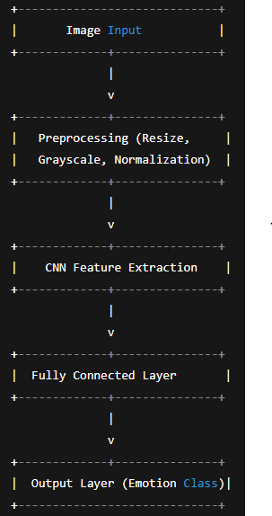
Fig 7.1: System Architecture of FER using CNN & DL

7.2 DATAFLOW DIAGRAM

7.2.1 Breakdown of Internal Components:
- User Uploads Image
  - Input passes to preprocessing
- Preprocessing Module
  - Converts image to grayscale
  - Resizes and normalizes
- CNN Model
  - Extracts features
  - Classifies emotion
- Emotion Predictor
  - Generates final emotion label
- UI Module
  - Displays result to user
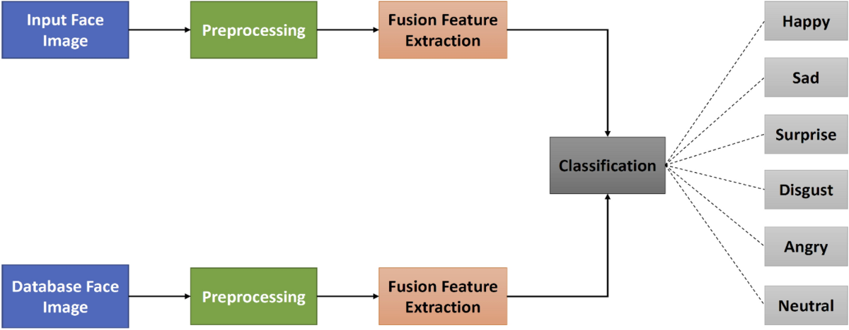
Fig 7.2: Dataflow diagram of FER using CNN & DL
7.2.2 Dataflow Diagram :
Input image → Face Detection → Preprocessing → CNN Model → Output (Emotion
Classification).
CHAPTER-8
IMPLEMENTATION AND CODE

8.1 SAMPLE CODE
8.1.1 Facial Expression Recognition Model
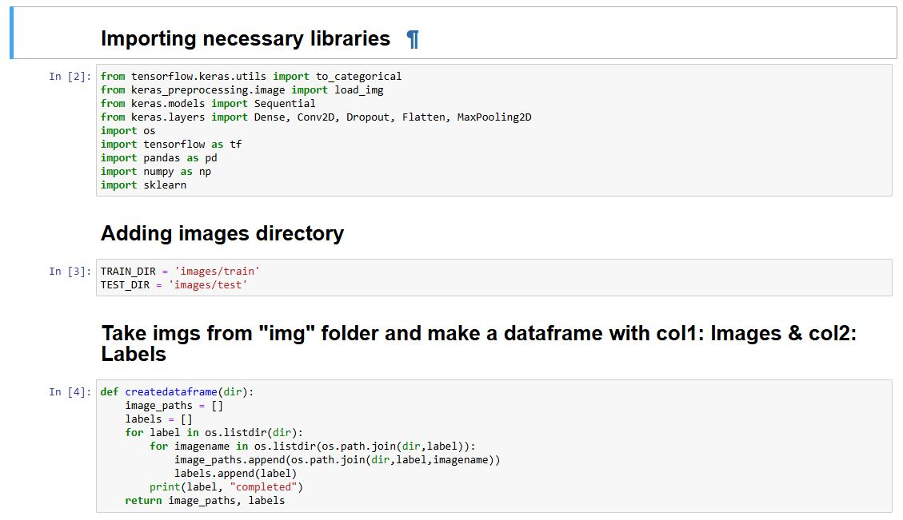
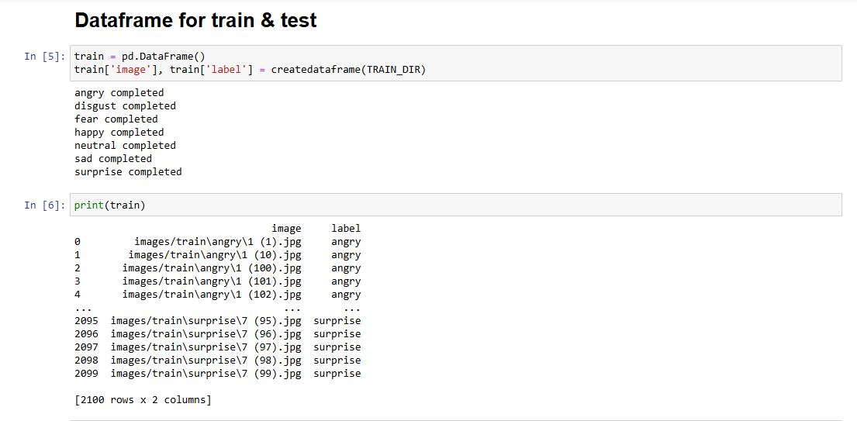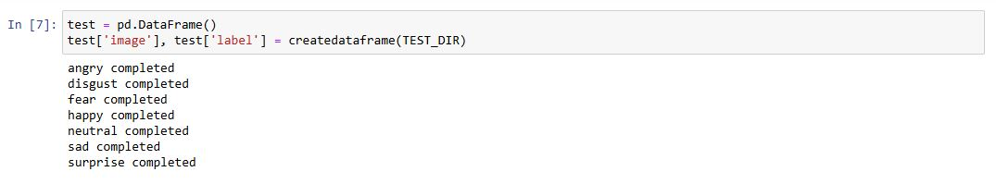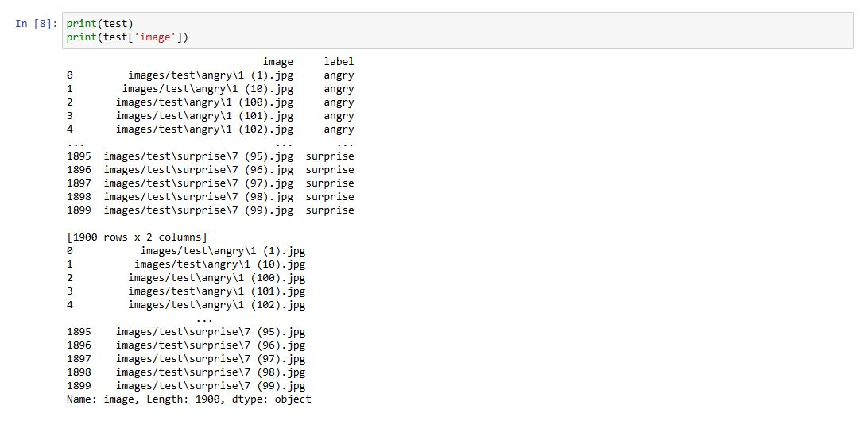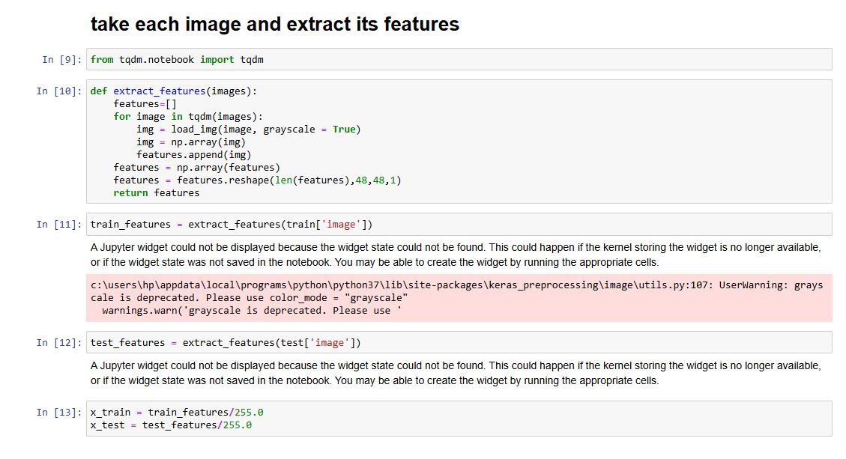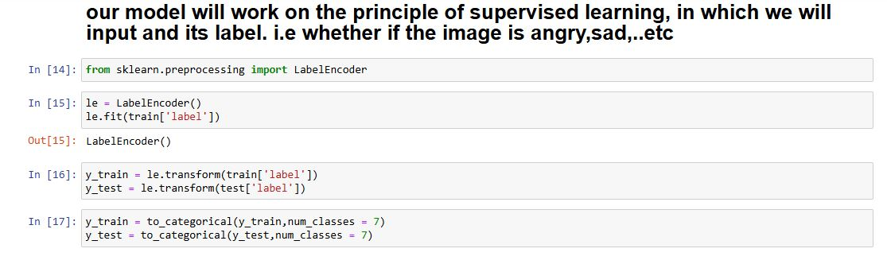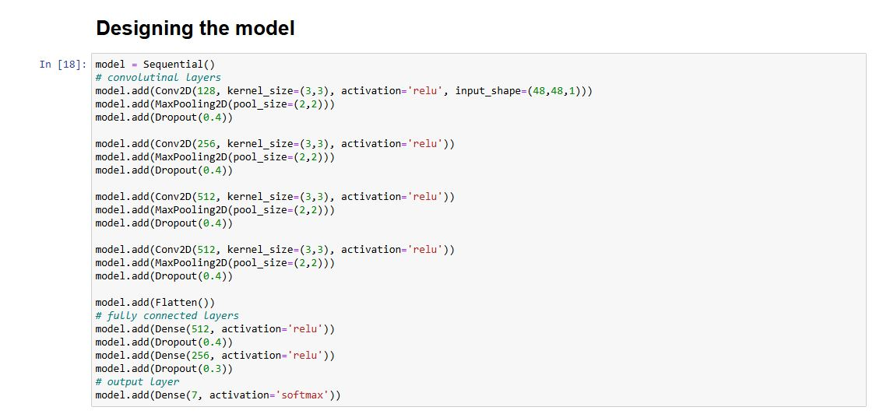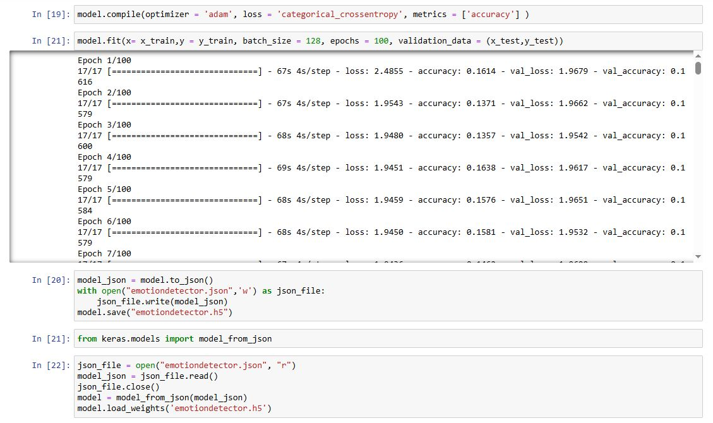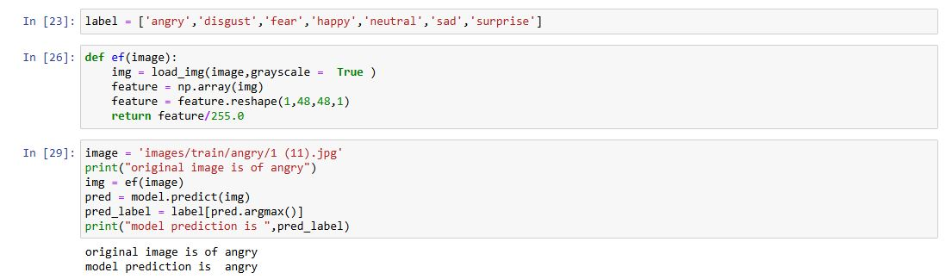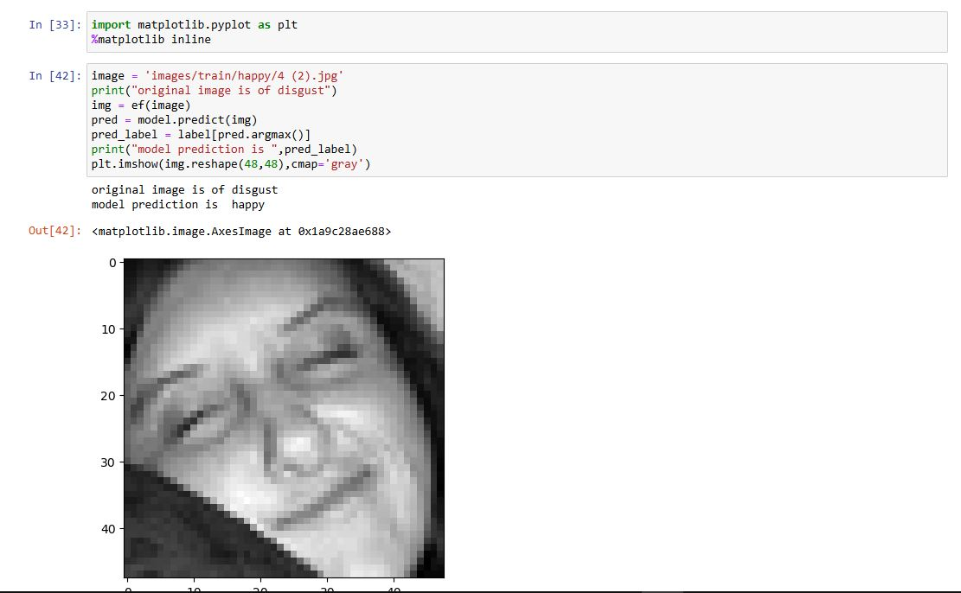

8.1.2 “result.html” code
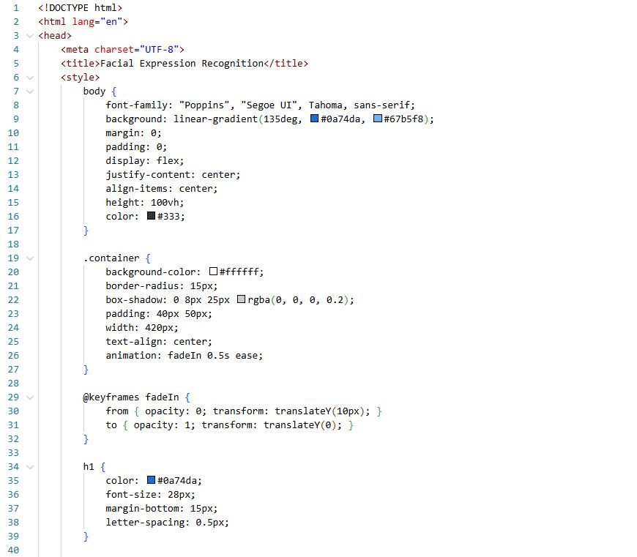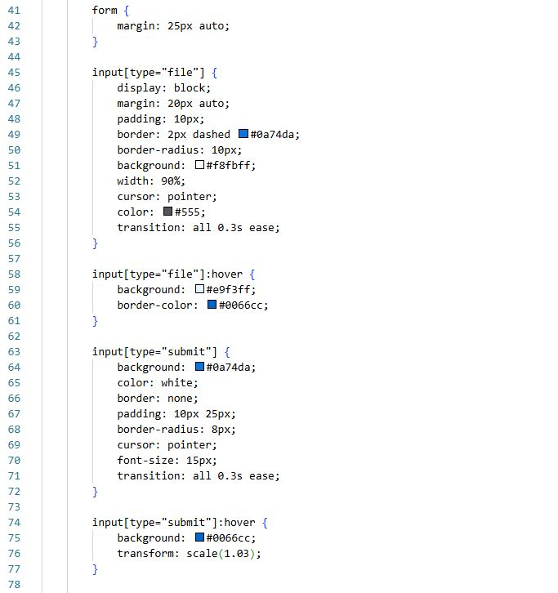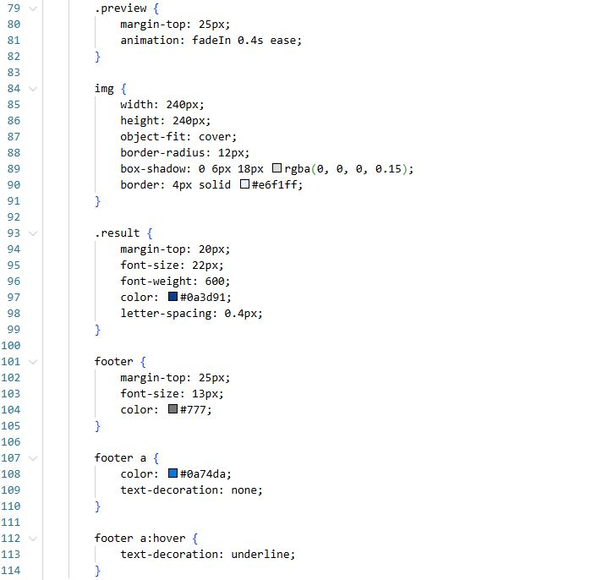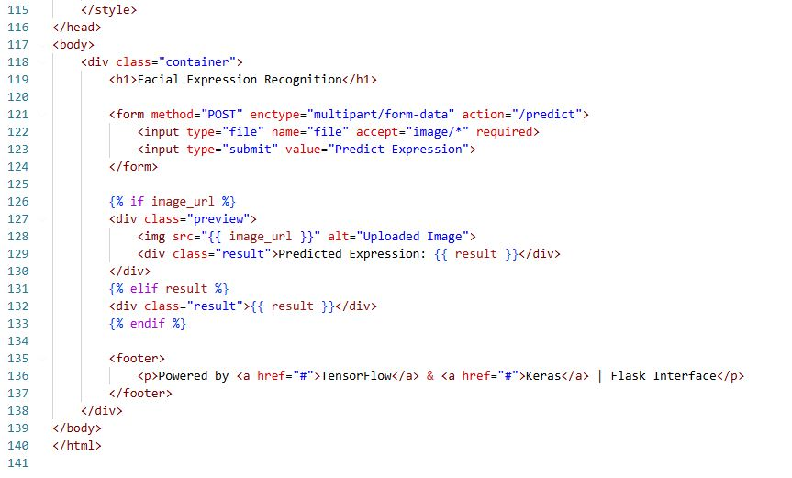

8.1.3 “app.py” code (connecting the model code and interface code)
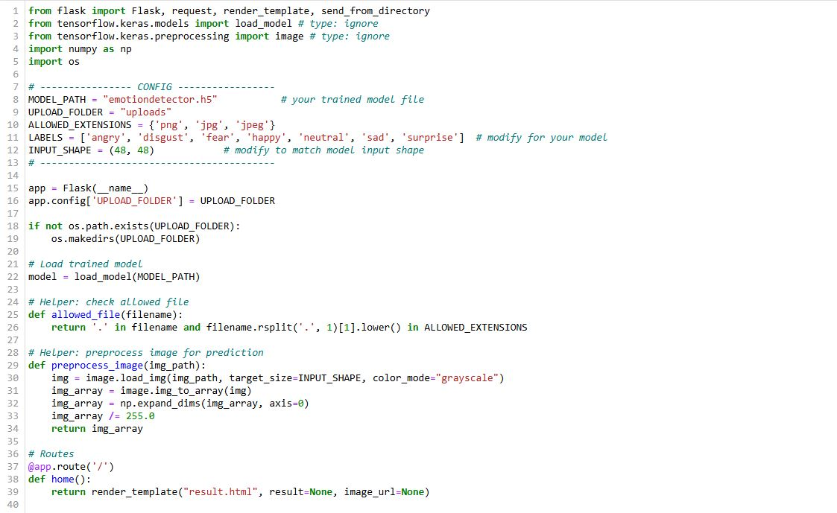
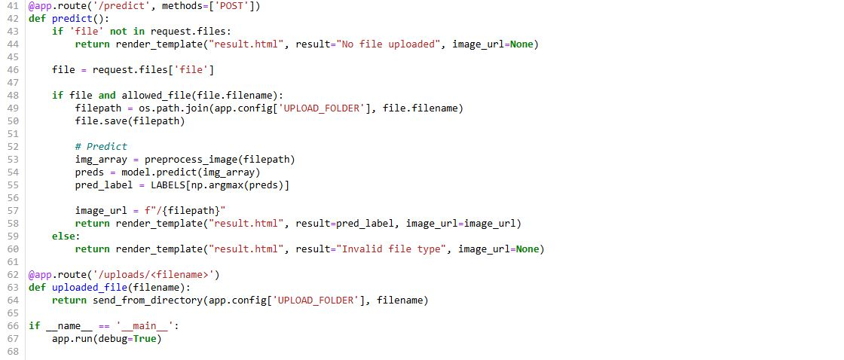
CHAPTER-9
OUTPUT

9.1 USER VIEW
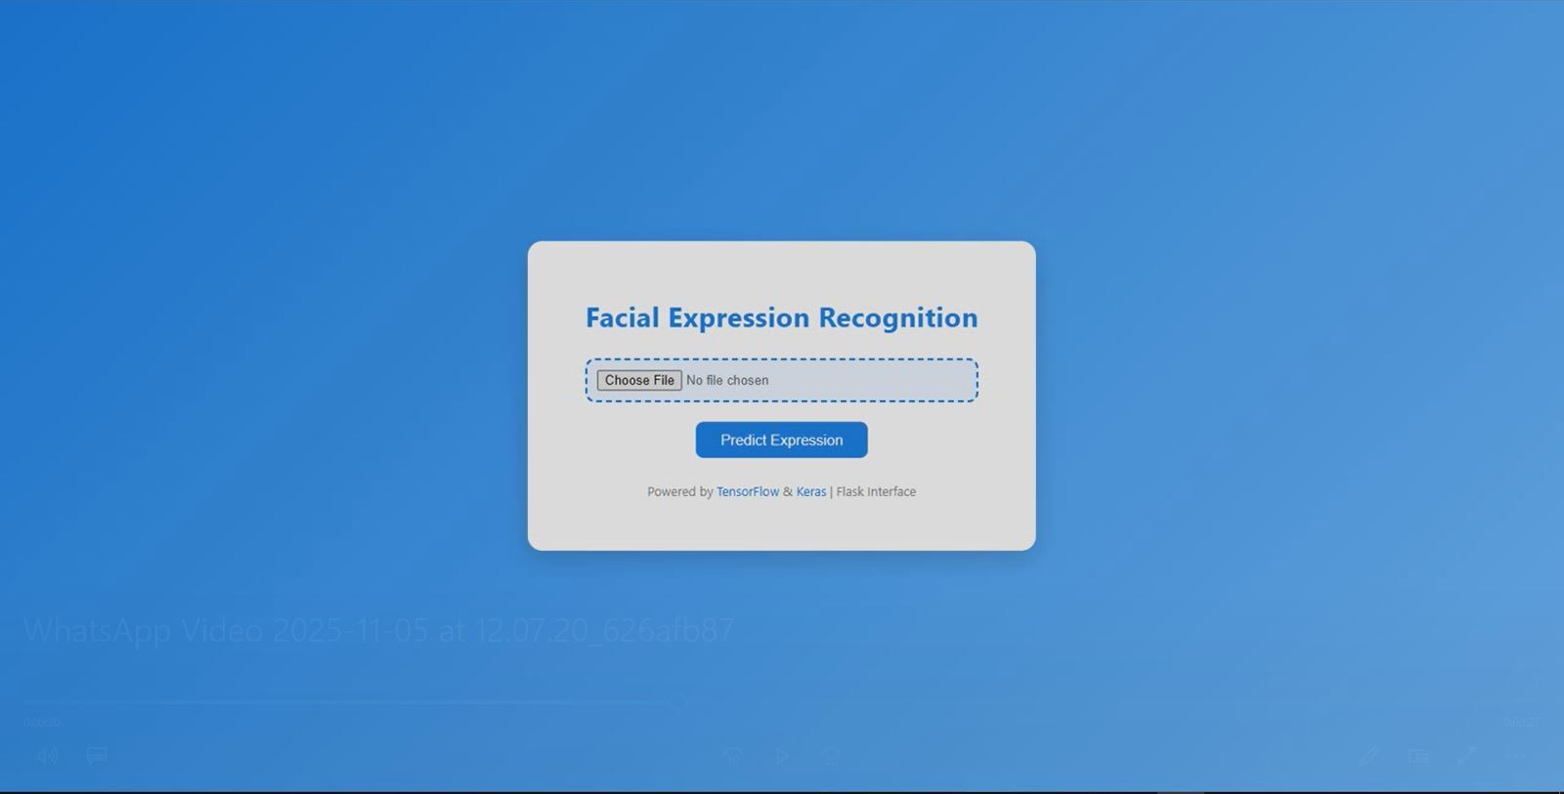
Fig 9.1: User View of Facial Expression Recognition

9.2 PREDICTION
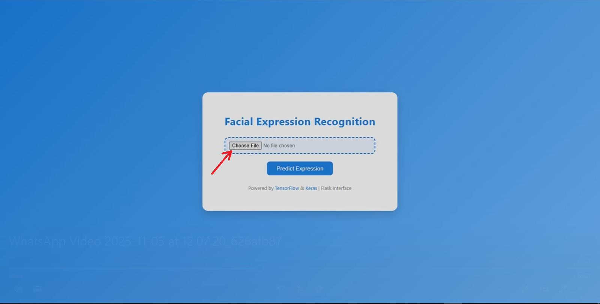
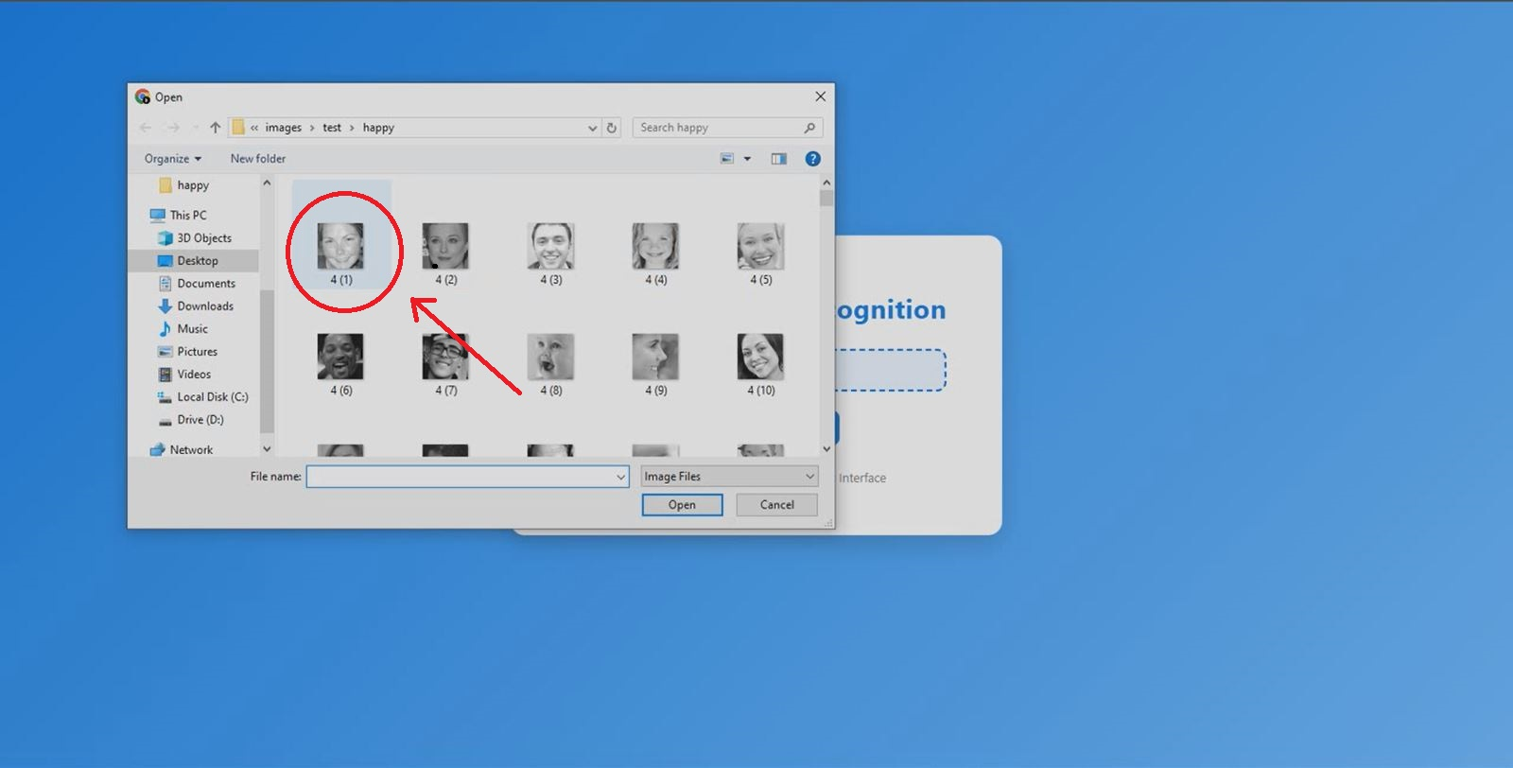
Fig 9.2: Choosing an image from files for Facial Expression Recognition

9.3 IMAGE PREPROCESSING
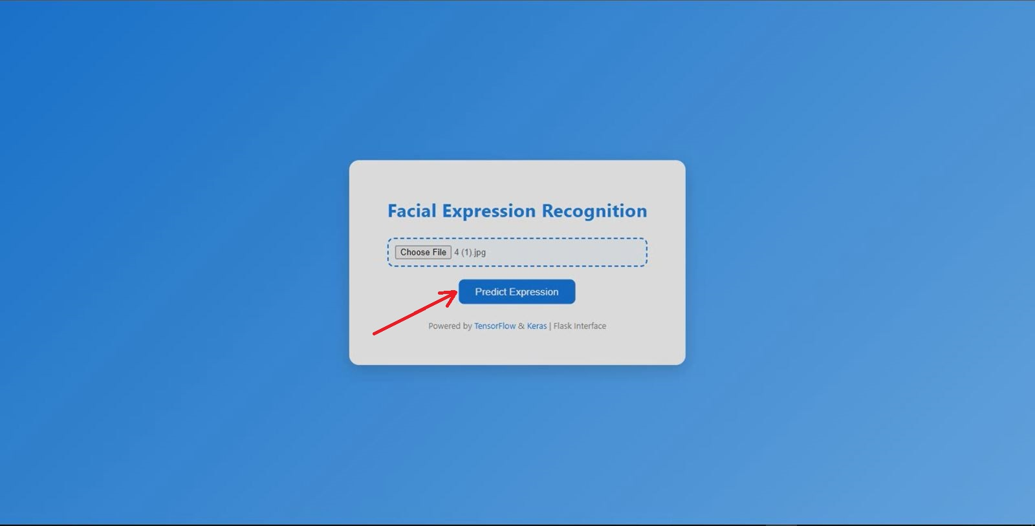
Fig 9.3: Prediction in process for Facial Expression Recognition

9.4 PREDICTED EXPRESSION OUTPUT
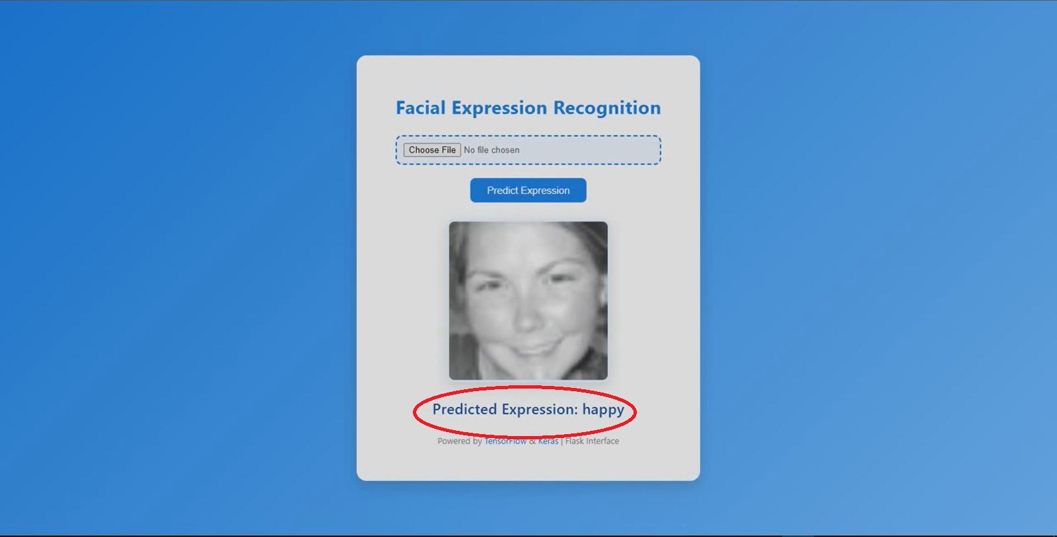
Fig 9.4: Result being displayed of Facial Expression

CHAPTER-10
CONCLUSION AND FUTURE SCOPE
10.1 CONCLUSION
Facial Expression Recognition (FER) has emerged as one of the most promising applications of computer vision, artificial intelligence, and affective computing. The primary objective of FER systems is to automatically interpret human emotions by analyzing facial features such as the eyes, eyebrows, mouth, and overall face geometry.
In the modern digital era—where human–computer interaction, automation, and intelligent decision-making systems are rapidly advancing—FER serves as a key technology to bridge the communication gap between humans and machines. It enables computers not just to process commands but to understand human emotions, thereby making interactions more natural, adaptive, and human-centric.
The project undertaken in this work successfully demonstrates the design and development of a Facial Expression Recognition model using Convolutional Neural Networks (CNNs). The system is capable of identifying basic emotions such as happy, sad, angry, fear, surprise, neutral, and disgust, depending on the dataset used.
Through rigorous preprocessing steps, dataset augmentation, model training, and evaluation, the system achieved reliable performance within the constraints of the training data. The integration of a user-friendly interface enables users to upload images and instantly receive emotion predictions, making the system practical for real-world use.
The project reiterates the fact that CNN-based FER models significantly outperform traditional machine-learning approaches due to their ability to learn hierarchical spatial features from images. The use of grayscale conversion, normalization, and facial alignment further enhances accuracy by minimizing noise and improving consistency.
Additionally, the modular architecture—comprising separate components such as the Image Processor, CNN Model, Emotion Predictor, and User Interface—demonstrates the importance of systematic design in achieving maintainability and scalability.
Despite the encouraging outcomes, the system also highlights some of the inherent challenges of FER. Factors like uneven lighting, occlusions (glasses, masks, hair), head pose variations, and dataset imbalance can reduce model accuracy.
Human emotions are also complex and dynamic; they often appear in mixed forms and may differ culturally. Therefore, achieving near-perfect accuracy remains a major challenge across the research community. Nonetheless, the project establishes a strong foundation upon which more advanced FER systems can be built.
Overall, this project has successfully met its core objectives: understanding facial expression detection principles, implementing CNN-based classification, designing a functional FER pipeline, developing a user interface, and evaluating model performance.
It demonstrates how artificial intelligence can be used to augment real-world applications such as healthcare, security, education, and entertainment. It also highlights the value of combining technology with human behavior analysis to create intelligent systems capable of emotional awareness.

ATTAINED:
PO: PO1, PO2, PO3, PO4, PO5, PO6, PO8, PO9, PO10, PO11, PO12
PSO: PSO1, PSO2, PSO3
SDG 16 : Peace, Justice and Strong Institutions
10.2 FUTURE SCOPE
Although the current Facial Expression Recognition system performs effectively under controlled conditions, there are numerous opportunities to enhance its accuracy, robustness, efficiency, and real-world applicability. As technology evolves, FER is expected to become a fundamental component in next-generation intelligent systems. The following points outline the potential future improvements and extensions of this project:

10.2.1. Integration of Real-Time Video Emotion Recognition
The present system focuses mainly on static image classification. Future expansion could include processing live video streams to detect emotions frame-by-frame in real time. This would significantly broaden the applications of FER in fields such as monitoring, surveillance, and human–robot interaction.

10.2.2 Incorporation of Deep Learning Advances
The current CNN architecture can be upgraded using modern neural network architectures such as:
- ResNet / DenseNet for deeper, more efficient feature extraction
- Vision Transformers (ViT) for improved global feature understanding
- CNN-RNN hybrid models for dynamic emotion recognition
- Generative Adversarial Networks (GANs) for dataset augmentation
These advanced models can drastically increase the system’s emotion classification accuracy.

10.2.3 Expansion to Multimodal Emotion Recognition
Human emotions are not expressed solely through facial expressions; tone of voice, speech patterns, hand gestures, and physiological signals also play important roles. Future systems can integrate multiple input modalities such as:
- Audio (speech emotion recognition)
- Text sentiment analysis
- Body pose estimation
- Heart rate and skin temperature (biosignals)
Multimodal FER systems can provide far more reliable emotion assessments.

10.2.4 Deployment with Cloud and Edge Technologies
The system can be deployed using cloud computing platforms such as AWS, Azure, or Google Cloud, enabling large-scale usage with lower latency. Alternatively, edge-AI deployment on devices such as mobile phones, Raspberry Pi, or IoT devices can make FER accessible without requiring internet connectivity.

10.2.5 Enhanced Dataset Diversity
FER accuracy heavily depends on dataset quality. Future improvements may include:
- Using larger datasets like RAF-DB, AffectNet, FERPlus, etc.
- Collecting custom datasets representing diverse ethnicities, age groups, and lighting conditions
- Including images with masks or partial occlusions
Better datasets directly translate to better model generalization.

10.2.6 Handling Mixed and Subtle Emotions
Real human emotions are often subtle, overlapping, or expressed partially. The system can be upgraded to:
- Detect compound emotions (e.g., happily surprised, angrily disgusted)
- Recognize micro-expressions, which last for less than 0.5 seconds
- Estimate emotion intensity levels rather than simply classifying labels
This would significantly improve the system’s psychological realism.

10.2.7 Integration with Human–Computer Interaction Systems
Future FER models can be embedded into:
- Virtual assistants (Alexa, Siri, Google Assistant)
- Chatbots for customer service
- Gaming and VR environments
- Educational platforms to monitor student engagement
- Healthcare tools to assist mental health analysis
Emotion-aware systems will play a major role in creating adaptive and personalized experiences.

10.2.8 Ethical and Privacy Considerations
As FER systems become more widespread, there is a growing need to address:
- Data privacy and protection
- Bias reduction in datasets and models
- Ethical usage policies
- Non-intrusive emotion monitoring
Future versions of FER systems must comply with global AI safety and fairness guidelines.

CHAPTER-11
REFRENCES

- Li, Shan, & Deng, Weihong (2018). Deep Facial Expression Recognition: A Survey. arXiv.
https://arxiv.org/abs/1804.08348 (arXiv)

- Huang, Y. (2019). Facial Expression Recognition: A Review. Symmetry, 11(10), 1189. DOI: 10.3390/sym11101189.
https://www.mdpi.com/2073-8994/11/10/1189 (MDPI)

- Sajjad, M., Min Ullah, F. U., Ullah, M., Christodoulou, G., et al. (2023). A Comprehensive Survey on Deep Facial Expression Recognition: Challenges, Applications, and Future Guidelines. Alexandria Engineering Journal, 68(6), 817–840. DOI: 10.1016/j.aej.2023.01.017.
https://www.sciencedirect.com/science/article/pii/S1110016823000327 (ScienceDirect)

- Adyapady, R. R. (2023). A Comprehensive Review of Facial Expression Recognition Techniques. Multimedia Systems, 29(1), 73–103. DOI: 10.1007/s00530-022-00984-w.
https://dl.acm.org/doi/abs/10.1007/s00530-022-00984-w (ACM Digital Library)

- Kopalidis, T., Solachidis, V., Vretos, N., & Daras, P. (2024). Recent Advances in Deep Facial Expression Recognition: A Survey of Methods, Benchmarks, Models, and Datasets. Information, 15(3), 135. DOI: 10.3390/info15030135.
https://www.mdpi.com/2078-2489/15/3/135 (MDPI)

- Anonymous / arXiv (2024). A Survey on Facial Expression Recognition of Static and Dynamic Methods. arXiv preprint 2408.15777v1.
https://arxiv.org/html/2408.15777v1 (arXiv)

- Zhang, Ligang, Verma, Brijesh, Tjondronegoro, Dian, & Chandran, Vinod (2018). Facial Expression Analysis under Partial Occlusion: A Survey. ACM Computing Surveys (CSUR), 51(2), Article 25. DOI: 10.1145/3158369.
https://dl.acm.org/doi/10.1145/3158369 (ACM Digital Library)

- Rajan, S., Chenniappan, P., Devaraj, S., & Madian, N. (2019). Facial Expression Recognition Techniques: A Comprehensive Survey. IET Image Processing, 13(7), 1031–1040. DOI: 10.1049/iet-ipr.2018.6647.
https://digital-library.theiet.org/doi/full/10.1049/iet-ipr.2018.6647 (IET Digital Library)

- Liang, Chengxu, & Dong, Jianshe (2023). A Survey of Deep Learning–Based Facial Expression Recognition Research.
ResearchGate link: https://www.researchgate.net/publication/375382951_A_Survey_of_Deep_Learning-based_Facial_Expression_Recognition_Research (ResearchGate)

- Qi, X. (2024). Deep Learning-Based Facial Expression Recognition: A Short Review. (This was listed in an earlier summary, but I could not find a published journal version in my search.)

