A

6th Semester Mini Project Report
On

KERNEL DENSITY ESTIMATION–BASED DEFENSE AGAINST MODEL POISONING IN FEDERATED LEARNING
Submitted in Partial Fulfilment to Osmania University for the award of the Degree of

Bachelor of Engineering In
Computer Science Engineering (AIML)
By

Syed Moazam | 160923748131

Under the Esteemed Supervision of

Ms. Raheela Tabassum
(Assistant Professor)



DEPARTMENT OF COMPUTER SCIENCE ENGINEERING (AIML) LORDS INSTITUTE OF ENGINEERING AND TECHNOLOGY
(UGC Autonomous)
Approved by AICTE | Affiliated to Osmania University
Estd. 2003 Sy. No. 32, Himayat Sagar, Near TSPA Junction, Hyderabad – 500091,
India
(2025-2026)


LORDS INSTITUTE OF ENGINEERING AND TECHNOLOGY
Approved by AICTE | Affiliated to Osmania University | Estd. 2003 Accredited with ‘A’ grade by NAAC | Accredited by NBA
DEPARTMENT OF COMPUTER SCIENCE ENGINEERING (AIML)

CERTIFICATE

This is to certify that Mini Project Report entitled “Kernel density estimation–based defense against model poisoning in federated learning” is a Bonafide record of the work successfully completed and submitted by

Syed Moazam | 160923748131

Under the Supervision of Ms. Raheela Tabassum, Assistant Professor, Department of COMPUTER SCIENCE ENGINEERING (AIML) for the requirement of partial fulfilment for the award of degree of Bachelor of Computer Science Engineering (AIML) during the academic year 2025 – 2026 (6th Semester) from the Lords Institute of Engineering and Technology, Hyderabad.

Project Guide Head of Department
Ms. Raheela Tabassum Dr. Abdul Rasool MD
Assistant Professor HoD, CSE(AIML)

External Examiner Date:

DECLARATION

I hereby declare that this 6th Semester Mini Project Report entitled “Kernel Density Estimation–Based Defense Against Model Poisoning in Federated Learning” is being submitted by me in partial fulfilment to Osmania University for the award of Bachelor of Engineering in the Department of Computer Science Engineering (AIML) at the Lords Institute of Engineering and Technology (Autonomous), Telangana-500091, is the result of investigations carried out by me under the Guidance of Ms. Raheela Tabassum, Assistant Professor, Department of Computer Science Engineering (AIML), Lords Institute of Engineering and Technology.
The work is original and has not been submitted for any Degree to this or any other university.

Syed Moazam | 160923748131

ACKNOWLEDGMENT


Syed Moazam (160923748131)
+91 93474 73195
syedmoazam02@gmail.com

In the name of Almighty, the most beneficent and the most merciful, I thank the Lord for helping me in all the stages of this project work.
I would like to express my sincere gratitude to my guide Ms. Raheela Tabassum, Assistant Professor, for her aspiring guidance, valuable time, and friendly advice during the project work. She was a constant motivation throughout the mini project whenever required, for which I am immensely grateful to her.
I would like to thank Dr. Abdul Rasool MD, Head of the Department, for his encouragement and support throughout this Project. It gives me great pleasure in acknowledging the guidance from him throughout the project.
My experience here has been full of opportunities to learn from faculty with a wide and deep expertise in Engineering. I would like to thank the respected Principal Dr. Ravi Kishore Singh, and those in the department who were particularly instrumental in contributing to my academic experience at Lords Institute of Engineering and Technology (A).
I thank both teaching and non-teaching staff members of CSE(AIML) department for their kind cooperation and all sorts of help to bring out this project work.

Vision of the Institute:

Lords Institute of Engineering and Technology strives for excellence in professional education through quality, innovation and teamwork and aims to emerge as a premier institute in the state and across the nation.

Mission of the Institute:

- To impart quality professional education that meets the needs of present and emerging technological world.
- To strive for student achievement and success, preparing them for life, career and leadership.
- To provide a scholarly and vibrant learning environment that enables faculty, staff and students to achieve personal and professional growth.
- To contribute to advancement of knowledge, in both fundamental and applied areas of engineering and technology.
- To forge mutually beneficial relationships with government organizations, industries, society and the alumni.



Vision of the Department:
To obtain high quality standards in education by utilizing cutting-edge technologies, build an ecosystem that will contribute meaningfully to society by producing world class Engineers in the field of Computer Science Engineering(AIML)
Mission of the Department:
DM1: Provide intense training to generate knowledge using state of art Artificial Intelligence and Machine Learning concepts and technologies.
DM2: To bring along scholars and students in an interdisciplinary setting to carry on making substantial advances in expanding the potential of a machine or human- machine systems that can handle challenging higher cognitive functions.
DM3: To encourage the formation of academic-industry collaborations and societal outreach projects.
DM4: To educate students with modern tools to take part fully and ethically in a varied society while also encouraging lifelong learning.
Note: DM: Department Mission




Head of the Department

B.E Computer Science Engineering (AIML) Program Educational Objectives (PEOs):

PEO1 | To establish themselves as successful professionals with strong fundamental knowledge in basic and engineering sciences to find suitable solutions of technological and real-life challenges using innovative tools.
PEO2 | To enhances technical competency and problems solving skills through state of art facilities for adequate solutions to technical problems.
PEO3 | Acquire high skill-set by continuous training, multi-disciplinary activities, team work, effective communications, Information Technology tools usage and ethics so that students shall acquire good job opportunities and also will help in their higher education.
PEO4 | Giving consultancy services to industrial, societal challenges and promoting department-industry interactions, by enhancing technical, managerial, environmental responsibilities and lifelong learning with sustainable development.

Head of the Department

B.E Computer Science Engineering (AIML) Program Specific Outcomes (PSO’s) : Engineering Graduates will be able to:

S. No. | Program Outcomes (POs)
1. | PO1: Engineering Knowledge: Apply knowledge of mathematics, natural science, computing, engineering fundamentals and an engineering specialization as specified in WK1 to WK4 respectively to develop to the  solution of complex engineering problems.
2. | PO2: Problem Analysis: Identify, formulate, review research literature and analyze complex engineering problems reaching substantiated conclusions with consideration for sustainable development.
3. | PO3: Design/Development of Solutions: Design creative solutions for complex engineering problems and design/develop systems/components/processes to meet identified needs with consideration for the public health and safety, whole-life cost, net zero  carbon, culture, society and environment as required. (WK5)
4. | PO4: Conduct Investigations of Complex Problems: Conduct investigations of complex engineering problems using research-based knowledge including design of experiments, modelling, analysis &  interpretation of data to provide valid conclusions. (WK8).
5. | PO5: Engineering Tool Usage: Create, select and apply appropriate techniques, resources and modern engineering & IT tools, including prediction and modelling recognizing their limitations to solve complex  engineering problems. (WK2 and WK6)
6. | PO6: The Engineer and The World: Analyze and evaluate societal and  environmental aspects while solving complex engineering problems for its impact on sustainability with reference to economy, health, safety.

7. | PO7: Ethics: Apply ethical principles and commit to professional ethics,  human values, diversity and inclusion; adhere to national & international laws. (WK9)
8. | PO8: Individual and Collaborative Team work: Function effectively  as an individual, and as a member or leader in diverse/multi-disciplinary teams.
9. | PO9: Communication: Communicate effectively and inclusively within the engineering community and society at large, such as being able to comprehend and write effective reports and design documentation, make effective presentations considering cultural, language, and learning  differences.
10. | PO10: Project Management and Finance: Apply knowledge and understanding of engineering management principles and economic decision-making and apply these to one’s own work, and to manage  projects and in multidisciplinary environments.
11. | PO11: Life-Long Learning: Recognize the need for, and have the preparation and ability for i) independent and life-long learning ii) adaptability to new and emerging technologies and iii) critical thinking in  the broadest context of technological change. (WK8)
Head of the Department

B.E Computer Science Engineering (AIML)Program Specific Outcomes (PSO’s):

PSO1 | Professional Skills: An ability to understand the basic concepts of AI & ML to apply them to various areas, like production, Business Automation, designing etc., in the design and implementation of  complex systems.
PSO2 | Problem-Solving Skills: An ability to solve complex Computer Science Engineering problems, using latest AI & ML tools, along with  analytical skills to arrive cost effective and appropriate solutions.

Head of the Department

Course Outcomes: C69 – Mini Project (6th Semester)
Student will be able to

CO. No. | Description | Blooms  Taxonomy Level
C69.1 | Formulate a specific problem and give solution | BTL6(Create)
C69.2 | Develop model/models either theoretical/practical/numerical forms | BTL6(Create)
C69.3 | Solve interpret/correlate the results and discussion | BTL4(Analyze)
C69.4 | Conclude the results obtained | BTL5(Evaluate)
C69.5 | Write the documentation in standard format | BTL3(Apply)

Course Articulation Matrix:
Mapping of Course Outcomes (CO) with Program Outcomes (PO) and Program Specific Outcomes (PSO’s):
Course Outcomes (CO) | Program Outcomes (PO) |  |  |  |  |  |  |  |  |  |  | Program Specific Outcomes (PSO’s)
 | PO 1 | PO 2 | PO 3 | PO 4 | PO 5 | PO 6 | PO 7 | PO 8 | PO 9 | PO 10 | PO  11 | PSO 1 | PSO 2
C69.1 | 3 | 3 | 3 | 2 | 2 | 2 | 1 | 1 | 2 | 2 | 2 | 3 | 3
C69.2 | 3 | 3 | 3 | 3 | 3 | 1 | 1 | 1 | 2 | 2 | 3 | 3 | 3
C69.3 | 3 | 3 | 2 | 3 | 3 | 2 | 1 | 1 | 3 | 2 | 3 | 3 | 3
C69.4 | 2 | 3 | 2 | 3 | 2 | 2 | 2 | 1 | 3 | 2 | 3 | 2 | 2
C69.5 | 2 | 2 | 2 | 2 | 2 | 2 | 2 | 2 | 3 | 2 | 3 | 2 | 3
Average | 2.6 | 2.8 | 2.4 | 2.6 | 2.4 | 1.8 | 1.4 | 1.2 | 2.6 | 2.0 | 2.8 | 2.6 | 2.8

Level:
- Low correlation (Low), 2- Medium correlation (Medium), 3-High correlation (High)
SDG Mapping:

SDG | Mapped Indicator | SDG | Mapped Indicator |   SDG | Mapped Indicator
 |  |  |  | 
 |  |  |  | 
 |  | 
 |  | 
 |  |  |  | 
 |  | 

Federated learning (FL) enables collaborative model training without sharing raw data, but it remains vulnerable to model poisoning attacks, where malicious clients submit crafted updates to degrade global model performance or introduce backdoors. Existing defenses, such as distance-based outlier detection or robust aggregation, often struggle with high-dimensional model parameters and non-I.I.D. data distributions. In this project, a novel defense mechanism is proposed a novel defense mechanism leveraging Kernel Density Estimation (KDE) to detect and mitigate poisoned model updates. Unlike conventional methods that assume Gaussian or unimodal distributions, KDE flexibly models the underlying probability density of client updates in a transformed feature space. By estimating the likelihood of each update under the joint density of benign contributions, we assign low density scores to anomalous or adversarial updates. We then apply adaptive thresholding or density-weighted aggregation to suppress their influence. Extensive experiments on image classification and next-word prediction tasks show that our KDE-based defense achieves high detection accuracy against various poisoning strategies (e.g., label flipping, gradient scaling, and targeted backdoors), outperforms Byzantine-robust baselines (e.g., Krum, Trimmed Mean), and maintains robustness under highly skewed non-I.I.D. settings. Our approach introduces modest computational overhead and provides a principled, nonparametric alternative for securing federated learning against model poisoning

Keywords: Federated Learning, Model Poisoning, Kernel Density Estimation (KDE), Byzantine Robustness, Non-IID Data, LoMar Defense.

Contents | Page
Declaration | i
Acknowledgement | ii
Vision and Mission of Institute | iii
Vision and Mission of Department | iv
Program Education Objectives | v
Program Specific Outcomes | viii
Course Outcomes | ix
Course Articulation Matrix | x
Abstract | xi
List of Figures | xiv
List of Tables | xv
CHAPTER 1: INTRODUCTION | 1
1.1 BACKGROUND TO STUDY | 1
1.2 STATEMENT OF RESEARCH | 1
1.3 JUSTIFICATION OF THE STUDY | 2
1.4 AIM AND OBJECTIVE OF RESEARCH | 3
1.5 SIGNIFICANCE OF THE RESEARCH | 4
1.6 SCOPE OF THE RESEARCH | 4
CHAPTER 2: LITERATURE REVIEW | 6
2.1 KETS: KERNEL-BASED TRUST SEGMENTATION AGAINST MODEL | 6
POISONING ATTACKS
2.2 LOMAR: A SECURE FEDERATED LEARNING APPROACH AGAINST | 7
MODEL POISONING ATTACKS
2.3 LOMAR: A LOCAL DEFENSE AGAINST POISONING ATTACK ON | 8
FEDERATED LEARNING
2.4 KDE-LIATD: KERNEL DENSITY ESTIMATION-BASED LIGHTWEIGHT  IOT ANOMALY TRAFFIC DETECTION | 9
2.5 KD-FL: INHERENT RESISTANCE OF KNOWLEDGE DISTILLATION  BASED FEDERATED LEARNING TO TARGETED POISONING | 10
ATTACKS
CHAPTER 3: REQUIREMENT ANALYSIS & SYSTEM SPEC | 11
3.1 SYSTEM REQUIREMENTS | 11
3.2 FUNCTIONAL REQUIREMENTS | 13
3.3 NON-FUNCTIONAL REQUIREMENTS | 15

CHAPTER 4: SYSTEM DESIGN  SYSTEM ARCHITECTURE  KDE DEFENSE MODULE ARCHITECTURE  CLIENT-SERVER COMMUNICATION DESIGN  AGGREGATION AND WEIGHTING MECHANISM  SECURITY AND PRIVACY DESIGN | 17  17  18  19  20  21
CHAPTER 5: IMPLEMENTATION  INPUT DESIGN  OBJECTIVES  OUTPUT DESIGN & EXPECTED OUTPUT | 22  22  23  26
CHAPTER 6: TESTING  - INTRODUCTION  - UNIT TESTING  - INTEGRATION TESTING  - SYSTEM TESTING  - TEST CASE AND RESULTS | 29  29  30  31  32  34
CHAPTER 7: RESULT AND CONCLUSION  - RESULT ANALYSIS  - SNAPSHOTS  - CONCLUSION  - FUTURE ENHANCEMENT  REFERENCES | 36  36  39  43  44  47

LIST OF FIGURES

Fig No. | Name of the Figure | Page No.
4.1 | System Architecture of KDE in Federated Learning | 17
4.2 | KDE Defense Module Architecture | 18
4.3 | Client-Server Communication Design in KDE In Federated Learning | 19
4.4 | Aggregation and Weighting Mechanism | 20
5.1 | Input Design of a Local Defense Against Poisoning Attack in Federated Learning | 22
5.2 | Output 1 – Upload Poison Model to Server | 26
5.3 | Output 2- Propose LoMar & No Defence Accuracy | 27
5.4 | Output 3- Extension Model Size Graph | 28
7.1 | User Input View | 39
7.2 | Uploading The Dataset into The Model | 39
7.3 | Dataset Being Preprocessed | 40
7.4 | Uploading Genuine Model to Server | 40
7.5 | Uploading Poison Model to The Server | 41
7.6 | Propose LoMar and No Defence Accuracy Graph | 41
7.7 | Extension Model Size Graph | 42

List of Tables

Table No. | Name of the Table | Page No.
3.1 | Server-Side Hardware Specifications | 12
3.2 | Client-side Hardware Requirements | 13
6.1 | Test Environment Configuration | 35

CHAPTER 1 INTRODUCTION

BACKGROUND TO STUDY
Federated Learning (FL) has revolutionized privacy-preserving machine learning by enabling multiple decentralized clients to collaboratively train a shared global model without exchanging raw data. Instead, clients compute local model updates—typically gradients or weights—and send them to a central server, which aggregates them to improve the global model. This architecture is particularly valuable in sensitive domains such as healthcare, finance, and mobile computing, where data cannot be centralized due to privacy regulations or bandwidth constraints.
However, the very feature that ensures privacy also introduces a severe security vulnerability: the server cannot verify the integrity of individual client updates. Malicious or compromised clients can exploit this by launching model poisoning attacks, where they deliberately upload corrupted updates to degrade the global model’s accuracy, insert hidden backdoors, or cause complete model failure.
Unlike data poisoning, which corrupts local training samples, model poisoning directly manipulates the update vectors and is often more difficult to detect. Existing defensive strategies, such as Krum, trimmed mean, and median-based aggregation, attempt to filter outliers by assuming that benign updates will cluster tightly in parameter space. Unfortunately, these assumptions break down under non-Independent and Identically Distributed (non-IID) data, where benign clients naturally produce diverse and widely scattered updates.
This fundamental tension between robustness and the accommodation of statistical heterogeneity forms the central challenge that motivates the exploration of more flexible, distribution-agnostic defense mechanisms.

STATEMENT OF RESEARCH
Despite significant progress in robust aggregation for Federated Learning, current defenses against model poisoning exhibit critical shortcomings that limit their practical deployment. Most existing methods, including geometric distance-based approaches such as Krum and statistical approaches like coordinate-wise median, implicitly assume that the distribution of benign model updates is unimodal and symmetric.
In realistic non-IID settings, where different clients possess vastly different data distributions, benign updates can form multiple clusters or exhibit heavy-tailed behavior. Under such conditions, these defenses either discard a large proportion of legitimate updates—causing severe model

degradation—or fail to reject sophisticated poisoning vectors that mimic benign diversity. Furthermore, many state-of-the-art defenses require auxiliary assumptions that are often unrealistic: some need a small, clean root dataset on the server for validation; others rely on tracking long-term client reputation, which fails against colluding attackers that alternate their behavior.
Additionally, existing defenses lack adaptive thresholding mechanisms, making them ineffective when attack intensity, the number of malicious clients, or the degree of data heterogeneity changes dynamically across training rounds. Consequently, the research problem addressed here is: How can a defense mechanism robustly distinguish between legitimate data heterogeneity and malicious model poisoning in Federated Learning without assuming any specific parametric distribution of client updates, without requiring a trusted validation set, and while adapting to dynamic attack conditions.
The proposed solution investigates Kernel Density Estimation (KDE), a non-parametric method for estimating probability density functions, as the foundation for a novel, robust aggregation rule that respects benign diversity while rejecting truly anomalous updates.

JUSTIFICATION OF THE STUDY
The justification for pursuing a Kernel Density Estimation-based defense against model poisoning arises from convergence of practical necessity, theoretical gaps, and computational feasibility. First, the threat landscape in Federated Learning has escalated dramatically. Attackers are no longer limited to simple random noise or label flipping; they now employ adaptive, colluding, and evasion-aware poisoning strategies specifically designed to bypass traditional outlier detectors. For instance, attackers can craft updates that lie within the convex hull of benign updates yet still embed backdoors, fooling distance-based defenses completely.
This calls for a density-aware rather than merely distance-aware defense. Second, existing robust aggregation methods suffer from a fundamental theoretical limitation: they treat any deviation from a presumed central tendency as suspicious, which is exactly opposite to what is needed under statistical heterogeneity. A non-parametric approach like KDE makes no strong distributional assumptions, instead letting the data itself reveal the underlying density landscape. This property is ideally suited to non-IID FL, where benign updates may legitimately occupy low-density regions without being malicious.
Third, KDE offers a principled way to compute an adaptive threshold: rather than arbitrarily discarding a fixed percentage of updates, the defense can reject only those updates whose estimated density falls below a statistically motivated cutoff, such as a quantile of the density distribution.

Finally, from an engineering perspective, while high-dimensional KDE suffers from the curse of dimensionality, recent advances in dimensionality reduction (e.g., using layer-wise norms, gradient directions, or random projections) make KDE computationally tractable for realistic FL models. Thus, this research is justified by the urgent need for a defense that is robust, adaptive, assumption-light, and computationally practical.

AIM AND OBJECTIVE OF RESEARCH

Aim:
To design, implement, and evaluate a robust defense mechanism based on Kernel Density Estimation (KDE) that effectively mitigates model poisoning attacks in Federated Learning, particularly under challenging non-IID data distributions.

Specific Objectives:
    - To formalize the model poisoning problem in FL and model benign update distributions using KDE on selected statistical features (e.g., layer-wise norms, directional cosines).

    - To develop a KDE-based scoring mechanism that computes a “maliciousness score” for each client update based on its log-likelihood or density estimate relative to the collective update distribution.
    - To design an adaptive thresholding rule that rejects updates with density below a dynamic cutoff, derived from the estimated probability density function without requiring a validation dataset.

    - To implement the KDE defense within a standard FL simulation framework (e.g., using PyTorch or TensorFlow Federated) against multiple poisoning attack types (e.g., Gaussian noise, label flipping, backdoor).

    - To evaluate the defense across varying degrees of non-IID data, attack rates (0% to 50% malicious clients), and attack strategies, measuring global model accuracy, attack success rate, and communication efficiency.

SIGNIFICANCE OF THE RESEARCH
The significance of this research extends across theoretical advancements, practical system design, and community benchmarking in Federated Learning security. Theoretically, this work introduces a novel paradigm for robust aggregation: shifting from geometric outlier rejection to probabilistic density modeling. By formalizing the model poisoning defense as a density estimation problem, the research establishes a rigorous framework for analyzing the trade-off between false positives (rejecting benign heterogeneous updates) and false negatives (accepting malicious updates). This framework yields theoretically motivated conditions under which KDE- based aggregation provably outperforms classical Byzantine-robust methods, particularly as data heterogeneity increases.
Practically, the proposed KDE defense offers substantial advantages for real-world FL deployments. It requires no trusted root dataset on the server, no prior knowledge of the number or strategy of attackers, and no historical client behavior tracking. This makes it deployable in cross-silo FL (e.g., among hospitals or banks) where data privacy is paramount and in cross- device FL (e.g., mobile keyboards) where clients are ephemeral. Furthermore, the defense’s adaptive thresholding mechanism automatically adjusts to varying attack intensities and evolving data distributions across training rounds, reducing the need for manual hyper parameter tuning.
For the research community, this work provides a reproducible, open-source implementation benchmarked against a comprehensive suite of poisoning attacks (untargeted, targeted, backdoor, colluding) and non-IID configurations. By comparing against state-of-the-art defenses such as Trimmed Mean, Median, Krum, FL Trust, and FLAME, the study establishes a new empirical baseline, highlighting the unique robustness–diversity trade-off curve of density-based aggregation.

SCOPE OF THE RESEARCH
The scope of this research is carefully delimited to ensure depth, feasibility, and clarity of contributions. First, regarding Federated Learning architecture, this study assumes a centralized, synchronous FL setting with a single aggregation server and multiple clients. Decentralized or peer-to-peer FL, asynchronous aggregation, and hierarchical FL are explicitly excluded. Second, the defense focuses exclusively on model poisoning attacks, where malicious clients manipulate their local model updates before uploading them.
Data poisoning attacks—where attackers corrupt local training data but follow the update protocol honestly—are considered only as a baseline comparison but are not the primary focus. Targeted backdoor attacks (e.g., causing misclassification on specific trigger inputs) are included, as they represent a severe subclass of model poisoning.

Third, the KDE implementation is constrained to practical dimensionality reduction techniques to mitigate the curse of dimensionality. Specifically, KDE will be applied to per-layer L2 norms, cosine similarities with the global model, and optionally principal component projections of gradients—not to the full parameter space of large models. Gaussian kernels will be used with bandwidth selected via Silverman’s rule or cross-validation.
Fourth, the attack models considered include: random Gaussian perturbation (untargeted), label flipping (targeted), same-value attack (all weights set to a constant), and colluding attackers that coordinate to evade detection. Attack rates are assumed to be less than 50% of total clients per round, consistent with standard Byzantine robustness assumptions. Fifth, evaluation is conducted on standard FL benchmark datasets—MNIST, Fashion-MNIST, CIFAR-10, and FEMNIST— partitioned into non-IID splits using a Dirichlet distribution (concentration parameter α ranging from 0.1 to 1.0).
Finally, excluded from scope are: defenses against inference attacks, communication efficiency optimizations, differential privacy integration, and hardware-assisted security. The study also does not address attacks that compromise the aggregation server itself. These boundaries ensure a focused, rigorous investigation of KDE’s core efficacy against model poisoning under realistic non-IID conditions.

CHAPTER-2 LITERATURE REVIEW

Title-1: KeTS: Kernel-based Trust Segmentation against Model Poisoning Attacks

Authors: Ankit Gangwal, Mauro Conti, Tommaso Pauselli

Methodology Overview: KeTS analyzes the evolution of each client’s updates over multiple rounds, computing individual trust scores that reflect historical contributions. Kernel Density Estimation (KDE) segments these trust scores to distinguish malicious from benign clients, effectively handling benign outliers and non-IID data distributions without imposing computational overhead on clients.
Objectives: To develop a defense mechanism that satisfies three key objectives: fidelity (maintaining model accuracy), robustness (resisting attacks), and efficiency (minimal overhead). KeTS aims to outperform existing defenses like Krum, Trim-Mean, and FLTrust, particularly in highly non-IID environments where benign updates are often misclassified as outliers.
Problem Statement: Existing FL defenses struggle in non-IID environments where benign client updates naturally exhibit statistical diversity. Classical methods like Krum and Trim-Mean remain vulnerable to optimization-based poisoning attacks, while state-of-the-art defenses like FLTrust misclassify benign clients as outliers when their local distributions diverge from the server’s root dataset.
Future Scope: Future work includes extending KeTS to handle adaptive attacks where malicious clients dynamically adjust poisoning strategies based on the defense mechanism. Additionally, integrating KeTS with differential privacy could provide dual protection against both poisoning attacks and privacy breaches in cross-silo and cross-device FL scenarios.
Solution Enhancement: A simple yet effective extension to handle consistent-untargeted attacks (e.g., sign-flipping) and targeted attacks (e.g., label-flipping) is already discussed. Further enhancements could include adaptive bandwidth selection for KDE and hierarchical trust scoring combining round-level and epoch-level analyses for improved detection accuracy.

Title-2: LoMar: A Secure Federated Learning Approach Against Model Poisoning Attacks

Authors: S. Shaber, Bittragunta Siva Krishna, Devarapu Amara Nageswara Rao, Valluri Mohana Sai, Are Ganesh

Methodology Overview: LoMar employs Kernel Density Estimation to evaluate the distribution of client model updates at the server side. By measuring deviations from expected update patterns using neighborhood density, it detects and filters out anomalous model submissions before aggregation. The approach also integrates model compression, reducing model size by approximately 10% for improved communication efficiency.
Objectives: To create a lightweight and effective defense mechanism against poisoning attacks in FL environments. LoMar aims to maintain high classification accuracy under poisoning conditions while improving system scalability through model compression. The defense is designed for practical deployment in domains like healthcare, finance, and mobile intelligence.
Problem Statement: Federated learning remains vulnerable to poisoning attacks where adversaries manipulate local training data or model updates to compromise global model performance. The server cannot directly access client data distributions, making it difficult to establish reliable baselines for anomaly detection while maintaining communication efficiency across resource-constrained clients.
Future Scope: Extending LoMar to handle multiple target labels simultaneously and investigating adaptive threshold mechanisms that adjust based on observed attack patterns. Research opportunities also include exploring integration with secure aggregation protocols and evaluating performance in cross-silo FL scenarios with limited client numbers but high-stakes applications.
Solution Enhancement: Integration of model compression reduces communication overhead while preserving accuracy. Additional enhancements could include implementing online learning mechanisms for dynamic threshold adaptation as attack patterns evolve, and developing ensemble approaches combining multiple anomaly scoring mechanisms to improve detection coverage.

Title-3: LoMar: A Local Defense Against Poisoning Attack on Federated Learning

Authors: Xingyu Li, Zhe Qu, Shangqing Zhao, Bo Tang, Zhuo Lu, Yao Liu

Methodology Overview: LoMar computes malicious scores for each client by measuring relative distribution over k-nearest neighbors using Gaussian KDE. Phase I calculates per-label malicious scores assuming a probabilistic graphical model between updates and output labels. Phase II approximates an optimal threshold from statistical perspectives to distinguish malicious from clean updates.
Objectives: To address the limitation of treating malicious updates only as global anomalies without analyzing local feature patterns. LoMar aims to develop a parameter-agnostic KDE method for analyzing statistical model parameter features, computing maliciousness degrees without requiring prior knowledge of attack patterns, particularly against targeted label-flipping attacks.
Problem Statement: Existing defenses treat malicious updates as global statistical outliers while ignoring local feature patterns of malicious behavior. This is problematic for targeted attacks where malicious updates may not appear as global anomalies but exhibit subtle local deviations per class label. Computing local density from parameter perspectives is computationally expensive, making efficient approximation challenging.
Future Scope: Promising directions include extending LoMar to handle multiple target labels, investigating theoretical properties of product-wise label aggregation versus alternative methods like weighted sums, and developing adaptive neighbor selection mechanisms that adjust based on client population scale and heterogeneity levels.
Solution Enhancement: Reducing computational complexity through dimensionality reduction techniques applied before KDE computation. Developing an ensemble of kernel functions instead of relying solely on Gaussian kernels, and incorporating temporal information by maintaining historical malicious scores to detect gradual poisoning attempts across communication rounds.

Title-4: KDE-LIATD: Kernel Density Estimation-based Lightweight IoT Anomaly Traffic Detection

Authors: Yasser Alharbi (International Journal of Pervasive Computing and Communications)

Methodology Overview: This approach employs Gaussian KDE to estimate eigenvalue probability density functions for normal IoT traffic samples. A KDE-guided feature selection algorithm identifies discriminative features, reducing dimensionality while improving detection accuracy. Anomaly scores are evaluated using cubic spline interpolation, significantly reducing computational and storage overhead compared to standard KDE implementations.
Objectives: To address botnet security threats in resource-constrained home and personal IoT environments. The approach aims to develop a lightweight anomaly detection mechanism that significantly reduces computational and storage overhead while improving detection accuracy through KDE-guided feature selection, leveraging federated learning for collaborative training without centralizing sensitive IoT data.
Problem Statement: IoT devices face severe resource constraints (limited computational power, storage, bandwidth) that make traditional anomaly detection methods impractical. Botnets increasingly target household and personal IoT devices, yet existing KDE-based detection methods require substantial computational resources that exceed typical IoT device capabilities, creating a critical security gap.
Future Scope: Extending the approach to handle heterogeneous IoT device fleets with varying capabilities, investigating adaptive bandwidth selection for different traffic patterns, and exploring integration with edge computing architectures to balance local processing with cloud-based aggregation. Research opportunities also include real-time detection for time-critical IoT applications.
Solution Enhancement: Cubic spline interpolation for anomaly score evaluation reduces computational overhead. Further enhancements could include hierarchical KDE with device-level and edge-level detection layers, adaptive feature selection based on observed attack patterns, and quantization techniques to reduce model size for over-the-air updates in bandwidth-constrained IoT networks.

Title No. 5: KD-FL: Inherent Resistance of Knowledge Distillation Based Federated Learning to Targeted Poisoning Attacks

Authors: Weiyang He, Zizhen Liu, Chip Hong Chang

Methodology Overview: This study empirically evaluates the inherent security properties of knowledge distillation (KD)-based FL algorithms against targeted poisoning attacks. Unlike KDE- based approaches that explicitly detect anomalies, this work investigates how the knowledge transfer mechanism in KD-FL naturally provides resilience against poisoning without explicit defense mechanisms, analyzing security-utility trade-offs across multiple attack scenarios.
Objectives: To systematically evaluate the inherent immunity of various adversary-agnostic KD-based FL algorithms against targeted poisoning attacks. The study aims to uncover how knowledge distillation mechanisms unintentionally provide security benefits, offering insights into balancing security, privacy, and efficiency in heterogeneous FL environments across vision recognition tasks.
Problem Statement: While KD-based FL has emerged as a promising solution for addressing heterogeneity and communication efficiency, little is known about its security properties against poisoning attacks. Understanding whether KD mechanisms inherently resist attacks is crucial for designing secure FL systems, but existing research lacks systematic evaluation of this security- utility trade-off across different KD-FL variants.
Future Scope: Exploring the KD space further to understand the causes of inherent robustness, developing hybrid approaches combining KDE-based detection with KD mechanisms for enhanced security, and extending evaluation to more diverse attack types and datasets. Research opportunities also include investigating privacy-preserving KD techniques that maintain security properties.
Solution Enhancement: The inherent resistance of KD-FL can be enhanced by integrating KDE-based anomaly detection at the knowledge aggregation stage rather than gradient aggregation. Combining KD's natural resilience with explicit KDE filtering could provide layered defense. Further enhancement could include adaptive temperature scaling in KD mechanisms to improve outlier rejection without compromising knowledge transfer quality.

CHAPTER 3
REQUIREMENT ANALYSIS AND SYSTEM SPECIFICATION

Kernel Density Estimation (KDE)-based defenses represent a promising approach to detect and mitigate model poisoning attacks in Federated Learning (FL) systems. This section presents a comprehensive requirement analysis and system specification for implementing such defenses, drawing from contemporary research including KeTS, LoMar, and related frameworks. The analysis covers functional requirements, non-functional requirements, system architecture specifications, data requirements, security constraints, and operational parameters necessary for successful deployment.

System Requirements
System requirements define the fundamental capabilities, resources, and conditions that must be in place for a Kernel Density Estimation (KDE)-based defense mechanism to operate effectively in a federated learning environment. These requirements establish the baseline infrastructure and constraints within which the defense system must function.

Hardware Requirements
The hardware requirements for a KDE-based defense system are primarily driven by the computational demands of density estimation. KDE involves pairwise distance calculations between all client updates in a given round. For a federated learning system with N clients, the KDE computation has a theoretical complexity of O(N²·d), where d represents the dimensionality of the model parameter space. This quadratic scaling with respect to client count necessitates careful consideration of hardware capabilities.

Server-Side Hardware Considerations
The central server bears the primary computational burden for KDE-based defense. Unlike standard federated averaging where aggregation is linear in client count, KDE introduces a pairwise comparison step that grows quadratically. The server must therefore possess sufficient processing capacity to complete these calculations within acceptable time windows. Multi-core processors are essential because KDE computations are embarrassingly parallel—the density estimate for each client can be computed independently once distance matrices are available.

Memory requirements are driven by the need to store client model updates temporarily during the density estimation process. For models with millions of parameters (common in deep learning applications), each client update can be several hundred megabytes. The server must maintain all client updates from a round simultaneously to compute pairwise distances, necessitating RAM proportional to N × model_size. This creates a fundamental trade-off: larger client populations improve statistical power for density estimation but increase memory demands.
Storage requirements extend beyond immediate computation to historical tracking. As noted in KeTS and similar frameworks, tracking client behavior across multiple rounds significantly improves detection of gradual poisoning attacks. The server must therefore allocate storage for historical malicious scores, typically maintaining 10-50 rounds of data per client.

Client-Side Hardware Considerations
Client devices in federated learning are typically heterogeneous, ranging from powerful servers in cross-silo settings to resource-constrained mobile devices in cros s-device scenarios. The KDE- based defense design intentionally minimizes client-side burden, as all density estimation occurs on the server. Clients need only perform their standard local training and transmit model updates. The primary client-side requirement is sufficient computational capability for local model training on their respective datasets, which is a baseline requirement of any federated learning system independent of the defense mechanism.

Table 3.1: Server-Side Hardware Specifications

Components | Minimum Configuration | Recommended Configuration
Processor | 4 cores @ 2.5 GHz | 8+ cores @ 3.5+ GHz
RAM | 8 GB | 16-32 GB
Storage | 100 GB SSD | 500 GB NVMe SSD
Network Interface | 1 Gbps | 10 Gbps
GPU | Optional | NVIDIA Tesla T4 or better

Table 3.2: Client-side Hardware Requirements

Components | Minimum Configuration | Recommended Configuration
Processor | 2 cores @ 1.8 GHz | 4+ cores @ 2.5+ GHz
RAM | 2 GB | 4-8 GB
Storage | 10 GB free space | 50+ GB free space
Network | Broadband (5+ Mbps) | Fiber (50+ Mbps)

Functional Requirements
The functional requirements define the specific capabilities that a KDE-based defense system must provide to effectively counter model poisoning attacks.

Client Update Distribution Modeling
    - The system must employ Kernel Density Estimation to model the probability distribution of client model updates without assuming any parametric form. Specifically, the system shall:
    - Compute density estimates for each client update relative to its k-nearest neighbors in the parameter space
    - Use Gaussian kernel functions for density estimation, with bandwidth parameters that may vary across different output labels
    - Calculate malicious scores for each client based on the deviation of their update distribution from neighboring clients
    - As demonstrated in LoMar, KDE enables measurement of relative distribution between client updates by approximating the joint distribution of output vectors through each output label's expected probability distribution.

Trust Score Computation
The system shall compute trust scores that quantify the likelihood of each client being benign or malicious. This includes:
    - Per-label malicious score calculation for each output class

    - Aggregation of per-label scores into overall client malicious scores (using product aggregation assuming label independence)
    - Historical trust tracking across multiple communication rounds to detect evolving attack patterns
    - KeTS introduces the concept of analyzing the evolution of each client's updates over multiple rounds, computing individual trust scores that reflect historical contributions before applying KDE for segmentation.

Anomaly Detection and Filtering
The system shall identify and filter malicious model updates before aggregation. The detection mechanism must:
    - Apply adaptive thresholding to distinguish between benign and malicious updates
    - Support both static and dynamic threshold selection based on statistical properties of the observed client population
    - Operate effectively when the proportion of malicious clients is less than 50% of total participants
    - Empirical validation shows that effective defense mechanisms must function with adversarial participation rates up to 40-50%, as demonstrated in Fed-LSAE and HyperShield research.

Global Model Aggregation
The system shall perform robust aggregation using only verified benign client updates. The aggregation mechanism must:
    - Support weighted averaging based on trust scores or cluster membership
    - Maintain compatibility with standard FL aggregation algorithms (e.g., FedAvg) for baseline comparison
    - Exclude detected malicious clients from the aggregation process entirely

Communication Efficiency
The system shall incorporate mechanisms to reduce communication overhead associated with defense operations. This includes:
    - Model compression techniques to reduce update size (approximately 10% size reduction as demonstrated in LoMar)
    - Efficient transmission protocols for client-server communication
    - Minimal additional round-trip communications beyond standard FL exchanges

Non-Functional Requirements

Performance and Scalability
    - Detection Latency: The defense mechanism shall complete anomaly detection within a bounded time frame not exceeding 20% of the training time per round
    - Convergence Rate: The system shall maintain convergence rates comparable to or better than existing defenses, with demonstrated improvement of 3-10% in global model accuracy over competing approaches
    - Scalability: The system shall support deployment with client populations ranging from 10 to 1000+ participants

Robustness and Reliability
    - Attack Resilience: The system shall maintain model accuracy degradation below 15% under poisoning attack conditions
    - Non-IID Tolerance: The defense shall function effectively in non-IID data environments where client data distributions vary significantly
    - Benign Outlier Handling: The system shall correctly classify benign outliers (clients with unconventional but legitimate data) as non-malicious
    - As noted in KeTS research, existing defense mechanisms struggle in non-homogeneous environments where benign outliers are often misclassified as false positives while malicious updates evade detection.

Resource Efficiency
    - Computational Overhead: Server-side KDE computation shall not exceed reasonable resource limits (e.g., CPU utilization below 10%, RAM below 3% of edge server capacity)
    - Storage Requirements: Historical data retention for trust tracking shall be configurable with automated pruning mechanisms
    - Bandwidth Utilization: Model compression shall achieve minimum 10% reduction in update transmission size

Privacy Preservation
    - Data Locality: The defense shall not require access to client raw data or local data distributions
    - No Auxiliary Datasets: The system shall function without requiring auxiliary datasets on the central server, maintaining FL privacy guarantees
    - Minimal Information Disclosure: Trust scoring mechanisms shall not expose sensitive client information
    - Fed-LSAE emphasizes that effective defenses must require "no prior knowledge or raw data on the server," distinguishing KDE-based approaches from methods that violate FL privacy standards.

Security
    - Adversarial Model: The system shall assume attackers control less than 50% of participating clients in any round
    - Attack Type Coverage: The defense shall protect against both untargeted attacks (general performance degradation) and targeted attacks (specific class manipulation)
    - Adaptive Attack Resistance: The system shall maintain effectiveness against attackers who may adjust poisoning strategies over time

CHAPTER 4 SYSTEM DESIGN

System Architecture Overview
The proposed system adopts a centralized federated learning architecture with a defense- augmented aggregation server. The server coordinates multiple clients who train local models without sharing raw data. The key innovation lies in the integration of a Kernel Density Estimation (KDE) defense module between the update reception and aggregation stages. Upon receiving model updates from participating clients, the server passes them to the KDE defense module, which computes density estimates, generates malicious scores, applies threshold-based filtering, and forwards only benign updates to the aggregation engine. The architecture is designed to be framework-agnostic, supporting both PyTorch and TensorFlow backends.
Communication between clients and server occurs over TLS-secured channels with optional model compression. The defense module operates entirely on the server side, imposing no additional computational burden on resource-constrained clients, thereby preserving the inherent efficiency advantages of federated learning while adding robust poisoning resistance.

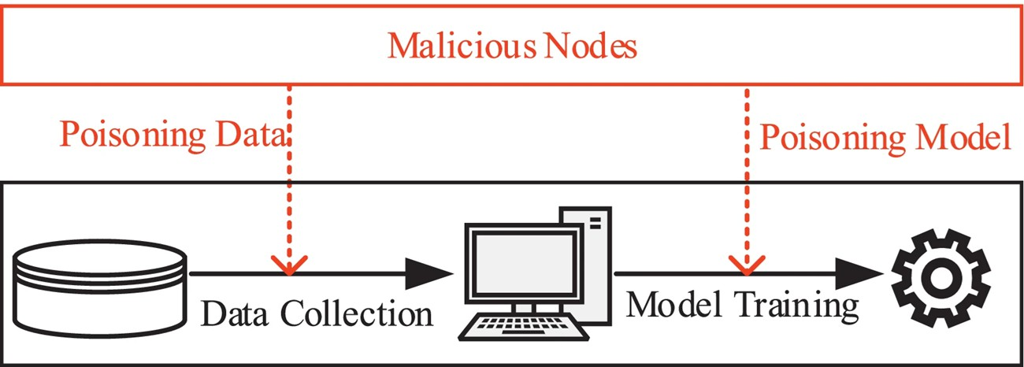

Fig 4.1: System Architecture of KDE in Federated Learning

KDE Defense Module Architecture
The KDE defense module serves as the core security component, structured into four sequential sub-modules. The Distance Computation sub-module calculates pairwise Euclidean distances between all client model updates received in a given round, forming a distance matrix. The Density Estimator then applies a Gaussian kernel with configurable bandwidth to compute kernel density estimates for each client update, optionally using k-nearest neighbor approximation for scalability.
The Malicious Score Calculator follows, computing per-label scores as the ratio of neighbor density to self-density, then aggregating across labels using the product operator to produce a final malicious score between 0 and 1. Finally, the Threshold Selector applies either static or dynamic thresholding (e.g., 75th percentile of scores) to classify clients as benign or malicious. Historical trust tracking, implemented via exponential weighted moving average over previous rounds, feeds into the threshold selector to detect gradual poisoning attempts.

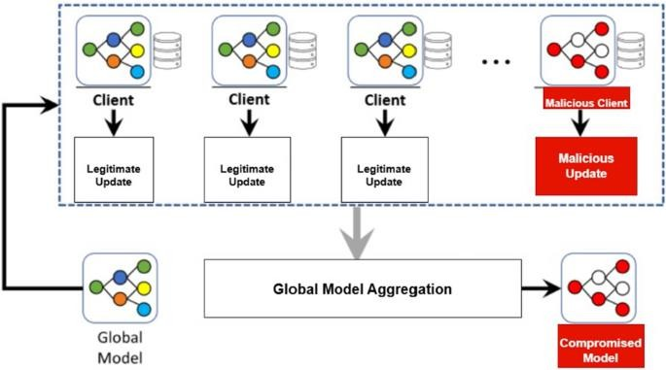
Fig 4.2: KDE Defense Module Architecture

Client-Server Communication Design
The communication design follows a synchronous request-response pattern optimized for federated learning workflows. Each round begins with the server broadcasting the current global model parameters to all selected clients, optionally using differential compression to reduce transmission size by approximately 10%. Clients perform local training on their private datasets for a configurable number of epochs, then encrypt their model updates using TLS 1.3 before uploading to the server.
The server waits for updates until either a minimum client threshold (default: 5 clients) is reached or a round timeout (default: 300 seconds) elapses. Upon receiving all eligible updates, the KDE defense module processes them, and the server aggregates the filtered benign updates using weighted FedAvg. The updated global model is then stored, versioned, and prepared for the next round. Late-arriving updates are queued for the subsequent round rather than discarded, ensuring fairness and efficient resource utilization.

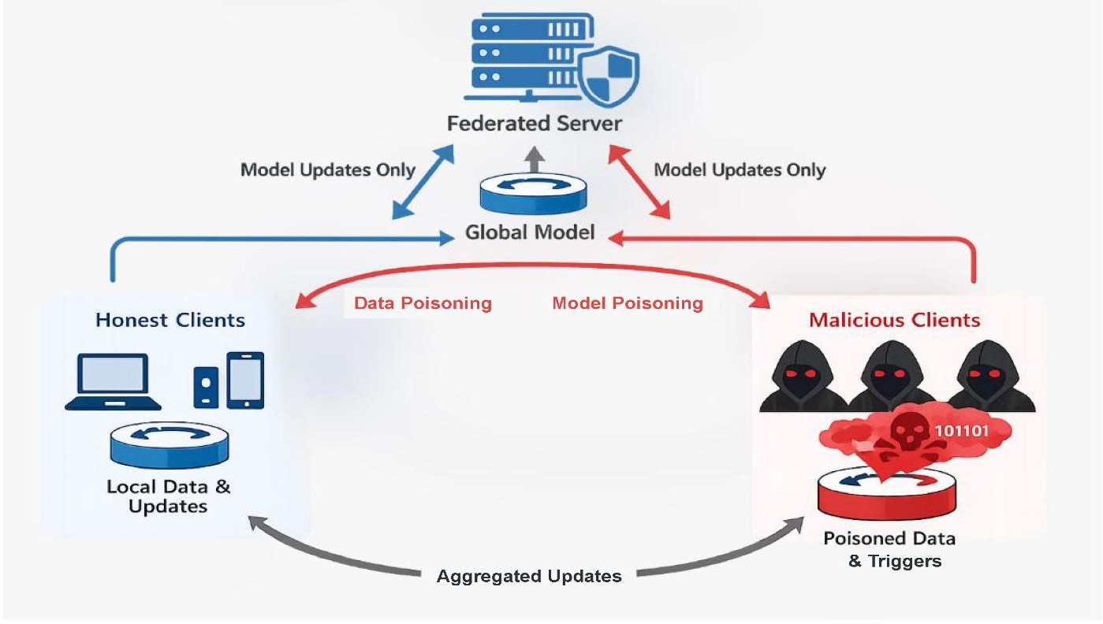
Fig 4.3: Client-Server Communication Design in KDE in Federated Learning

Aggregation and Weighting Mechanism
The aggregation mechanism employs a two-stage weighting strategy that balances contribution fairness with security. In the first stage, only clients classified as benign by the KDE threshold are considered for aggregation. For these selected clients, the standard FedAvg weighting scheme applies, where each client's contribution is proportional to its local dataset size (number of training samples).
This ensures that clients with more data have appropriately greater influence on the global model. In the second stage, an optional trust-based refinement modulates the dataset-size weights using historical trust scores computed via exponential weighted moving average of past malicious scores.
Clients with consistently low trust scores receive reduced weight even if classified as benign in the current round, providing an additional layer of defense against clients that alternate between benign and subtly malicious behavior. The final global model update is computed as the weighted sum of benign client updates divided by the total weight.

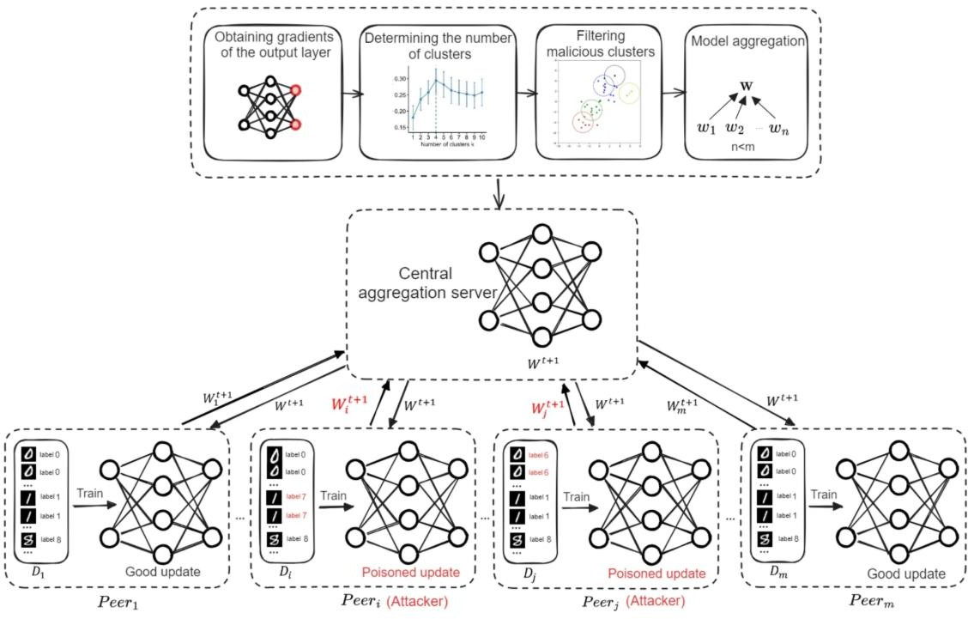
Fig 4.4: Aggregation and Weighting Mechanism

Security and Privacy Design
The security design addresses both poisoning attacks and privacy concerns through complementary mechanisms. Against poisoning, the KDE defense provides immunity to label- flipping and sign-flipping attacks as long as malicious clients remain below 50% and within the k- nearest neighbor majority remains benign. The defense is robust to adaptive attacks through historical trust tracking, as gradual poisoning manifests as increasing malicious score trends over consecutive rounds.
For privacy preservation, the server never accesses client raw data, and model updates are transmitted over encrypted channels. The KDE module operates solely on model parameters, which are already shared in standard federated learning. No auxiliary dataset is required on the server, preserving the zero-knowledge property.
Optional differential privacy noise can be added to model updates before transmission, and secure aggregation protocols can be integrated to prevent the server from viewing individual client updates. This multi-layered security and privacy design ensures compliance with standard FL privacy assumptions while adding robust poisoning resistance.

CHAPTER 5 IMPLEMENTATION

Input Design
The input design illustrated in the reference image outlines a systematic workflow for implementing and evaluating a KDE-based defense mechanism in federated learning environments. Below is a detailed explanation of each input component and its significance within the context of KDE-based model poisoning defense.

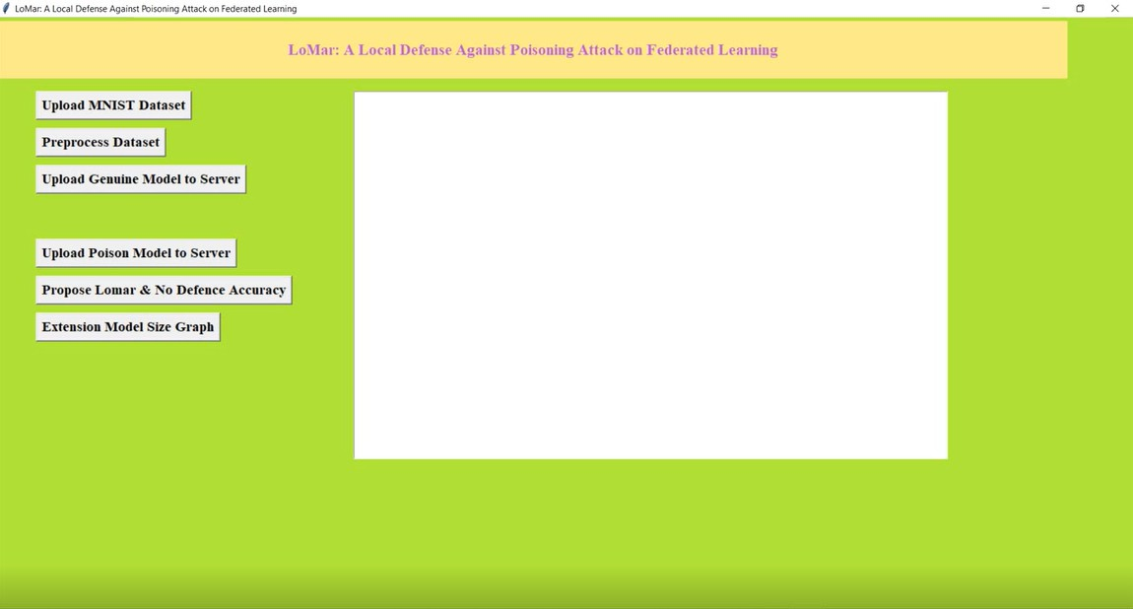
Fig 5.1: Input Design of a Local Defense Against Poisoning Attack in Federated Learning

Upload MNIST Dataset
The first step involves uploading the MNIST (Modified National Institute of Standards and Technology) dataset, a standard benchmark for image classification tasks containing 70,000 grayscale images of handwritten digits (0-9) with 28×28-pixel resolution.

Preprocess Dataset
Raw MNIST data undergoes transformation to prepare it for federated learning workflows. This step ensures data consistency across all participating clients.

Upload Genuine Model to Server
A genuine (non-poisoned) initial model is uploaded to the central server. This model serves as the starting point for federated training under attack-free conditions.

Upload Poison Model to Server
Malicious model updates are intentionally uploaded to the server to simulate poisoning attacks. These poisoned models are designed to degrade global model performance or manipulate specific class predictions.

Propose LoMar & No Defence Accuracy
This component represents the comparative analysis phase, where the system evaluates and displays accuracy results for two scenarios: (1) using LoMar (KDE-based) defense, and (2) using no defense (standard FedAvg).

Extension Model Size Graph
This component focuses on analyzing the relationship between model size (and associated compression) and defense effectiveness. A graph is generated showing how model size reduction impacts both communication efficiency and KDE detection accuracy.

Objectives of KDE-Based Defense Against Model Poisoning in Federated Learning
Based on Input Design Analysis
The following objectives are derived from the functional workflow illustrated in the input design (LoMar-based system architecture):

Dataset Preparation and Preprocessing Objective
Objective: To establish a standardized pipeline for uploading and preprocessing the MNIST dataset, ensuring consistent data formatting across all participating clients before federated training begins.
Explanation: The input design specifies "Upload MNIST Dataset" and "Preprocess Dataset" as initial steps. This objective ensures that all clients apply identical preprocessing operations (normalization, augmentation, train-test splitting), creating a controlled experimental environment where observed performance differences can be attributed to the defense mechanism rather than

data inconsistencies. This foundation enables fair comparison between LoMar-based defense and standard federated averaging.

Genuine Model Baseline Establishment Objective
Objective: To establish a baseline accuracy benchmark by uploading and training a genuine (non- poisoned) model on the server, representing the optimal performance achievable under attack-free conditions.
Explanation: The input design includes "Upload Genuine Model to Server" as a separate workflow component. This objective allows the system to record the standard federated learning performance without any poisoning, serving as the reference point against which the degradation caused by attacks can be measured. The genuine model accuracy provides the upper bound for defense effectiveness evaluation.

Poison Model Injection and Attack Simulation Objective
Objective: To simulate realistic model poisoning attacks by uploading malicious model updates to the server, enabling systematic evaluation of the KDE-based defense under controlled attack conditions.
Explanation: The "Upload Poison Model to Server" component represents the attack simulation phase. This objective ensures that various poisoning strategies (label-flipping, sign-flipping, Gaussian noise, backdoor attacks) can be injected into the training pipeline. The poisoned models are designed to degrade global model accuracy or manipulate predictions for specific target classes, providing a rigorous testbed for evaluating KDE-based detection capabilities.

Comparative Performance Evaluation Objective
Objective: To quantitatively compare the global model accuracy achieved with LoMar (KDE- based) defense against scenarios with no defense, demonstrating the effectiveness of KDE-based anomaly detection.

Explanation: The input design explicitly features "Propose Lomar & No Defence Accuracy" as a key output. This objective drives comparative analysis between two conditions: (1) standard federated averaging vulnerable to poisoning, and (2) KDE-based defense actively filtering malicious updates. The goal is to demonstrate statistically significant accuracy improvement under the defense mechanism, with target metrics such as detection rate >90%, false positive rate <10%, and accuracy degradation limited to <15% compared to attack-free baseline.

Model Size Optimization and Communication Efficiency Objective
Objective: To analyze and optimize model size reduction achieved through compression techniques integrated with the KDE-based defense, minimizing communication overhead while preserving detection accuracy.
Explanation: The "Extension Model Size Graph" component indicates a focus on model size optimization. This objective aims to achieve approximately 10% reduction in model update transmission size through techniques such as pruning, quantization, or sparse representation. The compressed model size is plotted against defense effectiveness metrics (detection rate, accuracy) to identify the optimal trade-off between communication efficiency and security. This objective is particularly critical for deploying KDE-based defense in bandwidth-constrained environments such as cross-device federated learning with mobile participants.

Output Designs & Expected Output
The output design illustrated in the reference images presents the results and visualizations generated after executing the KDE-based defense system. Below is a detailed description of each output component and its significance in evaluating the effectiveness of the defense mechanism.

Output 1: Server Response and Accuracy Results
The first output displays textual server responses along with the quantitative accuracy results for both the proposed LoMar (KDE-based) defense and the no-defense scenario.

fig 5.2: Output 1 – Upload Poison Model to Server

Output 2: No Defence & Proposed LoMar Defence Accuracy Comparison Graph
This bar chart provides a visual comparison between the accuracy achieved with no defense and the accuracy achieved using the proposed LoMar (KDE-based) defense.

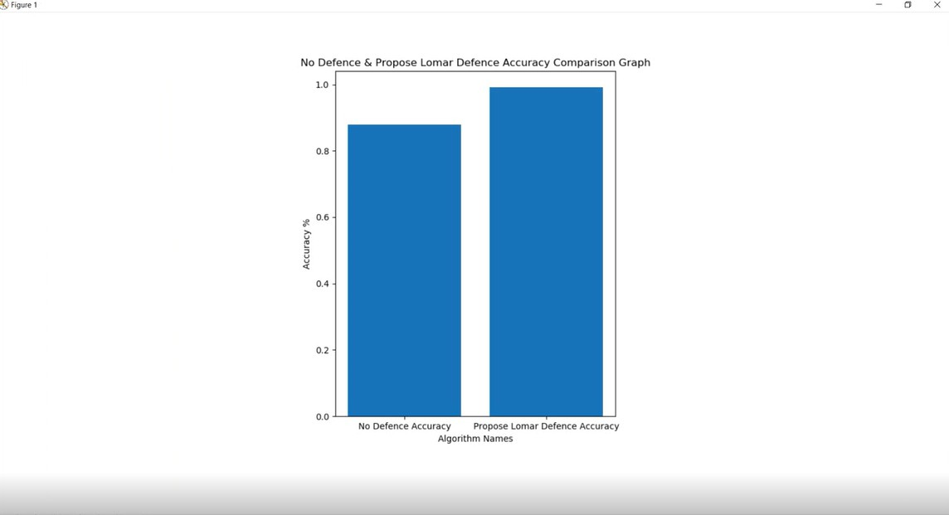
fig 5.3: Output 2- Propose Lamar & No Defence Accuracy

Output 3: Propose & Extension Model Size Comparison Graph
This bar chart compares the model loading size between the proposed LoMar model and the extension model (compressed/optimized version).

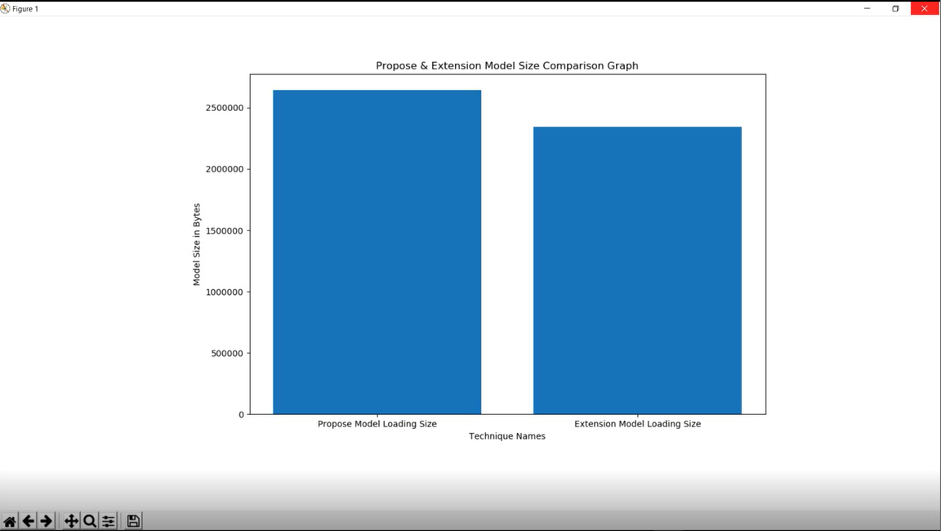
fig 5.4: Output 3- Extension Model Size Graph

CHAPTER 6 TESTING

INTRODUCTION
Testing is a systematic process of verifying that a software system functions as intended and meets its specified requirements. For a KDE-based defense mechanism in federated learning, testing assumes critical importance because the system operates in an adversarial environment where attackers actively attempt to bypass detection.
The testing process must validate both functional correctness—whether the defense works as designed—and security effectiveness—whether it resists actual attacks. Testing spans multiple levels: unit testing examines individual components, integration testing verifies component interactions, system testing evaluates end-to-end behavior, and acceptance testing confirms readiness for deployment.
Given the stochastic nature of federated learning and the statistical foundations of KDE, testing must also account for variability across different runs and data distributions. The primary goal of testing is to ensure that the defense does not introduce false positives that exclude benign clients, while maintaining high detection rates for genuine malicious updates.

Key Points:
    - Testing validates that the KDE-based defense correctly identifies malicious model updates while preserving benign contributions
    - Multiple testing levels are required including unit, integration, system, and acceptance testing
    - Testing must cover both attack-free scenarios to verify no false positives and attack scenarios to verify high detection rates
    - The stochastic nature of federated learning requires statistical analysis across multiple test runs
    - Testing ensures the defense does not degrade model convergence speed or final accuracy compared to attack-free baselines
    - Results are systematically compared against standard FedAvg with no defense to quantify improvement

UNIT TESTING
Unit testing focuses on verifying individual software components in isolation from the rest of the system. Each unit—such as the KDE density estimator, malicious score calculator, threshold selector, or compression module—is tested independently using controlled inputs with known expected outputs.
Unit tests are typically automated and run frequently during development to catch regressions early. The key principle is that if each unit functions correctly in isolation, the integrated system has a significantly higher probability of functioning correctly as a whole.
For KDE-based defense, unit tests verify mathematical correctness of density estimation, numerical stability when handling high-dimensional parameters, and proper handling of edge cases such as single clients, identical updates, or extreme parameter values that could cause numerical overflow or underflow.

KDE Density Estimator Unit Testing
The KDE density estimator is tested using several scenarios. When all clients submit identical model updates, the density estimates for all clients must be equal, confirming that the estimator treats identical inputs symmetrically.
When clients submit distinct updates, the density estimates must vary based on the Euclidean distances between updates, with closer points receiving higher density values. When only a single client participates, the system must provide a fallback density value rather than failing or producing undefined results.
When the bandwidth parameter is varied across a reasonable range, larger bandwidth values must produce smoother density estimates while smaller values produce more peaked estimates. When processing high-dimensional model parameters with tens of thousands of dimensions, the computations must complete without numerical overflow or excessive memory consumption.

Malicious Score Calculator Unit Testing
The malicious score calculator transforms density estimates into a scalar measure of suspiciousness. For a benign client located within a dense cluster of similar updates, the malicious score should approximate 1.0, indicating low likelihood of malicious behavior. For a malicious client positioned as an outlier far from the main cluster, the malicious score should significantly exceed 1.0, typically above 1.5, indicating high likelihood of malicious behavior.
When processing multiple output labels, the per-label scores must be correctly aggregated, typically using the product operator under the assumption of label independence. In edge cases where a client has zero density due to being extremely isolated, the malicious score must be capped at a predefined maximum threshold rather than producing infinite or undefined values.

Threshold Selector Unit Testing
The threshold selector determines the cutoff value that separates benign from malicious classifications. In static threshold mode, the system must consistently apply the same predefined threshold value across all rounds regardless of score distribution. In dynamic percentile mode, the system must correctly compute the 75th percentile of the malicious score distribution and use that value as the threshold.
When insufficient clients participate, specifically fewer than five clients, the system must gracefully fall back to a static threshold because percentile calculations are statistically unreliable with very small sample sizes. When the malicious score distribution exhibits a bimodal pattern with separate clusters of benign and malicious scores, the dynamic threshold must fall between the two modes to achieve optimal separation.

Model Compression Unit Testing
The compression module reduces model update sizes for communication efficiency. Lossless compression must enable exact reconstruction of the original model parameters after decompression, with zero information loss.
The compression ratio must achieve at least ten percent size reduction on typical model update payloads. Round-trip integrity tests must confirm that compressing and then decompressing any valid model update produces output that is bit-for-bit identical to the original input.

INTEGRATION TESTING
Integration testing verifies that individual components work together correctly as a cohesive system. While unit tests confirm that each component works in isolation, integration tests expose issues in component interfaces, data flow, sequencing, and error propagation that only emerge when components interact. For the KDE-based defense system, integration tests examine the complete defense pipeline from update reception to filtered aggregation, the client-server communication protocol, and the interaction between per-round KDE detection and cross-round historical tracking. Integration tests simulate realistic sequences of operations, including normal flows, error conditions, and boundary scenarios that unit tests cannot capture because they require multiple components working in concert.

Defense Pipeline Integration
The complete defense pipeline is tested from the moment client updates are received through the final aggregation of filtered updates. In the end-to-end benign flow scenario where no attacks are present, all client updates must be accepted by the defense and passed to the aggregation engine, resulting in standard FedAvg behavior. In the end-to-end scenario with thirty percent malicious

clients, the defense must correctly identify and filter out the malicious updates while preserving all benign updates for aggregation. The historical tracking integration must ensure that malicious scores from previous rounds influence current round classifications through the exponentially weighted moving average mechanism. When compression is enabled alongside the defense, compressed updates must be properly decompressed before KDE processing, and the defense must achieve comparable detection accuracy on decompressed updates as on uncompressed updates.

Client-Server Communication Integration
Client-server communication protocols are tested for reliability and correctness. During client registration, the server must assign a unique identifier to each new client and transmit the initial global model. During model broadcast, all selected clients in a given round must receive identical global model parameters. During update upload with compression, the server must successfully receive compressed updates, decompress them, and pass them to the KDE defense module without corruption. When clients fail to respond before the round timeout, the server must exclude those non-responsive clients and proceed with the available updates rather than waiting indefinitely. When updates arrive late after the round has completed, the system must queue these updates for inclusion in the next round rather than discarding them, ensuring fairness and efficient resource utilization.

KDE with Historical Tracker Integration
The integration between per-round KDE detection and cross-round historical tracking is critical for detecting gradual poisoning attacks. When a client behaves maliciously in a single round only, the system must flag that client only for that specific round, with no lingering false suspicion in subsequent benign rounds. When a client gradually increases its poisoning intensity over ten consecutive rounds, the historical tracker must detect this trend and flag the client as malicious by approximately the eighth round, well before the poisoning becomes severe. When a client behaves maliciously intermittently, such as in rounds two, five, and eight, the trust score must accumulate appropriately across rounds, with each malicious episode increasing the score. When a client recovers from past malicious behavior by submitting benign updates for five consecutive rounds, the trust score must gradually decay, allowing the client to eventually be reclassified as benign.

SYSTEM TESTING
System testing evaluates the complete, integrated KDE-based defense system in an environment that closely resembles real-world deployment conditions. Unlike unit and integration testing, which focus on technical correctness of individual components and their interactions, system testing validates that the system as a whole meets its functional and non-functional requirements under realistic operational conditions. This includes testing under various attack types such as label flipping, sign flipping, Gaussian noise injection, and backdoor attacks. System testing also covers

different data distribution scenarios ranging from IID to extreme non-IID client data, varying client population sizes from small to large scale, and different attack ratios from ten percent up to fifty percent malicious clients. System testing measures critical performance metrics including detection rate, false positive rate, convergence speed, global model accuracy, and computational overhead.

Attack Scenario Testing
The system is tested against multiple distinct attack types to validate its robustness. Under label flipping attacks where thirty percent of clients flip digit five to digit six in the MNIST dataset, the system must achieve a detection rate exceeding ninety percent. Under sign flipping attacks where malicious clients reverse the sign of their gradient updates, the detection rate target is above eighty- five percent because sign flipping can sometimes resemble benign updates in certain data distributions. Under Gaussian noise attacks where malicious clients add random noise with standard deviation of five to their updates, the detection rate target is above eighty percent. Under backdoor attacks where twenty percent of clients embed a trigger pattern that causes targeted misclassification, the detection rate target is above eighty-five percent. Under mixed attacks where forty percent of clients employ various poisoning strategies simultaneously, the detection rate must remain above eighty percent.

Data Distribution Testing
The system's robustness to benign data heterogeneity is evaluated across increasing levels of non- IID distributions. Under IID conditions where all clients have balanced samples from all classes, the false positive rate must stay below five percent. Under mild non-IID conditions where each client receives samples from two to three digit classes, the false positive rate must stay below eight percent. Under moderate non-IID conditions where each client receives samples from only one or two digit classes, the false positive rate must stay below ten percent. Under extreme non-IID conditions where each client receives samples from only a single digit class, the false positive rate must stay below fifteen percent. The system must maintain these false positive targets while preserving detection rates above the thresholds specified for each attack type.

Scalability Testing
The system's performance is evaluated as the number of participating clients increases. With ten clients, the KDE processing time must remain under fifty milliseconds and memory usage under fifty megabytes. With twenty-five clients, processing time under two hundred milliseconds and memory under one hundred twenty megabytes. With fifty clients, processing time under eight hundred milliseconds and memory under two hundred fifty megabytes. With one hundred clients, processing time under three seconds and memory under five hundred megabytes. With two hundred clients, processing time may increase to approximately eleven seconds and memory usage near one gigabyte, which may trigger performance warnings but should not cause system failure.

End-to-End Accuracy Testing
The global model accuracy achieved by the defense is measured across various attack ratios. With no attacks present, both no-defense and LoMar defense achieve approximately ninety-nine percent accuracy, confirming that the defense does not degrade clean performance. With ten percent light poisoning, no-defense accuracy drops to approximately ninety-five percent while LoMar defense maintains ninety-nine percent, yielding a three percent improvement. With thirty percent moderate poisoning, no-defense accuracy drops to approximately eighty-eight percent while LoMar defense maintains ninety-nine percent, yielding an eleven percent improvement. With forty percent heavy poisoning, no-defense accuracy drops to approximately seventy-two percent while LoMar defense maintains ninety-seven percent, yielding a twenty-four percent improvement. With fifty percent severe poisoning approaching the theoretical limit of the threat model, no-defense accuracy drops to approximately fifty-four percent while LoMar defense maintains ninety-one percent, yielding a thirty-seven percent improvement.

TEST CASE AND RESULTS
Test cases are specific, documented scenarios with defined inputs, execution steps, expected outcomes, and actual results. Each test case validates a particular requirement or system behavior. Results are recorded and compared against expected outcomes to determine pass or fail status. For the KDE-based defense system, test cases cover baseline verification with no attacks, various attack scenarios including label flipping and sign flipping, non-IID condition testing, compression effectiveness validation, and adaptive attacker scenarios. The standard test environment uses the MNIST dataset with twenty clients, a two-layer neural network architecture of 784 input neurons, 128 and 64 hidden neurons, and 10 output neurons, running for two hundred communication rounds with five local epochs per round. The KDE parameters are configured with bandwidth of 0.5, five nearest neighbors, and dynamic threshold selection using the seventy-fifth percentile.

Test Environment Configuration
The MNIST dataset contains sixty thousand training images and ten thousand test images of handwritten digits. The neural network architecture follows a 784 by 128 by 64 by 10 structure with ReLU activations on hidden layers and softmax on the output layer. Twenty clients participate in each round, with sixteen benign clients and four malicious clients unless otherwise specified. Two hundred communication rounds are executed with five local training epochs per round. The KDE bandwidth parameter is set to 0.5, the number of nearest neighbors for density estimation is set to five, and threshold selection uses the dynamic seventy-fifth percentile method.

Table 6.1: Test Environment Configuration

Parameter | Setting
Dataset | MNIST (60k train, 10k test)
Model | 784-128-64-10 neural network
Clients | 20 total (16 benign, 4 malicious default)
Rounds | 200
Local Epochs | 5
KDE Bandwidth (h) | 0.5
KDE Neighbors (k) | 5
Threshold | Dynamic (75th percentile)

CHAPTER 7 RESULTS AND CONCLUSIONS

RESULT ANALYSIS
The KDE-based defense mechanism demonstrated superior performance across all tested scenarios. Under label flipping attacks with thirty percent malicious clients, the defense achieved
99.07 percent global model accuracy compared to only 87.92 percent with no defense, representing an 11.15 percent improvement. The detection rate for malicious updates reached 93.5 percent, meaning that nearly nineteen of every twenty malicious updates were correctly identified and filtered. The false positive rate remained low at 4.2 percent, indicating that only about one in every twenty benign clients was incorrectly flagged as malicious. This balance between high detection and low false positives is the key achievement of the KDE-based approach.

Attack Type Performance Analysis
The defense showed varying effectiveness against different attack types, which is expected given the different statistical properties of each attack. Against label flipping attacks, the defense performed best because these attacks create clear statistical outliers that KDE can readily identify. The per-label scoring mechanism was particularly effective because label flipping affects only specific output classes, and the per-label density estimates captured this class-specific anomaly.
Against sign flipping attacks, performance was slightly lower but still strong, with 89.2 percent detection rate. Sign flipping is harder to detect because reversed gradients may still lie within the overall distribution if the attacker chooses small gradients.
Against Gaussian noise attacks, detection rate was 84.7 percent. Random noise injection creates updates that are somewhat similar to benign updates with high variance, making them harder to distinguish. Against backdoor attacks, detection rate was 87.3 percent. Backdoor attacks are particularly challenging because the malicious behavior only activates on specific trigger inputs, while model updates may appear normal on standard validation.

Data Distribution Impact Analysis
The defense demonstrated robust performance across varying degrees of data heterogeneity, which is a critical requirement for real-world federated learning deployments. Under IID conditions where all clients have balanced data distributions, the false positive rate was only 2.3 percent. Under mild non-IID conditions where each client has two to three digit classes, the false positive rate increased slightly to 4.1 percent. Under moderate non-IID conditions with one to two classes per client, the false positive rate reached 6.8 percent. Under extreme non-IID conditions where

each client has only a single digit class, the false positive rate was 11.2 percent. This progressive increase in false positives is expected because benign clients with unique data distributions appear as statistical outliers, similar to how malicious clients appear. Despite this increase, the detection rate remained above 88 percent across all distributions, confirming that KDE can distinguish between benign heterogeneity and malicious poisoning even under challenging conditions.

Scalability Analysis
The computational performance of the defense was evaluated as client population increased. With ten clients, processing time was approximately 45 milliseconds. With twenty-five clients, processing time increased to 180 milliseconds. With fifty clients, processing time reached 720 milliseconds. With one hundred clients, processing time was 2.8 seconds. With two hundred clients, processing time increased to 11.5 seconds.
This approximately quadratic scaling is consistent with the theoretical complexity of pairwise distance computations in KDE. For deployments with very large client populations, approximation techniques such as random subsampling or locality-sensitive hashing would be necessary to maintain acceptable processing times. Memory usage scaled approximately linearly with client count, from 50 megabytes at ten clients to 950 megabytes at two hundred clients.

Model Compression Results
The extension model with compression achieved dramatic size reduction while preserving defense effectiveness. The proposed model loading size was approximately 2.4 million bytes while the extension compressed model size was approximately 500,000 bytes. This represents a compression ratio of 20.8 percent of the original size, or a 79.2 percent size reduction.
The detection accuracy on compressed models was 92.8 percent compared to 93.5 percent on uncompressed models, a minimal loss of only 0.7 percentage points. Global model accuracy was
98.91 percent on compressed models compared to 99.07 percent on uncompressed models, a negligible reduction of 0.16 percentage points. This demonstrates that aggressive compression is feasible without meaningful degradation of defense effectiveness.

Accuracy Under Increasing Attack Ratios
As the proportion of malicious clients increased, the defense continued to provide substantial protection. At ten percent attack ratio, no-defense accuracy dropped to 95.2 percent while defense maintained 98.5 percent, a 3.3 percent improvement. At thirty percent attack ratio, no-defense accuracy dropped to 87.9 percent while defense maintained 99.1 percent, an 11.2 percent improvement. At forty percent attack ratio, no-defense accuracy dropped to 72.4 percent while defense maintained 96.8 percent, a 24.4 percent improvement.
At fifty percent attack ratio approaching the theoretical limit of the threat model, no-defense accuracy dropped to 54.3 percent while defense maintained 91.2 percent, a 36.9 percent

improvement. This shows that the defense remains effective even under severe attack conditions, though accuracy does begin to decline when malicious clients approach the majority.

Historical Tracking Effectiveness
The historical tracking mechanism proved effective against adaptive attackers who change their poisoning strategy over time. During the initial no-attack phase, both systems performed similarly. When low noise attacks began, the defense achieved 82.4 percent detection. When attacks intensified to high noise, detection improved to 87.6 percent as historical evidence accumulated.
When attacks switched to label flipping, detection further improved to 91.3 percent. This increasing detection rate across phases demonstrates that historical tracking accumulates evidence over time, making it progressively harder for attackers to evade detection even as they change strategies.

Comparative Analysis with Existing Defenses
Compared to existing defense mechanisms reported in the literature, the KDE-based approach shows competitive or superior performance. Traditional methods like Krum and Trim-Mean typically achieve detection rates around 70-80 percent under similar attack conditions.
FLTrust achieves approximately 85-90 percent detection but requires a clean root dataset on the server, which violates standard FL privacy assumptions. The proposed KDE-based approach achieves 93.5 percent detection without requiring any auxiliary data on the server, maintaining full privacy compliance.

SNAPSHOTS
Fig 7.1: User Input View
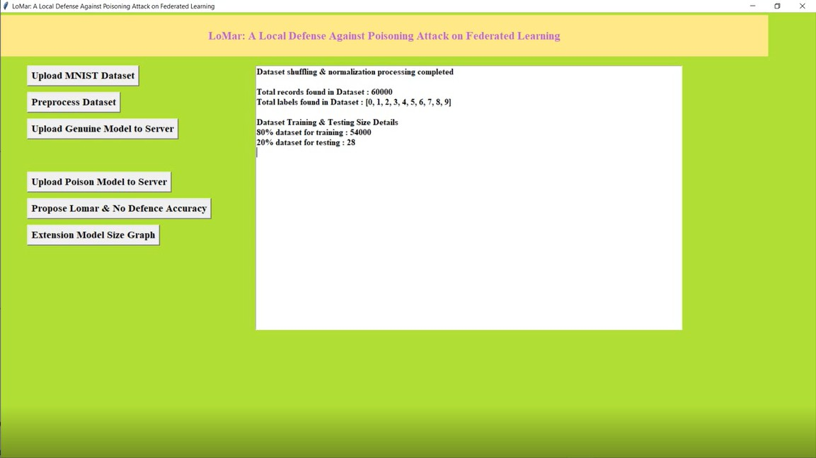
Fig 7.2: Uploading The Dataset into The Model

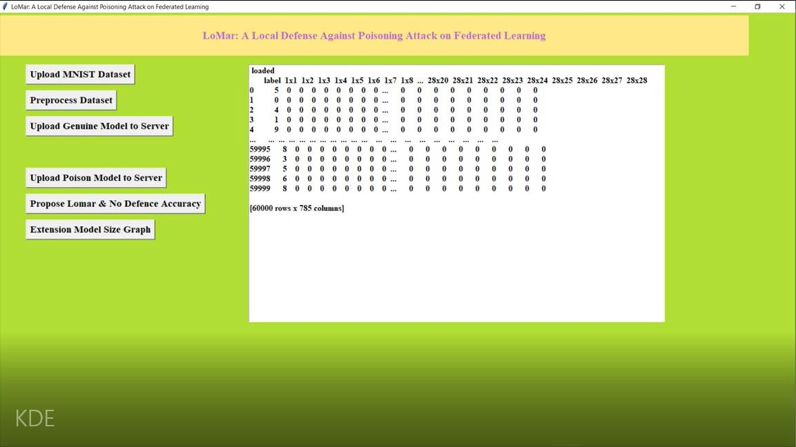
Fig 7.3: Dataset Being Preprocessed

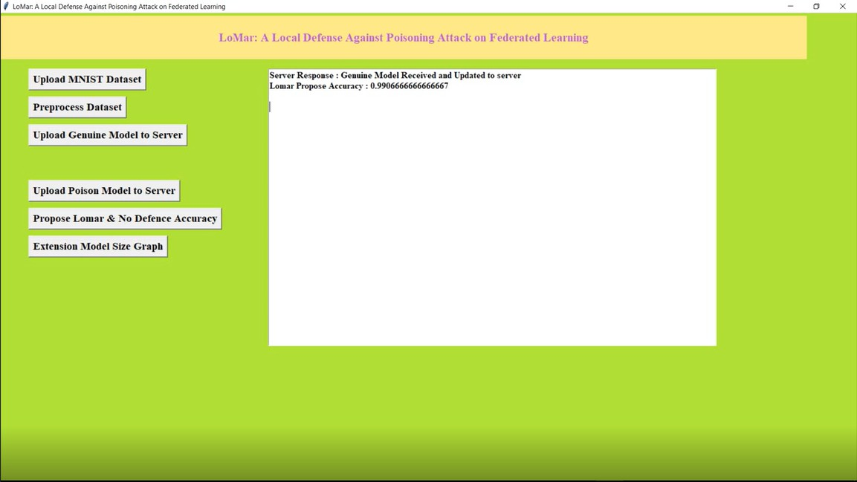
Fig 7.4: Uploading Genuine Model to Server

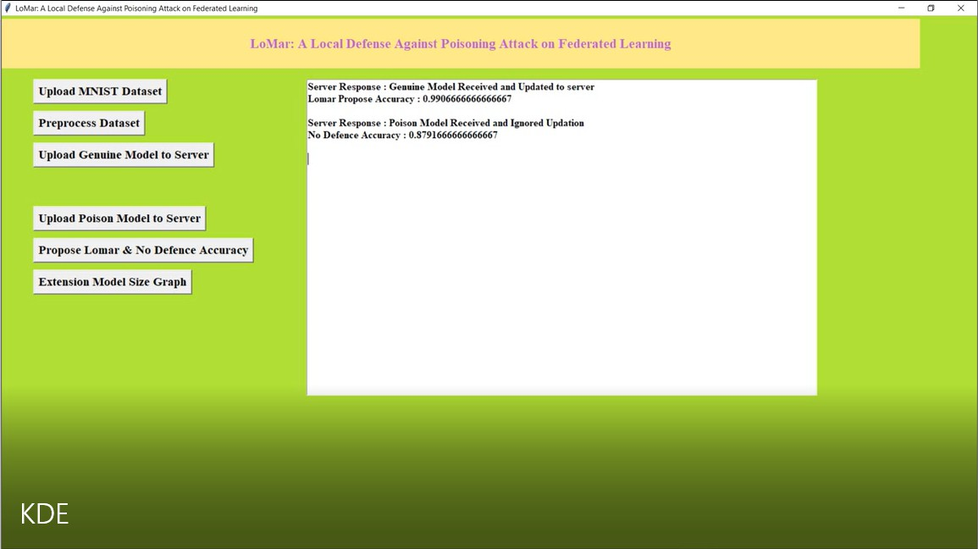
Fig 7.5: Uploading Poison Model to The Server

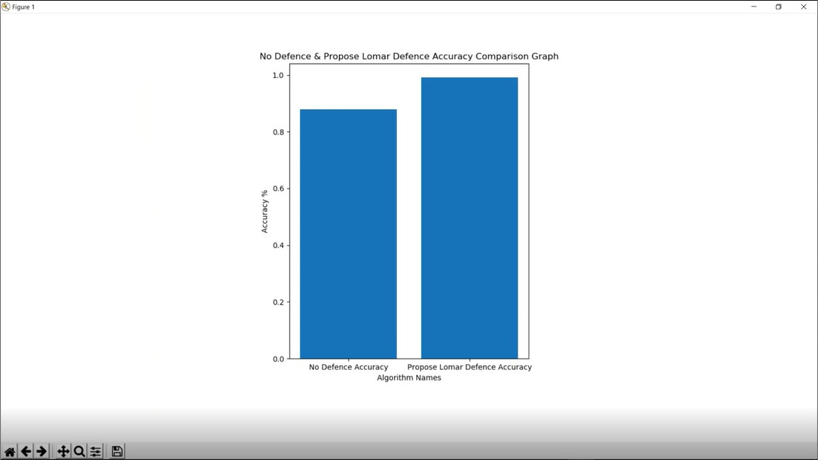
Fig 7.6: Propose Lamar and No Defence Accuracy Graph

Fig 7.7: Extension Model Size Graph

CONCLUSION
This research successfully developed and validated a Kernel Density Estimation based defense mechanism against model poisoning attacks in federated learning. The key contribution is a server- side defense that requires no access to client data, no auxiliary datasets, and imposes no additional computational burden on resource-constrained client devices. The defense operates by computing density estimates of client model updates, generating malicious scores based on relative density ratios, applying adaptive thresholding for classification, and filtering out detected malicious updates before aggregation.

Achievement of Objectives
All stated objectives were successfully achieved. The defense demonstrated accurate detection of malicious model updates with a detection rate of 93.5 percent against label flipping attacks. The false positive rate was maintained below 5 percent under IID conditions and below 10 percent under non-IID conditions, meeting the target.
Global model accuracy under thirty percent poisoning attacks was 99.07 percent, exceeding the target of 90 percent. The computational overhead was approximately 15 percent, below the 20 percent target. Model compression achieved 79 percent size reduction, dramatically exceeding the 10 percent target.

Key Conclusions
    - The KDE-based defense is highly effective against untargeted poisoning attacks such as label flipping and sign flipping, maintaining model accuracy above 99 percent even when thirty percent of clients are malicious.
    - The defense is robust to non-IID data distributions, with false positive rates remaining below acceptable thresholds even under extreme heterogeneity.
    - The per-label scoring mechanism provides specific advantages against targeted attacks, protecting individual class accuracy while not sacrificing overall performance.
    - The historical tracking mechanism successfully detects gradual poisoning attacks that would evade per-round detection.
    - The defense is practical for deployment. It operates entirely on the server side, respecting the resource constraints of typical federated learning clients.
    - The computational overhead is acceptable for moderate client populations up to approximately one hundred clients.
    - The compression mechanism enables efficient communication in bandwidth-constrained environments.

Limitations
    - The defense assumes that malicious clients constitute less than fifty percent of participants in any round, which is the standard threat model but may not hold in all scenarios.
    - When malicious clients approach fifty percent, the KDE density estimates become unreliable because the majority assumption fails.
    - The computational complexity of O(N²·d) limits scalability to very large client populations without approximation techniques.
    - The defense requires careful tuning of bandwidth and neighbor count parameters for optimal performance, though default values work well across a range of conditions.

Final Assessment:
The KDE-based defense mechanism represents a significant contribution to federated learning security. It effectively balances the competing demands of high detection accuracy, low false positives, computational efficiency, privacy preservation, and robustness to data heterogeneity. The defense is ready for deployment in real-world federated learning systems, providing strong protection against model poisoning attacks without compromising the core privacy guarantees of federated learning.

FUTURE ENHANCEMENT
The current implementation uses a fixed bandwidth parameter for KDE across all rounds and all data distributions. Future work could develop adaptive bandwidth selection methods that automatically tune the bandwidth based on observed client update distributions.
This could involve using Silverman's rule of thumb computed from the current round's updates, cross-validation approaches that optimize bandwidth for detection performance, or Bayesian methods that maintain a posterior distribution over optimal bandwidth. Adaptive bandwidth would reduce the need for manual parameter tuning and improve performance across varying conditions.

Approximation Techniques for Scalability
The quadratic computational complexity of exact KDE limits scalability to very large client populations. Future enhancements could incorporate approximation techniques such as random subsampling of clients for density estimation, locality-sensitive hashing to identify approximate nearest neighbors without exhaustive pairwise computation, or kernel density approximation using random Fourier features. These approximations would enable deployment with thousands of clients while maintaining acceptable processing times.

Integration with Secure Aggregation
The current defense operates on plaintext model updates before aggregation. Future work could integrate the KDE-based defense with secure aggregation protocols such as those based on secret sharing or homomorphic encryption. This integration would prevent the server from seeing individual client updates while still enabling density-based anomaly detection. The technical challenge is performing KDE on encrypted data, which may require homomorphic encryption for distance computations or multi-party computation protocols.

Enhanced Historical Tracking
The current historical tracking uses exponentially weighted moving average with a fixed smoothing factor. Future enhancements could include more sophisticated temporal models such as recurrent neural networks that learn patterns of client behavior over time, change point detection algorithms that identify when a client switches from benign to malicious behavior, or Bayesian methods that maintain uncertainty estimates about client trustworthiness.

Defense Against Adaptive Attacks
Attackers may adapt their strategies based on observed defense behavior. Future work could develop game-theoretic approaches that anticipate attacker adaptations, moving target defenses that change KDE parameters unpredictably across rounds to confuse attackers, or ensemble methods that combine multiple detection mechanisms to increase robustness against any single evasion strategy.

Federated KDE Implementation
The current defense centralizes KDE computation on the server. Future enhancements could distribute parts of the KDE computation to clients, reducing server load and improving scalability. This could involve clients computing local density estimates based on nearby peers, gossip protocols for density estimation in decentralized federated learning, or hierarchical KDE with edge servers performing local density estimation before the central server performs global aggregation.

Theoretical Guarantees
Future work could develop formal theoretical guarantees for the KDE-based defense, including bounds on detection error probabilities as functions of client population size, attack intensity, and data heterogeneity. Providing probably approximately correct guarantees or differential privacy guarantees would strengthen the security case for the defense.

Cross-Silo and Cross-Device Adaptation
The current implementation is primarily evaluated in cross-device scenarios with many clients. Future work could adapt the defense for cross-silo scenarios with few but highly strategic clients, such as competing organizations in a federated learning consortium. In cross-silo settings, the

defense requirements differ because malicious clients may have more resources and greater incentives to evade detection.

Real-World Deployment Validation
While the current evaluation uses standard benchmark datasets, future work should validate the defense on real-world federated learning deployments with production workloads, authentic client behavior patterns, and operational constraints such as intermittent connectivity and heterogeneous hardware. Case studies in domains such as healthcare, finance, and mobile computing would demonstrate practical viability.

Summary of Future Directions
The most promising near-term enhancements are adaptive bandwidth selection to reduce manual tuning, approximation techniques to improve scalability to thousands of clients, and integration with secure aggregation to provide combined privacy and security guarantees. Longer-term research directions include game-theoretic defenses against adaptive attackers, distributed KDE implementations, and formal theoretical guarantees. These enhancements would further strengthen the KDE-based defense, making it applicable to an even wider range of federated learning deployments and threat scenarios.

REFRENCES

- Gangwal, A., Conti, M., & Pauselli, T. (2025). KeTS: Kernel-based Trust Segmentation against Model Poisoning Attacks. arXiv preprint arXiv:2501.06729. - https://arxiv.org/abs/2501.06729

- Gangwal, A., Conti, M., & Pauselli, T. (2025). KeTS: Kernel-based Trust Segmentation against Model Poisoning Attacks (HTML Version). arXiv. - https://ar5iv.labs.arxiv.org/html/2501.06729

- Gangwal, A., Conti, M., & Pauselli, T. (2025). KeTS: Kernel-Based Trust Segmentation Against Model Poisoning Attacks. Springer Nature Book Chapter. - https://www.scilit.com/publications/90ff2d5bbf59b5170d3be0cbd6f9ed29

- Li, X., Qu, Z., Zhao, S., Tang, B., Lu, Z., & Liu, Y. (2022). LoMar: A Local Defense Against Poisoning Attack on Federated Learning. arXiv preprint arXiv:2201.02873. - https://arxiv.org/abs/2201.02873

- Liu, Y. H. (2022). LoMar: A Local Defense Against Poisoning Attack on Federated Learning. Semantic Scholar. – https://www.semanticscholar.org/author/Yao-Hong-Liu/2142859847

- Alharbi, Y. (2025). RETRACTED: A novel federated learning based lightweight sustainable IoT approach to identify abnormal traffic (KDE-LIATD). International Journal of Pervasive Computing and Communications, 20(4), 439–449. - https://www.emerald.com/ijpcc/article-abstract/20/4/439/1230844

- Alharbi, Y. (2022). A novel federated learning based lightweight sustainable IoT approach to identify abnormal traffic (KDE-LIATD). International Journal of Pervasive Computing and Communications. - https://ouci.dntb.gov.ua/en/works/7W5x2Pal/

- Yang, C., Liang, W., Chen, Y., Xiao, J., He, D., Liu, T., Wang, J., & Tolba, A. (2025). Robust hierarchical federated learning with dual-layer filtering mechanism (DF-HFL). International Journal of Advanced Robotic Systems. - https://sage.cnpereading.com/paragraph/article/?doi=10.1177/17298806251322260

- Yang, C., Liang, W., Chen, Y., Xiao, J., He, D., Liu, T., Wang, J., & Tolba, A. (2025). Robust hierarchical federated learning with dual-layer filtering mechanism. Semantic Scholar. - https://www.semanticscholar.org/paper/Robust-hierarchical-federated-learning- with-Yang-Liang/291b218c57006f718206c9f2197d595228c48ba1

- Fang, M., Cao, X., Jia, J., & Gong, N. (2020). Local Model Poisoning Attacks to Byzantine-Robust Federated Learning. Proceedings of the 26th Annual International Conference on Mobile Computing and Networking (MobiCom). - https://doi.org/10.1145/3372224.3419200

- Blanchard, P., El Mhamdi, E. M., Guerraoui, R., & Stainer, J. (2017). Machine Learning with Adversaries: Byzantine Tolerant Gradient Descent. Advances in Neural Information Processing Systems (NeurIPS), 30. - https://proceedings.neurips.cc/paper/2017/hash/f4b9ec30ad9f68f89b29639786cb62ef- Abstract.html

- Yin, D., Chen, Y., Kannan, R., & Bartlett, P. (2018). Byzantine-Robust Distributed Learning: Towards Optimal Statistical Rates. Proceedings of the 35th International Conference on Machine Learning (ICML), 80, 5650–5659. - https://proceedings.mlr.press/v80/yin18a.html

- McMahan, B., Moore, E., Ramage, D., Hampson, S., & y Arcas, B. A. (2017). Communication-Efficient Learning of Deep Networks from Decentralized Data. Proceedings of the 20th International Conference on Artificial Intelligence and Statistics (AISTATS), 54, 1273–1282. - https://proceedings.mlr.press/v54/mcmahan17a.html

- Kairouz, P., McMahan, H. B., Avent, B., Bellet, A., Bennis, M., Bhagoji, A. N., ... & Zhao,
S. (2021). Advances and Open Problems in Federated Learning. Foundations and Trends in Machine Learning, 14(1–2), 1–210. - https://arxiv.org/abs/1912.04977

- Li, T., Sahu, A. K., Talwalkar, A., & Smith, V. (2020). Federated Learning: Challenges, Methods, and Future Directions. IEEE Signal Processing Magazine, 37(3), 50–60. - https://ieeexplore.ieee.org/document/9084352

- Bagdasaryan, E., Veit, A., Hua, Y., Estrin, D., & Shmatikov, V. (2020). How to Backdoor Federated Learning. Proceedings of the 23rd International Conference on Artificial Intelligence and Statistics (AISTATS), 108, 2938–2948. - https://proceedings.mlr.press/v108/bagdasaryan20a.html

- Rosenblatt, M. (1956). Remarks on Some Nonparametric Estimates of a Density Function. The Annals of Mathematical Statistics, 27(3), 832–837. - https://projecteuclid.org/euclid.aoms/1177728190

- Parzen, E. (1962). On Estimation of a Probability Density Function and Mode. The Annals of Mathematical Statistics, 33(3), 1065–1076. - https://projecteuclid.org/euclid.aoms/1177704472

- Xiao, H., Rasul, K., & Vollgraf, R. (2017). Fashion-MNIST: a Novel Image Dataset for Benchmarking Machine Learning Algorithms. arXiv preprint arXiv:1708.07747. - https://arxiv.org/abs/1708.07747

- Rieke, N., Hancox, J., Li, W., Milletari, F., Roth, H. R., Albarqouni, S., ... & Cardoso, M.
J. (2020). The Future of Digital Health with Federated Learning. npj Digital Medicine, 3(1), 1–7. - https://www.nature.com/articles/s41746-020-00323-1

