Course code: AI2002
Artificial Intelligence

Assignment# 02
Submitted by:
Syed Muhammad | Roll# 23F-0559
Section: 6B
Submitted to:
Ma’am Rabia Maqsood

FAST UNIVERSITY FAISLABAD CAMPUS

1. Introduction
This report presents the design, implementation, and evaluation of six core uninformed search algorithms within a grid-based environment. The objective is to navigate from a designated start node (S) to a target node (T) while avoiding fixed obstacles (walls).
The grid allows six-directional movement: Up, Right, Down, Left, and two primary diagonals (Bottom-Right and Top-Left). This movement model introduces both uniform and weighted transitions, depending on the algorithm used.

2. Implementation of Search Strategies

2.1 Movement Priority Order
To maintain deterministic and fair comparison across all algorithms, neighboring nodes are expanded in a fixed clockwise sequence:
- Up (−1, 0)
- Right (0, 1)
- Down (1, 0)
- Bottom-Right (Diagonal) (1, 1)
- Left (0, −1)
- Top-Left (Diagonal) (−1, −1)
This consistent ordering ensures uniform exploration behavior and reproducible results.

2.2 Breadth-First Search (BFS)
Breadth-First Search explores nodes level by level using a First-In-First-Out (FIFO) queue. It systematically expands all nodes at a given depth before moving to the next level.
Advantages:
• Complete and guaranteed to find the shortest path in an unweighted grid.
Limitations:
• High memory consumption due to storing all nodes in the frontier at each depth level.

2.3 Depth-First Search (DFS)
Depth-First Search explores as far as possible along one branch before backtracking. It uses a Last-In-First-Out (LIFO) stack structure.
Advantages:
• Requires less memory compared to BFS.
Limitations:
• Does not guarantee the shortest path.
• May traverse very deep paths unnecessarily if no depth restriction is applied.

2.4 Uniform-Cost Search (UCS)
Uniform-Cost Search selects nodes for expansion based on the lowest cumulative path cost, utilizing a priority queue.
In this implementation:
• Straight moves have a cost of 1.0
• Diagonal moves have a cost of √2 ≈ 1.414
Advantages:
• Guarantees an optimal solution in weighted grids.
Limitations:
• Can be computationally expensive, particularly when many nodes have similar path costs.

2.5 Depth-Limited Search (DLS)
Depth-Limited Search is a modified version of DFS that imposes a predefined maximum depth limit. Once this limit is reached, further expansion along that branch is halted.
Advantages:
• Prevents infinite descent in deep or cyclic search spaces.
Limitations:
• Not complete if the solution lies beyond the specified depth limit.
• Does not guarantee optimality.

2.6 Iterative Deepening Depth-First Search (IDDFS)
IDDFS repeatedly performs Depth-Limited Search with progressively increasing depth limits (0, 1, 2, ...), until the target is found.
Advantages:
• Combines the space efficiency of DFS with the completeness and optimality (in unweighted grids) of BFS.
Limitations:
• Repeated exploration of nodes across iterations introduces additional computational overhead.

2.7 Bidirectional Search
Bidirectional Search simultaneously performs two BFS processes: one starting from the initial node and the other from the target node. The algorithm terminates when the two search frontiers intersect.
Advantages:
• Significantly reduces the effective search space (approximately 2 × b^(d/2) instead of b^d).
Limitations:
• Requires careful management of two frontiers and detection of intersection points.

Test Cases (Visual Proof)

Breadth-First Search (BFS)

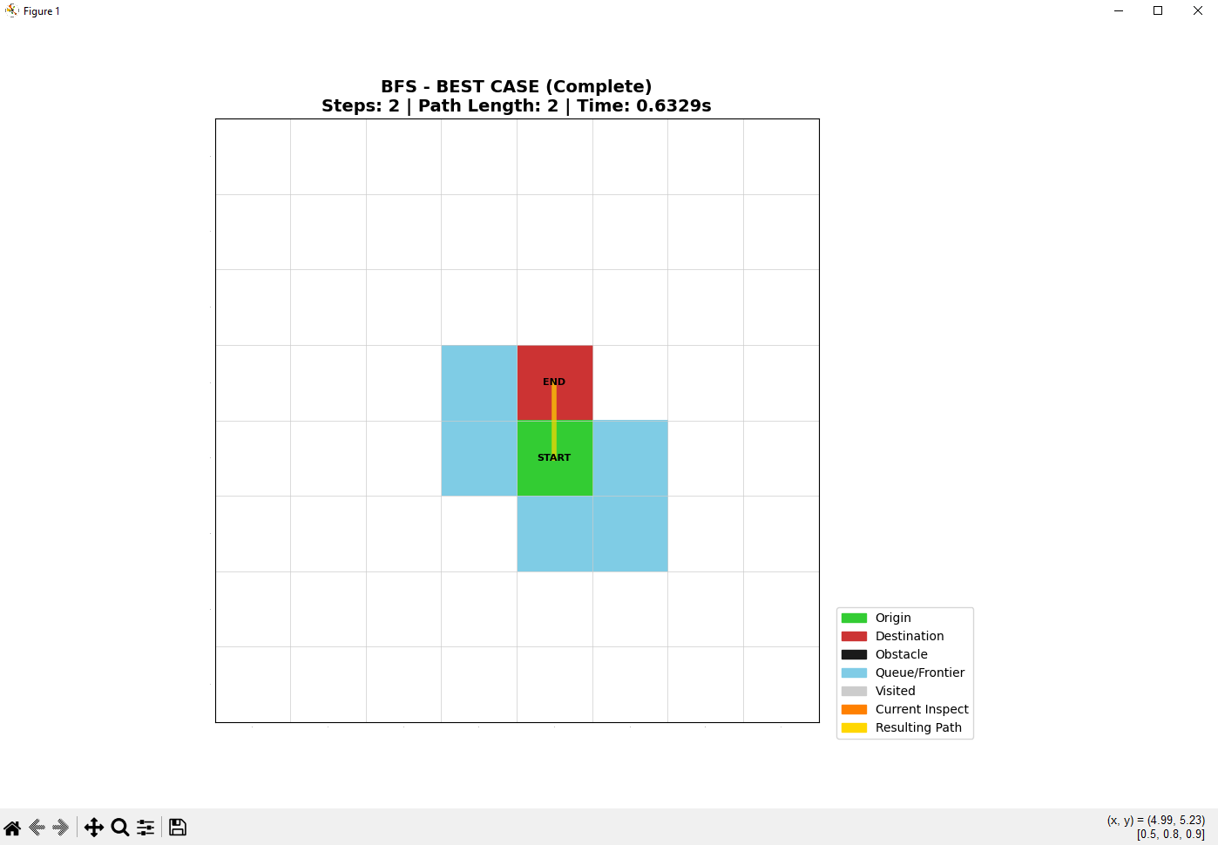
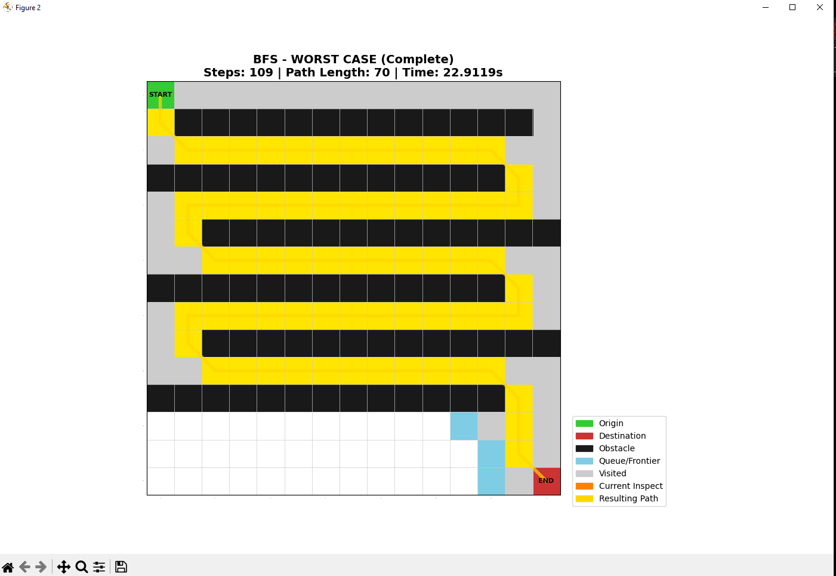

Depth-First Search (DFS)

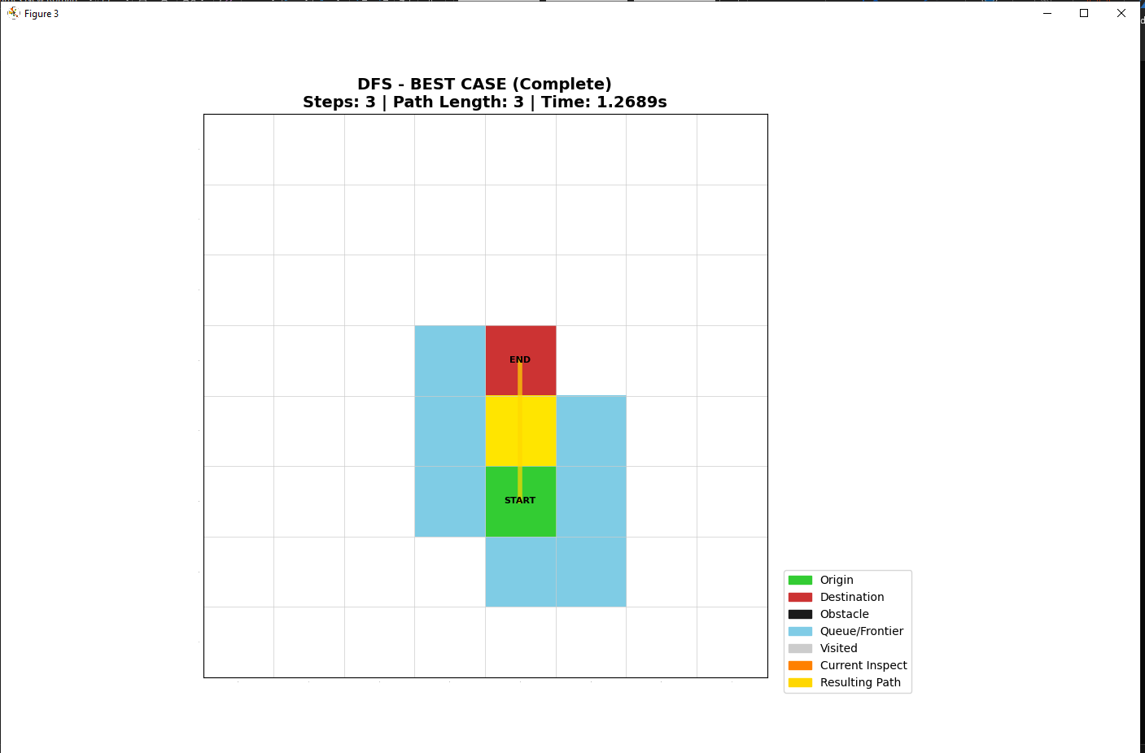

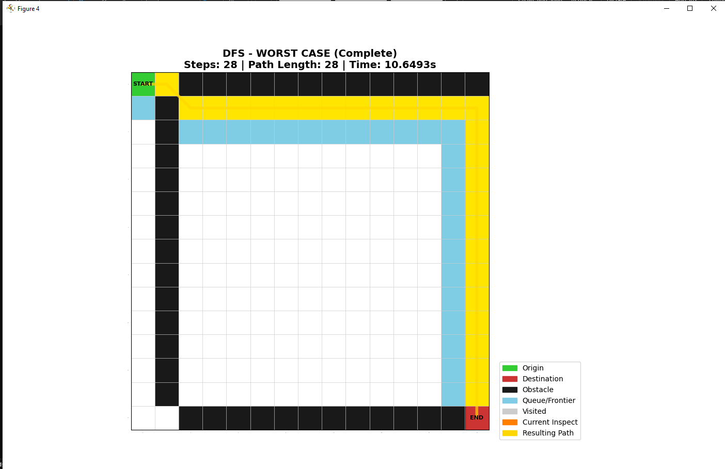

Uniform-Cost Search (UCS)
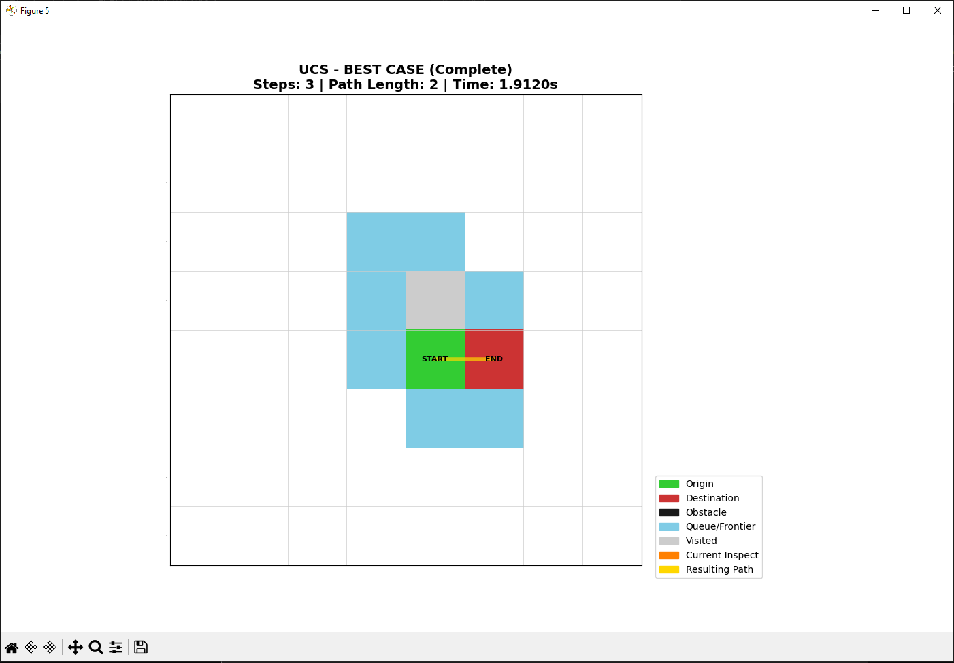
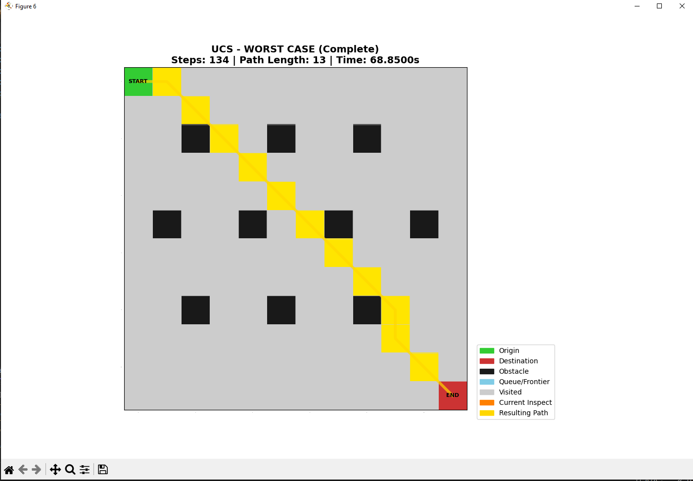

Depth-Limited Search (DLS)

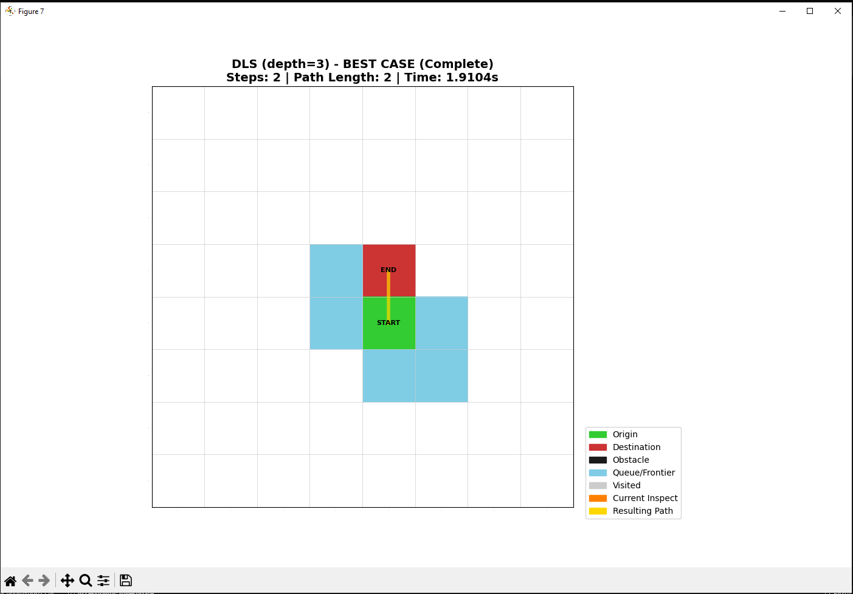

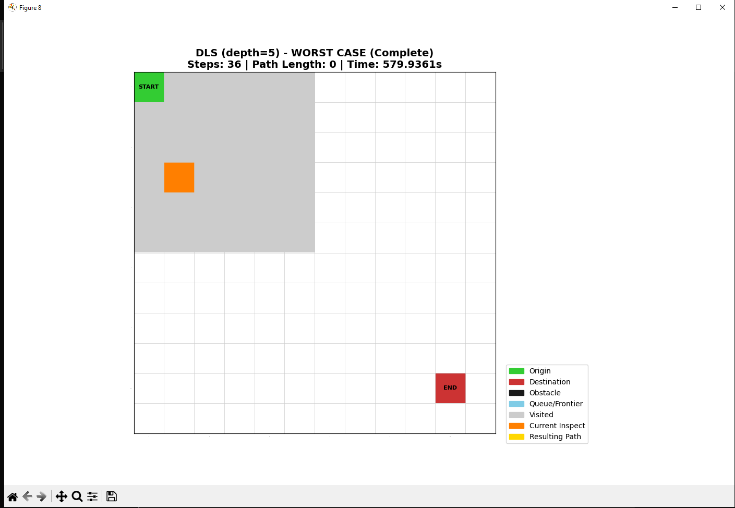

Iterative Deepening DFS (IDDFS)
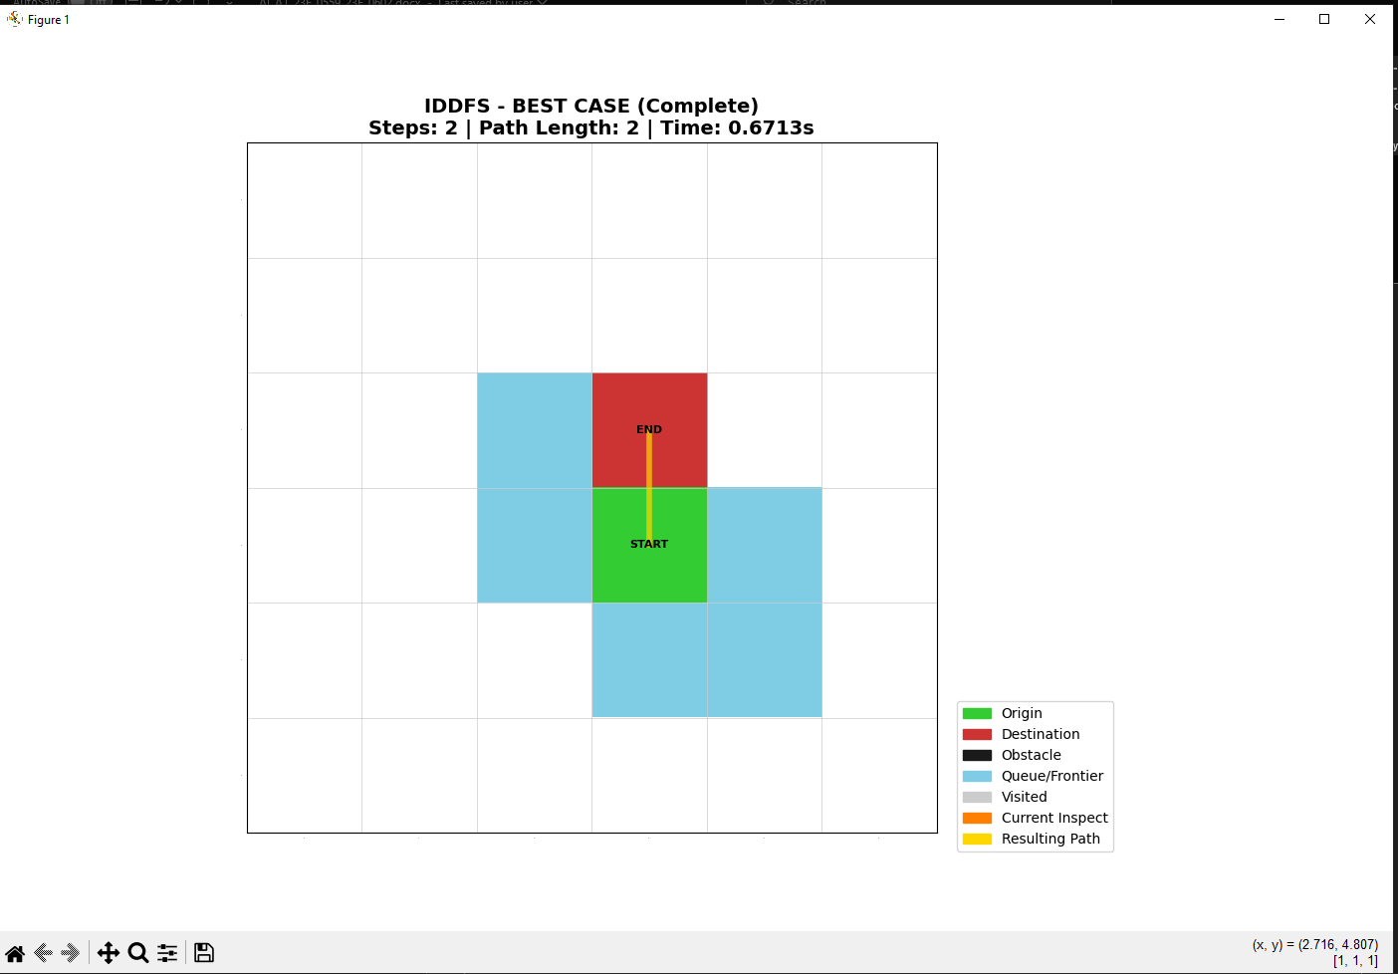
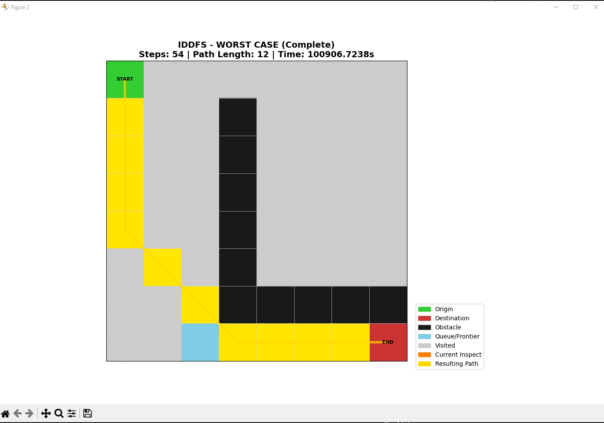

Bidirectional Search
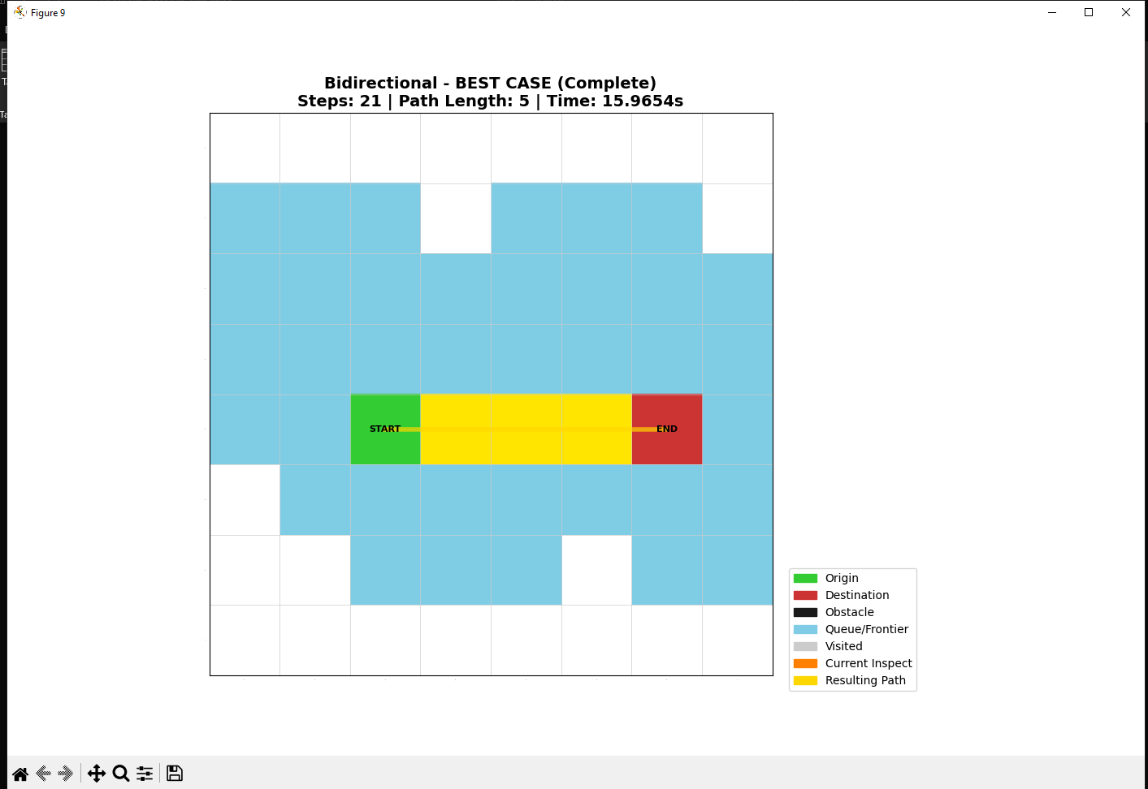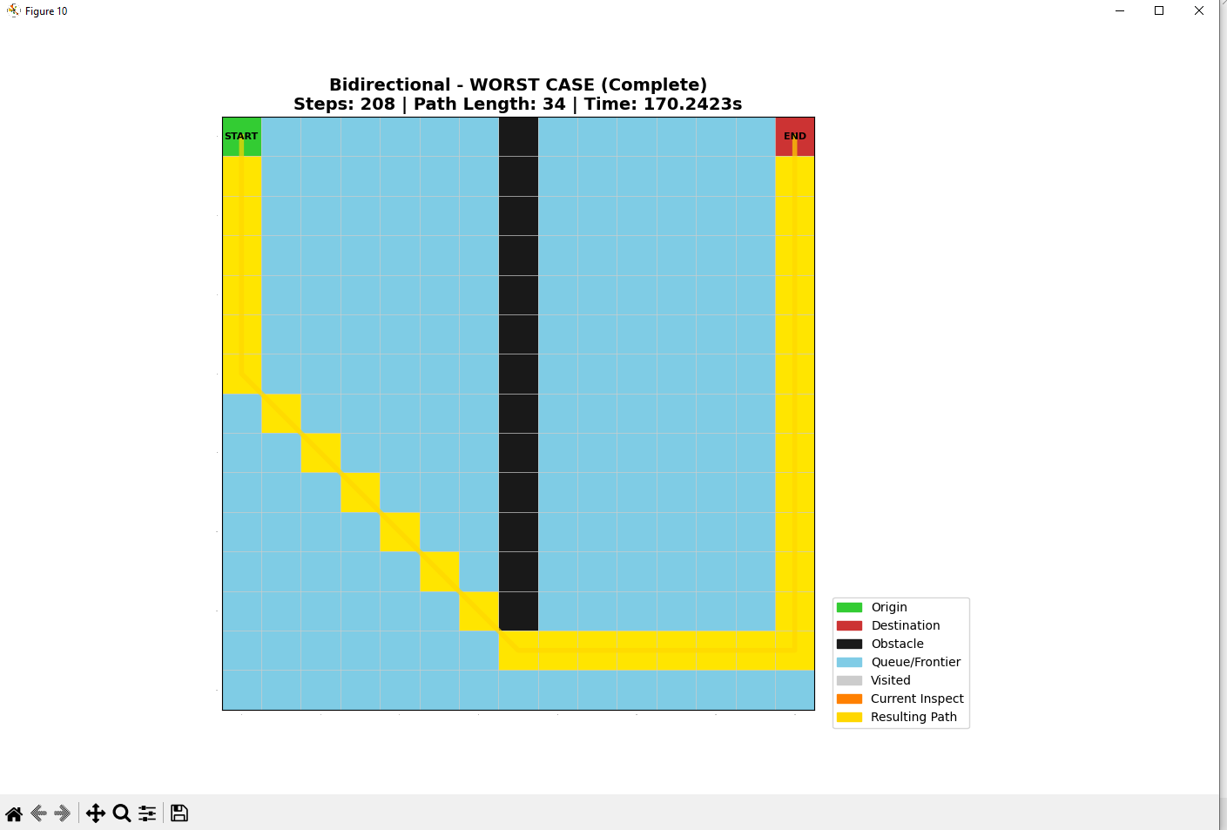

Conclusion
The implementation successfully visualizes the differences between uninformed search strategies. BFS and Bidirectional search were found to be most effective for finding direct paths, while DFS and UCS showed their unique exploration patterns based on stack depth and cumulative cost respectively.

