Title : Customer Churn Prediction - Exploratory Data Analysis (EDA)
Objective : Analyze customer data using Python to identify patterns, trends, and factors affecting customer churn.
1 . Dataset Overview
Result:
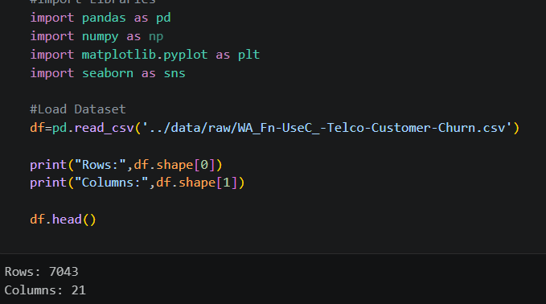
Insight: The dataset contains 7,043 customer records and 21 features related to customer demographics, services, billing information, and churn status.
Business Insight: A large dataset with multiple customer attributes provides sufficient information to identify patterns and factors influencing customer churn.
Conclusion: The dataset is comprehensive and suitable for performing exploratory data analysis and building churn prediction models.
2 . First 5 Records
Result:
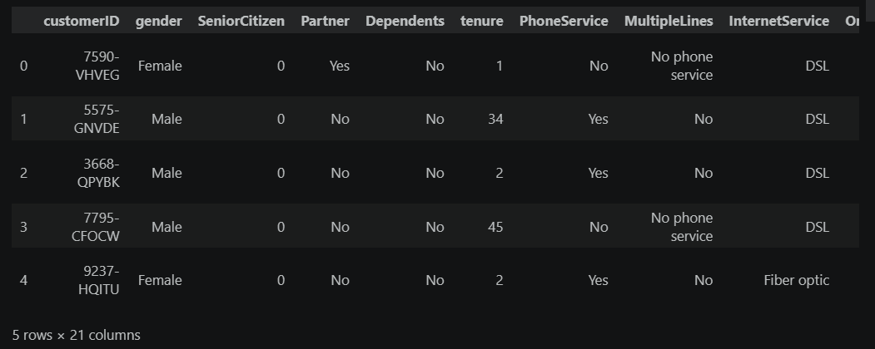
Insight: The dataset preview shows customer demographic details, service subscriptions, and account information. The data appears structured and contains relevant features such as gender, tenure, internet service, and customer status.
Business Insight: The company has access to rich customer information that can be used to understand customer behavior and identify factors that contribute to customer churn. These attributes can help create targeted retention strategies.
Conclusion: The dataset contains meaningful customer-level information required for exploratory analysis and churn prediction. The available features provide a strong foundation for identifying patterns associated with customer retention and customer loss.
3 . Dataset Information
Result:
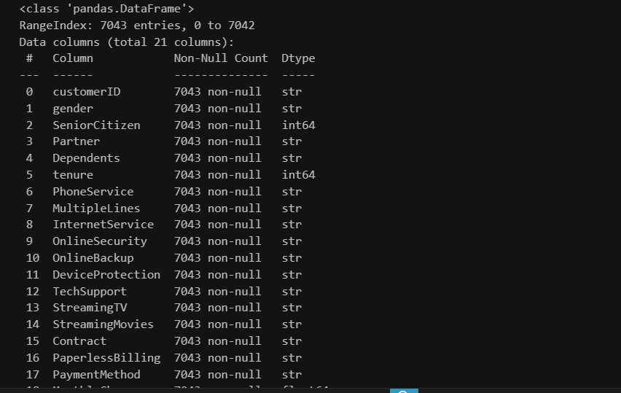
Insight: The dataset contains 7,043 customer records and 21 features. It includes both numerical and categorical variables such as tenure, monthly charges, contract type, internet service, and churn status. Most columns contain complete data with minimal missing values.
Business Insight: The availability of demographic, service usage, and billing-related attributes enables comprehensive customer behavior analysis. These features can help identify the key drivers of customer churn and support data-driven decision-making.
Conclusion: The dataset is well-structured and suitable for exploratory data analysis and predictive modeling. The mix of customer, service, and financial information provides a strong foundation for building an effective customer churn prediction system.
4. Missing Values Analysis
Result:
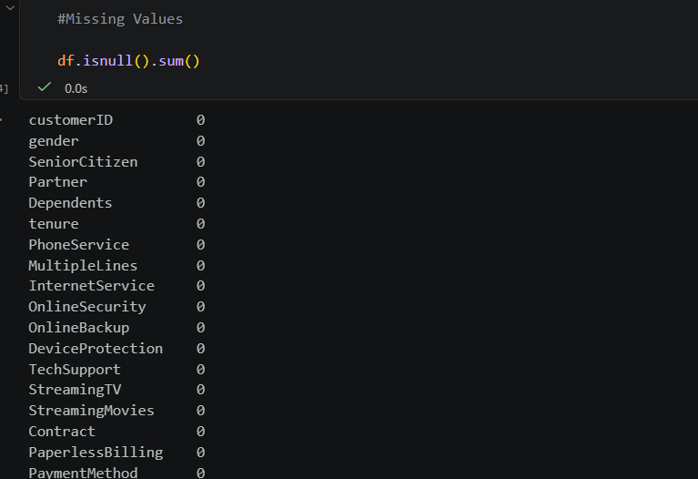
Insight: The missing values analysis shows that all columns contain 0 missing values. The dataset is complete and does not require any missing-value treatment or imputation.
Business Insight: Having a complete dataset improves the reliability of analysis and machine learning models. Since no customer information is missing, business decisions can be made with greater confidence and accuracy.
Conclusion: The dataset is clean and ready for further analysis. No additional preprocessing is required for handling missing values, allowing the project to move directly to exploratory data analysis and model development.
5 . TotalCharges Cleaning & Missing Values Handling
Result:
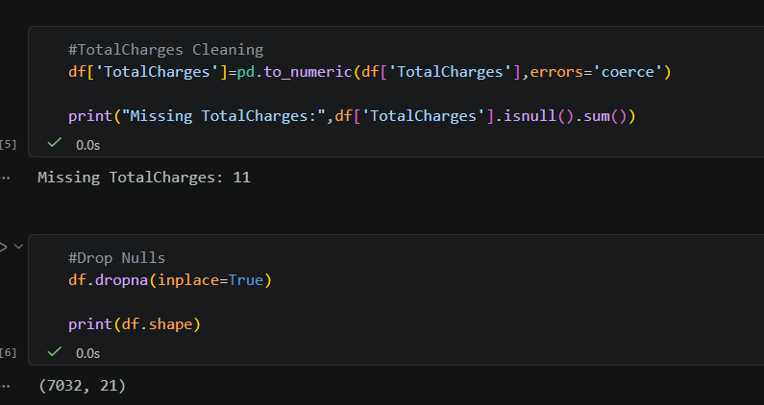
Insight: The TotalCharges column contained 11 invalid or blank values which were converted to null values during data type conversion. These records represented only 0.16% of the dataset and were removed to maintain data quality.
Business Insight: The number of missing values is extremely small compared to the total customer base. Removing these records has a negligible impact on business analysis while ensuring more accurate customer churn predictions and revenue-related insights.
Conclusion: The dataset has been successfully cleaned and is now ready for Exploratory Data Analysis (EDA) and machine learning. After handling the 11 missing values, the final dataset contains 7,032 customer records and 21 features, providing a reliable foundation for customer churn analysis
6 . Churn Distribution
Result:
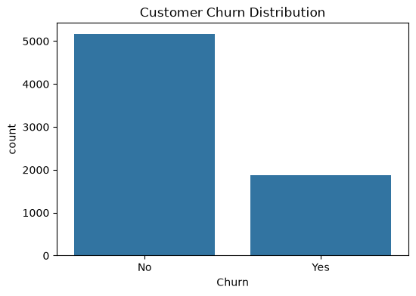
Insight: The customer churn distribution shows that most customers remain with the company, while a smaller portion have churned. Out of 7,032 customers, approximately 5,163 customers (73.4%) stayed and 1,869 customers (26.6%) left the service.
Business Insight: Although the majority of customers are retained, the churn rate of 26.6% is significant. The company is losing nearly one out of every four customers, which can negatively impact revenue and customer lifetime value.
Conclusion: Customer churn is a major business concern. Further analysis is required to identify the customer segments, services, contract types, and payment methods that contribute most to churn so that targeted retention strategies can be implemented.
7 . Exact Churn Rate
Result:
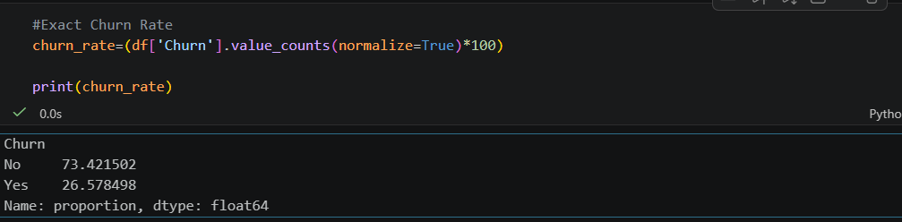
Insight: The customer churn distribution shows that most customers remain with the company, while a smaller portion have churned. Out of 7,032 customers, approximately 5,163 customers (73.4%) stayed and 1,869 customers (26.6%) left the service.
Business Insight: Although the majority of customers are retained, the churn rate of 26.6% is significant. The company is losing nearly one out of every four customers, which can negatively impact revenue and customer lifetime value.
Conclusion: Customer churn is a major business concern. Further analysis is required to identify the customer segments, services, contract types, and payment methods that contribute most to churn so that targeted retention strategies can be implemented.
8. Contract Type vs Churn
Result:
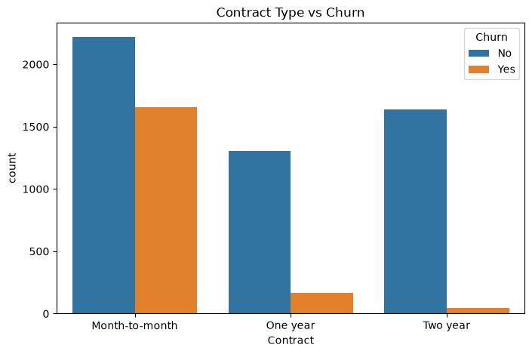
Insight: Customers with Month-to-Month contracts show the highest churn compared to customers with One-Year and Two-Year contracts. Customers with longer contract commitments tend to stay with the company.
Business Insight: Contract type is one of the strongest indicators of customer churn. Customers on Month-to-Month plans can easily switch to competitors, whereas customers on long-term contracts are more loyal and have a lower probability of leaving.
Conclusion: Long-term contracts significantly improve customer retention. Encouraging customers to move from Month-to-Month plans to One-Year or Two-Year contracts could help reduce churn and improve long-term revenue stability.
9. Monthly Charges vs Churn
Result:
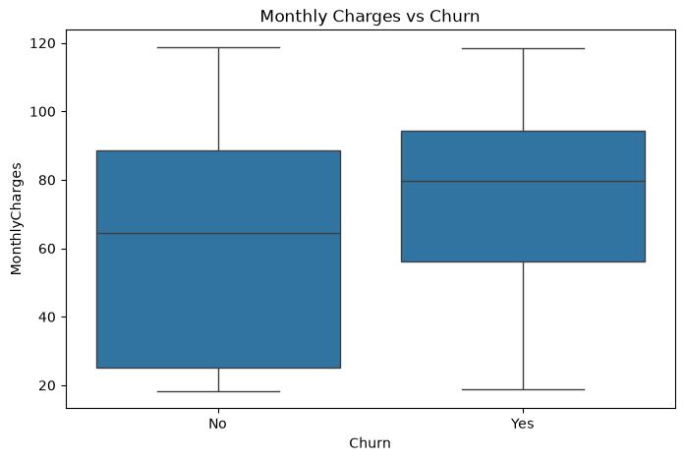
Insight: Customers who churn generally have higher monthly charges compared to customers who stay. The median monthly charge for churned customers is noticeably higher than that of retained customers.
Business Insight: Higher service costs may be a major factor influencing customer decisions to leave. Customers paying higher monthly fees may perceive less value for money or may be more likely to switch to competitors offering similar services at lower prices.
Conclusion: Monthly charges have a strong relationship with customer churn. Customers with higher monthly bills are more likely to leave, indicating that pricing strategy and service value play an important role in customer retention.
10 . Tenure vs Churn
Result:
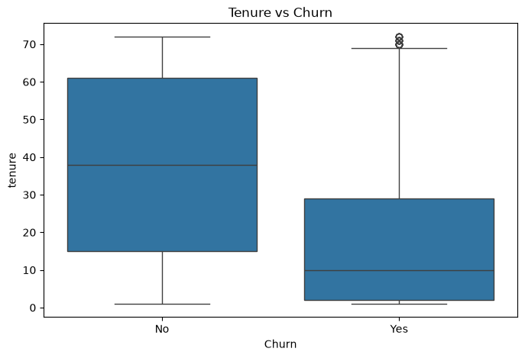
Insight: Customers who churn generally have a lower tenure compared to customers who remain with the company. Most churned customers have been associated with the company for a shorter period, while long-term customers are more likely to stay.
Business Insight: The highest risk of churn occurs during the early stages of the customer lifecycle. New customers may leave if their expectations are not met or if they find better alternatives. Customer onboarding and engagement programs are critical during the first few months.
Conclusion: Customer tenure is a strong predictor of churn. As tenure increases, the likelihood of churn decreases significantly. Long-term customers demonstrate higher loyalty and retention.
Key Findings
1. Customer Churn Rate
The overall churn rate is 26.58%, meaning approximately 1 in 4 customers leaves the company.

This indicates a significant customer retention challenge.
2. Contract Type Impact
Customers on Month-to-Month contracts show the highest churn.
Customers with One-Year and Two-Year contracts are much more likely to stay.
3. Tenure Influence
Customers with shorter tenure are more likely to churn.
Long-term customers demonstrate stronger loyalty and lower churn risk.
4. Monthly Charges Effect
Customers paying higher monthly charges tend to churn more frequently.
Pricing appears to be an important factor influencing customer decisions.
5. Data Quality
The dataset contained only 11 missing values in the TotalCharges column, which were successfully handled.
The dataset is clean, reliable, and suitable for analysis and predictive modeling.
6. Customer Retention Pattern
Most retained customers are those with longer relationships, stable contracts, and moderate service costs.
New customers and customers with flexible contracts are the most vulnerable segment.
Conclusion
The Customer Churn Analysis reveals that contract type, tenure, and monthly charges are the primary drivers of customer churn. Customers with Month-to-Month contracts, shorter tenure, and higher monthly charges are significantly more likely to leave the company. Although the majority of customers remain loyal, the churn rate of 26.58% represents a considerable business risk.

To reduce churn, the company should focus on:
- Converting Month-to-Month customers into long-term contracts.
- Improving onboarding and engagement for new customers.
- Offering personalized retention programs for high-risk customers.
- Reviewing pricing strategies and providing value-added service packages.
By implementing targeted retention initiatives based on these insights, the company can improve customer satisfaction, increase customer lifetime value, and achieve sustainable business growth.

