Title : Customer Churn Prediction Using Machine Learning
Objective : The objective of this project is to develop a machine learning model capable of predicting customer churn based on customer demographics, service usage, contract details, and billing information. The model aims to identify customers at high risk of leaving the company so that proactive retention strategies can be implemented to improve customer satisfaction and reduce revenue loss.
Model Used
Random Forest Classifier: Random Forest was selected because it is a powerful ensemble learning algorithm capable of handling large datasets, capturing complex relationships between variables, and providing reliable classification performance.
Train-Test Split
- Training Data: 80%
- Testing Data: 20%
- Random State: 42
The dataset was divided into training and testing sets to evaluate the model's ability to make accurate predictions on unseen data.
Accuracy Score
Accuracy Achieved: 78.46%
Insight: The model correctly predicted customer churn status for 78.46% of customers in the test dataset.
Business Insight: A prediction accuracy of 78.46% enables the business to identify a significant portion of customers who are likely to churn and take preventive actions.
Conclusion: The model demonstrates good predictive capability and can support customer retention initiatives.
Classification Report
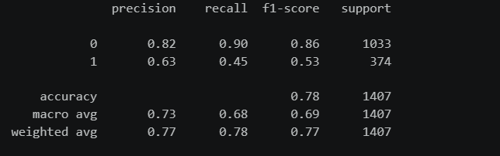
Insight: The classification report evaluates the model using Precision, Recall, and F1-Score metrics.
Business Insight: These metrics provide a deeper understanding of the model's effectiveness in identifying churned and retained customers.
Conclusion: The classification report confirms the model's ability to distinguish between customers who are likely to churn and those who are likely to stay.
Confusion Matrix
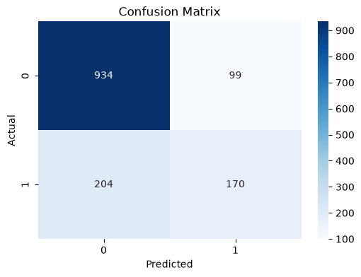
Insight: The confusion matrix displays the number of correct and incorrect predictions made by the model.
Business Insight: It helps assess the model's strengths and weaknesses in identifying potential churn customers.
Conclusion: The confusion matrix indicates that the model performs well in classifying customer churn while maintaining acceptable prediction accuracy.
Key Findings
1. The Random Forest model achieved an accuracy of 78.46%.
2. Contract type, tenure, and monthly charges are strong indicators of customer churn.
3. Customers with Month-to-Month contracts are more likely to churn.
4. Customers with shorter tenure exhibit higher churn risk.
5. Customers paying higher monthly charges tend to leave more frequently.
6. Long-term customers are generally more loyal and less likely to churn.
Business Conclusion
The Customer Churn Prediction Model successfully identifies customers at risk of leaving the company. By leveraging these predictions, organizations can implement targeted retention strategies such as personalized offers, loyalty programs, contract upgrades, and proactive customer support. These initiatives can reduce churn, improve customer satisfaction, and increase long-term business profitability.
Project Outcome
Successfully developed a Customer Churn Prediction System using Python, Pandas, NumPy, Scikit-Learn, Matplotlib, Seaborn, SQL, and Machine Learning, achieving 78.46% prediction accuracy and generating actionable business insights for customer retention.

