Title : Customer Churn Prediction

Objective : Analyze customer behavior and identify factors contributing to customer churn using SQL.
1. Total Customers
Result:
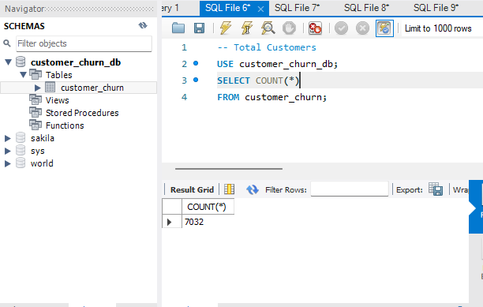
Insight: Dataset contains 7032 customer records.
Conclusion: The dataset is large enough to perform comprehensive churn analysis and build an accurate churn prediction model.
Business Insight: With over 7,000 customer records, the company can identify key churn drivers and implement data-driven customer retention strategies to reduce customer loss and improve business revenue.
2. Overall Churn Rate
Result:
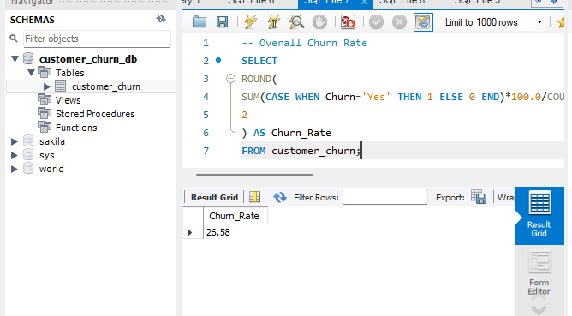
Insight: Around 1 in 4 customers have churned.
Conclusion: The churn rate of 26.58% indicates a notable loss of customers and highlights the need for effective retention strategies.
Business Insight: By identifying the key factors driving churn and proactively engaging at-risk customers, the company can reduce customer loss, improve retention, and increase long-term profitability.
3. Churn by Gender
Result:
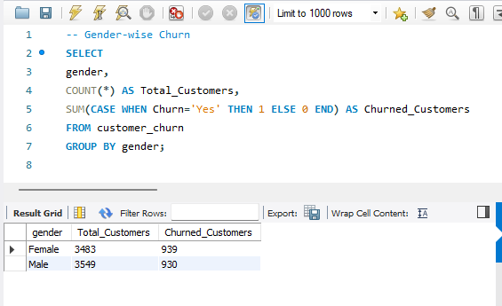
Insight: Female customers show a slightly higher churn count (939) than male customers (930).
Conclusion: Churn behavior is nearly identical across genders, suggesting gender has minimal impact on customer retention.
Business Insight: Customer retention strategies should focus on service usage patterns, pricing, and customer experience rather than gender-specific initiatives.
4. Churn by Senior Citizen
Result:
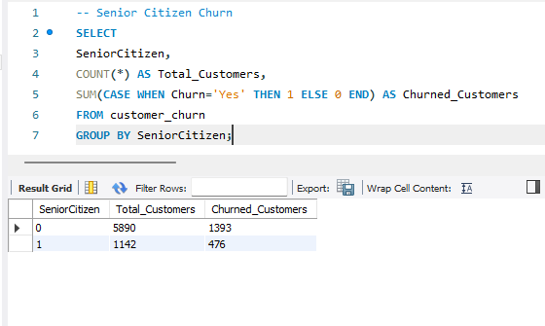
Insight: Senior citizens have a higher churn rate (41.68%) than non-senior customers (23.65%).
Conclusion: Senior citizens are more likely to discontinue the service, making them a high-risk customer segment.
Business Insight: The company should design targeted retention strategies for senior citizens, such as dedicated support, special discounts, and customer engagement programs to reduce churn.
5. Churn by Contract Type
Result:
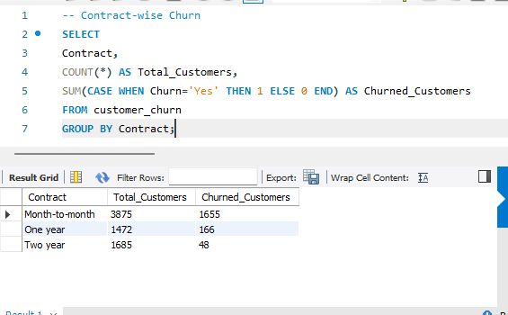
Insight: Month-to-Month customers have the highest churn rate (42.71%), while Two-Year contract customers have the lowest churn rate (2.85%).
Conclusion: Contract duration has a strong impact on customer retention. Customers on long-term contracts are significantly less likely to churn.
Business Insight: The company should implement incentives such as discounts, loyalty programs, and bundled services to convert Month-to-Month customers into long-term contract customers, reducing churn and increasing customer lifetime value.
6. Churn by Internet Service
Result:
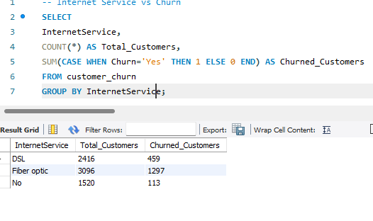
Insight: Fiber Optic customers have the highest churn rate (41.89%), whereas customers without internet service have the lowest churn rate (7.43%).
Conclusion: Internet service type is a major driver of customer churn, with Fiber Optic customers showing the greatest risk of leaving.
Business Insight: The company should prioritize retention efforts for Fiber Optic customers by improving service quality, addressing customer complaints, and offering loyalty incentives to reduce churn and increase customer satisfaction.
7. Average Monthly Charges
Result:
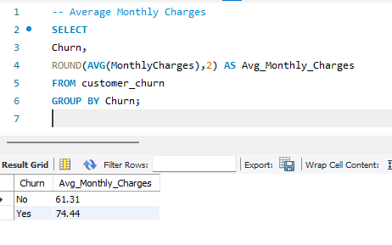
Insight: Churned customers have a higher average monthly charge (74.44) compared to retained customers (61.31).
Conclusion: Customers with higher monthly charges are more likely to leave the service.
Business Insight: The company should improve value propositions for high-paying customers through discounts, premium support, and customized service plans to reduce churn and increase customer satisfaction.
8. Average Tenure
Result:
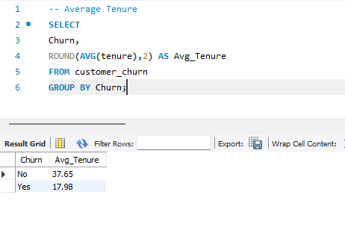
Insight: Churned customers have an average tenure of 17.98 months, whereas retained customers have an average tenure of 37.65 months.
Conclusion: Customers with shorter tenure are significantly more likely to churn than long-term customers.
Business Insight: The company should strengthen retention efforts for new customers by improving onboarding experiences, offering loyalty incentives, and providing proactive support during the early stages of the customer lifecycle.
9. Churn by Payment Method
Result:
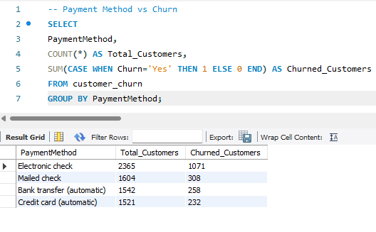
Insight: Electronic Check customers have the highest churn rate (45.29%), while Credit Card (Automatic) customers have the lowest churn rate (15.25%).
Conclusion: Customers using manual payment methods are more likely to churn compared to customers using automatic payment methods.
Business Insight: Promoting automatic payment methods through discounts, rewards, and simplified setup processes can help reduce churn and improve customer loyalty.
10. Top 10 Highest Paying Customers
Result:
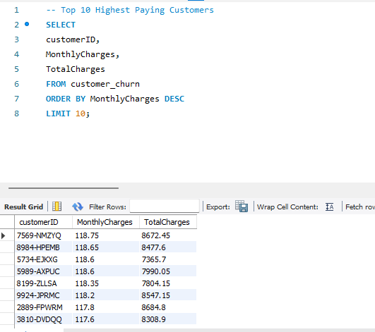
Insight: The top-paying customers generate substantial revenue through high monthly charges and large total lifetime spending.
Conclusion: High-value customers are critical to business profitability and should be actively retained.
Business Insight: Implement VIP retention programs, personalized customer support, loyalty rewards, and premium service offerings to improve satisfaction and reduce churn among high-revenue customers.
Final Key Findings
- The dataset contains 7,032 customer records.
- The overall customer churn rate is 26.58%, meaning approximately 1 in 4 customers have left the company.
- Senior citizens show a significantly higher churn rate compared to non-senior customers.
- Month-to-Month contract customers have the highest churn rate, while long-term contract customers are more likely to stay.
- Customers using Fiber Optic internet service have the highest churn rate among internet service types.
- Customers paying through Electronic Check exhibit the highest churn rate among payment methods.
- Customers who churn generally have higher monthly charges than retained customers.
- Customers who churn have a much shorter average tenure, indicating that newer customers are more likely to leave.
- Gender has only a minor impact on churn behavior.
- A small group of high-value customers contributes significantly to overall revenue and requires special retention efforts.
Conclusion
The SQL Business Analysis revealed that customer churn is primarily influenced by contract type, tenure, internet service, payment method, monthly charges, and senior citizen status. Customers with short tenure, month-to-month contracts, Fiber Optic services, and electronic check payments are at the highest risk of leaving.
To reduce churn and improve profitability, the company should focus on:
- Encouraging long-term contracts.
- Improving Fiber Optic service quality.
- Promoting automatic payment methods.
- Strengthening retention programs for new and senior customers.
- Providing loyalty rewards and personalized support for high-value customers.
By implementing these data-driven strategies, the company can improve customer retention, increase customer satisfaction, and achieve sustainable long-term revenue growth.

