1. ECU System diagram
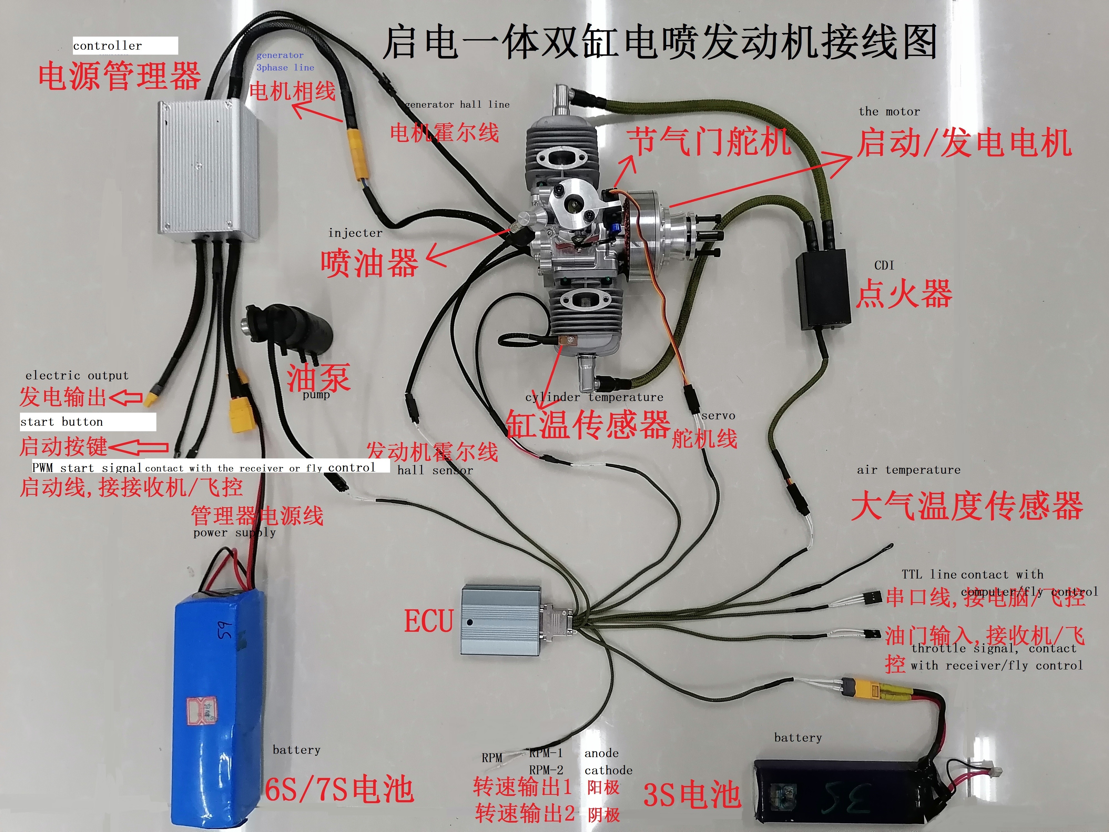
Figure 1
2. ECU communication protocol
2.1 Electrical Interface
ECU uses TTL level serial communication, the baud rate is 115200, the data bit is 8 bits, the stop bit is 1 bit, and there is no parity.

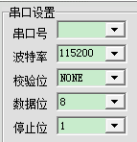
Figure 2
2.2 communication protocol
2.2.1 Read engine data
When the ECU receives the "a" command character (ASC code hexadecimal 0x61), it returns an 82-byte data packet, as shown in Figure 3 below.
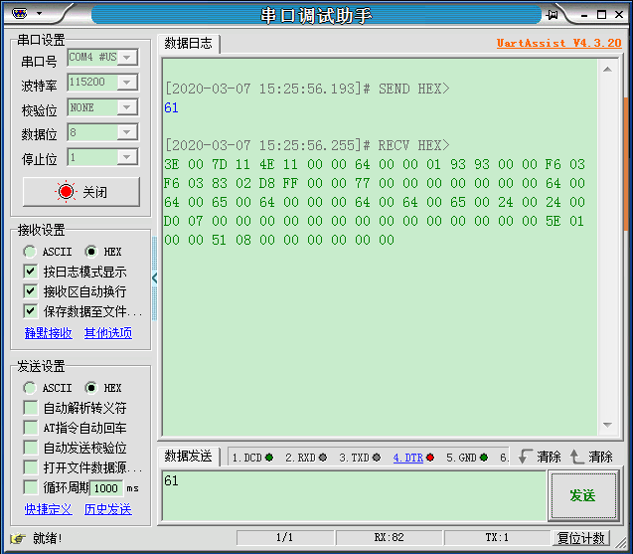
Figure 3
Variable type：uint8_t occupies one byte，int16_t and uint16_t variables both occupy two bytes。
The information contained in the data packet is shown in Figure 4 below. The user only needs to extract the speed, atmospheric pressure, atmospheric temperature, cylinder temperature, and battery voltage.
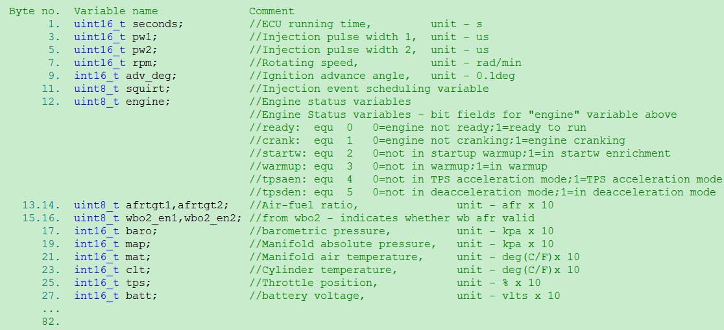
Figure 4
The data packet received in Figure 3 is as follows, displayed in hexadecimal:
3E 00 7D 11 4E 11 00 00 64 00 00 01 93 93 00 00 F6 03 F6 03 83 02 D8 FF 00 00 77 00 00 00 00 00 00 00 64 00 64 00 65 00 64 00 00 00 64 00 64 00 65 00 24 00 24 00 D0 07 00 00 00 00 00 00 00 00 00 00 00 00 00 00 5E 01 00 00 51 08 00 00 00 00 00 00
According to the byte order definition in Figure 4, extract the data in the data packet in Figure 3:
1) Rotating speed：
For the 7th and 8th bytes, the low byte is in front, and the high subsection is in the back：00 00 ：0rad/min.
2)barometric pressure：
The 17th and 18th bytes, the low byte is in front, and the high subsection is in
the back: F6 03, which is 0x03F6: decimal is 1014, which is 101.4Kpa.
3)Manifold air temperature：
The 21st and 22nd bytes, low byte first, high subsection after: 83 02, which is
0x0283: decimal is 643, which is 64.3F (Fahrenheit).
4) Cylinder temperature：
The 23rd and 24th bytes, the low byte first, and the high subsection after:
D8 FF, which is 0xFFD8: decimal is -40, which is -4.0F (Fahrenheit).
5) Battery voltage：
For the 27th and 28th bytes, the low byte is first, and the high subsection is last: 77 00, which is 0x0077: decimal is 119, which is 11.9V.

2.2.2 Turn off the engine
When the ECU receives three consecutive characters: "q q x", the hexadecimal ASC code is 0x71, 0x71, 0x78, the ECU will turn off the ignition and fuel injection, and the engine will stop.

0x71 | 0x71 | 0x78
Engine stall command
That is, the ECU serial port receives the data packet: 71 71 78 will turn off the engine, the operation is shown in Figure 5 below.
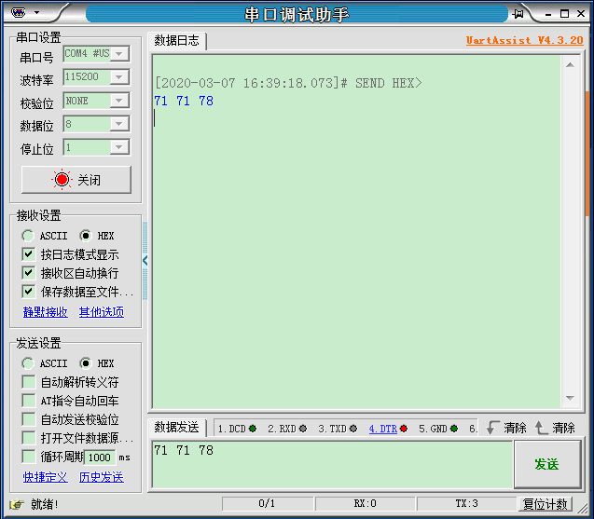
Figure 5

3. Build ECU speed output circuit
For users who need speed output, if they do not use the serial port to collect speed, they can build the circuit through the following steps and connect to the tachometer to display the speed.
The speed output circuit is shown in Figure 6 below. It is optocoupler isolation, and the two output pins are floating. Users need to build the circuit according to their own level requirements.
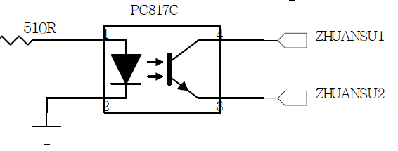
Figure 6

Build the circuit as shown in Figure 7 and connect ZHUANSU2 to the tachometer to realize the measurement of the speed signal.
If ZHUANSU1 pin is connected to a 5V power supply, then R36 selects a 510 ohm resistor, and ZHUANSU2 is the speed output, which is connected to the speed collection port.
If ZHUANSU1 pin is connected to a 3.3V power supply, R36 selects a 330 ohm resistor, and ZHUANSU2 is the speed output, which is connected to the speed collection port.

Note: The GND connected to R36 should share the same ground with the speed acquisition circuit.
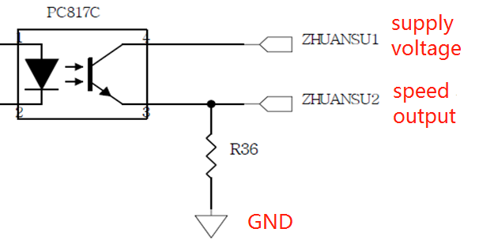
Figure 7

