Syed Mossaraf Hossain  4th year B.Tech, Computer Science & Engineering  https://www.linkedin.com/in/syed-mossaraf-hossain-506138339/  Portfolio: https://syedmossarafhossain.github.io/smh-portfolio/ | Phone: +91 – 9907978608  Email: syedmossarafhossain@gmail.com  Address: Kolkata, West Bengal, 721152
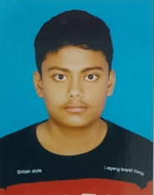
Career Objective
Motivated and passionate B.Tech Computer Science and Engineering student with a strong foundation in programming, web development, and emerging technologies. Seeking opportunities to apply technical skills, contribute to innovative projects, and gain hands-on experience through internships or Project work.

Education
2023-27 | Bachelor of Technology, Computer Science & Engineering 8.5/10  Brainware University, Kolkata
2023 | 12th (Senior Secondary Examination) 67.60%  West Bengal Council of Higher Secondary Education (WBCHSE)
2021 | 10th (Secondary Examination) 76.14%  West Bengal Board of Secondary Education (WBBSE)
Internships & Trainings
Jul-Sep’25  Sep-Oct’25 | Hybrid Systems Intern, Agni Rath Aerospace and Defence Research Pvt.Ltd, Kolkata  - Contributed to the development of the JATAYU Hybrid Drone-Car, an autonomous vehicle capable of both aerial flight and ground mobility.  - Designed and developed an intuitive UI/UX interface for the hybrid controller system to enhance user interaction.  - Created a user-friendly control panel enabling seamless switching between drone and rover operating modes.  - Collaborated with hardware and software teams to integrate the controller interface with the hybrid system, ensuring smooth functionality.  Cybersecurity with AI Virtual Internship | NIIT Foundation  • Completed a 4-week virtual internship focused on Cybersecurity and Artificial Intelligence (AI).  • Acquired practical knowledge of network security, threat detection, vulnerability assessment, risk management, and data protection.  • Learned ethical hacking concepts, cyber threat analysis, security best practices, and AI applications in cybersecurity.  • Strengthened analytical, problem-solving, and incident response skills through hands-on assignments and case studies.
Academic Projects
Aug-Dec’25  Jan-Jun’26  Jun-Jul’26 | Hospital Management System.  - Designed and developed a web-based Hospital Management System with an interactive dashboard to manage patients, doctors, appointments, and hospital records using HTML, CSS, JavaScript, and MySQL with secure database connectivity and validation.  Personal Medicine Recommendation System using Machine Learning.  • Implemented a machine learning-based Medicine Recommendation System that predicts diseases and recommends suitable medicines using Scikit-learn, Pandas, and NumPy through healthcare data preprocessing, classification algorithms, and performance evaluation.  Product Analysis System using AI.  • Designed and developed an AI-powered Product Analysis System that analyses product data, predicts product performance, and generates actionable business insights using Python, Pandas, NumPy, and Scikit-learn.
Technical Skills
Languages | Java, C, Python
Web Technologies | HTML, CSS, JavaScript
Database | MySQL
AI/ML | Scikit-learn, Pandas, NumPy
Soft Skills
• Team Collaboration.
• Leadership and Communication.
Certifications
• Introduction to Cyber Security – Cisco Network Academy.
• Introduction to Packet Tracer – Cisco Network Academy.
• Cybersecurity Essentials - Cisco Network Academy.
Additional Information
8-Feb’25 | • Participated in Design Thinking, Critical Thinking and Innovation Camp.
2026 | • Successfully registering on MY Bharat and taking a stride towards Viksit Bharat
 | • Hobbies include reading Books & Playing Cricket.
Declaration
I hereby declare that the information furnished above is true and correct to the best of my knowledge and belief.
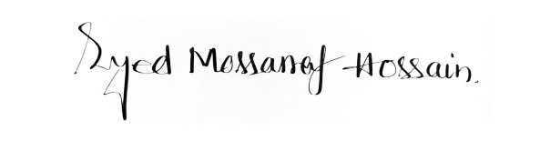
Date: 12/03/2026
Place: Barasat, Kolkata. Signature:

