|  |  |  |  |  |  |  |  |  |  |  |  |  |  |  |  |  |  |  |  |  |  |  |  |  |  |  |  |  |  |  |  |  |  |  |  |  |  |  |  |  |  |  |  |  |  |  |  |  |  |  |  |  |  |  |  |  |  |  |  |  |  |  |  |  |  |  |  |  |  |  |  |  |  |  |  |  |  |  |  |  |  |  |  |  |  |  |  |  |  |  |  |
| --- | --- | --- | --- | --- | --- | --- | --- | --- | --- | --- | --- | --- | --- | --- | --- | --- | --- | --- | --- | --- | --- | --- | --- | --- | --- | --- | --- | --- | --- | --- | --- | --- | --- | --- | --- | --- | --- | --- | --- | --- | --- | --- | --- | --- | --- | --- | --- | --- | --- | --- | --- | --- | --- | --- | --- | --- | --- | --- | --- | --- | --- | --- | --- | --- | --- | --- | --- | --- | --- | --- | --- | --- | --- | --- | --- | --- | --- | --- | --- | --- | --- | --- | --- | --- | --- | --- | --- | --- | --- | --- | --- |
| |  |  |  |  |  |  |  |  |  |  |  | | --- | --- | --- | --- | --- | --- | --- | --- | --- | --- | --- | | **Software Design Specifications**  ***[Automated Car Overspeeding Detection]***  **Version: [1.0]**   |  |  | | --- | --- | | Project Code | F24-204 | | Supervisor | Sir Kashan Hussain | | Co Supervisor | - | | Project Team | *Usman Rasheed (21K-3225)*  *Talha Minhaj (21K-3447)*  *Muneeb Ali (21K-4924)* | | Submission Date | 12/12/2024 | |       **Document History**   |  |  |  |  | | --- | --- | --- | --- | | Version | Name of Person | Date | Description of change | | 1.0 | Usman Rasheed | 12/10/2024 | [Document Created] | |  |  |  |  | |  |  |  |  | |  |  |  |  | |  |  |  |  | |  |  |  |  | |  |  |  |  |         **Distribution List**   |  |  | | --- | --- | | **Name** | **Role** | | Sir Kashan Hussain | Supervisor | | - | Co Supervisor | |  |  |       **Document Sign-Off**   |  |  |  |  |  | | --- | --- | --- | --- | --- | | **Version** | **Sign-off Authority** | **Project Role** | **Signature** | **Sign-off Date** | |  |  |  |  |  | |  |  |  |  |  | |  |  |  |  |  | |  |  |  |  |  | |  |  |  |  |  | |  |  |  |  |  | |  |  |  |  |  | |

**Document Information**

| **Category** | **Information** |
| --- | --- |
| Customer | FAST-NU |
| Project | Automated Car Overspeeding Detection |
| Document | Software Design Specification |
| Document Version | 1.0 |
| Status | Completed |
| Author(s) | Usman Rasheed  Talha Minhaj  Muneeb Ali |
| Approver(s) | Sir Kashan Hussain |
| Issue Date | 12/12/2024 |
| Document Location |  |
| Distribution | Advisor  Project Coordinator’s Office (through Advisor) |

**Definition of Terms, Acronyms and Abbreviations**

| **Term** | **Description** |
| --- | --- |
| IR | Infrared |
| MERN | MongoDB, Express, React.js, Node.js |
| AI | Artificial Intelligence |
| CPU | Central Processing Unit |
| OCR | Optical Character Recognition |
| SMTP | Simple Mail Transfer Protocol |
| API | Application Programming Interface |
|  |  |

**Table of Contents**

1 Introduction 9

1.1 Purpose of Document 9

1.2 Intended Audience 9

1.3 Document Convention 9

1.4 Project Overview 9

1.5 Scope 10

2 Design Considerations 11

2.1 Assumptions and Dependencies 11

2.1.1 Dependencies: 11

2.2 Risks and Volatile Areas 11

3 System Architecture 12

3.1 System Level Architecture 13

3.2 Software Architecture 14

3.3 Hardware Circuit Architecture 15

4 Design Strategy 16

4.1 Modularity: 16

4.2 User Interface Paradigm: 16

4.3 Data Management: 16

4.4 Tradeoffs 16

4.4.1 Cost Efficiency: 16

4.4.2 (Camera Activation Strategy: Passive vs Triggered): 16

5 Detailed System Design 17

5.1 Database Design 17

5.1.1 ER Diagram 17

5.1.2 Data Dictionary 18

5.1.2.1 Data 1 18

5.1.2.2 Data 2 18

5.2 Application Design 19

5.2.1 Sequence Diagram 19

5.2.1.1 <Sequence Diagram 1> 19

5.2.1.2 <Sequence Diagram 2> 19

5.2.1.3 <Sequence Diagram 3> 20

5.2.1.4 <Sequence Diagram 4> 20

5.2.1.5 <Sequence Diagram 5> 21

5.2.2 State Diagram 21

5.2.2.1 <State Diagram 1> 21

5.2.2.2 <State Diagram 2> 23

5.2.2.3 <State Diagram 3> 24

6 References 25

7 Appendices 26

# Introduction

## Purpose of Document

The purpose of this Software Design Specification (SDS) document is to provide a detailed and structured outline of design requirements for the performance management system. This document serves as a comprehensive guide for all stakeholders, including business users, developers, and technical teams, to ensure a shared understanding of the system’s goals, functionalities, and constraints.

To provide a clear communication framework among stakeholders

To act as a reference document for developers during the system’s design, implementation, and testing phases.

To ensure that the system’s design and implementation align with the business objectives

To establish a foundation for requirement traceability throughout the project lifecycle

## Intended Audience

* *Fast NU*
* *Jury*
* *Supervisor (Sir Kashan Hussain)*
* *Students of Fast NU*
* *Our Team(Designer, Developer, Tester)*
* *Potential Users of this product*

## Document Convention

Font Family = Arial

Font Size = 12 for headings, 10 for the rest of the content

## Project Overview

*This project aims to provide an automated solution for detecting overspeeding, accurate license plate recognition, and streamlining fine management to ensure a safer and more efficient system for high-traffic environments with repeated users.*

***Included Functionalities:***

1. ***Overspeeding Detection****:*
   * *Measure vehicle speed using IR sensors.*
   * *Detect overspeeding vehicles and log their details.*
2. ***License Plate Recognition****:*
   * *Use computer vision and EasyOCR to identify and record license plates.*
3. ***Data Logging and Notification****:*
   * *Store overspeeding data (number plate, speed, timestamp, license plate image) in a database.*
   * *Send email notifications to registered users with fine details.*
4. ***Admin Management via Webpage****:*
   * *Add new users (number plates, names, emails) to the system.*
   * *Delete user records.*
   * *View overspeeding records and fine payment statuses.*
   * *Update fines manually for cash payments.*
5. ***Unregistered User Handling****:*
   * *Record unregistered users' details for future reference.*

***Excluded Functionalities****:*

1. ***Continuous Tracking****:*

* *Continuous monitoring of vehicles for non-speed-related behaviors is not included.*

## Scope

***Included Functionalities:***

1. ***Overspeeding Detection****:*
   * *Measure vehicle speed using IR sensors.*
   * *Detect overspeeding vehicles and log their details.*
2. ***License Plate Recognition****:*
   * *Use computer vision and EasyOCR to identify and record license plates.*
3. ***Data Logging and Notification****:*
   * *Store overspeeding data (number plate, speed, timestamp, license plate image) in a database.*
   * *Send email notifications to registered users with fine details.*
4. ***Admin Management via Webpage****:*
   * *Add new users (number plates, names, emails) to the system.*
   * *Delete user records.*
   * *View overspeeding records and fine payment statuses.*
   * *Update fines manually for cash payments.*
5. ***Unregistered User Handling****:*
   * *Record unregistered users' details for future reference.*

***Excluded Functionalities****:*

1. ***Continuous Tracking****:*

* *Continuous monitoring of vehicles for non-speed-related behaviors is not included.*

# Design Considerations

## Assumptions and Dependencies

* Any vehicle that passes through the system has a license plate on it.
* Every user has provided correct details
* The distance between each IR Sensor has been set up correctly
* The System Admin correctly enters paid fines

### 2.1.1 Dependencies:

* The IR Sensors, Arduino and the camera are provided
* A MERN Stack is installed with correct database setup and required libraries
* The trained model has been downloaded
* Python is installed with ComputerVision and EasyOCR
* The API has been setup correctly and is available

## Risks and Volatile Areas

1. *Hardware Failure:*

* *Issues with the IR Sensors, the Arduino and the camera can cause disruption to the system.*
* *Keep backup hardware and maintain hardware periodically*

1. *Environmental Conditions:*

* *Rain, poor lighting, or dust storms could result in detection accuracy*
* *Keep the device weatherproof and place camera and device in a safe environment*

1. *System Downtime:*

* *Dependency on the internet for email and database management could result in downtime*
* *Implement local storage for critical data*

# System Architecture

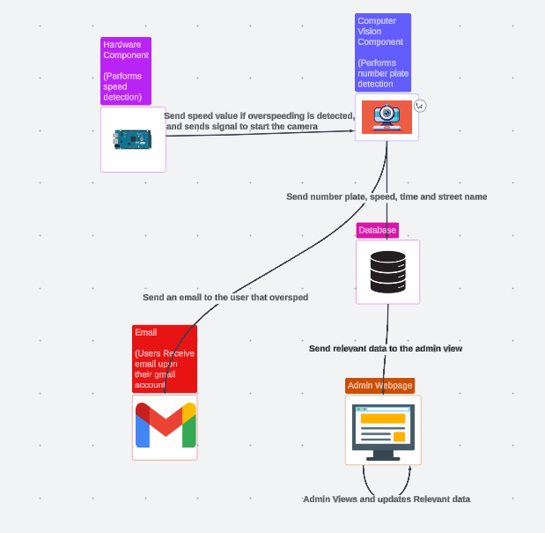

## System Level Architecture

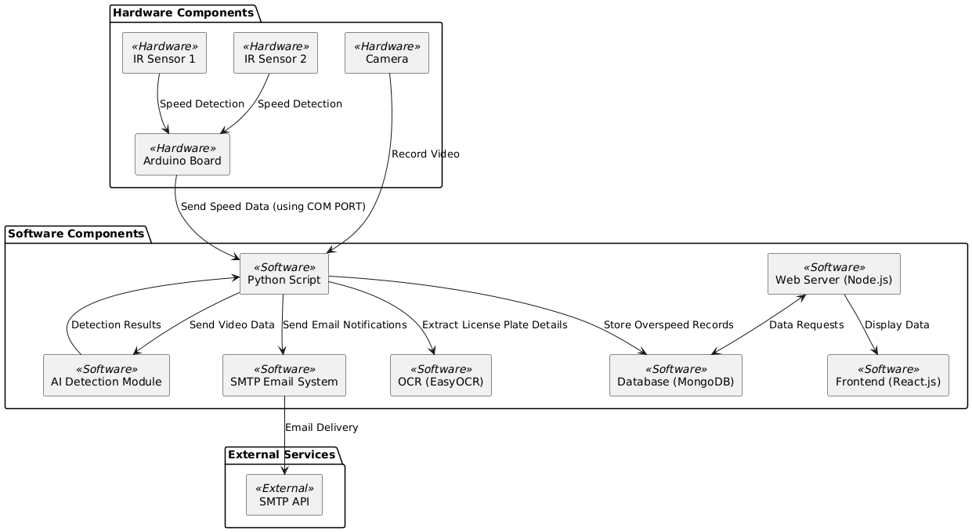

## Software Architecture

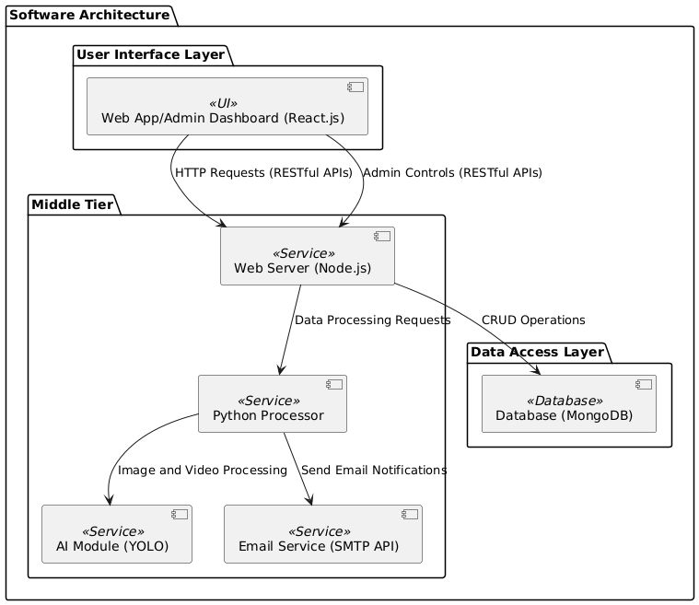

## Hardware Circuit Architecture

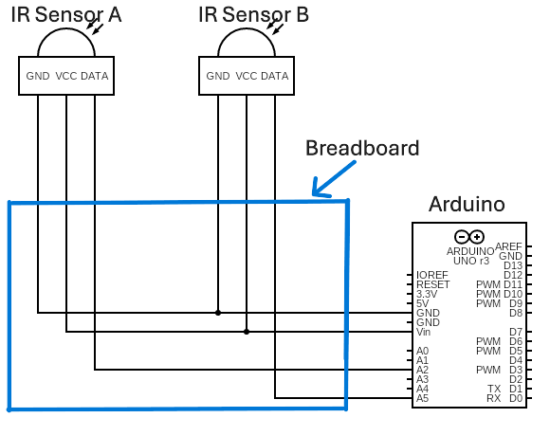

# Design Strategy

### Modularity:

For our project we plan to use a modular design, we will be using different modules for each functionality which are then again broken down into sub modules, our higher level modules are the Computer Vision module, the Hardware module and the Web Development module, each module broken down by the stack it uses and the functionality it performs.

### User Interface Paradigm:

Our project will use Node.js and React.js to allow our admin to use the web service with ease and intuitively, and with real time feedback upon all their updates.

### Data Management:

We will be using a MongoDB for our database due to our simpler database structure and the lack of need of a relational model, our project also relies upon adding multiple number plates for a single user which can be hectic for a relational database to handle.

### Tradeoffs

#### Cost Efficiency:

Our Current model is using cheaper hardware modules with lower performance, these cost cuts have been made strategically to make the project cheap but still completely functional, that being said expensive hardware can easily fit into the project’s structure with minimal changes and increase performance drastically.

#### (Camera Activation Strategy: Passive vs Triggered):

Currently our camera activates and records a video whenever a car passes through the sensors, this design choice was used as the live feed is constantly bottlenecked by the CPU and runs on extremely low frames vs the triggered module that has a slight delay since the camera must be activated but performs extremely well in comparison.

# Detailed System Design

## Database Design

### ER Diagram

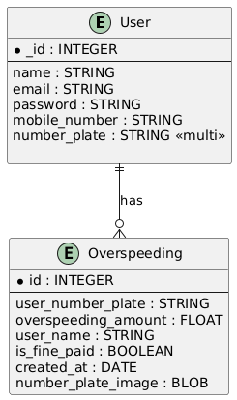



### Data Dictionary

#### Data 1

**User Entity**

| **Attribute** | **Data Type** | **Description** | **Constraints** |
| --- | --- | --- | --- |
| _id | INTEGER | Unique identifier for each user. | Primary Key |
| name | STRING | Full name of the user, typically includes first and last name. | Not Null |
| email | STRING | Email address of the user. | Unique, Not Null |
| password | STRING | Password set by the user. | Not Null |
| mobile_number | STRING | Mobile number of the user. | Not Null |
| number_plate | STRING | The vehicle number plate(s) associated with the user. | Multi-valued, Not Null |

#### Data 2

**Overspeeding Entity**

| **Attribute** | **Data Type** | **Description** | **Constraints** |
| --- | --- | --- | --- |
| id | INTEGER | Unique identifier for each overspeeding record. | Primary Key |
| user_number_plate | STRING | Number plate of the vehicle involved in overspeeding. | Foreign Key (references number_plate in User) |
| overspeeding_amount | FLOAT | Amount by which the vehicle was overspeeding. | Not Null |
| user_name | STRING | Redundant name field for reporting purposes. | Optional |
| is_fine_paid | BOOLEAN | Indicates whether the fine has been paid. | Not Null |
| created_at | DATE | Date and time when the overspeeding occurred. | Not Null |

## 5.2 Application Design

*[A detailed application design should include the following:*

### Sequence Diagram

#### <Sequence Diagram 1>

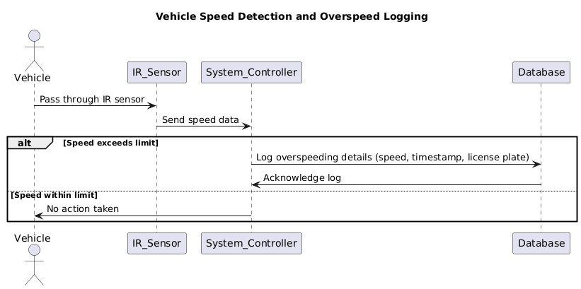

#### <Sequence Diagram 2>

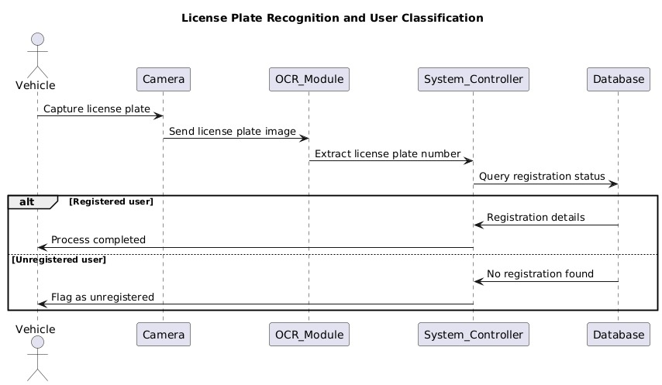

*.*

#### <Sequence Diagram 3>

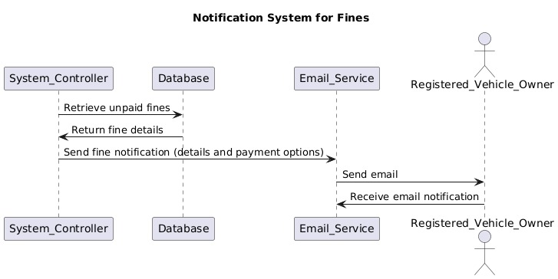

#### <Sequence Diagram 4>

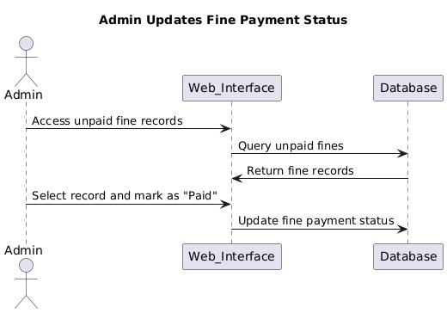

#### <Sequence Diagram 5>

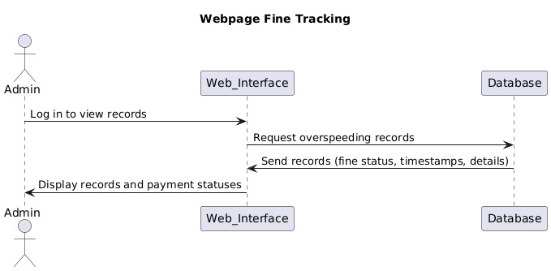

### State Diagram

#### <State Diagram 1>

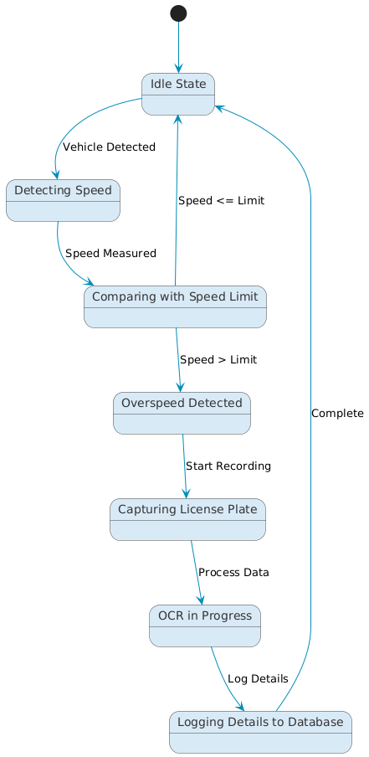

#### <State Diagram 2>

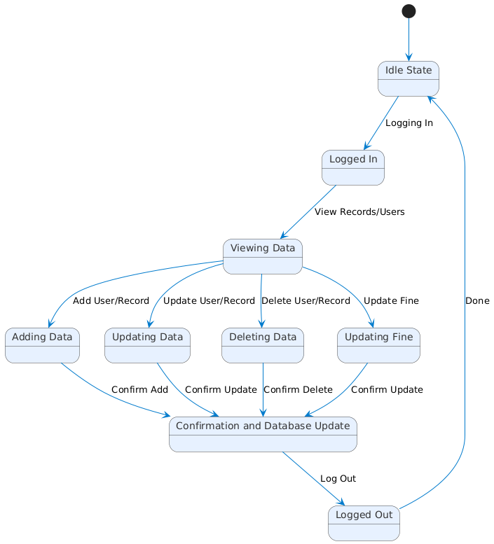

#### <State Diagram 3>

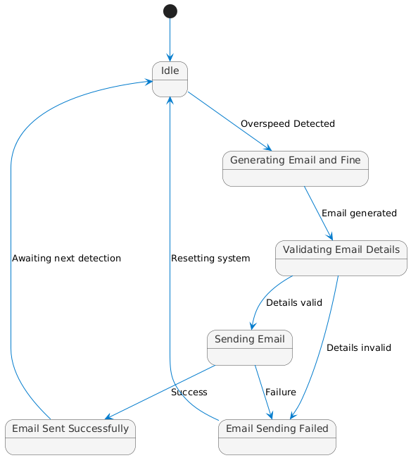

# References

1. Ali, S., & Singh, R. (2021). **AI-Powered Traffic Monitoring and Law Enforcement Systems**. *Journal of Intelligent Transportation Systems*, 13(2), 89-104.
2. Jain, R., & Srivastava, D. (2021). **Challenges in Automated Number Plate Recognition for Traffic Systems**. *International Journal of Smart Transportation*, 11(3), 67-82.
3. Khan, M., & Ahmed, S. (2022). **The Role of Smart Traffic Systems in Urban Management**. *International Journal of Urban Planning*, 14(4), 134-149.
4. Kumar, P., & Verma, S. (2020). **Technological Advancements in Speed Detection Systems for Smart Cities**. *IEEE Transactions on Smart Systems*, 15(3), 76-89.
5. Nguyen, H., & Patel, R. (2019). **Real-time Traffic Monitoring Using Radar and ANPR**. *IEEE Journal of Transportation Technology*, 12(1), 98-112.
6. Sharma, K., Verma, R., & Gupta, A. (2020). **Deep Learning Techniques in Automated Number Plate Recognition**. *International Journal of Computer Vision Applications*, 13(2), 45-58.

Zhao, Y., Liu, J., & Chen, H. (2021). **Advanced ANPR Systems Using Convolutional Neural Networks**. *Journal of Transportation Engineering*, 148(1), 345-359.

# Appendices