# AI-POWERED NUTRITION ANALYZER FOR FITNESS ENTHUSIASTS

* **TEAM MEMBERS:**

**Team Leader:** Syed. Muskan(228X1A05H6).

**Team Member:** Tatiparthi. Revanth Reddy(228X1A05H7).

**Team Member:** Gonugunta. Bhavani Sankar Sai(228X1A05I4).

## 1. Introduction:

The AI-powered Nutrition Analyzer for Fitness Enthusiasts is an innovative solution that uses artificial intelligence (AI) to help individuals analyze, monitor, and optimize their nutritional intake. The system is designed to support fitness goals by processing user dietary data, preferences, and objectives to provide personalized nutritional insights. This project empowers users with data-driven recommendations to maintain a healthy lifestyle effectively.

## 2. Project Objectives:

• Understand fundamental concepts and techniques of Convolutional Neural Networks (CNNs)  
• Gain knowledge on handling and preprocessing image data  
• Build and train an AI model for food image classification  
• Develop a Flask-based web application for user interaction  
• Provide nutritional information using integrated APIs

## 3. System Scenarios:

Scenario 1: Personalized Meal Planning  
Users input preferences and health restrictions to receive balanced meal plans.

Scenario 2: Nutrient Analysis and Tracking  
Tracks food intake and provides real-time nutrient feedback.

Scenario 3: Recipe Enhancement  
Suggests recipe modifications for healthier alternatives.

## 4. Technical Architecture:

The system architecture involves an AI-based model integrated into a Flask web framework. Users interact through a UI that allows uploading food images. The backend model, built using CNNs, classifies the food and retrieves its nutritional information via API integration. 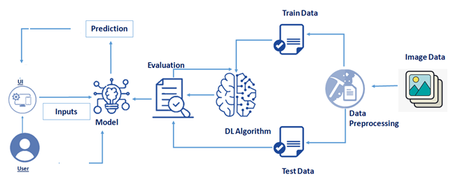

## 5.Project Structure:

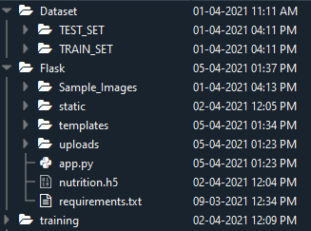

## 6. Project Flow:

1. User uploads an image through the interface.  
2. The Flask backend processes the image.  
3. The trained CNN model classifies the food item.  
4. Nutrition details are fetched using an external API.  
5. Results are displayed to the user.

## 7. Tools and Prerequisites:

• Anaconda Navigator – for Python environment management  
• Flask – web framework  
• Python libraries: NumPy, Pandas, TensorFlow, Keras, Scikit-learn, Flask  
• IDEs: Jupyter Notebook, Spyder, or PyCharm

## 8. Methodology:

a. Data Collection  
Images of food items (apple, banana, orange, pineapple, watermelon) were collected for training and testing.

b. Data Preprocessing  
Images were augmented using ImageDataGenerator for better model performance. https://lh4.googleusercontent.com/i2GGPoMi8FCdHVJ1XFdZ4ZdLv7cYXpPtX49hjv8EUIIufMLf-1YsnwaoW33m0kDUcWfi7QlBYLHYSu8yikyFfT7HAGOdu9iH9PcE2E-qeAVZ86zado6c_6hooaEoy_t_vJVDcong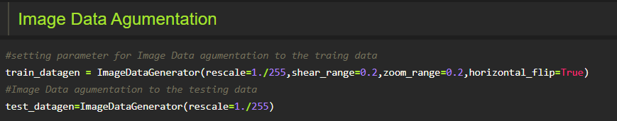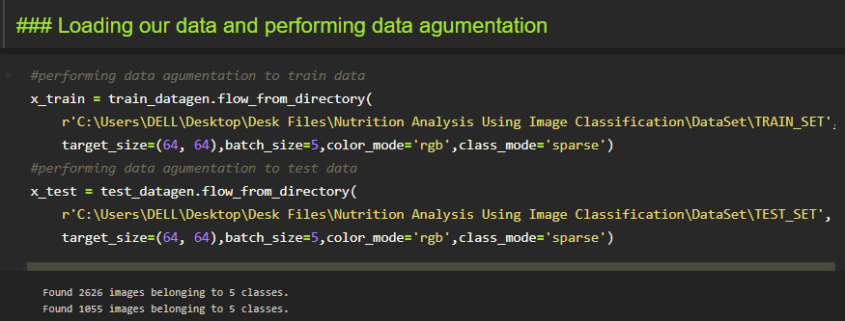

c. Model Building  
A CNN model was built with convolution, max pooling, flattening, and dense layers using ReLU and Softmax activation functions. 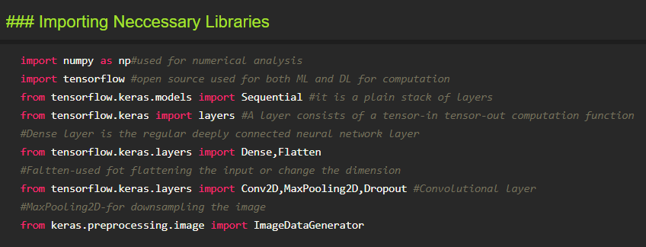https://lh6.googleusercontent.com/M_VuUBnoT2LbCaW-ZPu4QzKYUnENczEmw67Zbn0wnYETGxW1UM9Sn4jRuyNUV0CQcOLSXveqjJXhMWSpr1bAS0M0Y5xkgSPVQQivLnFD0H9Z_Htgt_P5aivjxPXstMwgPswDYZvP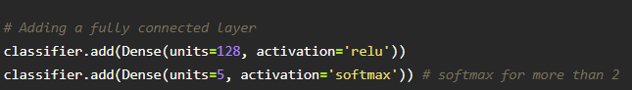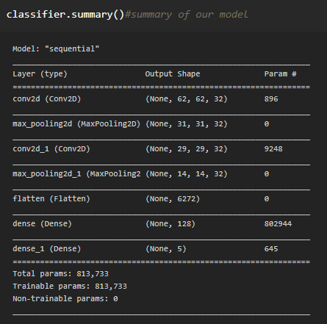

d. Model Training  
The model was trained for 20 epochs using Adam optimizer and categorical cross-entropy loss.

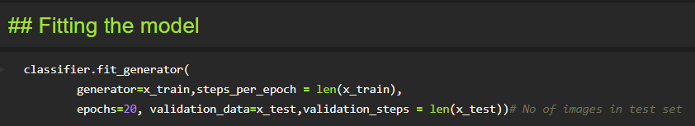

e. Model Evaluation and Saving  
The trained model was evaluated and saved as 'nutrition.h5'. 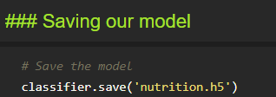

## 8. Application Development:

The Flask application serves as the bridge between users and the AI model. Users can upload images, and the app predicts the food type and displays nutritional details. HTML, CSS, and JavaScript are used for front-end design.

Home page : 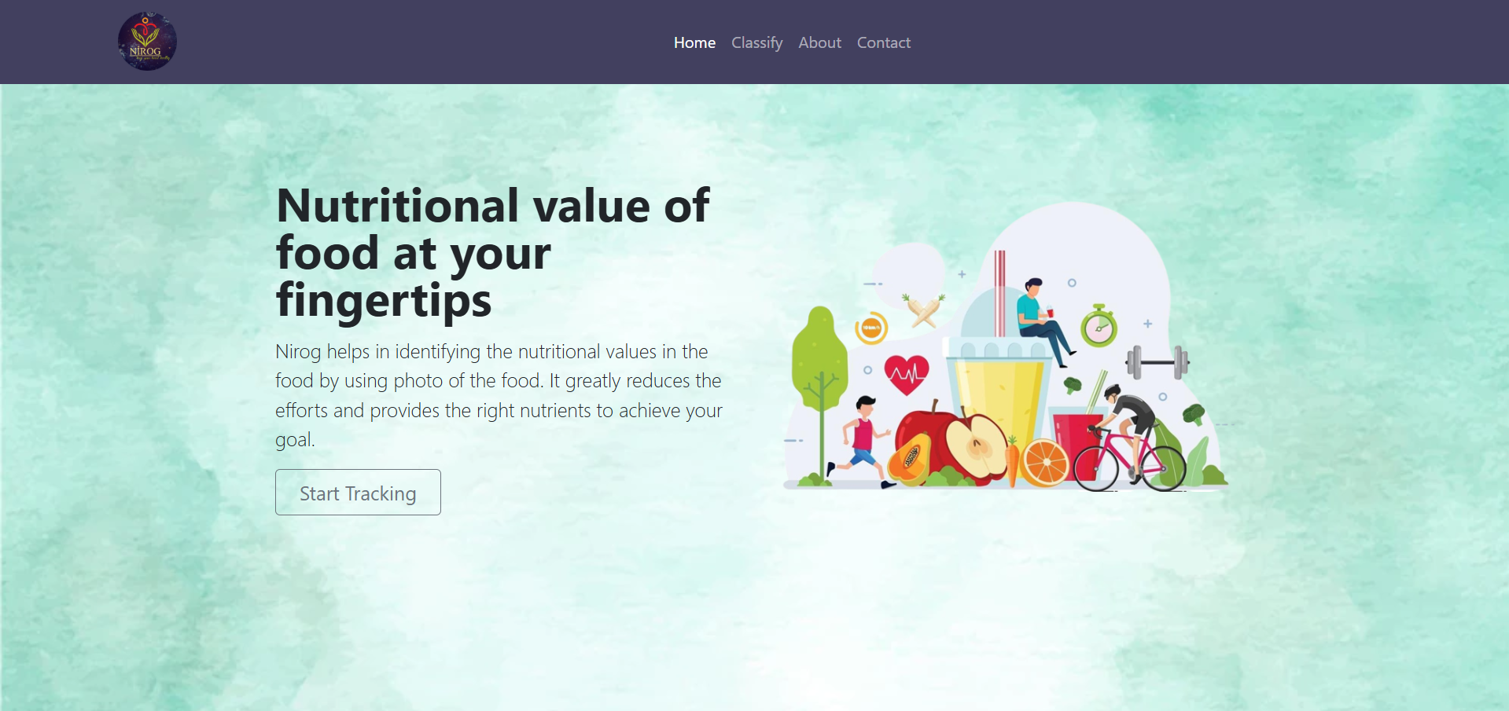

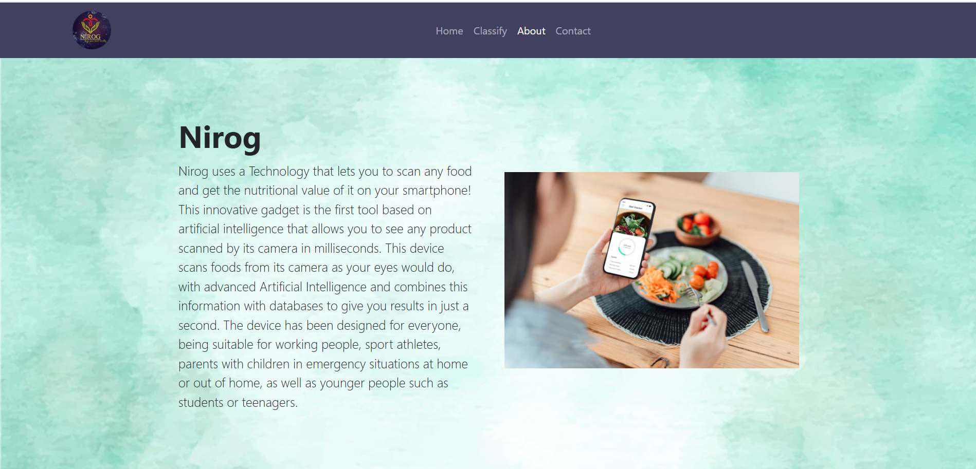About page :

Result page:

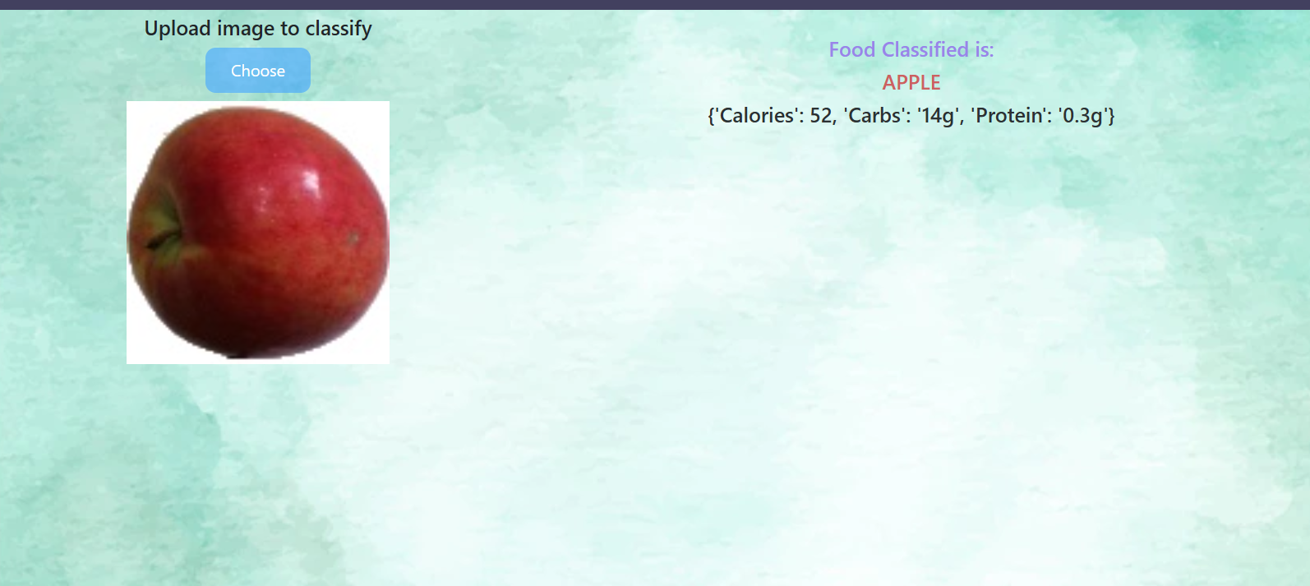

## 9. API Integration:

The application integrates with RapidAPI to fetch nutritional information for identified food items. The API provides calorie, macronutrient, and micronutrient details, enriching user insights.

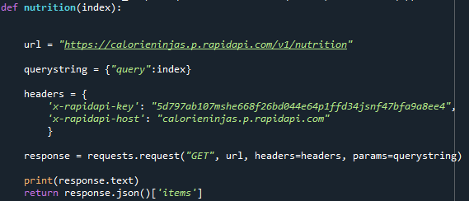

## 10. Results:

The trained CNN model successfully identifies food items and provides accurate nutritional analysis. Users can visualize meal data and improve dietary decisions effectively.

## 11. Conclusion:

The AI-powered Nutrition Analyzer bridges the gap between fitness and technology by providing an automated dietary analysis tool. It leverages AI and web technologies to make fitness tracking easier, personalized, and insightful.

## 12. Future Enhancements:

• Expanding the dataset with more food categories for improved accuracy  
• Implementing voice-based user interaction  
• Integrating wearable fitness tracker data  
• Adding real-time calorie tracking and recommendation engine  
• Deploying on a cloud platform for global access

**Thank You**