|  |
| --- |
| **ADVANCED WEB TECHNOLOGY**  **ASSIGNMENT-1** |

|  |
| --- |
| **NAME:S.HARIHARAN**  **ROLLNO:1831017**  **DEPARTMENT:MSC SOFTWARE SYSTEMS**  **DATE:20/08/2020** |

|  |  |
| --- | --- |
| **S.NO** | **TITLE** |
| **HTML5** | |
| **1** | **INPUT TAGS OF HTML5** |
| **2** | **DATA LIST ELEMENT AND AUTOCOMPLETE** |
| **CANVAS** | |
| **3** | **RECTANGLE IN CANVAS** |
| **4** | **USING PATHS TO DRAW LINES** |
| **5** | **DRAW CIRCLES AN ARCS** |
| **6** | **SHADOWS IN CANVAS** |
| **7** | **QUDRATIC CURVES** |
| **8** | **BEZIER CURVES** |
| **9** | **LINEAR-GRADIENT IN CANVAS** |
| **10** | **RADIAL-GRADIENT IN CANVAS** |
| **11** | **IMAGES IN CANVAS** |
| **12** | **TRANSFORMATION IN CANVAS** |
| **13** | **ROTATION METHOD IN CANVAS** |
| **14** | **SKEW IN CANVAS** |
| **15** | **TEXT IN CANVAS** |

**PROGRAM 1:**

**1.INPUT TAGS OF HTML5**

**PROGRAM CODE:**

<html>

<head>

<title>AWT ASSIGNMENT</title>

</head>

<style>

body{

font-family: sans-serif;

box-sizing: border-box;

margin:0;

}

.container{

width:50%;

background:white;

color:black;

left:50%;

margin-left:25%;

margin-top:4%;

padding:20px;

border:4px solid black;

}

td{

padding:10px 0px;

}

input[type="submit"]

{

background:burlywood;

color:white;

width:90%;

height:100

}

#Login{

background-color:dodgerblue;

font-size:15px;

position: relative;

left:0px;

border-radius:20%;

width: 85%;

border-radius: 30px;

letter-spacing: 2px;

color: white;

height: 50px;

cursor: pointer;

font-size: 20px;

border:none;

outline: none;

transform:scale(1);

transition:.5s;

}

#Login:hover{

transform:scale(1.2);

}

</style>

<body id="body">

<form autocomplete="off">

<div class="container"> <center>

<h3>INPUT-TAGS FOR HTML5</h3>

<table>

<tr>

<td><label>1)Choose The color for the Background Color</label>

</td>

<td> <input type="color" id="choosecolor" onfocusout="color()"required /></td>

</tr>

<tr>

<td>2)Date</td>

<td><input type="date" required/></td>

</tr>

<tr>

<td>3)Datetime</td>

<td>

<input type="datetime" required/></td>

</tr>

<tr>

<td>4)Datetime-Local</td>

<td><input type="datetime-local" required/></td>

</tr>

<tr>

<td>5)Month-Selection</td>

<td><input type="month" required/></td>

</tr>

<tr>

<td>6)Select The Number</td>

<td><input type="number" min="0" max="10" value="1" required/></td>

</tr>

<tr>

<td>7) Select Your Age</td>

<td><input type="range" id="range" min="1" max="100" value="1" onchange="rangeValue(this.value);" required/></td>

<td><input type="text" id="rangetext" required/></td>

</tr>

<tr>

<td>8)Time</td>

<td><input type="time" /></td>

</tr>

<tr>

<td>9)Search With URL</td>

<td> <input type="url" placeholder="http://www.google.com" required/></td>

</tr>

<tr>

<td>10)Select Week</td>

<td><input type="week" required/></td>

</tr>

<tr>

<td>11)Select The Mobile-Type</td>

<td><input type="text" list="Brands" required/>

<datalist id="Brands">

<option value="Apple"></option>

<option value="OPPO"></option>

<option value="VIVO"></option>

<option value="SAMSUNG"></option>

<option value="GOOGLE"></option>

</datalist></td>

</tr>

</table>

<input type="submit" value="Submit" id="Login"/>

</center>

</div>

</form>

</body>

<script>

function color(){

document.querySelector("#body").style.backgroundColor=document.querySelector("#choosecolor").value;

}

function rangeValue(val)

{

document.querySelector("#rangetext").value=val;

}

</script>

</html>

**OUTPUT:**

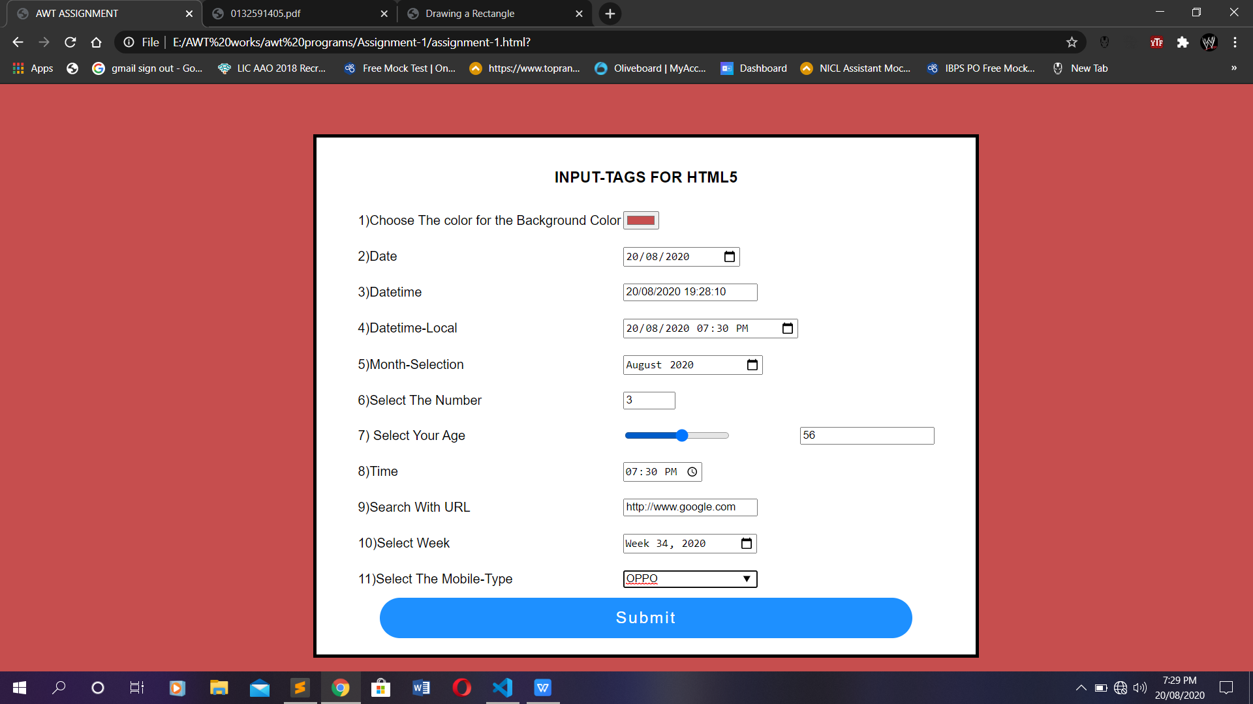

**PROGRAM 2:**

**2.DATALIST ELEMENT AND AUTOCOMPLETE**

**PROGRAM CODE:**

<html>

<body>

<form autocomplete=”off”>

<table>

<tr>

<td>1)DataList</td>

<td><input type="text" list="Brands" required/>

<datalist id="Brands">

<option value="Apple"></option>

<option value="OPPO"></option>

<option value="VIVO"></option>

<option value="SAMSUNG"></option>

<option value="GOOGLE"></option>

</datalist></td>

</tr>

</table>

</form>

</body>

</html>

**OUTPUT:**



**HTML5 CANVAS**

**PROGRAM 3:**

**3.RECTANGLE IN CANVAS**

**PROGRAM CODE:**

<!DOCTYPE html>

<!-- Fig. 14.2: drawrectangle.html -->

<!-- Drawing a rectangle on a canvas. -->

<html>

<head>

<meta charset = "utf-8">

<title>Drawing a Rectangle</title>

</head>

<body>

<canvas id = "drawRectangle" width = "300" height = "100"

style = "border: 1px solid black;">

Your browser does not support Canvas </canvas>

<script type>

var canvas = document.getElementById("drawRectangle");

var context = canvas.getContext("2d")

context.fillStyle = "yellow";

context.fillRect(5, 10, 200, 75);

context.strokeStyle = "royalblue";

context.lineWidth = 6;

context.strokeRect(4, 9, 201, 76);

</script>

</body>

</html>

**OUTPUT:**

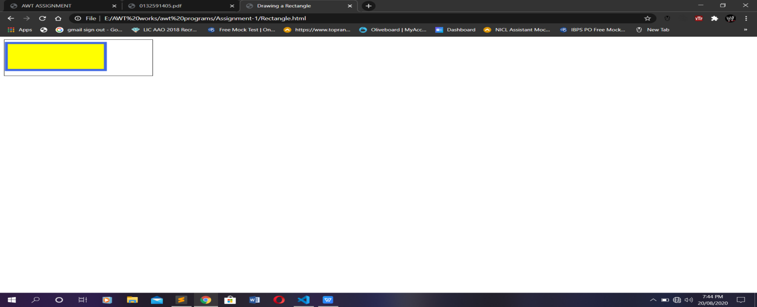

**PROGRAM 4**

**4.USING PATHS TO DRAW LINES**

**PROGRAM CODE:**

<!DOCTYPE html>

<!-- Fig. 14.3: lines.html -->

<!-- Drawing lines on a canvas. -->

<html>

<head>

<meta charset = "utf-8">

<title>Drawing Lines</title>

</head>

<body>

<canvas id = "drawLines" width = "400" height = "200"

style = "border: 1px solid black;">

</canvas>

<script>

var canvas = document.getElementById("drawLines");

var context = canvas.getContext("2d")

// red lines without a closed path

context.beginPath(); // begin a new path

context.beginPath(); //begin a new path

context.moveTo(40, 75); // path origin

context.lineTo(40, 55);

context.moveTo(10, 10); // path origin

context.lineTo(390, 10);

context.lineTo(390, 30);

context.lineTo(10, 30);

context.lineWidth = 10; // line width

context.lineJoin = "bevel" // line join style

context.lineCap = "butt"; // line cap style

context.strokeStyle = "red" // line c

context.stroke();

// orange lines without a closed path

context.beginPath(); //begin a new path

context.moveTo(40, 75); // path origin

context.lineTo(40, 55);

context.lineTo(360, 55);

context.lineTo(360, 75);

context.strokeStyle = "orange" //line color

context.stroke(); // draw path

// green lines with a closed path

context.beginPath(); // begin a new path

context.moveTo(10, 100); // path origin

context.lineTo(390, 100);

context.lineTo(390, 130);

context.strokeStyle = "green" // line color

context.stroke(); // draw path

// blue lines without a closed path

context.beginPath(); // begin a new path

context.moveTo(40, 140); // path origin

context.lineTo(360, 190);

context.lineTo(360, 140);

context.lineTo(40, 190);

context.strokeStyle = "blue" // line color

context.stroke(); // draw path

</script>

</body>

</html>

**OUTPUT:**

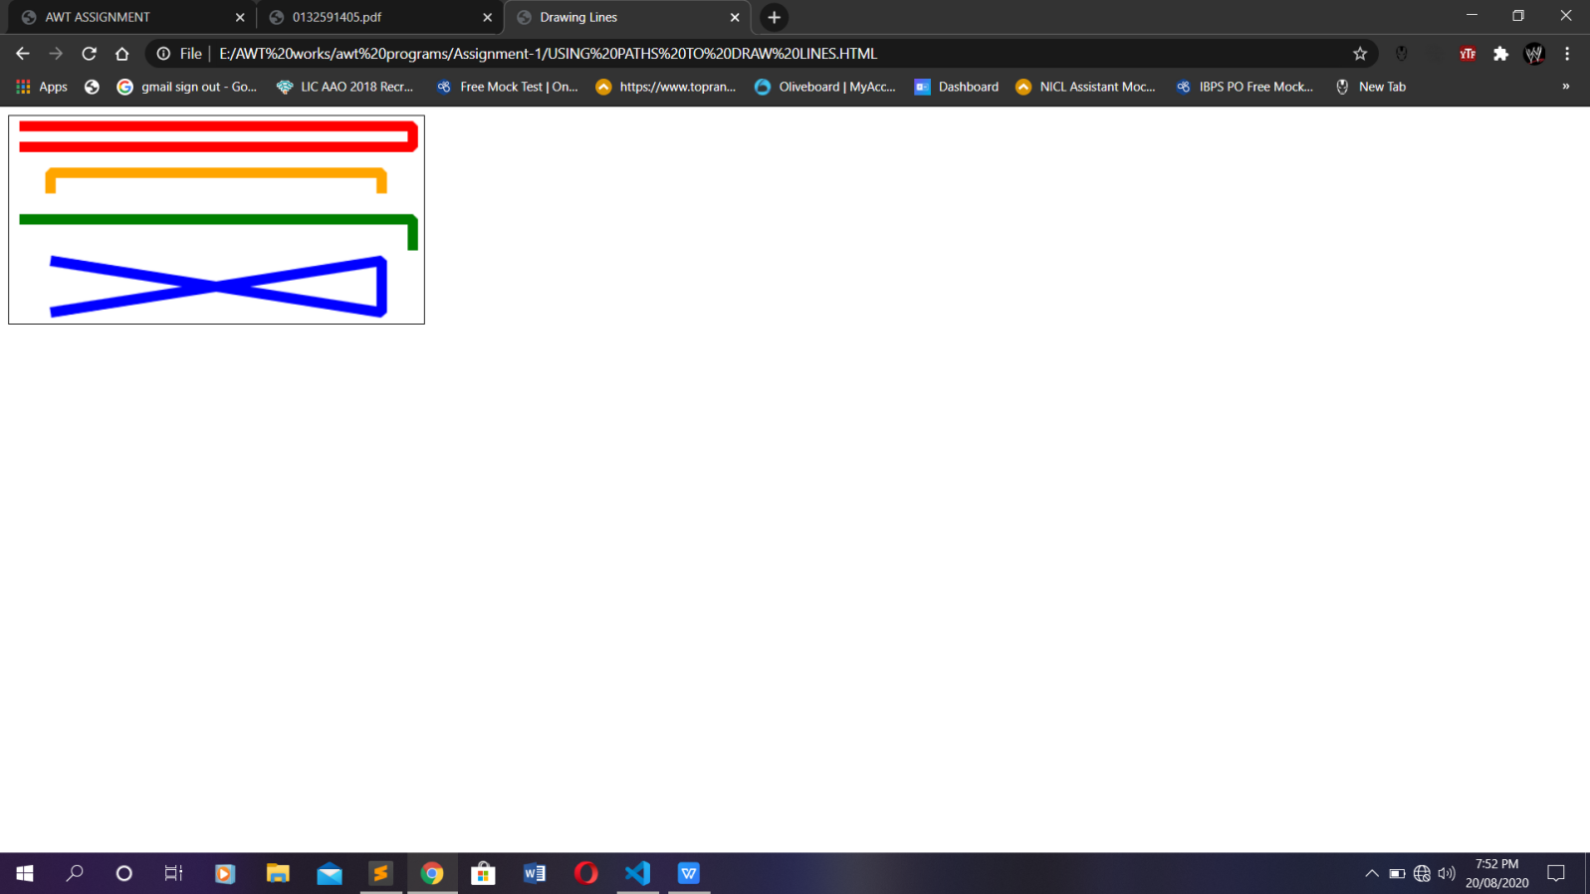

**PROGRAM 5:**

1. **DRAWING CIRCLES AND ARCS**

**PROGRAM CODE:**

<!DOCTYPE html>

<!-- Fig. 14.5: drawingarcs.html -->

<!-- Drawing arcs and a circle on a canvas. -->

<html>

<head>

<meta charset = "utf-8">

<title>Arcs and Circles</title>

</head>

<body>

<canvas id = "drawArcs" width = "225" height = "100">

</canvas>

<script>

var canvas = document.getElementById("drawArcs");

var context = canvas.getContext("2d")

// draw a circle

context.beginPath();

context.fillStyle = "mediumslateblue";

context.fill();

// draw an arc counterclockwise

context.beginPath();

context.stroke();

// draw a half-circle clockwise

context.beginPath();

context.fillStyle = "red";

context.fill();

// draw an arc counterclockwise

context.beginPath();

context.strokeStyle = "darkorange";

context.stroke();

</script>

</body>

</html>

**OUTPUT:**

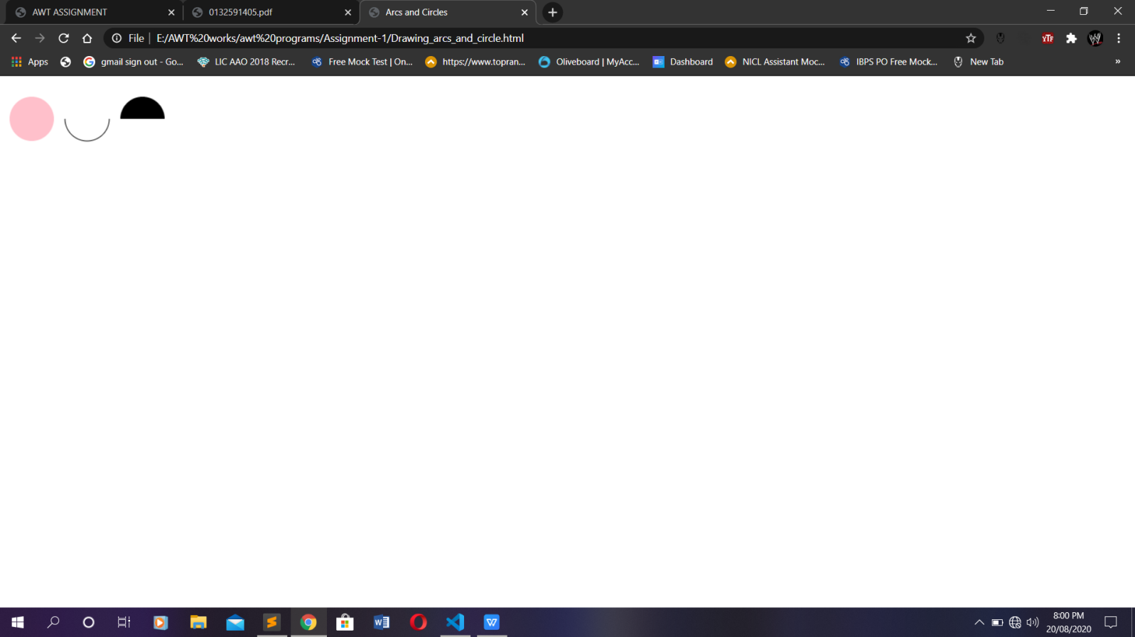

**PROGRAM 6:**

1. **SHADOWS IN CANVAS**

**PROGRAM CODE:**

<html>

<body>

<canvas id = "shadow" width = "525" height = "250"

style = "border: 1px solid black;">

</canvas>

<script>

// shadow effect with positive offsets

var canvas = document.getElementById("shadow");

var context = canvas.getContext("2d")

context.shadowBlur = 10;

context.shadowOffsetX = 15;

context.shadowOffsetY = 15;

context.shadowColor = "black";

context.fillStyle = "Red";

context.fillRect(25, 25, 200, 200);

// shadow effect with negative offsets

context.shadowBlur = 20;

context.shadowOffsetX = -20;

context.shadowOffsetY = -20;

context.shadowColor = "gray";

context.fillStyle = "RoyalBlue";

context.fillRect(300, 25, 200, 200);

</script>

</body>

</html>

**OUTPUT:**

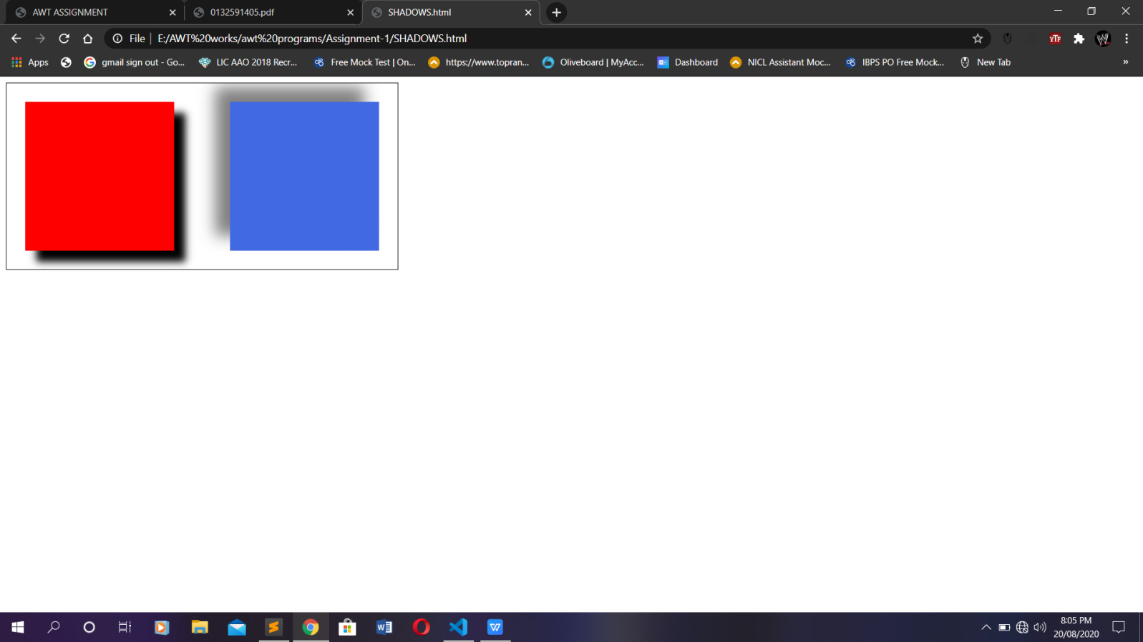

**PROGRAM 7:**

1. **QUADRATIC CURVES**

**PROGRAM CODE:**

<html>

<head>

<meta charset = "utf-8">

<title>Quadratic Curves</title>

</head>

<body>

<canvas id = "drawRoundedRect" width = "130" height = "130"

style = "border: 1px solid black;">

</canvas>

<script>

var canvas = document.getElementById("drawRoundedRect");

var context = canvas.getContext("2d")

context.beginPath();

context.moveTo(15, 5);

context.lineTo(95, 5);

context.quadraticCurveTo(105, 5, 105, 15);

context.lineTo(105, 95);

context.quadraticCurveTo(105, 105, 95, 105);

context.lineTo(15, 105);

context.quadraticCurveTo(5, 105, 5, 95);

context.lineTo(5, 15);

context.quadraticCurveTo(5, 5, 15, 5);

context.closePath();

context.fillStyle = "yellow";

context.fill(); //fill with the fillStyle color

context.strokeStyle = "royalblue";

context.lineWidth = 6;

context.stroke(); //draw 6-pixel royalblue border

</script>

</body>

</html>

**OUTPUT:**

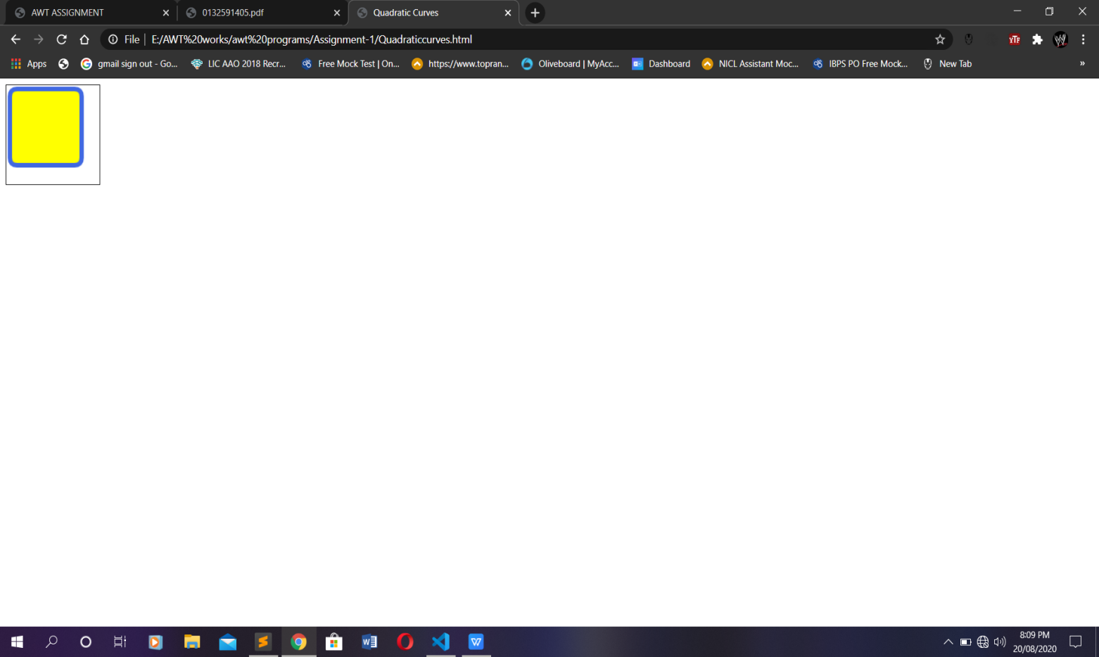

**PROGRAM 8:**

1. **BEZIER CURVE**

**PROGRAM CODE:**

<!DOCTYPE html>

<!-- Fig. 14.8: beziercurves.html -->

<!-- Drawing a Bezier curve on a canvas. -->

<html>

<head>

<meta charset = "utf-8">

<title>Bezier Curves</title>

</head>

<body>

<canvas id = "drawBezier" width = "150" height = "150"

style = "border: 1px solid black;">

</canvas>

<script>

var canvas = document.getElementById("drawBezier");

var context = canvas.getContext("2d")

context.beginPath();

context.moveTo(115, 20);

context.bezierCurveTo(12, 37, 176, 77, 32, 133);

context.lineWidth = 10;

context.strokeStyle = "red";

context.stroke();

</script>

</body>

</html>

**OUTPUT:**

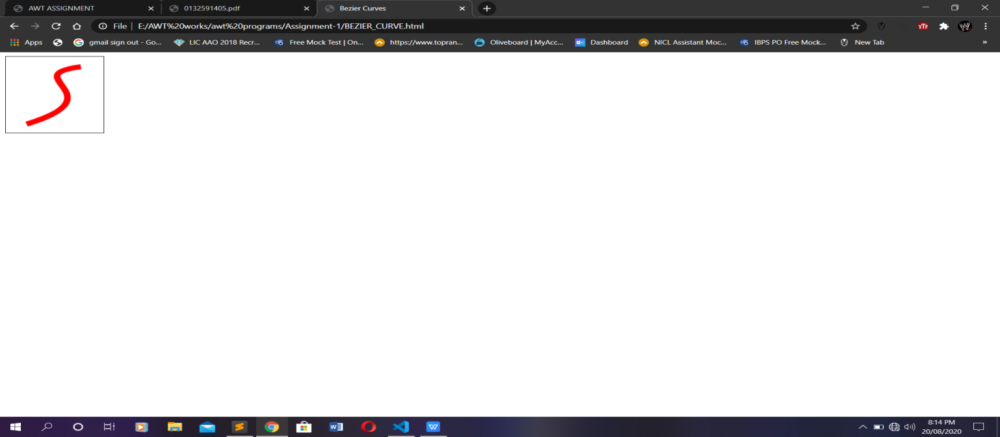

**PROGRAM 9:**

1. **LINEAR-GRADIENT IN CANVAS**

**PROGRAM CODE:**

<html>

<head>

<meta charset = "utf-8">

<title>Linear Gradients</title>

</head>

<body>

<!-- vertical linear gradient -->

<canvas id = "linearGradient" width = "200" height = "200"

style = "border: 1px solid black;">

</canvas>

<script>

var canvas = document.getElementById("linearGradient");

var context = canvas.getContext("2d");

var gradient = context.createLinearGradient(0, 0, 0, 200);

gradient.addColorStop(0, "white");

gradient.addColorStop(0.5, "lightsteelblue");

gradient.addColorStop(1, "navy");

context.fillStyle = gradient;

context.fillRect(0, 0, 200, 200);

</script>

<!-- horizontal linear gradient -->

<canvas id = "linearGradient2" width = "200" height = "200"

style = "border: 2px solid orange;">

</canvas>

<script>

var canvas = document.getElementById("linearGradient2");

var context = canvas.getContext("2d");

var gradient = context.createLinearGradient(0, 0, 200, 0);

gradient.addColorStop(0, "white");

gradient.addColorStop(0.5, "yellow");

gradient.addColorStop(1, "orange");

context.fillStyle = gradient;

context.fillRect(0, 0, 200, 200);

</script>

<!-- diagonal linear gradient -->

<canvas id = "linearGradient3" width = "200" height = "200"

style = "border: 2px solid purple;">

</canvas>

<script>

var canvas = document.getElementById("linearGradient3");

var context = canvas.getContext("2d");

var gradient = context.createLinearGradient(0, 0, 45, 200);

gradient.addColorStop(0, "white");

gradient.addColorStop(0.5, "plum");

gradient.addColorStop(1, "purple");

context.fillStyle = gradient;

var gradient = context.createLinearGradient(0, 0, 0, 200);

gradient.addColorStop(0, "white");

gradient.addColorStop(0.5, "lightsteelblue");

gradient.addColorStop(1, "navy");

context.fillStyle = gradient;

context.fillRect(0, 0, 200, 200);</script>

</body>

</html>

**OUTPUT:**

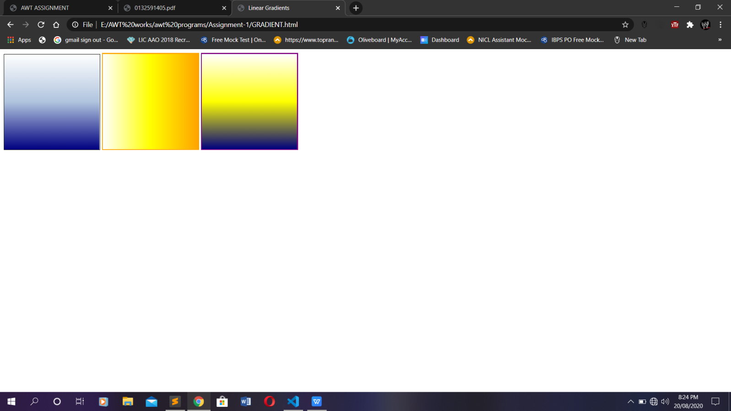

**PROGRAM 10:**

1. **RADIAL-GRADIENT IN CANVAS**

**PROGRAM CODE:**

<!DOCTYPE html>

<html>

<head>

<meta charset = "utf-8">

<title>Radial Gradients</title>

</head>

<body>

<!-- radial gradient with concentric circles -->

<canvas id = "radialGradient" width = "200" height = "200"

style = "border: 1px solid black;">

</canvas>

<script>

var canvas = document.getElementById("radialGradient");

var context = canvas.getContext("2d")

var gradient = context.createRadialGradient(

100, 100, 10, 100, 100, 125);

gradient.addColorStop(0, "white");

gradient.addColorStop(0.5, "yellow");

gradient.addColorStop(0.75, "orange");

gradient.addColorStop(1, "red");

context.fillStyle = gradient;

context.fillRect(0, 0, 200, 200);

</script>

<canvas id = "radialGradient2" width = "200" height = "200"

style = "border: 1px solid black;">

</canvas>

<script>

var canvas = document.getElementById("radialGradient2");

var context = canvas.getContext("2d")

var gradient = context.createRadialGradient(

20, 150, 10, 100, 100, 125);

gradient.addColorStop(0, "red");

gradient.addColorStop(0.5, "orange");

gradient.addColorStop(0.75, "yellow");

gradient.addColorStop(1, "white");

context.fillStyle = gradient;

context.fillRect(0, 0, 200, 200);

</script>

</body>

</html>

**OUTPUT:**

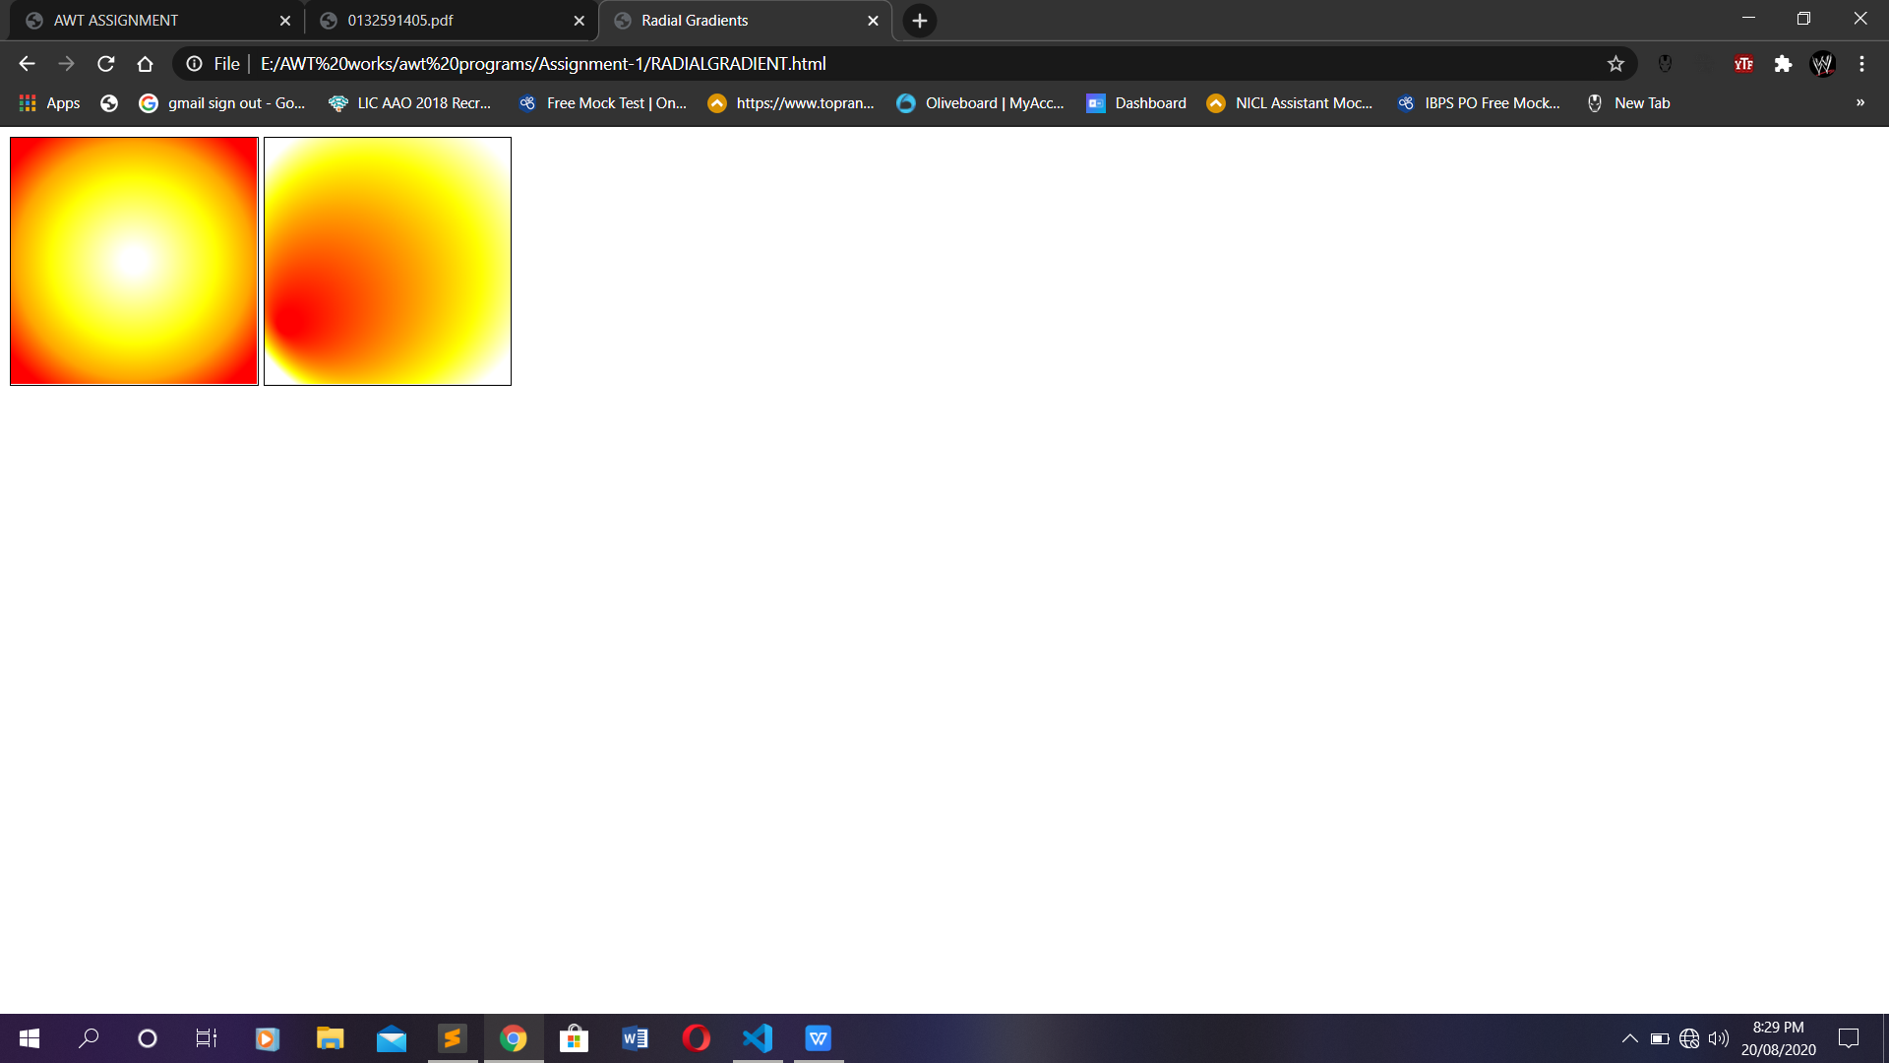

**PROGRAM 11:**

1. **IMAGES IN CANVAS**

**PROGRAM CODE:**

<!DOCTYPE html>

<html>

<head>

<meta charset = "utf-8">

<title>Images</title>

script>

var image = new Image();

image.src = "yellowflowers.png";

function draw()

{

var canvas = document.getElementById("myimage");

var context = canvas.getContext("2d")

} // end function draw

window.addEventListener( "load", draw, false );

</script>

</head>

<body>

<canvas id = "myimage" width = "200" height = "200"

style = "border: 1px solid Black;">

</canvas>

</body>

</html>

**OUTPUT:**

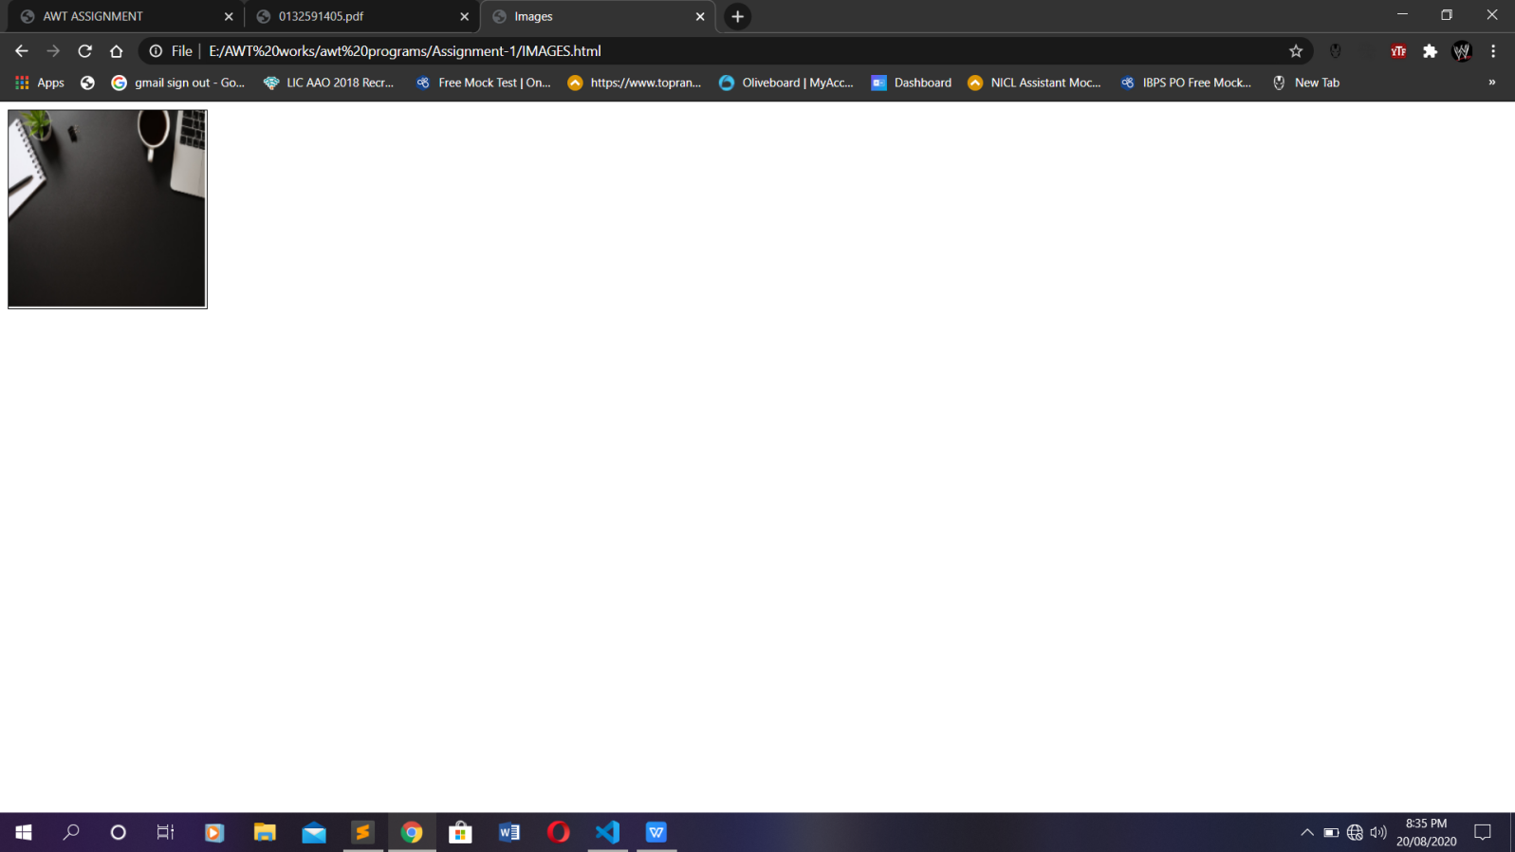

**PROGRAM 12:**

1. **TRANSFORMATION IN CANVAS**

**PROGRAM CODE:**

<!DOCTYPE html>

<html>

<head>

<meta charset = "utf-8"> <title>Ellipse</title> </head>

<body>

<canvas id = "drawEllipse" width = "200" height = "200"

style = "border: 1px solid black;">

</canvas>

<script>

var canvas = document.getElementById("drawEllipse");

var context = canvas.getContext("2d")

context.translate(canvas.width / 2, canvas.height / 2);

context.scale(1, 3);

context.beginPath();

context.arc(0, 0, 30, 0, 2 * Math.PI, true);

context.fillStyle = "red";

context.fill();

</script>

<!-- horizontal ellipse -->

<canvas id = "drawEllipse2" width = "200" height = "200"

style = "border: 1px solid black;">

</canvas>

<script>

var canvas = document.getElementById("drawEllipse2");

var context = canvas.getContext("2d")

context.translate(canvas.width / 2, canvas.height / 2);

context.beginPath();

context.arc(0, 0, 30, 0, 2 * Math.PI, true);

context.fillStyle = "blue";

context.fill();

</script>

</body>

</html>

**OUTPUT:**

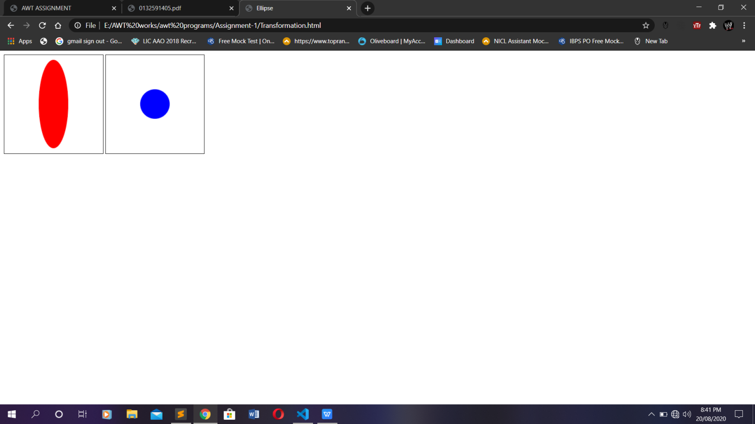

**PROGRAM 13:**

1. **ROTATION METHOD IN CANVAS**

**PROGRAM CODE:**

<!DOCTYPE html>

<html>

<head>

<meta charset = "utf-8">

<title>Rotate</title>

</head>

<body>

<canvas id = "rotateRectangle" width = "200" height = "200"

style = "border: 1px solid black;">

</canvas>

<script>

var canvas = document.getElementById("rotateRectangle");

var context = canvas.getContext("2d");

function startRotating()

{

context.translate(canvas.width / 2, canvas.height / 2);

setInterval(rotate, 10);

}

function rotate()

{

context.clearRect(-100, -100, 200, 200);

context.rotate(-Math.PI / 360);

context.fillStyle = "lime";

context.fillRect(-50, -50, 100, 100);

}

window.addEventListener( "load", startRotating, false );

</script>

</body>

</html>

**OUTPUT:**

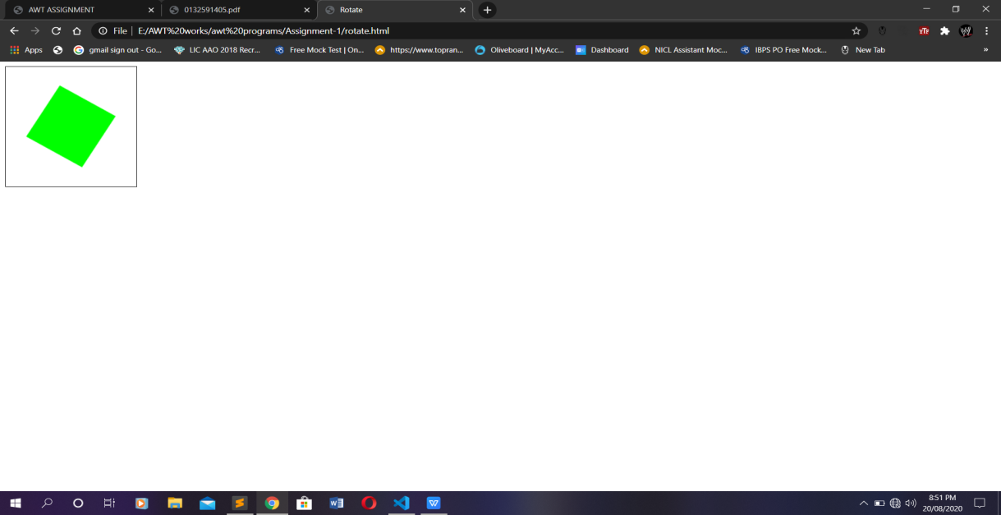

**PROGRAM 14:**

1. **SKEW IN CANVAS**

**PROGRAM CODE:**

<!DOCTYPE html>

<html>

<head>

<meta charset = "utf-8">

<title>Skew</title>

</head>

<body>

<!-- skew left -->

<canvas id = "transform" width = "320" height = "150"

style = "border: 1px solid Black;">

</canvas>

<script>

var canvas = document.getElementById("transform");

var context = canvas.getContext("2d");

var rectangleWidth = 120;

var rectangleHeight = 60;

var scaleX = 2;

var skewY = 0;

var skewX = 1;

var scaleY = 1;

var translationX = -10;

var translationY = 30;

context.translate(canvas.width / 2, canvas.height / 2);

context.transform(scaleX, skewY, skewX, scaleY,

translationX, translationY);

context.fillStyle = "red";

context.fillRect(-rectangleWidth / 2, -rectangleHeight / 2,

rectangleWidth, rectangleHeight);

</script>

<canvas id = "transform2" width = "220" height = "150"

style = "border: 1px solid Black;">

<script>

var canvas = document.getElementById("transform2");

var context = canvas.getContext("2d");

var rectangleWidth = 120;

var rectangleHeight = 60;

var scaleX = 1;

var skewY = 0;

var skewX = -1.5;

var scaleY = 2;

var translationX = 0;

var translationY = 0;

context.translate(canvas.width / 2, canvas.height / 2);

context.transform(scaleX, skewY, skewX, scaleY,

translationX, translationY);

context.fillStyle = "blue";

context.fillRect(-rectangleWidth / 2, -rectangleHeight / 2,

rectangleWidth, rectangleHeight);

</script>

</body>

</html>

**OUTPUT:**

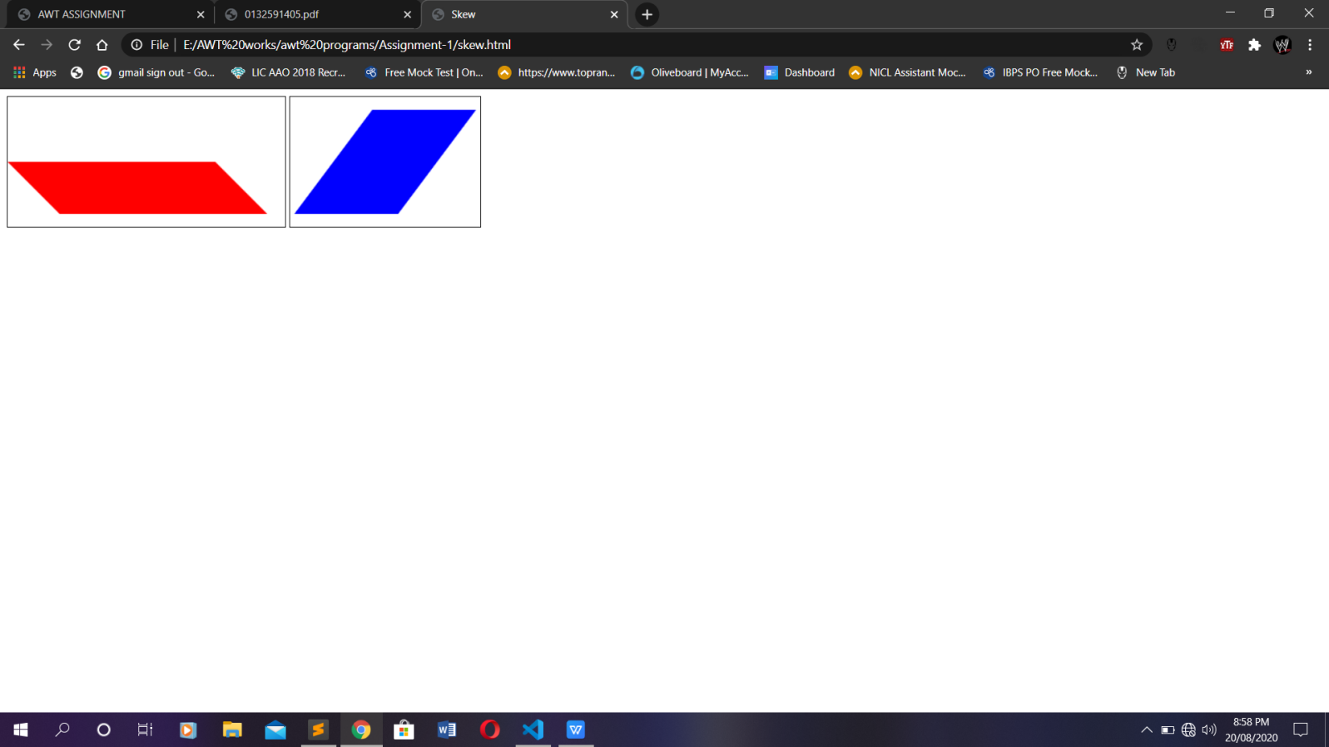

**PROGRAM 15:**

1. **TEXT IN CANVAS**

**PROGRAM CODE:**

<!DOCTYPE html>

<html>

<head>

<meta charset = "utf-8">

<title>Text</title>

</head>

<body>

<canvas id = "text" width = "230" height = "100"

style = "border: 1px solid black;">

</canvas>

<script>

var canvas = document.getElementById("text");

var context = canvas.getContext("2d")

context.font = "bold 30px sans-serif";

context.textAlign = "center";

context.lineWidth = 2;

context.strokeStyle = "navy";

context.strokeText("WELCOME HARIHARAN", 115, 50);

</script>

</body>

</html>

**OUTPUT:**

