

**Database Management**

**CSE303**

**Air Quality Monitoring System**

**Final Report**

**Section – 03 Group – 03**

|  |  |
| --- | --- |
| Name | ID |
| S.M.A Sayed Al Banna | 2021591 |
| Injamam ul Haque | 2021397 |
| Syed Niaz Mohtasim | 2021607 |
| Akib Raihan | 2020367 |
| Anannya Preeta | 2020977 |

Contents

CHAPTER 1: INTRODUCTION 3

a. BACKGROUND OF THE ORGANIZATION 3

b. BACKGROUND OF THE PROJECT 3

c. OBJECTIVE OF THE PROJECT 3

d. SCOPE OF THE PROJECT 3

CHAPTER 2: REQUIREMENT ANALYSIS 4

a. RICH PICTURE (AS IS) 4

b. SIX ELEMENTS ANALYSIS (AS IS) 5

c. PROCESS DIAGRAM (AS IS) 9

d. PROBLEM ANALYSIS 10

e. RICH PICTURE (TO BE) 11

f. SIX ELEMENTS ANALYSIS (TO BE) 12

g. PROCESS DIAGRAM (TO BE) 17

CHAPTER 3: LOGICAL SYSTEM DESIGN 17

a. BUSINESS RULES 17

b. ENTITY RELATIONSHIP DIAGRAM (ERD) 18

c. ENTITY RELATIONSHIP DIAGRAM (ERD) TO RELATIONAL SCHEMA 19

d. NORMALIZATION 19

e. DATA DICTIONARY 19

CHAPTER 4: PHYSICAL SYSTEM DESIGN 24

CHAPTER 5: CONCLUSION 24

REFERENCES 24

# CHAPTER 1: INTRODUCTION

## a. BACKGROUND OF THE ORGANIZATION

One of the most important problems of this decade is air pollution. It is dangerous for both humans and the environment itself. CASE stands for Clean Air and Sustainable Environment. It is a World Bank funded project started in 2009 with an initial of investment of USD $62.20 million with the intention of improving air condition and refine the processes that produce significant pollution such brick production and traffic congestion.

## b. BACKGROUND OF THE PROJECT

The project in its current state collects real-time air quality data and monitors pollutants using sensors. The data is passed along to multiple entities and representatives before being entered into the system. The data is then used to calculate the Air Quality Index, which is a tool for reporting daily air quality of any city or country. The system also generates atmospheric maps and various charts on request. (CASE, n.d.)

## c. OBJECTIVE OF THE PROJECT

The primary goal of this project is to construct a fully automated system that can take input of weather data directly and generate AQI, weather charts, tables, or graphs of locations as required by the user without error.

* To allow weather data collectors to entry the data directly into the system through a form without having to go through multiple channels, thus streamlining the process and reducing red tape.
* To bring in multiple sources of data like private weather stations and verified research organizations.
* To bring in weather data combined with location data from vehicles around the city in order to produce a route wise AQI map.
* To allow the relevant ministries and city corporations to propose changes to the system and templates of the reports directly through a comment box without having to go through multiple channels.
* To have the system verify the data by itself through software removing the need for it to be done manually.
* To let the data collectors know about any faults in the sensors (detected after the automated data verification) through the generated reports.

## d. SCOPE OF THE PROJECT

The scope is to make the existing system more efficient and user-friendly and introduce new features to ensure the proposed system is a valid upgrade.

* Improve data collection and bring in more data sources.
* Improve storages of the data by keeping less physical copies, thus using less paper.
* Keeping the data in a relational database.
* Streamlining the entire process, reducing number of people involved.
* Automating the process as much as possible.
* Building unique interfaces for all different stakeholders involved.
* Ensuring data and system security.
* Generating necessary reports instantly.
* Allowing the option to propose changes immediately and also making said changes as soon as possible.

# CHAPTER 2: REQUIREMENT ANALYSIS

## a. RICH PICTURE (AS IS)

Figure 1: Rich Picture AS IS

## b. SIX ELEMENTS ANALYSIS (AS IS)

|  |  |  |  |  |  |  |
| --- | --- | --- | --- | --- | --- | --- |
| **Process** | **System Roles** | | | | | |
| **Human** | **Non-Computing**  **Hardware** | **Computing**  **Hardware** | **Software** | **Database** | **Communication**  **& Network** |
| **Data Entry** | **A. Weather stations** 1. Send data collected from sensors to ministry representative.  **B. Forest Ministry Representative**  1. Collect data from weather station.  2. Send data to forest ministry.  **C. Forest Ministry**  1. Send data to city corporation representative.  **D. City Corporation Representative**  1. Input data to the system.  **D. Internal IT Expert**  1. The IT experts make sure the data is protected in the system.  2. They must make sure the website is always running.  3. They keep a backup ready in case of power failures.  **E. External IT Expert**  1. The internet service providers provides internet connection to the representative to do entry data. | **A. Paper**  1. Data sheet is printed on paper and this is stored as backup.  **B. File Holder**  1. Data sheets are kept in organised file holders.  **C. Cabinets**  1. The files are kept in the cabinets.  **D. Telephone/Cell Phones**  1. If there is need for telecommunication, telephones will be needed. | **A. Sensors**  1. To collect the weather data, these devices are needed. Data is collected by weather stations only.  **B. PC/ Laptop/**  **Other**  **computing**  **device**  1. The data from the sensors are stored on storage devices of computers.  **C. Printers/Copiers**  1. Printers and copiers are used to print and make copies of the data sheet.  **D. Router/ Internet Cables by ISP Providers/ Switch**  1. From networking side, internet cables by the ISP providers or router or switch used by the users of system.  **E. Pen Drives**  1. This is used as another medium by the users of system to pass the data. | **A. Microsoft Excel / Google Sheets**  1. All data collected is stored on computers in .CSV files which can be accessed using Excel/Sheets  **B. Operating System**  1. To operate the computer where data is collected and stored, we need an operating system like Windows/ Linux  **C. Printing software**  1. Printing software needed if data sheet is wanted in physical form or copies are to be made.  **Servers**  1. Database servers used by system for storing data and data entry by city corporation n representative. | **A. Microsoft Excel / Google Sheets**  1. All data collected is stored on computers in .CSV files which can be accessed using Excel/Sheets.  **B. System database**  1. Representative can use the system database in order to input and update data.  **C. Data files/ Log files (physical copies)** 1. Paper copies of data is printed and stored in holders and cabinets. | **A. Telecommunication/phone calls**  1. Representative and ministry can communicate with each other by making phone calls.  **B. Internet**  1. Internet will be needed for representative to entry data into system.  **C. Emails**  1. Representative and ministry can communicate with each other by sending emails. |
| **Data Verification** | **A. City Corporation Representative**  1. After receiving data and before inputting data, representative verifies the data manually. | **A. Pen and Paper**  1. Verifies that data is alright and processed with stamps and signatures. **B. Data Sheet in**  **Printed Version**  1. Data sheet is collected in a printed form.  **C. File Holder**  1. Data sheets are kept in organised file holders  **D. Cabinets**  1. The files are kept in the cabinets  **E. Telephone/Cell Phones**  1. If there is need for telecommunication, telephones will be needed. | **A. Printers/Copiers**  1. Printers and copiers are used to make copies of the verified data sheet. | **A. Printing software**  1. Printing software needed if data is wanted in physical form or copies are to be made. | **A. Data files/ Log files (physical copies)** 1. Paper copies of data is printed and stored in holders and cabinets. | **A. Telecommunication/phone calls**  1. If necessary, representative can communicate with ministry and other stakeholders by making phone calls. |
| **Generate reports** | **A. Forest Ministry**  1. Downloads reports to analyse any changes are needed to the system.  **B. City Corporation**  1. Downloads reports for making decisions and announcing if people of the city should be wary about atmosphere.  **C. Weather stations**  1. Downloads reports as well for making important decisions.  **D. Users**  1. Users are able to generate weather reports and make relevant decisions.  **E. Internal IT Expert**  1. Creates the report template for to be downloaded.  2. Maintains the system so that if there is any problem they can fix that.  **F. External IT Expert**  1. The internet service providers provides internet connection to the representative to access system and download relevant reports. | **A. Paper**  1. Users and other stakeholders have the options to print physical copies of reports.  **B. Telephone/Cell Phones**  1. If there is need for telecommunication, telephones will be needed. | **A. PC/ Laptop/**  **Other**  **computing**  **device**  1. PC is used to access the system and view and print relevant reports.  **B. Printers/Copiers**  1. Printers and copiers are used to print and make copies of the reports.  **C. Router/ Internet Cables by ISP Providers/ Switch**  1. From networking side, internet cables by the ISP providers or router or switch used by the users of system. | **A. Operating System**  1. To operate the computer, we need an operating system like Windows/ Linux  **B. Printing software**  1. Printing software needed if report is wanted in physical form or copies are to be made. | **A. HDD**  1. Soft copies of reports are the data the users and stakeholders have access to at this stage.  **A. Reports (physical copies)** 1. Paper copies of reports are the data the users and stakeholders have access to at this stage. | **A. Internet**  1. Internet will be needed for stakeholders to access the system and the data.  **B. Telecommunication/phone calls**  1. Forest ministry, city corporations and representatives can communicate with each other by making phone calls.  **C. Emails**  1. Forest ministry, city corporations and representatives can communicate with each other through emails. |
| **Propose changes to system** | **A. Forest Ministry**  1. After analysing the report, propose changes to system and send it to city corporation representative.  **B. City Corporation Representative**  1. Receive proposed changes from ministry and passes it along to the city corporation.  **C. City Corporation**  1. Receive proposed changes from representative and implement it.  **D. Internal IT Expert**  1. Apply the proposed changes to the system.  **E. External IT Expert**  1. The internet service providers provides internet connection to the stakeholders’ emails and access to system. | **A. Paper**  1. Document of proposed changes is printed on paper and sent out.  2. A copy of this document is stored as backup.  **B. File Holder**  1. Documents are kept in organised file holders.  **D. Cabinets**  1. The holders are kept in the cabinets.  **D. Telephone/Cell Phones**  1. If there is need for telecommunication, telephones will be needed. | **A. PC/ Laptop/**  **Other**  **computing**  **device**  1. PC is used to access the system and view and print relevant reports.  **B. Printers/Copiers**  1. Printers and copiers are used to print and make copies of the reports.  **C. Router/ Internet Cables by ISP Providers/ Switch**  1. From networking side, internet cables by the ISP providers or router or switch used by the users of system. | **A. Operating System**  1. To operate the computer, we need an operating system like Windows/ Linux  **B. Printing software**  1. Printing software needed if report is wanted in physical form or copies are to be made.  **C. Microsoft Word**  1. The document is drafted on a text editing software and the most used software is Microsoft Word. | **A. Microsoft Word**  1. The document for changes is the only form of data and can be accessed using Word.  **B. Physical copies of document** 1. Paper copies of document is printed and stored in holders and cabinets. | **A. Internet**  1. Internet will be needed for stakeholders to access the system and the data.  **B. Telecommunication/phone calls**  1. If necessary, stakeholders can communicate with each other by making phone calls.  **C. Emails**  1. If necessary, stakeholders can communicate with each other emails. |

## c. PROCESS DIAGRAM (AS IS)

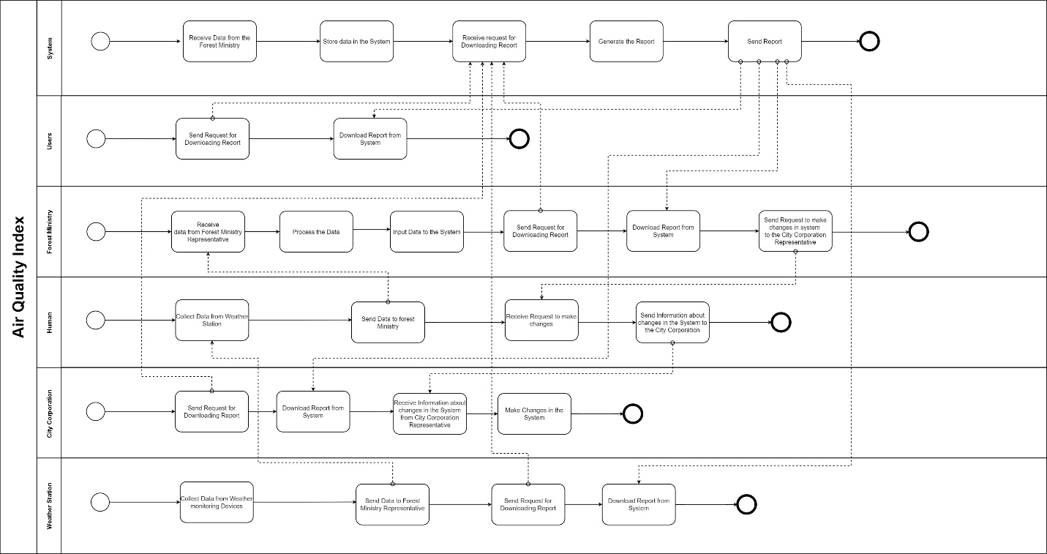

Figure 2: Process Diagram AS IS

## d. PROBLEM ANALYSIS

|  |  |  |  |  |
| --- | --- | --- | --- | --- |
| **Process Name** | **Stakeholders** | **Concerns (Problems)** | **Analysis (Reason of the Problem)** | **Proposed Solution** |
| **Data Entry** | A. Weather station  B. Forest Ministry Representative  C. Forest Ministry  D. City Corporation Representative | 1. Time Consuming  2. Too many entities involved  3. No direct way to entry data. | 1. Data has to be collected and then sent from one source to another and then another source for verification before entry.  2. There is no process for data collectors to directly entry data into the system and to know whether their sensors are working perfectly. | 1. Make the process more streamlined, no need to involve so many entities.  2. Create a form through which data can be entered by data collectors directly. |
| **Data Verification** | A. City Corporation Representative | 1. Manual Checking  2. Lack of relevant communication. | 1. Data has to be collected and then sent from one source to another and then another source for verification before entry.  2. There is no process for data collectors to directly entry data into the system and to know whether their sensors are working perfectly. | 1. This verification can be done automatically by the system through checking software.  2. Any issues or changes in data or sensors can be caught and can be informed to the data collectors through reports. |
| **Generate reports** | A. Forest Ministry  B. City Corporation  C. Weather stations  D. Users | 1. No way to edit templates of reports.  2. Reports do not have information regarding data verification. | 1. There is no way to make changes or additions to the reports in case more information is asked to be represented on the report.  2. After data verification, if there is problem with sensors there is no way to inform data collectors. | 1. Allow option for city corporation to make changes to template of reports as required.  2. Include information about data verification and sensors to the reports to be downloaded by data collectors. |
| **Propose changes to system** | A. Forest Ministry  B. City Corporation Representative  C. City Corporation | 1. Time Consuming.  2. Too many entities involved | 1. Information about changes has to be proposed by ministry and then sent to representative and then to city corporation for actually implementing changes, very slow process. | 1. Make the process more streamlined, no need to involve so many entities.  2. Make a comment box in the system where city corporation can directly send in proposed changes. |

## e. RICH PICTURE (TO BE)

Figure 3: Rich Picture TO BE

## f. SIX ELEMENTS ANALYSIS (TO BE)

|  |  |  |  |  |  |  |
| --- | --- | --- | --- | --- | --- | --- |
| **Process** | **System Roles** | | | | | |
| **Human** | **Non-Computing**  **Hardware** | **Computing**  **Hardware** | **Software** | **Database** | **Communication**  **& Network** |
| **Data Entry** | **A. Weather station**  1. Collect information from sensors  2. Save a copy of the data (.CSV file and physical).  3. Send weather data (.CSV file) to the system directly using a form.  **B. Research Organizations**  **and NGOs**  1. Collect information from sensors.  2. Save a copy of the data (.CSV file and physical).  3. Send weather data (.CSV file) to the system directly using a form.  **C. Drivers around the city** 1. Data is collected when these people drive around the city with their vehicles through a sensor connected on the vehicle. Both weather and data location data is sent to the system.  **D. Internal IT Expert**  1. The IT experts make sure the data is protected in the system.  2. They must make sure the website is always running.  3. They keep a backup ready in case of power failures.  **E. External IT Expert**  1. The internet service providers provides internet connection to the representative to do entry data. | **A. Paper**  1. Physical copy of data sheet is also kept as backup.  **B. File Holder**  1. Data sheets are kept in organised file holders.  **C. Cabinets**  1. The files are kept in the cabinets.  **D. Telephone/Cell Phones**  1. If there is need for telecommunication, telephones will be needed. | **A. Sensors**  1. To collect the weather data, these devices are needed.  **B. PC/ Laptop/**  **Other**  **computing**  **device**  1. The data from the sensors are stored on storage devices of computers.  2. PCs are used by stakeholders access the system and to input weather data to the system.  **C. Printers/Copiers**  1. Printers and copiers are used to print and make copies of the data sheet.  **D. Router/ Internet Cables by ISP Providers/ Switch**  1. From networking side, internet cables by the ISP providers or router or switch used by the users of system.  **E. Pen Drives**  1. This is used as another medium by the users of system to pass the data. | **A. Microsoft Excel / Google Sheets**  1. All data collected is stored on computers in .CSV files which can be accessed using Excel/Sheets  **B. Operating System**  1. To operate the computer where data is collected and stored, we need an operating system like Windows/ Linux.  **C. Google Forms**  1. Data is collected by system through a provided Google Form.  **D. Printing software**  1. Printing software needed if data is wanted in physical form | **A. Microsoft Excel / Google Sheets**  1. All data collected through Google Forms is stored on computers in .CSV files which can be accessed using Excel/Sheets.  **B. System database**  1. Representative can use the system database in order to input and update data.  2. System keeps a cumulative data file in its own database.  **C. Data files/ Log files (physical copies)** 1. Paper copies of data is printed and stored in holders and cabinets for backup purposes. | **A. Internet**  1. Internet will be needed for stations and organisations to access the system and form and send the data.  2. The data collecting vehicles will also need internet connection through WIFI or mobile network to send weather and location data to the system.  **B. Telecommunication/phone calls**  1. Stakeholders can communicate with each other using by making phone calls.  **C. Emails**  1. Stakeholders can communicate with each other through email. |
| **Data Verification** |  |  | **A. PC/ Laptop/**  **Other**  **computing**  **device**  1. Data Verification is done automatically in the system using software. To access the system, a computing device is required.  **B. Router/ Internet Cables by ISP Providers/ Switch**  1. From networking side, internet cables by the ISP providers or router or switch used by the users of system. | **A. Operating System**  1. To operate the computer where data is collected and stored, we need an operating system like Windows/ Linux.  **B. Verifying Software**  1. Software is added to the system in new version, which verifies the inputted data without any manual input. | **A. System database**  1. System keeps the verified data file in its own database. | **A. Internet**  1. Internet will be needed for stations and organisations to access the system. |
| **Generate reports** | **A. Forest Ministry**  1. Downloads reports to analyse any changes are needed to the system.  **B. City Corporation**  1. Downloads reports for checking if any changes to system have been proposed by ministry.  2. Downloads reports for making decisions and announcing if people of the city should be wary about atmosphere.  **C. Weather stations**  1. Downloads reports as to check if data verification has spotted any issues in their sensors.  **D. Drivers around the city**  1. Downloads reports as to check if data verification has spotted any issues in their sensors (location and weather).  **E. Research Organizations**  **and NGOs**  1. Downloads reports as to check if data verification has spotted any issues in their sensors.  **F. Users**  1. Users are able to generate weather reports and make relevant decisions.  **G. Internal IT Expert**  1. Creates and makes changes (if asked) the report template for to be downloaded.  2. Maintains the system so that if there is any problem they can fix that.  **H. External IT Expert**  1. The internet service providers provides internet connection to the representative to access system and download relevant reports. | **A. Paper**  1. Users and other stakeholders have the options to print physical copies of reports.  **B. Telephone/Cell Phones**  1. If there is need for telecommunication, telephones will be needed. | **A. PC/ Laptop/**  **Other**  **computing**  **device**  1. PC is used to access the system and view and print relevant reports.  **B. Printers/Copiers**  1. Printers and copiers are used to print and make copies of the reports.  **C. Router/ Internet Cables by ISP Providers/ Switch**  1. From networking side, internet cables by the ISP providers or router or switch used by the users of system. | **A. Operating System**  1. To operate the computer, we need an operating system like Windows/ Linux  **B. Printing software**  1. Printing software needed if report is wanted in physical form or copies are to be made. | **A. HDD**  1. Soft copies of reports are the data the users and stakeholders have access to at this stage.  **A. Reports (physical copies)** 1. Paper copies of reports are the data the users and stakeholders have access to at this stage. | **A. Internet**  1. Internet will be needed for stakeholders to access the system and the data.  **B. Telecommunication/phone calls**  1. Forest ministry, city corporations and representatives can communicate with each other by making phone calls.  **C. Emails**  1. Forest ministry, city corporations and representatives can communicate with each other through emails. |
| **Propose changes to system** | **A. Forest Ministry**  1. After analysing the report, propose changes to system through a comment box in the system.  **B. City Corporation**  1. View proposed changes in the downloaded report and implement it.  **D. Internal IT Expert**  1. Apply the proposed changes to the system.  **E. External IT Expert**  1. The internet service providers provides internet connection to the stakeholders’ emails and access to system. | **A. Telephone/Cell Phones**  1. If there is need for telecommunication, telephones will be needed. | **A. PC/ Laptop/**  **Other**  **computing**  **device**  1. PC is used to access the system and view and print relevant reports.  **B. Printers/Copiers**  1. Printers and copiers are used to print and make copies of the reports.  **C. Router/ Internet Cables by ISP Providers/ Switch**  1. From networking side, internet cables by the ISP providers or router or switch used by the users of system. | **A. Operating System**  1. To operate the computer, we need an operating system like Windows/ Linux  **B. Printing software**  1. Printing software needed if report is wanted in physical form or copies are to be made. | **A. System database**  1. System keeps the verified data file in its own database.  2. Changes proposed through comment box are also kept in the same database, which can be viewed in the generated reports. | **A. Internet**  1. Internet will be needed for stakeholders to access the system and the data.  **B. Telecommunication/phone calls**  1. Forest ministry and city corporation can communicate with each other by making phone calls.  **C. Emails**  1. Forest ministry and city corporations can communicate with each other through emails. |

## g. PROCESS DIAGRAM (TO BE)

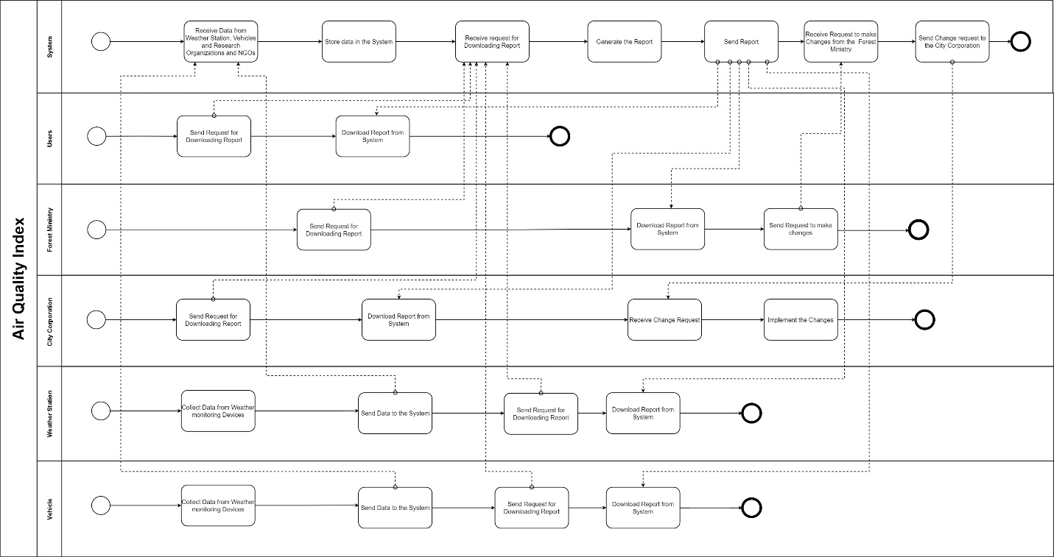

Figure 4: Process Diagram (TO BE)

# CHAPTER 3: LOGICAL SYSTEM DESIGN

## a. BUSINESS RULES

Business rules describe the operations, definitions and constraints that govern the data model. As opposed to the ERD, they are made using regular English sentences so that a non-technical stakeholder can decipher information about the data model without notation knowledge. The business rules that govern our data model are as follows

USER has username, email and password. USER must be a part of a CITY CORPORATION. CITY CORPORATION may have many USERS. USER must be a part of a FOREST MINISTRY. FOREST MINISTRY may have many USERS. USER may be part of multiple ORGANIZATIONS and ORGANIZATIONS may have multiple USERS.

FOREST MINISTRY has minID and minName. MINISTRY may have multiple CITY CORPORATION working under them while CITY CORPORATION will be working under one MINISTRY. MINISTRY may be working with many ORGANIZATIONS and ORGANIZATIONS may be working with many MINISTRY.

CITY CORPORATION has corpID and corpName. STATION might receive WEATHER INFO from multiple source, while WEATHER INFO is sent to one STATION. STATION has stationID, stationNo and stationOwner.

ORGANIZATION has orgID and orgName. ORGANIZATION may work with multiple STATIONS and STATION will work with one ORGANIZATION.

## b. ENTITY RELATIONSHIP DIAGRAM (ERD)

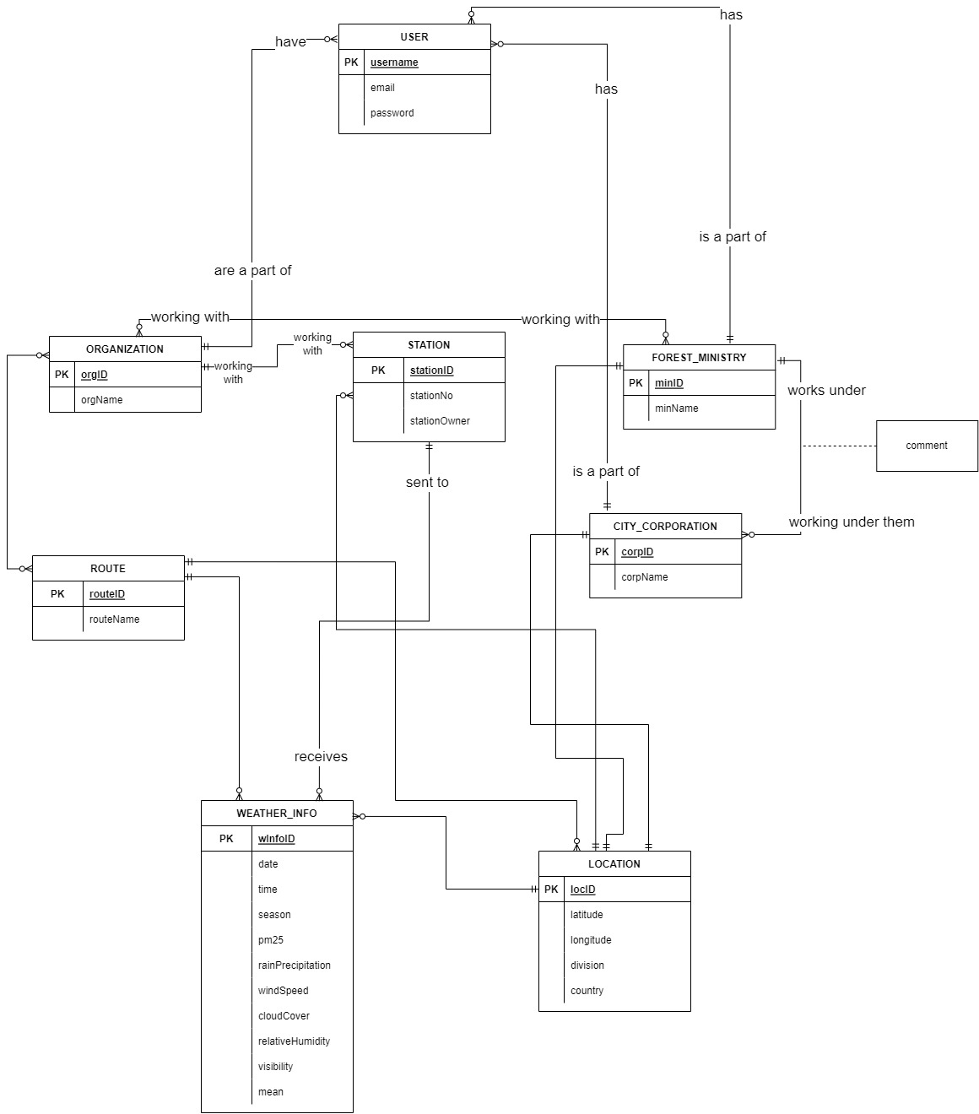

## c. ENTITY RELATIONSHIP DIAGRAM (ERD) TO RELATIONAL SCHEMA

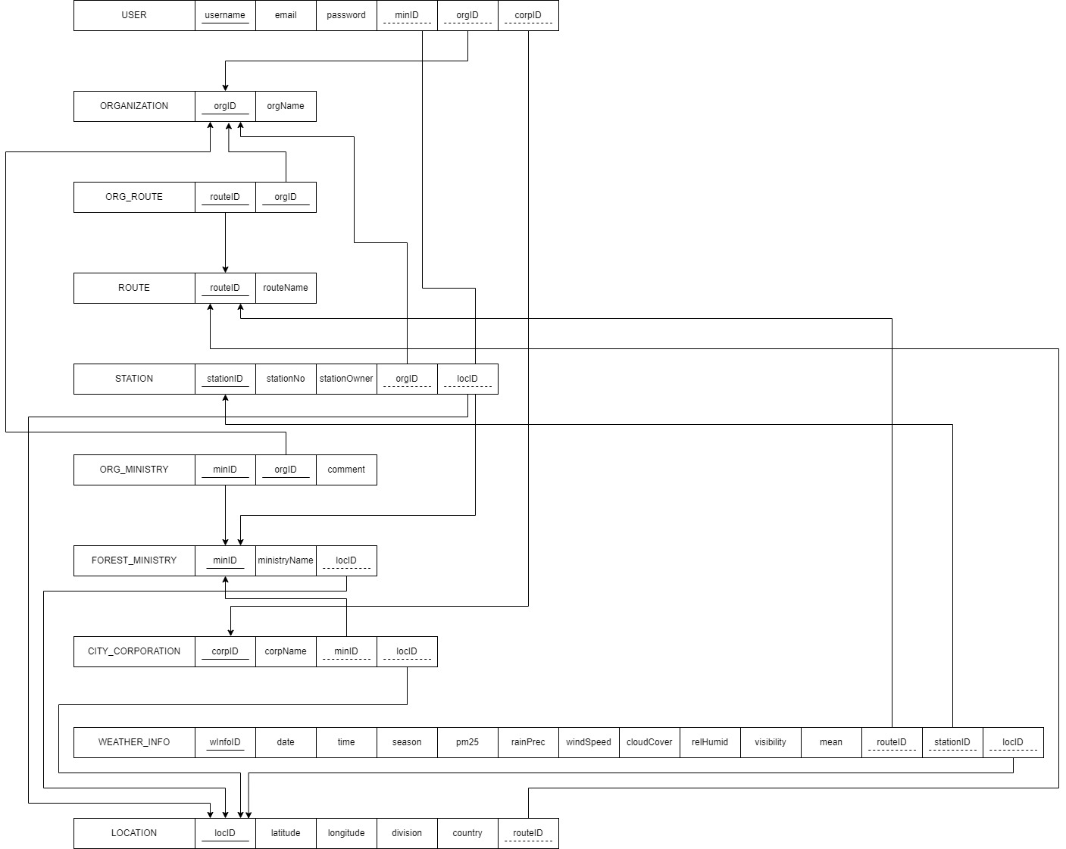

## d. NORMALIZATION

## e. DATA DICTIONARY

Tblcity_corporation

|  |  |  |  |
| --- | --- | --- | --- |
| Name | Data Type | Size | Remark |
| corpID | VARCHAR | 10 | This is the primary key for the City Corporation table. E.g: “corpBan1” |
| corpName | TEXT |  | This is the name for the City Corporation. E.g: “Barishal City Copororation” |
| minID | VARCHAR | 10 | This is a foreign key from Forest Ministry table. E.g. “fminBan” |
| locID | VARCHAR | 10 | This is a foreign key from Location table. E.g. “cntBan” |

Tblforest_ministry

|  |  |  |  |
| --- | --- | --- | --- |
| Name | Data Type | Size | Remark |
| minID | VARCHAR | 10 | This is the primary key for the Forest Ministry table. E.g: “fminBan” |
| ministryName | TEXT |  | This is the name for the Forest Ministry. E.g: “Forest Ministry of Bangladesh” |
| locationID | VARCHAR | 10 | This is a foreign key from Location table. E.g. “cntBan” |

Tbllocation

|  |  |  |  |
| --- | --- | --- | --- |
| Name | Data Type | Size | Remark |
| locID | VARCHAR | 10 | This is the primary key for the Location table. E.g. “cntBan” |
| latitude | TEXT |  | This is the latitude for Location table. E.g: “41.965193” |
| longitude | TEXT |  | This is the longitude for Location table. E.g: “-87.876265” |
| division | TEXT |  | This is the division for Location table. E.g: “Sylhet” |
| country | TEXT |  | This is the county for Location table. E.g: “Bangladesh” |

Tblorg_ministry

|  |  |  |  |
| --- | --- | --- | --- |
| Name | Data Type | Size | Remark |
| orgID | VARCHAR | 10 | This is part of the primary key for the Organization Ministry table. E.g. “org1”  This is also a foreign key referencing Organization table. |
| minID | VARCHAR | 10 | This is part of the primary key for the Organization Ministry table.  This is a foreign key from Forest Ministry table. E.g: “fminBan” |
| comment | TEXT |  | This is the comment column, where feedback is to be stored. |

Tblorg_route

|  |  |  |  |
| --- | --- | --- | --- |
| Name | Data Type | Size | Remark |
| orgID | VARCHAR | 10 | This is part of the primary key for the Organization route table. E.g. “org1”  This is also a foreign key referencing Organization table. |
| routeID | VARCHAR | 10 | This is part of the primary key for the Organization route table. E.g. “r10”  This is a foreign key from Route table. |

Tblorganization

|  |  |  |  |
| --- | --- | --- | --- |
| Name | Data Type | Size | Remark |
| orgID | VARCHAR | 10 | This is the primary key for the Organization table. E.g. “org1” |
| orgName | TEXT |  | This is the name for the Organization. E.g: “Purple Air” |

Tblstation

|  |  |  |  |
| --- | --- | --- | --- |
| Name | Data Type | Size | Remark |
| stationID | VARCHAR | 10 | This is the primary key for the Station table. E.g. “EPAbar10” |
| stationName | TEXT |  | This is the name for the Station. E.g: “EPA Barishal 10” |
| stationNo | INT |  | This is the number assigned to the Station. E.g. “10” |
| stationOwner | TEXT |  | This is the name for the Station Owner. E.g: “EPA” |
| locID | VARCHAR | 10 | This is a foreign key from Location table. E.g. “divbar” |
| orgID | VARCHAR | 10 | This is a foreign key from Organization table. E.g. “org1” |

Tbluser

|  |  |  |  |
| --- | --- | --- | --- |
| Name | Data Type | Size | Remark |
| username | VARCHAR | 10 | This is the primary key for the User table. E.g. “corp1” |
| email | TEXT |  | This is the email of the User. E.g. “corp1@gmail.com” |
| password | TEXT |  | This is the password of the User. E.g. “1proc” |
| minID | VARCHAR | 10 | This is a foreign key from Forest Ministry table. E.g: “fminBan” |
| orgID | VARCHAR | 10 | This is a foreign key from Organization table. E.g. “org1” |
| corpID | VARCHAR | 10 | This is a foreign key from City Corporation table. E.g: “corpBan7” |

Tblweather_info

|  |  |  |  |
| --- | --- | --- | --- |
| Name | Data Type | Size | Remark |
| WInfoID | INT |  | This is the primary key for the Weather Info table. E.g. “11” |
| daily | TIMESTAMP |  | This is the daily times of the collected weather data. E.g. “2019-10-21 21:06:35” |
| season | TEXT |  | This is the attribute indicating season. E.g “Winter” |
| pm25 | DOUBLE |  | PM2.5 refers to atmospheric particulate matter (PM) that have a diameter of less than 2.5 micrometers. E.g. “135.9” |
| rainPrec | DOUBLE |  | This attribute measures the rainfall. E.g. “0.6” |
| cloudCover | DOUBLE |  | This attribute contains how much (%) of the sky is covered by clouds. E,g, “35.3” |
| windSpeed | DOUBLE |  | This attribute contains the wind speed at the time of data collection. E,g. “9.2” |
| relHumid | DOUBLE |  | This attribute contains how much (%) humid it is in a region. E,g. “56.56” |
| visibility | DOUBLE |  | This attribute contains the measure of the distance at which an object or light can be clearly detected. E.g. “2.5” |
| mean | DOUBLE |  | This attribute contains mean data. E.g. “24.8” |
| routeID | VARCHAR | 10 | This is a foreign key from Route table. E.g. “divbar” |
| locID | VARCHAR | 10 | This is a foreign key from Location table. E.g. “divbar” |
| stationID | VARCHAR | 10 | This is a foreign key from Station table. E.g. “divbar” |

# CHAPTER 4: PHYSICAL SYSTEM DESIGN

# CHAPTER 5: CONCLUSION

# REFERENCES

*CASE*. (n.d.). Retrieved from CASE: http://case.doe.gov.bd/index.php?option=com_content&view=article&id=9&Itemid=31