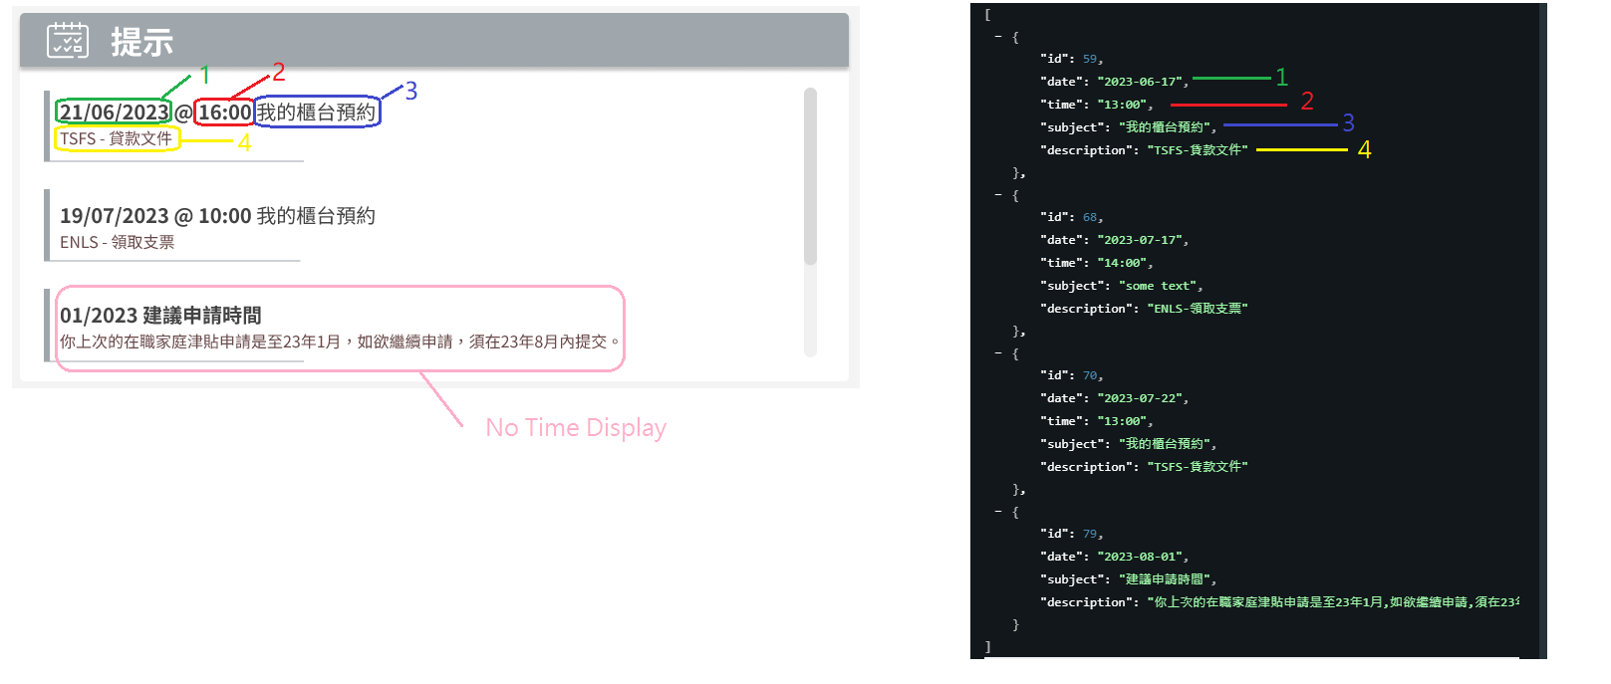
- Date field . may need format to dd/mm/yyyy. This is optional field. If date and time are not given, display as pink area. (i.e. subject only)
- Time field. @{time} . This is optional field. If date and time are not given, display as pink area. (i.e. subject only)
- Subject of reminder
- Description of reminder
Please note that this component should have a fixed height and display max 3 records at a time. If results list size > 3 , this component should be scrollable.

