# Introduction:

Air quality analysis in Tamil Nadu, a state in southern India, is of paramount importance due to its growing population, industrialization, and urbanization. Ensuring clean and breathable air is crucial for the well-being of the state's residents and the preservation of its environment. This introduction will provide an overview of the significance of air quality analysis in Tamil Nadu. Poor air quality has severe health implications, leading to respiratory diseases, cardiovascular issues, and other health problems. Vulnerable populations, such as children and the elderly, are particularly at risk. Effective air quality analysis is essential for mitigating these health risks. Air pollution not only affects human health but also harms the environment. It can lead to acid rain, damage to ecosystems, and the deterioration of historical monuments. Tamil Nadu has taken steps to monitor and control air pollution. Government agencies such as the Tamil Nadu Pollution Control Board (TNPCB) oversee air quality regulations and emission standards. Continuous monitoring stations are set up across the state to collect air quality data. Air quality analysis relies on advanced technologies, including air quality monitoring stations, satellite imagery, and data analytics. Innovations in sensor technology and data integration are helping to provide real-time air quality information.

# Flowchart:

Data collection

Data processing

Data analysis

Air quality index Calculation

Data visualization

# Steps involved in air quality analysis:

1. Data Collection:

- Establish monitoring stations: Set up air quality monitoring stations at various locations to collect data on air pollutants.

- Select monitoring parameters: Determine which air pollutants to monitor, such as particulate matter (PM), gases like nitrogen dioxide (NO2) and sulfur dioxide (SO2), ozone (O3), carbon monoxide (CO), and volatile organic compounds (VOCs).

- Continuous monitoring: Use instruments like gas analyzers, particle counters, and meteorological sensors for real-time data collection.

- Periodic sampling: Collect air samples for laboratory analysis to measure pollutants not monitored continuously.

2. Data Processing:

- Quality control: Ensure data accuracy and reliability through quality control measures, including sensor calibration and data validation.

- Data aggregation: Collect and store data over time, grouping it by location and pollutant type.

- Data integration: Combine air quality data with meteorological and geographic information to understand the influence of weather and geography on air quality.

3. Data Analysis:

- Descriptive analysis: Calculate statistical measures such as mean, median, and standard deviation to summarize air quality data.

- Trend analysis: Identify long-term trends in air pollutant concentrations to assess whether air quality is improving or deteriorating.

- Spatial analysis: Analyze spatial patterns to identify pollution hotspots and sources.

- Source apportionment: Determine the sources of pollutants using techniques like chemical mass balance or receptor modeling.

4. Air Quality Index (AQI) Calculation:

- Compute the AQI based on pollutant concentrations using standard formulas or guidelines provided by environmental agencies.

- Assign AQI categories (e.g., Good, Moderate, Unhealthy) to provide a simple representation of air quality to the public.

5. Data Visualization and Reporting:

- Create visualizations, such as charts, graphs, and maps, to make air quality data more understandable to the public and policymakers.

- Generate regular reports summarizing air quality trends, highlighting areas of concern, and providing recommendations for mitigation measures.

# Objectives of air quality analysis:

* Health Protection: Assess the levels of air pollutants to identify potential health risks to the population, especially vulnerable groups like children, the elderly, and individuals with preexisting health conditions.
* Environmental Preservation: Evaluate the impact of air pollution on ecosystems, vegetation, water bodies, and historical landmarks to protect natural resources and cultural heritage.
* Source Identification: Identify and quantify the sources of air pollutants, including industrial emissions, transportation, and natural sources, to target pollution control efforts effectively.
* Pollution Monitoring: Continuously monitor air pollutant concentrations and meteorological conditions to provide real-time information to the public, policymakers, and regulatory agencies.
* Trend Analysis: Analyze historical air quality data to identify long-term trends, seasonal variations, and patterns of pollutant concentrations.
* Air Quality Forecasting: Develop models and tools to forecast air quality conditions, allowing for early warnings and the implementation of mitigation measures during pollution events.
* Policy Development: Provide scientific data and analysis to support the development of air quality policies, regulations, and emission reduction strategies.
* Public Awareness: Raise public awareness about air quality issues, health risks, and protective measures through educational campaigns and public communication.
* Research and Innovation: Support research efforts to advance air quality analysis techniques, technologies, and models for better understanding and management of air pollution.

# Test Dataset:

A test dataset is a subset of data that is distinct from the training dataset and is used to assess the performance and evaluate the accuracy of a machine learning model or data analysis technique. The test dataset used for analysis is given below.

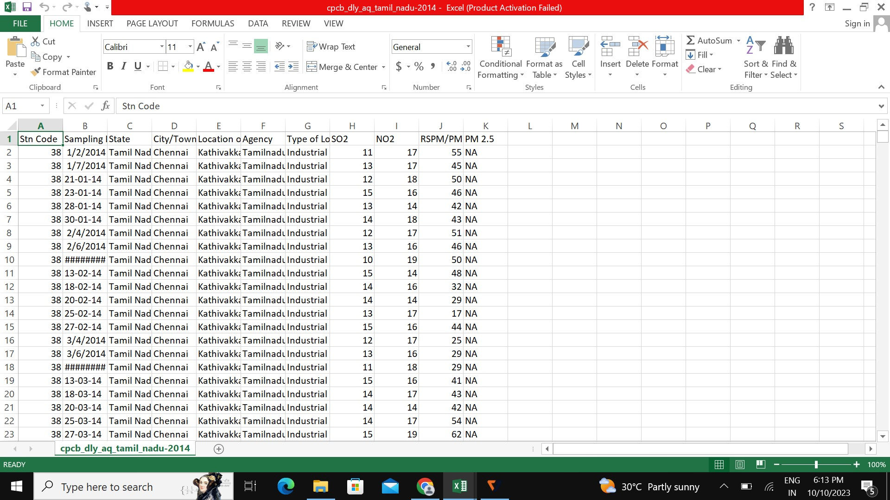

# Conclusion:

Tamil Nadu, particularly in major cities like Chennai and Coimbatore, faces air quality challenges. The air quality can vary significantly throughout the year, with periods of poor air quality primarily linked to factors such as industrial emissions, vehicular pollution, and meteorological conditions. Tamil Nadu experiences seasonal variations in air quality. For instance, during the monsoon season, air quality tends to improve due to rain, while it can deteriorate in dry, hot months. Rapid urbanization and a growing number of vehicles have contributed to vehicular pollution, particularly in Chennai. Initiatives to promote public transportation, electric vehicles, and stricter emission norms have been introduced to combat this issue. Industrial areas in Tamil Nadu contribute to air pollution, with emissions from manufacturing, chemical processing, and power generation being significant factors. The government has been working on stricter regulations and enforcement to mitigate industrial pollution.