**AIR QUALITY ASSESSMENT TAMIL NADU**

**INTRODUCTION:**

As part of the initiative, data from Tamil Nadu monitoring stations will be examined and shown. Understanding the amount of air pollution and developing a forecast model to determine RSPM/PM10 levels based on amounts of NO2 and SO2. The objectives of this project are established, and the analytical plan is a design is chosen, visualization techniques are used, and a prediction model is constructed.utilizing Python and the necessary libraries.

**DESCRIPTION:**

Phase 3 is all about prepping the data in the provided csv file in order to do various operations, including analysis, exploratory data analysis, and dataset visualization.

**PHASE 3 OF AIR QUALITY ANALYSIS:**

The phase 3 of the project **“AIR QUALITY ANALYSIS”** refers to visualizing of the data using the “IBM Cognos Tool”. The various charts displayed in this documen are Bar chart,Pie chart,Line chart and heat map.

**IBM COGNOS TOOL:**

The IBM Cognos tool is used for analyzing the files such as csv files and other files to visualize data from them.

* **LINE CHART:**
* RSPM/PM10 41 has the highest NO2 due to Stn Code 161.
* Stn Code 767 has the highest NO2 at 80, out of which SO2 18 contributed the most at 12.
* Stn Code 767 has the highest SO2 at 108, out of which RSPM/PM10 95 contributed the most at 4.
* RSPM/PM10 41 SO2 from Stn Code 71 is 4, whereas 44 is only 1.

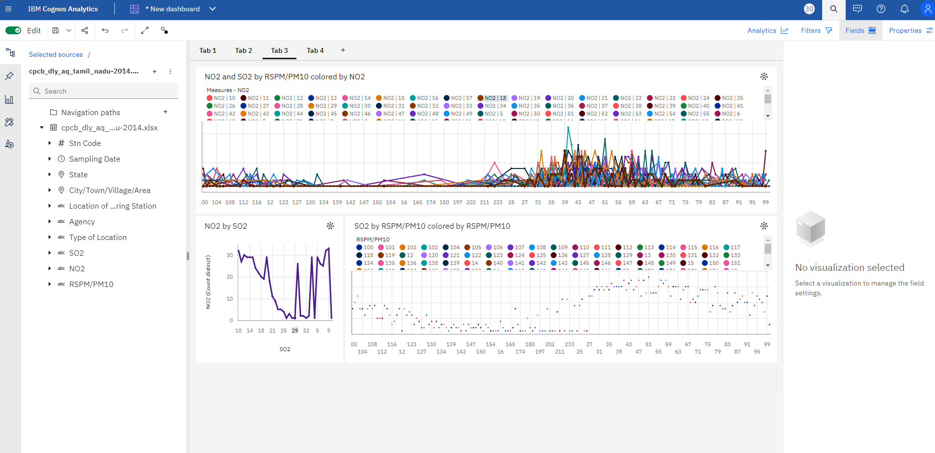

* **BAR CHART:**
* 13 has a RSPM/PM10 of 20 for Stn Code 366.
* NO2 22 RSPM/PM10 from Stn Code 239 is 17, whereas 24 is only 7.
* 4 has a RSPM/PM10 of 45 for Stn Code 375.
* City/Town/Village/Area Chennai has the highest RSPM/PM10 due to Stn Code 766.

