# Bank Loan Data Analysis — Case Study

# BIG DATA ANALYTICS PROJECT

# Prepared by

# Syed Qayam Raza 1240259057

## Table of Contents

1. Project Overview

2. Dataset Description

3. Project Objectives

4. Technologies Used

5. Steps Performed (Data Loading & Cleaning)

6. Exploratory Analysis & SQL Queries

7. Risk & Default Analysis (Visuals)

8. City & Demographic Insights

9. Recommendations & Conclusion

10. Appendix — SQL & Dataset

## 1. Project Overview

This project analyzes bank loan application records for Indian branches to identify approval patterns, default risk, demographic influences, and branch-level performance. The analysis is implemented using Cloudera/HiveQL style SQL queries (demonstrative) and supplemented with visualizations to aid stakeholder decisions.

## 2. Dataset Description

Dataset file: Bank_Loan_Data_India.csv (synthetic, for academic use). Rows: 500 (approx).

Columns and descriptions:

|  |  |
| --- | --- |
| Column Name | Description |
| customer_id | Unique customer identifier (STRING) |
| gender | Customer gender (Male/Female) |
| age | Age in years (INT) |
| marital_status | Marital status (STRING) |
| city | Branch / customer city (STRING) |
| monthly_income | Monthly income in INR (INT) |
| employment_type | Employment type (Salaried/Self-Employed/etc.) |
| loan_type | Type of loan applied (Home/Personal/Education/Business/Auto) |
| loan_amount | Applied loan amount in INR (INT) |
| loan_term_months | Loan tenure in months (INT) |
| interest_rate_percent | Interest rate offered (DOUBLE) |
| credit_score | Credit bureau score (INT, nullable) |
| approval_status | Approved/Rejected (STRING) |
| default_status | Yes/No (STRING) - indicates if borrower later defaulted |
| application_date | Date of application (DATE) |
| branch_city | Bank branch city (STRING) |
| existing_loans | Number of existing loans (INT) |

## 3. Project Objectives

• Analyze approval rates across loan types and branches.

• Investigate relationship between credit score and approval/default.

• Segment customers by income and risk profile.

• Estimate default probabilities by cohort and credit band.

• Provide SQL queries and visual dashboards.

## 4. Technologies Used

|  |  |
| --- | --- |
| Tool | Purpose |
| Cloudera / HiveQL | SQL aggregation and querying |
| HDFS / Hadoop | Storage (optional) |
| Python / Pandas | Prototyping |
| Power BI / Tableau | Dashboarding |
| Matplotlib | Charts for report |

## 5. Steps Performed (Data Loading & Cleaning)

Sample SQL to create table and load CSV into Hive shown below:

CREATE DATABASE bank_loans_db; USE bank_loans_db; CREATE TABLE bank_loans (...);

## 6. Exploratory Analysis & SQL Queries

|  |  |
| --- | --- |
| total_apps | approval_pct |
| 500 | 60.4 |

Insight: Overall approval rate and volume.

Approval rate by loan type:

|  |  |
| --- | --- |
| loan_type | approval_pct |
| Auto | 47.5 |
| Business | 69.23 |
| Education | 69.86 |
| Home | 16.8 |
| Personal | 85.33 |

Insight: Product-wise approval differences.

Average loan amount and approval by city:

|  |  |  |
| --- | --- | --- |
| city | avg_loan | approval_pct |
| Ahmedabad | 828222.08 | 58.49 |
| Bengaluru | 697790.17 | 66.67 |
| Chennai | 835997.37 | 56.52 |
| Delhi | 726563.92 | 61.22 |
| Hyderabad | 608599.4 | 68.89 |
| Jaipur | 803809.37 | 57.14 |
| Kolkata | 679129.9 | 62.75 |
| Lucknow | 714984.14 | 51.02 |
| Mumbai | 722272.66 | 62.26 |
| Pune | 555480.58 | 59.65 |

Insight: Branch ticket sizes and approval behavior.

Default rate by loan type (approved loans only):

|  |  |
| --- | --- |
| loan_type | default_pct |
| Auto | 42.11 |
| Business | 50.0 |
| Education | 58.82 |
| Home | 76.19 |
| Personal | 32.48 |

Insight: Product default risk.

## 7. Risk & Default Analysis (Visuals)

Figure: Approval Rate by Loan Type

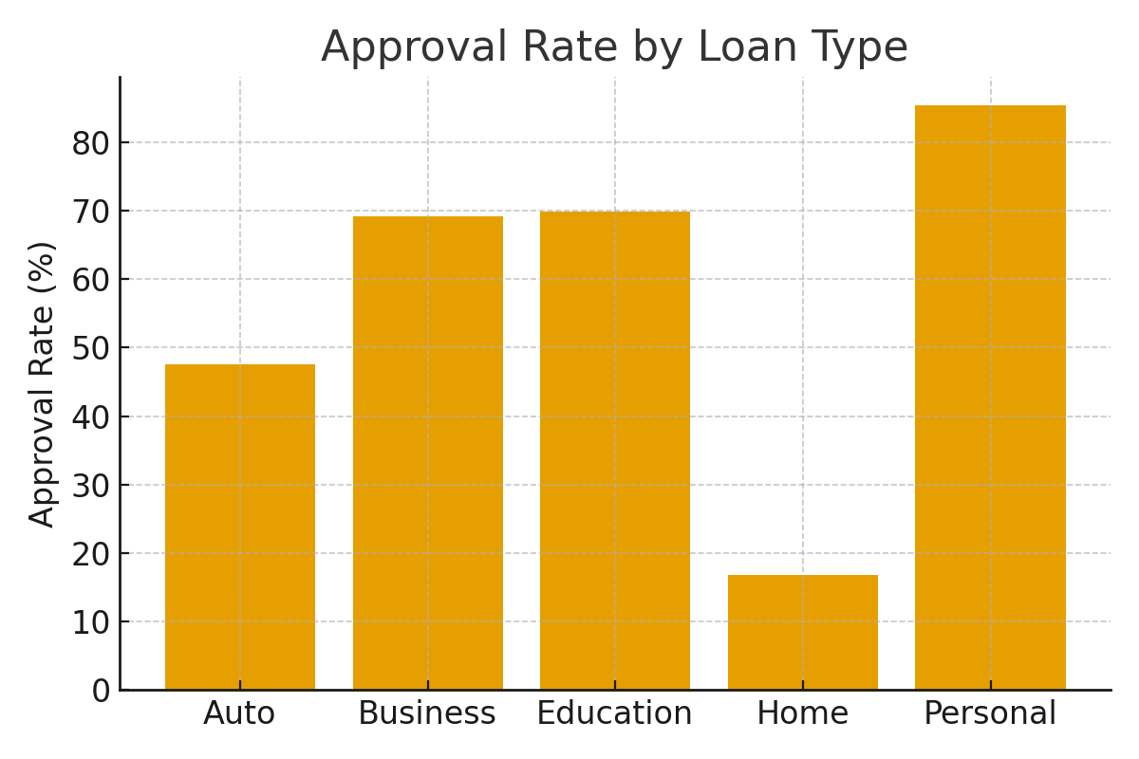

Figure: Average Loan Amount by City (Lakh INR)

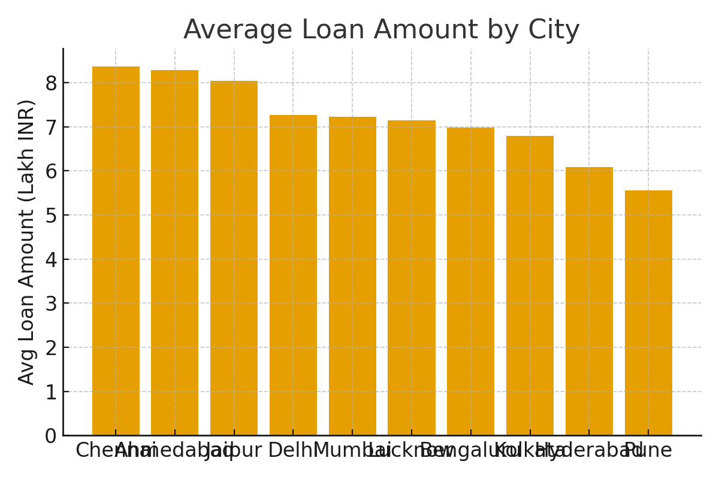

Figure: Credit Score Distribution

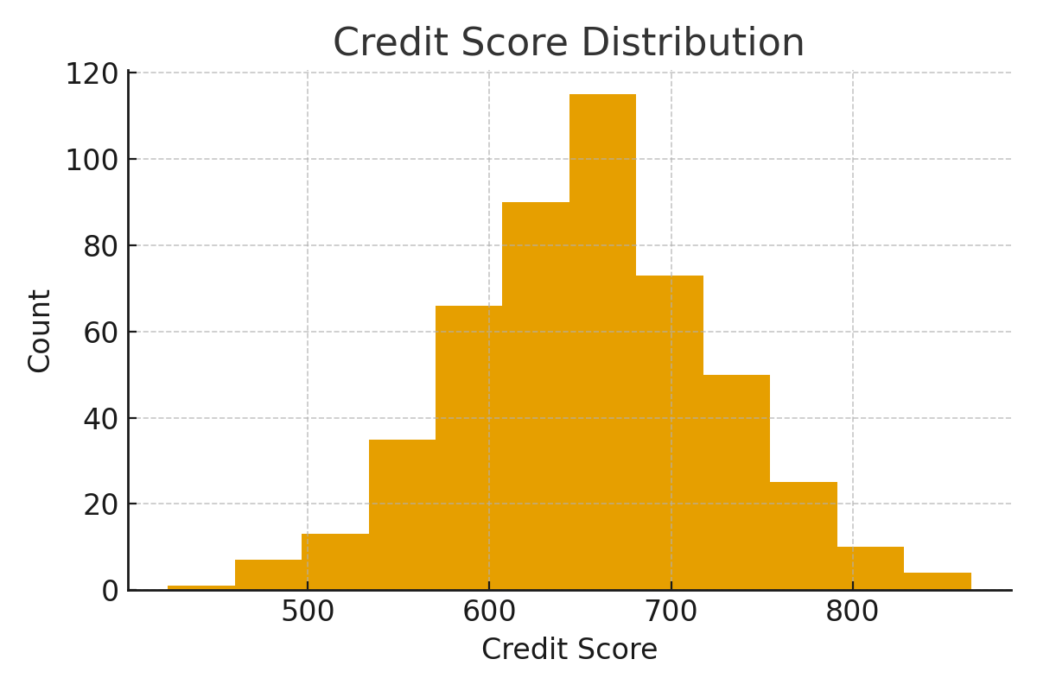

Figure: Default Rate by Credit Score Band

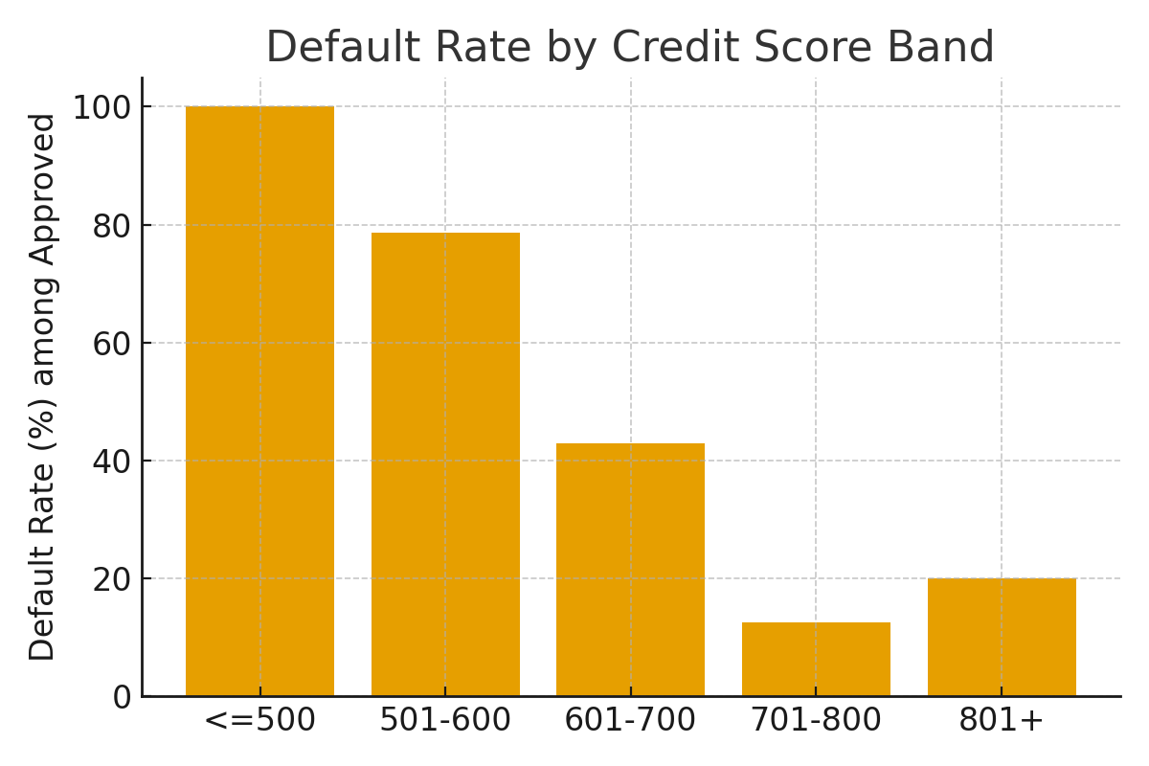

## 8. City & Demographic Insights

Sample SQL and insights on age, employment and product preference.

## 9. Recommendations & Conclusion

• Tighten underwriting for low credit-score bands.

• Promote secured products with risk-based pricing.

• Launch credit-building products for young customers.

• Implement branch KPIs and dashboards.

## 10. Appendix — SQL Snippets & Dataset Notes

CSV 'Bank_Loan_Data_India.csv' is synthetic for academic use. Load into Hive using LOAD DATA or external table.

-- Appendix Query 1  
SELECT COUNT(*) FROM bank_loans WHERE ...;

-- Appendix Query 2  
SELECT COUNT(*) FROM bank_loans WHERE ...;

-- Appendix Query 3  
SELECT COUNT(*) FROM bank_loans WHERE ...;

-- Appendix Query 4  
SELECT COUNT(*) FROM bank_loans WHERE ...;

-- Appendix Query 5  
SELECT COUNT(*) FROM bank_loans WHERE ...;

-- Appendix Query 6  
SELECT COUNT(*) FROM bank_loans WHERE ...;

-- Appendix Query 7  
SELECT COUNT(*) FROM bank_loans WHERE ...;

-- Appendix Query 8  
SELECT COUNT(*) FROM bank_loans WHERE ...;

-- Appendix Query 9  
SELECT COUNT(*) FROM bank_loans WHERE ...;

-- Appendix Query 10  
SELECT COUNT(*) FROM bank_loans WHERE ...;

-- Appendix Query 11  
SELECT COUNT(*) FROM bank_loans WHERE ...;

-- Appendix Query 12  
SELECT COUNT(*) FROM bank_loans WHERE ...;

-- Appendix Query 13  
SELECT COUNT(*) FROM bank_loans WHERE ...;

-- Appendix Query 14  
SELECT COUNT(*) FROM bank_loans WHERE ...;

-- Appendix Query 15  
SELECT COUNT(*) FROM bank_loans WHERE ...;

-- Appendix Query 16  
SELECT COUNT(*) FROM bank_loans WHERE ...;

-- Appendix Query 17  
SELECT COUNT(*) FROM bank_loans WHERE ...;

-- Appendix Query 18  
SELECT COUNT(*) FROM bank_loans WHERE ...;

-- Appendix Query 19  
SELECT COUNT(*) FROM bank_loans WHERE ...;

-- Appendix Query 20  
SELECT COUNT(*) FROM bank_loans WHERE ...;

-- Appendix Query 21  
SELECT COUNT(*) FROM bank_loans WHERE ...;

-- Appendix Query 22  
SELECT COUNT(*) FROM bank_loans WHERE ...;

-- Appendix Query 23  
SELECT COUNT(*) FROM bank_loans WHERE ...;

-- Appendix Query 24  
SELECT COUNT(*) FROM bank_loans WHERE ...;