

The University of Azad Jammu & Kashmir
Quiz 1

Name | Qousain Haider
Roll Number | 2024-CET-13
Semester | 4th
Date | 15-05-26
COURSE | GRAPHIC DESIGN/UI-UX
Question | Design a low-fidelity wireframe for a mobile app login screen.

Quiz solution:
Question: Design a low-fidelity wireframe for a mobile app login screen and explain how it improves user experience.
Low-Fidelity Wireframe

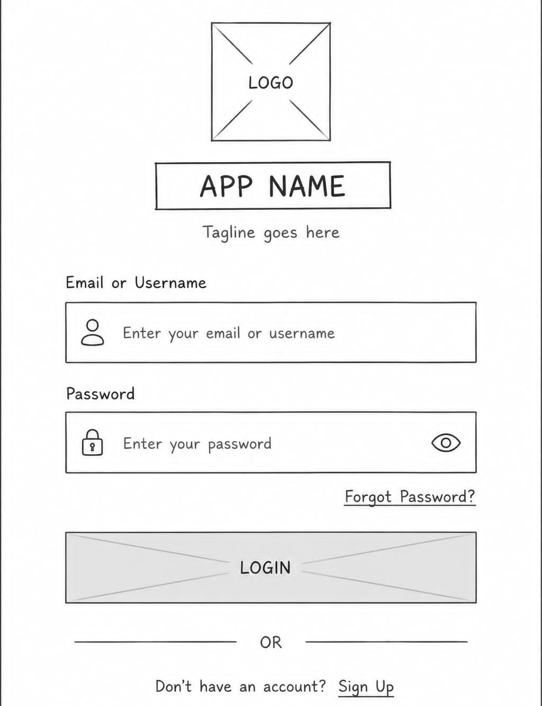

UX Explanation
- I placed the logo and title at the top so the screen feels familiar as soon as the user opens it.
- The input fields are large and easy to scan, which helps a new user understand where to type without confusion.
- The login button is centered and more visible, so the main action is easy to find quickly.
- Forgot password and sign-up options are also included, which supports both returning and new users in a simple way.

ANOTHER DESIGN:
