
University of Azad Jammu & Kashmir
Department of Software Engineering

Name: | SYED QOUSAIN HAIDER NAQVI
Roll Number: | 2024-CET-13
Session: | 2024-2028
Subject: | Graphic Designing
Lab Instructor: | Engr. Ahmed Khawaja
Class: | 4th Semester
Semester: | Spring-2026

MID TERM LAB EXAM
- QUESTION 01:
A new student society named "Creative Tech Society" has been launched in the Department of Software Engineering. The society wants to promote its first event, "Design Sprint 2026", where students will learn basic poster designing, logo designing, and branding skills.
- DESIGN:
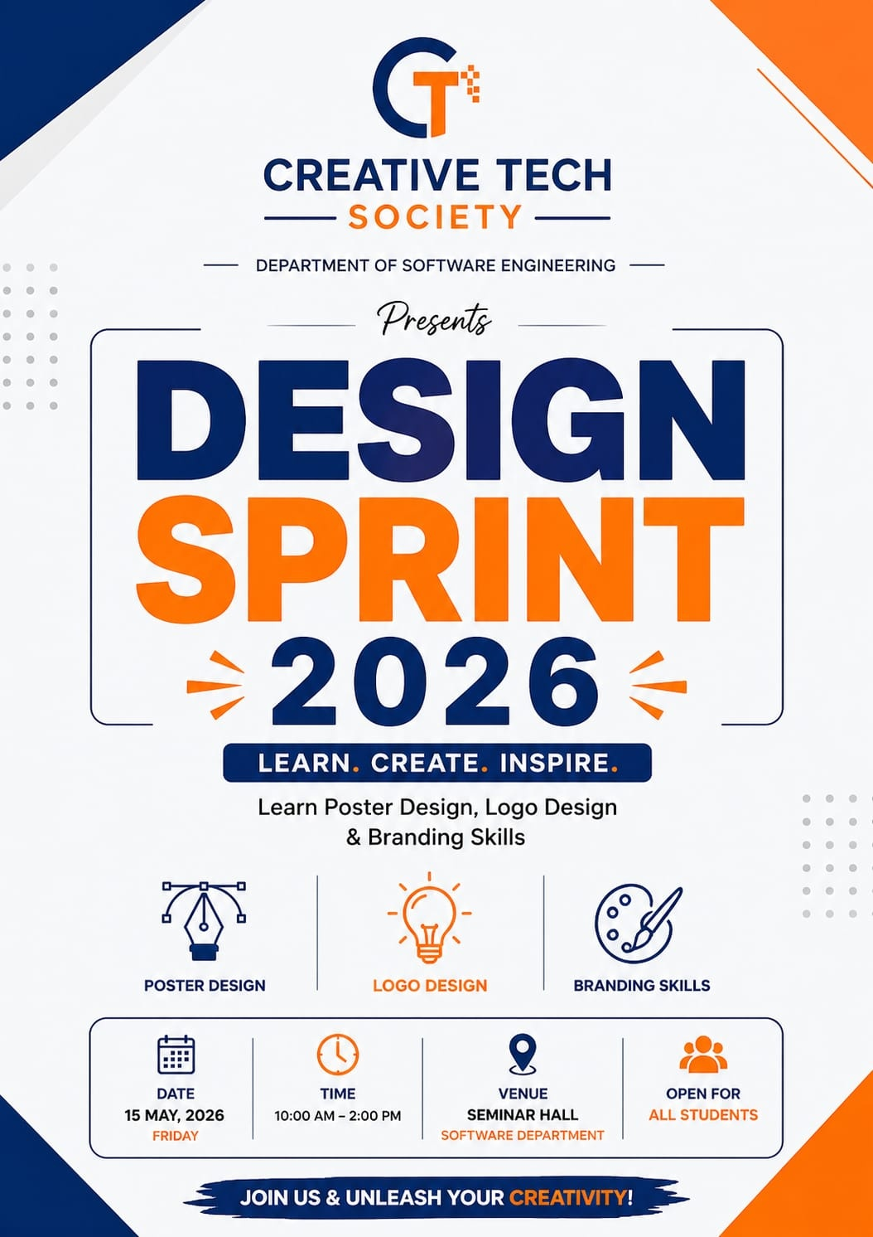

- QUESTION 02:
Design a simple and meaningful logo for "Creative Tech Society." The logo should represent creativity, technology, teamwork, or innovation. It should be suitable for use on posters, certificates, social media pages, and event banners.
- LOGO:
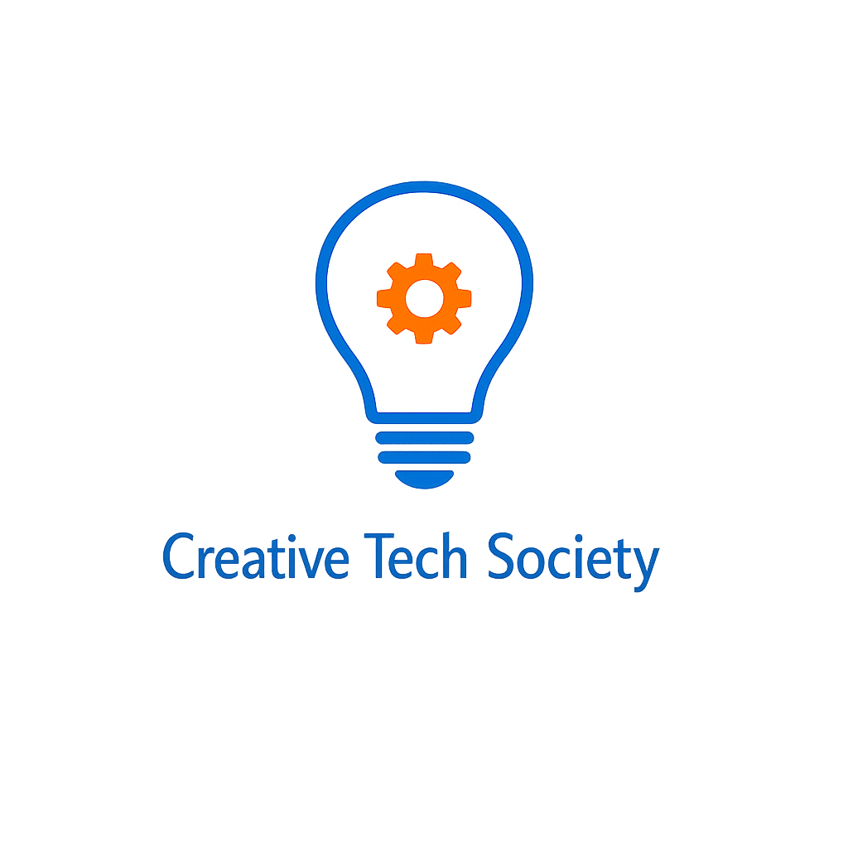

- QUESTION 3:
A startup named "GreenByte Solutions" is launching an awareness campaign titled "Save Energy, Save Future." The startup wants a poster to promote the campaign. Design a campaign poster with proper structure, clear message, readable text, a suitable green/environmental color scheme, balanced spacing, and professional alignment. Use relevant visual elements such as leaves, bulbs, earth, energy icons, or eco-friendly symbols.

- DESIGN:
