A PROJECT REPORT ON

HOTEL MANAGEMENT SYSTEM

YOUR NAME
CBSE Roll Number: 28610520
CLASS – XII SCIENCE
2025–2026



PM SHRI SCHOOL JAWAHAR NAVODAYA VIDYALAYA
BANAVASI–518360,
YEMMIGANUR (KURNOOL) DISTRICT, A.P.
PM SHRI SCHOOL JAWAHAR NAVODAYA VIDYALAYA
BANAVASI–518360,
YEMMIGANUR (KURNOOL) DISTRICT, A.P.



Certified that this is a bonafied report of the Project Work entitled

HOSPITAL MANAGEMENT

Submitted by

YOUR NAME

Roll Number: 28610520

In partial fulfillment of the requirement for the Practical Examination of Class – XII

Central Board of Secondary Education

in the subject of

Informatics PrActices (065)

(SYED RAFIQ) E PADMAVATHI
PGT IP PRINCIPAL
INTERNAL EXAMINER JNV, KURNOOL

Signature of the
EXTERNAL EXAMINER

DECLARATION

I, YOUR NAME, hereby declare that this project report entitled "HOSPITAL MANAGEMENT" submitted to Central Board of Secondary Education in partial fulfilment of Practical Examination of Class–XII in the subject of Informatics Practices (065) is a bonafied record of the work carried out by me during the academic year 2025–2026 under the supervision of
Mr.SYED RAFIQ, PGT (IP), PM SHRI Jawahar Navodaya Vidyalaya, Banavasi, Yemmiganur (Kurnool) District, A. P.

I further declare that this project is a result of my own effort and not been submitted previously for any institution or for any other purpose.

Place : BANAVASI Signature of the Student

Date : Roll Number: 28610520

ACKNOWLEDGEMENTS

I sincerely acknowledge my deep sense of gratitude to Smt. E.PADMAVATHI, Principal, JNV, Banavasi for his valuable suggestions and encouragement during the course of study and in particular for her help and encouragement throughout this project work.

I extend my sincere thanks to all staff members of JNV, Kurnool for their
co–operation and attention towards me in data collection and all other aspects of the administration.

I am greatly indebted to my parents and all my friends who gave me moral and able support during this project work. Without the support of all these members, this project may not be at its best.

YOUR NAME1
YOUR NAME2
YOUR NAME3
YOUR NAME4

INTRODUCTION OF PROJECT –

HOTEL MANAGEMENT SYSTEM
The Hotel Management System is a computer-based application developed to manage the day-to-day activities of a hotel efficiently. The main purpose of this project is to simplify hotel operations such as room booking, customer registration, room allocation, food billing, payment processing, and maintaining customer records.
In the traditional method, hotel information is maintained manually in registers, which may lead to errors, duplication of records, and difficulty in retrieving information. The Hotel Management System overcomes these problems by storing and managing data digitally.
This project is developed using Python as the programming language and MySQL as the database management system. Python is used to create an interactive, menu-driven application, while MySQL stores customer details, room information, booking records, and billing details. The system allows hotel staff to add, view, search, update, and delete records whenever required.
The project helps improve the accuracy, speed, and efficiency of hotel management. It also reduces paperwork, saves time, and provides a systematic way to maintain hotel records. This project demonstrates the practical application of Python programming and database connectivity in solving real-world problems.

Objectives of the Project – Hotel Management System
The main objectives of the Hotel Management System are:
1. To automate hotel operations: Simplify daily activities such as room booking, customer registration, and room allocation.
2. To maintain customer records: Store and manage customer details, including names, contact numbers, check-in dates, and check-out dates.
3. To manage room availability: Maintain room details, room types, tariffs, and booking status.
4. To simplify billing and payments: Calculate room charges and other applicable expenses and generate customer bills.
5. To provide efficient data management: Use MySQL to store, retrieve, update, and delete hotel records systematically.
6. To reduce manual errors: Minimize errors and duplication associated with maintaining records manually.
7. To save time and effort: Enable hotel staff to access information quickly and perform tasks efficiently.
8. To generate accurate reports: Provide useful information about bookings, customer details, room occupancy, and billing.
9. To improve customer service: Help hotel staff provide faster and more organized service to customers.
10. To apply programming concepts: Demonstrate the practical use of Python, MySQL, and database connectivity in developing a real-world application.

Software and Hardware Requirements

1. Software Requirements
S.No | Software | Description
1 | Operating System: Windows 10 / 11 | For running Python and MySQL smoothly.
2 | Programming Language: Python 3.10 or above | Used for developing the chatbot and integrating AI logic.
3 | IDE / Code Editor: IDLE / VS Code / PyCharm | For writing, debugging, and executing Python programs.
4 | Database: MySQL Server / XAMPP / WAMP | To store and retrieve chatbot conversation data or FAQs.
5 | Python Libraries: chatterbot, nltk, mysql.connector, pandas, matplotlib | For AI, NLP, database connectivity, and visualization.
6 | Web Browser: Google Chrome / Edge | For displaying chatbot interface (if using GUI or web version).

2. Hardware Requirements
S.No | Hardware | Minimum Specification
1 | Processor: | Intel Core i3 or higher
2 | RAM: | 4 GB or more
3 | Hard Disk: | Minimum 500 GB
4 | Keyboard and Mouse: | For user input and interaction
5 | Monitor: | Standard Display (15-inch or higher)
6 | Internet Connection: | Required for installing libraries or cloud-based data access

SYSTEM IMPLEMENTATION
Step 1: | To connect Python to MySQL, ‘mysql–connector–python’ need to be installed using ‘pip’ command. Ensure proper internet connectivity while installing.  C:\>pip install mysql–connector–python
Step 2: | Ensure proper import of mysql.connector in Python IDLE without generating any error  >>> import mysql.connector  >>>  If the above statement doesn’t generate any error, then  mysql–connector is properly installed.

About the Operating System
This project can run on Windows 10 or Windows 11. The operating system provides the environment needed to run Python, MySQL Server, and the project program.

Python Programming Language
Python is a high-level, general-purpose programming language known for its readable syntax. In this project, Python controls the menu, accepts customer and booking details, communicates with MySQL, handles errors, and displays charts.

Main Python Libraries
1. mysql.connector: Connects the Python program to the MySQL database and executes SQL statements.
2. tkinter.simpledialog: Displays a password-entry dialog when the program starts.
3. datetime: Validates the check-in and check-out dates and ensures that the check-out date is after the check-in date.
4. matplotlib.pyplot: Creates a line chart of bookings by check-in date, a bar chart of room types, and a histogram of room prices.

Database Management System (DBMS)
A Database Management System (DBMS) is software used to create, store, retrieve, and manage data. This project uses MySQL, a relational DBMS, to store customer, room, booking, and billing records in separate tables.

Structured Query Language (SQL)
SQL is used to work with data in a relational database. The project uses CREATE DATABASE and CREATE TABLE to define the database structure; INSERT to add records; SELECT to retrieve records; UPDATE to change room status; and JOIN to display booking details with customer names.

Python–MySQL Connectivity
Install the connector from Command Prompt using:
pip install mysql-connector-python
Import the connector in Python with `import mysql.connector`. The program connects to the local MySQL server using the database name `hotel`. SQL statements are executed through a cursor, and `commit()` saves changes. The cursor and connection are closed when the program exits.

Data Visualization
Matplotlib is used to present database information graphically. The line chart shows booking counts by check-in date, the bar chart compares the number of rooms in each room type, and the histogram shows the distribution of room prices.
MYSQL DATABASE TABLES

The Hotel Management System uses MySQL to store customer details, room information, booking records, and billing information. The database name is hotel.

1. Create Database
CREATE DATABASE hotel;
USE hotel;

2. Customer Table
Stores customer details.
CREATE TABLE Customer (
CustomerID INT PRIMARY KEY AUTO_INCREMENT,
CustomerName VARCHAR(50) NOT NULL,
Phone VARCHAR(15),
Address VARCHAR(100)
);

3. Room Table
Stores room number, type, price, and availability status.
CREATE TABLE Room (
RoomNo INT PRIMARY KEY,
RoomType VARCHAR(20),
Price DECIMAL(10,2),
Status VARCHAR(20) DEFAULT 'Available'
);

4. Booking Table
Stores customer room bookings and check-in/check-out dates.
CREATE TABLE Booking (
BookingID INT PRIMARY KEY AUTO_INCREMENT,
CustomerID INT,
RoomNo INT,
CheckIn DATE,
CheckOut DATE,
FOREIGN KEY (CustomerID) REFERENCES Customer(CustomerID),
FOREIGN KEY (RoomNo) REFERENCES Room(RoomNo)
);

5. Billing Table
Stores bill amounts and payment information.
CREATE TABLE Billing (
BillID INT PRIMARY KEY AUTO_INCREMENT,
BookingID INT,
TotalAmount DECIMAL(10,2),
PaymentMode VARCHAR(20),
PaymentStatus VARCHAR(20) DEFAULT 'Pending',
FOREIGN KEY (BookingID) REFERENCES Booking(BookingID)
);

6. Sample Records
INSERT INTO Customer (CustomerName, Phone, Address) VALUES
('Rahul Sharma', '9876543210', 'Hyderabad'),
('Priya Reddy', '9876501234', 'Vijayawada');
INSERT INTO Room (RoomNo, RoomType, Price, Status) VALUES
(101, 'Single', 1000.00, 'Available'),
(102, 'Double', 1800.00, 'Available'),
(103, 'Deluxe', 2500.00, 'Available');

7. Display the Tables
SHOW TABLES;
SELECT * FROM Customer;
SELECT * FROM Room;
SELECT * FROM Booking;
SELECT * FROM Billing;

Table Relationships
Table | Primary Key | Foreign Key
Customer | CustomerID | —
Room | RoomNo | —
Booking | BookingID | CustomerID, RoomNo
Billing | BillID | BookingID
Note: PK means Primary Key and FK means Foreign Key. Booking connects customers to rooms, and Billing connects a bill to a booking.

SOURCE CODE
#Menu driven program for transfer data from MySQL to Python DataFrame and for Analysis and Visualize Data

import mysql.connector
import tkinter as tk
from tkinter import simpledialog
import matplotlib.pyplot as plt
from datetime import datetime

# MySQL password dialog (shows * while typing)
root = tk.Tk()
root.withdraw()

password = simpledialog.askstring(
"MySQL Login",
"Enter MySQL password:",
show="*"
)
root.destroy()

if password is None:
raise SystemExit("Login cancelled.")

# Connect to MySQL
con = mysql.connector.connect(
host="localhost",
user="root",
password=password,
database="hotel"
)

cur = con.cursor()

# 1. Add customer
def add_customer():
name = input("Customer name: ")
phone = input("Phone number: ")
address = input("Address: ")
cur.execute(
"""INSERT INTO customer
(CustomerName, Phone, Address)
VALUES (%s, %s, %s)""",
(name, phone, address)
)
con.commit()
print("Customer added successfully.")
# 2. View customers
def view_customers():
cur.execute("SELECT * FROM customer")
print("\nCUSTOMER DETAILS")

for row in cur.fetchall():
print(row)

# 3. View rooms
def view_rooms():
cur.execute("SELECT * FROM room")
print("\nROOM DETAILS")

for row in cur.fetchall():
print(row)

# 4. Book a room
def book_room():
try:
customer_id = int(input("Customer ID: "))
room_no = int(input("Room number: "))
check_in = input("Check-in (YYYY-MM-DD): ")
check_out = input("Check-out (YYYY-MM-DD): ")

start = datetime.strptime(
check_in, "%Y-%m-%d"
).date()
end = datetime.strptime(
check_out, "%Y-%m-%d"
).date()

if end <= start:
print("Check-out must be after check-in.")
return

cur.execute(
"SELECT CustomerID FROM customer WHERE CustomerID=%s",
(customer_id,)
)

if cur.fetchone() is None:
print("Customer not found.")
return

cur.execute(
"SELECT Status FROM room WHERE RoomNo=%s",
(room_no,)
)
room = cur.fetchone()

if room is None or room[0] != "Available":
print("Room is not available.")
return
cur.execute(
"""INSERT INTO booking
(CustomerID, RoomNo, CheckIn, CheckOut)
VALUES (%s, %s, %s, %s)""",
(customer_id, room_no, check_in, check_out)
)
cur.execute(
"UPDATE room SET Status='Booked' WHERE RoomNo=%s",
(room_no,)
)
con.commit()
print("Room booked successfully.")

except ValueError:
con.rollback()
print("Invalid ID or date format.")
except mysql.connector.Error as err:
con.rollback()
print("Booking error:", err)
# 5. View bookings
def view_bookings():
cur.execute(
"""SELECT b.BookingID, c.CustomerName,
b.RoomNo, b.CheckIn, b.CheckOut
FROM booking b
JOIN customer c
ON b.CustomerID = c.CustomerID"""
)
print("\nBOOKING DETAILS")
for row in cur.fetchall():
print(row)
# 6. Display all three charts in one window
def show_all_charts():

# Line chart: Bookings by check-in date
cur.execute(
"""SELECT CheckIn, COUNT(*)
FROM booking
GROUP BY CheckIn
ORDER BY CheckIn"""
)
booking_data = cur.fetchall()

dates = [str(row[0]) for row in booking_data]
booking_counts = [row[1] for row in booking_data]

# Bar chart: Number of rooms by type
cur.execute(
"""SELECT RoomType, COUNT(*)
FROM room
GROUP BY RoomType
ORDER BY RoomType"""
)
room_data = cur.fetchall()
room_types = [row[0] for row in room_data]
room_counts = [row[1] for row in room_data]
# Histogram: Distribution of room prices
cur.execute(
"SELECT Price FROM room WHERE Price IS NOT NULL"
)
price_data = cur.fetchall()

prices = [float(row[0]) for row in price_data]
# Create one window with three charts
fig, axes = plt.subplots(1, 3, figsize=(15, 5))

# Line chart
if dates:
axes[0].plot(
dates, booking_counts,
marker="o", label="Bookings"
)
axes[0].legend()
else:
axes[0].text(
0.5, 0.5, "No booking records",
ha="center", va="center"
)
axes[0].set_title("Bookings by Date")
axes[0].set_xlabel("Check-in Date")
axes[0].set_ylabel("Number of Bookings")
axes[0].tick_params(axis="x", rotation=45)
# Bar chart
if room_types:
axes[1].bar(
room_types, room_counts, label="Rooms"
)
axes[1].legend()

axes[1].set_title("Rooms by Type")
axes[1].set_xlabel("Room Type")
axes[1].set_ylabel("Number of Rooms")
# Histogram
if prices:
axes[2].hist(
prices, bins=5,
edgecolor="black", label="Room Prices"
)
axes[2].legend()
else:
axes[2].text(
0.5, 0.5, "No room prices",
ha="center", va="center"
)
axes[2].set_title("Room Price Distribution")
axes[2].set_xlabel("Room Price (Rs.)")
axes[2].set_ylabel("Number of Rooms")
fig.tight_layout()
plt.show()
# Main menu
try:
while True:
print("\n===== HOTEL MANAGEMENT SYSTEM =====")
print("1. Add Customer")
print("2. View Customers")
print("3. View Rooms")
print("4. Book Room")
print("5. View Bookings")
print("6. Display All Charts")
print("7. Exit")
choice = input("Enter choice: ")
try:
if choice == "1":
add_customer()
elif choice == "2":
view_customers()
elif choice == "3":
view_rooms()
elif choice == "4":
book_room()
elif choice == "5":
view_bookings()
elif choice == "6":
show_all_charts()
elif choice == "7":
break
else:
print("Invalid choice.")

except mysql.connector.Error as err:
con.rollback()
print("Database error:", err)

finally:
cur.close()
con.close()
print("MySQL connection closed.") plt.show()

VISUALIZATION OF TABLES
Line Chart
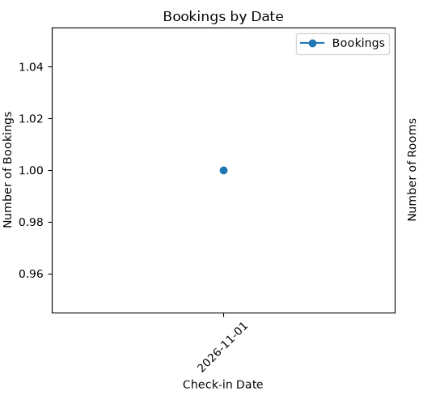
BAR CHART
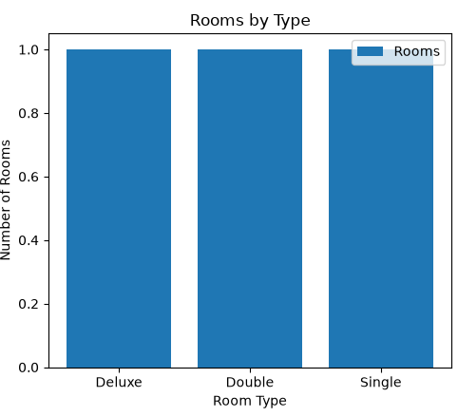
HISTOGRAM

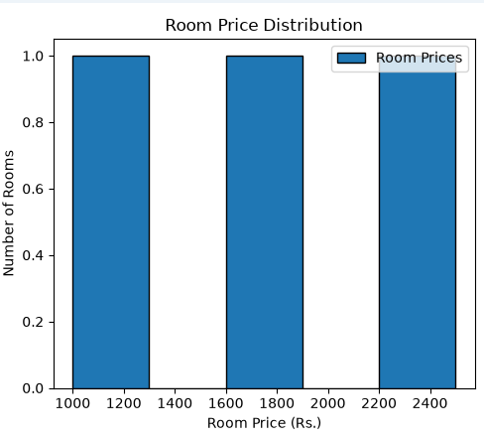

Conclusion

CONCLUSION OF THE PROJECT – HOTEL MANAGEMENT SYSTEM
The Hotel Management System project successfully demonstrates the use of Python programming and MySQL database management to automate basic hotel operations. The system allows users to add and view customer details, display room information, manage room bookings, and view booking records through a simple menu-driven interface.
MySQL is used to store and retrieve customer, room, booking, and billing information in an organized manner. Matplotlib is also integrated into the project to display data using line charts, bar charts, and histograms, helping users understand booking trends, room types, and room price distributions.
This project reduces manual record-keeping, improves the organization of hotel information, and demonstrates the practical application of database connectivity and data visualization. Through this project, students gain hands-on experience with Python functions, SQL queries, database operations, exception handling, and graphical data representation.
In conclusion, the Hotel Management System provides a foundation for developing more advanced hotel applications. In the future, it can be enhanced with online reservations, date-wise room availability, customer check-out management, automated billing, payment integration, and report generation.

BIBLIOGRAPHY

- Informatics Practices Text Book by NCERT for Class–XII
• Python Official Documentation – Python 3.13: https://docs.python.org/3/
• MySQL Official Documentation – MySQL 8.0: https://dev.mysql.com/doc/
• Matplotlib Documentation – Python Data Visualization Library: https://matplotlib.org/
• Seaborn Documentation – Statistical Data Visualization: https://seaborn.pydata.org/
• CBSE Class 12 Computer Science Syllabus 2022–25: https://www.cbse.gov.in/
• “AI Chatbots – Concepts and Applications”, Journal of Artificial Intelligence Research, 2023.
• TutorialsPoint – Python MySQL Integration: https://www.tutorialspoint.com/python_mysql/index.htm
• GeeksforGeeks – Data Analysis with Python: https://www.geeksforgeeks.org/data-analysis-in-python/

