A PROJECT REPORT ON

COVID-19 Data Analysis System

YOUR NAME
CBSE Roll Number:
CLASS – XII SCIENCE
2026–2027



PM SHRI SCHOOL JAWAHAR NAVODAYA VIDYALAYA
MADDIRALA-522616,
CHILAKALURIPETA,PALNADU DISTRICT, A.P.

PM SHRI SCHOOL JAWAHAR NAVODAYA VIDYALAYA
MADDIRALA-522616,
CHILAKALURIPETA,PALNADU DISTRICT, A.P.



Certified that this is a bonafied report of the Project Work entitled

HOSPITAL MANAGEMENT

Submitted by

YOUR NAME

Roll Number: 28610520

In partial fulfillment of the requirement for the Practical Examination of Class – XII

Central Board of Secondary Education

in the subject of

Informatics PrActices (065)

(SYED RAFIQ) P.SRINIVASA RAO
PGT IP PRINCIPAL
INTERNAL EXAMINER JNV, PALNADU

Signature of the
EXTERNAL EXAMINER

DECLARATION

I, YOUR NAME, hereby declare that this project report entitled "HOSPITAL MANAGEMENT" submitted to Central Board of Secondary Education in partial fulfilment of Practical Examination of Class–XII in the subject of Informatics Practices (065) is a bonafied record of the work carried out by me during the academic year 2026–2027 under the supervision of
Mr.SYED RAFIQ, PGT (IP), PM SHRI Jawahar Navodaya Vidyalaya, Maddirala, Chilakaluri Peta(Planadu) District, A. P.

I further declare that this project is a result of my own effort and not been submitted previously for any institution or for any other purpose.

Place : MADDIRALA Signature of the Student

Date : Roll Number: 28610520

ACKNOWLEDGEMENTS

I sincerely acknowledge my deep sense of gratitude to Sri.P.Srinivasa Rao, Principal, JNV, Palnadu for his valuable suggestions and encouragement during the course of study and in particular for her help and encouragement throughout this project work.

I extend my sincere thanks to all staff members of JNV, Planadu for their
co–operation and attention towards me in data collection and all other aspects of the administration.

I am greatly indebted to my parents and all my friends who gave me moral and able support during this project work. Without the support of all these members, this project may not be at its best.

YOUR NAME1
YOUR NAME2
YOUR NAME3
YOUR NAME4

SNO | PARTICUALRS
1 | INTRODUCTION OF PROJECT
2 | OBJECTIVES AND SCOPE OF THE PROJECT
3 | SOFTWARE & HARDWARE REQUIREMENTS
4 | SYSTEM DESIGN AND IMPLEMENTATION
5 | MYSQL DATABASE DESIGN AND TABLE STRUCTURE
6 | PYTHON SOURCE CODE
7 | DATA ANALYSIS AND GRAPHICAL REPRESENTATION
8 | OUTPUTS AND SAMPLE RESULTS
9 | CONCLUSION
10 | BIBIOLOGRAPHY

1.INTRODUCTION OF PROJECT –

COVID-19 Data Analysis System
The COVID-19 pandemic affected public health systems and communities worldwide. Analyzing COVID-19 data helps us understand how confirmed cases, recoveries, and deaths changed over time.
The COVID-19 Data Analysis System is a Python-based application designed to store, retrieve, process, and analyze COVID-19 statistics. MySQL is used to store the data, Pandas is used to organize and analyze records in DataFrames, and Matplotlib is used to present trends and comparisons through graphs.
The system provides tabular reports, location-wise comparisons, summary calculations, and graphical representations of COVID-19 statistics.

2.Objectives of the Project – covid

Objectives
- To maintain COVID-19 statistics in a structured MySQL database.
- To record confirmed cases, recoveries, and deaths by date and location.
- To calculate active cases from the recorded cumulative figures.
- To retrieve and filter data using SQL queries.
- To analyze records using Pandas DataFrames.
- To compare statistics across locations and dates.
- To represent trends and distributions using Matplotlib graphs.
- To demonstrate practical applications of Python, SQL, Pandas, and data visualization.

3.Software and Hardware Requirements

1. Software Requirements
S.No | Software | Description
1 | Operating System: Windows 10 / 11 | For running Python and MySQL smoothly.
2 | Programming Language: Python 3.10 or above | Used for developing the chatbot and integrating AI logic.
3 | IDE / Code Editor: IDLE / VS Code / PyCharm | For writing, debugging, and executing Python programs.
4 | Database: MySQL Server / XAMPP / WAMP | To store and retrieve chatbot conversation data or FAQs.
5 | Python Libraries: chatterbot, nltk, mysql.connector, pandas, matplotlib | For AI, NLP, database connectivity, and visualization.
6 | Web Browser: Google Chrome / Edge | For displaying chatbot interface (if using GUI or web version).

2. Hardware Requirements
S.No | Hardware | Minimum Specification
1 | Processor: | Intel Core i3 or higher
2 | RAM: | 4 GB or more
3 | Hard Disk: | Minimum 500 GB
4 | Keyboard and Mouse: | For user input and interaction
5 | Monitor: | Standard Display (15-inch or higher)
6 | Internet Connection: | Required for installing libraries or cloud-based data access

4.SYSTEM IMPLEMENTATION
Step 1: | To connect Python to MySQL, ‘mysql–connector–python’ need to be installed using ‘pip’ command. Ensure proper internet connectivity while installing.  C:\>pip install mysql–connector–python
Step 2: | Ensure proper import of mysql.connector in Python IDLE without generating any error  >>> import mysql.connector  >>>  If the above statement doesn’t generate any error, then  mysql–connector is properly installed.

About the Operating System
This project can run on Windows 10 or Windows 11. The operating system provides the environment needed to run Python, MySQL Server, and the project program.

Python Programming Language
Python is a high-level, general-purpose programming language known for its readable syntax. In this project, Python controls the menu, accepts customer and booking details, communicates with MySQL, handles errors, and displays charts.

Main Python Libraries
1. mysql.connector: Connects the Python program to the MySQL database and executes SQL statements.
2. tkinter.simpledialog: Displays a password-entry dialog when the program starts.
3. datetime: Validates the check-in and check-out dates and ensures that the check-out date is after the check-in date.
4. matplotlib.pyplot: Creates a line chart of bookings by check-in date, a bar chart of room types, and a histogram of room prices.

Database Management System (DBMS)
A Database Management System (DBMS) is software used to create, store, retrieve, and manage data. This project uses MySQL, a relational DBMS, to store customer, room, booking, and billing records in separate tables.

Structured Query Language (SQL)
SQL is used to work with data in a relational database. The project uses CREATE DATABASE and CREATE TABLE to define the database structure; INSERT to add records; SELECT to retrieve records; UPDATE to change room status; and JOIN to display booking details with customer names.

Python–MySQL Connectivity
Install the connector from Command Prompt using:
pip install mysql-connector-python
Import the connector in Python with `import mysql.connector`. The program connects to the local MySQL server using the database name `hotel`. SQL statements are executed through a cursor, and `commit()` saves changes. The cursor and connection are closed when the program exits.

Data Visualization
Matplotlib is used to present database information graphically. The line chart shows booking counts by check-in date, the bar chart compares the number of rooms in each room type, and the histogram shows the distribution of room prices.

5.MYSQL DATABASE TABLES

The Hotel Management System uses MySQL to store customer details, room information, booking records, and billing information. The database name is hotel.

1. Create Database
CREATE DATABASE covid;
USE hotel;

2. Customer Table
Stores customer details.
CREATE TABLE Customer (
CustomerID INT PRIMARY KEY AUTO_INCREMENT,
CustomerName VARCHAR(50) NOT NULL,
Phone VARCHAR(15),
Address VARCHAR(100)
);

3. Room Table
Stores room number, type, price, and availability status.
CREATE TABLE Room (
RoomNo INT PRIMARY KEY,
RoomType VARCHAR(20),
Price DECIMAL(10,2),
Status VARCHAR(20) DEFAULT 'Available'
);

4. Booking Table
Stores customer room bookings and check-in/check-out dates.
CREATE TABLE Booking (
BookingID INT PRIMARY KEY AUTO_INCREMENT,
CustomerID INT,
RoomNo INT,
CheckIn DATE,
CheckOut DATE,
FOREIGN KEY (CustomerID) REFERENCES Customer(CustomerID),
FOREIGN KEY (RoomNo) REFERENCES Room(RoomNo)
);

5. Billing Table
Stores bill amounts and payment information.
CREATE TABLE Billing (
BillID INT PRIMARY KEY AUTO_INCREMENT,
BookingID INT,
TotalAmount DECIMAL(10,2),
PaymentMode VARCHAR(20),
PaymentStatus VARCHAR(20) DEFAULT 'Pending',
FOREIGN KEY (BookingID) REFERENCES Booking(BookingID)
);

6. Sample Records
INSERT INTO Customer (CustomerName, Phone, Address) VALUES
('Rahul Sharma', '9876543210', 'Hyderabad'),
('Priya Reddy', '9876501234', 'Vijayawada');
INSERT INTO Room (RoomNo, RoomType, Price, Status) VALUES
(101, 'Single', 1000.00, 'Available'),
(102, 'Double', 1800.00, 'Available'),
(103, 'Deluxe', 2500.00, 'Available');

7. Display the Tables
SHOW TABLES;
SELECT * FROM Customer;
SELECT * FROM Room;
SELECT * FROM Booking;
SELECT * FROM Billing;

Table Relationships
Table | Primary Key | Foreign Key
Customer | CustomerID | —
Room | RoomNo | —
Booking | BookingID | CustomerID, RoomNo
Billing | BillID | BookingID
Note: PK means Primary Key and FK means Foreign Key. Booking connects customers to rooms, and Billing connects a bill to a booking.

6.SOURCE CODE
# COVID-19 DATA ANALYSIS SYSTEM
# CBSE Class XII Informatics Practices (065) Project
# MySQL database: covid | MySQL table: covid
# Uses mysql.connector, Pandas and Matplotlib. No SQLAlchemy.

import mysql.connector
import pandas as pd
import matplotlib.pyplot as plt

def get_connection():
return mysql.connector.connect(
host="localhost",
user="root",
password="tiger", # Replace with your actual MySQL password
database="covid"
)

def fetch_data(query, params=None):
"""Fetch query results using MySQL Connector, without pandas.read_sql()."""
con = get_connection()
try:
cursor = con.cursor()
cursor.execute(query, params or ())
rows = cursor.fetchall()
columns = [column[0] for column in cursor.description] if cursor.description else []
return pd.DataFrame(rows, columns=columns)
finally:
con.close()

def display_all():
df = fetch_data(
"SELECT report_date, location, confirmed, recovered, deaths "
"FROM covid ORDER BY location, report_date"
)
if df.empty:
print("No records found.")
return
df["active_cases"] = df["confirmed"] - df["recovered"] - df["deaths"]
print("\nCOVID-19 RECORDS")
print(df.to_string(index=False))

def search_location():
location = input("Enter location: ").strip()
df = fetch_data(
"""SELECT report_date, location, confirmed, recovered, deaths
FROM covid WHERE location = %s ORDER BY report_date""",
(location,)
)
if df.empty:
print("No records found.")
return
df["active_cases"] = df["confirmed"] - df["recovered"] - df["deaths"]
print(df.to_string(index=False))

def active_cases():
df = fetch_data(
"""SELECT report_date, location, confirmed, recovered, deaths
FROM covid ORDER BY location, report_date"""
)
if df.empty:
print("No records found.")
return
df["active_cases"] = df["confirmed"] - df["recovered"] - df["deaths"]
print("\nACTIVE CASES")
print(df.to_string(index=False))

def latest_stats():
location = input("Enter location: ").strip()
df = fetch_data(
"""SELECT report_date, location, confirmed, recovered, deaths
FROM covid WHERE location = %s ORDER BY report_date DESC LIMIT 1""",
(location,)
)
if df.empty:
print("No records found.")
return
row = df.iloc[0]
active = row["confirmed"] - row["recovered"] - row["deaths"]
print("\nLatest statistics for", row["location"])
print("Date :", row["report_date"])
print("Confirmed :", row["confirmed"])
print("Recovered :", row["recovered"])
print("Deaths :", row["deaths"])
print("Active :", active)

def line_graph():
location = input("Enter location: ").strip()
df = fetch_data(
"""SELECT report_date, confirmed FROM covid
WHERE location = %s ORDER BY report_date""",
(location,)
)
if df.empty:
print("No records found.")
return

plt.plot(df["report_date"], df["confirmed"], marker="o", label="Confirmed")
plt.title("Confirmed Cases Trend - " + location)
plt.xlabel("Date")
plt.ylabel("Cumulative confirmed cases")
plt.xticks(rotation=45)
plt.grid(True)
plt.legend()
plt.tight_layout()
plt.show()

def bar_graph():
df = fetch_data(
"""SELECT c.report_date, c.location, c.confirmed
FROM covid AS c
INNER JOIN (
SELECT location, MAX(report_date) AS latest_date
FROM covid GROUP BY location
) AS latest
ON c.location = latest.location
AND c.report_date = latest.latest_date
ORDER BY c.location"""
)
if df.empty:
print("No records found.")
return

plt.bar(df["location"], df["confirmed"])
plt.title("Confirmed Cases by Location (Latest)")
plt.xlabel("Location")
plt.ylabel("Cumulative confirmed cases")
plt.tight_layout()
plt.show()

def histogram():
df = fetch_data("SELECT confirmed FROM covid")
if df.empty:
print("No records found.")
return

plt.hist(df["confirmed"], bins=5, edgecolor="black")
plt.title("Distribution of Recorded Confirmed Counts")
plt.xlabel("Cumulative confirmed cases")
plt.ylabel("Frequency")
plt.tight_layout()
plt.show()

def main():
while True:
print("\n===== COVID-19 DATA ANALYSIS SYSTEM =====")
print("1. Display all records")
print("2. Search records by location")
print("3. Calculate active cases")
print("4. Display latest statistics for a location")
print("5. Line graph - confirmed cases trend")
print("6. Bar graph - compare locations")
print("7. Histogram - confirmed counts")
print("8. Exit")

try:
choice = int(input("Enter your choice (1-8): ").strip())
except ValueError:
print("Please enter a number from 1 to 8.")
continue

try:
if choice == 1:
display_all()
elif choice == 2:
search_location()
elif choice == 3:
active_cases()
elif choice == 4:
latest_stats()
elif choice == 5:
line_graph()
elif choice == 6:
bar_graph()
elif choice == 7:
histogram()
elif choice == 8:
print("Thank you for using the COVID-19 Data Analysis System.")
break
else:
print("Invalid choice. Try again.")
except mysql.connector.Error as error:
print("MySQL error:", error)

if __name__ == "__main__":
main()

7.VISUALIZATION OF TABLES
Line Chart
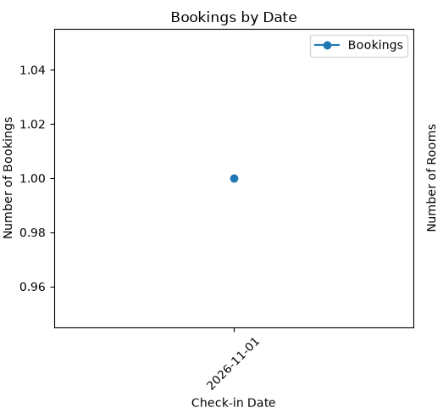
BAR CHART
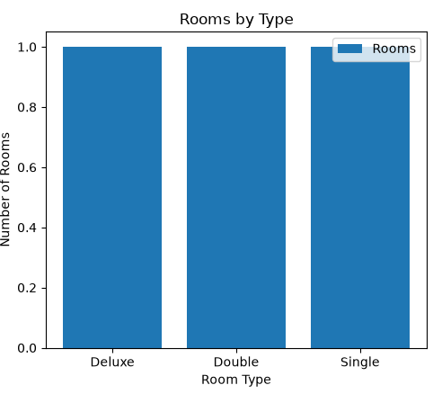
HISTOGRAM

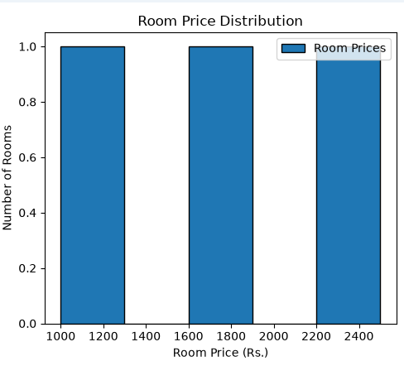

8.Conclusion

CONCLUSION OF THE PROJECT – HOTEL MANAGEMENT SYSTEM
The Hotel Management System project successfully demonstrates the use of Python programming and MySQL database management to automate basic hotel operations. The system allows users to add and view customer details, display room information, manage room bookings, and view booking records through a simple menu-driven interface.
MySQL is used to store and retrieve customer, room, booking, and billing information in an organized manner. Matplotlib is also integrated into the project to display data using line charts, bar charts, and histograms, helping users understand booking trends, room types, and room price distributions.
This project reduces manual record-keeping, improves the organization of hotel information, and demonstrates the practical application of database connectivity and data visualization. Through this project, students gain hands-on experience with Python functions, SQL queries, database operations, exception handling, and graphical data representation.
In conclusion, the Hotel Management System provides a foundation for developing more advanced hotel applications. In the future, it can be enhanced with online reservations, date-wise room availability, customer check-out management, automated billing, payment integration, and report generation.

9.BIBLIOGRAPHY

- Informatics Practices Text Book by NCERT for Class–XII
• Python Official Documentation – Python 3.13: https://docs.python.org/3/
• MySQL Official Documentation – MySQL 8.0: https://dev.mysql.com/doc/
• Matplotlib Documentation – Python Data Visualization Library: https://matplotlib.org/
• Seaborn Documentation – Statistical Data Visualization: https://seaborn.pydata.org/
• CBSE Class 12 Computer Science Syllabus 2022–25: https://www.cbse.gov.in/
• “AI Chatbots – Concepts and Applications”, Journal of Artificial Intelligence Research, 2023.
• TutorialsPoint – Python MySQL Integration: https://www.tutorialspoint.com/python_mysql/index.htm
• GeeksforGeeks – Data Analysis with Python: https://www.geeksforgeeks.org/data-analysis-in-python/

