A PROJECT REPORT ON

AI CHATBOTS

YOUR NAME
CBSE Roll Number: 28610520
CLASS – XII SCIENCE
2025–2026



PM SHRI SCHOOL JAWAHAR NAVODAYA VIDYALAYA
BANAVASI–518360,
YEMMIGANUR (KURNOOL) DISTRICT, A.P.
PM SHRI SCHOOL JAWAHAR NAVODAYA VIDYALAYA
BANAVASI–518360,
YEMMIGANUR (KURNOOL) DISTRICT, A.P.



Certified that this is a bonafied report of the Project Work entitled

HOSPITAL MANAGEMENT

Submitted by

YOUR NAME

Roll Number: 28610520

In partial fulfillment of the requirement for the Practical Examination of Class – XII

Central Board of Secondary Education

in the subject of

Informatics PrActices (065)

(SYED RAFIQ) E PADMAVATHI
PGT IP PRINCIPAL
INTERNAL EXAMINER JNV, KURNOOL

Signature of the
EXTERNAL EXAMINER

DECLARATION

I, YOUR NAME, hereby declare that this project report entitled "HOSPITAL MANAGEMENT" submitted to Central Board of Secondary Education in partial fulfilment of Practical Examination of Class–XII in the subject of Informatics Practices (065) is a bonafied record of the work carried out by me during the academic year 2025–2026 under the supervision of
Mr.SYED RAFIQ, PGT (IP), PM SHRI Jawahar Navodaya Vidyalaya, Banavasi, Yemmiganur (Kurnool) District, A. P.

I further declare that this project is a result of my own effort and not been submitted previously for any institution or for any other purpose.

Place : BANAVASI Signature of the Student

Date : Roll Number: 28610520

ACKNOWLEDGEMENTS

I sincerely acknowledge my deep sense of gratitude to Smt. E.PADMAVATHI, Principal, JNV, Banavasi for his valuable suggestions and encouragement during the course of study and in particular for her help and encouragement throughout this project work.

I extend my sincere thanks to all staff members of JNV, Kurnool for their
co–operation and attention towards me in data collection and all other aspects of the administration.

I am greatly indebted to my parents and all my friends who gave me moral and able support during this project work. Without the support of all these members, this project may not be at its best.

YOUR NAME1
YOUR NAME2
YOUR NAME3
YOUR NAME4

Introduction of Project: AI Chatbots
Artificial Intelligence (AI) has become an essential part of modern technology, transforming the way humans interact with machines. One of the most practical and popular applications of AI is the AI Chatbot — a computer program designed to simulate human conversation using natural language processing (NLP) and machine learning techniques.
This project titled “AI Chatbot” aims to demonstrate how artificial intelligence can be used to create a virtual assistant capable of answering user queries and providing information in an interactive manner. The chatbot is trained to understand text input, process it intelligently, and respond meaningfully, just like a human conversation.
In this project, Python has been used as the main programming language due to its simplicity and the availability of AI and NLP libraries such as NLTK, ChatterBot, and TensorFlow. The chatbot can be connected with a MySQL database to store and retrieve conversation data or frequently asked questions.
Through this project, students learn how AI systems analyze text, identify intent, and generate appropriate responses. It also helps in understanding how AI is shaping industries such as education, customer support, healthcare, and e-commerce.
The main goal of the project is to develop a simple, intelligent, and interactive chatbot system that enhances user experience and demonstrates the practical use of AI in real-life applications.

Objectives of the Project
The main objectives of the AI Chatbot Project are as follows:
- To develop an intelligent chatbot system that can interact with users through text-based communication.
- To apply Artificial Intelligence and Natural Language Processing (NLP) concepts for understanding and responding to user queries.
- To design a user-friendly interface for smooth and meaningful human–computer interaction.
- To connect the chatbot with a MySQL database for storing, retrieving, and managing conversation data or FAQs.
- To automate repetitive tasks such as answering common questions, thereby reducing human workload.
- To demonstrate the real-life application of AI technology in education, customer support, and online assistance.
- To enhance students’ practical knowledge of Python programming, data handling, and AI libraries.
- To encourage problem-solving and logical thinking skills by implementing an AI-based solution.

Software and Hardware Requirements

1. Software Requirements
S.No | Software | Description
1 | Operating System: Windows 10 / 11 | For running Python and MySQL smoothly.
2 | Programming Language: Python 3.10 or above | Used for developing the chatbot and integrating AI logic.
3 | IDE / Code Editor: IDLE / VS Code / PyCharm | For writing, debugging, and executing Python programs.
4 | Database: MySQL Server / XAMPP / WAMP | To store and retrieve chatbot conversation data or FAQs.
5 | Python Libraries: chatterbot, nltk, mysql.connector, pandas, matplotlib | For AI, NLP, database connectivity, and visualization.
6 | Web Browser: Google Chrome / Edge | For displaying chatbot interface (if using GUI or web version).

2. Hardware Requirements
S.No | Hardware | Minimum Specification
1 | Processor: | Intel Core i3 or higher
2 | RAM: | 4 GB or more
3 | Hard Disk: | Minimum 500 GB
4 | Keyboard and Mouse: | For user input and interaction
5 | Monitor: | Standard Display (15-inch or higher)
6 | Internet Connection: | Required for installing libraries or cloud-based data access

SYSTEM IMPLEMENTATION
About Operating System:

Windows is a line of operating system developed by Microsoft for use on general purpose computer systems, including home and business desktops, notebook computers, and media centers. Windows is the first
consumer–oriented operating system produced by Microsoft.

Windows is known for its improved stability and efficiency. It presents a significantly redesigned graphical user interface, a change Microsoft promoted as more user–friendly than previous versions of Windows that did not sit well with some users and privacy advocates. Windows has also been criticized by some users for security vulnerabilities, tight integration of applications such as Internet Explorer and Windows Media Player, and for aspects of its user interface.

About the Language:
History of Python:
Python was developed by Guido van Rossum in the late eighties and early nineties at the National Research Institute for Mathematics and Computer Science in the Netherlands. Python is derived from many other languages, including ABC, Modula-3, C, C++, Algol-68, SmallTalk, Unix shell, and other scripting languages. Python is copyrighted. Like Perl, Python source code is now available under the GNU General Public License (GPL). Python is now maintained by a core development team at the institute, although Guido van Rossum still holds a vital role in directing its progress.

Features of Python:
Python's features include:
- Easy-to-learn: Python has few keywords, simple structure, and a clearly defined syntax. This allows the student to pick up the language quickly.
- Easy-to-read: Python code is more clearly defined and visible to the eyes.
- Easy-to-maintain: Python's source code is fairly easy-to-maintain.
- A broad standard library: Python's bulk of the library is very portable and cross platform compatible on UNIX, Windows, and Macintosh.
- Interactive Mode: Python has support for an interactive mode which allows interactive testing and debugging of snippets of code.
- Portable: Python can run on a wide variety of hardware platforms and has the same interface on all platforms.
- Extendable: You can add low-level modules to the Python interpreter. These modules enable programmers to add to or customize their tools to be more efficient.
- Databases: Python provides interfaces to all major commercial databases.
- GUI Programming: Python supports GUI applications that can be created and ported to many system calls, libraries, and windows systems, such as Windows MFC, Macintosh, and the X Window system of UNIX.
- Scalable: Python provides a better structure and support for large programs than shell scripting.

Apart from the above-mentioned features, Python has a big list of good features, few are listed below:
- It supports functional and structured programming methods as well as OOP.
- It can be used as a scripting language or can be compiled to byte-code for building large applications.
- It provides very high-level dynamic data types and supports dynamic type checking.
- It supports automatic garbage collection.
- It can be easily integrated with C, C++, COM, ActiveX, CORBA, and Java.

Database:
A DataBase Management System (DBMS) is computer software designed for the purpose of managing databases, a large set of structured data, and run operations on the data requested by numerous users. Typical examples of DBMSs include Oracle, DB2, Microsoft Access, Microsoft SQL Server, Firebird, PostgreSQL, MySQL, SQLite, FileMaker and Sybase Adaptive Server Enterprise. DBMSs are typically used by Database administrators in the creation of Database systems. Typical examples of DBMS use include accounting, human resources and customer support systems.

Description
A DBMS is a complex set of software programs that controls the organization, storage, management, and retrieval of data in a database. A DBMS includes:
- A modeling language to define the schema of each database hosted in the DBMS, according to the DBMS data model. The four most common types of organizations are the hierarchical, network, relational and object models. Inverted lists and other methods are also used. A given database management system may provide one or more of the four models. The optimal structure depends on the natural organization of the application’s data, and on the application’s requirements (which include transaction rate(speed), reliability, maintainability, scalability, and cost)

- A database query language and report writer to allow users to interactively interrogate the database, analyze its data and update it according to the users privileges on data.
  - It also controls the security of the database
  - Data security prevents unauthorized users from viewing or updating the database. Using passwords, users are allowed access to the entire database or subsets of it called sub–schemas. For example, an employee database can contain all the data about an individual employee, but one group of users may be authorized to view only payroll data, while others are allowed access to only work history and medical data.
  - If the DBMS provides a way to interactively enter and update the database, as well as interrogate it, this capability allows for managing personal databases. However, it may not leave an audit trail of actions or provide the kinds of controls necessary in a multi–user organization. These controls are only available when a set of application programs are customized for each data entry and updating function
- A transaction mechanism, that ideally would generate the ACID properties, in order to ensure data integrity, despite concurrent user accesses (concurrency control), and faults (fault tolerance)
  - It also maintains the integrity of the data in the database
  - The DBMS can maintain the integrity of the database by not allowing more than one user to update the same record at the same time. The DBMS can help prevent duplicate records via unique index constraints; for example, no two customers with the same customer numbers (key fields) can be entered into the database. See ACID properties for more information (Redundancy avoidance)

MYSQL
Structured Query Language (SQL) is the language used to manipulate relational databases. MYSQL is tied very closely with the relational model

In the relational model, data is stored in structures called relations or tables. MYSQL statements are issued for the purpose of:

Data Definition: Defining tables and structures in the database (DDL used to create, alter and drop schema objects such as tables and indexes)

Data Manipulation: Used to manipulate the data within those schema objects (DML inserting, updating, deleting the data and querying the database)

A schema is collection of database objects that can include tables, views, indexes and sequences.

List of MYSQL statements that can be issued against an Oracle database schema are:
- ALTER – Change an existing table, view or index definition(DDL)
- COMMENT – Add a comment to a table or column in a table (DDL)
- COMMIT – Make all recent changes permanent (DML –
Transactional)
- CREATE – Create new database objects such as tables or views
(DDL)
- DELETE – Delete rows from a database table (DML)
- DROP – Drop a database object such as a table, view or index
(DDL)
- INSERT – Insert new data into a database table (DML)
- ROLLBACK – Undo any recent changes to the database (DML –
Transactional)
- SELECT – Retrieve data from a database table (DML)
- UPDATE – Change the values of some data items in a database table (DML)
Connectivity and Data Transfer between MySQL and Python:
Establishing Connection: To transfer data of MySQL database to Pandas dataframe, necessary application to be installed and required connections in Python need to be provided.

Before establishing the connection between Pandas and MySQL, any of the following packages can be installed

- MySQLdb: It is the Python module to work with MySQL databases. It is one of the most commonly used Python packages for MySQL

- MySQL–Connector–Python: This package contains the mysql.connector module, which is entirely written in Python

- PyMySQL: This package contains PyMySQL module. It has been designed as replacement for MySQLdb

Out of the three, MySQL–Connector–Python is frequently used to establish connectivity between Python & MySQL. The method of establishing connectivity between Python & MySQL is as follows

Steps to install Connector:

Step 1: | To connect Python to MySQL, ‘mysql–connector–python’ need to be installed using ‘pip’ command. Ensure proper internet connectivity while installing.  C:\>pip install mysql–connector–python
Step 2: | Ensure proper import of mysql.connector in Python IDLE without generating any error  >>> import mysql.connector  >>>  If the above statement doesn’t generate any error, then  mysql–connector is properly installed.

Establishing Connection:

- Python can be connected with MySQL by using the library mysql.connector. Hence before establishing connectivity, the library mysql.connector need to be imported like below

importmysql.connector (Or)
importmysql.connector as <object>

Ex: import mysql.connector as mycon

- Now, a connection object can be created connect( ) function, whose syntax is below

<Connection-Object> = mysql.connector.connect(host = <host-name>, user = <username>, passwd = <password> [,database=<database>]])

Here, user – Username on MySQL
password – Password of the user
host-name – The database server hostname or IP address
database – It is optional, and is the name of the database
my MySQL to which the connectivity to be
established

Ex: mydb = mysql.connector.connect (host = "localhost",
user = "root", passwd = "root1", database="mln")

Executing SQL Command to fetch rows from Table of a database into DataFrame:
The read_sql( ) function is used to fetch rows from a table of a database into an object of dataframe. The syntax of read_sql( ) is,

<DF-Object>=pandas.read_sql(“<SQLStatement>”, <connection-name>)

Ex: import pandas as pd
importmysql.connector as mycon

mydb = mycon.connect (host = "localhost", user = "root",
passwd = "root1", database="class12")

dtfrm = pd.read_sql(“SELECT * FROM Employee”, mydb)
print (dtfrm)
mydb.close( )

Closing Connection: The established connection can be closed using the
close( ) function of connection object. The syntax of close( ) function is,

<connection–object>⋅close( )

Ex: mydb.close( )

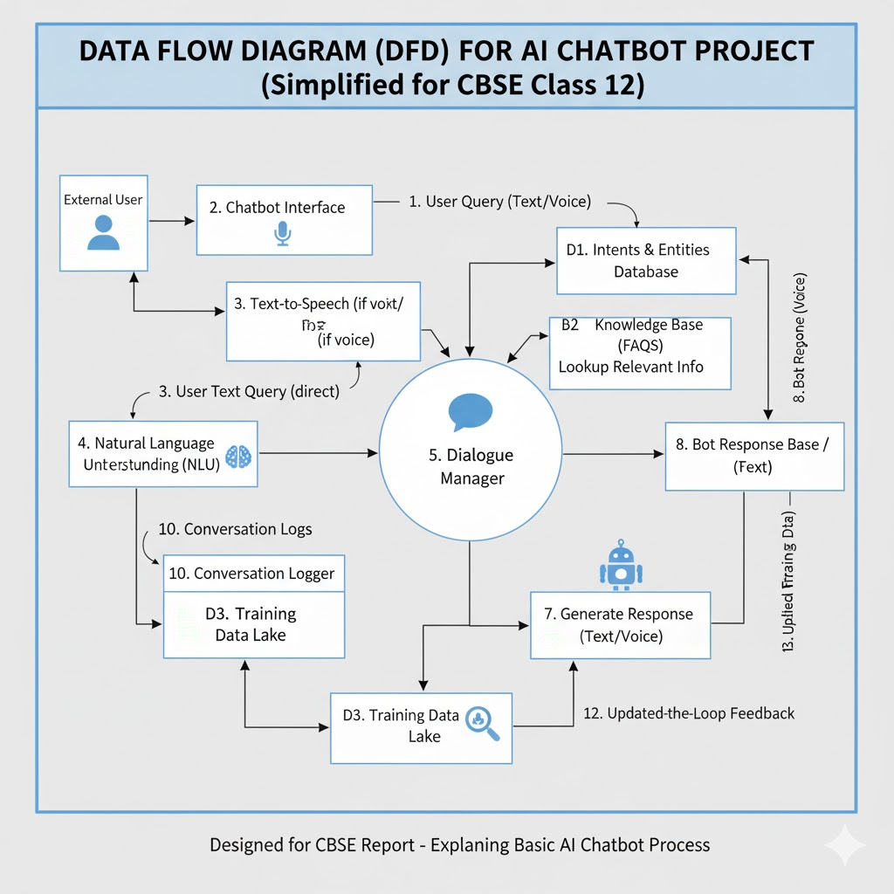

MYSQL TABLES IN PROJECT

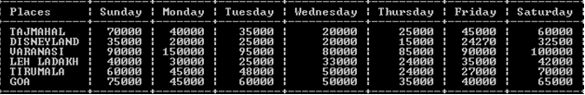

SOURCE CODE
#Menu driven program for transfer data from MySQL to Python DataFrame and for Analysis and Visualize Data

import mysql.connector
import pandas as pd
import matplotlib.pyplot as plt

# ---------------- MySQL Connection ----------------
con = mysql.connector.connect(
host="localhost",
user="root",
password="root",
database="ai_chatbots"
)
cur = con.cursor()

# ---------------- Helper: Safe Column Access ----------------
def get_column(df, col_name):
# Find actual column name ignoring case
for c in df.columns:
if c.lower() == col_name.lower():
return df[c]
raise KeyError(f"Column '{col_name}' not found in DataFrame.")

# ---------------- Show All Chatbots ----------------
def show_chatbots():
df = pd.read_sql("SELECT * FROM chatbots", con)
print("\n------ Top AI Chatbots ------")
print(df)

# ---------------- Add New Chatbot ----------------
def add_chatbot():
name = input("Enter Chatbot Name: ")
developer = input("Developer: ")
release_year = int(input("Release Year: "))
rating = float(input("User Rating (0-5): "))
users = int(input("Monthly Users: "))
languages = int(input("Languages Supported: "))
free_paid = input("Free / Paid / Freemium: ")
category = input("Category: ")

query = """INSERT INTO chatbots
(name, developer, release_year, user_rating, monthly_users, languages_supported, free_or_paid, category)
VALUES (%s,%s,%s,%s,%s,%s,%s,%s)"""
cur.execute(query, (name, developer, release_year, rating, users, languages, free_paid, category))
con.commit()
print("✅ Chatbot Added Successfully!")

# ---------------- Ranking & Scores ----------------
def rank_chatbots():
df = pd.read_sql("SELECT * FROM chatbots", con)

# Safe column access
rating = get_column(df, 'user_rating')
users = get_column(df, 'monthly_users')
languages = get_column(df, 'languages_supported')

# Feature-based score (weights: rating 40%, users 30%, languages 30%)
df['score'] = rating*0.4 + (users/users.max())*0.3 + (languages/languages.max())*0.3
df_sorted = df.sort_values(by='score', ascending=False)

print("\n------ Chatbot Ranking (Feature-Based Score) ------")
print(df_sorted[['name','score']])

# Bar chart
plt.bar(df_sorted['name'], df_sorted['score'], color='skyblue')
plt.title("Top AI Chatbots by Feature Score")
plt.xlabel("Chatbot Name")
plt.ylabel("Score")
plt.xticks(rotation=45)
plt.show()

# ---------------- Visualizations ----------------
def visualize_chatbots():
df = pd.read_sql("SELECT * FROM chatbots", con)

# Safe column access
users = get_column(df, 'monthly_users')
rating = get_column(df, 'user_rating')
free_paid = get_column(df, 'free_or_paid')
category = get_column(df, 'category')

# ---- Bar Chart: Monthly Users ----
plt.bar(df['name'], users, color='orange')
plt.title("Top AI Chatbots by Monthly Users")
plt.xlabel("Chatbot")
plt.ylabel("Monthly Users")
plt.xticks(rotation=45)
plt.show()

# ---- Pie Chart: Free vs Paid ----
df_grouped = df.groupby(free_paid)[users.name].sum()
df_grouped.plot.pie(autopct='%1.1f%%', title='User Distribution: Free vs Paid', startangle=90)
plt.ylabel("")
plt.show()

# ---- Histogram: Ratings Distribution ----
plt.hist(rating, bins=5, color='green', edgecolor='black')
plt.title("User Ratings Distribution")
plt.xlabel("Ratings")
plt.ylabel("Number of Chatbots")
plt.show()

# ---- Category Distribution ----
cat_count = df[category.name].value_counts()
cat_count.plot.bar(color='purple', title='Chatbots by Category')
plt.xlabel("Category")
plt.ylabel("Count")
plt.show()

# ---------------- Menu ----------------
def menu():
while True:
print("\n==== Top AI Chatbots Project ====")
print("1. Show All Chatbots")
print("2. Add Chatbot")
print("3. Rank Chatbots by Feature Score")
print("4. Visualize Data")
print("5. Exit")
choice = input("Enter Choice (1-5): ")

if choice=='1':
show_chatbots()
elif choice=='2':
add_chatbot()
elif choice=='3':
rank_chatbots()
elif choice=='4':
visualize_chatbots()
elif choice=='5':
print("Thank you! Stay AI Smart! 🤖")
break
else:
print("❌ Invalid Choice!")

menu()
con.close()
VISUALIZATION OF TABLES
Line Chart
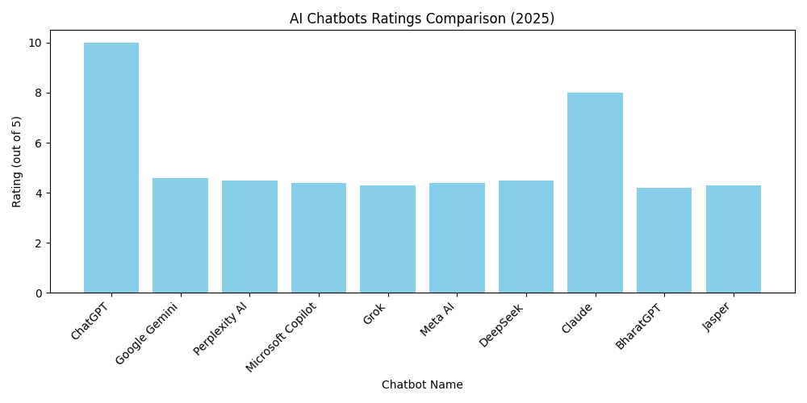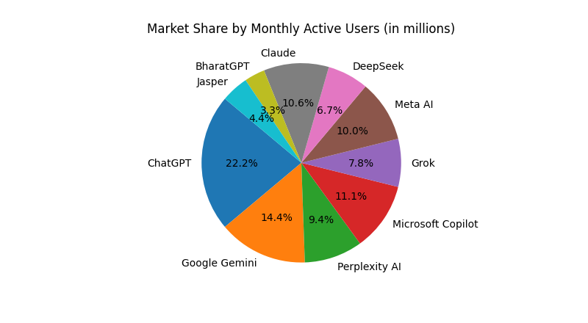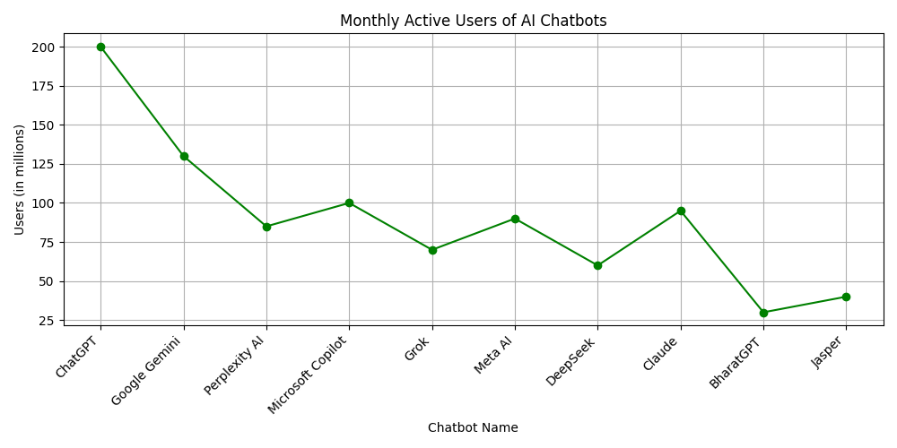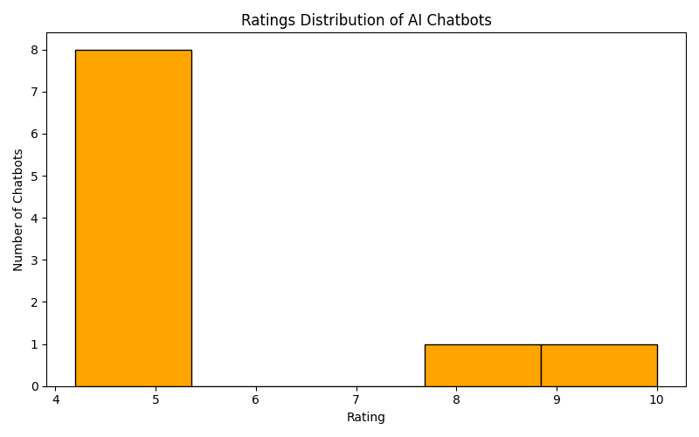

Conclusion
The project on Data Analysis of AI Chatbots demonstrates how Python and MySQL can be effectively used to analyze user interactions, chatbot performance, and response efficiency. By studying patterns such as query frequency, response times, and user satisfaction, we gained valuable insights into chatbot behavior and areas for improvement.
The visualizations, including bar charts, histograms, and pie charts, provided a clear understanding of trends and helped identify peak usage times and common issues. This analysis highlights the importance of data-driven decision-making in improving AI chatbot functionality and enhancing user experience.
Overall, the project illustrates the practical application of programming, databases, and data visualization in understanding and optimizing AI systems, which is highly relevant for students preparing for future technology careers.

BIBLIOGRAPHY

- Informatics Practices Text Book by NCERT for Class–XII
• Python Official Documentation – Python 3.13: https://docs.python.org/3/
• MySQL Official Documentation – MySQL 8.0: https://dev.mysql.com/doc/
• Matplotlib Documentation – Python Data Visualization Library: https://matplotlib.org/
• Seaborn Documentation – Statistical Data Visualization: https://seaborn.pydata.org/
• CBSE Class 12 Computer Science Syllabus 2022–25: https://www.cbse.gov.in/
• “AI Chatbots – Concepts and Applications”, Journal of Artificial Intelligence Research, 2023.
• TutorialsPoint – Python MySQL Integration: https://www.tutorialspoint.com/python_mysql/index.htm
• GeeksforGeeks – Data Analysis with Python: https://www.geeksforgeeks.org/data-analysis-in-python/

