Memo: PageTurner, a Budgeted Document-Answering Agent
Track: AI/ML, Agentic Systems and Harness Design | Team of 2
1. Architecture
A plain-Python controller wraps an LLM that only proposes JSON actions: the LLM is a policy, not an authority. Per question, list_headings runs first (call 1, no LLM). The planner (up to 4 rounds) requests searches and page reads; the gateway validates and executes them under a hard budget of 6, and an evidence ledger built only from tool outputs is fed back. One final answer call (no tools) is then checked by a verifier that confirms every quote appears in a page fetched in this run; otherwise the answer is downgraded to insufficient information. No agent framework is used.
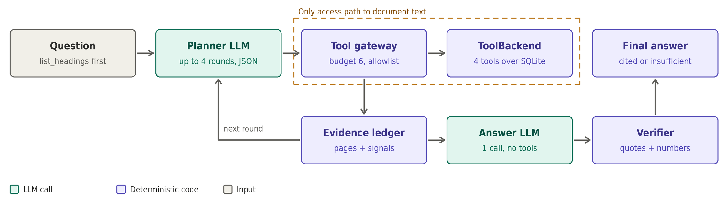
2. What we did and why
Choice | Why / what it prevents
Budget enforced in gateway code, not the prompt | Models miscount. The 7th call is impossible, not just discouraged; an adversarial fake-LLM test spams 50 actions.
Controller owns doc_id; allowlist + schema checks | Injected text cannot add tools, switch documents, or request page ranges.
list_headings first | Cheapest orientation; resolves cross-references without extra calls.
Bracketing, amendment sweep, reserved 6th call | Contradiction and supersession: read earliest and latest hit, then check amendment or errata sections.
Authority order in the answer prompt | Explicit supersession, errata, later date, scoped amendment, specific over general. If unresolved, do not pick a side.
Verbatim-quote and numeric verifier | Hallucination control; abstention becomes a measurable outcome, not a model mood.
Page text treated as untrusted data + injection detector | Defense in depth: delimiters, schema-validated output, echo check on the answer.
Per-run state, no cross-question page cache | Respects the intent of the budget.
Import-boundary test and full trace | Shows the agent has no side channel to raw text; nothing hidden.
Heading cascade: bookmarks, font heuristics, first line per page | Generalizes to unseen PDFs that have no table of contents.
Interpretation: only executed document-tool calls count toward the 6; planner rounds are capped at 4 and fully logged.
3. Known failure modes (not fully fixed)
- Vocabulary mismatch. Search is lexical, so "vacation" vs "annual leave" can return []. Fix: LLM proposes 2–3 keyword variants, one tried per call; match heading titles first. Not fully solvable in 6 calls.
- Questions needing more than ~4 pages (e.g. "list all deadlines") exceed the budget; we return partial with explicit coverage.
- Scanned PDFs have no text layer, so pages come back empty. Fix: OCR fallback in ingestion behind a flag.
- Tables split across pages or merged columns can misalign values. Fix: table-aware extraction and reading the continuation page.
- Overrides with no cue words, or in unrelated sections, can be missed; the unread-later-hits signal helps but a full fix needs more calls.
- Weak heading detection on messy layouts lowers page targeting; synthetic headings are coarse.
- The verifier is lexical: a correct but paraphrased figure ("twice the limit") may be wrongly downgraded. Fix: extend the safe-arithmetic check.
- Broad keywords that hit most pages waste a call; the ledger flags them but the planner can still choose them.
- Budget ambiguity: if planner LLM calls count toward 6, we would collapse to one planning round (config flag), at some cost in accuracy.

