

DATA STRUCTURES AND
ALGORITHMS
23CSE203 LAB
SUBMITTED BY
NAME | SYED RAMEEZ
ROLL NO. | Av.sc.u4cse25052
YEEAR/SEM/SECTION | 2nd year /sem-3/Cse-A
CREDITS | 05
GIT REPO LINK | https://github.com/syedrameez8524-cmd/-DSA-LAB-CSE25052-
SUBMITTED TO | DR.RAJ KUMAR BATCHU
DESIGNATION | ASST.PROFFESSOR(S l .Grade)
DEPARTMENT | School of Computing
MANUAL
INDEX
 | TITLE | PAGE NO | REMARKS
1 | Lab1:-  1a) rocket launch systems display the countdown of before launch instead of using a loop implement the countdown using the recursion write a recursion Python program to display the countdown from n to 1 followed by launch.  1b)Banks calculate the growth of an investment using compound interest. The formula requires calculating powers, which can be implemented recursively. Write a recursive Python program to calculate P^n (power), where P = Principal growth factor, n = number of years.  1c) An HR department stores employee IDs in a list. Develop a recursive program to search for a given employee ID. Write a recursive function to search for an employee ID in a list.  1d) In a logistics company, the number of possible ways to arrange n different parcels is calculated using the factorial formula. Develop a recursive program to calculate the factorial of a given number.  1e) Write a recursive Python program to print the first n terms of a Fibonacci series. | 3-12
2 | Lab2:-  2a) Write a Python program to perform linear search for the given input.  2b) Write a Python program to perform binary search of the given input, verifying by taking a sorted array and an unsorted array as input. | 13-18
3
4
5

LAB-1

1A)AIM:- rocket launch systems display the countdown of before launch instead of using a loop implement the countdown using the recursion write a recursion Python program to display the countdown from n to 1 followed by launch.

PROGRAM:-
def countdown(n):
if n == 0:
print("Launch!")
else:
print(n)
countdown(n - 1)
# Input
n = int(input("Enter countdown number: "))
# Function call
countdown(n)

OUTPUT:-
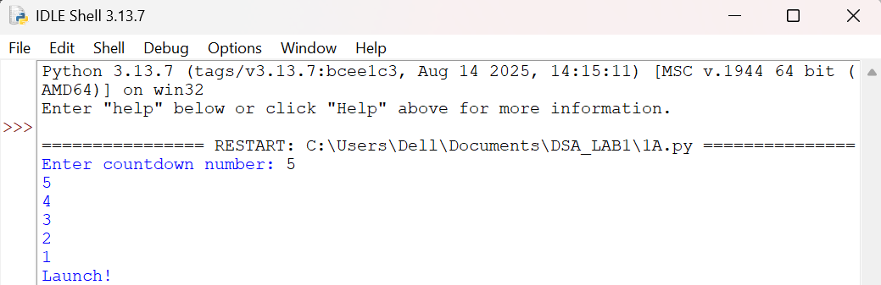

EXPLANATION:-
- def defines the countdown() function.
- input() accepts the countdown value from the user.
- int() converts the input into an integer.
- countdown() starts the recursive countdown process.
- if checks the base case (n == 0).
- else executes when the condition is False.
- print(n) displays the current countdown number.
- countdown(n - 1) recursively calls the function with the value decreased by 1.
- print("Launch!") displays the launch message when the countdown reaches 0.
- The program demonstrates the use of functions, recursion, conditional statements, input, and output to perform the countdown.
ERRORS:-
SNO | Errors Observed | Rectification
1 | Invalid (non-numeric) input entered by the user. | Enter a valid integer as input.
2 | Missing base case (if n == 0) causing infinite recursion. | Include the base case to stop recursion .l
3 | incorrect indentation leading to an Indentation Error | Maintain proper Python indentation.
4 | Missing colon (:) after def, if, or else. | Add the required colon (:) after statements.
5 | Calling countdown(n) instead of countdown(n - 1), causing infinite recursion. | Decrease the value by 1 in each recursive call using countdown(n - 1).

TIME COMPLEXITY:- O(n)
SPACE COMPLEXITY:- O(n)
REASON:- Function is called once for each value from n to 0.

1B)AIM:- Banks calculate the growth of an investment using compound interest. The formula requires calculating powers, which can be implemented recursively. Write a recursive Python program to calculate P^n (power), where P = Principal growth factor, n = number of years.

PROGRAM:-
def power(p, n):
if n == 0:
return 1
else:
return p * power(p, n - 1)

# Input
p = int(input("Enter principal growth factor: "))
n = int(input("Enter number of years: "))

# Function call
result = power(p, n)

# Output
print("Power =", result)

OUTPUT:-
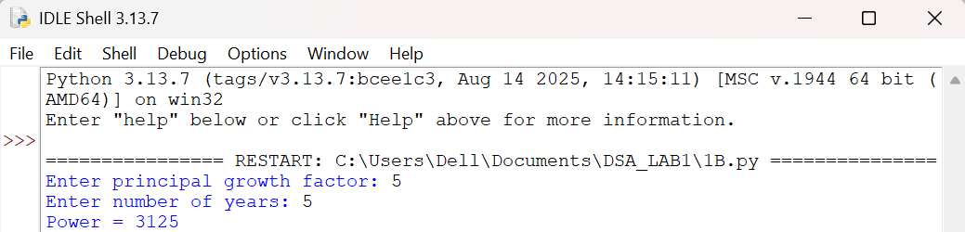

EXPLANATION:-
- power() is the recursive function that computes P raised to n.
- The base case is n == 0, which returns 1 (any number to the power 0 is 1).
- The recursive case multiplies p with power(p, n - 1), reducing n by 1 on each call.
- float() allows the principal growth factor to be a decimal value.
- input() collects the values of P and n from the user.
- Each recursive call is stacked until the base case is reached, then the results are multiplied back up the call stack.
- print() displays the final computed value of P^n.
ERRORS:-
SNO | Errors Observed | Rectification
1 | Missing base case (n == 0) causing infinite recursion. | Include the base case to stop recursion.
2 | Entering a negative value for n causes the recursion to never reach 0. | Restrict input to non-negative integers or handle negative n separately.
3 | Using int() for P truncates decimal growth factors. | Use float() to accept decimal values for P.
4 | Incorrect indentation leading to an IndentationError. | Maintain proper Python indentation.
5 | Calling power(p, n) instead of power(p, n - 1), causing infinite recursion. | Decrease n by 1 in each recursive call using power(p, n - 1).

TIME COMPLEXITY:- O(n)
SPACE COMPLEXITY:- O(n)
REASON:- Recursive call is made n times to compute Pⁿ.
1C)AIM:- An HR department stores employee IDs in a list. Develop a recursive program to search for a given employee ID. Write a recursive function to search for an employee ID in a list.

PROGRAM:-
def search_employee(emp_list, emp_id, index=0):
if index == len(emp_list):
return -1
elif emp_list[index] == emp_id:
return index
else:
return search_employee(emp_list, emp_id, index + 1)
# Input
employee_ids = [101, 102, 103, 104, 105]
search_id = int(input("Enter Employee ID to search: "))
# Function call
position = search_employee(employee_ids, search_id)
if position != -1:
print("Employee ID", search_id, "found at position", position)
else:
print("Employee ID", search_id, "not found")

OUTPUT:-
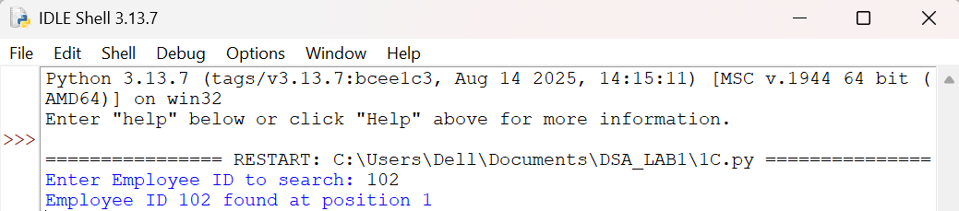

EXPLANATION:-
- search_employee() is the recursive function that searches the list one index at a time.
- The base case index == len(emp_list) means every element was checked and the ID was not found, so it returns -1.
- The second condition checks if the current element matches the employee ID being searched.
- If not matched, the function calls itself with index + 1, moving to the next employee in the list.
- employee_ids is the list of employee IDs stored by the HR department.
- input() and int() collect the employee ID to search for from the user.
- The if-else block reports whether the employee ID was found and at which position.
ERRORS:-
SNO | Errors Observed | Rectification
1 | Missing base case (index == len(emp_list)) causing infinite recursion. | Include the base case to stop recursion when the list is exhausted.
2 | Invalid (non-numeric) input entered by the user. | Enter a valid integer as input.
3 | Calling search_employee(emp_list, emp_id, index) without incrementing index, causing infinite recursion. | Increase index by 1 in each recursive call using index + 1.
4 | Incorrect indentation leading to an IndentationError. | Maintain proper Python indentation.
5 | Searching an empty list without handling it, giving a confusing result. | Add a check for an empty list before searching.

TIME COMPLEXITY:- O(n)
SPACE COMPLEXITY:- O(n)
REASON:- In the worst case, every element in the list is checked recursively.
1D)AIM:- In a logistics company, the number of possible ways to arrange n different parcels is calculated using the factorial formula. Develop a recursive program to calculate the factorial of a given number.

PROGRAM:-
def factorial(n):
if n == 0 or n == 1:
return 1
else:
return n * factorial(n - 1)
# Input
n = int(input("Enter a number to find its factorial: "))
# Function call
print("Factorial of", n, "is", factorial(n))

OUTPUT:-
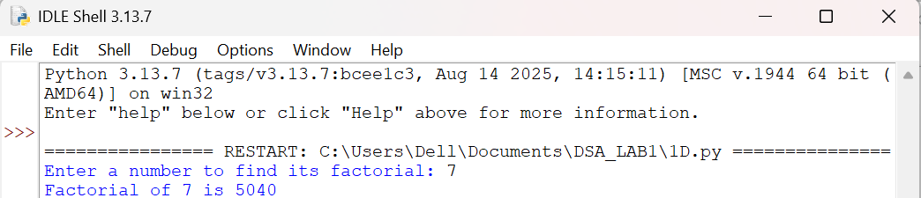
EXPLANATION:-
- factorial() is the recursive function that computes n! (n factorial).
- The base case is n == 0 or n == 1, both of which return 1.
- The recursive case multiplies n with factorial(n - 1), reducing n by 1 on each call.
- input() and int() collect the number whose factorial is to be found.
- Each recursive call is stacked until the base case is reached, then the results are multiplied back up the call stack.
- print() displays the number of possible arrangements (the factorial value).
ERRORS:-
SNO | Errors Observed | Rectification
1 | Missing base case (n == 0 or n == 1) causing infinite recursion. | Include the base case to stop recursion.
2 | Entering a negative number, for which factorial is undefined. | Restrict input to non-negative integers.
3 | Invalid (non-numeric) input entered by the user. | Enter a valid integer as input.
4 | Incorrect indentation leading to an IndentationError. | Maintain proper Python indentation.
5 | Calling factorial(n) instead of factorial(n - 1), causing infinite recursion. | Decrease n by 1 in each recursive call using factorial(n - 1).

TIME COMPLEXITY:- O(n)
SPACE COMPLEXITY:- O(n)
REASON:- Function calls itself n times until reaching the base case.
1E)AIM:- Write a recursive Python program to print the first n terms of a Fibonacci series.

PROGRAM:-
def fibonacci(n):
if n == 0:
return 0
elif n == 1:
return 1
else:
return fibonacci(n - 1) + fibonacci(n - 2)
# Input
n = int(input("Enter the number of terms: "))
# Function call
print("Fibonacci series:")
for i in range(n):
print(fibonacci(i), end=" ")

OUTPUT:-
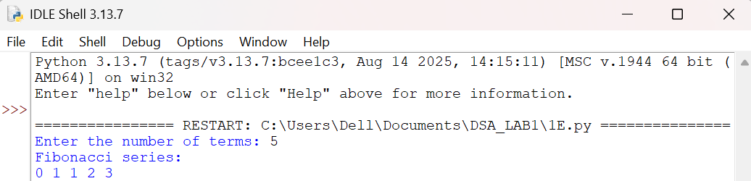

EXPLANATION:-
- fibonacci() is the recursive function that returns the nth Fibonacci term.
- The base cases are n == 0 (returns 0) and n == 1 (returns 1).
- The recursive case adds fibonacci(n - 1) and fibonacci(n - 2), following the Fibonacci rule.
- input() and int() collect the number of terms to be printed.
- The for loop calls fibonacci(i) for each index from 0 to n - 1.
- print(..., end=" ") displays each term on the same line, separated by a space.
ERRORS:-
SNO | Errors Observed | Rectification
1 | Missing base cases (n == 0 and n == 1) causing infinite recursion. | Include both base cases to stop recursion.
2 | Entering a negative number of terms. | Restrict input to non-negative integers.
3 | Invalid (non-numeric) input entered by the user. | Enter a valid integer as input.
4 | Incorrect indentation leading to an IndentationError. | Maintain proper Python indentation.
5 | Using fibonacci(n - 1) - fibonacci(n - 2) instead of addition, giving wrong terms. | Use addition, fibonacci(n - 1) + fibonacci(n - 2), as per the Fibonacci rule.

TIME COMPLEXITY:- O(2^{n})
SPACE COMPLEXITY:- O(n)
REASON:- Each call creates two recursive calls, resulting in exponential time, while the recursion depth is n.

LAB-2

2A)AIM:- Write a Python program to perform linear search for the given input.

PROGRAM:-
def linear_search(arr, target):
for index in range(len(arr)):
if arr[index] == target:
return index
return -1
# Input
n = int(input("Enter number of elements: "))
arr = []
for i in range(n):
arr.append(int(input(f"Enter element {i+1}: ")))
target = int(input("Enter the element to search: "))
# Function call
result = linear_search(arr, target)
# Output
if result != -1:
print("Element found at index", result)
else:
print("Element not found in the list")
OUTPUT:-
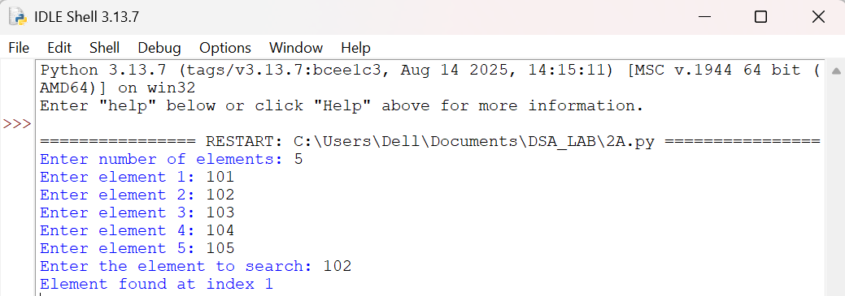

EXPLANATION:-
- linear_search() checks each element of the list one by one from the beginning.
- The for loop iterates over every index of the array using range(len(arr)).
- If arr[index] equals the target, the matching index is returned immediately.
- If the loop finishes without a match, -1 is returned to indicate the element is not present.
- input() and int() collect the number of elements, the elements themselves, and the target value.
- The if-else block reports whether the target was found and at which index, or that it was not found.
ERRORS:-
SNO | Errors Observed | Rectification
1 | Invalid (non-numeric) input entered by the user. | Enter a valid integer as input.
2 | Entering more or fewer elements than the specified count n. | Ensure exactly n elements are entered, one per prompt.
3 | Searching an empty list (n = 0) without handling it. | Add a check for an empty list before searching.
4 | Incorrect indentation leading to an IndentationError. | Maintain proper Python indentation.
5 | Using == to compare elements of different types (e.g. int vs str), causing a false "not found". | Ensure the target and list elements are converted to the same type (int) before comparing.

TIME COMPLEXITY:- O(n)
SPACE COMPLEXITY:- O(1)
REASON:- In the worst case, every element in the list is checked once; no extra space is used besides a few variables.
2B)AIM:- Write a Python program to perform binary search of the given input, verifying by taking a sorted array and an unsorted array as input.

PROGRAM:-
def binary_search(arr, target):
low = 0
high = len(arr) - 1
while low <= high:
mid = (low + high) // 2
if arr[mid] == target:
return mid
elif arr[mid] < target:
low = mid + 1
else:
high = mid - 1
return -1
# Input
n = int(input("Enter number of elements: "))
arr = []
for i in range(n):
arr.append(int(input(f"Enter element {i+1}: ")))
target = int(input("Enter the element to search: "))
# Verify whether the input array is sorted or unsorted
if arr == sorted(arr):
print("Input array is sorted:", arr)
result = binary_search(arr, target)
if result != -1:
print("Element found at index", result)
else:
print("Element not found in the list")
else:
print("Input array is NOT sorted:", arr)
print("Binary search requires a sorted array.")
print("Result on unsorted array cannot be trusted. Sorting the array first...")
sorted_arr = sorted(arr)
print("Sorted array:", sorted_arr)
result = binary_search(sorted_arr, target)
if result != -1:
print("Element found at index", result, "in the sorted array")
else:
print("Element not found in the list")

OUTPUT:-
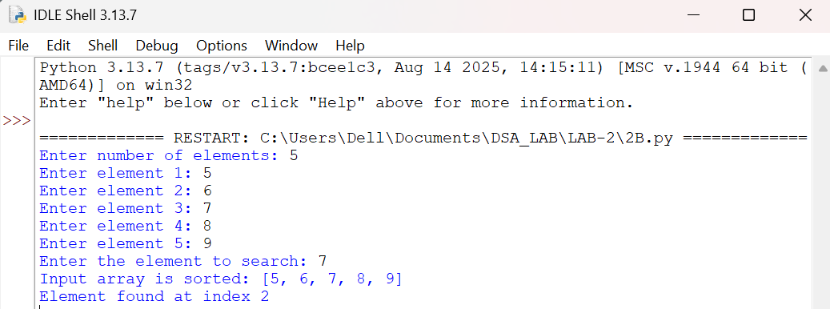

EXPLANATION:-
- binary_search() repeatedly narrows the search range between low and high using the midpoint mid.
- If arr[mid] equals the target, the index mid is returned immediately.
- If arr[mid] is less than the target, the search continues in the right half by moving low to mid + 1.
- Otherwise, the search continues in the left half by moving high to mid - 1.
- arr == sorted(arr) checks whether the entered array is already sorted, to verify binary search's precondition.
- If the array is sorted, binary search runs directly on it and reports the result.
- If the array is unsorted, the program shows that binary search cannot be trusted on it, sorts the array with sorted(), and re-runs binary search on the sorted copy.
ERRORS:-
SNO | Errors Observed | Rectification
1 | Running binary search directly on an unsorted array gives an unreliable or wrong result. | Always verify with arr == sorted(arr) and sort the array before searching.
2 | Using mid = (low + high) / 2 gives a float, causing a TypeError when indexing the list. | Use integer floor division (//) instead of / to compute mid.
3 | Using low < high instead of low <= high, missing the case where low equals high. | Use low <= high so a single remaining element is still checked.
4 | Not updating low or high inside the loop, causing an infinite loop. | Always set low = mid + 1 or high = mid - 1 inside the loop body.
5 | Invalid (non-numeric) input entered by the user. | Enter a valid integer as input.

TIME COMPLEXITY:- O(log n)
SPACE COMPLEXITY:- O(1)
REASON:- The search range is halved on every iteration, so the number of comparisons grows logarithmically with n; only a few variables (low, high, mid) are used regardless of input size.

