7.A) Aim: create a GitHub account and create a repository in it and push all the week 6 code files in it.
Procedure :
Step 1: browse for GitHub and enter it.
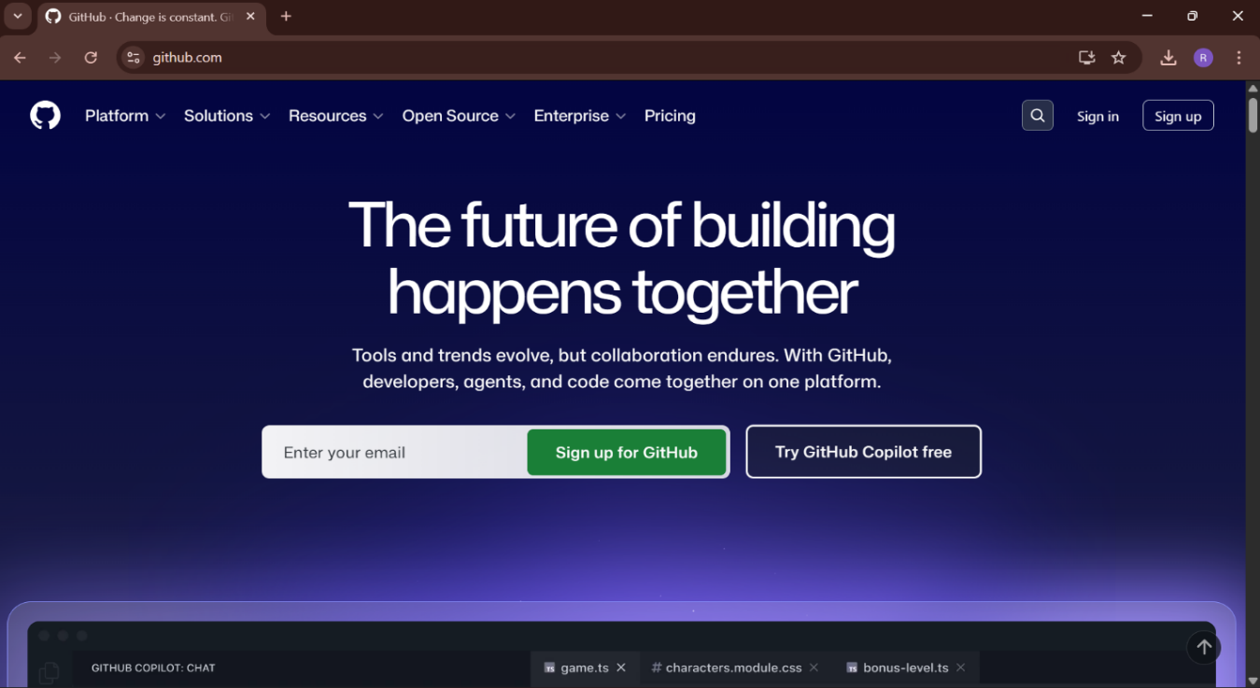
Step 2:login to GitHub account.
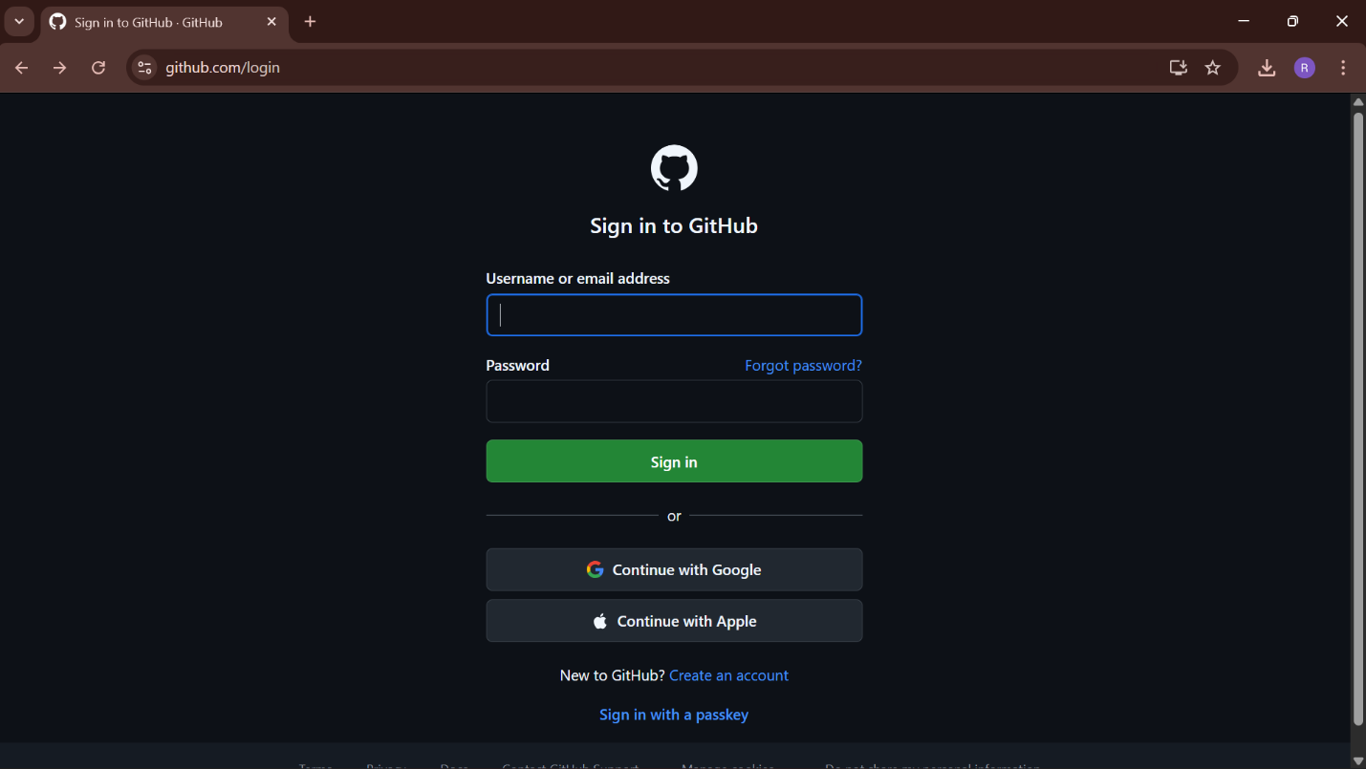
Step 3:create a repository after login by clicking new.
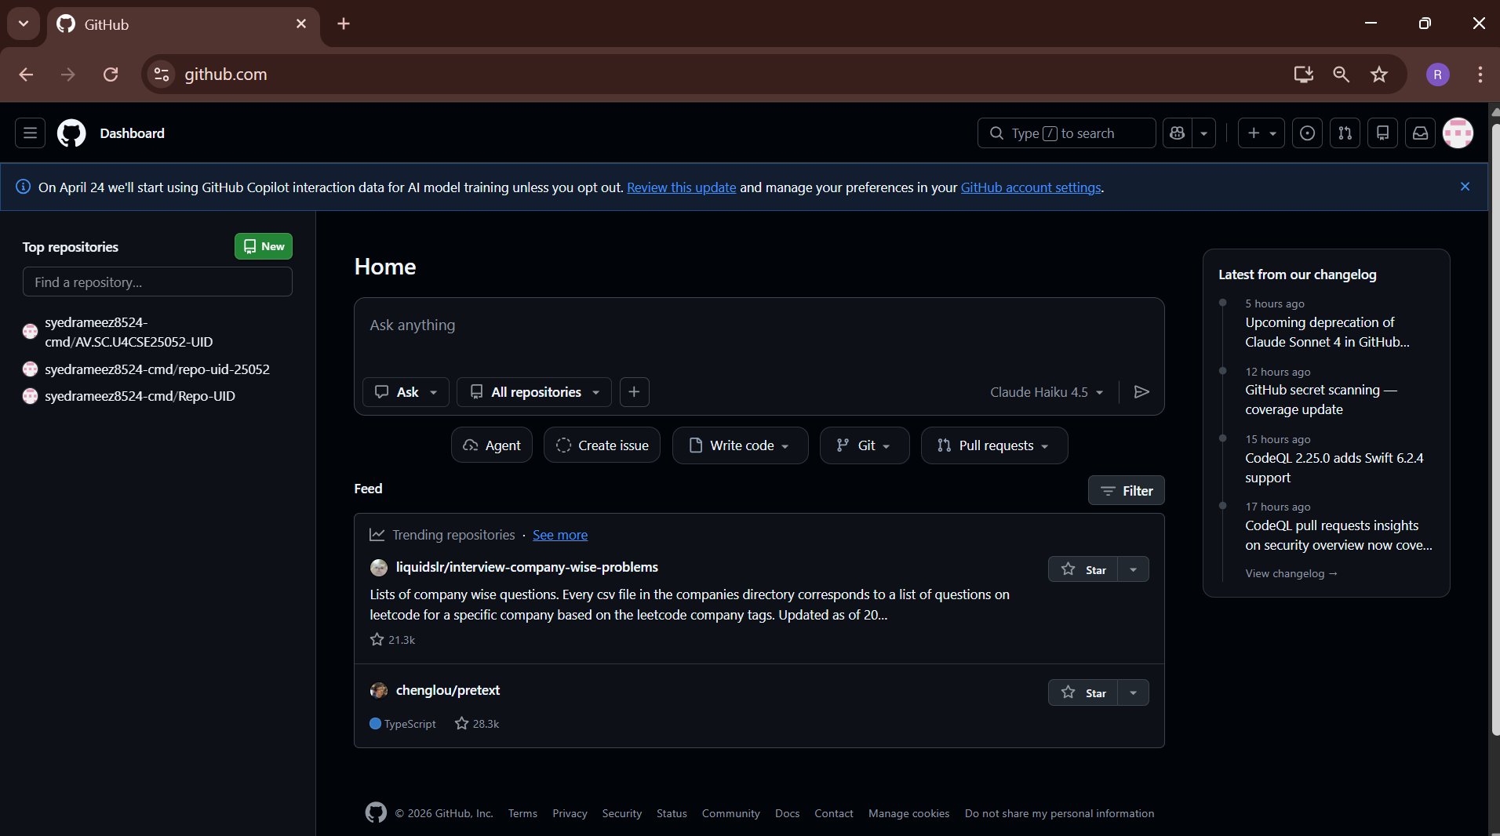
Step 4:specify the repository specifications.
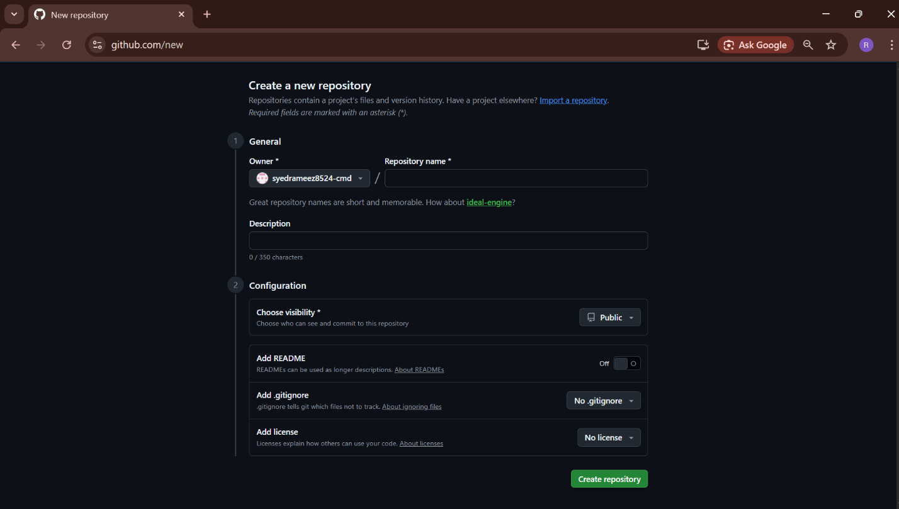

Step 5:download GitHub desktop and Lauch it .
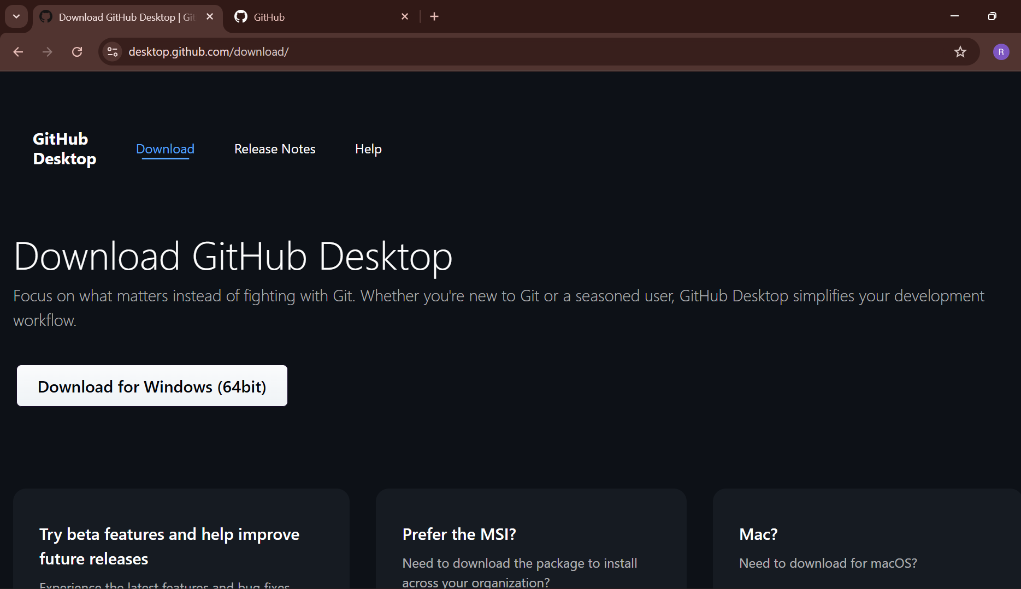

Step 6:add the repository to it .
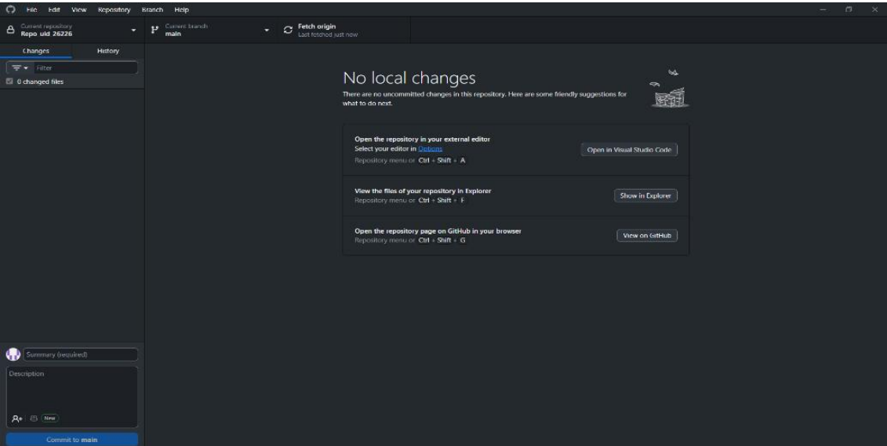

Step 7:add the vs code file to the GitHub desktop.
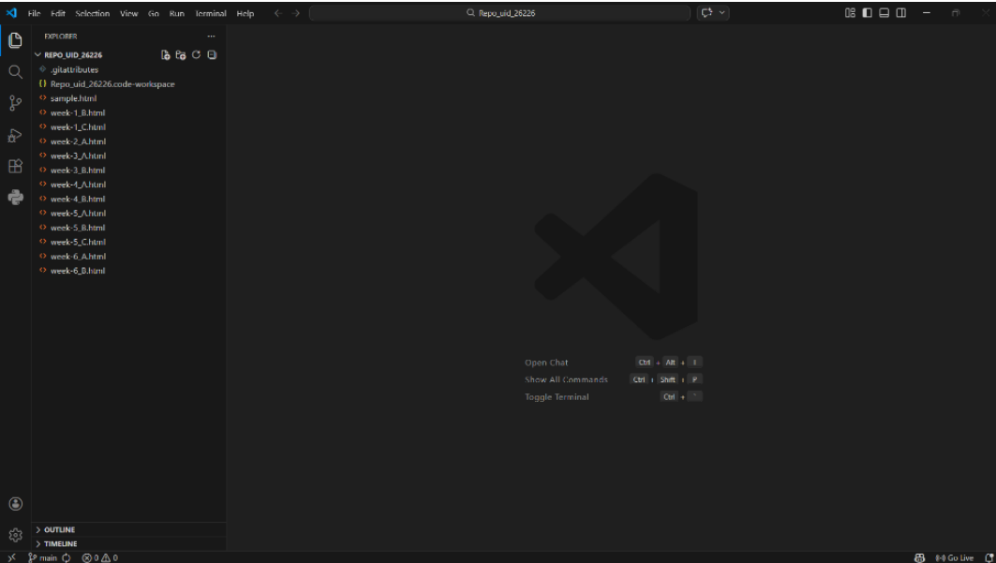

Step 8: add commit to it and the files to repository and sync the changes . it automatically pushes the files
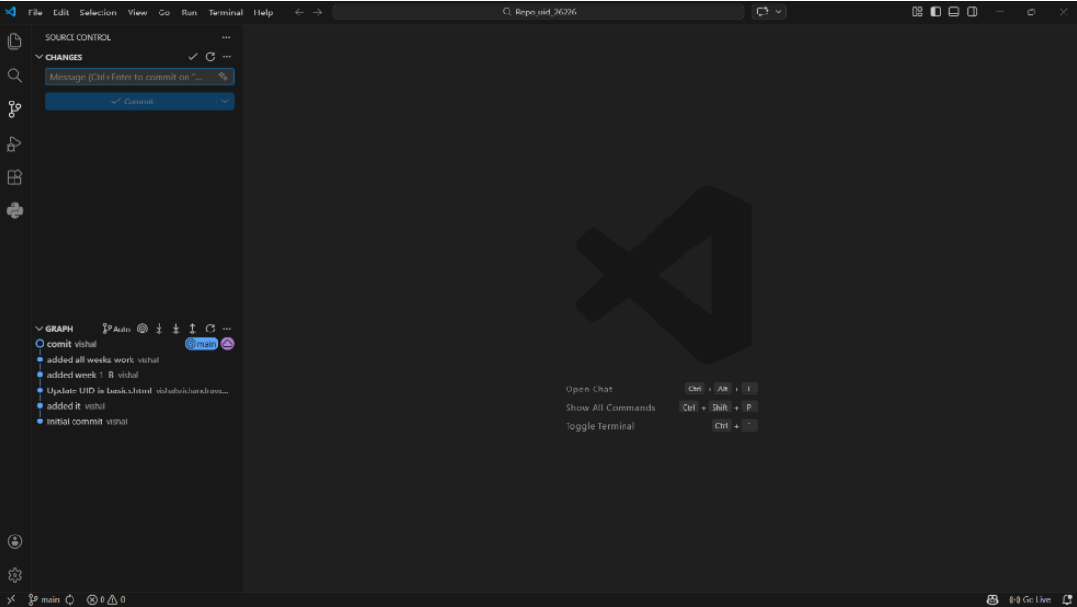

Step 9:now go to browser and check it . it will show all the new added files in the repository .
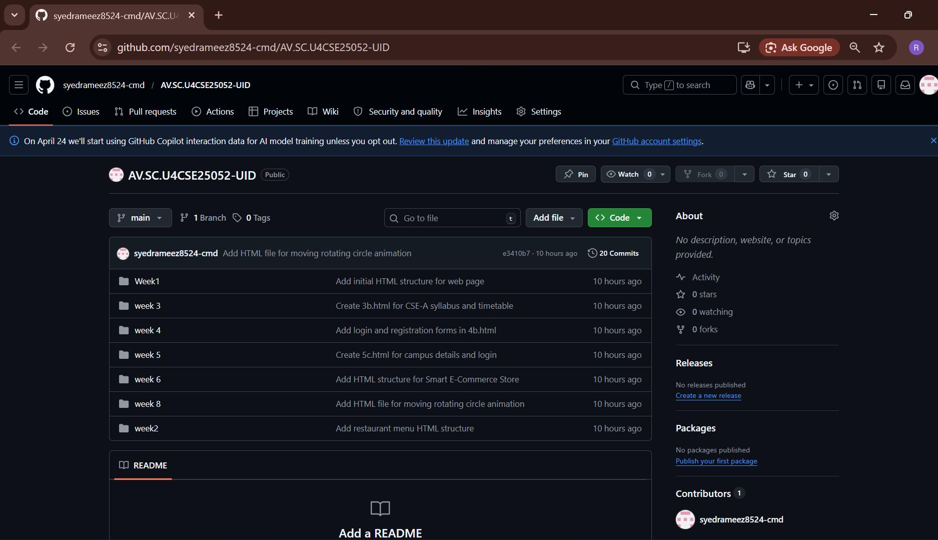

My repository link for the uid all week’s work:
https://github.com/syedrameez8524-cmd/AV.SC.U4CSE25052-UID.git

