

USER INTERFACE DESIGN
23CSE113
ASSIGNMENT

SUBMITTED BY
NAME | SYED RAMEEZ
ROLL NO. | Av.sc.u4cse25052
YEEAR/SEM/SECTION | 1st Year/Sem-02/CSE-A
CREDITS | 03
SUBMITTED TO | DR.RAJ KUMAR BATCHU
DESIGNATION | ASST.PROFFESSOR(S l .Grade)
DEPARTMENT | School of Computing

Assignment:-

Aim:- To Select a website and clone its UI as much as possible.
Website selected:- https://www.chennaisuperkings.com/

Cloning done by me:-

Main Page HTML Code:-

index.html:-

<!DOCTYPE html>
<html lang="en">
<head>
<meta charset="UTF-8" />
<meta name="viewport" content="width=device-width, initial-scale=1.0" />
<title>Chennai Super Kings</title>
<link rel="stylesheet" href="style.css" />
<link href="https://fonts.googleapis.com/css2?family=Oswald:wght
@400;600;700&family=Open+Sans:wght@400;600;700&display=swap"
rel="stylesheet" />
<link rel="stylesheet" href="https://cdnjs.cloudflare.com/ajax/libs/
font-awesome/6.5.0/css/all.min.css" />
</head>
<body>

<!-- TOP BAR -->
<div class="top-bar">
CSK — 5x IPL Champions | Whistlepodu!
</div>

<!-- NAVBAR -->
<nav class="navbar" id="navbar">
<div class="nav-container">
<div class="nav-links left">
<a href="#home" class="nav-link active">HOME</a>
<a href="#news" class="nav-link">NEWS</a>
<a href="#team" class="nav-link">TEAM</a>
<a href="#csktv" class="nav-link">CSKTV</a>
</div>
<div class="nav-logo">
<div class="logo-circle">
<img src="https://upload.wikimedia.org/.../Chennai_Super_Kings_Logo.svg"
alt="CSK" />
</div>
</div>
<div class="nav-links right">
<a href="#gallery" class="nav-link">GALLERY</a>
<a href="#shop" class="nav-link">SHOP</a>
<a href="#highlights" class="nav-link">HIGHLIGHTS</a>
<a href="#" class="nav-link">MORE</a>
<a href="login.html" class="nav-btn-login">LOGIN</a>
</div>
</div>
</nav>

<!-- HERO (3-slide auto-carousel) -->
<section class="hero" id="home">
<div class="hero-slides">
<div class="hero-slide active">
<img class="hero-bg" src="..." alt="CSK champions" />
<div class="hero-content">
<div class="hero-badge">IPL 2026</div>
<h1 class="hero-title">WHISTLE<span>PODU!</span></h1>
<p class="hero-sub">5x Champions · Forever Yellow · Thala Forever</p>
<div class="hero-actions">
<a href="#team" class="btn-primary">OUR SQUAD</a>
<a href="#news" class="btn-outline">LATEST NEWS</a>
</div>
</div>
</div>
<!-- slide 2 & 3 follow same structure -->
</div>
<div class="hero-dots">
<span class="dot active" data-i="0"></span>
<span class="dot" data-i="1"></span>
<span class="dot" data-i="2"></span>
</div>
</section>

<!-- SPONSOR BANNER -->
<div class="sponsor-banner"> ... </div>

<!-- NEWS | CSK TV | MATCH HIGHLIGHTS | GALLERY -->
<!-- OUR LIONS | CSK SHOP | OUR PARTNERS | FOOTER -->
<!-- (See full source in index.html) -->

<script src="script.js"></script>
</body>
</html>

CSS File of Main Page:-

style.css:-

:root {
--y: #f5a800; /* CSK Yellow */
--yd: #d4900a; /* Yellow dark */
--b: #003399; /* CSK Blue */
--bd: #002266; /* Blue dark */
--dk: #1a0a00; /* Near black */
--r: 8px; /* Border radius */
--sh: 0 4px 20px rgba(0,0,0,.15);
--tr: .3s ease;
}
*, *::before, *::after { box-sizing: border-box; margin: 0; padding: 0; }
html { scroll-behavior: smooth; }
body { font-family: 'Open Sans', sans-serif; color: #222; overflow-x: hidden; }

/* TOP BAR */
.top-bar {
background: #2d1600; color: var(--y);
text-align: center; padding: 7px;
font-family: Oswald, sans-serif; font-size: .82rem;
}

/* NAVBAR */
.navbar { background: var(--y); position: sticky; top: 0; z-index: 999; }
.nav-container { max-width: 1300px; margin: 0 auto;
display: flex; align-items: center;
justify-content: space-between; min-height: 70px; }
.nav-link { font-family: Oswald, sans-serif; font-weight: 600;
color: var(--bd); position: relative; }
.nav-link::after { content: ''; position: absolute;
bottom: -4px; left: 0; width: 0; height: 2px;
background: var(--bd); transition: width var(--tr); }
.nav-link:hover::after, .nav-link.active::after { width: 100%; }
.nav-btn-login { background: var(--b); color: #fff;
border-radius: 30px; padding: 9px 22px; }

/* HERO */
.hero { position: relative; overflow: hidden; min-height: 500px; }
.hero-slide { display: flex; align-items: center;
justify-content: space-between; padding: 70px 80px; opacity: 0;
position: absolute; width: 100%; transition: opacity .8s ease; }
.hero-slide.active { opacity: 1; position: relative; }
.hero-title { font-family: Oswald; font-size: 4.5rem; color: #fff; }
.hero-title span { color: var(--y); }

/* CARDS / SECTIONS (shared pattern) */
.news-card, .hl-card, .shop-item {
border-radius: var(--r); overflow: hidden;
background: #fff; box-shadow: var(--sh);
cursor: pointer; transition: transform var(--tr); }
.news-card:hover, .hl-card:hover, .shop-item:hover {
transform: translateY(-4px); }

/* PLAYER SLIDER */
.team-slider { display: flex; gap: 16px;
overflow-x: auto; scroll-behavior: smooth; }
.player-card { flex-shrink: 0; width: 255px; border-radius: var(--r); }
.pl-info { background: linear-gradient(rgba(0,0,0,.7), rgba(0,0,0,.92));
position: absolute; bottom: 0; left: 0; right: 0; padding: 14px; }

/* SHOP TABS */
.shop-tabs { display: flex; border-bottom: 2px solid #ddd; }
.shop-tab { font-family: Oswald; color: #888;
border-bottom: 3px solid transparent; cursor: pointer; }
.shop-tab.active { color: var(--b); border-bottom-color: var(--b); }

/* FOOTER */
.footer { background: var(--b); color: #fff; padding: 20px 0; }

JavaScript Code:-

script.js:-

// ── HERO AUTO-SLIDE ──────────────────────────────────────────────
const slides = document.querySelectorAll('.hero-slide');
const dots = document.querySelectorAll('.dot');
let current = 0;
let timer = setInterval(() => changeSlide((current + 1) % slides.length), 4000);

function changeSlide(n) {
slides[current].classList.remove('active');
dots[current].classList.remove('active');
current = n;
slides[current].classList.add('active');
dots[current].classList.add('active');
}
dots.forEach(d => d.addEventListener('click', () => {
clearInterval(timer);
changeSlide(+d.dataset.i);
timer = setInterval(() => changeSlide((current + 1) % slides.length), 4000);
}));

// ── HAMBURGER MENU ───────────────────────────────────────────────
document.getElementById('hamburger').addEventListener('click', function () {
this.classList.toggle('open');
document.getElementById('mobileMenu').classList.toggle('open');
});

// ── PLAYER SLIDER ────────────────────────────────────────────────
const slider = document.getElementById('teamSlider');
document.getElementById('prevBtn').addEventListener('click',
() => slider.scrollBy({ left: -280, behavior: 'smooth' }));
document.getElementById('nextBtn').addEventListener('click',
() => slider.scrollBy({ left: 280, behavior: 'smooth' }));

// ── GALLERY FILTER ───────────────────────────────────────────────
document.querySelectorAll('.gf-btn').forEach(btn => {
btn.addEventListener('click', function () {
document.querySelectorAll('.gf-btn').forEach(b => b.classList.remove('active'));
this.classList.add('active');
const filter = this.dataset.filter;
document.querySelectorAll('.gal-card').forEach(card => {
card.classList.toggle('hide',
filter !== 'all' && card.dataset.cat !== filter);
});
});
});

// ── SHOP TABS ────────────────────────────────────────────────────
const shopData = {
jerseys: [
{ name: 'CSK Home Jersey 2026', price: '₹1499', old: '₹1799',
desc: 'Official CSK home jersey in yellow with moisture-wicking fabric.' },
{ name: 'CSK Away Jersey 2026', price: '₹1599', old: '₹1899',
desc: 'Lightweight away jersey styled for comfort and performance.' }
],
caps: [
{ name: 'CSK Yellow Cap', price: '₹699', old: '₹799',
desc: 'Classic yellow cap with the CSK logo and adjustable strap.' },
{ name: 'CSK Supporter Scarf', price: '₹499', old: '',
desc: 'Show your support with this vibrant CSK scarf.', badge: 'TRENDING' }
],
collectibles: [
{ name: 'Champions 2021 Poster', price: '₹299', old: '',
desc: "Collector poster celebrating CSK's championship journey." },
{ name: 'Champions Throw Pillow', price: '₹599', old: '',
desc: 'Premium throw pillow for your fan zone or living room.' }
]
};

document.querySelectorAll('.shop-tab').forEach(tab => {
tab.addEventListener('click', function () {
document.querySelectorAll('.shop-tab').forEach(t => t.classList.remove('active'));
this.classList.add('active');
renderShop(this.dataset.tab);
});
});

function renderShop(key) {
const grid = document.getElementById('shopGrid');
grid.innerHTML = shopData[key].map(item => `
<div class="shop-item">
<div class="shop-img">
${item.badge ? `<span class="shop-badge">${item.badge}</span>` : ''}
</div>
<div class="shop-info">
<h4>${item.name}</h4>
<span class="shop-price">
${item.old ? `<span class="old">${item.old}</span>` : ''}
${item.price}
</span>
<p>${item.desc}</p>
</div>
</div>
`).join('');
}
renderShop('jerseys');

// ── MODAL HELPERS ────────────────────────────────────────────────
function openVideo(id, title) {
document.getElementById('videoTitle').textContent = title;
document.getElementById('videoFrame').src =
'https://www.youtube.com/embed/' + id + '?autoplay=1';
document.getElementById('videoModal').classList.add('open');
}
function closeModal(id) {
document.getElementById(id).classList.remove('open');
if (id === 'videoModal')
document.getElementById('videoFrame').src = '';
}

// ── SCROLL REVEAL ────────────────────────────────────────────────
const observer = new IntersectionObserver(entries => {
entries.forEach(e => { if (e.isIntersecting) e.target.classList.add('visible'); });
}, { threshold: 0.12 });
document.querySelectorAll('.reveal').forEach(el => observer.observe(el));

Login Page HTML Code:-

login.html:-

<!DOCTYPE html>
<html lang="en">
<head>
<meta charset="UTF-8" />
<title>Login — Chennai Super Kings</title>
<link rel="stylesheet" href="login.css" />
<link href="https://fonts.googleapis.com/css2?family=Oswald:wght
@400;600;700&family=Open+Sans:wght@400;600&display=swap"
rel="stylesheet" />
<link rel="stylesheet" href="https://cdnjs.cloudflare.com/ajax/libs/
font-awesome/6.5.0/css/all.min.css" />
</head>
<body>

<!-- NAVBAR -->
<nav class="login-nav">
<a href="index.html" class="login-nav-logo">
<div class="logo-sm">CSK</div>
<span>Chennai Super Kings</span>
</a>
</nav>

<div class="login-page">

<!-- LEFT PANEL — branding & stats -->
<div class="login-left">
<div class="left-content">
<div class="csk-brand">
<div class="brand-logo">🏆</div>
<h1>WHISTLE<span>PODU!</span></h1>
<p>Join the Yellow Army. Get exclusive access to CSK content,
match updates, and behind-the-scenes moments.</p>
<div class="brand-stats">
<div class="stat">
<span class="stat-num">5x</span>
<span class="stat-label">IPL Champions</span>
</div>
<div class="stat">
<span class="stat-num">15M+</span>
<span class="stat-label">Fans Worldwide</span>
</div>
<div class="stat">
<span class="stat-num">22+</span>
<span class="stat-label">IPL Seasons</span>
</div>
</div>
</div>
</div>
</div>

<!-- RIGHT PANEL — login form -->
<div class="login-right">
<div class="login-box">
<div class="login-header">
<div class="login-logo"><img src="...CSK_Logo.svg" alt="CSK"/></div>
<h2>Welcome Back!</h2>
<p>Login to your CSK account</p>
</div>

<div class="social-btns">
<button class="social-btn google">
<i class="fab fa-google"></i> Continue with Google
</button>
<button class="social-btn facebook">
<i class="fab fa-facebook-f"></i> Continue with Facebook
</button>
</div>

<div class="divider"><span>OR</span></div>

<div class="login-form">
<div class="form-group">
<label>Email Address</label>
<div class="input-wrapper">
<i class="fas fa-envelope"></i>
<input type="email" placeholder="you@example.com" id="emailInput" />
</div>
</div>
<div class="form-group">
<label>Password</label>
<div class="input-wrapper">
<i class="fas fa-lock"></i>
<input type="password" placeholder="Enter your password" id="passInput"/>
<button class="toggle-pass" id="togglePass" type="button">
<i class="fas fa-eye" id="eyeIcon"></i>
</button>
</div>
</div>
<div class="form-row">
<label class="checkbox-label">
<input type="checkbox" /> Remember me
</label>
<a href="#" class="forgot-link">Forgot Password?</a>
</div>
<button class="login-btn" id="loginBtn">LOGIN</button>
</div>

<p class="signup-text">
Don't have an account? <a href="#">Sign Up Free</a>
</p>
</div>
</div>
</div>

<script>
// Toggle password visibility
document.getElementById('togglePass').addEventListener('click', function() {
const input = document.getElementById('passInput');
const icon = document.getElementById('eyeIcon');
if (input.type === 'password') {
input.type = 'text';
icon.className = 'fas fa-eye-slash';
} else {
input.type = 'password';
icon.className = 'fas fa-eye';
}
});
// Login validation
document.getElementById('loginBtn').addEventListener('click', function() {
const email = document.getElementById('emailInput').value;
const pass = document.getElementById('passInput').value;
if (!email || !pass) {
this.style.background = '#cc0000';
this.textContent = 'Please fill in all fields!';
setTimeout(() => {
this.style.background = '';
this.textContent = 'LOGIN';
}, 2000);
return;
}
this.textContent = 'Logging in...';
setTimeout(() => { window.location.href = 'index.html'; }, 1500);
});
</script>
</body>
</html>

Login Page CSS:-

login.css:-

:root {
--csk-yellow: #f5a800;
--csk-blue: #003399;
--csk-blue-dark: #002266;
--csk-dark: #1a0a00;
}
*, *::before, *::after { box-sizing: border-box; margin: 0; padding: 0; }
body { font-family: 'Open Sans', sans-serif; background: #f0f4f8; }

/* NAVBAR */
.login-nav {
position: fixed; top: 0; left: 0; right: 0;
background: var(--csk-yellow); padding: 12px 30px;
display: flex; align-items: center; z-index: 100;
}

/* PAGE LAYOUT */
.login-page { display: flex; min-height: 100vh; padding-top: 60px; }

/* LEFT PANEL */
.login-left {
flex: 1;
background: linear-gradient(135deg, var(--csk-dark) 0%,
#3d1f00 50%, var(--csk-yellow) 100%);
display: flex; align-items: center; justify-content: center;
padding: 60px 50px;
}
.csk-brand h1 {
font-family: 'Oswald', sans-serif; font-size: 4rem;
color: #fff; line-height: 1; margin-bottom: 16px;
}
.csk-brand h1 span { color: var(--csk-yellow); }
.brand-stats { display: flex; gap: 32px; }
.stat-num {
font-family: 'Oswald', sans-serif; font-size: 2rem;
font-weight: 700; color: var(--csk-yellow);
}

/* RIGHT PANEL — login form */
.login-right {
width: 480px; background: #fff;
display: flex; align-items: center; justify-content: center;
padding: 40px;
}
.login-btn {
width: 100%; padding: 13px;
background: var(--csk-blue); color: #fff;
font-family: 'Oswald', sans-serif; font-weight: 700;
letter-spacing: 1.5px; border: none; border-radius: 6px;
cursor: pointer;
}
.social-btn {
display: flex; align-items: center; justify-content: center;
gap: 10px; padding: 11px 20px; border-radius: 6px;
border: 1.5px solid #ddd; background: #fff; cursor: pointer;
}
.input-wrapper input {
width: 100%; padding: 11px 40px 11px 36px;
border: 1.5px solid #ddd; border-radius: 6px;
}
.input-wrapper input:focus {
border-color: var(--csk-blue);
box-shadow: 0 0 0 3px rgba(0,51,153,0.08);
}
@media (max-width: 900px) {
.login-left { display: none; }
.login-right { width: 100%; }
}

Output:-

Cloned Home Page:-

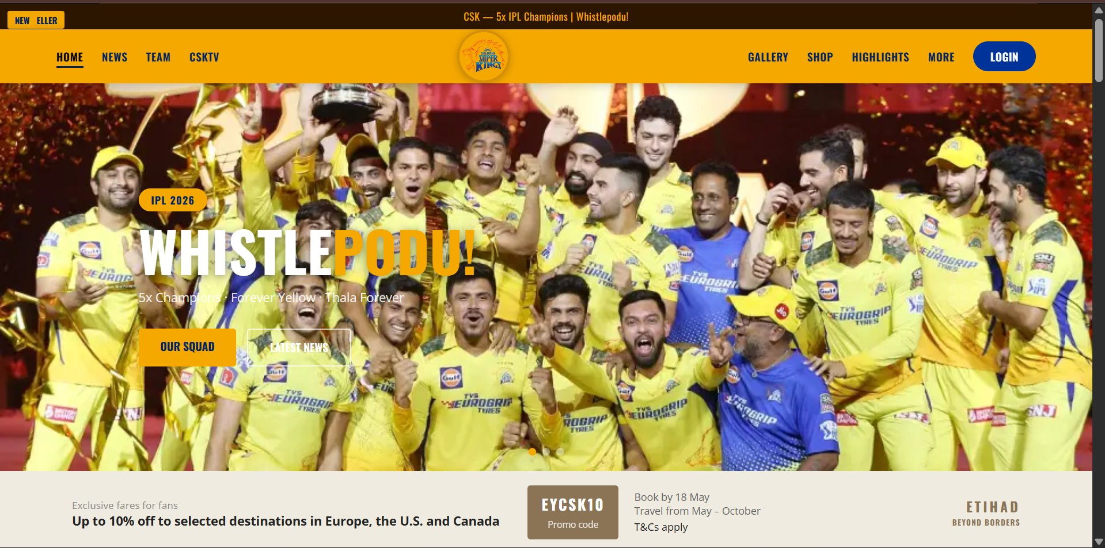
Hero Section — Whistlepodu! Banner with IPL 2026 badge & CTA buttons

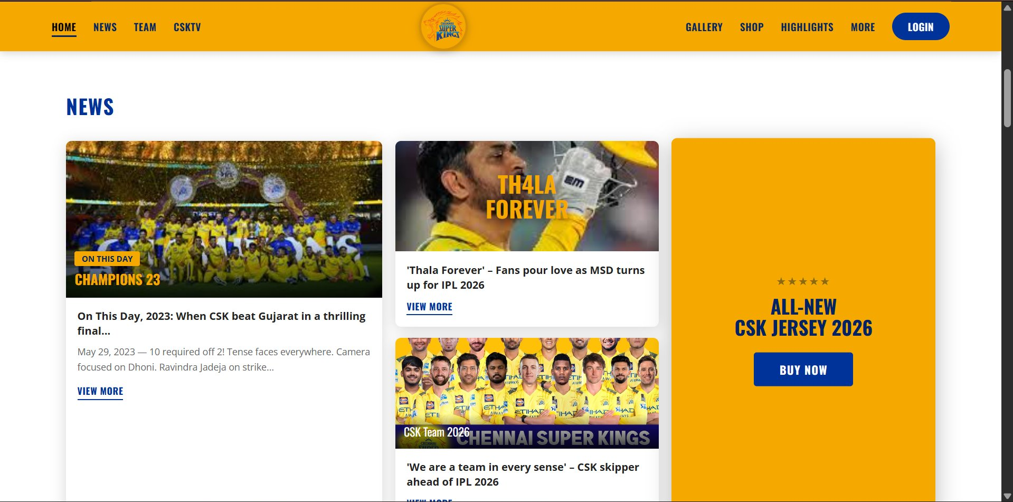
News Section — Featured article, column cards & All-New Jersey 2026 promo

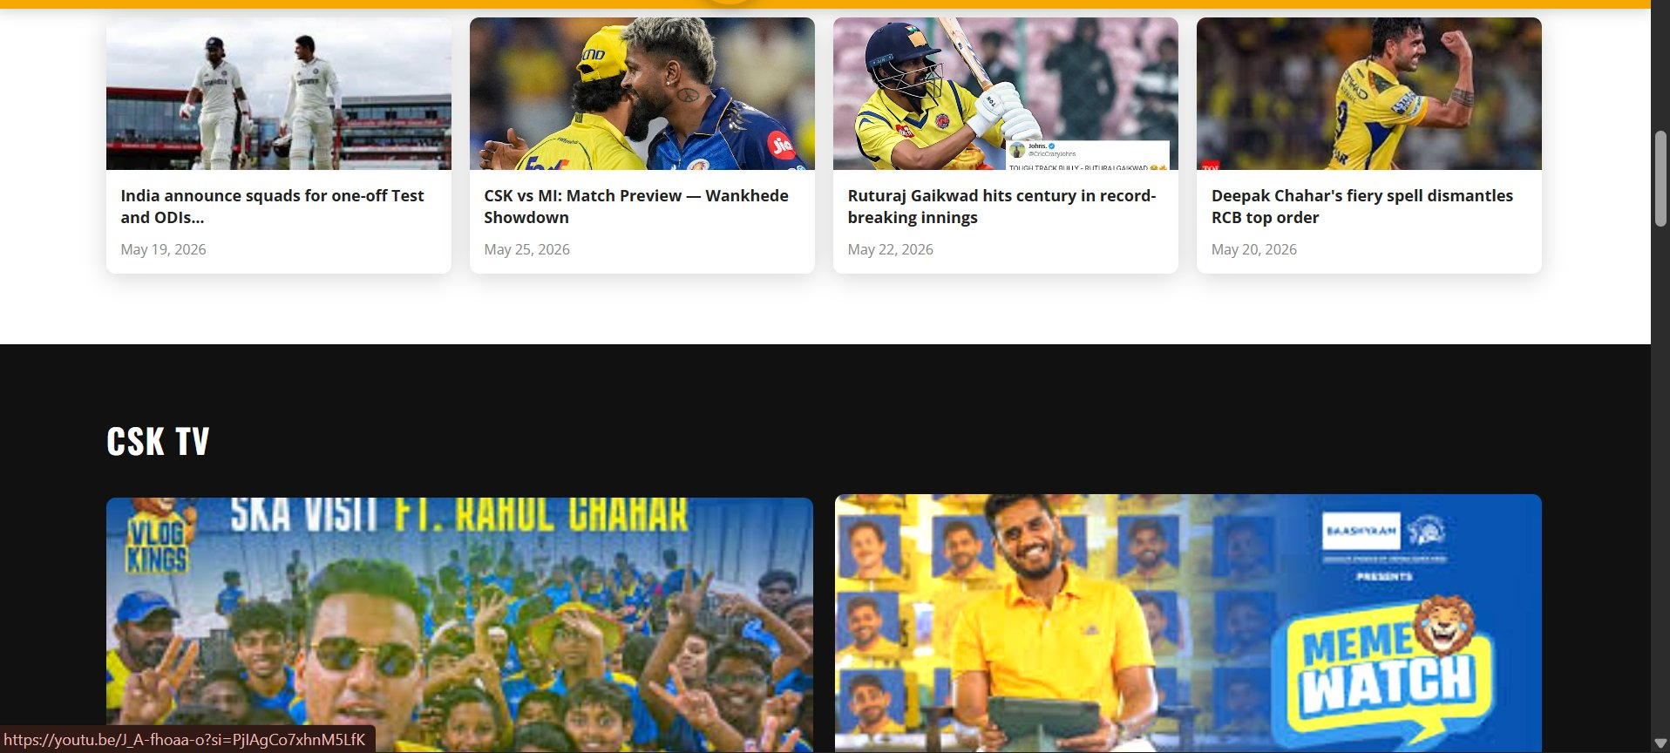
News Row 2 & CSK TV Video Grid

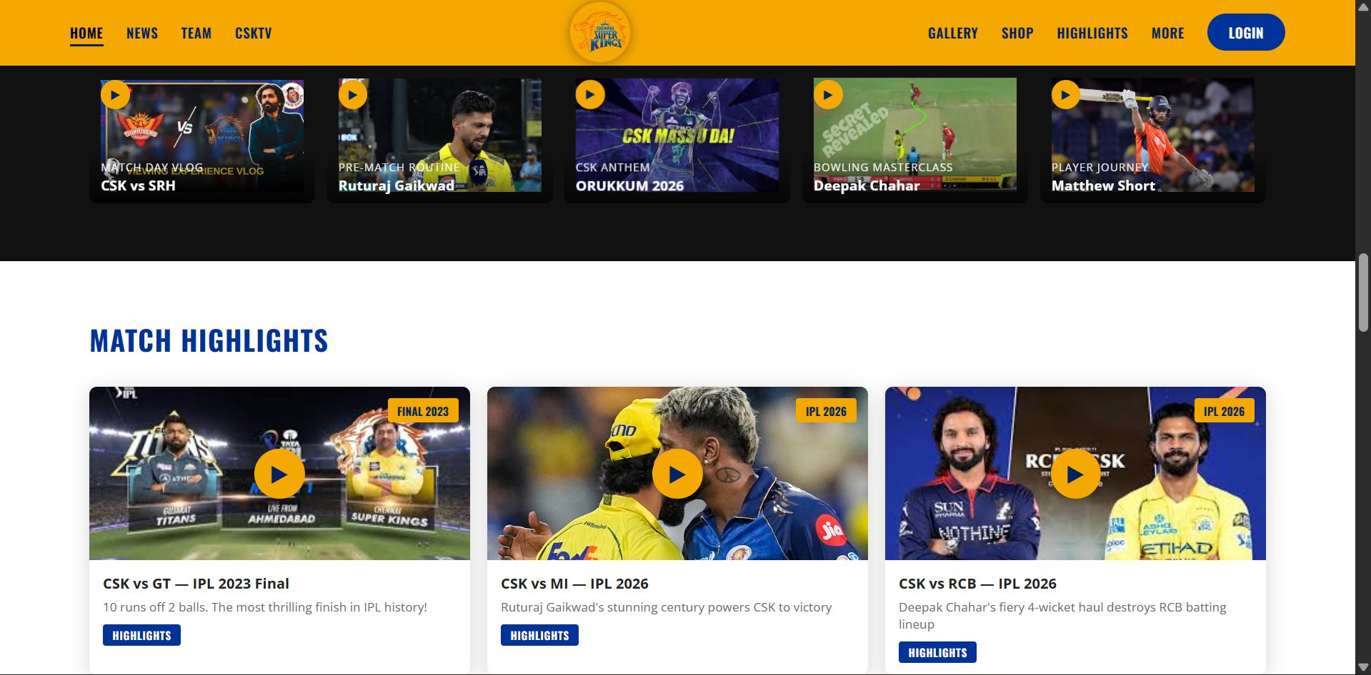
CSK TV Small Row & Match Highlights Grid

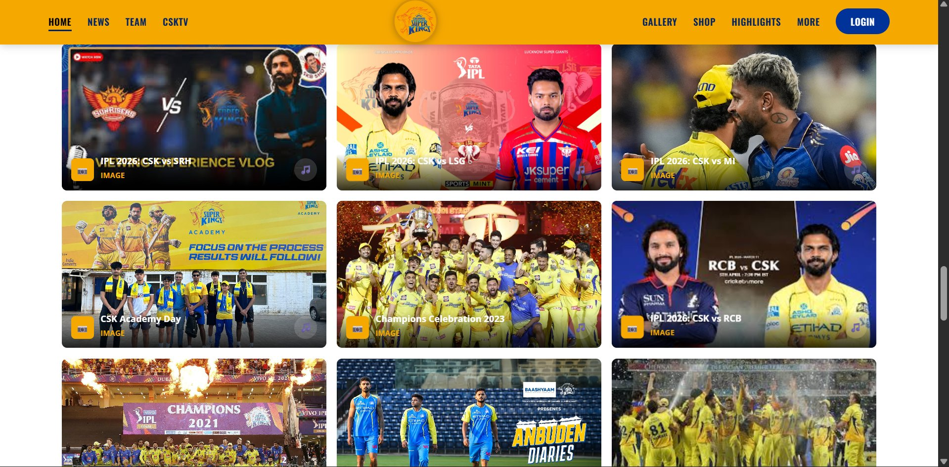
Gallery Section — 3-column image grid with filter buttons

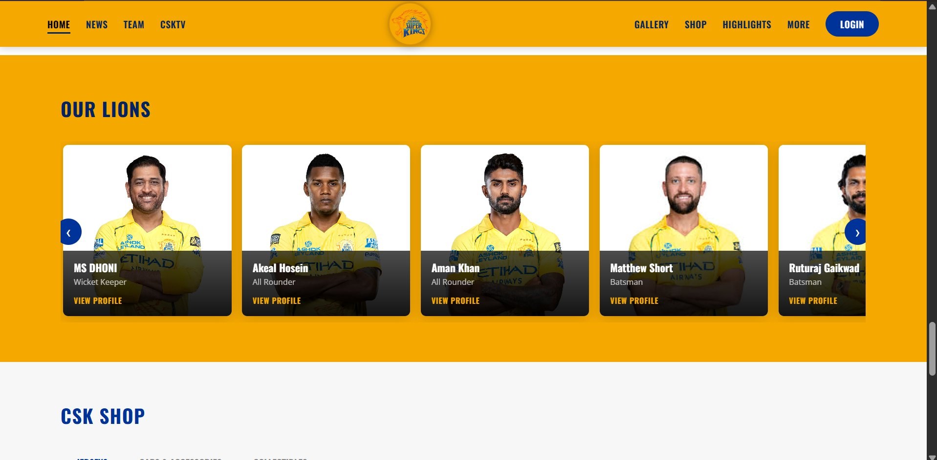
Our Lions — Player Carousel & CSK Shop Header

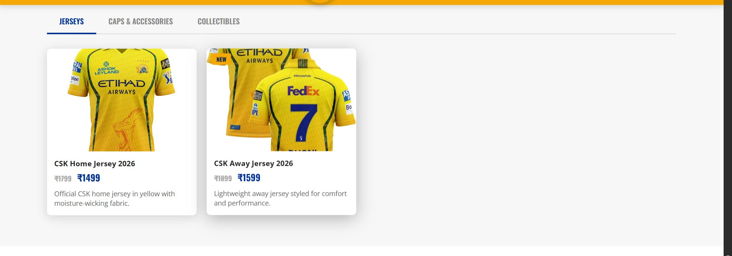
CSK Shop — Jerseys Tab

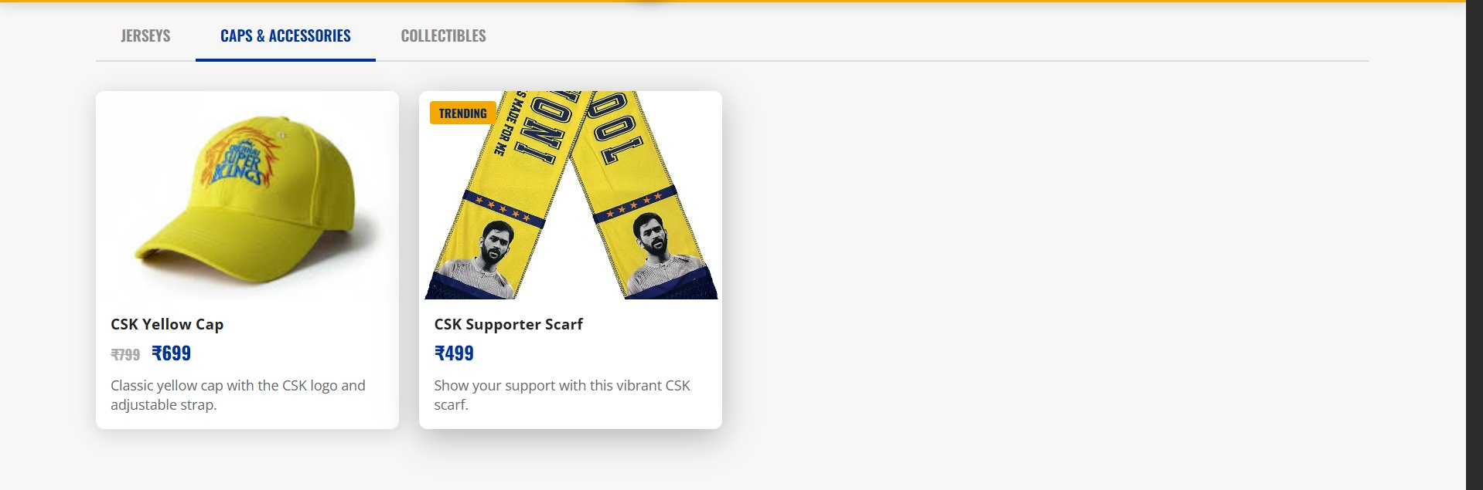
CSK Shop — Caps & Accessories Tab

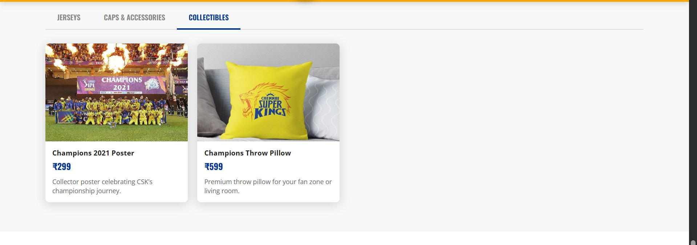
CSK Shop — Collectibles Tab

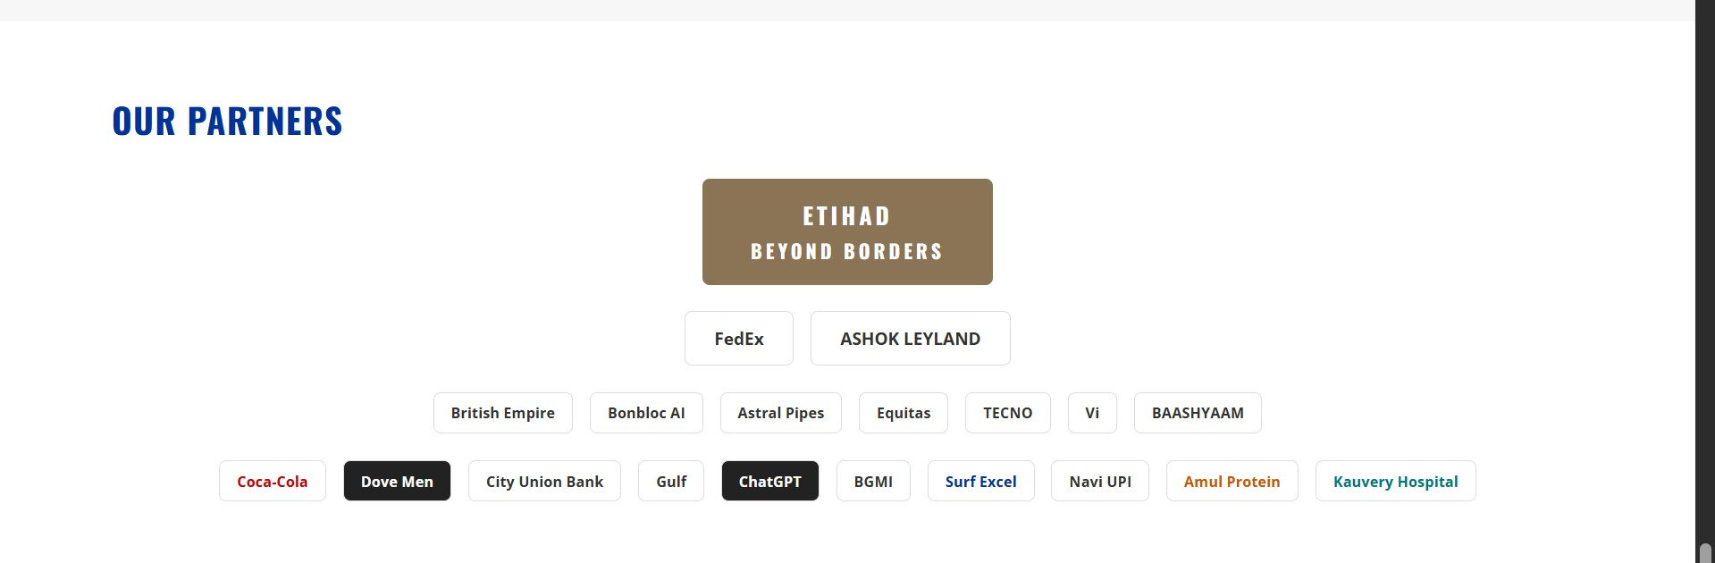
Our Partners Section

Explanation of Important Elements

In this project, I used several important HTML, CSS, and JavaScript elements and concepts to make the website look similar to the official Chennai Super Kings website, and also to make it interactive and user-friendly. The project mainly focuses on front-end web development concepts such as layout design, multimedia integration, dynamic content generation, and event handling.

HTML Elements Used

1. Hero Section with Auto-Sliding Banner
The hero section uses multiple <div class="hero-slide"> elements stacked together, with the active slide shown using CSS transitions. Each slide contains a background image, badge, heading, sub-text, and call-to-action buttons.

<div class="hero-slides">
<div class="hero-slide active">
<img class="hero-bg" src="..." alt="CSK champions" />
<div class="hero-content">
<div class="hero-badge">IPL 2026</div>
<h1 class="hero-title">WHISTLE<span>PODU!</span></h1>
<div class="hero-actions">
<a href="#team" class="btn-primary">OUR SQUAD</a>
<a href="#news" class="btn-outline">LATEST NEWS</a>
</div>
</div>
</div>
<span class="dot active" data-i="0"></span>
</div>

Explanation:
- Three slides are stacked; only the .active slide has opacity:1.
- JavaScript cycles through slides every 4 seconds using setInterval().
- Dot indicators at the bottom allow manual slide selection.

2. Semantic Sectioning Elements
HTML5 semantic elements such as <section>, <nav>, <footer>, and <div> with meaningful class names are used to structure all major page areas clearly.

<nav class="navbar" id="navbar"> ... </nav>
<section class="section" id="news"> ... </section>
<section class="section dark-bg" id="csktv"> ... </section>
<section class="section yellow-bg" id="team"> ... </section>
<footer class="footer"> ... </footer>

Explanation:
- Semantic tags improve accessibility and help screen readers understand the page structure.
- Each section has an id="" used as a navigation anchor target.

3. Font Awesome Icons
To add icons in the login page and footer social links, Font Awesome icons are used via the CDN.

<i class="fab fa-google"></i> Continue with Google
<i class="fab fa-facebook-f"></i> Continue with Facebook
<i class="fab fa-twitter"></i>
<i class="fab fa-instagram"></i>
<i class="fab fa-youtube"></i>

Explanation:
- fab stands for Font Awesome Brands — used for brand/company logos.
- fas stands for Font Awesome Solid — used for UI icons like envelope and lock.

4. Google Fonts Integration
Two custom fonts are loaded via Google Fonts to match the official CSK website typography.

<link href="https://fonts.googleapis.com/css2?
family=Oswald:wght@400;600;700
&family=Open+Sans:wght@400;600;700
&display=swap" rel="stylesheet" />

Explanation:
- Oswald (condensed, bold) is used for all headings, navigation, and section titles — matching CSK's strong visual identity.
- Open Sans is used for body text, giving a clean and readable appearance.

5. Modal Overlays
The website uses four separate modal overlay elements for videos, news articles, player profiles, and shop items.

<div class="modal-overlay" id="videoModal"
onclick="closeModal('videoModal')">
<div class="modal-box video-modal"
onclick="event.stopPropagation()">
<button class="modal-close">✕</button>
<h3 id="videoTitle"></h3>
<div class="iframe-wrap">
<iframe id="videoFrame" src="" allowfullscreen></iframe>
</div>
</div>
</div>

Explanation:
- Clicking the dark overlay closes the modal; clicking the box itself does not (event.stopPropagation).
- The YouTube iframe src is set dynamically by JavaScript when a video card is clicked.

CSS Concepts Used

1. CSS Custom Properties (Variables)
All CSK brand colors and common values are defined as CSS variables inside :root, making the entire color scheme easy to manage.

:root {
--y: #f5a800; /* CSK Yellow */
--yd: #d4900a; /* Yellow dark */
--b: #003399; /* CSK Blue */
--bd: #002266; /* Blue dark */
--dk: #1a0a00; /* Near black */
--r: 8px; /* Border radius */
--sh: 0 4px 20px rgba(0,0,0,.15);
--tr: .3s ease;
}

Explanation:
- Variables are referenced as var(--y) throughout the stylesheet, so changing one value instantly updates the entire theme.

2. Sticky Navbar
The top navigation bar stays visible while the user scrolls down the page.

.navbar {
background: var(--y);
position: sticky;
top: 0;
z-index: 999;
box-shadow: 0 2px 12px rgba(0,0,0,.18);
}

Explanation:
- position: sticky keeps the navbar fixed at the top once the user scrolls past it.
- z-index: 999 ensures the navbar always appears above all other content.

3. CSS Grid Layout
CSS Grid is used extensively across the News, Highlights, Gallery, and Shop sections to create multi-column card layouts.

/* 3-column news layout */
.news-grid {
display: grid;
grid-template-columns: 1.2fr 1fr 1fr;
gap: 18px;
}

/* 3-column gallery grid */
.gallery-grid {
display: grid;
grid-template-columns: repeat(3, 1fr);
gap: 16px;
}

Explanation:
- grid-template-columns defines the number and size of columns. Using 1fr makes columns flexible and equal-width.
- 1.2fr gives the featured news card slightly more width than the others.

4. Flexbox for Navigation & Player Slider
Flexbox is used for the navbar layout, footer, player slider, and login page side-by-side layout.

/* Navbar — logo centred, links on each side */
.nav-container {
display: flex;
align-items: center;
justify-content: space-between;
}

/* Horizontal player slider */
.team-slider {
display: flex;
gap: 16px;
overflow-x: auto;
scroll-behavior: smooth;
}

Explanation:
- justify-content: space-between pushes left links, center logo, and right links to their respective positions.
- overflow-x: auto on the player slider allows horizontal scrolling when player cards exceed the container width.

5. Hover Effects and Transitions
Interactive hover effects are applied to cards, buttons, and nav links using CSS transitions.

.news-card:hover,
.hl-card:hover,
.shop-item:hover {
transform: translateY(-4px);
box-shadow: 0 8px 32px rgba(0,0,0,.28);
}

.nav-link::after {
content: "";
position: absolute; bottom: -4px; left: 0;
width: 0; height: 2px; background: var(--bd);
transition: width .3s ease;
}
.nav-link:hover::after { width: 100%; }

Explanation:
- translateY(-4px) lifts cards slightly upward on hover, providing a 3D feel.
- The nav underline uses a pseudo-element ::after that expands from width:0 to width:100% on hover.

6. Responsive Design with Media Queries
The layout adapts to tablet and mobile screens using CSS media queries.

@media (max-width: 768px) {
.nav-links { display: none; }
.hamburger { display: flex; }
.news-grid { grid-template-columns: 1fr; }
.highlights-grid { grid-template-columns: 1fr 1fr; }
.gallery-grid { grid-template-columns: 1fr 1fr; }
.hero-title { font-size: 2.8rem; }
}
@media (max-width: 480px) {
.hero-title { font-size: 2rem; }
.shop-grid, .gallery-grid { grid-template-columns: 1fr; }
}

Explanation:
- On screens below 768px, the desktop nav links are hidden and replaced by a hamburger menu icon.
- Multi-column grids collapse to single or double columns for better readability on mobile.

JavaScript Concepts Used

1. Hero Auto-Slide with setInterval
The hero banner automatically cycles through three slides using JavaScript's setInterval function.

const slides = document.querySelectorAll('.hero-slide');
const dots = document.querySelectorAll('.dot');
let current = 0;

let timer = setInterval(() => {
changeSlide((current + 1) % slides.length);
}, 4000);

function changeSlide(n) {
slides[current].classList.remove('active');
dots[current].classList.remove('active');
current = n;
slides[current].classList.add('active');
dots[current].classList.add('active');
}

Explanation:
- setInterval() calls changeSlide() every 4 seconds automatically.
- % slides.length wraps the index back to 0 after the last slide, creating a continuous loop.
- Clicking a dot calls clearInterval() to stop auto-slide before jumping manually.

2. Shop Dynamic Rendering with Arrays and innerHTML
Instead of writing each product card manually in HTML, shop items are stored in a JavaScript object and rendered dynamically with innerHTML.

const shopData = {
jerseys: [
{ name: 'CSK Home Jersey 2026', price: '₹1499', old: '₹1799',
desc: 'Official CSK home jersey in yellow...' },
{ name: 'CSK Away Jersey 2026', price: '₹1599', old: '₹1899',
desc: 'Lightweight away jersey...' }
],
// caps, collectibles follow same structure
};

function renderShop(key) {
const grid = document.getElementById('shopGrid');
grid.innerHTML = shopData[key].map(item => `
<div class="shop-item">
<div class="shop-info">
<h4>${item.name}</h4>
<span class="shop-price">${item.price}</span>
<p>${item.desc}</p>
</div>
</div>
`).join('');
}
renderShop('jerseys'); // show jerseys on page load

Explanation:
- shopData is a JavaScript object where each key (jerseys, caps, collectibles) holds an array of product objects.
- Array.map() transforms each object into an HTML string. .join('') combines all strings into one block.
- Clicking a shop tab calls renderShop() with the relevant key, swapping the grid content instantly.

3. Gallery Filter with classList
The gallery filter buttons show or hide image cards based on their data-cat attribute.

document.querySelectorAll('.gf-btn').forEach(btn => {
btn.addEventListener('click', function () {
document.querySelectorAll('.gf-btn')
.forEach(b => b.classList.remove('active'));
this.classList.add('active');

const filter = this.dataset.filter;
document.querySelectorAll('.gal-card').forEach(card => {
card.classList.toggle('hide',
filter !== 'all' && card.dataset.cat !== filter);
});
});
});

Explanation:
- Each gallery card has a data-cat="match" / "team" / "champ" attribute.
- classList.toggle('hide', condition) adds the hide class when the card does not match the selected filter.
- The CSS .gal-card.hide { display: none; } rule makes the card disappear.

4. IntersectionObserver for Scroll Reveal
Sections fade in smoothly as the user scrolls down, using the browser's built-in IntersectionObserver API.

const observer = new IntersectionObserver(entries => {
entries.forEach(e => {
if (e.isIntersecting)
e.target.classList.add('visible');
});
}, { threshold: 0.12 });

document.querySelectorAll('.reveal')
.forEach(el => observer.observe(el));

Explanation:
- IntersectionObserver watches elements and fires a callback when they enter the viewport.
- threshold: 0.12 means the callback fires when 12% of the element is visible.
- Adding the .visible class triggers the CSS transition: opacity 0 → 1, translateY(24px) → 0.

5. Password Visibility Toggle
The login page lets the user reveal or hide their password by toggling the input type between "password" and "text".

document.getElementById('togglePass')
.addEventListener('click', function() {
const input = document.getElementById('passInput');
const icon = document.getElementById('eyeIcon');
if (input.type === 'password') {
input.type = 'text';
icon.className = 'fas fa-eye-slash';
} else {
input.type = 'password';
icon.className = 'fas fa-eye';
}
});

Explanation:
- Changing input.type between "password" and "text" shows or hides the characters typed.
- The Font Awesome icon class is also updated (fa-eye vs fa-eye-slash) to reflect the current state.

Conclusion

Overall, HTML was used to create the structure of the website, CSS was used for styling and layout design, and JavaScript was used to add dynamic functionality and interactivity. By combining these technologies, I was able to build a Chennai Super Kings-inspired website with features such as an auto-sliding hero banner, filterable gallery, dynamically rendered shop tabs, interactive player carousel, video modals, scroll-reveal animations, and a polished login page.

The project closely mirrors the visual identity of the official CSK website — using the brand's signature yellow (#f5a800) and blue (#003399) color scheme, the Oswald typeface for headings, and card-based layouts for news, highlights, and gallery sections.

"THE END!"

