.

UNIVERSITY OF SOUTH ASIA
Department of Computer Science
FINAL YEAR PROJECT PROPOSAL

Identifying the Best Deployable Machine Learning Model for Malaria and Dengue Diagnosis
A Comparative Benchmarking and Deployment Framework for Low-Resource Healthcare Settings
Submitted by
Student Name | Registration No.
[Student 1 Name] (Group Leader) | [B-XXXXX]
[Student 2 Name] | [B-XXXXX]
[Student 3 Name] | [B-XXXXX]

Supervised by
[Supervisor Name]
Session [20XX – 20XX]

Table of Contents
1. Introduction3
1.1 Project Title3
1.2 Project Overview Statement3
1.3 Background5
2. Problem Statement5
3. Existing Systems and Current Challenges5
4. Proposed Solution6
5. Project Goals and Objectives6
5.1 Goal6
5.2 Objectives7
6. Scope of the Project7
6.1 High-Level System Components7
6.2 List of Optional Functional Units8
6.3 Exclusions8
7. Significance of the Project8
8. Novelty and Unique Features9
9. Roles and Responsibilities9
10. Methodology10
10.1 Data Collection and Preprocessing10
10.2 Malaria Image Model Benchmarking10
10.3 Dengue Clinical Model Benchmarking10
10.4 Model Compression and Export10
10.5 Deployability Scoring11
10.6 Explainability and Clinical Review11
11. System Architecture11
11.1 AI / ML Pipeline12
11.2 Workflow Diagram13
11.3 User Interaction Flow14
12. Functional Requirements15
13. Non-Functional Requirements16
14. AI / ML Models16
15. Dataset Information17
16. Database Design Overview17
17. APIs and Integrations18
18. Security and Ethical Considerations19
19. Hardware and Software Specification19
20. Tools and Technologies Used, with Reasoning19
21. Success Criteria and Evaluation Methodology20
22. Expected Outcomes and Commercialisation Potential20
23. Project Timeline21
24. Future Enhancements22
References22
No Plagiarism and Fair Play Declaration23

1. Introduction

1.1 Project Title
Identifying the Best Deployable Machine Learning Model for Malaria and Dengue Diagnosis

1.2 Project Overview Statement
Malaria and dengue are two mosquito-borne diseases that keep coming back every year in Pakistan and much of South Asia. Both often start with fever, body aches and fatigue, so in the early days a patient with one can easily be mistaken for a patient with the other. Getting the diagnosis right quickly matters: malaria needs antimalarial drugs, while dengue needs careful fluid management and close monitoring of platelets, and the wrong call can be dangerous.
A large number of research papers already show that machine learning can detect malaria parasites in blood smear images and can flag likely dengue cases from routine blood test values. The problem is that most of this work stops at a high accuracy number on a test set. Very few studies ask the question a hospital or a rural health unit would actually ask: which of these models can we run on the hardware we have, fast enough, with results that a doctor can trust and understand?
MalDen-Deploy is our attempt to answer that question. We will train and compare a range of models for two tasks: (1) classifying thin blood smear cell images as parasitized or uninfected for malaria, and (2) predicting dengue from complete blood count (CBC) values and reported symptoms. Every model will be judged not only on diagnostic performance but also on inference speed, memory use, model size, calibration, robustness and explainability. These measures will be combined into a single Deployability Score using a multi-criteria ranking method, and the best-ranked model for each disease will be packaged into a working web application and a lightweight Android prototype.
The project is therefore both research and development. The research side produces an honest, repeatable comparison of models under realistic deployment constraints. The development side shows that the chosen models can actually be used by lab staff and clinicians in a simple, explainable tool.

Project Title | MalDen-Deploy: Identifying the Best Deployable Machine Learning Model for Malaria and Dengue Diagnosis

Name | Registration # | Email Address
[Student 1 Name] | [B-XXXXX] | [b-xxxxx@student.usa.edu.pk]
[Student 2 Name] | [B-XXXXX] | [b-xxxxx@student.usa.edu.pk]
[Student 3 Name] | [B-XXXXX] | [b-xxxxx@student.usa.edu.pk]

Group Leader | [Student 1 Name] ([B-XXXXX])
Project Goal | To identify, through systematic benchmarking, the most suitable machine learning model for malaria detection and for dengue prediction when accuracy, speed, size, reliability and explainability are all taken into account, and to deploy the selected models in a usable web and mobile diagnostic support tool.
Project Success Criteria | The project will be considered successful if at least six candidate models are trained and evaluated for each disease under the same protocol, and a Deployability Score is produced for each one.  The selected malaria model should reach at least 95% sensitivity and 95% accuracy on the held-out test set, and the selected dengue model should reach at least 85% sensitivity with a ROC-AUC of 0.85 or higher.  After compression, the deployed models should run in under 200 ms per prediction on a standard CPU or mid-range Android phone.  The final application should be rated as usable (SUS score of 70 or more) by a small group of test users.
Assumptions, Risks and Obstacles | We assume that the public malaria image dataset and the public dengue clinical datasets are representative enough to train useful models, and that the group will have access to a GPU (university lab or Google Colab) for training.  The main risk is on the dengue side. Public dengue datasets are small, come from different hospitals and are sometimes imbalanced, which can make models look better than they really are. We will reduce this risk through stratified cross-validation, class balancing and, if possible, external validation on a second dataset.  Other risks include loss of accuracy after quantisation, limited compute time, and difficulty getting clinicians to review the explanations. These will be handled by early prototyping, keeping a full-precision fallback model, and contacting medical staff early in the project.

Type of Project | Research and Development
Target End Users | Laboratory technicians and medical officers in basic health units, rural health centres and small private clinics where expert microscopists are not always available. Researchers and students working on medical AI are secondary users, since the benchmarking module and its results can be reused for other diseases.
Development Technology | Python will be used for all data processing and model training (PyTorch, TensorFlow/Keras, scikit-learn, XGBoost, LightGBM). Trained models will be exported to ONNX and TensorFlow Lite for deployment. The backend will be built with FastAPI, the web interface with React, and the mobile prototype with Android (Kotlin) running TFLite. PostgreSQL will store users, test records, predictions and benchmark results. MLflow will track experiments and model versions.
Platform | A web-based platform accessible through any modern browser, supported by an Android application that can run the selected malaria and dengue models fully offline. Offline support is important because many of the intended locations have weak or unreliable internet.
Suggested Project Supervisor | [Supervisor Name]

1.3 Background
According to the World Health Organization, there were an estimated 263 million malaria cases and about 597,000 malaria deaths worldwide in 2023 [1]. Dengue has been spreading even faster. Global case counts have risen sharply over the last two decades, and 2024 set a new record with more than 14 million reported cases [2][3]. Pakistan carries a share of both burdens. Malaria remains endemic in several districts, and large dengue outbreaks have hit cities such as Lahore, Rawalpindi and Karachi in recent years, usually after the monsoon.
The standard test for malaria is microscopic examination of a Giemsa-stained blood smear. It is cheap, but it depends heavily on the skill and workload of the microscopist, and accuracy drops when staff are tired or inexperienced [4]. Dengue is usually confirmed with NS1 antigen or antibody tests, which are not always available in small facilities. In practice, many doctors rely on a falling platelet count, a low white cell count and the patient's symptoms to suspect dengue.
Machine learning fits well into both situations. Convolutional neural networks have reached very high accuracy on smear image datasets [5], and tree-based models trained on CBC data have shown good results in separating dengue from other febrile illnesses. However, published models are usually large, are tested on powerful GPUs, and are reported with accuracy alone. A model that scores 99% but takes several seconds per image on a clinic laptop, or that cannot explain why it made a decision, is unlikely to be used. This gap between what works in a notebook and what works in a clinic is the motivation for our project.

2. Problem Statement
Many machine learning models have been proposed for malaria and dengue diagnosis, but there is no clear, practical way to decide which of them is actually the best choice for deployment in low-resource healthcare settings. Most studies report accuracy on one dataset, use different preprocessing and data splits, and ignore factors such as inference time, memory, model size, calibration and explainability.
As a result, a developer or a health organisation that wants to build a diagnostic support tool has to guess which model to use. A model chosen on accuracy alone may be too slow or too heavy for the available hardware, may be overconfident in its wrong predictions, or may give no explanation that a doctor can check.
MalDen-Deploy addresses this problem by building a fair, repeatable benchmarking framework that evaluates candidate models for malaria and dengue on both diagnostic and deployment criteria, ranks them using a weighted multi-criteria method, and proves the result by deploying the top-ranked models in a working application.

3. Existing Systems and Current Challenges
Existing work in this area falls into three broad groups. The first group is academic models for malaria smear classification. The NIH malaria dataset released by the U.S. National Library of Medicine has become the common benchmark, and studies using pre-trained CNNs such as VGG, ResNet and DenseNet report accuracies in the high nineties [5][6]. These results are encouraging, but the models are often hundreds of megabytes, and very few papers report how long a prediction takes or how the model behaves on a phone.
The second group is dengue prediction from clinical data. Researchers have used logistic regression, decision trees, random forests, support vector machines and neural networks on CBC values and symptoms. These studies usually rely on small single-hospital datasets, and results are hard to compare because each study uses different features and evaluation methods.
The third group is commercial or semi-commercial tools such as automated digital microscopy systems and rapid diagnostic test readers. These can be accurate but they are expensive, need special hardware, and are rarely affordable for a basic health unit.
The common challenges across all of these can be summarised as follows:
- Accuracy-only evaluation: models are ranked on accuracy alone, while sensitivity (missing a sick patient) matters far more in medicine.
- No deployment metrics: latency, memory, model size and energy use are rarely measured, so it is unclear whether a model can run on low-cost devices.
- Inconsistent protocols: different splits, preprocessing and metrics make it almost impossible to compare papers fairly.
- Black-box predictions: most systems give a label without showing which part of the image or which blood value drove the decision.
- Two diseases, two separate tools: malaria and dengue are usually studied in isolation, even though they present similarly and are often tested for together.

4. Proposed Solution
MalDen-Deploy proposes a two-part solution. The first part is a benchmarking framework. All candidate models for a disease will be trained on the same data splits, with the same preprocessing and the same random seeds, and evaluated with the same set of metrics. Alongside diagnostic metrics, the framework will automatically measure inference latency on CPU and on an Android device, peak memory use, model file size, calibration error and robustness to image noise or missing values. Each model will also produce explanations (Grad-CAM heatmaps for images and SHAP values for clinical data) that will be reviewed for clarity.
These measurements will be normalised and combined using TOPSIS, a well-known multi-criteria decision-making method [7], to produce a Deployability Score between 0 and 1. A hard rule will remove any model whose sensitivity falls below a set clinical threshold before ranking, so that a fast but unsafe model can never win. The weights for each criterion will be set with input from our supervisor and, where possible, a medical professional, and we will also run a sensitivity analysis to show how the ranking changes if the weights change.
The second part is a deployment prototype. The top-ranked model for each disease will be compressed (post-training quantisation and, where useful, pruning), exported to ONNX and TensorFlow Lite, and integrated into a web application and an Android app. A lab technician will be able to upload a cell image or enter CBC values and symptoms, and receive a prediction, a confidence level, a simple risk flag and a visual explanation. All predictions will be stored so that results can be reviewed later.

5. Project Goals and Objectives

5.1 Goal
The main goal of MalDen-Deploy is to find out, using a fair and transparent process, which machine learning model is most suitable for real-world deployment for malaria detection and for dengue prediction, and to demonstrate that choice through a working, explainable diagnostic support application.

5.2 Objectives
- To collect, clean and prepare a malaria blood smear image dataset and at least one dengue clinical dataset under a single, documented preprocessing protocol.
- To train and tune at least six candidate models for each disease, covering lightweight, mid-size and large architectures.
- To measure diagnostic performance (sensitivity, specificity, precision, F1-score, ROC-AUC) and deployment performance (latency, memory, model size, calibration, robustness) for every model.
- To design a Deployability Score using TOPSIS with a clinical safety constraint, and to test how stable the ranking is under different weightings.
- To apply quantisation and pruning to the leading models and measure the trade-off between size, speed and accuracy.
- To add explainability through Grad-CAM for images and SHAP for clinical data, and to collect feedback on these explanations.
- To develop a web application and an offline Android prototype that use the selected models for prediction.
- To document the full benchmark so that other researchers can repeat it or extend it to other diseases.

6. Scope of the Project
The scope of MalDen-Deploy covers model benchmarking for two diseases, selection of the best deployable model for each, and a prototype application that uses those models. The main components are described below.

6.1 High-Level System Components
1. Data Management and Preprocessing Module
Handles loading, cleaning, splitting and augmenting the malaria image data and the dengue clinical data. It keeps a fixed record of the train, validation and test splits so that every model is evaluated on exactly the same samples.
2. Malaria Image Model Benchmark
Trains and evaluates image classification models, from a small custom CNN up to transfer-learning models such as ResNet-50, DenseNet-121, MobileNetV3, EfficientNet-B0 and a small Vision Transformer.
3. Dengue Clinical Model Benchmark
Trains and evaluates tabular models such as Logistic Regression, Support Vector Machine, Random Forest, XGBoost, LightGBM and a small Multi-Layer Perceptron on CBC values and symptoms.
4. Model Optimisation Module
Applies post-training quantisation, quantisation-aware training where needed, and pruning, then exports models to ONNX and TFLite and re-tests them to confirm accuracy has not dropped noticeably.
5. Deployability Scoring Engine
Collects all metrics, normalises them, applies the clinical safety constraint and the TOPSIS ranking, and produces comparison tables and charts.
6. Explainability Module
Generates Grad-CAM heatmaps that highlight the parasite region in a cell image and SHAP plots that show which blood values pushed a dengue prediction up or down.
7. Diagnostic Support Application
A web dashboard and an Android app that let users run predictions, view explanations, keep patient test history, and let researchers view benchmark results.

6.2 List of Optional Functional Units
1. Malaria Species Identification
If time allows, the malaria model may be extended to distinguish between P. falciparum and P. vivax using a species-labelled dataset.
2. Parasite Density Estimation
An object detection model could count infected cells in a full smear field to give a rough parasite density.
3. Urdu Language Interface
The mobile app may provide Urdu labels and instructions for staff who are more comfortable in Urdu.
4. Outbreak Heatmap
Anonymised positive predictions could be shown on a district-level map to give an early view of local case clusters.

6.3 Exclusions
- The system is a decision support tool only. It will not give a final diagnosis or prescribe treatment.
- The project will not build any new laboratory hardware or automated microscope.
- Clinical trials or formal regulatory approval are outside the scope of a final year project.
- Dengue serotype identification and severe dengue (shock) prediction are not included.

7. Significance of the Project
The value of this project lies in shifting the question from "which model is most accurate?" to "which model is most useful where it is needed?". For health workers in under-resourced areas, a model that runs offline on a cheap phone and shows its reasoning is far more valuable than a slightly more accurate model that needs a server and a stable connection.
For the research community, the project provides a single, consistent benchmark covering both a medical imaging task and a clinical tabular task, with deployment metrics that are usually missing from published work. The Deployability Score and the code behind it can be reused for other diseases such as tuberculosis or typhoid.
For students and developers, the project shows the complete path from dataset to deployed model, including compression, explainability and a working interface. This is the part that is often skipped in academic projects but matters most in practice.

8. Novelty and Unique Features
The main features that make MalDen-Deploy different from existing work are:
- Deployment-aware model selection: models are ranked on a combined Deployability Score instead of accuracy alone.
- Clinical safety gate: any model that misses too many positive cases is removed before ranking, no matter how fast or small it is.
- Dual-disease scope: malaria (image data) and dengue (clinical data) are handled in one framework, reflecting the real diagnostic overlap between the two.
- Real-device measurements: latency and memory are measured on an actual mid-range Android phone and a normal laptop CPU, not only on a GPU.
- Compression study: the effect of quantisation and pruning on accuracy, size and speed is measured and reported for every leading model.
- Built-in explainability: every prediction comes with a Grad-CAM heatmap or SHAP explanation, and explanation quality is part of the score.
- Offline-first prototype: the Android app runs the chosen models without internet access.

9. Roles and Responsibilities
Work will be divided among the three group members according to their strengths, while all members will take part in testing, writing and the final presentation. Weekly meetings with the supervisor will be used to review progress and adjust the plan.
Member / Role | Responsibilities
Supervisor / Project Coordinator  [Supervisor Name] | Technical guidance, approval of evaluation criteria and weights, milestone review, and preparation for the mid and final defence.
[Student 1 Name] (Group Leader)  Malaria Imaging & Model Optimisation | Malaria dataset preparation and augmentation, training and tuning of all image models, Grad-CAM explanations, quantisation and pruning experiments, TFLite/ONNX export, and overall project coordination.
[Student 2 Name]  Dengue Modelling & Deployability Scoring | Dengue data collection and cleaning, handling class imbalance, training of all clinical models, SHAP explanations, calibration and robustness tests, and design and implementation of the TOPSIS-based Deployability Score with sensitivity analysis.
[Student 3 Name]  Application Development & Testing | Database design, FastAPI backend, React web dashboard, Android app integration with TFLite models, on-device latency measurement, system testing and usability (SUS) evaluation.
All Members  Documentation & Evaluation | Literature review, proposal and final report writing, test case preparation, result analysis and final presentation.

10. Methodology
We will follow an iterative, experiment-driven approach. Each step below produces outputs that feed into the next, and all experiments will be logged in MLflow so that results can be traced back to the exact code, data split and settings used.

10.1 Data Collection and Preprocessing
Malaria: The NIH Malaria Cell Images dataset contains 27,558 segmented red blood cell images, split equally between parasitized and uninfected cells [5]. Images will be resized (224 x 224 for transfer-learning models, smaller for the custom CNN), normalised, and augmented with flips, rotations, small colour shifts and blur to simulate differences in staining and microscope quality. Because several images can come from the same patient, we will split by patient where patient IDs are available so that the same person does not appear in both training and test sets.
Dengue: We will use publicly available dengue clinical datasets that include CBC values (platelet count, white blood cell count, haemoglobin, haematocrit and others), basic demographics and symptoms. If ethical approval and permission can be obtained, anonymised records from a partner hospital will be used as an external test set. Preprocessing will include removing duplicates, handling missing values with median or KNN imputation, scaling numeric features, encoding symptoms, and balancing classes with SMOTE applied only to the training folds.
For both tasks, the data will be split into stratified training (70%), validation (15%) and test (15%) sets. The test set will be locked and only used for final reporting.

10.2 Malaria Image Model Benchmarking
- Candidates: a small custom CNN (baseline), ResNet-50, DenseNet-121, MobileNetV3-Small/Large, EfficientNet-B0 and a small Vision Transformer (ViT/DeiT-Tiny).
- Training: transfer learning from ImageNet weights, first training the new classification head and then fine-tuning deeper layers with a lower learning rate. Binary cross-entropy loss, Adam or AdamW optimiser, and early stopping on validation loss.
- Tuning: learning rate, batch size and degree of fine-tuning will be tuned on the validation set using a limited search to keep the comparison fair across models.
- Output: the probability that a cell is parasitized, with a threshold chosen to favour high sensitivity.

10.3 Dengue Clinical Model Benchmarking
- Candidates: Logistic Regression (baseline), Support Vector Machine, Random Forest, XGBoost, LightGBM and a small Multi-Layer Perceptron.
- Validation: stratified 5-fold cross-validation on the training data, repeated with different seeds, to give a mean and spread for every metric instead of a single lucky number.
- Tuning: Bayesian or random search over each model's key hyperparameters (for example, tree depth and learning rate for XGBoost).
- Calibration: Platt scaling or isotonic regression so that a predicted 80% risk really means roughly 80%.

10.4 Model Compression and Export
The best few models from each benchmark will be optimised for deployment. We will apply post-training dynamic and full-integer (INT8) quantisation [8], and quantisation-aware training if the accuracy drop is too large. Magnitude pruning will be tested on the CNNs. Each optimised model will be exported to ONNX (for the web backend) and TFLite (for Android) and re-evaluated on the same test set to record any loss in accuracy.

10.5 Deployability Scoring
All models will be compared using five groups of criteria, shown in the figure below. Each raw metric will be normalised, weighted and passed through TOPSIS, which ranks models by how close they are to an ideal solution and how far they are from the worst one [7]. Before ranking, any model below the minimum sensitivity threshold (95% for malaria and 85% for dengue) will be excluded. We will then vary the weights by plus or minus 10% to check whether the top model stays the same.
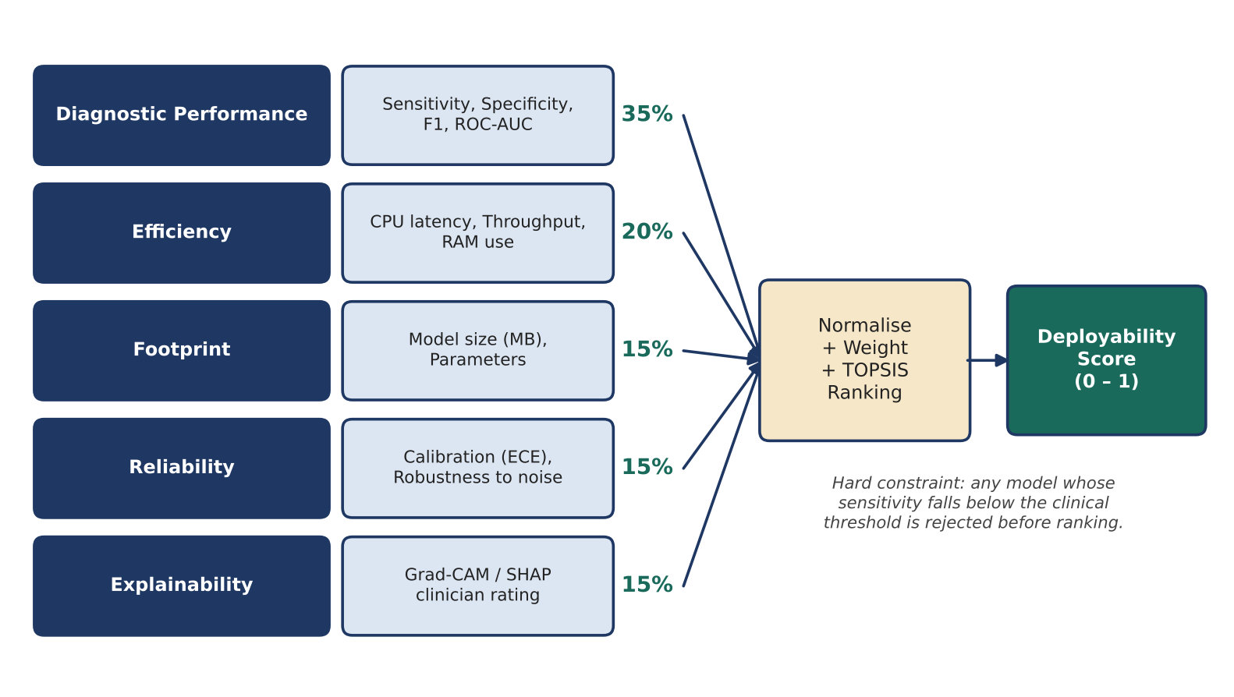
Figure 1: Deployability Scoring Framework

10.6 Explainability and Clinical Review
For the image models, Grad-CAM [9] will produce heatmaps showing which region of a cell influenced the prediction. A good model should focus on the stained parasite, not on the background or the cell edge. For the clinical models, SHAP [10] will show how much each feature (for example, a low platelet count) pushed the prediction towards dengue. A short questionnaire will ask a small number of medical students or doctors to rate a sample of explanations for clarity and usefulness, and the average rating will feed into the explainability criterion.

11. System Architecture
MalDen-Deploy follows a four-layer architecture. The presentation layer contains the web dashboard and the Android app. The application layer is a FastAPI service that handles authentication, prediction requests, benchmark runs and explanation generation. The AI/ML layer contains the trained and optimised models, the compression tools and the scoring engine. The data layer stores structured records in PostgreSQL, images in object storage and model versions in an MLflow registry.
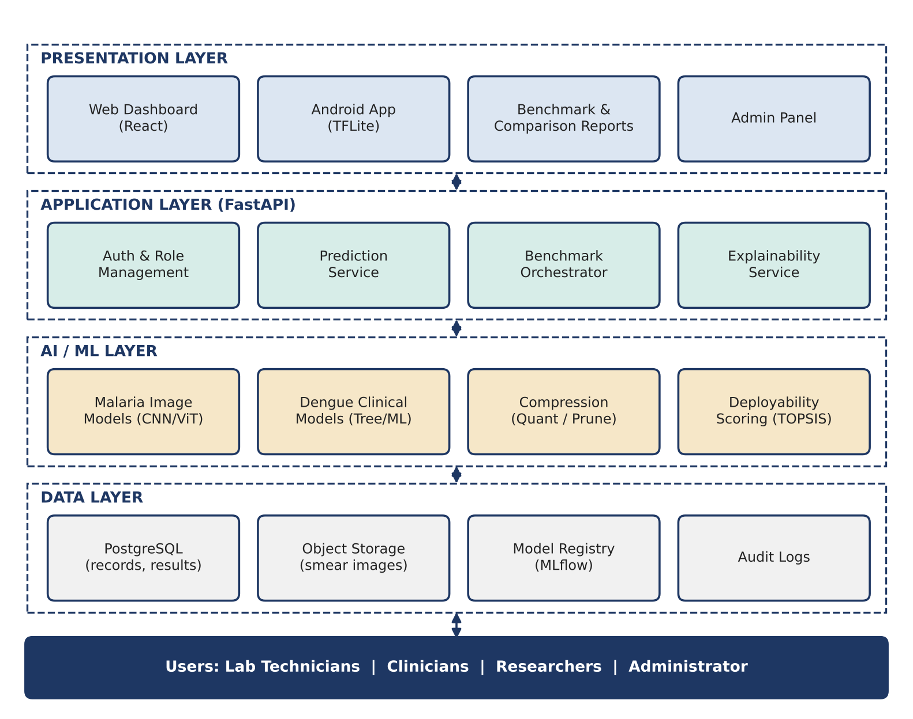
Figure 2: Layered System Architecture
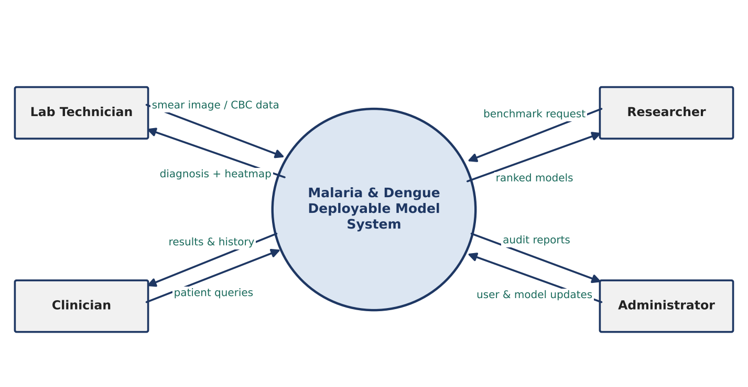
Figure 3: Context Level Data Flow Diagram

11.1 AI / ML Pipeline
The pipeline has two parallel lanes, one for malaria images and one for dengue clinical records. Both lanes go through preprocessing, model training, optimisation and export. Their results meet at the multi-criteria evaluation stage, which produces the best deployable model for each disease. Only these selected models are pushed to the production application.
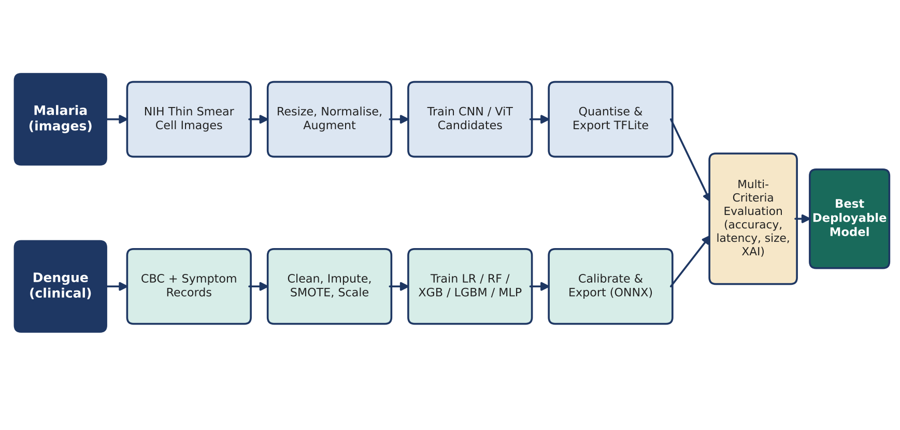
Figure 4: AI / ML Benchmarking Pipeline

11.2 Workflow Diagram
The workflow below shows what happens from the moment a user logs in until the result is saved. The user chooses whether the test is for malaria or dengue, provides the relevant input, and the system validates the input, runs the deployed model, creates an explanation, and stores the record.
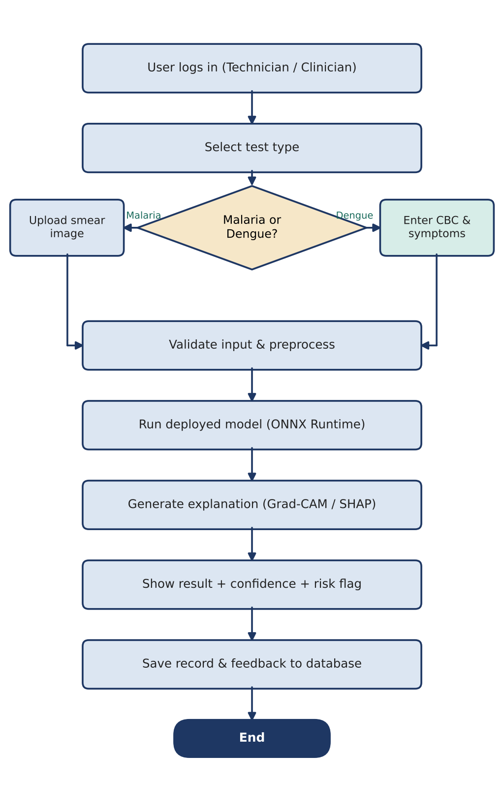
Figure 5: System Workflow

11.3 User Interaction Flow
Four types of users interact with the system. Lab technicians upload smear images or enter CBC values and view results. Clinicians review results, explanations and patient history. Researchers run benchmarks and compare Deployability Scores. The administrator manages users and approves which model version is active. The use case diagram below summarises these interactions.
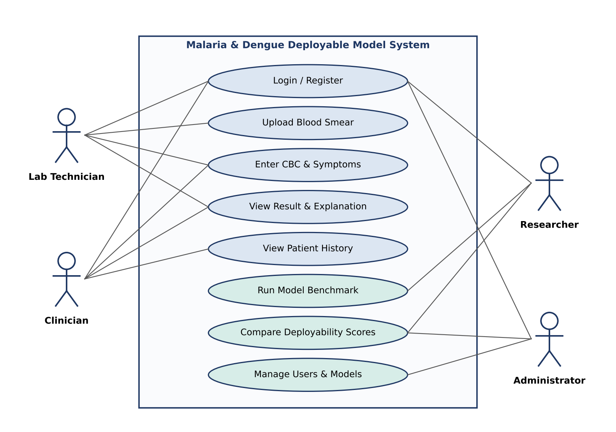
Figure 6: Use Case Diagram

12. Functional Requirements
ID | Requirement
FR-1 | The system shall allow users to register and log in with role-based access (technician, clinician, researcher, administrator).
FR-2 | The system shall allow a user to upload a thin blood smear cell image and receive a malaria prediction (parasitized / uninfected) with a confidence score.
FR-3 | The system shall allow a user to enter CBC values and symptoms and receive a dengue risk prediction with a probability.
FR-4 | The system shall validate inputs (image format and size, valid ranges for blood values) before running a prediction.
FR-5 | The system shall display a Grad-CAM heatmap for malaria predictions and a SHAP feature explanation for dengue predictions.
FR-6 | The system shall store every test, prediction and explanation with the model version used.
FR-7 | The system shall allow researchers to run the benchmark for a selected disease and view metrics for all candidate models.
FR-8 | The system shall calculate and display the Deployability Score and ranking of all models, including the result of the sensitivity analysis.
FR-9 | The system shall allow the administrator to activate, deactivate or roll back model versions.
FR-10 | The Android app shall run the selected models offline and sync records with the server when a connection is available.

13. Non-Functional Requirements
Category | Requirement
Performance | A single prediction should complete in under 200 ms on a standard laptop CPU and on a mid-range Android device, excluding network time.
Accuracy & Safety | Deployed models must meet the minimum sensitivity thresholds (95% malaria, 85% dengue) on the held-out test set.
Usability | The interface should be simple enough for a lab technician to complete a test in a few steps without training; target SUS score of 70 or above.
Portability | The selected models should be under 20 MB after compression so they can be shipped inside the mobile app.
Reliability | The app should keep working offline and should not lose records if the connection drops during sync.
Security & Privacy | Patient data must be anonymised, passwords hashed, and all data transferred over HTTPS.
Maintainability | Models should be versioned in a registry so that a new model can replace an old one without changing application code.
Reproducibility | All experiments must be repeatable from logged code, data splits, seeds and settings.

14. AI / ML Models
The candidate models were chosen to cover a range of sizes and approaches, from simple baselines to modern architectures, so that the benchmark shows real trade-offs.
Model | Task | Reason for Inclusion
Custom CNN | Malaria | Small baseline (3–4 conv layers) that shows how far a simple model can go.
ResNet-50 [11] | Malaria | Widely used, strong accuracy; represents the heavier end of the spectrum.
DenseNet-121 | Malaria | Frequently reported in malaria literature with very high accuracy.
MobileNetV3 [12] | Malaria | Designed for mobile devices; expected to be a strong deployment candidate.
EfficientNet-B0 [13] | Malaria | Good balance between accuracy and parameter count.
ViT / DeiT-Tiny [14] | Malaria | Tests whether a transformer offers any benefit on small cell images.
Logistic Regression | Dengue | Simple, interpretable baseline that doctors find easy to understand.
Support Vector Machine | Dengue | Works well on small, clean tabular datasets.
Random Forest [15] | Dengue | Robust to noise and outliers; provides feature importance.
XGBoost [16] | Dengue | Often the strongest model on tabular data; handles missing values.
LightGBM [17] | Dengue | Fast training and inference with low memory use.
MLP | Dengue | Tests whether a small neural network adds value over tree models.

15. Dataset Information
Dataset | Description | Use
NIH Malaria Cell Images (NLM) | 27,558 segmented thin smear cell images, balanced between parasitized and uninfected, collected from patients in Bangladesh and stained with Giemsa [5]. | Training, validation and testing of malaria image models.
Public dengue clinical datasets (e.g., Kaggle / Mendeley Data) | Patient-level CBC values, age, gender and symptoms with confirmed dengue status from hospitals in South Asia. Exact dataset(s) will be finalised after quality checks. | Training and cross-validation of dengue models.
Partner hospital records (optional) | Anonymised CBC and NS1 results, used only with ethical approval and hospital permission. | External validation to test how well models generalise.
Self-collected smear images (optional) | A small number of smear images captured with a phone camera through a microscope, if a lab gives access. | Robustness check on real-world image quality.
All datasets will be checked for duplicates, label errors and class imbalance before use. No personally identifying information will be stored by the system.

16. Database Design Overview
The database is designed in PostgreSQL and stores users, anonymised patients, test requests, inputs, predictions, models and benchmark results. The main entities are:
- User: account details and role of each person using the system.
- Patient: an anonymised code, age, gender and district; no names or CNIC numbers are stored.
- Test Request: links a patient, the user who performed the test, the test type and the date.
- Smear Image / Clinical Record: the actual input for a malaria or dengue test.
- Prediction: the label, confidence, explanation file and the model version that produced it.
- Model and Benchmark Result: registered models with their format and size, and all metrics and Deployability Scores from the benchmark runs.
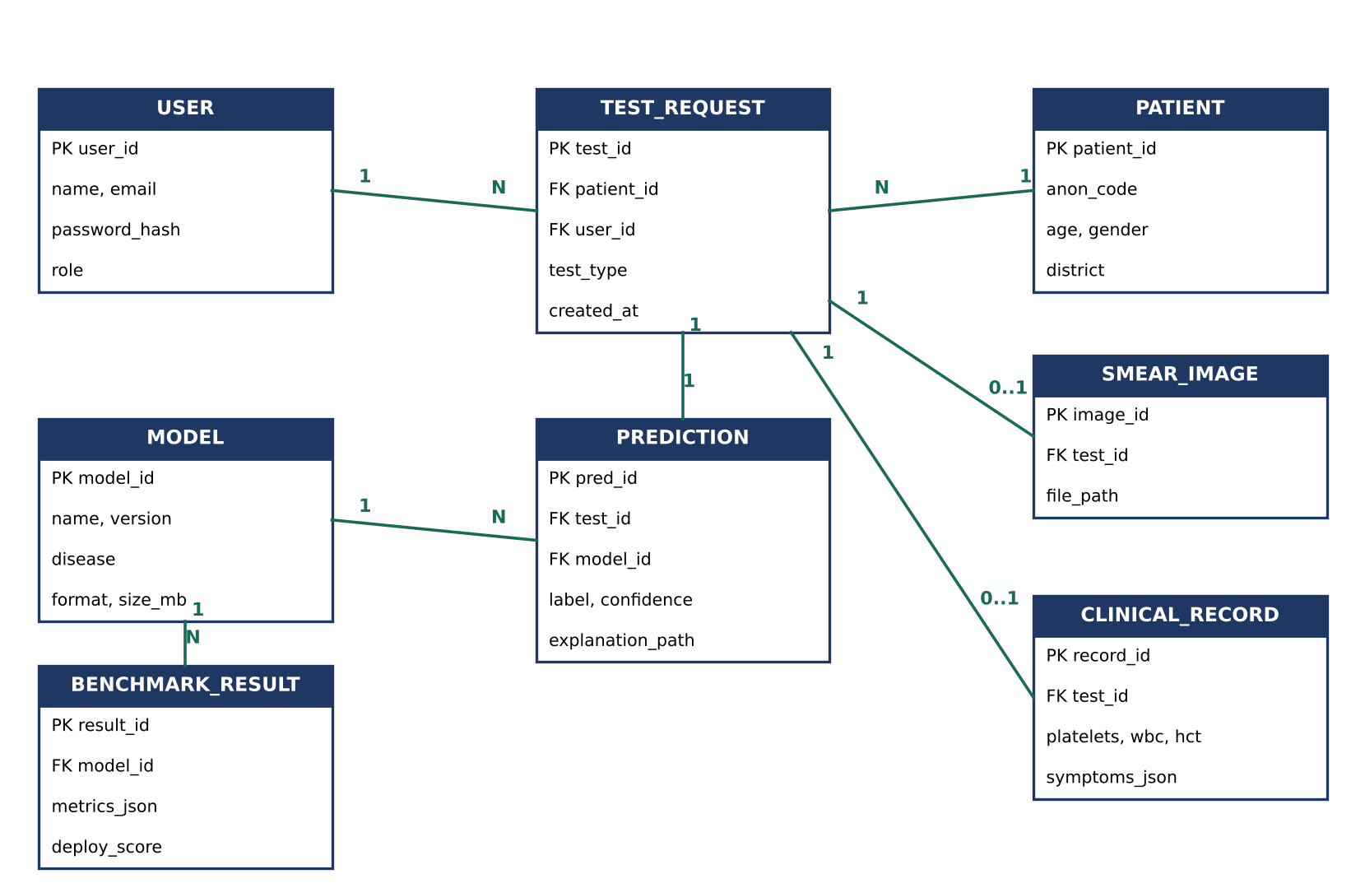
Figure 7: Entity Relationship Diagram

17. APIs and Integrations
1. Prediction API (FastAPI)
REST endpoints such as /predict/malaria and /predict/dengue accept an image or a JSON record, run the active model through ONNX Runtime and return the label, confidence and explanation.
2. Benchmark API
Endpoints that start a benchmark run, return progress, and serve the final comparison tables and charts to the dashboard.
3. Model Registry Integration (MLflow)
Used to log experiments and store model versions. The backend loads whichever version is marked as production.
4. Mobile Integration (TensorFlow Lite)
The Android app bundles the TFLite models for offline inference and calls a sync endpoint to upload records when online.
5. Database Integration
SQLAlchemy will connect the FastAPI backend to PostgreSQL for storing and retrieving all records.

18. Security and Ethical Considerations
- Patient data will be anonymised at entry; only an internal code links records to a patient.
- Passwords will be hashed with bcrypt, and access will be controlled with JWT tokens and user roles.
- All communication between the app, web client and server will use HTTPS.
- Uploaded images and records will be stored with restricted access, and every prediction will be logged for audit.
- The app will clearly state that results are for decision support and must be confirmed by a qualified professional.
- Any use of hospital data will require approval from the relevant ethics committee and written permission from the hospital.
- We will report model performance separately for different groups (for example, age bands) where data allows, to check for bias.

19. Hardware and Software Specification
Development System | Laptop or desktop with Intel Core i5 / Ryzen 5 or better, 16 GB RAM recommended, and at least 256 GB SSD.
Training Hardware | NVIDIA GPU with at least 8 GB VRAM (university lab) or Google Colab / Kaggle GPU notebooks.
Test Devices | A standard laptop CPU (no GPU) and a mid-range Android phone (4 GB RAM, Android 10 or later) for latency testing.
Operating System | Windows 10/11 or Ubuntu Linux for development; Android for the mobile prototype.
Software | Python 3.10+, PyTorch, TensorFlow/Keras, scikit-learn, XGBoost, LightGBM, ONNX Runtime, TFLite, FastAPI, React, Android Studio (Kotlin), PostgreSQL, MLflow, Git and GitHub.

20. Tools and Technologies Used, with Reasoning
Python | The standard language for machine learning, with mature libraries for every part of the pipeline.
PyTorch & TensorFlow | PyTorch for flexible model training and research; TensorFlow/Keras mainly for its smooth export path to TFLite on Android.
scikit-learn, XGBoost, LightGBM | Reliable, well-documented libraries for tabular models, cross-validation and calibration.
ONNX & ONNX Runtime | A common model format that lets models from different frameworks run quickly on CPU in the backend.
TensorFlow Lite | Runs quantised models efficiently on Android devices without internet.
SHAP & Grad-CAM | Widely accepted methods to explain tabular and image model predictions.
FastAPI | Lightweight, fast Python web framework that integrates easily with ML models and generates API documentation automatically.
React | Component-based framework for building an interactive dashboard with charts and comparison tables.
PostgreSQL | Reliable open-source relational database with good support for JSON fields used for metrics.
MLflow | Tracks experiments and model versions, which is essential for a fair and repeatable benchmark.
Git & GitHub | Version control and collaboration among the three group members.

21. Success Criteria and Evaluation Methodology
The project will be evaluated at three levels: the models, the selection process, and the final application.
Area | Metric | Target
Malaria model | Sensitivity / Accuracy / ROC-AUC | ≥ 95% / ≥ 95% / ≥ 0.97
Dengue model | Sensitivity / ROC-AUC / F1-score | ≥ 85% / ≥ 0.85 / ≥ 0.80
Calibration | Expected Calibration Error (ECE) | ≤ 0.05 after calibration
Efficiency | Latency per prediction (CPU and Android) | < 200 ms
Footprint | Model size after compression | < 20 MB
Compression | Accuracy loss after quantisation | ≤ 1 percentage point
Ranking stability | Top model unchanged under ±10% weight changes | Yes for at least one disease
Explainability | Average clinician rating of explanations (1–5) | ≥ 3.5
Usability | System Usability Scale (SUS) | ≥ 70
Statistical tests (McNemar's test for image models and paired t-tests over cross-validation folds for clinical models) will be used to check whether differences between the top models are meaningful and not just noise.

22. Expected Outcomes and Commercialisation Potential
By the end of the project we expect to deliver: a documented, repeatable benchmark of at least twelve models across the two diseases; a clear recommendation of the best deployable model for malaria and for dengue, backed by data; compressed versions of these models ready for real use; and a working web and Android application with built-in explanations.
Beyond the academic result, the project has practical potential. A low-cost, offline diagnostic support app could be offered to basic health units, NGOs running mobile health camps, and small private laboratories, where a second opinion on smear slides and CBC reports can save time and catch missed cases. The benchmarking framework itself could also be offered as a service to teams who want to choose models for other medical tasks. Any real-world use would, of course, require further clinical validation and regulatory approval.

23. Project Timeline
The project is planned over approximately eight months. Some phases overlap so that application development can start while model experiments are still being finalised.
Phase | Deliverables
Phase 1 – Literature Review & Requirements | Review of existing malaria and dengue ML work, finalised requirements, evaluation criteria and proposal.
Phase 2 – Data Collection & Preprocessing | Cleaned, split and documented datasets; data quality report.
Phase 3 – Malaria Model Benchmark | Trained and tuned image models with full metrics and Grad-CAM outputs.
Phase 4 – Dengue Model Benchmark | Trained and calibrated clinical models with cross-validation results and SHAP outputs.
Phase 5 – Compression & Deployability Scoring | Quantised/pruned models, TOPSIS ranking, sensitivity analysis and selected models.
Phase 6 – Application Development | Database, FastAPI backend, React dashboard and Android app with offline models.
Phase 7 – Integration & Testing | End-to-end testing, on-device latency tests, clinician review and SUS evaluation.
Phase 8 – Documentation & Final Defence | Final report, research write-up, presentation and demo.
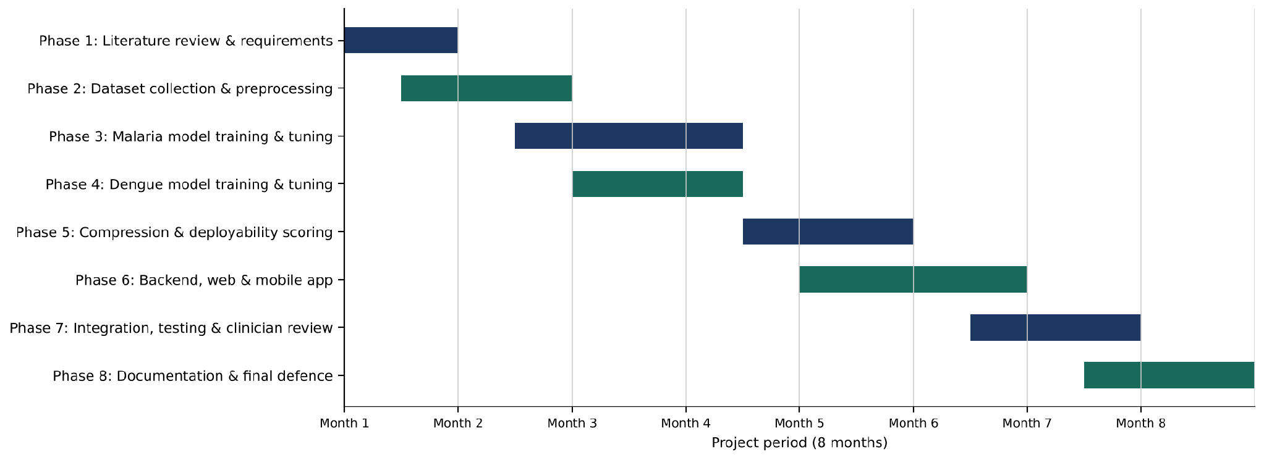
Figure 8: Project Timeline (Gantt Chart)

24. Future Enhancements
- More diseases: extending the same benchmarking framework to tuberculosis, typhoid or chikungunya.
- Species and stage detection: identifying malaria species and parasite life-cycle stages from full smear fields.
- Federated learning: letting multiple hospitals improve the models together without sharing raw patient data.
- Integration with health information systems: connecting with district health reporting systems for real-time surveillance.
- Smartphone microscope support: using low-cost clip-on lenses so that images can be captured directly by the phone.
- Continuous monitoring: detecting when a deployed model's performance drifts as new data arrives.

References
[1]World Health Organization. (2024). World Malaria Report 2024. Geneva: WHO.
[2]World Health Organization. (2025). Dengue: global situation, surveillance and progress – 2024 update. Weekly Epidemiological Record, 100(52).
[3]World Health Organization. Dengue and severe dengue (Fact sheet). Geneva: WHO.
[4]Poostchi, M., Silamut, K., Maude, R. J., Jaeger, S., & Thoma, G. (2018). Image analysis and machine learning for detecting malaria. Translational Research, 194, 36–55.
[5]Rajaraman, S., Antani, S. K., Poostchi, M., Silamut, K., Hossain, M. A., Maude, R. J., Jaeger, S., & Thoma, G. R. (2018). Pre-trained convolutional neural networks as feature extractors toward improved malaria parasite detection in thin blood smear images. PeerJ, 6, e4568.
[6]Huang, G., Liu, Z., Van Der Maaten, L., & Weinberger, K. Q. (2017). Densely connected convolutional networks. Proceedings of the IEEE Conference on Computer Vision and Pattern Recognition (CVPR), 4700–4708.
[7]Hwang, C. L., & Yoon, K. (1981). Multiple Attribute Decision Making: Methods and Applications. Springer-Verlag, Berlin.
[8]Jacob, B., Kligys, S., Chen, B., Zhu, M., Tang, M., Howard, A., Adam, H., & Kalenichenko, D. (2018). Quantization and training of neural networks for efficient integer-arithmetic-only inference. Proceedings of CVPR, 2704–2713.
[9]Selvaraju, R. R., Cogswell, M., Das, A., Vedantam, R., Parikh, D., & Batra, D. (2017). Grad-CAM: Visual explanations from deep networks via gradient-based localization. Proceedings of the IEEE International Conference on Computer Vision (ICCV), 618–626.
[10]Lundberg, S. M., & Lee, S. I. (2017). A unified approach to interpreting model predictions. Advances in Neural Information Processing Systems (NeurIPS), 30.
[11]He, K., Zhang, X., Ren, S., & Sun, J. (2016). Deep residual learning for image recognition. Proceedings of CVPR, 770–778.
[12]Howard, A., Sandler, M., Chu, G., Chen, L. C., Chen, B., Tan, M., et al. (2019). Searching for MobileNetV3. Proceedings of ICCV, 1314–1324.
[13]Tan, M., & Le, Q. (2019). EfficientNet: Rethinking model scaling for convolutional neural networks. Proceedings of the International Conference on Machine Learning (ICML), 6105–6114.
[14]Dosovitskiy, A., Beyer, L., Kolesnikov, A., Weissenborn, D., Zhai, X., Unterthiner, T., et al. (2021). An image is worth 16x16 words: Transformers for image recognition at scale. International Conference on Learning Representations (ICLR).
[15]Breiman, L. (2001). Random forests. Machine Learning, 45(1), 5–32.
[16]Chen, T., & Guestrin, C. (2016). XGBoost: A scalable tree boosting system. Proceedings of the 22nd ACM SIGKDD International Conference on Knowledge Discovery and Data Mining, 785–794.
[17]Ke, G., Meng, Q., Finley, T., Wang, T., Chen, W., Ma, W., Ye, Q., & Liu, T. Y. (2017). LightGBM: A highly efficient gradient boosting decision tree. Advances in Neural Information Processing Systems (NeurIPS), 30.
[18]Bhatt, S., Gething, P. W., Brady, O. J., Messina, J. P., Farlow, A. W., Moyes, C. L., et al. (2013). The global distribution and burden of dengue. Nature, 496(7446), 504–507.

No Plagiarism and Fair Play Declaration
We, the members of the Final Year Project group working on "MalDen-Deploy: Identifying the Best Deployable Machine Learning Model for Malaria and Dengue Diagnosis", understand the importance of academic integrity and the consequences of plagiarism.
We declare that this proposal is our own work. All ideas, datasets, models, methods and published results taken from other sources have been properly acknowledged and referenced.
We agree to follow the guidance of our project adviser, keep regular contact throughout the project, and carry out the work honestly and ethically. We understand that plagiarism, misrepresentation of results or any other form of academic misconduct may lead to disciplinary action under university rules.
Signed:
Name | Registration # | Email | Signature
[Student 1 Name] | [B-XXXXX] | [b-xxxxx@student.usa.edu.pk]
[Student 2 Name] | [B-XXXXX] | [b-xxxxx@student.usa.edu.pk]
[Student 3 Name] | [B-XXXXX] | [b-xxxxx@student.usa.edu.pk]

Project Adviser: [Supervisor Name]Signature: ____________________
Project Coordinator Name: ____________________Signature: ____________________
HOD CS Name: ____________________Signature: ____________________

