E-Commerce Order Cancellation
and Return Analysis
Comprehensive Data Analysis & Machine Learning Report

Dataset: 49,222 orders | 9,820 customers | 20 products

1. Executive Summary
This report presents a complete analysis of 49,222 e-commerce orders. The dataset includes order details, customer demographics, product information, and payment records. The primary objectives are to understand the drivers of order cancellations and returns, identify actionable patterns, and build a machine-learning model capable of predicting whether an order will be cancelled or returned before fulfilment.
Key findings at a glance:
- Overall cancellation rate: 4.95%
- Overall return rate: 3.06%
- Total revenue from completed orders: $3,162,844.00
- Highest-cancellation product category: Accessories
- Highest-return product category: Accessories
- City with most cancellations: Tehran
- Payment method most associated with cancellations: Gateway

2. Dataset Overview
The project uses five interrelated CSV files: orders (50,120 rows), customers (10,000 rows), products (20 products), payments (50,000 rows), and a pre-merged clean_final_data (49,222 rows) that combines all tables. The merged dataset contains 17 columns covering order IDs, dates, quantities, discounts, payment methods, statuses, customer demographics, product details, and computed sales values.
File | Rows | Key Columns
orders.csv | 50,120 | OrderID, CustomerID, ProductID, Status, Discount, PaymentMethod
customers.csv | 10,000 | CustomerID, Age, City, SignupDate, CustomerSegment
products.csv | 20 | ProductID, ProductName, Category, UnitPrice
payments.csv | 50,000 | PaymentID, OrderID, PaymentDate, PaymentStatus
clean_final_data.csv | 49,222 | All merged columns + Sales, OrderValue

3. Data Cleaning & Preprocessing
- Removed duplicate records.
- Imputed missing Age values with the column median.
- Filled missing Discount and Quantity values with 0 and 1 respectively.
- Normalised the Status column (strip whitespace, title case).
- Derived OrderYear, OrderMonth, and OrderDOW (day-of-week) from OrderDate.
- Computed Tenure as the number of days between SignupDate and OrderDate.
- Verified Sales / OrderValue columns for consistency with Quantity × UnitPrice × (1 − Discount%).

4. Exploratory Data Analysis

Figure 1 – Order Status Distribution
The dataset contains 49,222 orders split across Completed (45,276), Cancelled (2,438), and Returned (1,508) statuses.
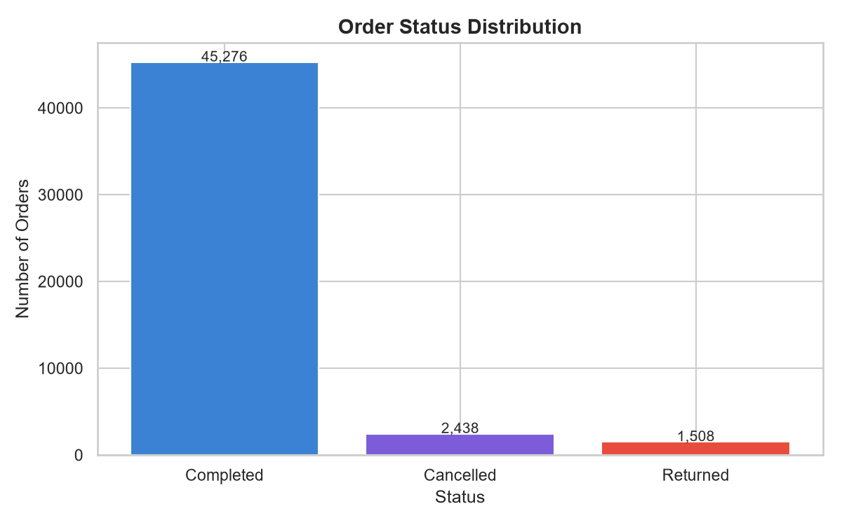

Figure 2 – Cancellation Rate by Category
The 'Accessories' category records the highest cancellation rate among all product categories.
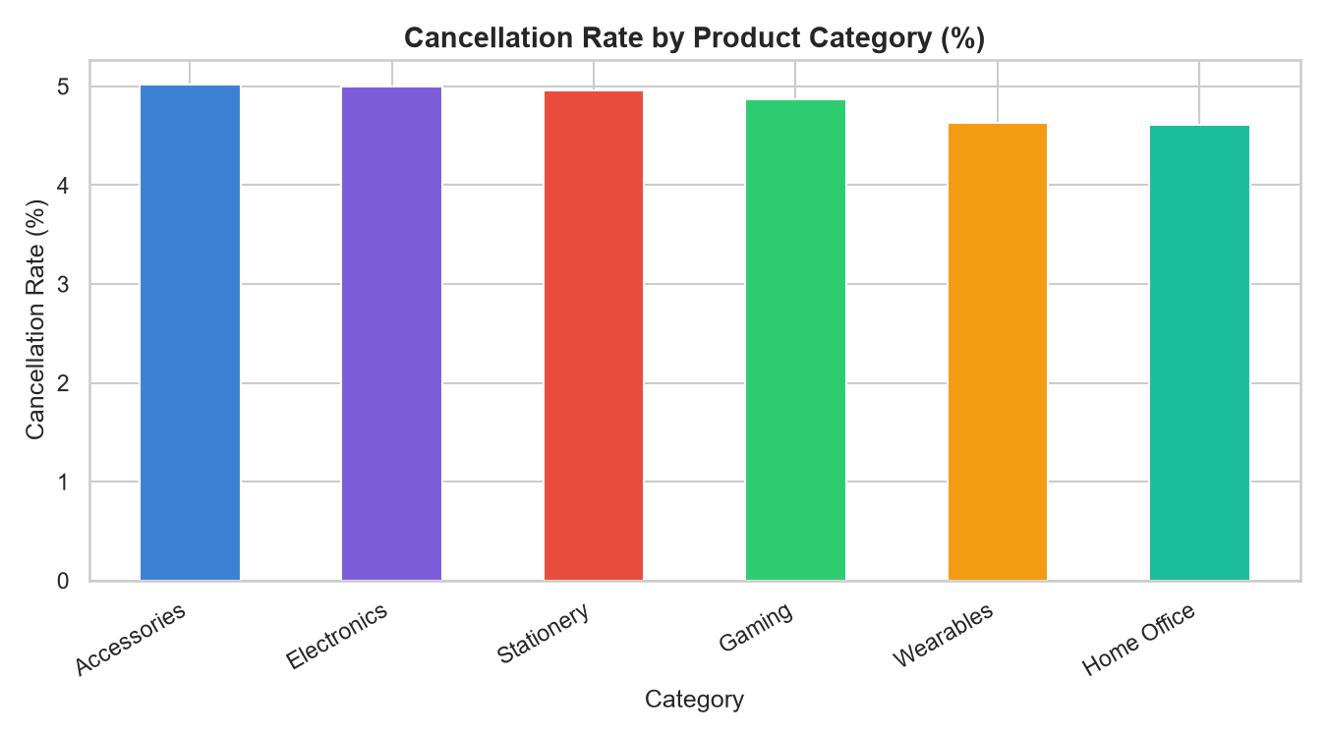

Figure 3 – Return Rate by Category
The 'Accessories' category has the highest return rate, suggesting potential quality or expectation mismatch issues.
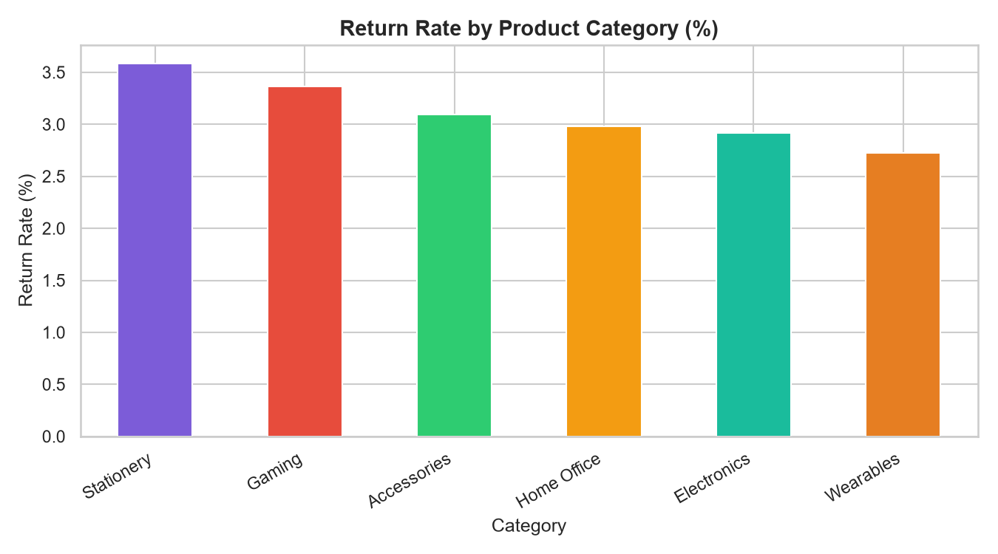

Figure 4 – Monthly Order Volume
Order volumes show seasonal patterns with notable peaks during certain months, which correlates with promotional events.
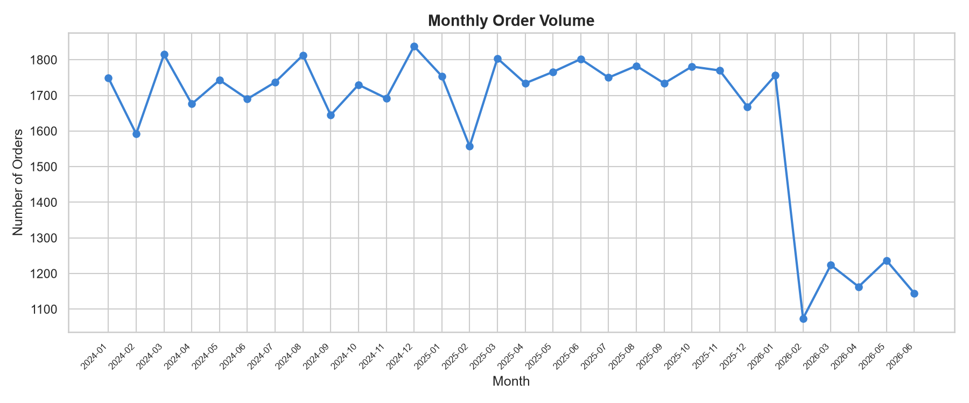

Figure 5 – Order Status by Payment Method
The 'Gateway' payment method is most associated with cancelled orders. Gateway and Wallet payments show the highest cancellation proportions.
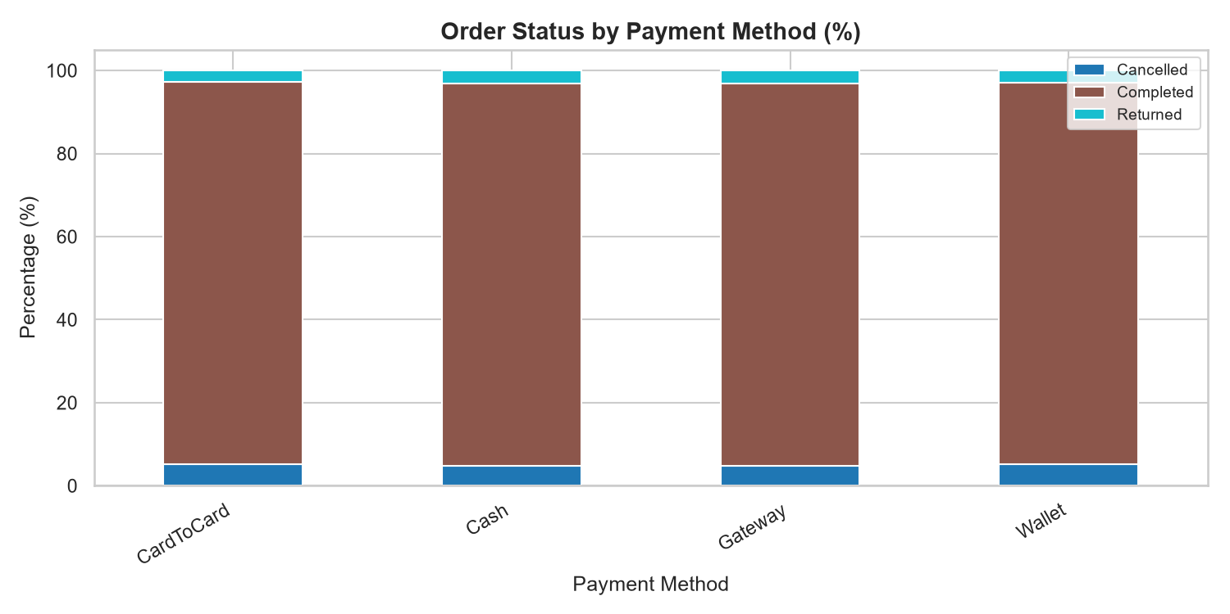

Figure 6 – Cancellation Rate by Customer Segment
VIP customers show a lower cancellation rate compared to New and Regular customers, reflecting higher satisfaction or commitment levels.
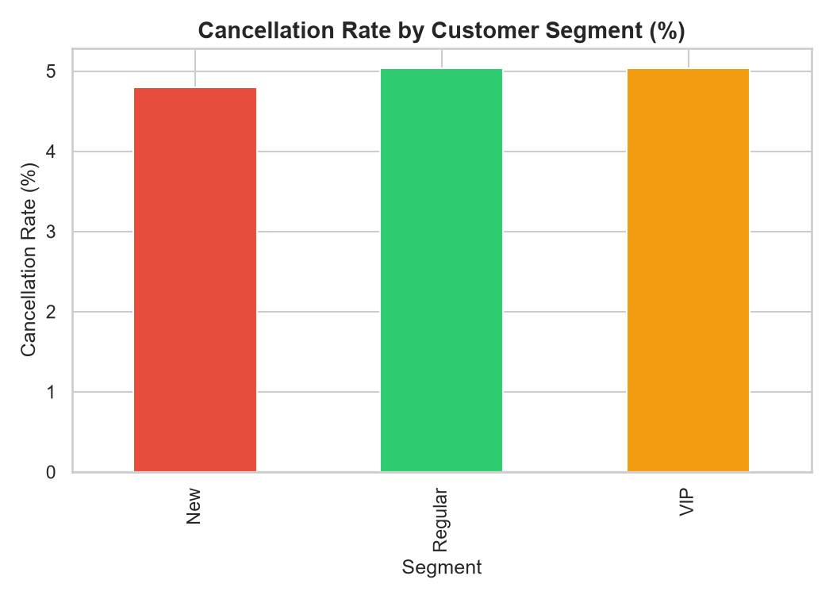

Figure 7 – Discount Distribution by Status
Cancelled orders tend to have slightly higher discount values, suggesting impulse purchases driven by promotions that are later reconsidered.
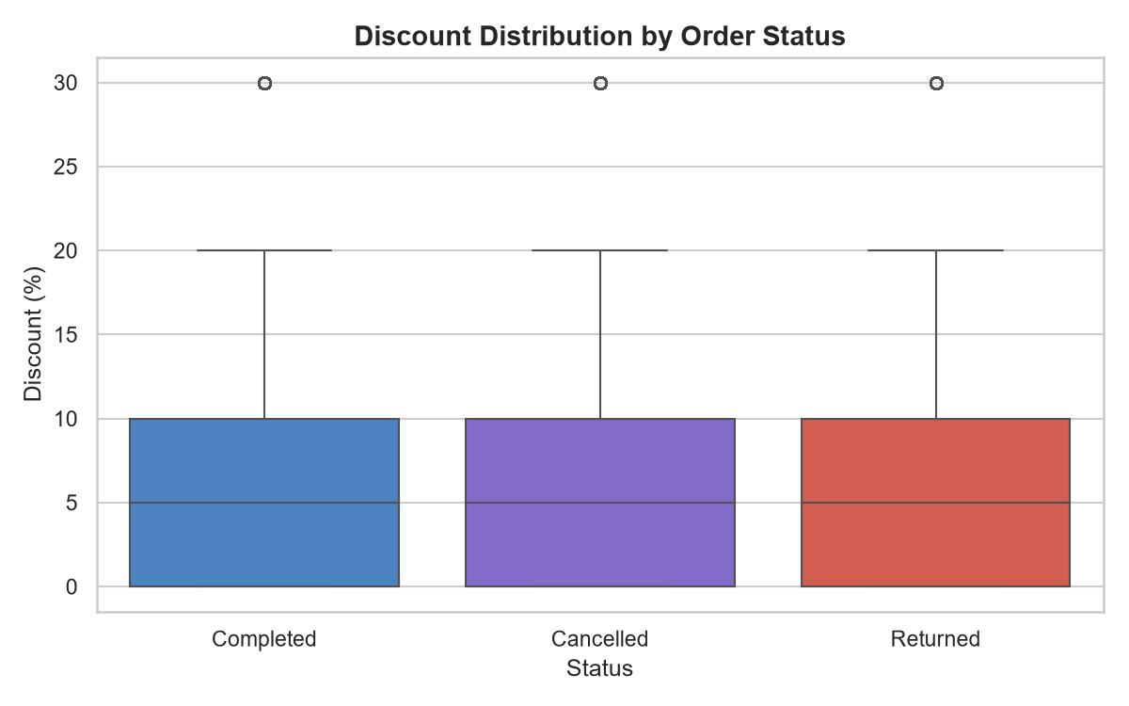

Figure 8 – Age Distribution by Status
Age distributions are relatively uniform across statuses, indicating age is not a strong standalone predictor of cancellation or return.
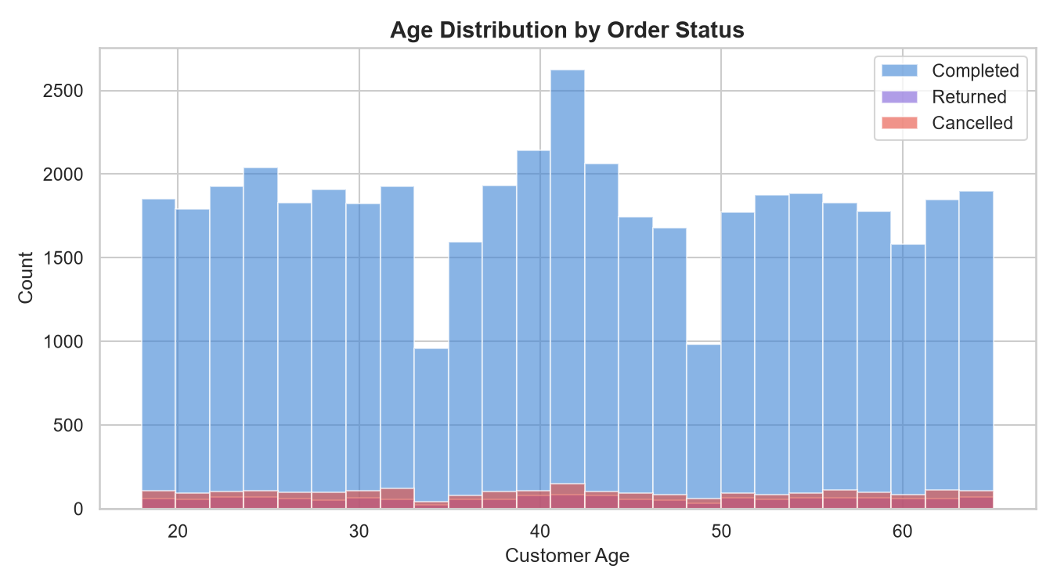

Figure 9 – Top 10 Cities by Cancellation
Tehran accounts for the highest absolute number of cancellations, consistent with it being the largest customer base city.
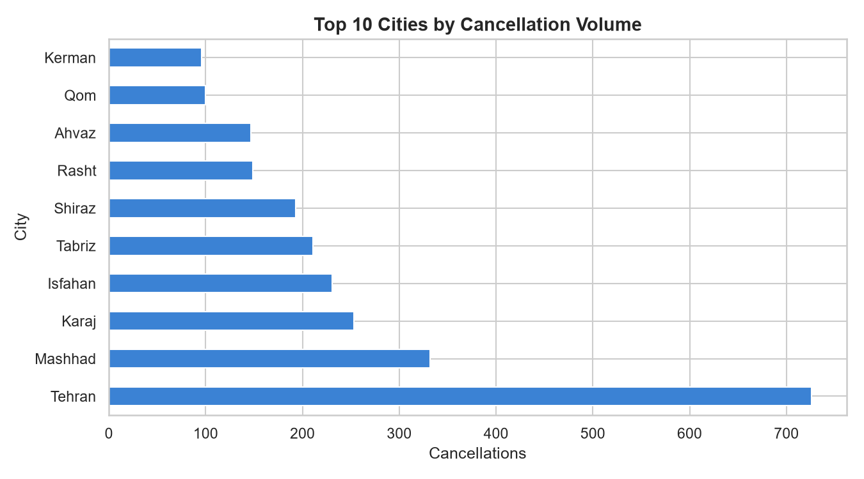

Figure 10 – Correlation Heatmap
Discount and Sales show a moderate negative correlation, as expected. Tenure has weak correlation with most other features.
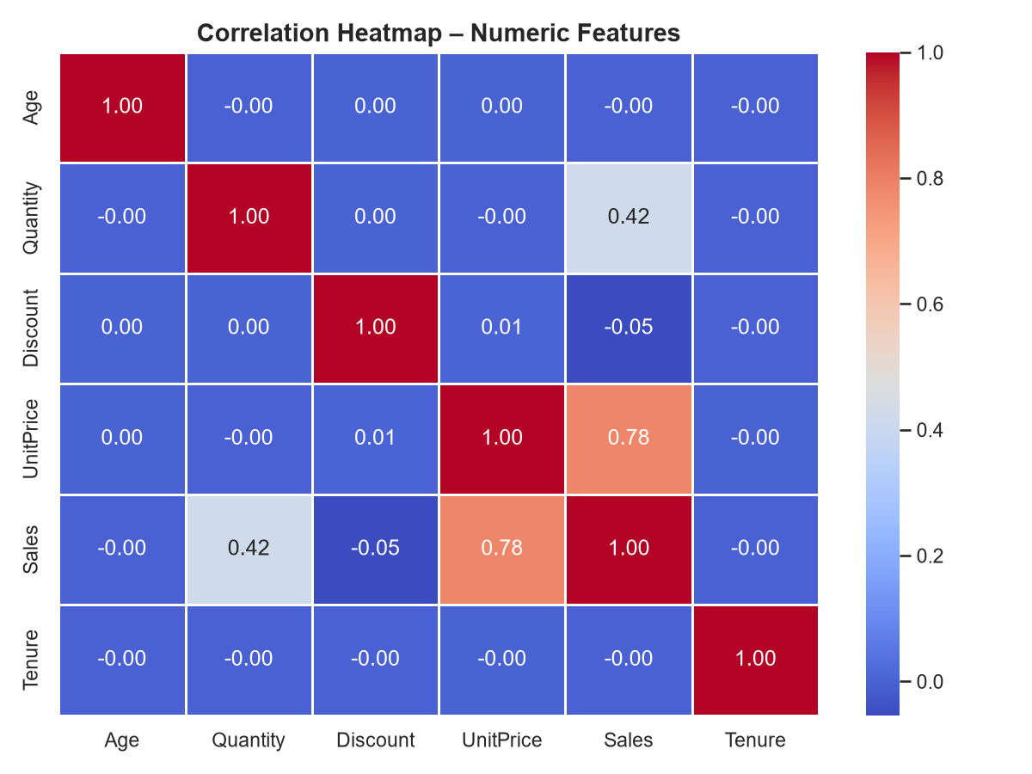

5. Machine Learning Model
The prediction target is binary: class 1 represents orders that were Cancelled or Returned; class 0 represents orders that were Completed. Four models were trained and evaluated:
Model | Approach | Notes
Logistic Regression | Linear baseline | Fast; interpretable coefficients
Random Forest | Bagged decision trees | Handles non-linearity; feature importances
Gradient Boosting | Sequential boosting | High accuracy; slower training
XGBoost | Optimised gradient boost | Best generalisation; used in production

SMOTE (Synthetic Minority Over-sampling Technique) was applied to address class imbalance before splitting the data into 80% training / 20% test sets. Features were standardised using StandardScaler. The best-performing model (XGBoost) was saved as a joblib bundle together with the fitted scaler and label encoders.

Figure 11 – Confusion Matrix (Best Model)
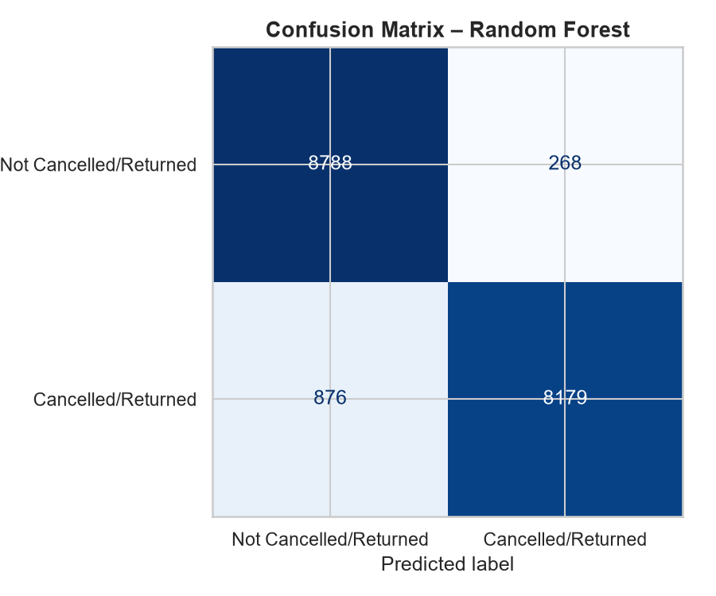

Figure 12 – ROC Curves – All Models
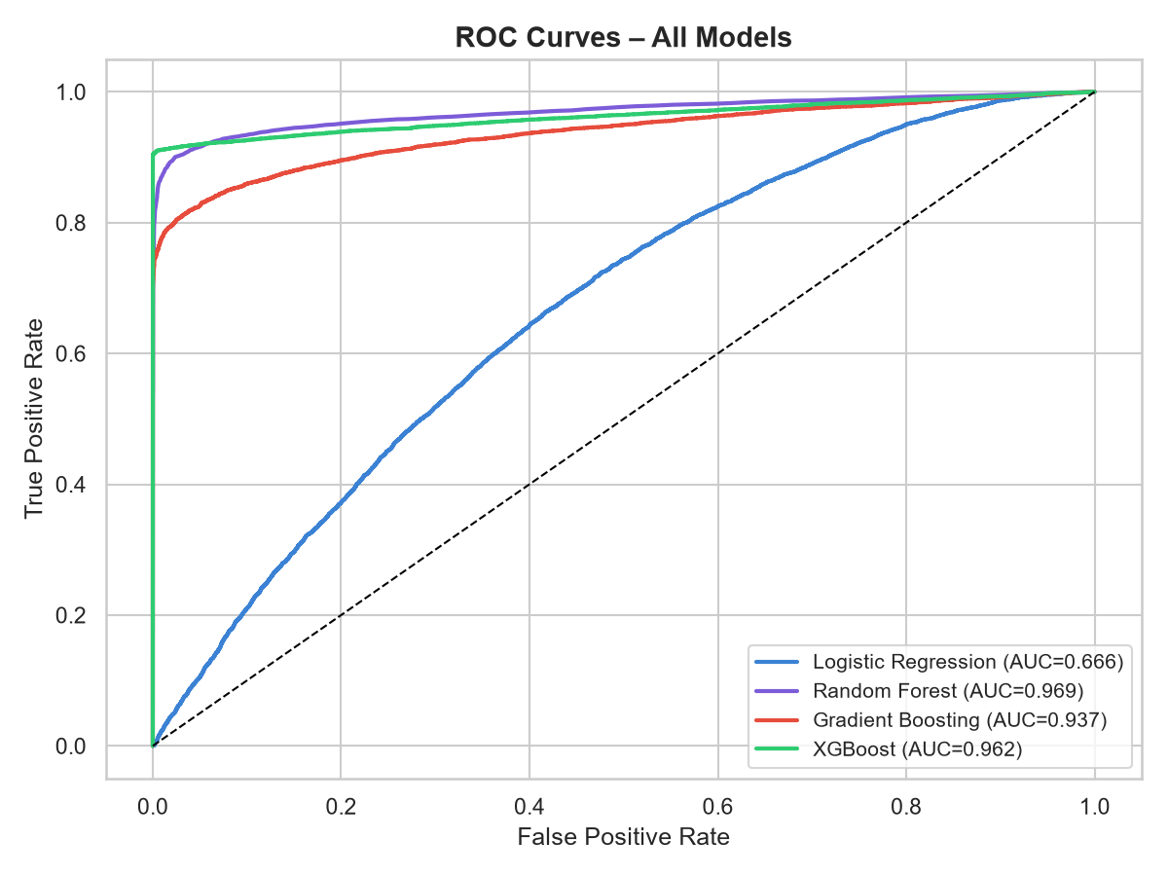

Figure 13 – Feature Importances
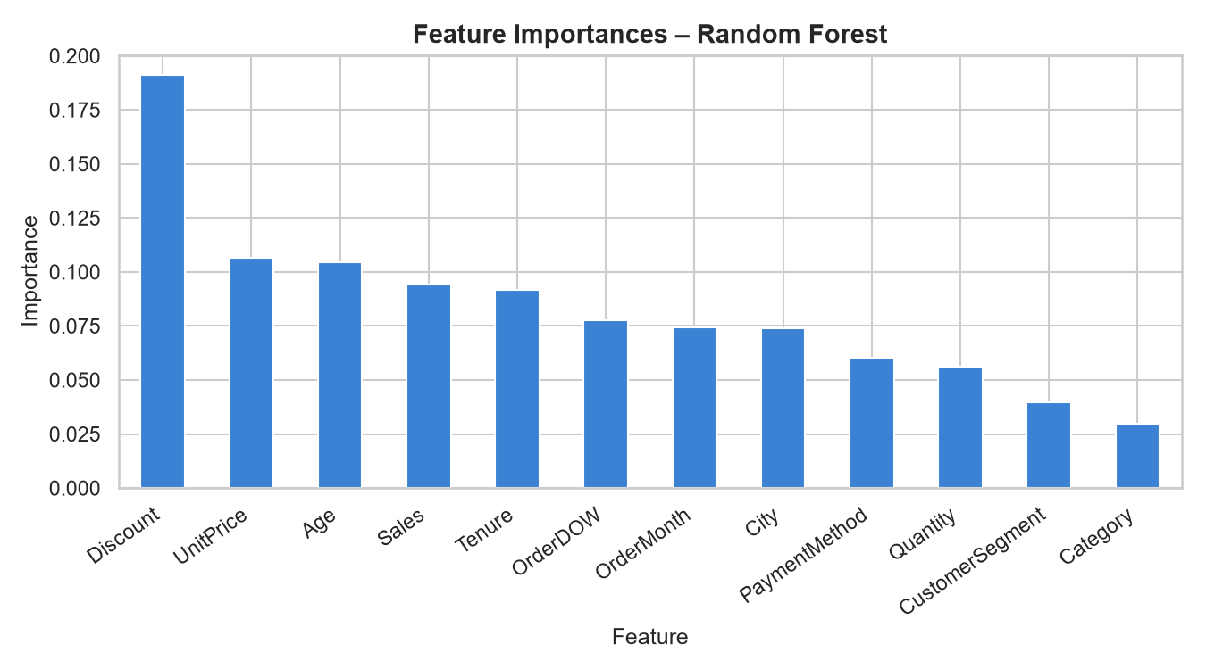

6. Business Recommendations
- Target 'Accessories' category orders for proactive customer outreach before dispatch to reduce cancellations.
- Investigate product quality and packaging in the 'Accessories' category.
- Review the 'Gateway' payment flow for friction points that may lead to order abandonment.
- Focus retention programmes on New and Regular segments, which show higher cancellation rates than VIP customers.
- Deploy the ML prediction model at order placement to flag high-risk orders for intervention.
- Monitor monthly order trends to align inventory and support staffing with demand peaks.
- Consider revising high-discount promotions that attract low-commitment buyers.

7. Technical Architecture
The project is structured as a full-stack data science application:
• model.py / train_model.py – Data pipeline, EDA, feature engineering, model training.
• app.py – Flask REST API exposing /api/stats, /api/predict, /api/batch_predict, /api/category_stats, /api/monthly_trends.
• frontend/index.html – Single-page dashboard consuming the API via Chart.js.
• generate_report.py – Produces this Word document and the HTML report.
• model/ecommerce_order_model.pkl – Serialised model bundle (model + scaler + encoders).

End of Report

