Programming Fundamental
Assignment-1
Roll Number: 26k-0013
Syed Sajid Ali

Part A — Foundational Practice Problems:
Question 1
Take a number N and print numbers from N down to 1.

Algorithm:
1. Start.
2. Prompt and input positive integer N.
3. Check N: If N < 1, display error message and go to step 6.
4. start loop as variable i = N.
5. Repeat while i >= 1:
Output the value of i.
Decrement i by 1 (i = i - 1).
6. End.

Pseudo Code:
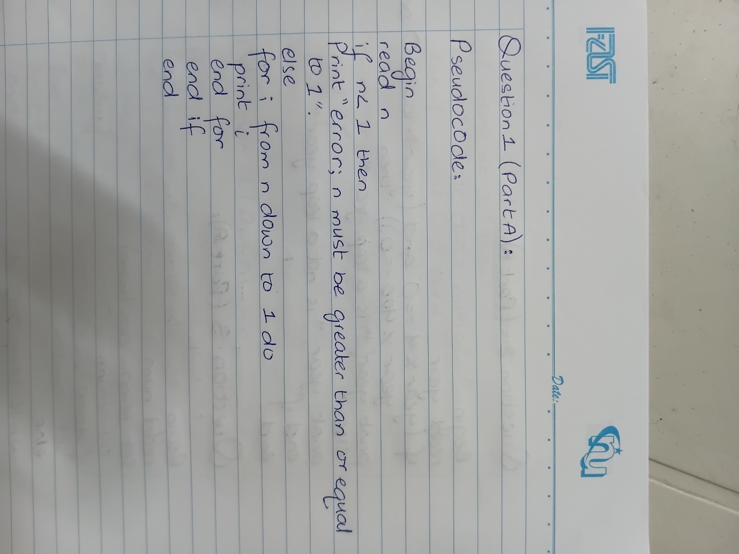

Question 2
Input a year and determine whether it is a leap year. (Rule: divisible by 4 AND (not divisible by 100 OR divisible by 400).)

ALGORITHM:
1. Start
2.input Y (Year)
3. condition (Y% 4 == 0) AND (Y % 100!= 0 OR Y %400 ==0).
4 If condition is TRUE, output "Y is a Leap Year".
5. Else (condition is FALSE), output "Y is not a Leap Year".
6 End..

Pseudocode:
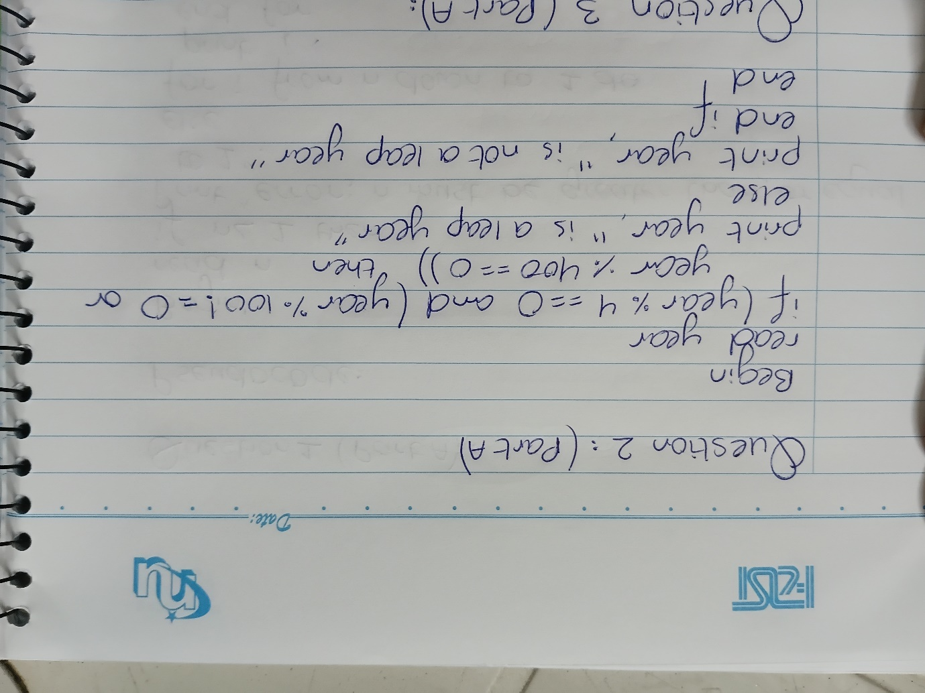

Question 3
Take a number, count how many digits it has, and state whether it is a single-digit, double-digit, or triple-digit (or more) number.

ALGORITHM:
1. Start.
2. Read input integer `num`.
3. Store absolute value `temp = abs(num)`.
4. Initialize `count = 0`.
5. If `temp == 0`, set `count = 1`.
6. Else, while `temp > 0`:
a. `temp = temp / 10`.
b. Increment `count = count + 1`.
7. Output total digit count.
8. Classification Decision:- If `count == 1`, print "Single-digit number".- Else if `count == 2`, print "Double-digit number".- Else (`count >= 3`), print "Triple-digit (or more) number".
9. End.

Pseudocode:
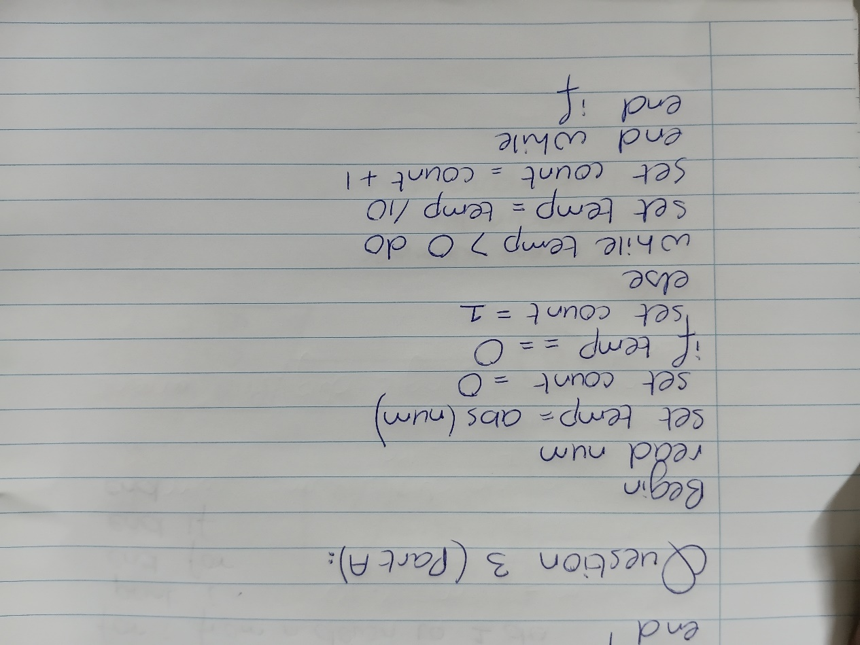
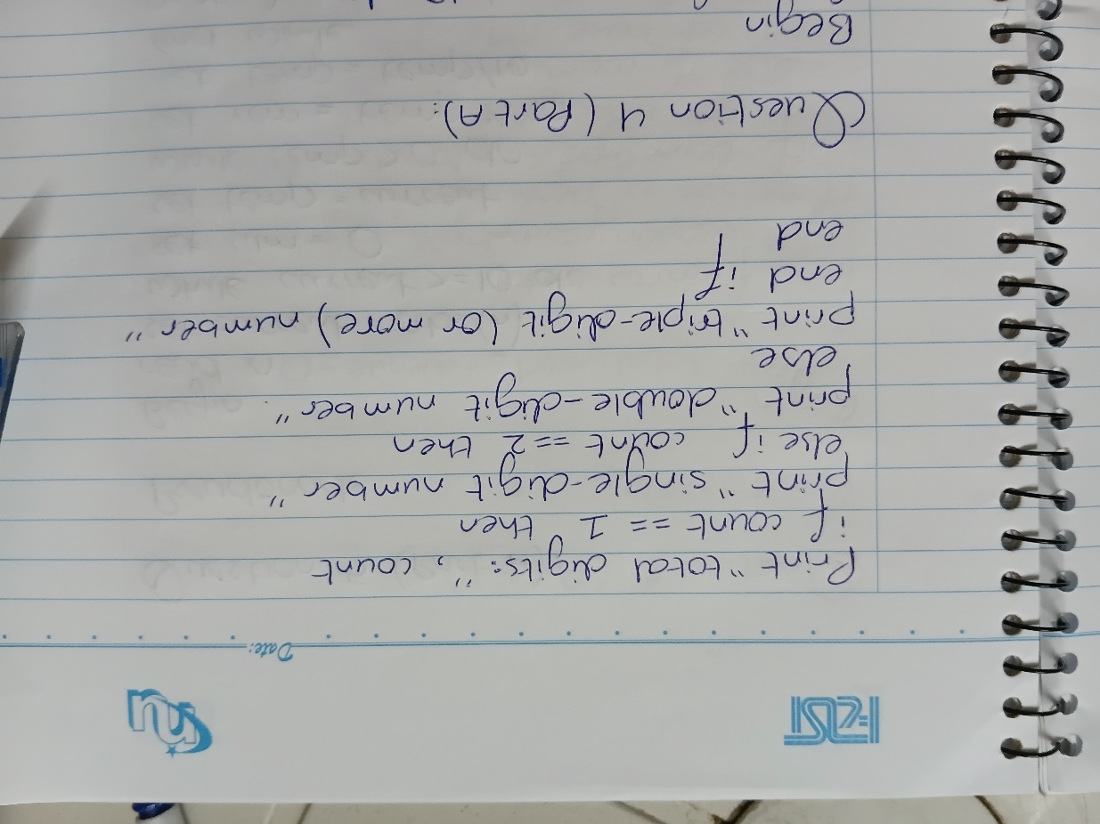

Question 4
Print the multiplication tables from 1 to 10, but skip the table of any number that is a multiple of

ALGORITHM:

1. Start.
2. Outer loop variable i runs from 1 to 10.
3. For eachi:
a. If `i % 3 == 0`, skip the table (continue to next `i`).
b. Else:
i. Output Table Heading for i.
ii. Inner loop variable `j` runs from 1 to 10.
iii. Compute product = i * j.
iv. Output `i x j = product`.
4. End..

PSEUDOCODE:
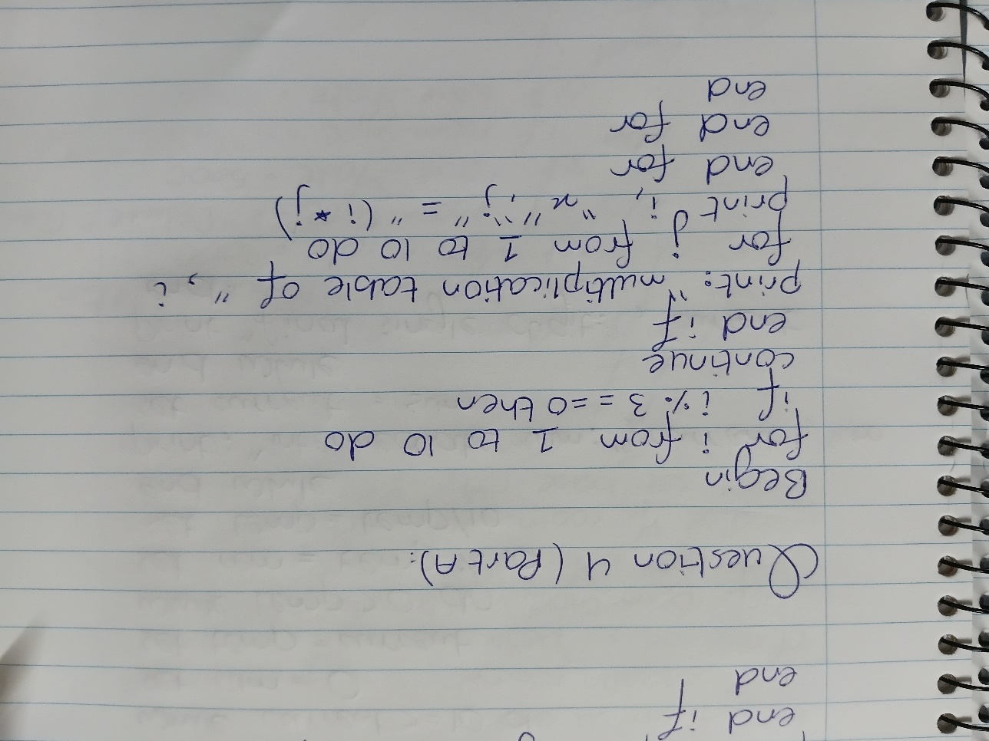

Question 5
Take a number, repeatedly sum its digits until the result is a single digit, and display each intermediate result. For example, if the number is 123, the sum of its digits is 6.

ALGORITHM:
1. Start.
2. Read integer n.
3. Set current = abs(n).
4. While current >= 10`:
a. Set Sum = 0, temp = current.
b. While temp > 0:
i. rem = temp % 10`.
ii. sum = sum + rem.
iii. temp = temp / 10.
c. Print intermediate result: current -> sum.
d. current = sum.
5. Output final single-digit result current.
6. End.

PSEUDOCODE:

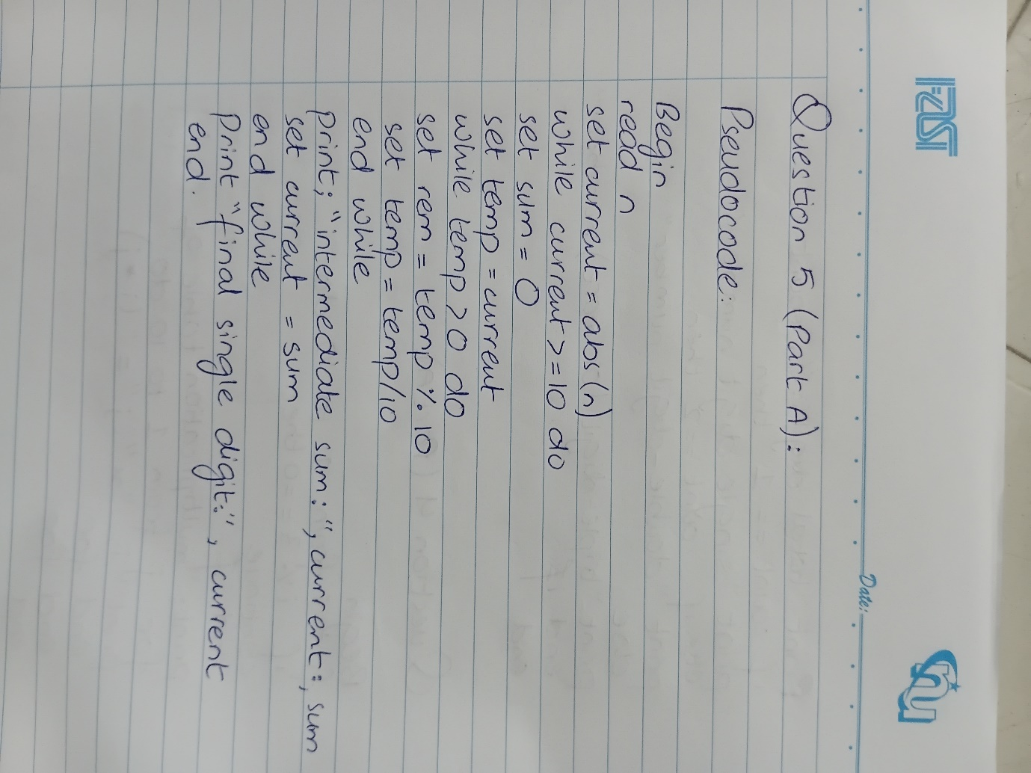

FLOWCHART:
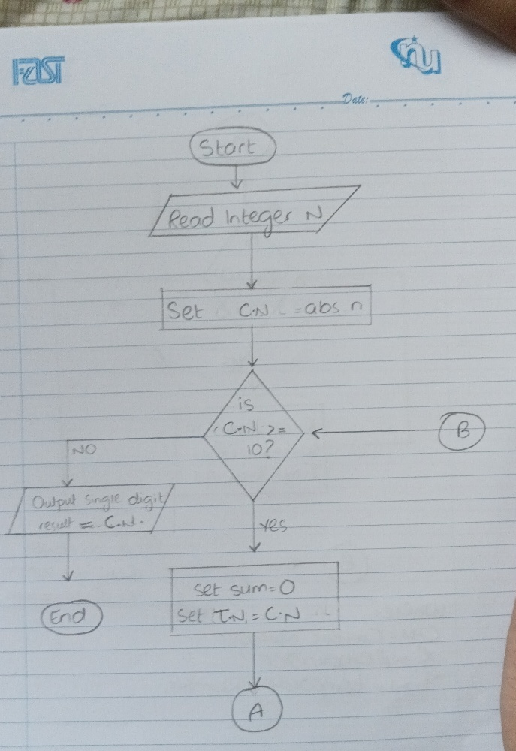
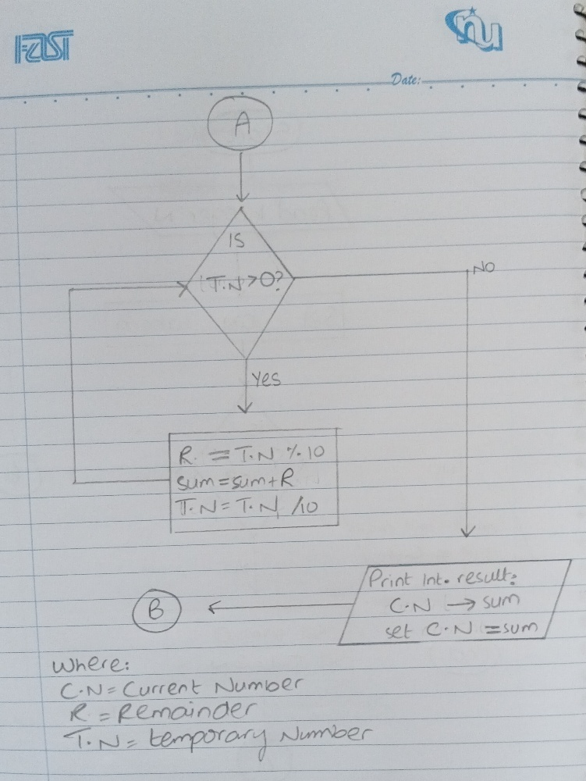

LEGENDS:
temp “Temporary Number”
Rem “Remainder”
current “current number”

Question 01: Hotel Booking System
1. Algorithm
Step 1: Start.
Step 2: Initialize Total_Hotel_Revenue = 0.0.
Step 3: Read total number of guests N (e.g., N = 4).
Step 4: Set loop counter i = 1.
Step 5: If i > N, go to Step 16 (exit loop).
Step 6: Read Season ('Peak' or 'Off-Peak'), Room_Type ('Standard', 'Deluxe', or 'Suite'), and Nights_Stayed.
Step 7: Check Season condition:
If Season == 'Peak':
If Room_Type == 'Standard', set Base_Rate = 5000.
Else if Room_Type == 'Deluxe', set Base_Rate = 8000.
Else if Room_Type == 'Suite', set Base_Rate = 12000.
Else if Season == 'Off-Peak':
If Room_Type == 'Standard', set Base_Rate = 3000.
Else if Room_Type == 'Deluxe', set Base_Rate = 5000.
Else if Room_Type == 'Suite', set Base_Rate = 8000.
Step 8: Calculate Gross_Amount = Base_Rate * Nights_Stayed.
Step 9: Initialize Discount = 0.0.
Step 10: If Nights_Stayed > 7, set Discount = 0.15 * Gross_Amount.
Step 11: Calculate Guest_Final_Price = Gross_Amount - Discount.
Step 12: Display Guest_Final_Price for Guest i.
Step 13: Update Total_Hotel_Revenue = Total_Hotel_Revenue + Guest_Final_Price.
Step 14: Increment loop counter i = i + 1.
Step 15: Go to Step 5.
Step 16: Display Total_Hotel_Revenue.
Step 17: End.

2. Problem Analysis Chart (PAC)
Given Data / Inputs | Processing & Operations | Required Output | Constraints & Rules
• N (Total Guests)  • Season (Peak/Off-Peak)  • Room Type (Standard/Deluxe/Suite)  • Nights Stayed | 1. Base rate selection via nested season & room type check.  2. Gross = Base Rate × Nights.  3. Discount = 15% of Gross if Nights > 7; else 0.  4. Guest Price = Gross - Discount.  5. Total Revenue = ∑ Guest Price. | • Individual Guest Final Price  • Total Hotel Revenue | • Loop executes for N guests.  • Peak Rates: Standard=5000, Deluxe=8000, Suite=12000.  • Off-Peak Rates: Standard=3000, Deluxe=5000, Suite=8000.  • 15% discount strictly for Nights > 7.

3. Input-Process-Output (IPO) Chart
Input | Processing | Output
• N (Integer)  • Season (String)  • Room_Type (String)  • Nights_Stayed (Integer) | 1. Loop i from 1 to N:  a. Input Season, Room_Type, Nights.  b. Determine Base_Rate based on Season and Room_Type.  c. Compute Gross = Base_Rate * Nights.  d. If Nights > 7, Discount = 0.15 * Gross; else 0.  e. Guest_Price = Gross - Discount.  f. Total_Revenue += Guest_Price.  2. Output Total_Revenue after loop. | • Guest_Final_Price (for each guest)  • Total_Hotel_Revenue (final total)

4. Flowchart Diagram

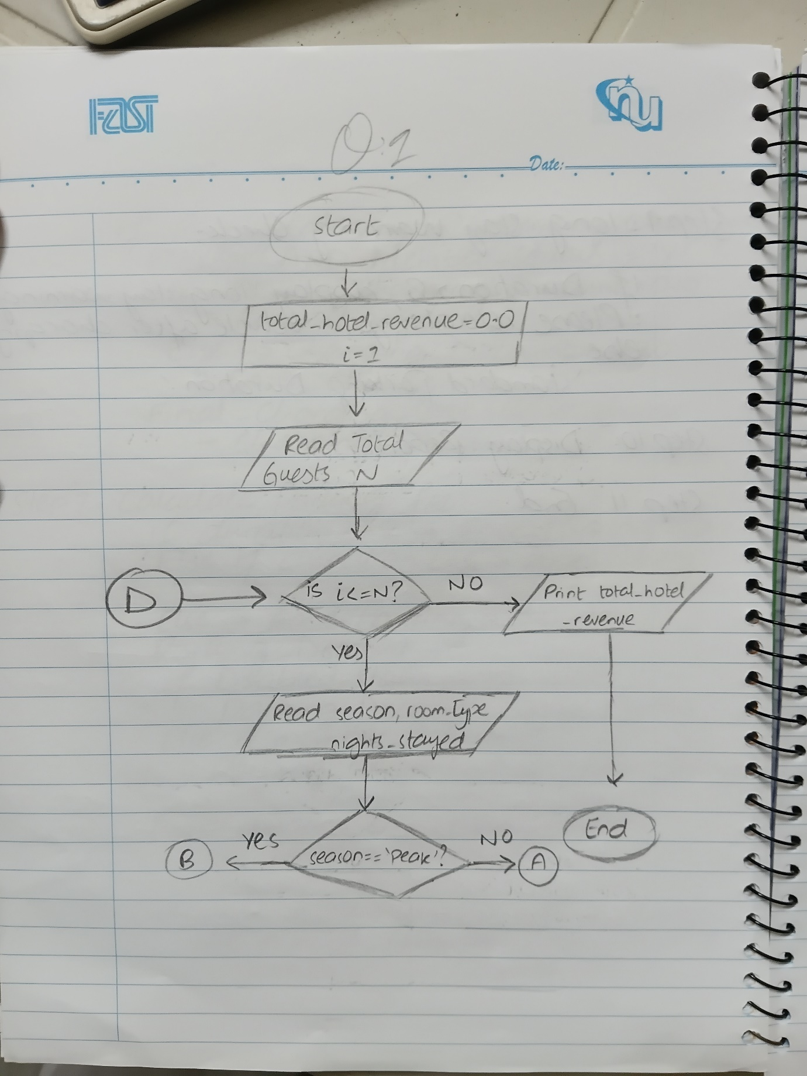

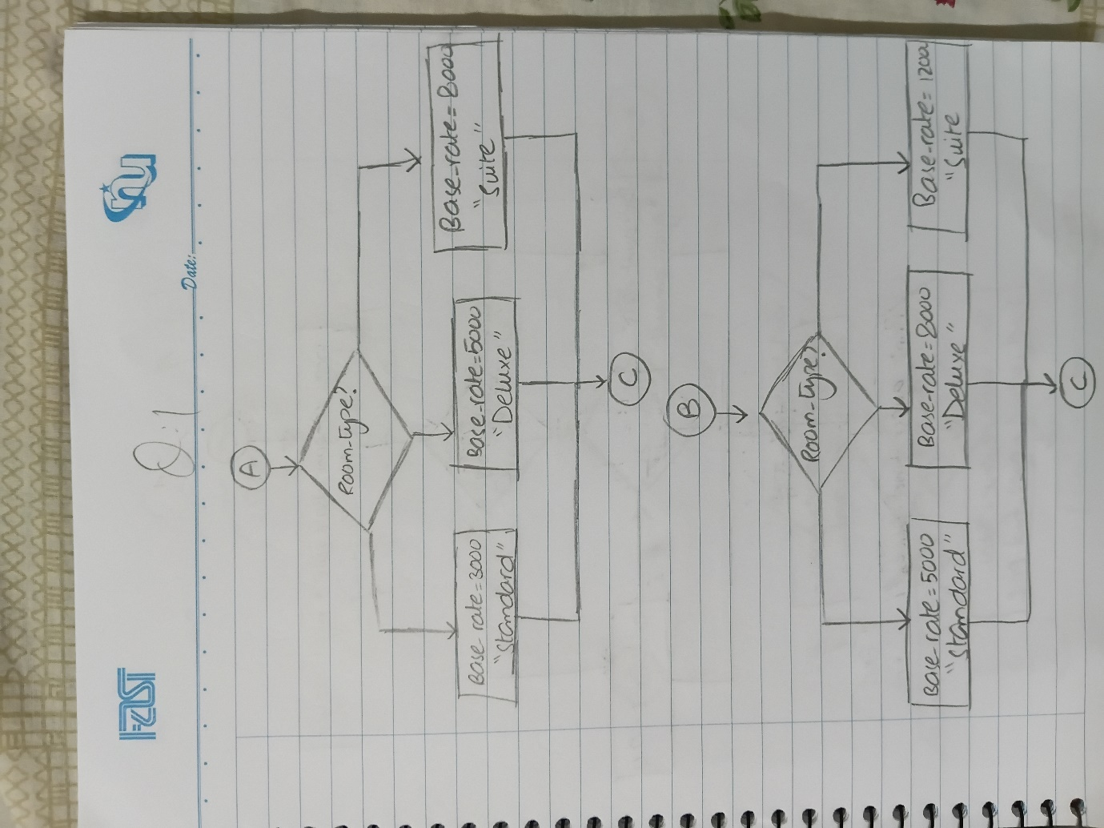
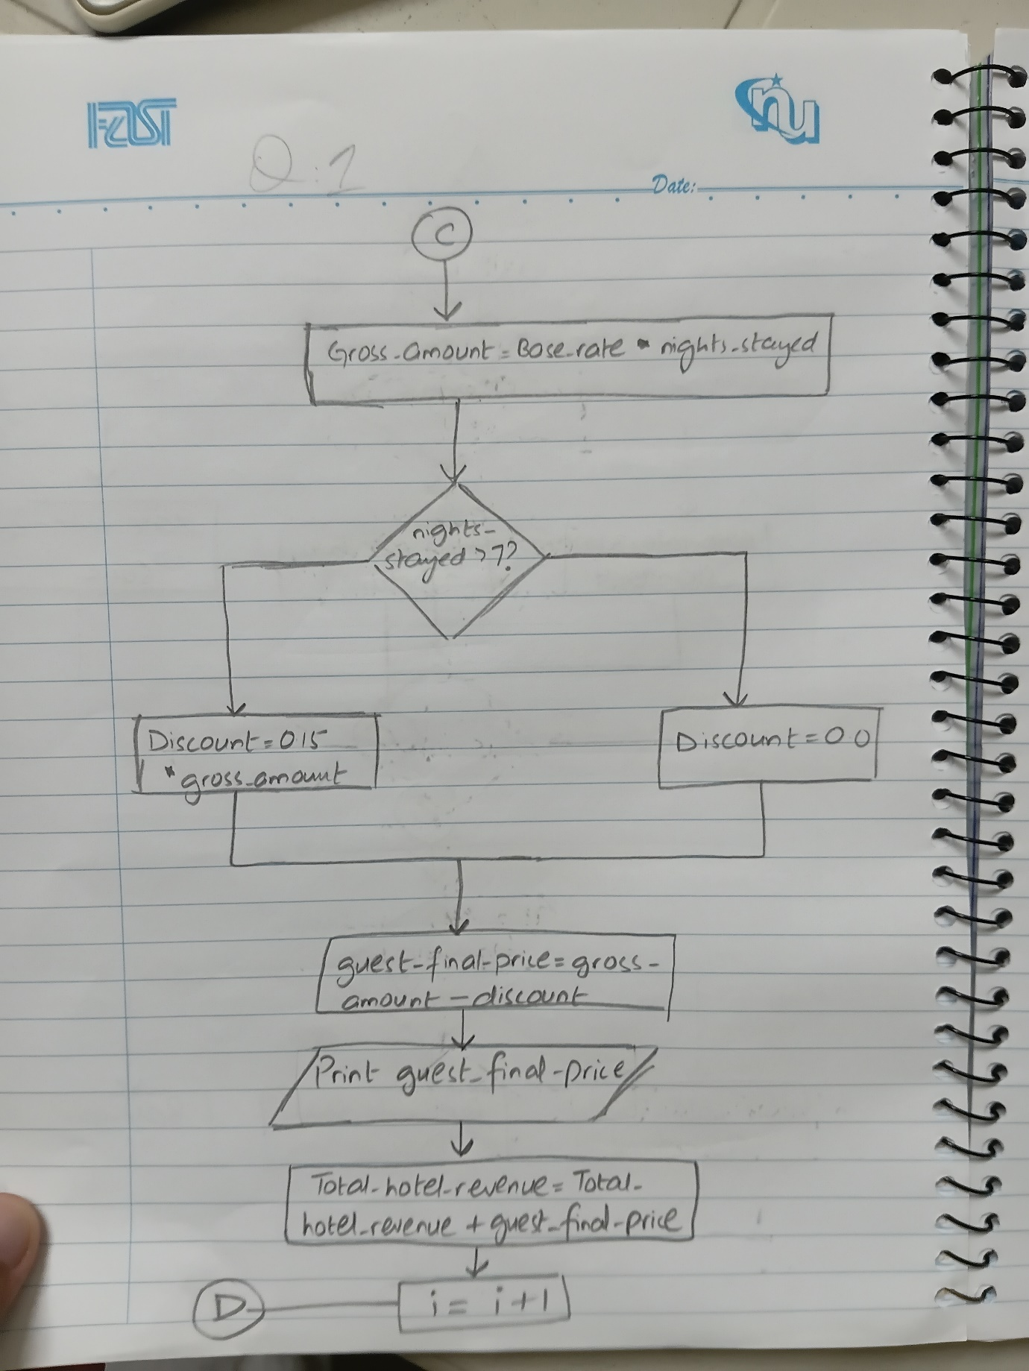

Pseudocode
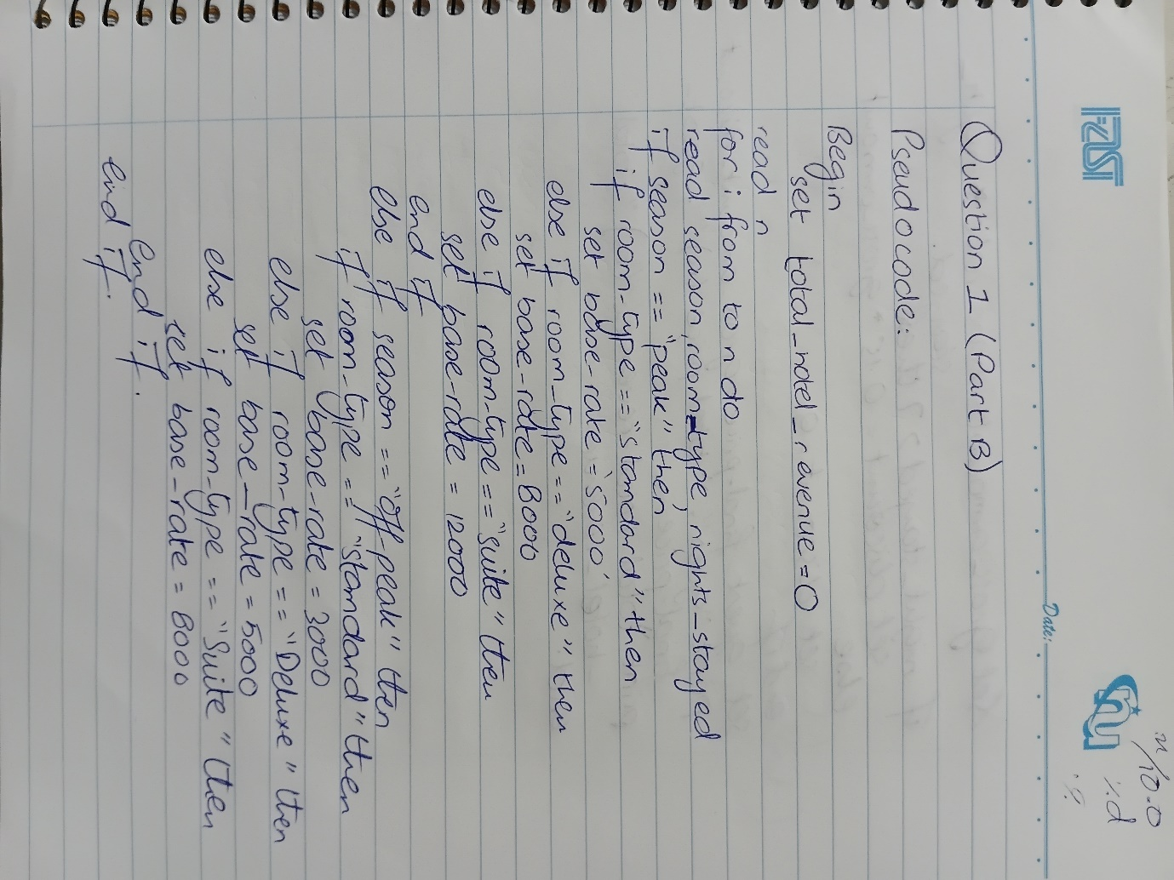

Question 02: Elevator Simulation
1. Algorithm
Step 1: Start.
Step 2: Initialize current_floor = 0 (elevator starts at ground floor).
Step 3: Read total number of floor requests N (e.g., N = 5).
Step 4: Set loop counter i = 1.
Step 5: If i > N, go to Step 12 (exit loop).
Step 6: Read requested_floor for request i.
Step 7: Check floor comparison:
If requested_floor > current_floor, print 'Moving Up'.
Else if requested_floor < current_floor, print 'Moving Down'.
Else (requested_floor == current_floor), print 'Doors Opening'.
Step 8: Update current_floor = requested_floor.
Step 9: Increment loop counter i = i + 1.
Step 10: Go to Step 5.
Step 11: End.
2. Problem Analysis Chart (PAC)
Given Data / Inputs | Processing & Operations | Required Output | Constraints & Rules
• Initial floor = 0  • N (Total requests)  • requested_floor (for each request) | 1. For each request, compare requested_floor with current_floor.  2. If requested > current -> Print 'Moving Up'.  3. If requested < current -> Print 'Moving Down'.  4. If requested == current -> Print 'Doors Opening'.  5. Update current_floor = requested_floor after each stop. | • Direction message for each stop ('Moving Up', 'Moving Down', or 'Doors Opening')  • Updated current_floor status | • Elevator starts at Floor 0.  • Process requests sequentially one by one in a loop.  • List of N requests (e.g., 3, 1, 5, 2, 2).

3. Input-Process-Output (IPO) Chart
Input | Processing | Output
• N (Integer, number of requests)  • requested_floor (Integer sequence) | 1. Set current_floor = 0.  2. Loop i from 1 to N:  a. Read requested_floor.  b. IF requested_floor > current_floor -> Output 'Moving Up'.  c. ELSE IF requested_floor < current_floor -> Output 'Moving Down'.  d. ELSE -> Output 'Doors Opening'.  e. Set current_floor = requested_floor. | • Status string per request: 'Moving Up', 'Moving Down', or 'Doors Opening'

4. Flowchart Diagram
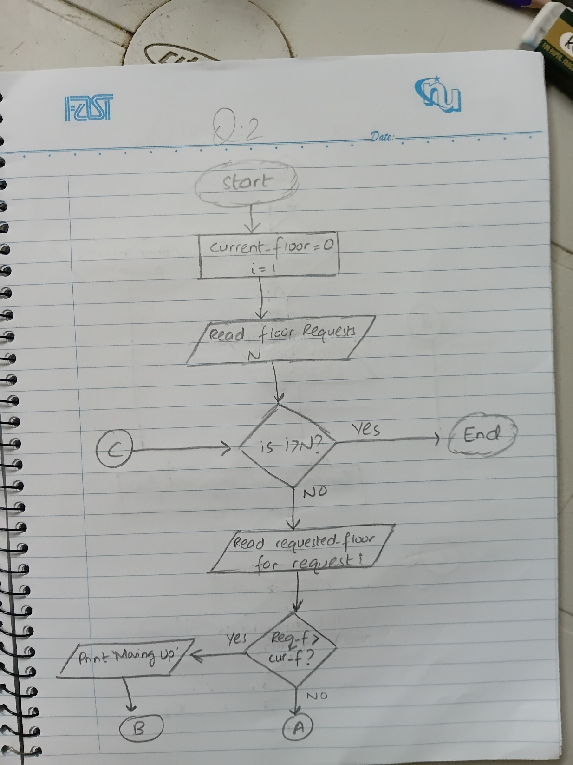
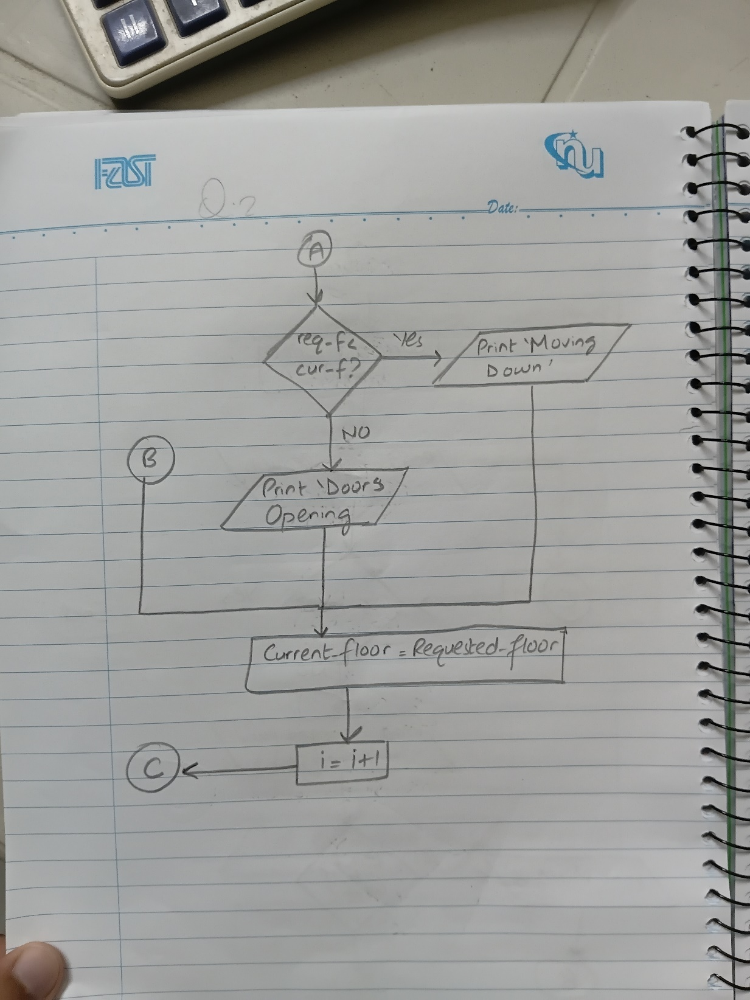

Pseudocode
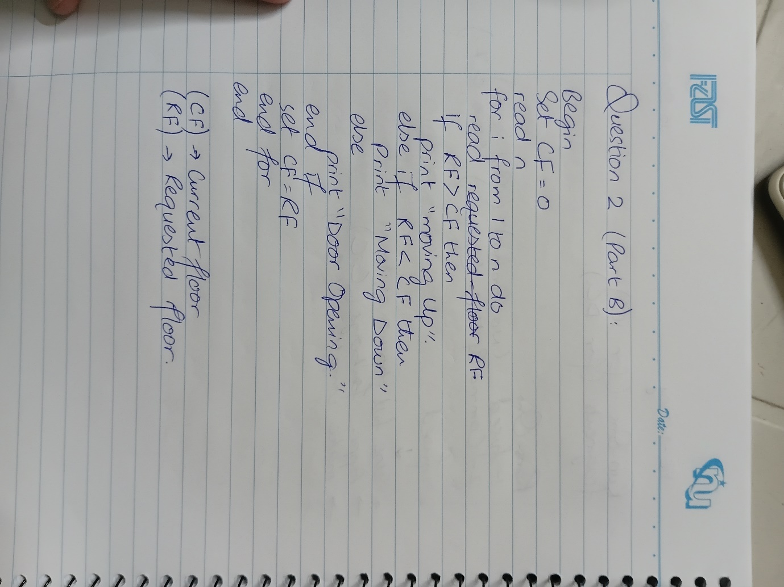

Question 03: Class Result Processing
1. Algorithm
Step 1: Start.
Step 2: Read total number of students N (N = 3).
Step 3: Set outer loop counter student_count = 1.
Step 4: If student_count > N, go to Step 18 (exit outer loop).
Step 5: Initialize sum_marks = 0, has_deficiency = 0.
Step 6: Set inner loop counter subj_count = 1.
Step 7: f subj_count > 5, go to Step 12 (exit inner loop).
Step 8: Read mark for suject subj_count.
Step 9: Add mark to sum_marks (sum_marks = sum_marks + mark).
Step 10: If mark < 33, set has_deficiency = 1.
Step 11: Increment subj_count = subj_count + 1, go to Step 7.
Step 12: Compute average = sum_marks / 5.0.
Step 13: Determine student classification:
If has_deficiency == 1, result = 'Fail - Subject Deficiency'.
Else if average >= 80, reult = 'Distinction'.
Else if average >= 60, result = 'Pass'.
Else, result = 'Fail'.
Step 14: Display Student ID, average, and final result.
Step 15: Increment student_count = student_count + 1.
Step 16: Go to Step 4.
Step 17: End.
2. Problem Analysis Chart (PAC)
Given Data / Inputs | processing & Operations | Required Output | Constraints & Rules
• N (Total students)  • 5 subject marks per student (out of 100) | 1. Inner loop: Read 5 marks, compute sum, check if any mark < 33.  2. Average = sm / 5.0.  3. Override Check: If any mark < 33 -> 'Fail - Subject Deficiency'.  4. If no deficiency: Avg >= 80 -> 'Distinction', Avg >= 60 -> 'Pass', Else -> 'Fail'. | • Total marks sum  • Calculated average  • Classification grade per student | • N students processed in outer loop.  • 5 subjects per student in inner loop.  • Passing mark per subject is 33.  • Subject deficiency overrides high average.

3. Input-Process-Output (IPO) Chart
Input | Processing | Output
• n (integer)  • mark1, mark2, mark3, mark4, mark5 (floats/integers) | 1. outer loop student = 1 to n:  a. sum = 0, deficiency = 0.  b. inner loop subj = 1 to 5:  - input mrk.  - sum += mark.  - if mark < 33 then deficiency = 1.  c. avg = sum / 5.0.  d. if deficiency == 1 then status = 'fail - subject deficiency'  else if avg >= 80 then status = 'distinction'  else if avg >= 60 then status = 'pass'  else status = 'fail'. | • student average  • classification status per student

4. Flowchart Diagram
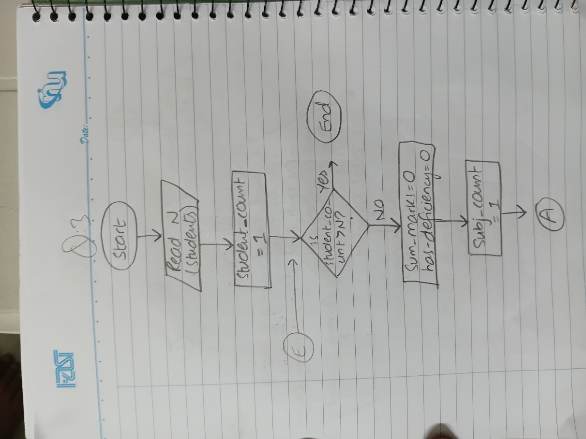
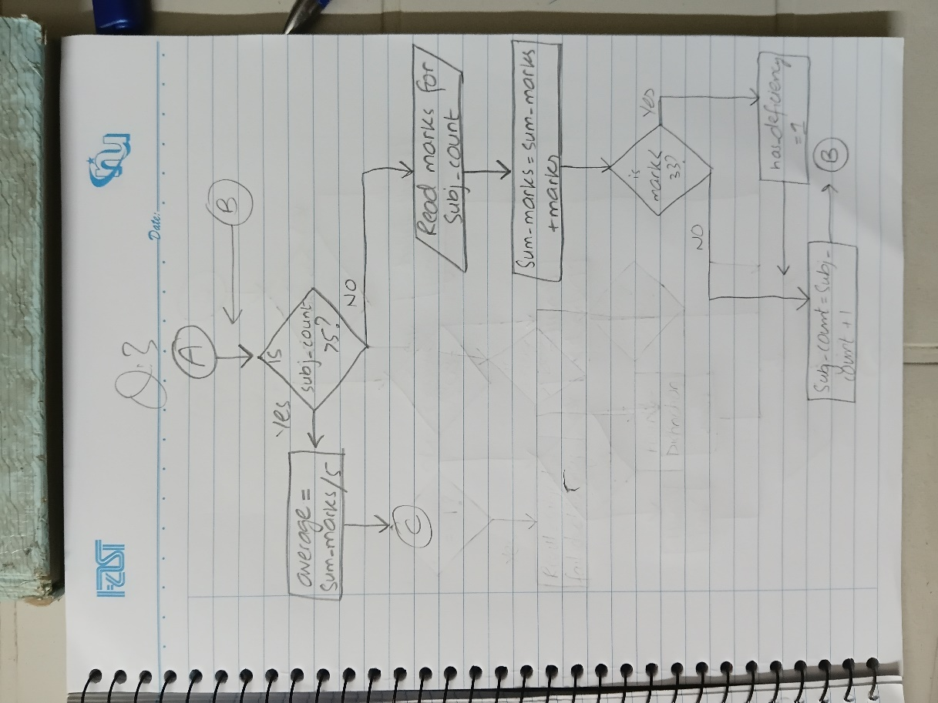
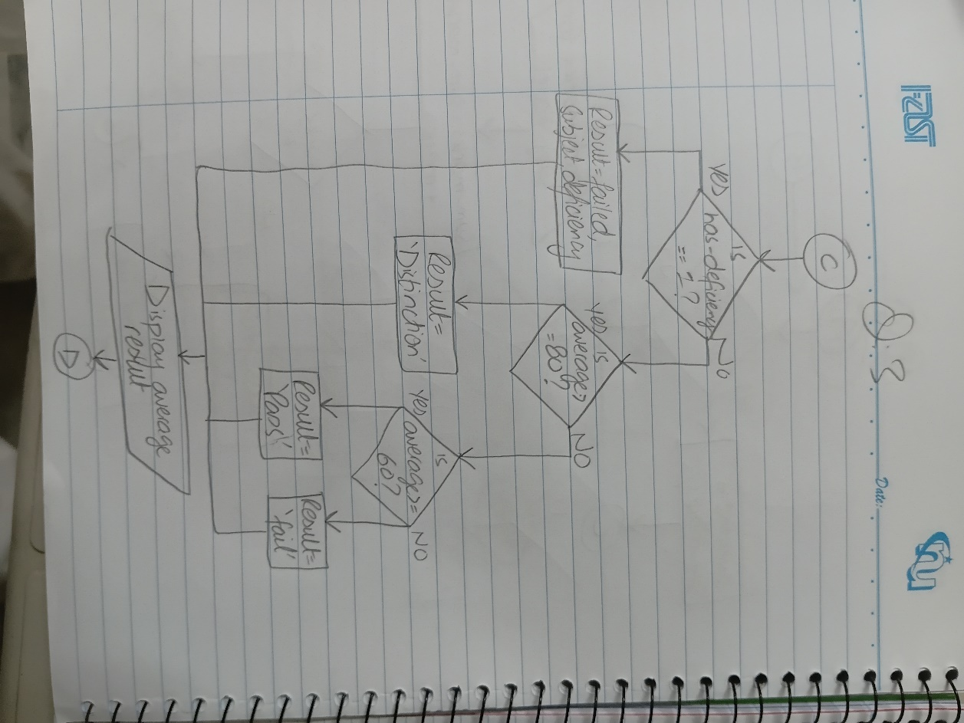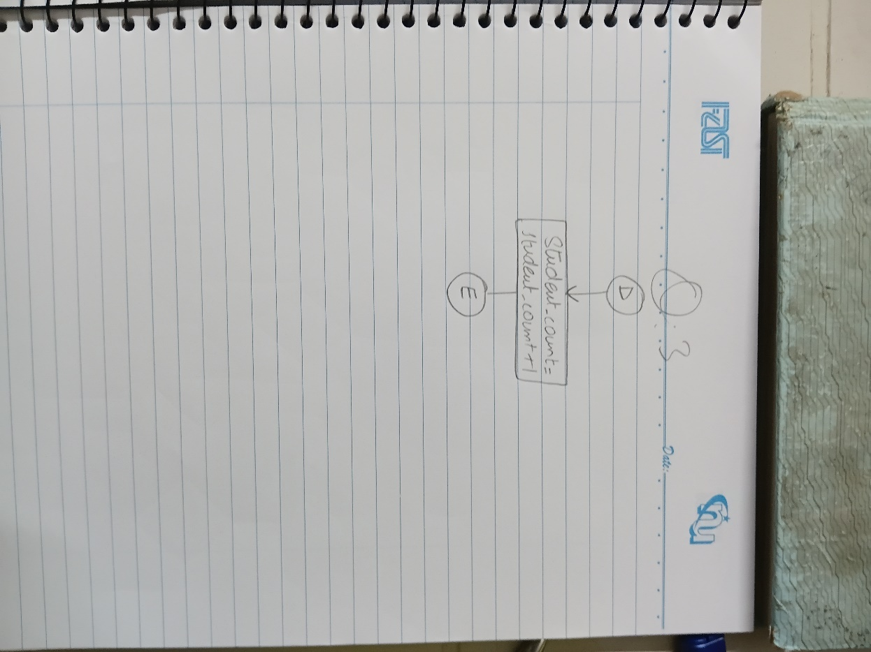

Pseudocode
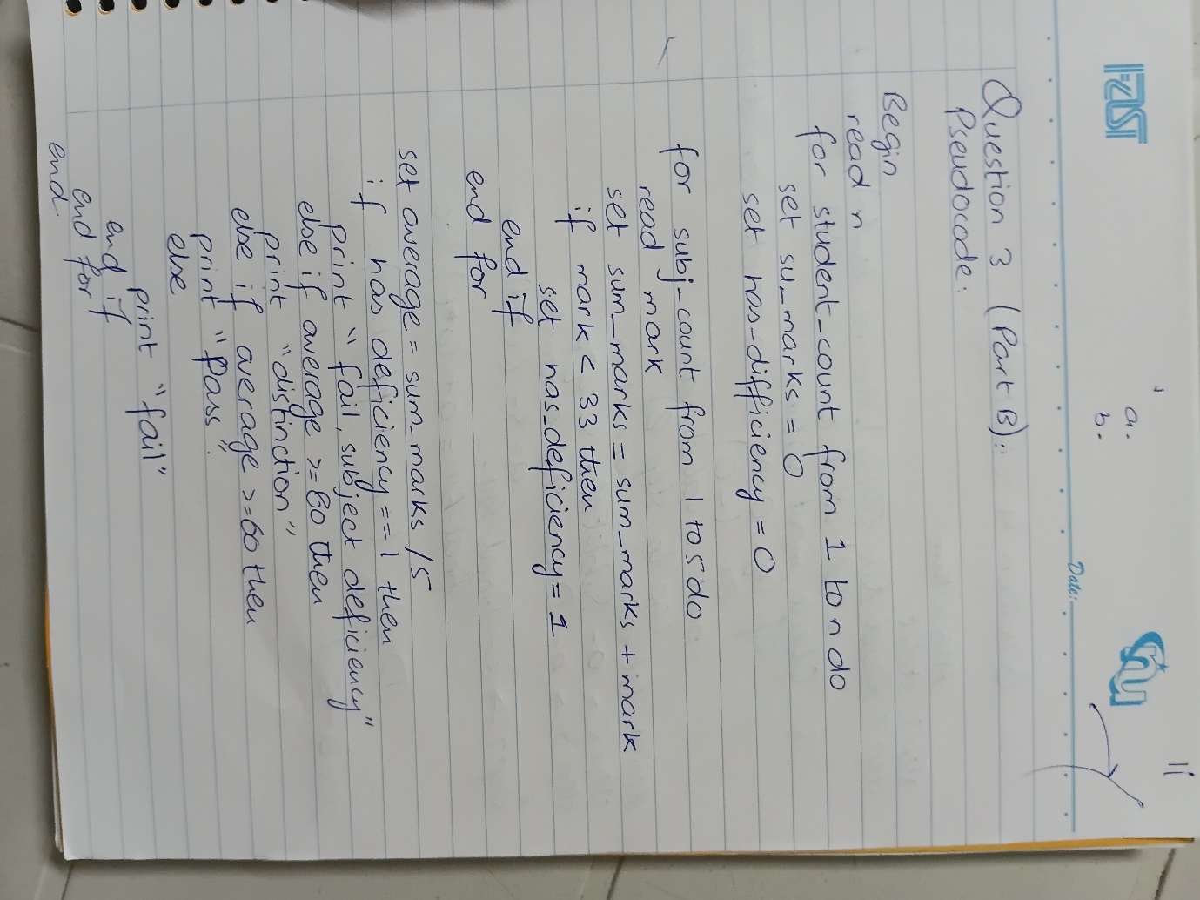

Question 04: Online Shopping Bill Calculator

1. Algorithm
Step 1: Start.
Step 2: Read quantity(q), price_per_item(p), discount_percent (d), and tax_percent (t).
Step 3: Validate input values:
If (q <= 0 OR p <= 0 OR d < 0 OR d > 100 OR t < 0):
Print 'Error: Invalid input parameters.'
Go to Step 8 (terminate execution).
Step 4: Compute Stage 1 - Subtotal: s = q * p.
Step 5: Compute Stage 2 Discounted Amount: a = s - (s * d) / 100.0.
Step 6: Compute Stage 3 - Final Bill: final_bill = a + (a * t) / 100.0.
Step 7: Display Itemized Bill Summary (Subtotal 's', Discounted Amount 'a', Tax Added, Final Payable 'final_bill').
Step 8: End.
2. Problem Analysis Chart (PAC)
Given Data / Inputs | Processing & Operations | Required Output | Constraints & Rules
• q (Quantity purchased)  • p (Price per item)  • d (Discount percentage)  • t (Tax percentage) | 1. Input validation check.  2. Subtota: s = q × p.  3. Discounted Amount: a = s - (s × d)/100.  4. Final Bill: final_bill = a + (a × t)/100. | • Error message (if invalid)  • Subtotal (s)  • Discounted Amount (a)  • Final Payable Bill | • Inputs must be positive (q>0, p>0, d>=0, t>=0).  • Dependent staged functions.  • Single record transaction.

3. Input-Process-Output (IPO) Chart
Input | Processing | Output
• quantity (q: Integer)  • price (p: Float)  • discount_percent (d: Float)  • tax_percent (t: Float) | 1. IF q <= 0 OR p <= 0 OR d < 0 OR d > 100 OR t < 0 THEN display error and terminate.  2. s = q * p  3. a = s - (s* d) / 100.0  4. final_bill = a + (a * t) / 100.0  5. Format and print bill receipt. | • Subtotal (s)  • Discounted Amount (a)  • Final Bill Amount

4. Flowchart Diagram
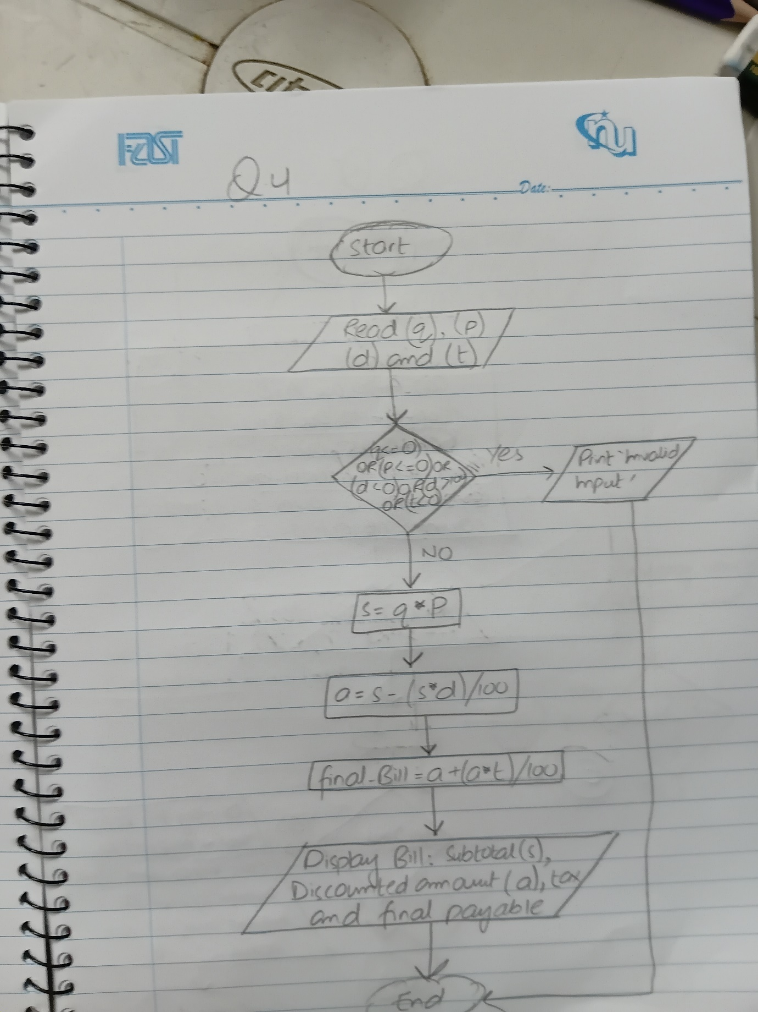

Pseudocode
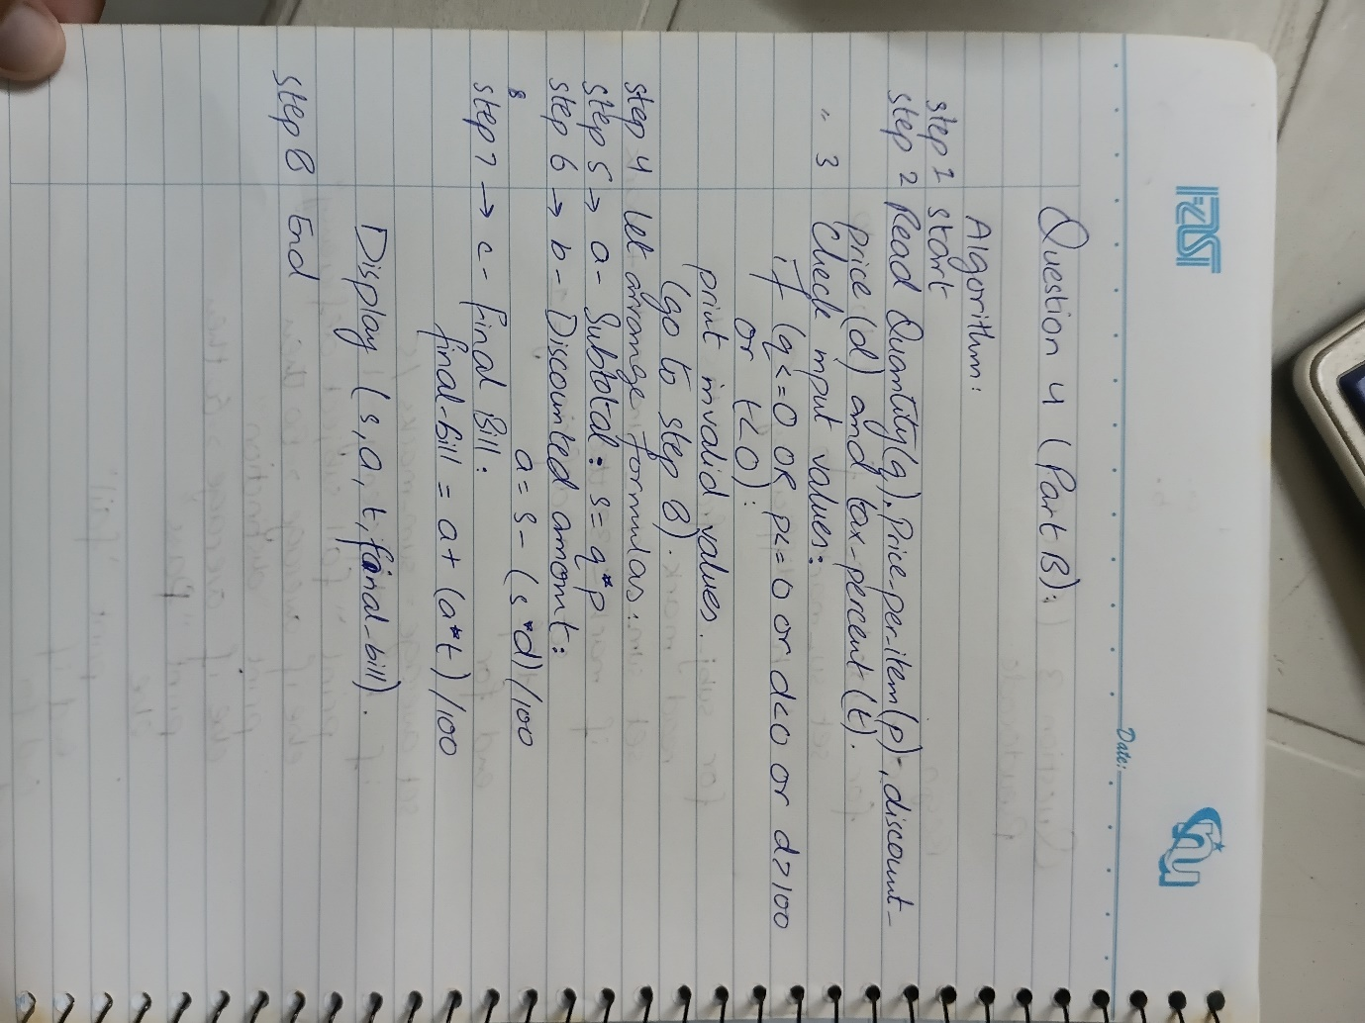

Question 05: Smart Campus Parking and Access Management System
1. Algorithm
Step 1: Start.
Step 2: Initialize Zone Capacities and Occupancy:
Cap_A = 20, Occ_A = 0; Cap_B = 40, Occ_B = 0; Cap_C = 15, Occ_C = 0.
Set count_cars = 0, count_bikes = 0, count_vans = 0, count_accepted = 0, cont_rejected = 0.
Step 3: Read total vehicles to process N.
Step 4: Set loop counter i = 1.
Step 5: If i > N, go to Step 14 (exit loop).
Step 6: Input Vehicle_Type ('C', 'B', 'V'), User_Category ('F', 'S', 'G'), and Valid_Permit ('Y', 'N')
Step 7: Validation Loop: If values are invalid, prompt user to re-enter until valid inputs are received.
Step 8: Emergency Check: If Valid_Permit == 'N', ask if Emergency_Vehicle ('Y', 'N'). If 'N', reject vehicle and go to Step 12.
Step 9: Zone Assignment & Capacity Verification:
- Faculty ('F'): Check Zone A capacity (1 space for C/B, 1 space for V if space available).
- Student ('S'): Check Zne B capacity (1 space for C/B). If Van ('V'), redirect to Zone C if space available.
- Visitor ('G'): Check Zone C capacity (1 space for C/B; 2 spaces for V if at least 2 spaces available).
Step 10: Processing Outcome:
If suitable zone space is available:
Update Zone Occupancy (Occ_A, Occ_B, or Occ_C).
Increment count_accepted, and appropriate vehicle counter (count_cars, count_bikes, or count_vans).
Display assigned zone and remaining capacity.
Else:
Increment count_rejected.
Display rejection reason ('No space available' or 'No suitable zone').
Step 11: Increment loop counter i = i + 1.
Step 12: Go to Step 5
Step 13: Generate Parking Summary Report:
Display Total Processed (N), Total Accepted, Total Rejected, counts of Cars/Bikes/Vans parked.
Display final occupancy and remaining capacity for Zone A, Zone B, Zone C.
Determine and display zone with highest occupancy percentage.
Display whether entire facility is FULL (Occ_A==20 AND Occ_B==40 AND Occ_C==15).
Step 14: End.
2. Problem Analysis Chart (PAC)
Given Data / Inputs | Processing & Operations | Required Output | Constraints & Rules
• n (total expected vehicles)  • vehicle type (c/b/v)  • user category (f/s/g)  • valid permit (y/n)  • emergency status (y/n) | 1. repeated validation loop.  2. rules: faculty->zone a (cap 20), student->zone b (cap 40), visitor->zone c (cap 15).  3. vn rules: faculty van->zone a if space; student van->zone c if space; visitor van->zone c if >=2 spaces free.  4. emergency override allows entry regardless of permit.  5. capacity updates & counter increments. | • assigned zone & remaining capacity  • rejection reason (if rejected)  • final summary: total processed, accepted, rejected, counts by type, zone occupancies, highest occupancy zone, facility full status. | • zone a: 20 max, zone b: 40 max, zone c: 15 max.  • visitor van consumes 2 spaces.  • input validation repeat until valid.

3. Input-Process-Output (IPO) Chart
Input | Processing | Output
• n (integer)  • type ('c','b','v')  • category ('f','s','g')  • permit ('y','n')  • emergency ('y','n') | 1. initialize cap_a=20, cap_b=40, cap_c=15, occ_a=occ_b=occ_c=0.  2. loop 1 to n:  a. input & validate type, category, permit.  b. evaluate zone eligibility & space requirement (1 space for c/b, 2 for c-van).  c. if space exists -> allocate, occ+=spaces, increment type counter.  d. else -> reject, increment reject counter.  3. compute highest occupancy zone & full status. | • individual parking assignment / rejection notice  • comprehensive parking summary report

4. Flowchart Diagram
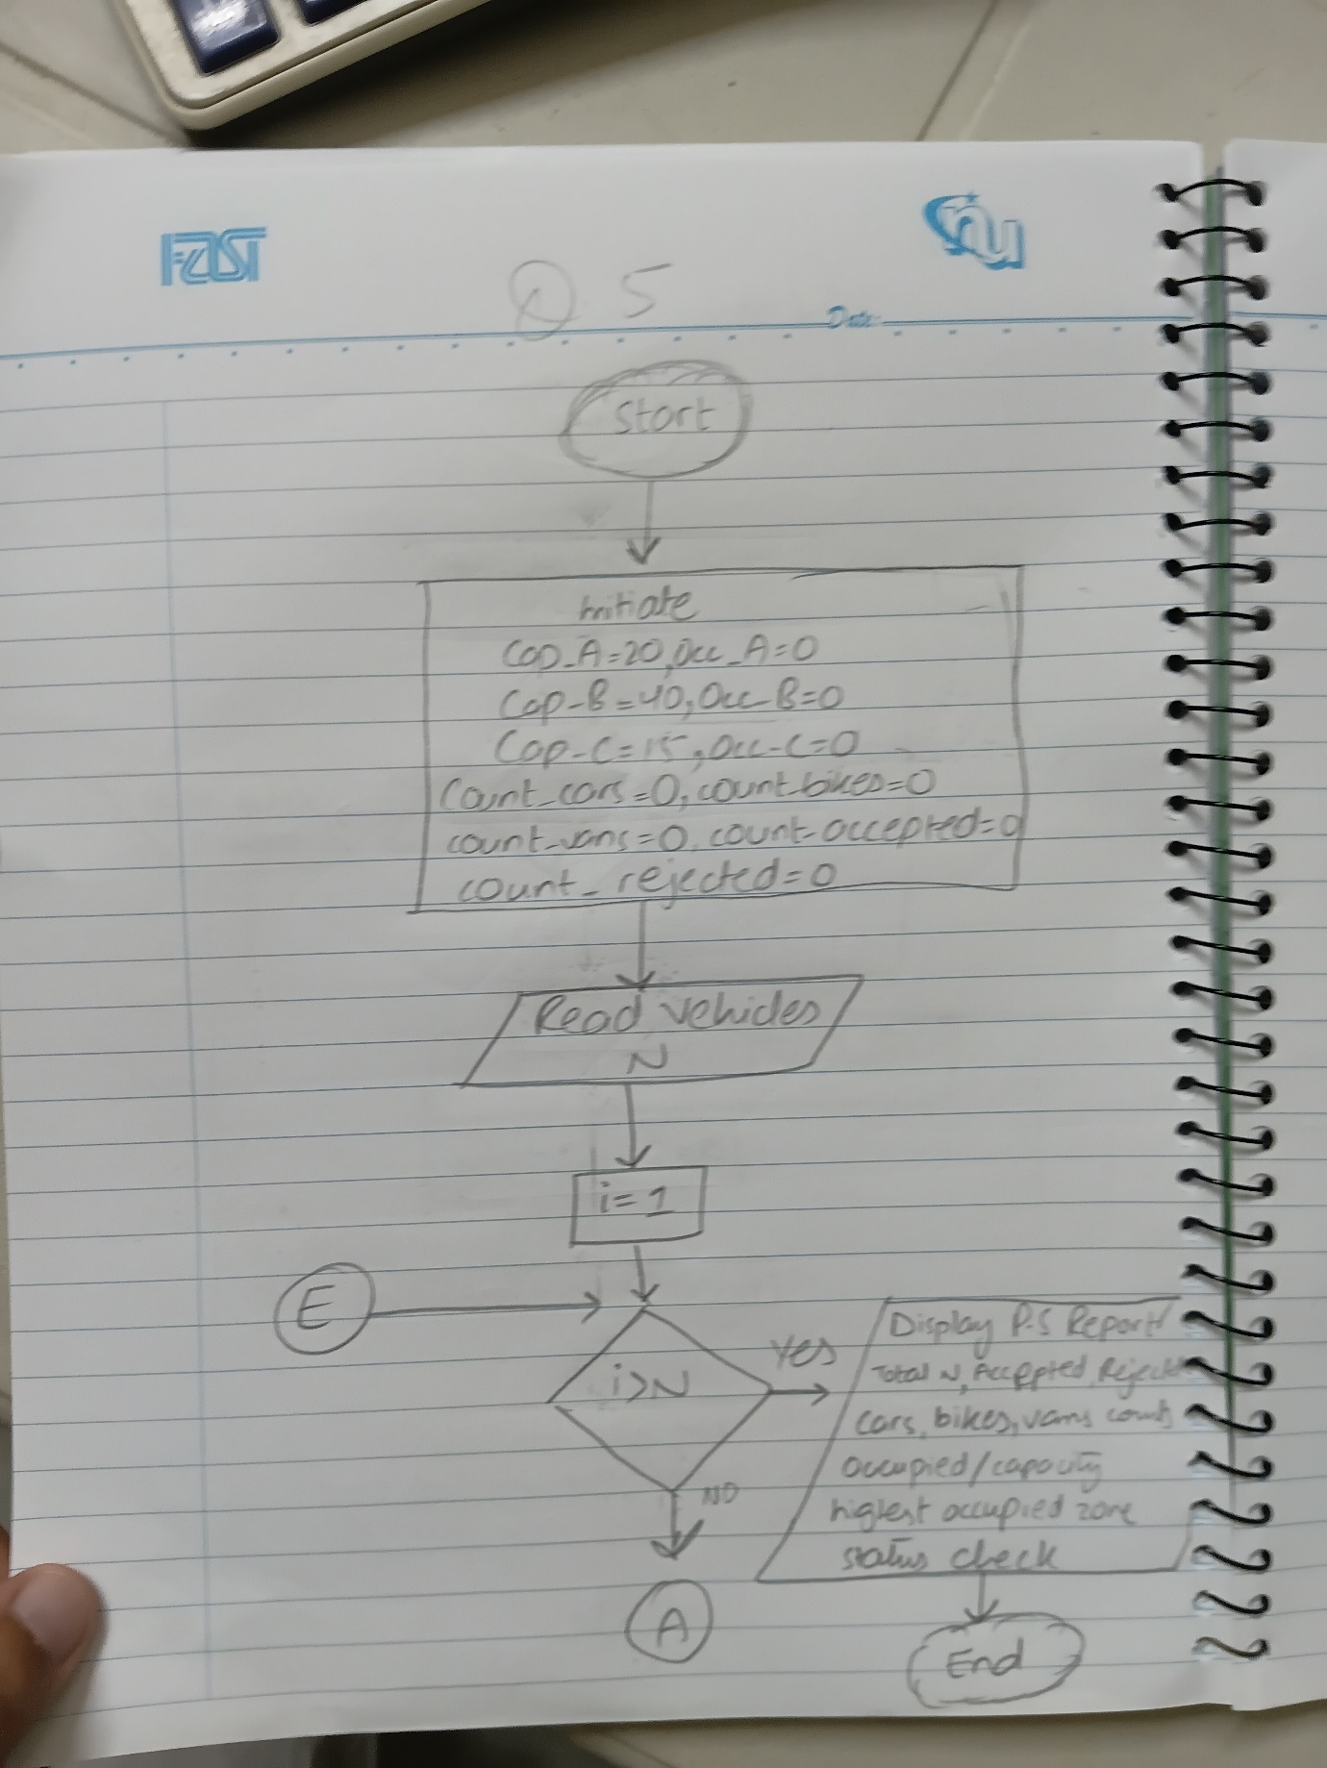
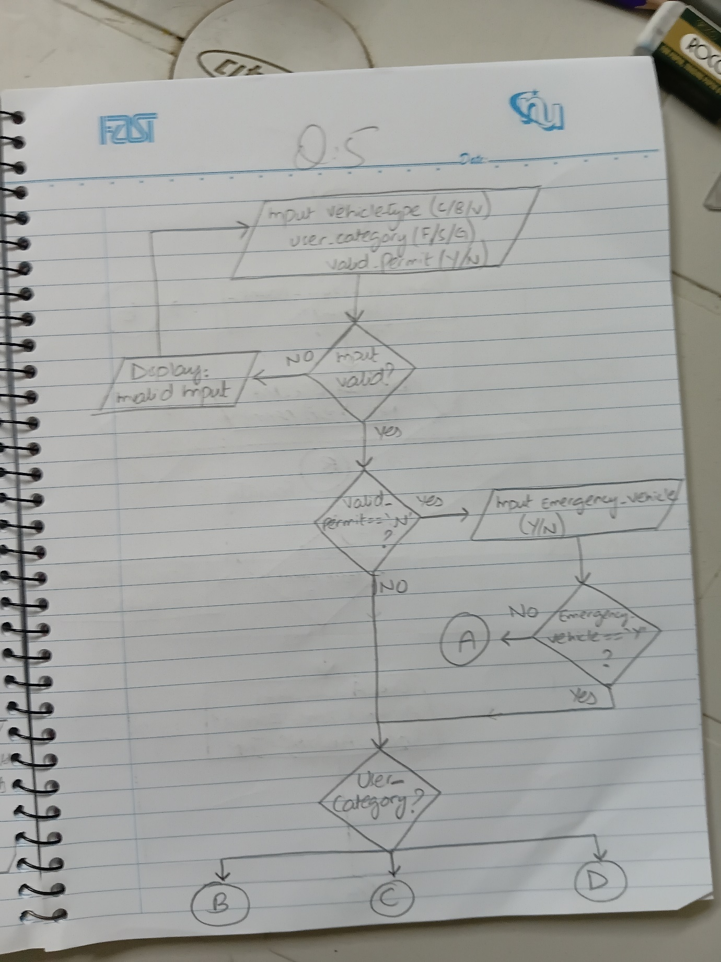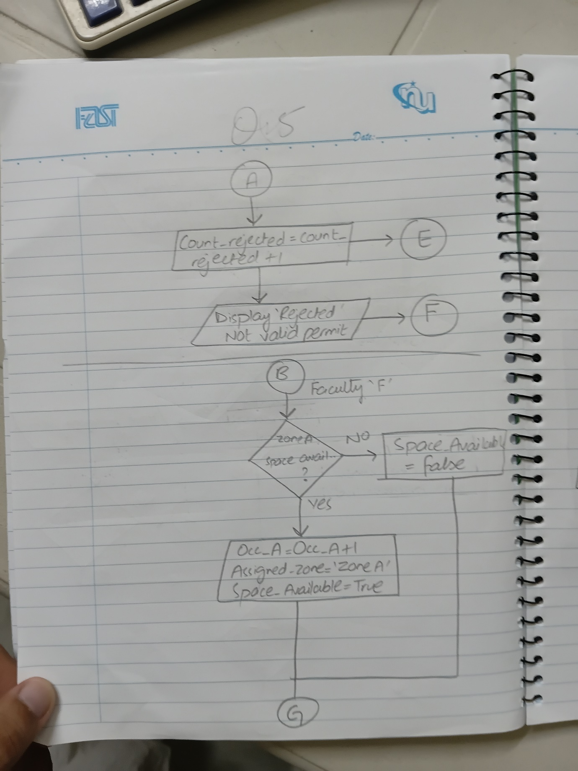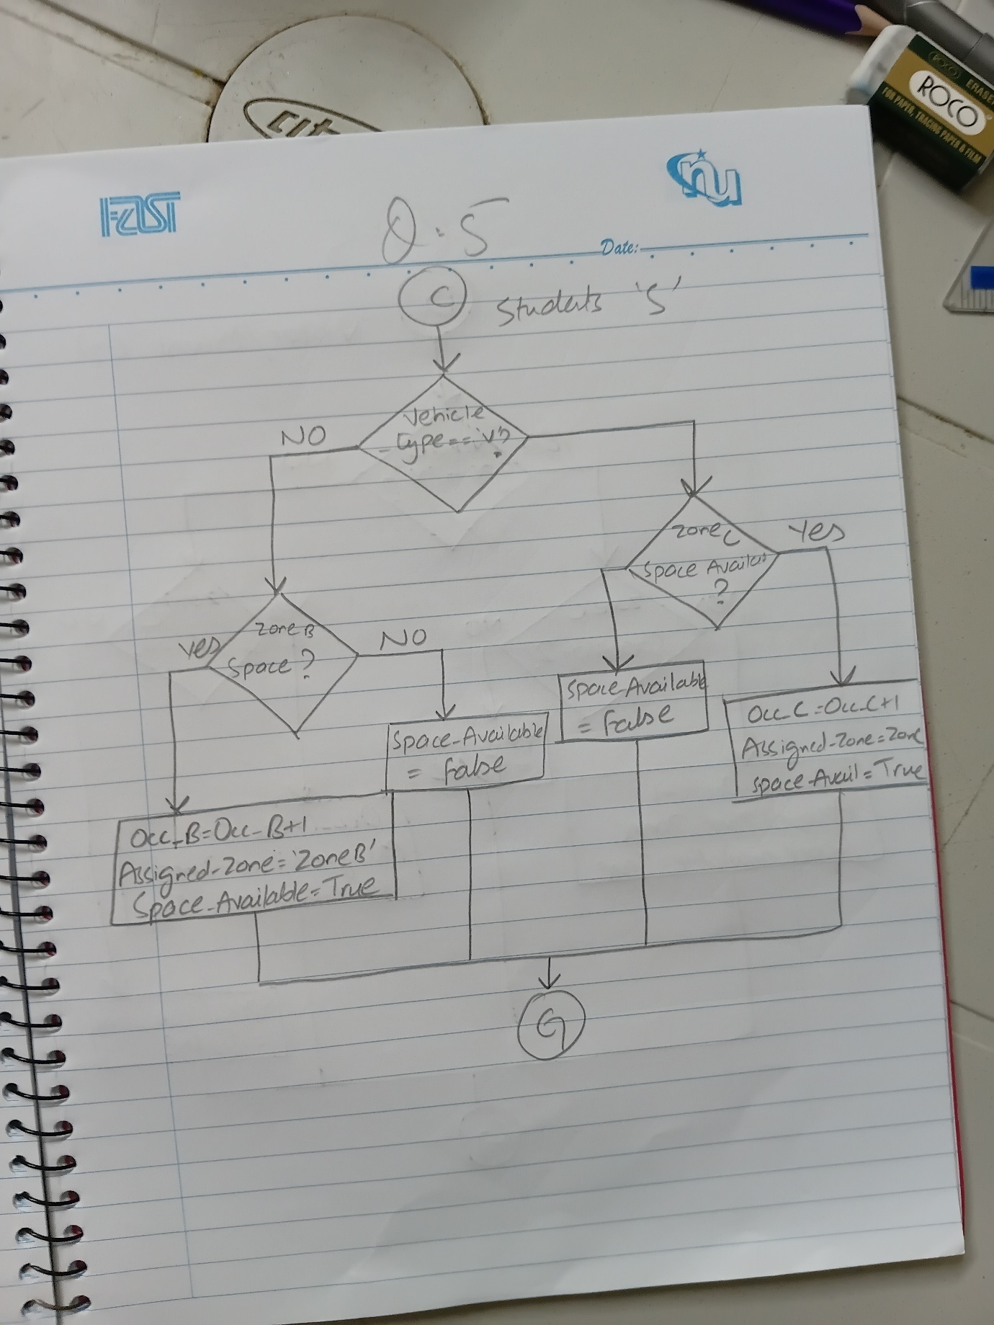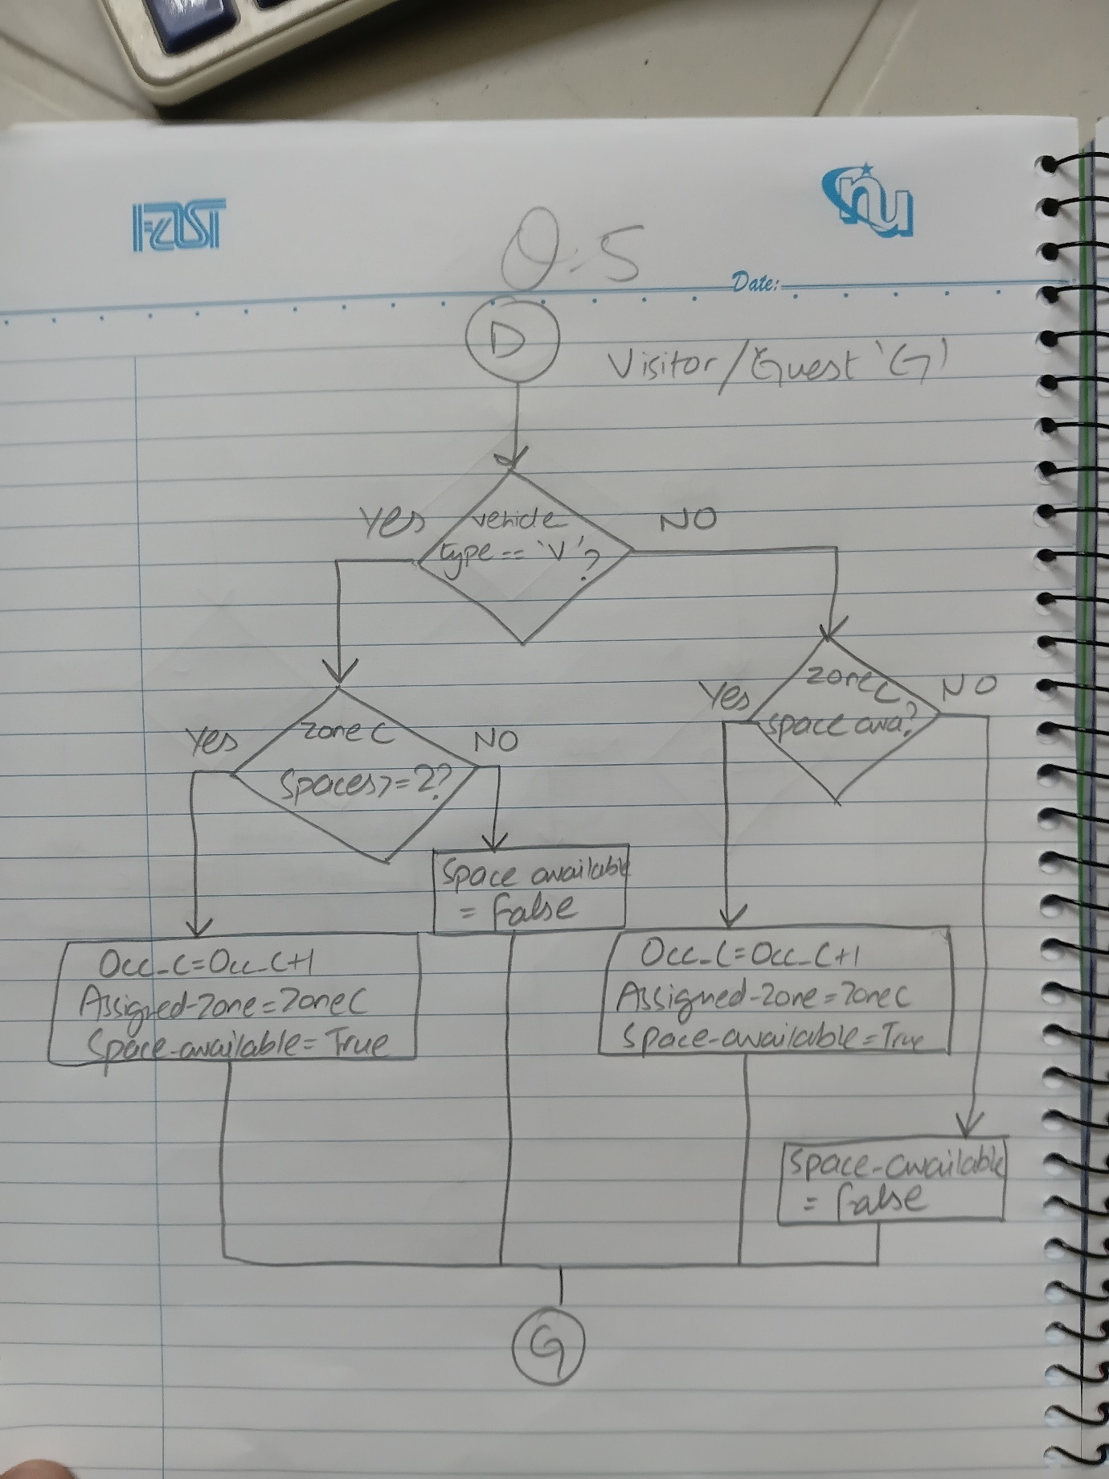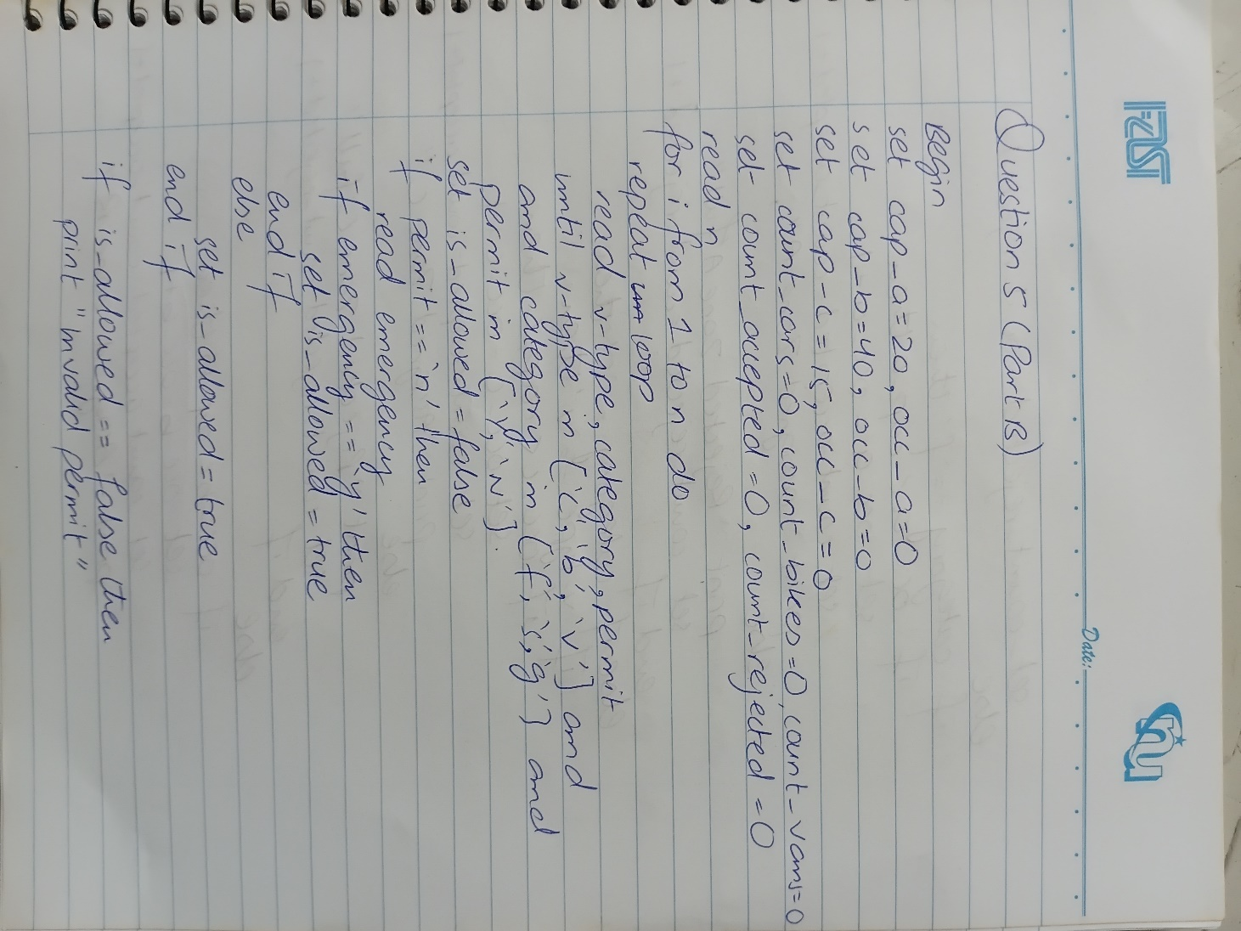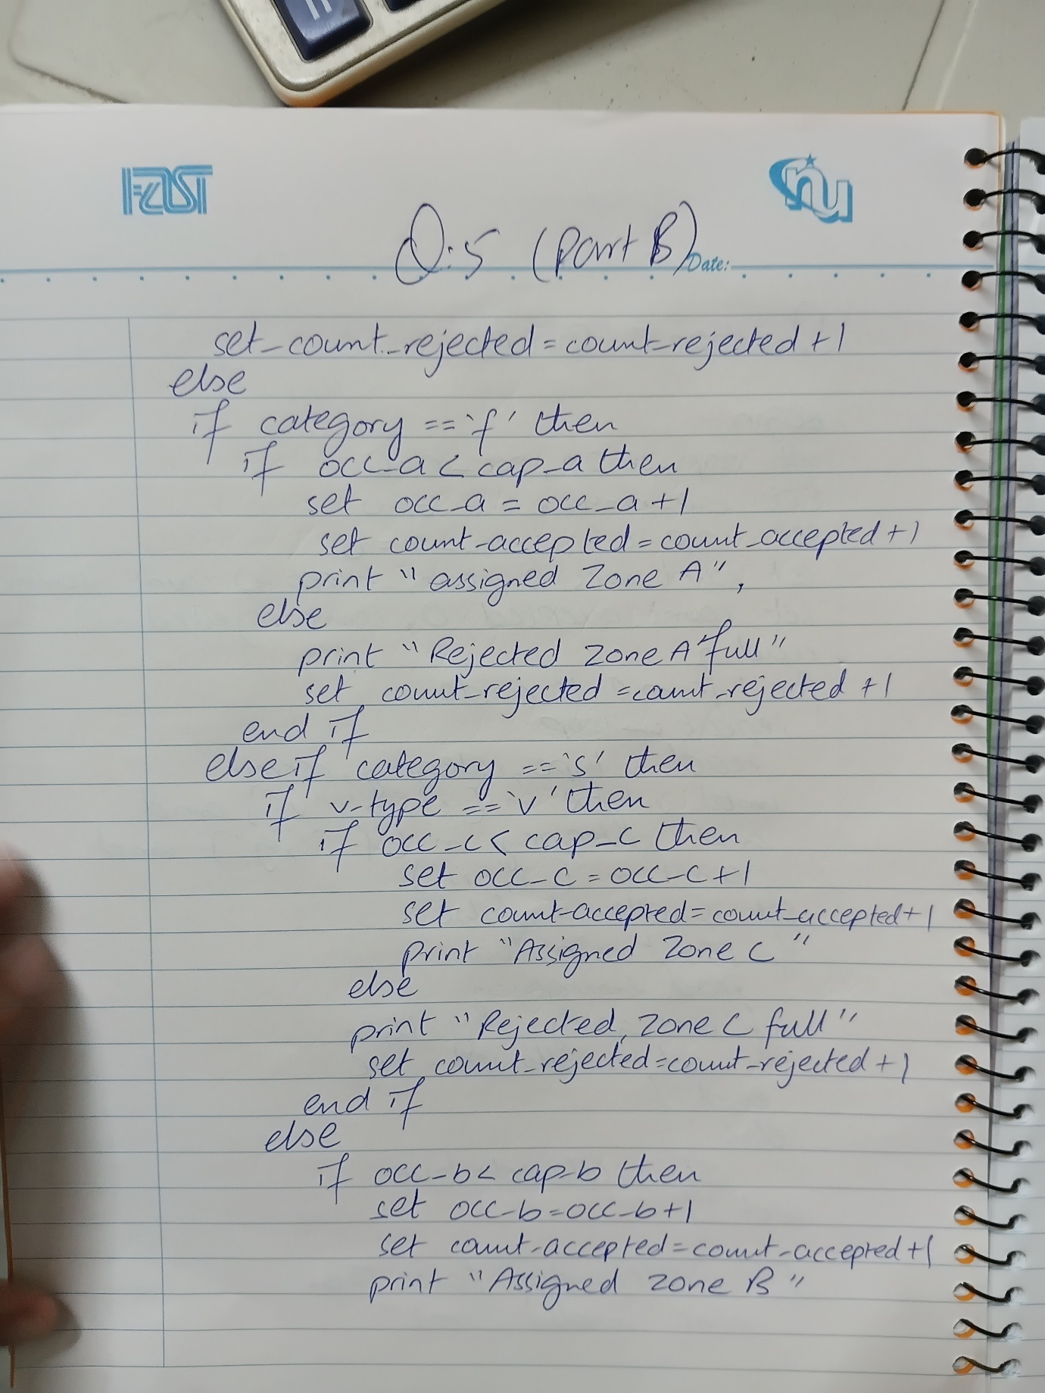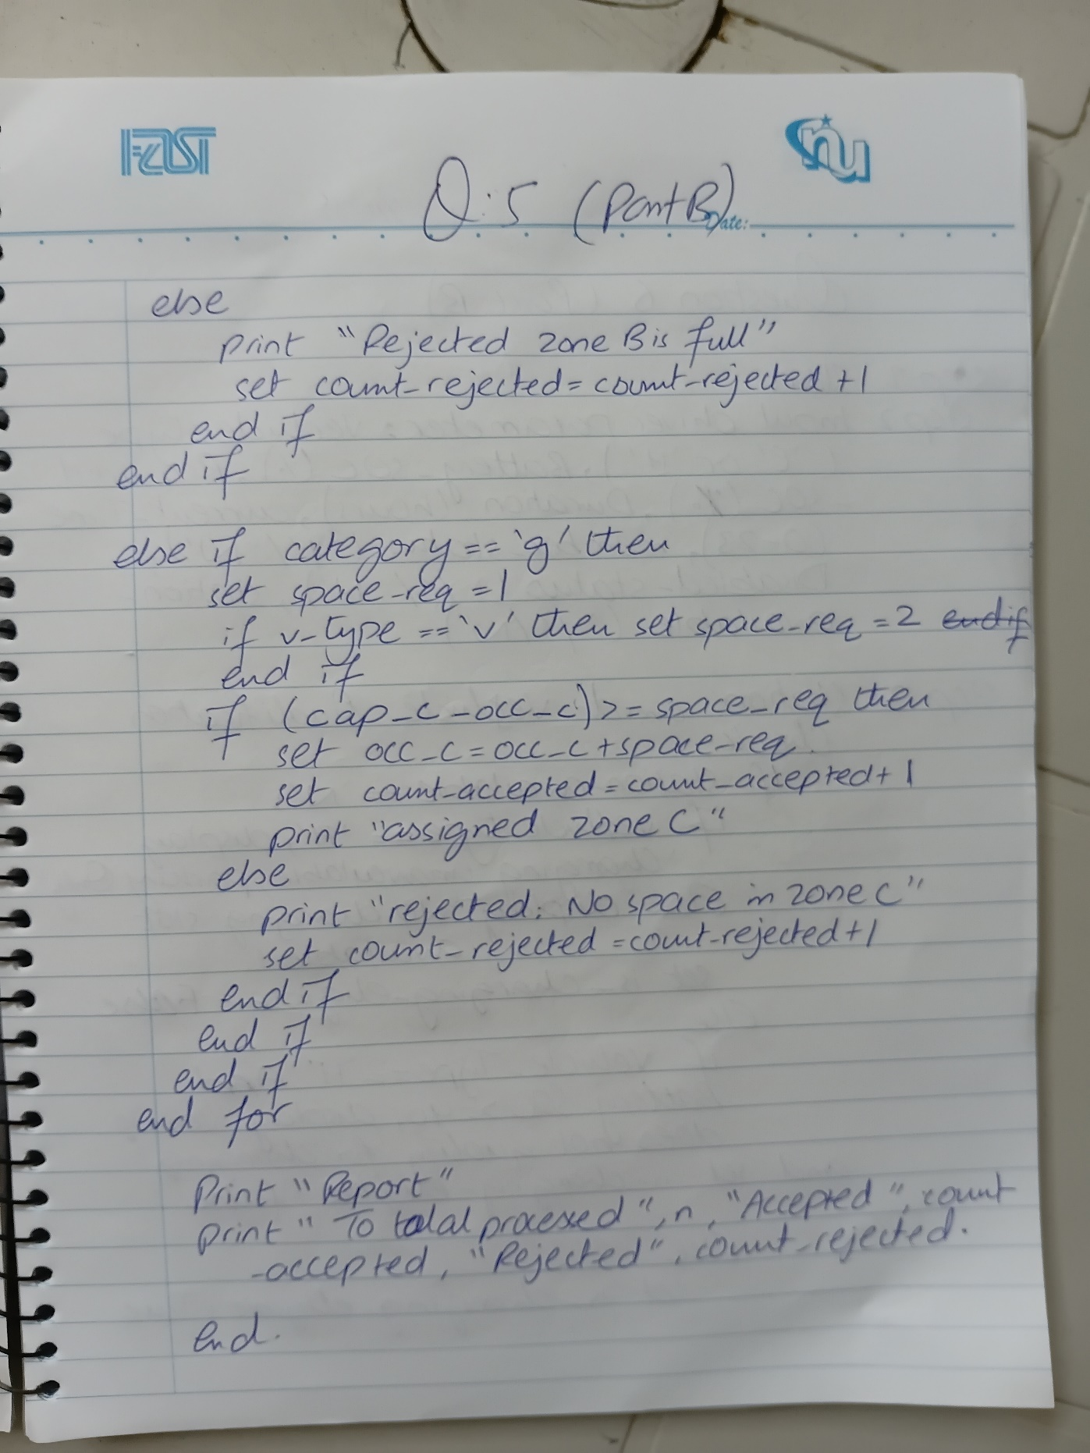

Question 06: Smart EV Charging and Parking Management System
1. Algorithm
Step 1: Start.
Step 2: Input driver parameters: Vehicle_Type ('E' or 'H'), Battery_SOC (%), Required_SOC (%), Duration (hours), Current_Time (0-23), Member_Status ('Y'/'N'), Disabled_Status ('Y'/'N'), Station_Available ('Y'/'N').
Step 3: Station & Vehicle Qualification Check:
If Station_Available == 'N':
If Vehicle_Type == 'H', display 'Charging unavailable. Parking only.'
Else display 'No charging slot available.'
Set is_charging_eligible = FALSE.
Else:
If Vehicle_Type == 'H' AND Battery_SOC >= 40, display 'Vehicle does not qualify for EV charging.' and set is_charging_eligible = FALSE.
Else set is_charging_eligible = TRUE.
Step 4: Required Charging Check:
If is_charging_eligible == TRUE:
Calculate Req_Units = Required_SOC - Battery_SOC.
If Req_Units <= 0, display 'No charging required.' and set is_charging_eligible = FALSE.
Step 5: Priority Category Assignment (if eligible):
- Priority 1: If Battery_SOC <= 15 AND Required_SOC >= 80 -> Priority_Category = 'Emergency Charging Priority'.
- Priority 2: Else if Disabled_Status == 'Y' OR (Member_Status == 'Y' AND Battery_SOC <= 30) -> Priority_Category = 'Priority Charging'.
- Priority 3: Else -> Priority_Category = 'Normal Charging'.
Step 6: Calculate Electricity Charging Fee:
Determine Peak status: If Current_Time >= 17 AND Current_Time < 22 -> Rate = Rs. 50 (Peak); else Rate = Rs. 35 (Off-Peak).
Base_Charge = Req_Units * Rate.
Charging_Discount = 0.
If Priority_Category != 'Emergency Charging Priority' AND Member_Status == 'Y':
If Peak -> Charging_Discount = 0.10 * Base_Charge.
Else -> Charging_Discount = 0.20 * Base_Charge.
Final_Charging_Cost = Base_Charge - Charging_Discount.
Step 7: Calculate Parking Fee:
If Duration <= 2 -> Base_Parking = 200.
Else if Duration <= 5 -> Base_Parking = 400.
Else -> Base_Parking = 700.
Parking_Discount = 0.
If Disabled_Status == 'Y':
Parking_Discount = Base_Parking (Free Parking).
Else if Member_Status == 'Y':
Parking_Discount = 0.20 * Base_Parking.
Final_Parking_Cost = Base_Parking - Parking_Discount.
Step 8: Calculate Total Payable = Final_Charging_Cost + Final_Parking_Cost.
Step 9: Long Stay Warning Check: If Duration > 8, display 'Long-stay warning: Please relocate your vehicle after charging.' else 'Standard parking duration.'
Step 10: Display complete itemized invoice.
Step 11: End.
2. Problem Analysis Chart (PAC)
Given Data / Inputs | Processing & Operations | Required Output | Constraints & Rules
• vehicle type (e/h)  • battery soc%  • required soc%  • duration (hours)  • current time (0-23)  • member (y/n)  • disabled (y/n)  • station available (y/n) | 1. eligibility checks: station availability, soc limits.  2. priority classification (p1, p2, p3).  3. charging cost: peak (17-22h: rs.50) vs off-peak (rs.35) with member discounts.  4. parking cost: <=2h: 200, 2-5h: 400, >5h: 700 with free disabled parking.  5. long stay warning (>8h). | • vehicle type & battery soc  • charging priority & peak status  • charging cost & parking cost  • discounts & final payable amount  • long-stay warning message | • emergency priority gets no charging discount.  • hybrid qualifies only if soc < 40%.  • disabled gets free parking (0 parking fee).  • peak hours: 17:00 to 22:00.

3. Input-Process-Output (IPO) Chart
Input | Processing | Output
• type ('E','H')  • soc, req_soc (Floats)  • duration (Float)  • time (Integer)  • member, disabled, station ('Y','N') | 1. IF station=='N' OR (type=='H' AND soc>=40) OR req_soc<=soc -> charging_eligible = FALSE.  2. IF P1 (soc<=15 AND req_soc>=80) -> 'Emergency charging priority'.  Else if p2 (disabled=='y' or (member=='y' and soc<=30)) -> 'priority charging'.  Else -> 'normal charging'.  3. Charging rate: peak (17-22h)=50, off-peak=35. Member discount: 10% peak, 20% off-peak (except P1).  4. Parking fee: <=2h:200, <=5h:400, >5h:700. Disabled=0, Member=20% off.  5. Final = Charging + Parking. | • Complete EV Charging & Parking Summary Invoice

4. Flowchart Diagram





