Serverless Shopping Website – Project Documentation

1. Introduction
This project demonstrates a Serverless Architecture-based Shopping Website built using AWS services. The goal is to design a scalable, cost-effective, and highly available web application without managing servers.

2. SDLC Model Followed
The Software Development Life Cycle (SDLC) followed for this project is the Agile-based iterative approach.
• Requirement Analysis – Identified functional and non-functional requirements
• System Design – Created serverless architecture design
• Implementation – Developed frontend and backend components
• Testing – Verified API responses, database entries, and UI behavior
• Deployment – Deployed application using AWS managed services
• Maintenance – Monitoring logs and fixing issues

3. Architecture Overview
The application follows a fully serverless architecture using AWS managed services.
Frontend:
• Amazon S3 (Static Website Hosting)
Backend:
• Amazon API Gateway
• AWS Lambda (Python)
• Amazon DynamoDB
Security & Monitoring:
• IAM Roles & Policies
• Amazon CloudWatch

4. Architecture Flow
1. User accesses the shopping website hosted on Amazon S3.
2. Frontend sends requests to API Gateway.
3. API Gateway invokes Lambda functions.
4. Lambda processes business logic and interacts with DynamoDB.
5. Response is returned to the frontend.
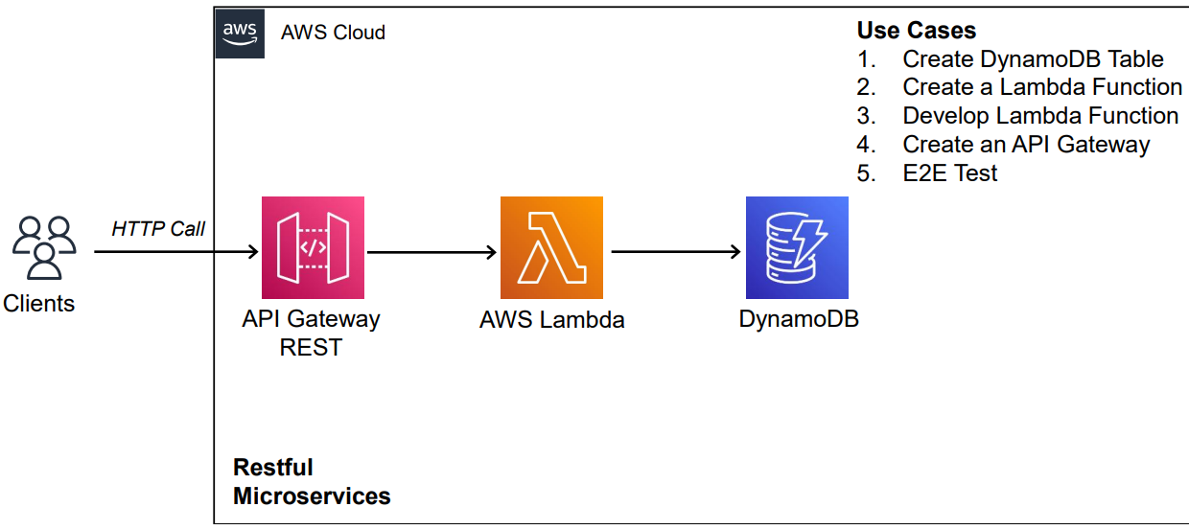

5. Implementation Details
• Frontend developed using HTML, CSS, and JavaScript
• Backend APIs implemented using AWS Lambda (Python)
• Data stored in DynamoDB tables
• CORS enabled in API Gateway for cross-origin access
Coding:
getorders.py
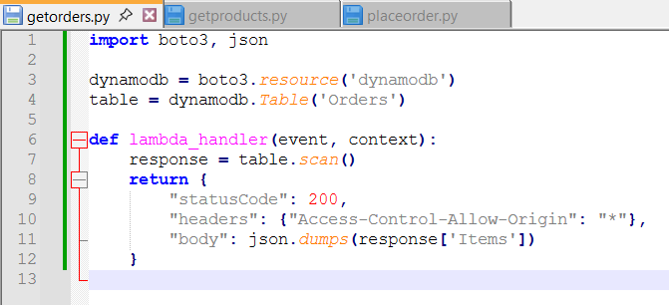

getproducts.py
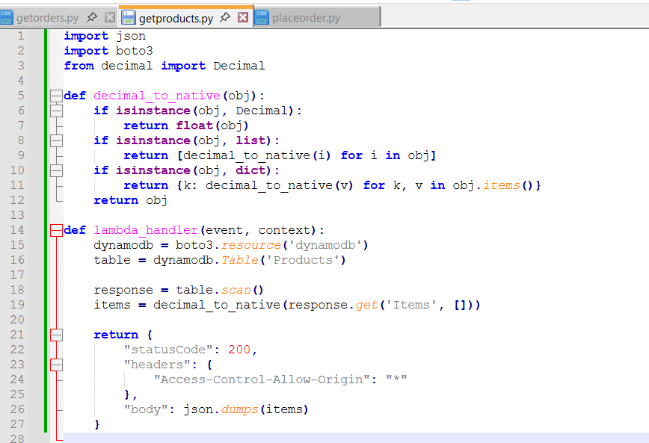
placedorder.py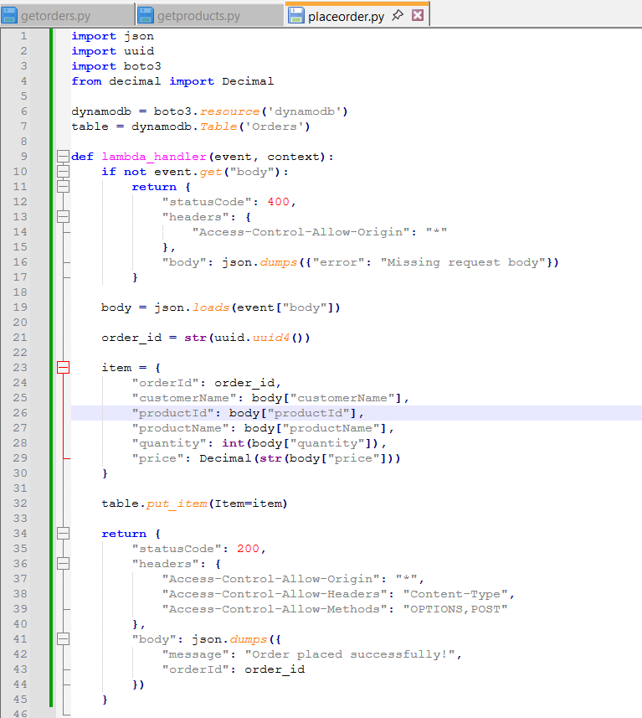

6. Testing
• API tested using browser and console logs
• DynamoDB verified for correct data insertion
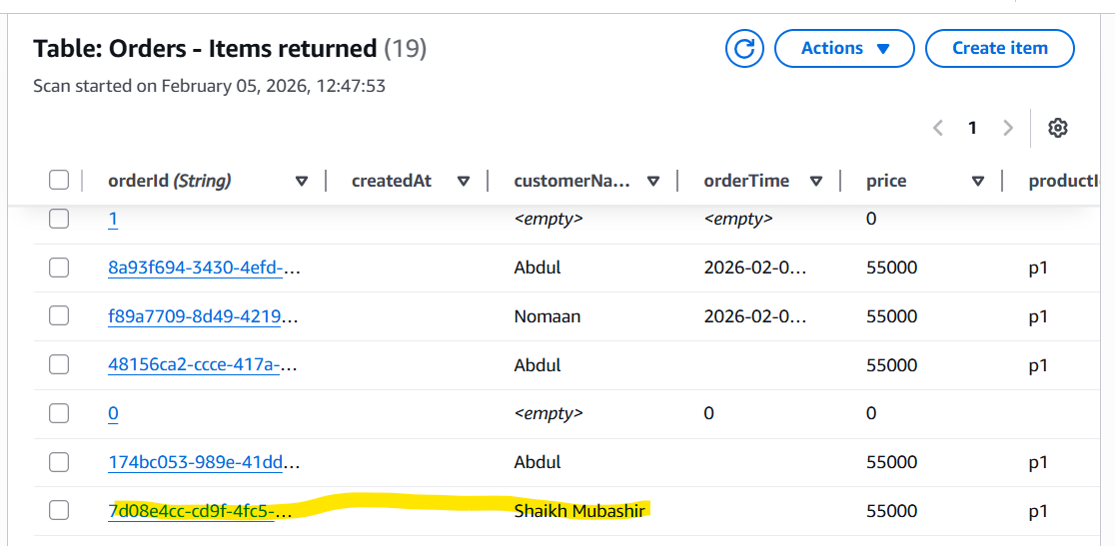
• Error handling validated

7. Advantages of Serverless Architecture
• No server management
• Automatic scaling
• Pay-per-use pricing
• High availability

8. Conclusion
The serverless shopping website successfully demonstrates modern cloud-native application development using AWS.

