PAAREES Perfumes

ADIDAS MEN

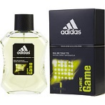

**Adidas for Men - 100ml**

By Adidas

Key Features

* Discounts available on App
* Eau de Toilette
* For Men
* 100ml